Тема : СОЦІАЛЬНІ МЕРЕЖІ ( Урок для 11-10 класів)

Мета:
очікуєтья сформувати комунікативні навички по темі « Соціальні мережі в житті людей»,
активізувати мовленнєву активність,
сформувати доброзичливе ставлення до опонента та навички толерантного спілкування, вміння аргументувати свій погляд, знаходити альтернативне рішення проблеми
очікуєтья, що урок сприятиме активізації навичок аудіювання , читання та письма,
будуть розвиватися вміння аналізувати отриману інформацію,
буде удосконалюватися монологічне мовлення з опорою на відео та аудіоматеріали,
розвивається вміння розрізняти корисну та недоцільну інформацію в мережі Інтернет,
планується розвивати креативність та критичне мислення та вміння співпрацювати під час групової роботи.
Обладнання: підручник Focus 4, відеоматеріали, інтерактивна дошка, презентація до уроку
Хід уроку.
Teacher: Nowadays we live in a digital age, the time of technology and the Internet. The usage of social networking platforms is popular among adults and teenagers. How many social media users are there in the world?
Students` own answers.
- Teacher: Complete the sentences to make them true for you.
1. I carry my phone in………
2. I check my phone………
3. My favourite social media app is……
Students` own answers.
- Teacher: Discuss some questions.
1. Is the amount of time we spend on social media a problem?
2. What are some of the ways that you and I can use social media in a better way?
3.Is it true that creativity can be actually good for our health?
4. Do you think that social media can be good for your health?
Students` own answers.
- Teacher: Watch the video and compare your ideas with the answers given in the video.
Students watch the video and compare their answers.
- Teacher:
Complete the table with some of the comments describing the use of the phones in the video.
What are the most important advantages and disadvantages of mobile phones for you?

Be very careful with your privacy,
being creative, connectivity,
easy to get addicted, low-quality content, makes you
more mindful, opened up so many new activities,
scrolling through mindlessly
Advantages | Disadvantages

- Teacher:
Your next task is reading. The text is cut into some paragraphs which you have to read and be ready to answer the questions. Each part contains one or two answers.
1. When did smartphones become mainstream?
2. Who made the claim that they have invented the selfie?
3. When does the oldest selfie date back to and how was it taken?
4. What do Australians have a habit of adding to the end of the words?
5. What might some people be seeking by taking a lot of selfies?
6. What can taking lots of selfies help you to shake off?
7. What kinds of apps are gaining popularity and why?
8. What does BDD mean and what can trigger it?

A short history of the selfie
They’re everywhere – people posing with their phones held out in front of them or on a selfie-stick. And it’s not just young people – social media users of all ages take selfies, including space-walking astronauts and the Pope. So when did this selfie mania begin? Most people would guess that it was around the beginning of this century or perhaps a bit later when smartphones became mainstream.
But most people would be wrong, just as Britney Spears and Paris Hilton were wrong when they declared on Twitter in 2017 that they had invented the selfie eleven years previously. In fact, they were around 167 years too late to make that claim.
The oldest existing selfie dates back to 1839 when photographer Robert Cornelius took a self-portrait photograph of himself. To achieve this, he had to uncover the lens, run to his place and pose in the same position for up to fifteen minutes and then run back to cover the lens again. Cornelius couldn’t take a dozen shots and choose the best one – his selfie had to be just one photo. Half a century later, in 1914, thirteen-year-old Grand Duchess Anastasia Nikolaevna of Russia took a picture of herself in a mirror and became the first teenager to take a selfie. The first image taken in the same way as today, with the photographer holding the camera at arm’s length, was in December 1920. The image shows five photographers standing on the roof of their studio in New York. The men were the main photographers of the Byron Company, a photographic studio founded in Manhattan in 1892 and still in business today. An image taken by another man shows that the camera was so heavy in those days that it took two of the photographers to hold it up. Thanks to innovations and improvements in cameras, a selfie gradually became easier to take, but it was the smartphone coming out in the early 2000s that led to selfie dominance. Surveys have shown that every third photo taken by those aged eighteen to twenty-four is a selfie.
And what about the origin of the word itself? It is thought to come from Australia where people have a habit of putting -ie on the end of words – barbie for barbecue, postie for postal worker and even Aussie for Australian. In 2002, an Australian man took a photo of an injury to his lip and put it up on a public forum to ask for advice on how to treat it. He referred to the photo as a selfie, and the term was born. Selfie became Oxford Dictionaries’ word of the year in 2013.
So, why do we take so many photos of ourselves? A 2017 study into ‘selfitis’, as the obsessive taking of selfies has been called, found a range of motivations, from seeking to feel more part of a group to shaking off depressive thoughts and – of course – capturing a memorable moment.
Since we live so much of our lives online, there is pressure to present good quality images, and so it is no surprise that airbrushing apps that enable people to retouch images and present an idealised version of themselves are gaining popularity. For the most part, this is harmless fun, normal behaviour in the age of social media.
But a recent report in a medical journal suggested that filtered images ‘blurring the line of reality and fantasy’ could be triggering body dysmorphic disorder. BDD, as it is known, is a mental health condition where people imagine defects in their appearance. Nowadays it’s not unusual for young people to ask for plastic surgery, not to look more like their favourite celebrity, but to look like their own filtered image. In a 2018 report on facial plastic surgery, 55 percent of surgeons said patients’ motivation was to look better in selfies, up from just 13 percent in 2016. Whatever your motivation, once you’re in the selfie habit, it’s hard to stop. So tousle your hair, extend your arm, check the lighting is right, zoom in, smile/duck-face/wink, and snap a selfie. It’s blurred. Take another snap. Once more. Delete the ugly ones and post the cutest shot. Wait for the likes!

( Pupils read different parts of the text . After that they answer the questions, using their paragraphs.)
- Teacher:
Now let us imagine the situation, that we are on the conference and some participants don`t speak English. So, we need to convey the main points of our meeting to the guests. And it`s time to choose a speaker and an interpreter. The speaker has to retell the main points of the text , the interpreter has to translate them simultaneously.

( Two pairs of students do the task Speaker- Interpreter ).
Students` own answers.
- Teacher: Now we`ll have a team game.
Everybody stands up. Listen to me very attentively and do what I say. If I say “walk “– you walk, if I say “stop”- you stop.
(Students walk around the classroom.) Now do the opposite: if I say” stop” – you walk. If I say “walk” – you stop. (Students walk around the classroom.) When I say “clap” – you clap, when I say “Twitter” – you say “Twitter” but continue to do the opposite the previous activities. Next task is if I say” jump” – you jump, if I say “dance” – you dance. But if I say “clap” – you say “Twitter”, if I say “Twitter” – you clap. And if I say” stop” – you walk. If I say “walk” – you stop.
- Teacher: Discuss the questions.
1. When was the last time you took a selfie and why did you take it?
2. Which of your friends posts the most interesting selfies?
3. Why do you think selfies are so popular?
Students` own answers.
- Teacher:
Your task was to prepare your own selfie and describe it. Let`s listen to you.
Students` own answers.
- Teacher:
Some students had the task to find information about advantages and disadvantages of Social Media. So, we`ll listen to them.
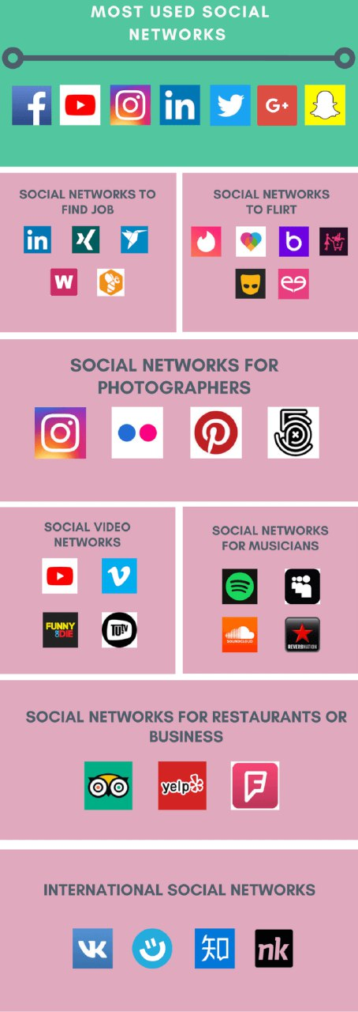

Students` own answers.
- Teacher: One of our students has her own blog and she `ll tell us a few words about it.


- Teacher:
Now think about tips for social media projects, blogs and vlogs using the Internet resources.
Students` own answers.
Teacher: Thank you for excellent cooperation. Your work is perfect today. Your home task is to write the essay about pros and cons of social media.

