Іноземні мови
ВІДДІЛ ОСВІТИ
ЧЕРКАСЬКОЇ РАЙОННОЇ ДЕРЖАВНОЇ АДМІНІСТРАЦІЇ
РАЙОННИЙ МЕТОДИЧНИЙ КАБІНЕТ
ДУБІЇВСЬКА ЗАГАЛЬНООСВІТНЯ ШКОЛА І-ІІІ СТУПЕНІВ ЧЕРКАСЬКОЇ РАЙОННОЇ РАДИ ЧЕРКАСЬКОЇ ОБЛАСТІ

Cемінар-практикум вчителів іноземних мов

«Формуванння навичок критичного мислення на уроках англійської мови якзасіб розвитку творчої особистості»

Черкаси 2018

Вступ

Сьогодення, новий Державний стандарт вимагають від вчителя здійснювати компетентнісний підхід у навчанні іноземних мов і це неможливо вирішити без оновлення методів навчання, без використання нових продуктивних навчальних технологій, до яких належить технологія розвитку критичного мислення. Вона як ніколи актуальна, бо спрямована на підготовку такої особистості, яка здатна брати участь у розв’язанні проблем, що постають перед нею у сучасному суспільстві.
Досвід роботи висвітлює питання розвитку критичного мислення, через застосування ефективних інноваційних технік, зокрема використання таксономії Бенджаміна Блума в шкільній практиці, за допомогою якої можна вести учнів від розумової діяльності нижчого порядку( запам’ятовування, розуміння) до вищого порядку(застосування, аналіз, оцінювання та творення).Даний посібник також містить практичні поради щодо перетворення таксономії Б.Блума у практичний інструмент проектування уроку англійської мови.
Значна увага приділяється розкриттю методів та прийомів як засобів розвитку критичного мислення, підвищення творчого потенціалу учнів.
Матеріали досвіду корисні для використання вчителями іноземних мов.

Plan of the workshop
- Better understand what it means to “think critically”. Bloom’s taxonomy.
- Examine how to build critical thinking skills
- Introduce some practical ideas for the classroom.

Hello, everyone! I’m so excited to be here with you learning and growing. Today we are going to be talking about helping our students develop their critical thinking skills using Bloom’s taxonomy and to take a look at some ideas for practical classroom activities.
Before we start I’d like to do an activity with you all [Appendix 1].
You are going to see a quote on the screen and this quote says:
“Good thinkers see possibilities where others see only obstacles or road blocks”
[1, p. 5]
I’d like you to react to that quote. You have seven options there in appendix 1. Take a moment and read all of the options before you make your final decision. OK, make a note of your answer and see where it falls on this scale.
So, if you chose answer one from the critical thinking perspective and an active participation in class, again, if we’re thinking about doing this with our students’ perspective, you don’t have to be interested in every topic that comes up, but try to form a position when you’re asked.
If you answered 2or 3 - You have a strong opinion, but can you give reasons for your opinion?
Answers 4-5- those are both safe choices, like, I’m not so sure here but critical thinkers need to be active in discussions and that usually means picking a side
6- Good. You can express a reason or evidence for your opinion.
7- Excellent! You have reasons for your opinion, and you want more information before you make your final decision. [Appendix 2]
So this is just to make us think about critical thinking activities and, also, this can be a great activity to use with your class if you’re having some trouble with critical thinking in discussions, for example. You can use this activity as a way to set expectations for what you would like to see from your students in terms of depth and format of answer.
Let’s go back to my presentation and I would like to know how you define critical thinking.
Now, I’d like to draw your attention to Bloom’s taxonomy-model which classifies critical thinking skills.
I think many of you are probably familiar with Bloom’s taxonomy. Although, it might be new to some of you.
This system for classifying thinking skills was developed by Benjamin Bloom in 1950s. It is usually showing skills from lower order thinking skills at the bottom to higher order thinking skills at the top, so less complex to more complex.
The diagram is usually shown as a pyramid but I wanted to show you this lovely picture of the mountain.
Now I would like you to work in groups and make some predictions concerning Bloom’s Taxonomy diagram steps. You have to match each definition with its correct stage. [Appendix 3]
It’s time to check your answers and let’s start at the bottom of the pyramid or mountain.
That’s remembering-that’s the ability of locating information, recalling details from some sort of the text that you have interacted with or some type of content that you have interacted with.
Moving up in complexity is the understanding, that’s being able to organize ideas or explain the ideas and concepts in that content. And then it’s taking that information that you’ve understood and applying it to do something different. We do a lot of application activities in the language classroom. Right?
We do true or false comprehension, fill in the blank, complete the chart- those types of things where we are asking our students to demonstrate through application their understanding.
Next in complexity we have analysis, that’s breaking apart a whole. That’s looking at a part-looking at the parts of something and how they relate to each other, really taking a close look at how something is structured. We do this a lot when we analyze texts in terms of how they are built and put together.
Then we get into evaluation, looking at the quality, the validity, reliability of argument, information and how it’s organized.
This is where we start making some judgements about the information and according to Bloom’s taxonomy the top of the mountain here is creation. Taking the information you have analyzed and evaluated and coming up with something new and that could be new thoughts, ideas and a new product. May be you are developing something in the class like a role-play or a poster project or you might be just developing a solution to a challenging problem or situation.
So, these steps are not sequential. It’s not that every time in class we need to go from remembering up to creation to have a critical thinking skills oriented lesson. You might be doing some of these at the same time. You might be skipping around among these steps. This is just meant to, again, show the quick progression from less to more complex thinking skills. You know that there are six lists of verbs which characterize each stage of Bloom’s Taxonomy. And I would like you to do one another group work matching the lists of verbs with the correct categories of thinking skills [Appendix 4]. The next task will be to raise a green card if you think that it is a low-order thinking skills activity and a red card if it is a high-order thinking skills activity. Look at the screen and when I name the activities you will raise your cards explaining your choice. [Appendix 5] Now in your groups choose a leader who will take the strip of paper with any category from Bloom’s Taxonomy pyramid. Your task is to create some tasks or activities according to the category your group leader has chosen. You can see the topic for your task on the screen and it is “Travelling”.
Now it’s time to demonstrate some practical activities for critical thinking practice.
Let’s get down to learning stations with critical thinking tasks to complete
You have already been divided into groups of five according to different pictures. On each card there is a number – that’s the number of the station you have to start visiting the learning stations with. There are 5 stations and you are given five minutes to complete each task of the station. (Appendix 6)
Conclusion
Critical thinking skills have a lot to do with succeeding on standardized tests and in life. That's why many teachers keep Bloom's Taxonomy in mind when developing questions for class discussions, tests, journal prompts, and reader-response essays. Bloom's Taxonomy identifies six levels of cognitive thinking. At the basic level there's knowledge and comprehension. At the higher level, there's evaluation, synthesis, analysis and application. To help you sharpen those higher level, critical thinking skills, keep this word list in mind as you teach and ask questions throughout the day.
Thank you for being devoted to our workshop and I hope our cooperation has been mutual and beneficial for your teaching experience.

Bibliography

- Longman Dictionary of English Language and Culture, 2001
- Spector, J. Michael - de la Teja, Ileana. ERIC Clearinghouse on Information and Technology Syracuse NY. Competencies for Online Teaching. ERIC Digest. Competence, Competencies and Certification. - Р.1.
- Рижак Л. Університетська освіта в ХХІ сторіччі: філософсько-синергетичний аспект // Вісник Львів. ун-ту. Серія філос. - 2009. - Вип. 12. - C. 26-35.
- Тягло О.В. Критичне мислення: Навчальний посібник. - Х: Основа, 2008. - 189 с.
- Тягло А.В., Воропай Т.С. Критическое мышление: проблема мирового образования ХХI века // Постметодика, №3 (35). - 2001. - С. 19-26.
- Технології розвитку критичного мислення на урокахіноземних мов. З досвіду роботи вчителів. - Миколаїв: Наук.-метод. центр Упр. освіти Миколаївської міської ради, 2008. - 47 с.
- Mario Rinvolucri. Thinking patterns that effect our classroom. // Modern English Teacher. - Vol. 5. - N 3. - P. 39-43.
- Sherman Jane. Sour own thoughts in your own words. // ELT Sournal. - 1995. - Vol. 47/1. - P. 190-198.
- Ніколаєва С.Ю., Гринюк Г.А. Сучасні технології навчання іншомовного спілкування. - К.: "Ленвінг", 1997. - Вип. 1 (3). - С. 19-53.

Appendix 1
What is your response to the quote?
- I’m not interested in this topic.
- I agree. It’s true.
- I disagree. It’s false.
- I’m not sure.
- I agree up to a point, but I also disagree.
- I agree/disagree because…..
- I agree/ disagree for a number of reasons, but I also want to see more evidence related to this topic.

Appendix 2
Where does your response fall?
1 - You don’t have to be interested, but try to form a position when asked.
2 and 3 – You have a strong opinion, but can you give reasons for your opinion?
4 and 5 – safe responses, but critical thinkers need to be active in discussions.
6- Good. You can express a reason or evidence for your opinion.
7- Excellent! You have reasons for your opinion, and you want more information
(before you make your final decision)

Appendix 3
Match the stages with their lists of verbs
Level I Remembering | That’s the ability of locating information, recalling details from some sort of the text that you have interacted with or some type of content that you have interacted with.
Level II Understanding | Organizing ideas or explaining the ideas and concepts in the particular content.
Level III Applying | Using previously learned information in actual situations
Level IV Analyzing | Break down objects or ideas into simpler parts and find evidence to support generalizations.
Level V Evaluating | Looking at the quality, the validity, reliability of argument, information and how it’s organized.
Level VI Creating | Taking the information you have analyzed and evaluated and coming up with something new.

Appendix 4
Level I Remembering | list, name, search, write, find, label, match, show, spell, recall, read, memorize, arrange, underline, trace, repeat
Level II Understanding | locate, match, describe, give examples, paraphrase, classify, illustrate, explain, understand, show, recognize, understand, translate, select, report, extend
Level III Applying | fill in the gaps, choose, illustrate, complete, solve, use, interview, practice, write, change
Level IV Analyzing | compare, identify, explain, categorize, contrast, criticize, differentiate, outline, point out, prioritize, analyze, characterize, examine, divide, break down, survey
Level V Evaluating | rate, rank, prioritize, argue, judge, select, support, value, evaluate, summarize, recommend, convince, criticize, assess
Level VI Creating | create, imagine, design, plan, discuss, invent, compose, make up, transform

Appendix 5
High-order and low-order thinking skills activities
- Problem solving
- Hypothesis game
- Selling an imaginary product
- Predicting
- Brainstorming
- Gap –filling
- Labelling
- Interviewing
- Doing a poster project
- Guess meaning
- Sentence completion
- Dictation
- Role playing
- Arranging scrambled story
- Comparing two of the main characters
- Selecting parts of the story that were the funniest, saddest, happiest, and the most unbelievable

Appendix 6
Station1 “Senses Poem”
Writing Poetry
Senses Poem
I see_________
I feel_________
I hear_________
I smell_________
I think_________
Create your own poem
You can change the frame
Be ready to recite your poem
Good Luck!

Learning Station 2
“Silly Story Telling”
Make up a few sentences to continue each story

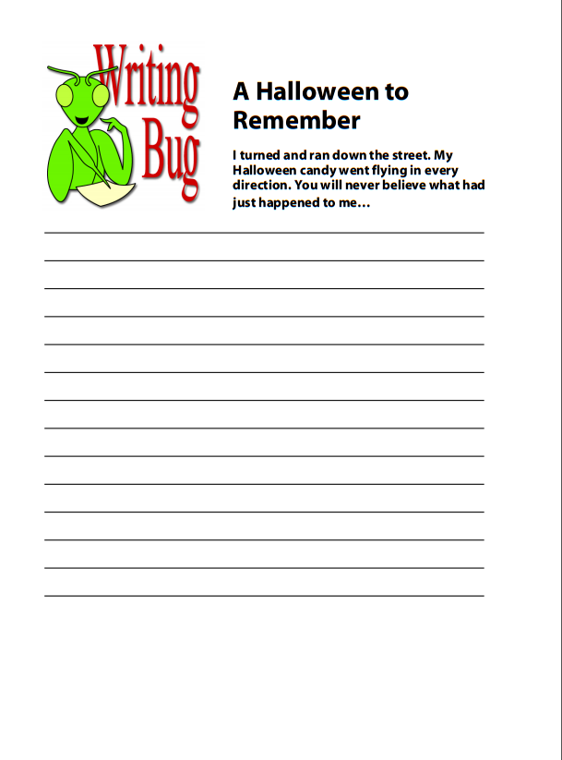
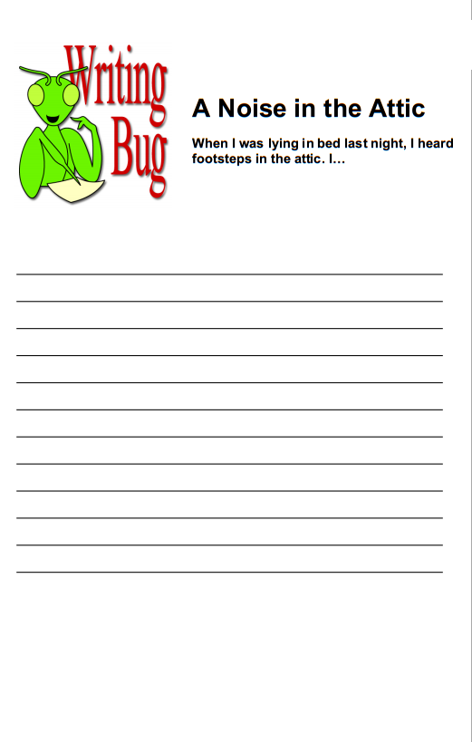
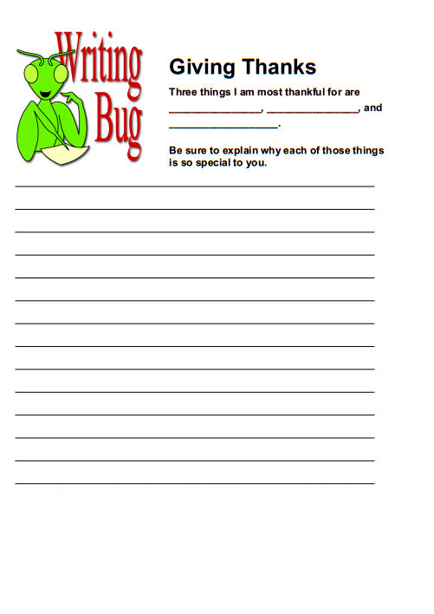

Station3
“Brain Teasers”
ACTIVITY 1 “Communicating in Code”
Create and leave a message for another group using the Braille alphabet
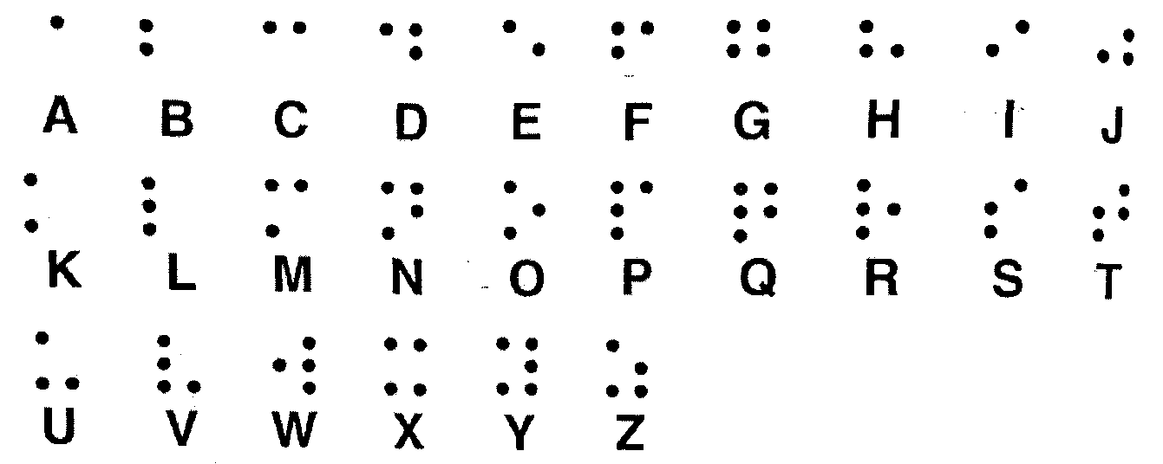
Decode the message from the previous group and create another one.

ACTIVITY2 “Morse Code”
Here is what Morse code looks like. It sounds like this: dot = quick sound or tap, dash = longer sound). Using Morse code, write a note to a friend using only the dots and dashes of the code. Be sure to allow enough space between each letter so that the letters don't run into each other.
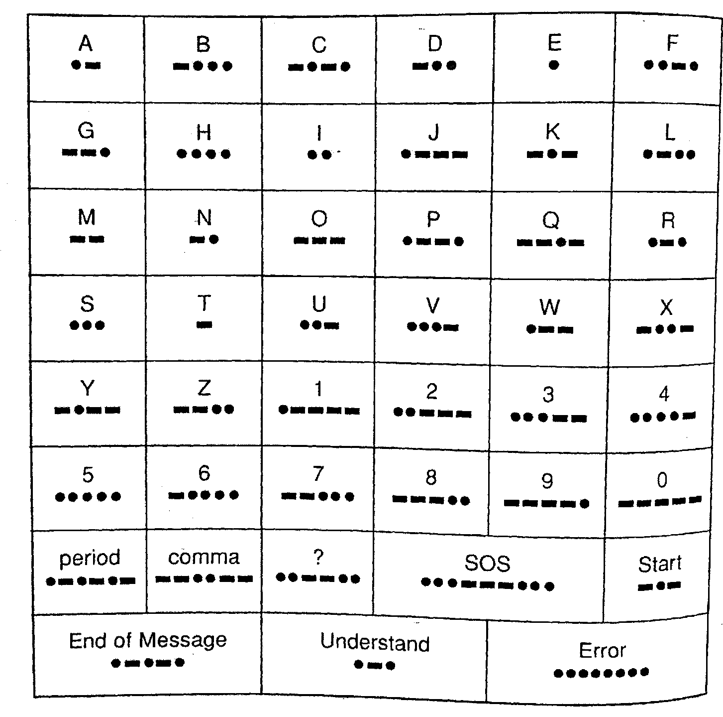
Leave the message from your group to another group!!!
Decode the message from the previous group and create another one.
1.____________________________________________________________________________________________________________________________________________________________________2._____________________________________________________________________________________________________________________________________________________________________________________________________3.______________________________
Activity 3 “The Value of Words ”
In the value box, each letter of the alphabet has been given a dollar value.To find the value a word, add the values of all the letters. For example, the word “school” would be worth$72(19+3+8+15+15+12=72). Write words with appropriate values in each of the boxes below.

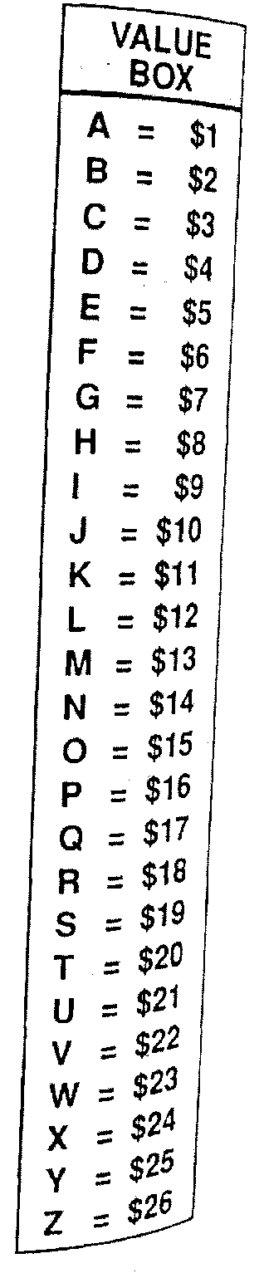
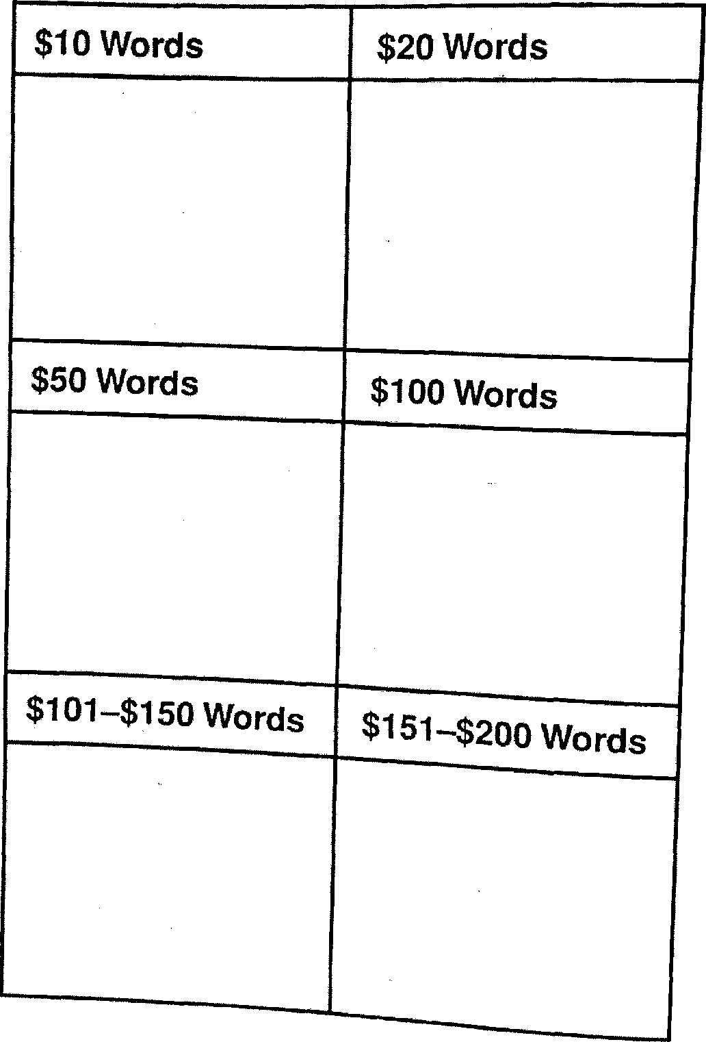
Learning Station 4 “Choices in the Bag”
If you had to choose……… what’s your choice?
Take a card (do it in turns)
Read aloud for the whole group
Answer individually
Explain your choice
Make three more cards in your group and add them to the common list

Learning Station 5 “Running Dictation”
One person from your group has to "run" to the paper with a riddle dictation ,read and remember as much as possible and come back to your group as fast as possible and dictate what they have read, while the person, who is chosen as a writer, writes down the story. In the middle of the “game” you have to swap the roles, so that it gets more interesting and that all the members from your group try out both roles. As soon as you finish try to solve it and suggest your answer.

“Running Dictation”
13 people came into a hotel with 12 rooms and each guest wanted his own room. The bellboy solved this problem.
He asked the thirteenth guest to wait a little with the first guest in room number 1. So in the first room there were two people. The bellboy took the third guest to room number 2, the fourth to number 3, ..., and the twelfth guest to room number 11. Then he returned to room number 1 and took the thirteenth guest to room number 12, still vacant.
How can everybody have his own room?

