Contents
- Introduction……………………………………………………………………..4
- Chapter I.5 Steps for Bringing Your Classroom into the 21st Century…………7
- Chapter II. 21st Century Competencies Symbols……………………………..11
- Chapter III. Activities and Ideas………………………………………………12
- Conclusion…………………………………………………………………….47
- References…………………………………………………………………….49

Introduction
Our nation faces serious questions in regards to our educational system. The purpose of these recommendations is to provide you with perspective on the key issues to consider—as a policymaker, as state leader, as a district or school administrator—to ensure that you are planning for the future and building strategies that will solidify the success of our students, not only in school and work, but in life.
The 21st century skills are a set of abilities that students need to develop in order to succeed in the information age. These skills have always been important for students, though they are particularly important in our information-based economy. To hold information-age jobs, though, students also need to think deeply about issues, solve problems creatively, work in teams, communicate clearly in many media, learn ever-changing technologies, and deal with a flood of information. The rapid changes in our world require students to be flexible, to take the initiative and lead when necessary, and to produce something new and useful. The Partnership for 21st Century Skills lists three types:
Learning and innovation skills increasingly are being recognized as the skills that separate students who are prepared for increasingly complex life and work environments in the 21st century, and those who are not. A focus on creativity, critical thinking, communication and collaboration is essential to prepare students for the future.
Information, Media and Technology Skills. Today we live in a technology and media-suffused environment with: 1) access to an abundance of information, 2) rapid changes in technology tools, and 3) the ability to collaborate and make individual contributions on an unprecedented scale. To be effective in the 21st century, citizens and workers must be able to create, evaluate, and effectively utilize information, media, and technology.
Life and Career Skills. Today's students need to develop thinking skills, content knowledge, and social and emotional competencies to navigate complex life and work environments.

Every 21st century skills implementation requires the development of key academic subject knowledge and understanding among all students. Those who can think critically and communicate effectively must build on a base of key academic subject knowledge. Within the context of key knowledge instruction, students must also learn the essential skills for success in today’s world, such as critical thinking, problem solving, communication and collaboration.
The elements described below are the critical systems necessary to ensure student mastery of 21st century skills. 21st century standards, assessments, curriculum, instruction, professional development and learning environments must be aligned to produce a support system that produces 21st century outcomes for today’s students.
21st Century Standards
- Focus on 21st century skills, content knowledge and expertise
- Build understanding across and among key subjects as well as 21st century interdisciplinary themes
- Emphasize deep understanding rather than shallow knowledge
- Engage students with the real world data, tools and experts they will encounter in college, on the job, and in life; students learn best when actively engaged in solving meaningful problems
- Allow for multiple measures of mastery

Chapter I
5 Steps for Bringing Your Classroom into the 21st Century
Set up Learning Stations
Independent learning stations are a great way to engage students and give them freedom and ownership in their education. Set a few desks around the perimeter of your classroom. At each desk, set up a learning activity that students can do on their own. For example, you might have a CD player and a listening textbook that they can work with at one station. You might have a grammar exercise at another desk. At still another you might have a vocabulary game. And of course, have a reading nook with a classroom library available, too. Give your students freedom to choose what activity they work on during designated free work periods. They’ll get out from behind their desks, move around the classroom, and gain a little more ownership in their education – perfect for today’s postmodern generation.
Create Gathering Places
You’re an English teacher, so you know how important communication is for students of the English language. We talk about communicative classrooms, as we should. But have you thought about how your classroom setup can contribute to conversation in your class? You’ll see it happen when you create gathering places in your classroom. Think about your living room or the cushy chairs in a coffee shop. When you are comfortable and facing your friends, conversation flows. You can set something up like this in your classroom. Think about the seating you have available. Are there comfy chairs? Is there natural lighting? If you can, give your classroom a living room like feel by setting up soft seats, simple tables, and lamps. Create conversation areas for students to do group work. Make it feel like they’ve accepted an invitation rather than fulfilling an obligation when they come into your class. Even if you can’t bring in outside furniture, consider setting your student desks up to create a larger tables rather than rows and columns. When your student are comfortable and they feel like they are in a homey environment, they will ready to communicate comfortably with each other.
Have a Classroom Technology Wish list
Is your classroom high-tech? If you are lucky, you might already have computers, a television and DVD player, student tablets, and other high tech devices. But if you don’t, you shouldn’t despair at the school budget. Consider setting up a technology wish list for your class. You might be surprised at what friends, students, and others are willing to contribute to your classroom. Particularly if you aren’t set on having the newest generation of today’s high-tech gadgets, your friends who wait in line for the newest iPhone might gladly donate older computers, tablets, kindles, and other items. But they won’t pass them along if they don’t know you are looking for them. If you have a classroom blog or website, keep a running list of donations you are looking for. You may find that one person’s clutter is just what you need to bring your classroom into today’s world of technology.
Give Your Students a Voice on the Wall
In some ways, teaching in the postmodern era is more like facilitating than instructing. It does not mean not to have information to give your students. Not by any means. The part of our jobs today is to encourage our students to contribute to their own learning. You can do that by setting aside a space or two on the wall for your students to help each other learn. One of popular ways to do this is a classroom Good reads wall. If you are on Good reads, you know that on your account you can keep a list of books that you have read along with reviews for each of them. If you choose to review those books, your review become public to anyone else with an account. If your students are at the point where they are reading books in English, encourage them to rate and review any books they have read for the rest of the class. When students finish a book, print out a picture of the cover and then give them a 5x8 index card on which to write a short book review. They should write the title of the book on the top of the card, give it a rating of one to five stars, and write a few sentences to say why they either liked the book or didn’t like it. On your Goodreads wall, post the book cover and then put the review index card near it. Then when other students are looking for a book to read, they can check out the reviews of their classmates and either choose one of the books on your wall or a new one. When other students write reviews on the same books, post their index cards near the book cover on the wall, too. As the school year continues, your Goodreads wall will grow and students will share their ideas about what they have read when they write and read book reviews.
Create a Flexible Classroom
No matter what you decide to do with your classroom arrangement, you will get the best results from your interior decorating when you have furniture that moves around easily. Being able to arrange and rearrange the furniture in your room will not only allow you to change things up throughout the school year. It will also let you try different arrangements and find out what works best for your particular class. So choose simple tables over heavy desks. Use chairs that are separate from tables rather than all in one units. We can’t always choose what furniture we have in our rooms, but you can make suggestions when it’s time to get new pieces or add what you want piece by piece. Keep your classroom decorating goals in mind and work toward them little by little. Over time, you will have the room you want and the one that connects best with your students.

Chapter II
21st Century Competencies Symbols


- Intercultural awareness

2.Critical thinking

3. Autonomous learning

4. Communication



5. Cooperation


6. Creativity
7. ICT literacy


8. Personal and social
responsibility

Chapter III
Activities and Ideas
- BLIND/DEAF/TASTE/DUMP EXPERIENCE
The students spend one hour either "blind" or "deaf" in a safe situation of their choosing and then they write. Note: This assignment should be done individually, and not as a group, because the group experience lessens its value in strengthening perceptions.
- BULWER-LYTTON
This assignment helps students recognize a sense of style in writing, which most of them have, but may not be aware of it. It focuses on four or more story genres. Begin with a general genre such as adventure. Then go on to romance, science fiction, western, mystery, etc.
- "THREE MINUTE" WRITING CYCLES

The students sit in a circle, each having sufficient writing paper and their names on the first sheet. When the instructor says, 'Begin' they begin writing a story starting with the phrase "It was a dark and stormy night." [The teacher should instruct the class not to write about anyone in the class or in the school.] After 3 minutes, the teacher instructs them to pass the story to the person on their right/left. The next student adds to the story for 3+[?] minutes and passes it on, and so forth. The instructor keeps track of the time periods, adjusting them for the "speed" of the class but 3 ½ minutes is generally best. *The instructor joins in the writing. As the time for a conclusion draws near, the instructor announces that the next writer will begin to finish up the story and the one after that will conclude the story. (The class may be told that this will happen so that they can mentally prepare for finishing a story although they won't know which one.)
- SEEING LIKE A WRITER

Look at the pictures. Think about what you see. What ideas for writing a paragraph about yourself do the pictures give you?

- DIAMOND POEM
A noun
2 adjectives
3 –ing words
A sentence or phrase
A synonym
- Literature Circles
"In literature circles, small groups of students gather together to discuss a piece of literature in depth. The discussion is guided by students' response to what they have read. You may hear talk about events and characters in the book, the author's craft, or personal experiences related to the story."
How do teachers do it?
- Select members for the Literature Circles (discussion groups).
- Assign roles for the members of each circle.
- Select circle meeting dates.
- Help students prepare for their roles in their circle.
- Act as a facilitator for the circles.

Roles
To structure the discussion in a literature circle, it is best at least initially to assign roles to members of the group. Roles should be exchanged after each discussion so students experience a range of tasks over the course of the literature circle. There are many variations on these roles.
Many teachers have produced handouts for students outlining the roles in a literature circle. These are some of the most useful:
Discussion Facilitator
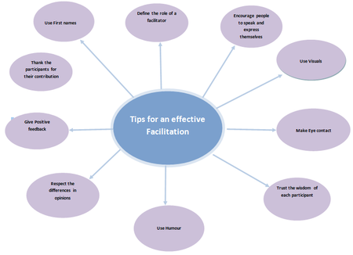
This role involves developing a list of questions that the group might discuss about the section of the novel to be discussed for that meeting. Questions should be designed to promote lively conversation and insights about the book; they should be open-ended and should not be "yes/no" questions. A student with this task asks these questions to the group to prompt discussion; overall, the job is to keep the group talking and on-task. Questions that a student might ask could be: "What was going through your mind when you read this passage?" or "How did the main character change as a result of this incident?"

Locator
This role involves locating a few significant passages of text that are thought-provoking, funny, interesting, disturbing, or powerful. The quotations are copied down with properly cited page numbers. A student with this task can read the passages out loud him/herself or ask other group members to read as well. Commentary and discussion will be generated from these passages. and also draw a part of the scene that locates where the person took place
Illustrator
As the term implies, this job entails drawing, sketching, or painting a picture, portrait or scene relating to the appropriate section of the novel. Collages from magazines, images from the internet, and other media can also be used. The student with this role then shares the artwork with the group, explaining the passage(s) that relate to the art. Often students who do not like to write do very well with this role. The pictures usually generate interesting group conversations.
Connector
This role involves locating several significant passages in the novel and connecting these passages to real life. The connections might relate to school, friends or family, home, the community, or they might relate to movies, celebrities, the media etc. Students should also feel free to connect incidents or characters with other books that they have read. Of all the roles, this role is often the most personal in its focus.
Summarizer
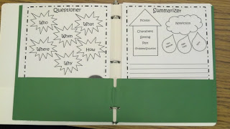
This role involves preparing a brief summary of the reading that was assigned for that day's meeting. The summary should include the main ideas or events to remember, major characters, symbols or other significant highlights of the passage. Good summarizers are important to literature circles, as they can help their peers see the overall picture (DaLie, 2001). Also include important events.

Vocabulary Enricher
Also called the Word Master or Word Wizard, this role is to record important words for that day's reading. Words that are unusual, unknown, or that stand out in some way are usually chosen by the student. Their page number and definition is also recorded. Often students do not see this role as particularly stimulating; however, it can be a role suited to students who are still developing confidence in English classes or textual analysis.
Travel Tracer
This role involves recording where the major shifts in action or location take place in the novel for the reading section. Keeping track of shifts in place, time, and characters helps students keep track of important shifts in the novel. Artistic students also are drawn to this role, as artwork can be incorporated into this role as well. The student's role is to describe each setting in detail, using words or maps that illustrate the action.
Investigator
This role includes investigative work where background information needs to be found on any topic relating to the book. Historical, geographical, cultural, musical or other information that would help readers connect to the novel is often researched and shared with the group. The research is informal in nature, providing small bits of information in order that others can better understand the novel.
Figurative Language Finder
This role includes identification of various types of figurative language, including but not limited to simile, metaphor, personification, hyperbole, and idiom. This may lead to discussion about the author's craft - why the author chose to use those particular words or phrases, and whether or not they were effective. This in-context identification can be more relevant and memorable than isolated instruction by the teacher of these types of tools.
The teacher will determine what roles should be used depending upon the age and ability of the students as well as the reading selections.
- CUBING: QUESTIONING
1. Who 2. What
3. When 4. Where 5. Why 6. How
Ideas for Use:
- Students create their own questions about a text they just read. Their question must start with the word they roll on the cube. This helps make sure they don’t just ask yes/no questions.
- To research a person or event, have the students roll the cube 3 or 4 times and then look up and write a short answer in response to each prompt they get.
- Use to plan a story the student will write.
- CUBING: DEPTH OF KNOWLEDGE
1. Describe
2. Compare
3. Contrast
4. Analyze
5. Evaluate
6. Imagine
Ideas for Use:
- Use with any 2-5 objects/people/events/formulas/theories, etc.
For example: candy bars
    - Describe: It’s in a silver and brown wrapper. It’s small. It’s brown. It’s rectangular.
    - Analyze: It has _____ calories. It looks fresh. It smells like chocolate.
    - Evaluate: It tastes really good!
    - Imagine: Imagine if chocolate was calorie free…
Once the kids knew the process, we could use is for all sorts of things.

- The ‘Connect’ game

Creativity begins with generating ideas, speculating and creating new associations. As a warm-up or focusing activity play ‘Connect’. Ask a student to suggest a word. You say a word that is related to that word e.g. if the word is ‘football’ you might say ‘goal’. The next child then says a word connected with the previous word eg ‘goal’, ‘net’ and so on. Players take turns. They are allowed thinking time, but can be challenged by any other player to explain the connection between their word and the previous word.
10. Mystery objects

Creativity involves developing ideas through suggesting hypotheses (‘What if …?’) and applying imagination. This activity encourages children to develop ideas that are original and have a purpose, which is to improve or add value to something. It encourages children to ask themselves the creative question: ‘How can this be improved?’
Show a box that contains an unfamiliar or interesting ‘mystery object’ (or a picture of an object). Without showing or saying what it is, describe the object’s appearance (or ask a child to). Ask children to try to visualize what is described, to hypothesise what it might be and then ask questions to try to identify the object. The child who identifies the object must also describe it. Show the object and ask children to reflect on the description given and their ability to visualize it. Discuss what it was made for, and its possible uses. Ask for suggestions of how it might be improved. Encourage creative suggestions.

  - Drawing games

Creativity involves expanding existing knowledge. This is done through building on existing ideas or thinking of new ideas. Creative thinking will involve both visual and verbal thinking, children thinking by themselves and with others.
      - Squiggles

Play a drawing game such as ‘Squiggles’. Make a squiggle shape on the board (a squiggle is a small mark such as a curve or wavy line). Show how this can be added to make a complete drawing of something. Draw identical squiggles on two halves of the board and invite two children to make them starting points for their own quick drawings. Discuss the creative aspects of each drawing. Children work in pairs at the activity, then display pairs of drawings. Other children must guess what each completed drawing shows.
13. What might the shape be?

Draw a simple shape on the board and ask the children what it might possibly be. Collect their ideas and add some of your own. Ask what might be added to the shape to make it something else – what could we do to change or add to it? Invite children to sketch their own picture of something new by adding to the given shape. Discuss their range of ideas.
`

14. Is Coffee Good for You?
Video link: https://www.youtube.com/watch?v=lutMjeIIm-w
This activity is a discussion based on YouTube videos about the effects of drinking coffee. The students first will talk about the issue after watching the video in class and for homework they will write an essay about it. Suitable for teenagers and adult students at advanced levels.
Answer the following questions about the reports
- Which country tops the charts for coffee consumption?
- What is the average coffee consumption in this country?
- Coffee contains ______________, which fight the damaging effects of oxygen in the body?
- According to the repot, which is the ingredient are coffee drinkers most interested in?
- Caffeine blocks the chemical associated with_______________.
- How many cups of coffee do you drink every day?
Watch the video 7 Facts about coffee you probably did not know and make a short essay about the coffee addiction.
Video link: https://www.youtube.com/watch?v=TN0cxBYh8t8
15. It’s Music to My Ears…

This is a conversation worksheet about music. The worksheet is to help low-fluency learners have conversations about topics. The worksheet particularly concentrates on using phrases to describe likes and dislikes, as well as various other conversational skills such as catching up with recent events. It includes full teacher notes with suggestions about how to use the worksheet.


Talking Challenge
- Do you know any of the artists below?
Tell your partner who they are. Do you like them or don’t you like them?
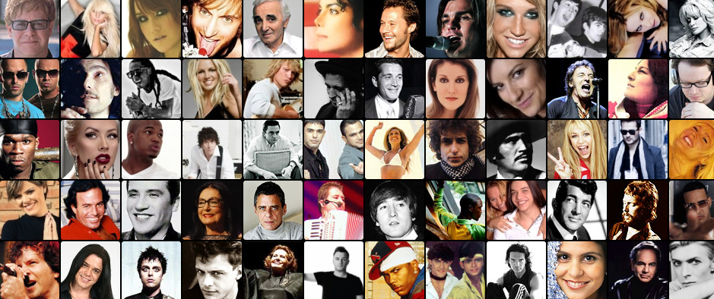

- What kind of music do you like? What kind of music don’t you like?
Here are some types of music. They are called “genres”: rock, blues, folk, J-pop, etc. Tell your partner!
Here is some useful language: “I like/don’t like...because...”, “I’m a fan of...”, “...is good/bad/OK/terrible.”, ...is better than...”, “I prefer ... because ...”.
- Role play.
A) Please match the questions and answers.
Question | Answer
What’s your favorite band and why? | Yes, because I think it’s harder to play classical music than pop music.
What genre are you a fan of? | No, but I used to play the violin.
Do you think some music is better than others? | My favorite band is One Direction because they make me happy and excited.
Do you play a musical instrument? | I’m a fan of pop, for example Miley Cyrus.
What is your least favorite genre and why? | Heavy metal is my least favorite genre because I find it stressful.

B) Please practice reading the questions and answers with your partner, try to speak naturally. The teacher will give an example.
C) Now, try to make a dialogue with your partner using the words in bold from the matching activity.
A: Hey, __________________, how are you?
B: I’m fine, and you?
A: Good thanks. What’s your favorite ________________________and why?
B: _______________________________________________________________.
A: _______________________________________________________________.
B: _______________________________________________________________.
A: _______________________________________________________________.
B: _______________________________________________________________.
A: _______________________________________________________________.
B: _______________________________________________________________.
A: _______________________________________________________________.
B: _______________________________________________________________.
D) Practice it and perform it for the class.

E) Practice having a natural conversation like this, but don’t use your notes!
- Native English
Look at the following English phrases used by native speakers. Top-notch; as fit as a fiddle; as busy as a bee; how d’ya feel about...; what d’ya say to...

Now put them in the correct sentences:
- I love this music, it’s _____________________.
- ______________________________________ going to a restaurant tonight?
- He’s old but healthy, he’s ___________________________________________.
- _____________________________ rock music? Do you like it?
- He’s always working or studying or looking after his children, he’s ____________________________.
Finally, try to use your dialogue again with a new partner.
- Elicit artist from the students, try to have them work in pairs and recognize as many as possible in a set time.
- Elicit genres, drill and give some examples of the useful language/concept check by asking whether the phrases are positive or negative. You could have students make mind maps with genres and artists.
- Have Ss try to match questions and answers alone, then compare in pairs, and then as a class. Have them practice using the phrases in pairs. You could also practice with some simple substitutions.
Have them make their own role-plays in pairs. If this is easy or not interesting you could have them imagine they are a different person (the teacher, their favorite celebrity, etc.) and practice.
Have them circulate and speak to different class members. You could have them give feedback to others, note down similarities to their own tastes, interesting answers, or even try to give feedback to the class and include one lie, asking the class to guess what the lie was.
- Drill the phrases, check any new lexis (such as fiddle, which is another word for a violin) and try to elicit meanings with guided questions, e.g.: do you think fit as a fiddle has a good/bad meaning? Do you think it means healthy or unhealthy?
Have students try the cloze activity, reminding them it is challenging and that you will read out the answers at the end. Again, have them try individually, then in pairs, then change partners and share their ideas.
- Elicit an example dialogue, then have Ss practice some of their own role-plays. This is only recommended for stronger classes, as using idioms can be rather difficult.
This worksheet explores topics such us youth, music and urban tribes. It contains lots of exercises to work with young students. In the first part, students will explore different music styles and they will learn to express preference, likes and dislikes. In the second part, they will reflect about adolescence and teenage problems. There is also an exercise about urban tribes, in which students may revise vocabulary related to clothes and appearance.

- Music and youth: URBAN TRIBES

1) Listen to these song extracts and order them.
Classical Music |  | Rock
Techno Music |  | Hip Hop
Cumbia |  | Reggaeton
Punk |  | Tango
2) Expressing opinion:
I hate it!
What do you think of pop?

I love it!




I don’t like it.
I like it.
3) Add a comment ….
I think it’s …… | + | -
I think it’s …… | FANTASTIC | BORING
I think it’s …… | GREAT | TERRIBLE
I think it’s …… | OK | AGGRESIVE
I think it’s …… | AWESOME ° | SAD
I think it’s …… | COOL | DEPPRESING
I think it’s …… | AMUSING * | OUGH!
* funny and entertaining ° marvelous, incredible.
4) Answer:
a) What do you think about rock? ………………………………………………………………………………………
b) What do you think about classical music? ………………………………………………………………………………………
c) Do you like cambia? ………………………………………………………………………………………
d) What do you think about reggae ton? ………………………………………………………………………………………
e) What kind of music do you like? ………………………………………………………………………………………
f) What´s your favourite band/singer? ………………………………………………………………………………………

5) Read the chart
 |  LOVE |  LIKE |  NOT LIKE | HATE
KATE | TECHNO | POP | HIP HOP | CUMBIA
ANN | CUMBIA | REGGEATON | ROCK | PUNK
ANDREW | REGGEATON | CUMBIA | TANGO | TECHNO
STAS | REGGEATON | CUMBIA | PUNK | TECHNO
YOU
6) Write sentences.

For example: Kate/techno……..Kate loves techno
a) Kate/pop …………………………………………………………….
b) Ann/cumbia ……………………………………………………………
c) Andrew/punk ………………………………………………………
d) Stas/techno …………………………………………………………….
e) Andrew/ reggeaton ……………………………………………………….
f) Kate/ cumbia ……………………………………………………………
7) Answer these questions:
a) Does Kate like hip hop? b) Does Andrew hate techno?
c) Does Ann hate cumbia? d) Does Stas love reggeaton?
e) Does Kate love cumbia? f) Does Ann love cumbia?
g) Do you like pop? h) Dou you like reggaeton?

8) Group- work: Complete these mind map
PROBLEMS
AGE

FEELINGS
INTERESTS AND
ACTIVITIES
TEENAGERS

18. Look at the pictures and identify the different urban tribes.
Make a list of items related to each of them.
Urban tribes are made up by groups of young people, with a distinct common identity: the same aesthetic codes, the same identity symbols, the same rules, the same language, the same music… A whole ideology!
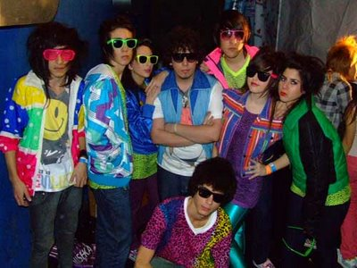
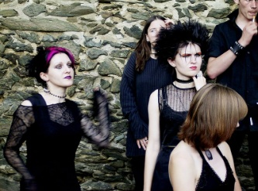
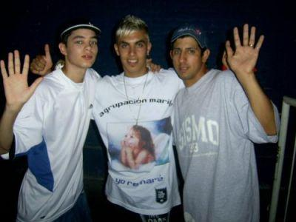

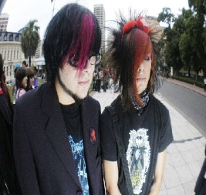

…………………. ……………… …………………. ………………….
……………….. ……………… …………………. ………………….. …………………. ……………… …………………. ………………….
Read these sentences and guess the urban tribe.

a) They wear colorful clothes …………………………………………..
b) They wear sporty clothes ……………………………………………
c) They listen to electro-dance music ……………………………………………..
d) They listen to slow heavy metal music. ………………………………………...
e) Girls wear black make-up: lipstick and nail polish ……………………………..
f) They read dark poetry and watch horror films …………………………………
g) They think life is sad, depressing and boring …………………………………
h) They like rap and hip-hop music ……………………………………………….
i) They always wear a cap …………………………………………………………
j) They wear a long fringe brushed to one side ………………………………….
k) They are shy, introverted, emotional and sensitive ……………………………
l) They wear golden or silver jewelry. ……………………………………………
19. Reading Comprehension

A Skater is someone who lives and breaths skateboarding.

What do they wear? 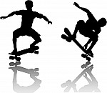
- They wear baggy jeans or trousers, hoodies and caps.
- They usually wear two-t-shirts together.
- Good trainers are the most important part of a skater's wardrobe.
- They prefer to spend money on their skateboard.

What about music?
- They like good rock music and a little bit of Hip-Hop, it has to be music that's fun.

What do they do?
- They skateboard every day without fail.
- When they are not skateboarding, they like going to the cinema and play on the Playstation and their friends.

What do they think?
- If at first you don't succeed, try, try, try ,try, try, try, try, try, try, try, try again.
- They can't walk down a street anymore without looking at the way they could try some new tricks down it.
Flogger is a teenage fashion originated in Argentina, which is closely related to Fotolog, a photoblog website. Floggers constantly upload pictures of themselves to their fotologs to find friends through the World Wide Web.
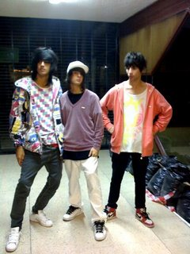 They wear very tight and colourful jeans or joggings on males and females alike, broad V-neck T-shirts in neon colours, canvas sneakers or skate shoes, long fringe brushed to one side of the face or over one eye, straight hair and horn-rimmed glasses.
This fashion has also developed a particular way of dancing techno music, called Electro. The moves consist of rapidly spreading one leg, hitting the floor with the heel, and drawing the other leg backwards, and then quickly changing the position of the legs.

Compare skaters and floggers and complete the chart
 | Floggers | Skaters
Preferences
Clothing
Activities
Music
Join question and answer

1-Where are floggers from? | a-They think try, try, and try
2-What music do floggers listen? | b-They wear tight and colorful trousers and V-neck T-shirts
3-What do skaters do? | c-They listen to techno music
4-What do floggers wear? | d-They skate and try new moves
5-What do skaters think? | e-They are from Argentina

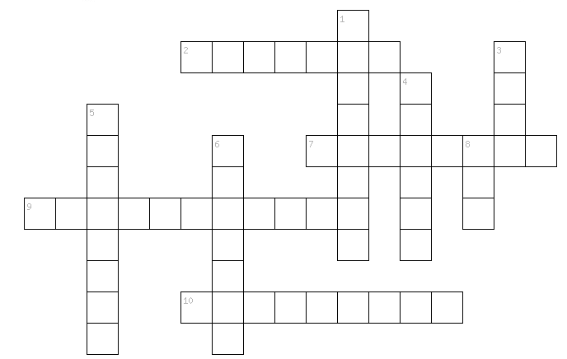
20. Crossword

Down
- A person who is between 13 and 19 years old
3- Cumbieros usually wear this accessory on their heads (pl.)
4- A…………is someone who likes challenges.
5- This person likes listening to “La liga” or “El Villano”
6- A Flogger constantly uploads pictures in his f.……….
8- An…………uses a long fringe brushed to one side covering one or both eyes.
Across
- A …………likes listening to and dancing Electro music
7- There is an urban tribe that likes J…………e anime.
9- An…….is a group of people that share the same culture: music, believes,
interests and dress styles
10- A flogger usually wears …………….jeans.
21. Categorizing

In this worksheet, students are provided with groups of words. One word in each group does not belong. Students must determine which word that is. To expand the activity, have students explain why a word doesn't belong or ask them to come up with a word that does belong in the group. Students can also come up with titles for the groups of words.
1. Which word DOES NOT belong?  a. Mother  b. Uncle  c. Sister  d. Grandma | 2. Which word DOES NOT belong?  a. Father  b. Uncle  c. Grandma  d. Brother
3. Which word DOES NOT belong?  a. Aunt  b. Uncle  c. Cousin  d. Parent | 4. Which word DOES NOT belong?  a. TV  b. Movie  c. Radio  d. DVD
5. Which word DOES NOT belong?  a. Girl  b. Boy  c. King  d. Prince | 6. Which word DOES NOT belong?  a. Slide  b. Pool  c. Swing  d. Teeter totter
7. Which word DOES NOT belong?  a. Sand  b. Waves  c. Water  d. Dirt | 8. Which word DOES NOT belong?  a. Sleep  b. Pillow  c. Bed  d. Din
9. Which word DOES NOT belong?  a. Turkey  b. Ham  c. Chicken  d. Potato | 10.Which word DOES NOT belong?  a. Salad  b. Cake  c. Cookie  d. Pie
22. A cause effect essay

This is an essay that is about causes and effects of smoking among students. It is composed of four paragraphs. The main ones in the body are about causes of smoking among students and its bad consequences. This essay is a kind of warning for students to stop smoking.
The causes and effects of smoking among students
Smoking is one of the most dangerous widespread phenomena that threaten lives of a huge number of people worldwide. It starts as a way of having fun, but ends as an addiction that is therefore so difficult to give up. Today, we often hear of “smoking among students”. So why do students smoke and what are the effects that smoking has on them?
There are many reasons behind the phenomenon of smoking among students. To start with, students smoke because they are curious and want to discover the world of those who smoke. They are just trying to have some fun when they smoke the first cigarette. Other students take up smoking due to the family problems, especially when they see their parents having quarrels. Moreover, some students smoke since they think a cigarette would relieve stress they had during the day, especially at school. Last but not least, students try to imitate adult smokers because they want to show that they are adults, too.
If we look at the consequences of smoking, we will find so many. Smoking causes cancer. As a result, the addict students would suffer from health problems that end in death. Another effect is that after certain years, the addict would develop respiratory problems and will face a lot of problems in running without losing breath. So, asthma, bronchitis, and emphysema are always a lingering threat. One more important effect of smoking is that it causes a lot of anger for the addict. Whenever they lack cigarettes, they start reacting angrily and strangely.
To sum up, smoking is an ongoing threatening danger for addicts and might affect the next generation. The best solution is prevention according to the proverb that says “Prevention is better than cure”.
23. Inventions Presentation Worksheet

This worksheet uses inventions and discoveries in history to help students learn how to form the past passive tense. Combine it with other worksheets on the passive tense to create a complete curriculum.
- Answer these questions using the past passive voice (was/were + past participle):
- Who invented the telephone?..........................................................................
- Who lost the Battle of Waterloo?.........................................................................................................
- Who discovered the moons of Jupiter? ………………………………………
- Who painted the Mona Lisa?...........................................................................
- When was the first plane built? ………………………………………………
- Which things were invented or created in your country?
………………………………………………………………………………………………………………………………………………………………
………………………………………………………………………………………………………………………………………………………………
- Complete the rule for the Past Passive Voice:
To form the Past Passive Voice we use ------------- or …………………….. + the past participle (ed or the 3rdcolumn form)

- Complete these sentences using the Past Passive Voice:

- World war II ……………………………..……………. (win) by the allies.
- Girl with the golden earring …………..……………………………… (paint) by Jan Vermeer.
- The telescope ………………………..……. (improve) by Galileo.
- The Andes ………………….………………. (cross) by San Martín and his army.
- Many battles …………………………………………… (fight) for liberty in Latin America

- Make 5 sentences using the Past Passive Voice:
paper / powder/ Windows/ the first plane/ the wheel/the first computer/ the first test tube baby/the ballpoint pen
………………………………………………………………………………………………………………………………………………………………
………………………………………………………………………………………………………………………………………………………………
24.Take A Look At This

Take a look at the warning signs of stress listed below. Check EACH of the warning signs that apply to you. When you are finished checking your warning signs, discuss your list with someone you can trust. Are there any similarities? How much stress do you think you are currently under? Discuss ways that you can eliminate some of the stress that could start to cause you physical or emotional or behavioral difficulties.

Physical | Emotional | Behavioral
____headaches  ____ stomach aches  ____ dizziness  ____ back pain  ____ neck stiffness  ____ ulcer sores on mouth  ____ jaw pains  ____ weight loss  ____ weight gain  ____ twitches (eyelids, face  ____ nausea  ____ indigestion  ____ excessive sleeping  ____ loss of appetite  ____ inability to sleep  ___ skin problems  ____ cold hands or feet  ____ constant fatigue  ____excessive sweating  ____ chest pains  ____ high blood pressure  ____rapid or difficult breathing  ____ weakness | ____ mood changes  ____ lack of concentration  ____ nightmare  ____ panic attacks  ____ anxiety  ____ anger  ____ irritability  ____ crying  ____ thoughts of suicide  ____ depression  ____ confusion  ___feelings of helplessness  ____ racing thoughts  _____aggressiveness  ____ restlessness | ____ smoking  ____ nail biting  ____ tapping  ____ pulling hair  ____ grinding teeth  ____ use of alcohol  ____ use of medication  ____ compulsive dieting  ____ hair chewing  ____ nervous laughter  ____ pacing  ____ lateness  ____ putting things off  ____ not caring about physical appearance  ____ compulsive overeating
25. How I See It!

Are the beliefs that you have about yourself TRUE or FALSE? Do you see yourself as being a loser? Really stupid? Not fitting in with your group of friends? Even though your friends say you are NOT a loser—and tell you how smart you are—and what a wonderful friend you are? It is still hard for you to think that they are being honest and real with you. Our perception is our reality; therefore we must work at changing how we see ourselves.

Write three words that describe how you SEE yourself.
________________
________________
________________
Write three words that describe how you FEEL about yourself.
________________
________________
________________
Write three reasons why those beliefs about yourself are RIGHT or WRONG in your eyes.
____________________________________________________________
___________________________________________________________
____________________________________________________________
Now it is time to note your good qualities. Name three of your good qualities.
_____________________________________________________________
____________________________________________________________
___________________________________________________________


26. Stress Journal

Can you recognize what causes the stress? Think about last week and list as many events as you can remember that caused you stress. Use the chart below to record the stressful events. Include all the information that will help you determine if there is a pattern to your stress. This journal will help you recognize what causes the most stress in your life. Be sure to rate each event as "high", "medium", or "low." Think of your reaction to the stress. For example, Did your heart start to pound? or Did you feel your temperature rise? Write your reaction in the space provided. Now, think of some ways to relieve the stress so you can keep your cool!

Date | Time | Event  (Who, what, where) | Stress Level  (high, medium,  low) | My Reaction

27. But We Always Do It This Way

Flexibility means that you are able to adapt to change and sometimes do things differently. Flexibility skills can be learned and improved. If we refuse to try new ideas or accept change, we may miss great opportunities to mature.
Use this situation: You are a teacher and the Vice-Principal, Counselor and Custodian all have the flu and called in sick. Think of ways that being flexible will be very helpful for you as you make sure your students have a good day. Think of some examples of problems that will occur if you refuse to be flexible.
Write a short story to describe your day.
28.Responsibility Journal
What does personal responsibility mean to you?
Being flexible means we can change in order to become more responsible. Think about some responsible things that you did during the last week. Write down things you said or did that were responsible. Also, write down things you said or did that you realize were not responsible. Based on your honest answers now, examine your not responsible list. Complete the “what I have learned” section.

Responsible
ACTION | CONSEQUENCE
Not responsible
ACTION | CONSEQUENCE
What I have learnt?

Thought Questions:
1. Which do I have more of, actions which are responsible or actions which are not responsible?
2. What surprised me?
3. How do I feel about my not responsible actions?
4. What steps will I take to improve?

29.Understanding Emotions
Understanding emotional competence will help you know yourself and learn ways to fine-tune your relationship skills. Using the definitions listed on the right side of the page, place the letter of the correct definition on the space for each Emotional Intelligence Competency term listed. There is only one correct choice for each term.
1. _______ Stress Tolerance  2. _______ Independence  3. _______ Empathy  4. _______ Self-Regard  5. _______ Optimism  6. _______ Impulse Control  7. _______ Problem Solving  8. _______ Social Responsibility  9. _______ Assertiveness  10. _______ Flexibility  11. _______ Interpersonal Relationship  12. _______ Emotional Self-Awareness  13. _______ Happiness  14. _______ Reality Testing  15. _______ Self-Actualization | a. I am a responsible, cooperative and contributing member of society. I am socially conscious and concerned about others.  b. I am able to resist or delay an impulse, drive or temptation when I choose.  c. I am able to achieve my potential and get involved in things that lead to an interesting, exciting and meaningful life.  d. I understand, accept and respect myself.  e. I am sensitive to what, how and why people feel and think the way they do. I care about others and show interest and concern for them.  f. I am self-reliant and autonomous in my thoughts and actions.  g. I am able to look at the brighter side of life and maintain a positive attitude even when times are tough.  h. I am able to identify problems as well as generate and implement solutions.  i. I know what I feel and why I feel the way I do.  j. I am able to establish and maintain mutually satisfying relationships. I am comfortable giving and receiving affection.  k. I am able to withstand stressful situations without falling apart by actively and positively coping with stress.  l. I feel good and at ease in school, work and leisure situations. I am able to relax and enjoy my life.  m. I able to adjust my feelings, thoughts and behaviors to changing situations and conditions. I am open to different ideas and ways of doing things.  n. I am able to tune into the immediate situation and can see things objectively; the way they are, rather than how I wish or fear them to be.  o. I am able to express my thoughts and feelings and can ask for what I need. I can defend my rights in a constructive manner.

Understanding Emotions
Answer Key
1. k Stress Tolerance
2. f Independence
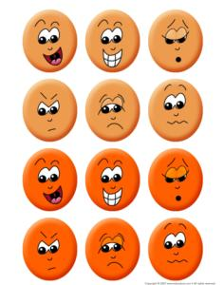
3. e Empathy
4. d Self-Regard
5. g Optimism
6. b Impulse Control
7. h Problem Solving
8. a Social Responsibility
9. o Assertiveness
10. m Flexibility
11. j Interpersonal Relationship
12. i Emotional Self-Awareness
13. l Happiness
14. n Reality Testing
15. c Self-Actualization
30.If I Had a Million Dollars!
WAIT A MINUTE! MONEY ISN’T EVERYTHING!
On each gift tag below, write the name of a person you would like to give a gift. Around each gift box, write the gift that you would like to give that person. The gift should be something that will help develop a real friendship, like a smile or an encouraging word.

Now, think of other gifts you can give to anyone at anytime.
31. Fishing for Compliments

We all need compliments once in a while. Write your name in the space provided, and then pass this paper around to someone in your group. When you receive a paper, in the spaces provided, write a compliment to the person whose name is at the top. Continue to pass the paper around until it is filled with compliments then return it to the owner. (Draw as many fish on a paper as many students are in your class)
Name____________
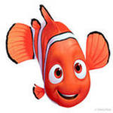

How does it feel to receive so many compliments?

32. Focus Group

Form a focus group to debate an issue to find a solution. Share your feelings, beliefs and thoughts on one of the following statements. As a group, come to an agreement about the best way to address the topic.
1. Volunteering is a good way to learn responsibility.
Why and why not?
2. The only person that I should really compete with is myself.
Why and why not?
3. If I am a team member, I should put the good of the team before my own desires.
Why and why not?
33. Overcoming Problems
“Breakthrough not Breakdown”
Problems often seem hard to solve. For some it’s like facing a brick wall. Knocking down the barriers and pushing through the brick wall is a remarkable feat. Without taking the problem on yourself, whom would you help and what problems would you help them solve? On each brick below write the name of the person you would like to help, and the problem you would like to help them remove.

34. High Five
(Group Activity)
Building self-esteem in yourself and others is an easy task when giving and receiving compliments. You will need a large sheet of colored construction paper taped to the back of each person and a colored marker or crayon. Each person will move around the room and write at least one positive comment on every other person’s paper. Comments should draw attention to that person’s strengths.
When finished, ask each person to remove the paper and read what others have said about him or her. Open discussion should follow based on the comments shared.
35. It’s All in Your Head
What does your brain contain? The picture of the head is divided into sections. In each section write or draw what you spend the most time thinking about. Optimism is the ability to look at the brighter side of life and to maintain a positive attitude, even in the face of adversity. Next, using a different color pen or pencil, write positive thoughts to fill your brain.

36. Ha-ha
Laughter helps us feel good. So, spending time with people who make you laugh is a good way to relax. Answer the questions below and have a laugh or two!
Who is one of the funniest people you know?
What is something this person said or did that made you laugh?
What is the funniest thing that has ever happened to you? Describe.
____________________________________________________________________________________________________________________________________
What is the funniest thing that has ever happened to your best friend? Describe._____________________________________________________________________________________________________________________________
Describe something your favorite comedian did that made you laugh.
__________________________________________________________________
Did anything make you laugh today? If so, what?
__________________________________________________________________
Draw a cartoon character of yourself as a baby, teenager, and distinguished elder. Have fun!

Conclusion
21st century skills comprise skills, abilities, and learning dispositions that have been identified as being required for success in 21st century society and workplaces by educators, business leaders, academics, and governmental agencies. This is part of a growing international movement focusing on the skills required for students to master in preparation for success in a rapidly changing, digital society. Many of these skills are also associated with deeper learning, which is based on mastering skills such as analytic reasoning, complex problem solving, and teamwork. These skills differ from traditional academic skills in that they are not primarily content knowledge-based.
The skills and competencies that are generally considered "21st Century skills" are varied but share some common themes. They are based on the premise that effective learning, or deeper learning, a set of student educational outcomes including acquisition of robust core academic content, higher-order thinking skills, and learning dispositions. This pedagogy involves creating, working with others, analyzing, and presenting and sharing both the learning experience and the learned knowledge or wisdom, including to peers and mentors as well as teachers. This contrasts with more traditional learning methodology that involves learning by rote and regurgitating info/knowledge back to the teacher for a grade. The skills are geared towards students and workers to foster engagement; seeking, forging, and facilitating connections to knowledge, ideas, peers, instructors, and wider audiences; creating/producing; and presenting/publishing. The classification or grouping has been undertaken to encourage and promote pedagogies that facilitate deeper learning through both traditional instruction as well as active learning, project-based learning, problem based learning, and others.
Collaborative learning environments have fostered flexibility in furniture and classroom layout. Literacy with, and access to, digital technology has impacted the design of furniture and fixed components as students and teachers use tablets, interactive whiteboards and interactive projectors. Classroom sizes have grown to accommodate a variety of furniture arrangements and grouping, many of which are less space-efficient than traditional configurations of desks in rows. The rapid changes in our world require students to be flexible, to take the initiative and lead when necessary, and to produce something new and useful.
Now, these skills represent just the starting point on the path towards mastering 21st-century skills. Competencies describe how students approach complex challenges. For example, critical thinking is the ability to identify, analyse and evaluate situations, ideas and information in order to formulate responses to problems. Creativity is the ability to imagine and devise innovative new ways of addressing problems, answering questions or expressing meaning through the application, synthesis or repurposing of knowledge. Communication and collaboration involve working in coordination with others to convey information or tackle problems.
Character qualities describe how students approach their changing environment. Amid rapidly changing markets, character qualities such as persistence and adaptability ensure greater resilience and success in the face of obstacles.
Curiosity and initiative serve as starting points for discovering new concepts and ideas.
Leadership and social and cultural awareness involve constructive interactions with others in socially, ethically and culturally appropriate ways.
Competencies such as these are essential to the 21st-century workforce, where being able to critically evaluate and convey knowledge, as well as work well with a team, has become the norm.

References
      - Chris Dede, Comparing Frameworks for 21st Century Skills, Harvard Graduate School of Education, 2009
      - Stedman Graham, Preparing for the 21st Century: Soft Skills Matter, Huffington Post, April 26, 2015
3.http://www.p21.org/our-work/p21-framework
4. http://edglossary.org/21st-century-skills/
5.https://www.aeseducation.com/careercenter21/what-are-21st-century-skills
6.https://www.envisionexperience.com/blog/13-essential-21st-century-skills-for-todays-students
7. https://www.youtube.com/watch?v=qwJIhZcAd0I
8. https://globaldigitalcitizen.org/21st-century-skills-every-student-needs
9. Б.Триллінг і Ч.Фейдл «Навички ХХІ століття. Навчання для життя у наш час» (переклад з англійської С.Христофорової) http://edu.rucamp.org/posts/14425029
10. https://www.youtube.com/watch?v=lutMjeIIm-w
11. https://www.youtube.com/watch?v=TN0cxBYh8t8

