Міністерство освіти і науки України
Ковельський промислово-економічний коледж
Луцького національного технічного університету

Методична розробка заняття для педагогів
Дисципліна: Іноземна мова

Workshop topic “ Developing thinking skills in the classroom”
Підготувала:
Л.В.Прокопчук,
викладач іноземної мови,

Ковель 2019
Workshop topic “ Developing thinking skills in the classroom”
Outcomes:
By the end of the workshop participants will be able to:
- identify and define low and high order thinking skills
- categorise thinking skills and select questions that could be used to promote them
- evaluate activities in terms of thinking skills
Procedure
Lead-in

Look at this word cloud and try to make predictions what we are going to discuss today.
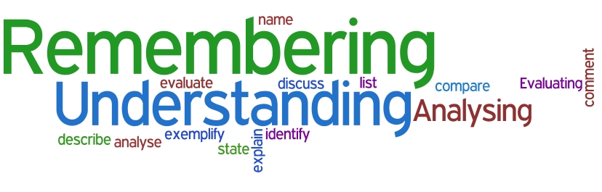
- Identifying thinking skills
Developing students’thinking skills is one of the biggest challenges any teacher faces.We need not only assist our students in learning the content immediately at hand but also prepare students for the learning they will have to do after they leave our classroom. Students who develop thinking skills become life-long learners – capable of analyzing new situations, relating new information to what they already know, and thinking critically and creatively to solve problems, improve processes, and understand their world.So , what are thinking skills?
Let’s work in groups: take a card, make up groups of the same colour.
What are thinking skills, knowledge or practical skills? Put the phrases into the three categories below.
thinking skills | knowledge | practical skills
Solving maths problems | The names of poets | Fixing a puncture
Analyzing data collected in a survey | Important dates in history | Making a wood carving
Making decisions about which capital city to visit | What a graph looks like | Baking a cake
Evaluating poetry | The periodic table | Painting a portrait
Organizing information about a historical event | The four times table | Playing football
Prioritisingmetals according to their mass | The names of capital cities | Playing the piano

How would you define each of the headings?
What are thinking skills / knowledge / practical skills? 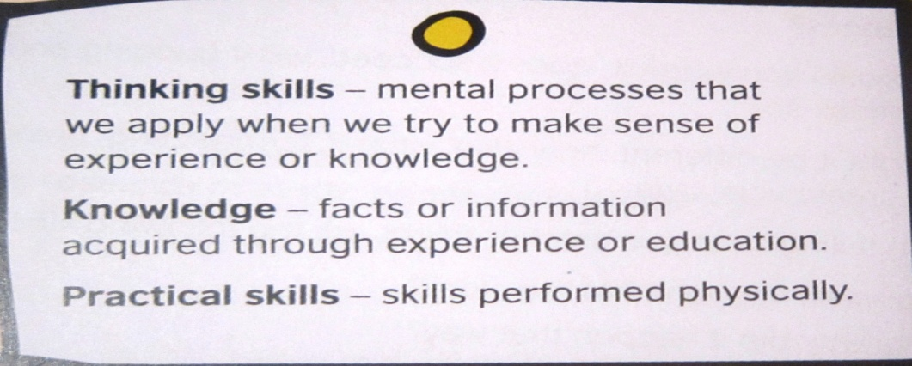

2.
Why develop thinking skills?
Doyouthinkitisimportanttoteachthinkingskills? Why? Whynot? – Yes, becausetheyare
importantforemployment. Societyandemployersexpectindividualstobeabletothinkfor
themselves, makecontributeideas.
Someteachersmayalreadyteachthinkingskills, thoughothersmayuseteachingmethodsthatrequirememorisation/rotelearning.

• Asktheparticipantsto:
–– workingroupsofthreeorfour
–– readtheheadingcolumninthetable
–– chooseonememberofthegrouptogotothewall, take a paragraphandreturntothegroup
–– decideas a groupwhichheadingtheparagraphfitsbest
–– writetheletteroftheparagraphinthetable
–– choose a differentmemberofthegrouptotaketheparagraphbacktothewallandreturnwith a newparagraph
–– repeatthiswithmoreparagraphsuntiltheletterofparagraphcolumniscomplete.

E.Recently there has been interest in ways of developing children’s thinking
and learning skills (Fisher, 2010). This is because of new knowledge about
how the brain works and how people learn. When people use their minds
to solve problems this is called ‘thinking skills’. Helping children to develop
their thinking skills will help them get more out of learning and life.

C. Thinking skills refers to the way people think to achieve certain purposes.
This includes remembering, questioning, forming concepts, planning,
reasoning, imagining, solving problems, making decisions and judgements,
translating thoughts into words, etc.

B. We often refer to skills as ‘practical skills’, such as being good at cooking
or playing football. To become good takes practice. Thinking skills also
need practice. Through practice people can become better at giving
reasons or asking questions.

A. Many researchers have attempted to identify the key skills in human
thinking… the most famous of these is Bloom’s Taxonomy. The National
Curriculum in England also uses a thinking skills list.

F. Thinking skills are important because the ‘basics’ in education (literacy,
maths, science, etc.), however well taught, are not enough for the world
of work and citizenship. Modern jobs require people who can comprehend
and judge, generating new knowledge and processes.

D. The challenge is to develop educational programmes that enable all
learners to become great thinkers. As Paul, aged ten, put it: ‘We need
to think better if we are going to become better people.’

• Takefeedbackbycheckingthegroupshavethecorrectanswers.
• Asktheparticipantstoputtheparagraphsintothecorrectorder.
• Takefeedbackby:
–– elicitingtheorderoftheparagraphsfromthegroups
–– askingtheparticipantssomequestionstocheckcomprehension.

F. 1. Skills required for adult lifefifth
C. 2. Definition of thinking skills and examples second
B. 3. A skill and thinking skills contrasted third
D. 4. The need for thinking skills in education sixth
E. 5. Introduction and context for topic first
A. 6. Identifying sets of thinking skills fourth

3. Using questions to promote thinking skills
One way to promote thinking skills is to think carefully about the kind of questions you use. Teachers should help the students to use a mix of high and low order thinking skills.
Work in groups of 3. Match the questions to the answers. Identify which thinking skills can be developed.
.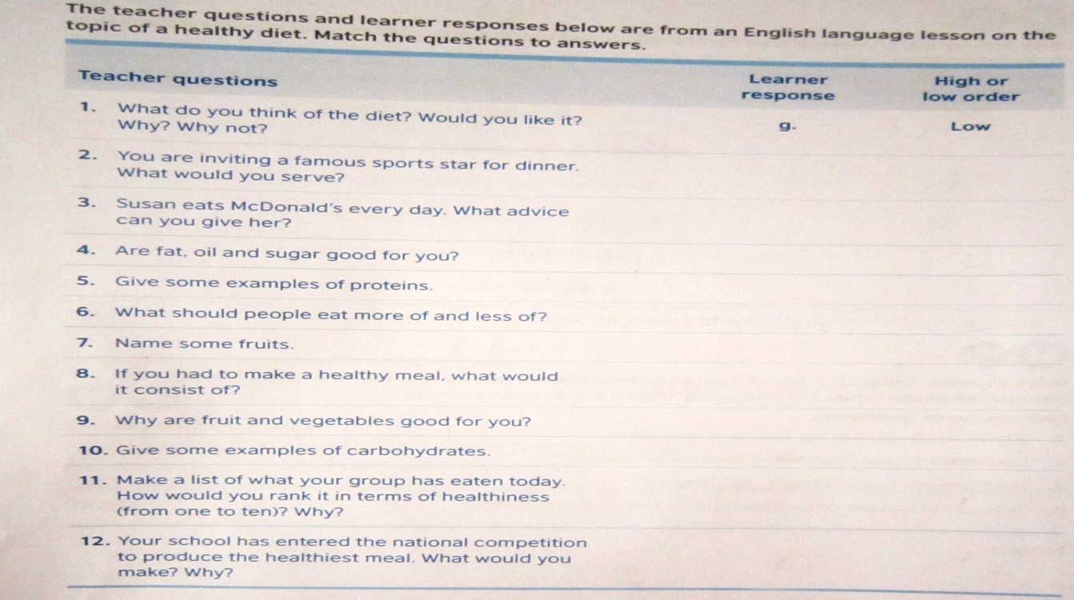
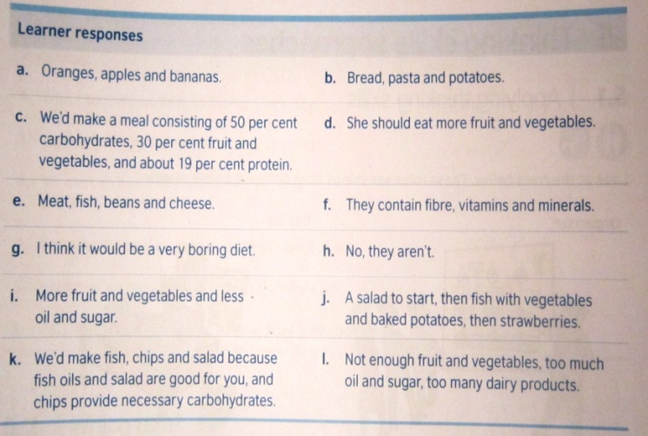
Teacher questionsLearnerresponseHigh orlow order
1. What do you think of the diet? Would you like it? g. Low
Why? Why not?
2. You are inviting a famous sports star for dinner.
What would you serve?
3. Susan eats McDonald’s every day. What advice
can you give her?
4. Are fat, oil and sugar good for you?
5. Give some examples of proteins.
6. What should people eat more of and less of?
7. Name some fruits.
8. If you had to make a healthy meal, what would
it consist of?
9. Why are fruit and vegetables good for you?
10. Give some examples of carbohydrates.
11. Make a list of what your group has eaten today.
How would you rank it in terms of healthiness
(from one to ten)? Why?
12. Your school has entered the national competition
to produce the healthiest meal. What would you
make? Why?

Learner responses
a. Oranges, apples and bananas.
b. Bread, pasta and potatoes.
c. We’d make a meal consisting of 50 per cent
carbohydrates, 30 per cent fruit and
vegetables, and about 19 per cent protein.
d. She should eat more fruit and vegetables.
e. Meat, fish, beans and cheese.
f. They contain fibre, vitamins and minerals.
g. I think it would be a very boring diet.
h. No, they aren’t.
i. More fruit and vegetables and less
oil and sugar.
j. A salad to start, then fish with vegetables
and baked potatoes, then strawberries.
k. We’d make fish, chips and salad because
fish oils and salad are good for you, and
chips provide necessary carbohydrates.
l. Not enough fruit and vegetables, too much
oil and sugar, too many dairy products.

Answers
1. g. low 2. j. high 3. d. high
4. h. low 5. e. low 6. i. low
7. a. low 8. c. high 9. f. low
10. b. low 11. l. high 12. k. high
There are a wide variety of possible answers for low and high order thinking; accept any
thatarelogical

4. Evaluating activities
Work in pairs. Look at the classroom activities below.
Do the activities require low or high order thinking skills?
Writethetypeofactivityunderthecorrectheading .

- Summarising - H
- Cloze/gap fill - L
- Dictation - L
- Feature identification/labelling - L
- Freeze frame/still - H
- Information/data transfer - L
- Interview - H

- Guess meaning from context - H
- Poster presentation - H
- Predicting - L
- Questionnaires - H
- Skimming/scanning - L
- Word searches -L
- Word/text /sentence completion – L

Feedback and answers
The answers below are suggestions only, as much depends on how the activity is presented.
Loworderskills:
• cloze/gap fill (depending on level of text)
• dictation; feature identification/labelling
• information/data transfer
• predicting
• questionnaires
• word searches
• word/text/sentence completion
• skimming/scanning (dependent on level of text).
High order skills:
• summarising
• freeze frame/still
• interview
• guessmeaningfromcontext

Do you use activities like this in your classes? Which ones? Which of them can be found in our course books?

Teachers need to challenge children to think more deeply and more widely and in more systematic and sustained ways. To sum up what we have discussed today let’s watch a cartoon “Hots Snails”.
https://www.youtube.com/watch?v=UauypiPS-60
You have endless possibilities when you get the big ideas!
Before you leave I would be very grateful if you could answer some questions about our today’s workshop.
- Did you learn anything new?
- What was the most useful part of the workshop?
- How did you find the grouping?
- What topics are very important for CPD today?

Categorising thinking skills: Bloom’s Taxonomy
One way to categorise thinking skills comes from Bloom’s taxonomy. This taxonomy is widely used by teachers in planning their teaching.
- How many thinking skills did Bloom identify ?
- Which are low-order thinking skills?
- Which are high-order thinking skills?
You have the cards on the board, put them in the correct order.
Now let’s work in 4 groups( of the same shape), different groups will have different tasks:
Verbs, materials/ situations, potential activities and products, questions.
Put them under the correct heading.
Stand up, move clockwise to the next desk, read their options, check, correct if you disagree… When you are back to your place, have a look if anything has changed. Let’s compare and contrast these thinking skills.
What verbs can be used to develop remembering?
What materials/ situations can be used?
What questions can be asked?
What are potential activities and products?
How did you find this sorting activity? Which thinking skills did you use?

