Larisa Shapoval
Kharkiv Lyceum # 153
GAME-QUEST «IceBreaker»
Age: 12-14
Time: 60 min
Objectives:
- to develop students’ listening, speaking, writing and reading skills;
- to revise students’ knowledge on the vocabulary (clothes, food and drinks, parts of the body)
- to teach cooperation in group work;
- to engage students in meaningful interaction;
- to develop students’ social habits;
- to motivate students for practicing English and sharing ideas.
Rules:
Unite students into 2-4 teams; 3-5 students in each team. I advise to divide students into teams randomly, that gives them additional feeling of competitiveness (e.g. I buy sweets in different colour of wrappers depending of the number of students taking part. Each student takes the candy out of the bag and joins the team of chosen colour. The name for the team can be Greens, Yellows and so on. Students of each team sit round at the desk with the coloured flag of corresponding colour. Every team chooses a captain and each captain will get the tasks.
Equipment:
Coloured flags, paper, pens, blackboard, interactive whiteboard, interactive board Miro, mobile phones with Internet, sweet prizes, certificates for winners and participants, feedback papers
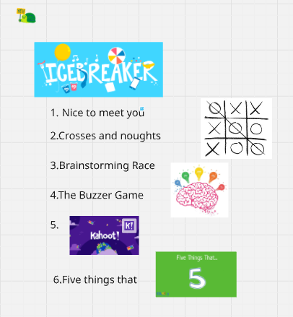Screen of Whiteboard, interactive board Miro
Rules for the quest game "IceBreaker":
The quest game "IceBreaker" is a series of tasks that all teams perform one by one. At 7 stations, the children are waiting for various competitions and quizze. Each team must complete a number of tasks within a certain time limit and achieve a result - collect the maximum possible number of points. The team with the highest score wins. Completing each stage gives the opportunity to move on to the next stage.
Quest location: classrooms, assembly hall. The game can also be played online, using Zoom breaking rooms
Procedure:
- IceBreaker – Nice to meet you –warming up
- Crosses and Noughts
- Brainstorming Race
- The Buzzer Game
- Kahoot –Counting
- Five things that

Game description
- IceBreaker
Activity Type: speaking, answering questions using necessary grammar and vocabulary
Focus: speaking, warming up, communicating
Preparation: prepare and save a link of a game on the Whiteboard
Time: 10 min
Aim: to warm up, to spread friendly and relaxed atmosphere, to revise question forms and corresponding grammar constructions.
Points: none
Procedure
Participants don’t get any points for this game, but they are tuned in to communication. The game is on the Whiteboard, it is the set of Breaking Ice questions which students need to answer. There is a wide choice of IceBreaking questions on Wordwall platform and you can choose any, which fits your students’ level. I used this one.
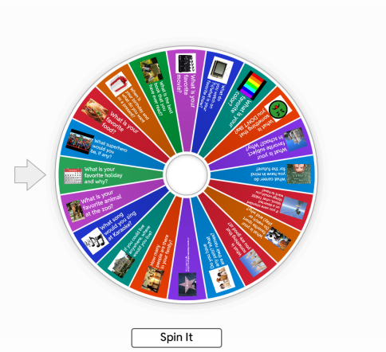

- CROSSES and NOUGHTS
Activity Type: Vocabulary Game, marking the correct word in a certain way
Focus: vocabulary, physically active game
Preparation: write words of a topic chosen on the blackboard
Time: 10 min
Aim: to revise vocabulary and spelling
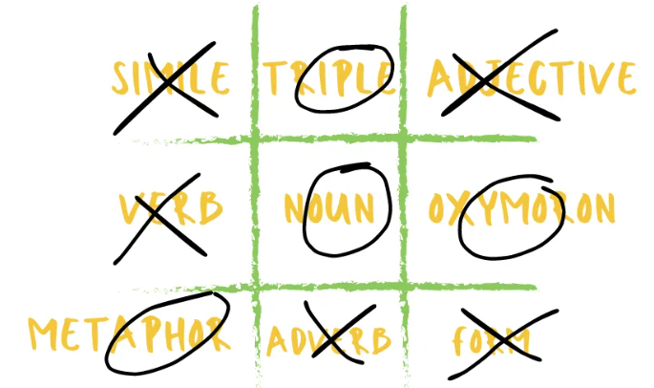
Points: 1 point for each correct answer
Procedure
The game should be prepared beforehand. The teacher writes the words on any topic studied on the blackboard (e.g this time I wrote 15 words on the topic Parts of the Body). And again, you may pick up words to your students’ level. Students line up in front of the board into two rows, and the captains stand first with pieces of chalk in their hands. The teacher pronounces the words, one word in a time, in Ukrainian, and the participants have to find this word faster than their opponents. One team must circle the correct word, the other team needs to draw a cross on it. The participants take their turns to take the chalk one by one, running to the back of the row after doing the task on the board. The student who does it correct and faster than his opponents from the other team, gets his/her team a point. The organizer writes the score on the board.

- BRAINSTORMING RACE
Activity Type: Vocabulary and Spelling Game: brainstorming, writing words (group work)
Focus: Vocabulary and lexical sets
Preparation: None
Time: 20 minutes
Aim: to brainstorm vocabulary and revising categories of words, practise spelling
Points: 1 point for each correct word (spelling, meaning)
Procedure
Draw two to four columns on the board.
Divide the students into a corresponding number of teams. Have each team line up in front of a column.
Give each team a marker or chalk for writing.
Set a time limit (e.g. five minutes) and then call out a category for the teams to brainstorm.
The teams' task is to write all the words they can think of belonging to that category in the column.
The first student in each team runs to the board, writes a word from the category in the column, runs back, gives the marker or chalk to the next student and goes to the back of the line.
Then, the second student runs to the board and so on. When the time limit has been reached, stop the game and check the words and spelling for each team. For each correctly spelt word belonging to the category, teams score one point. Play several rounds using a different category each time.
The team with the highest score at the end of the game wins. To stop teams copying each other, you can cross out all the words that are duplicated across the teams.

- THE BUZZER GAME
Activity Type: Speaking Game: answering questions (pair work)
Focus: Giving answers
Preparation: Questions, e.g.
- How many states are there in the USA? (50)
- Which country is famous for salsa dancing? (Brazil)
- How many elements are there on the periodical table? (118)
- What galaxy does the Earth belong to? (Milky Way)
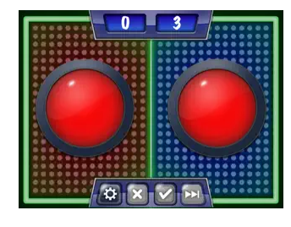
- How many bones are there in the human body? (206)
- What is an average lifespan of a hamster? (2 years)
- How many players does a football team consist of? (11)
- How were rulers in Ancient Egypt called? (Pharaons)
- How many letters are there in English Alphabet? (26)

Time: 10 minutes
Aim: to practise speaking, communicating, cooperating (answering questions) in class. To work out interdisciplinary connections between different school subjects
Points: 1 point for each correct answer
Procedure
Set up the classroom in a horseshoe-shaped seating arrangement with enough seats for half the class.
Divide the students into teams of two.
One student sits on the chair, and the other student stands behind their partner.
Explain that the seated students are 'buzzers' and the standing students are 'contestants'.
Contestants place their hands on the shoulders of their respective buzzer, ready to press down when they know the answer to a question.
Go around checking every team's buzzer is working correctly.
This can be quite entertaining as the students acting as buzzers can make some very interesting buzzer sounds. Next, read a question to the class.
The first contestant to sound their buzzer can answer the question.
If the contestant gives the correct answer, they score one point.
If not, they are out of that round and other contestants can sound their buzzers and try to answer.
The only one who can answer a question is the contestant.
If a buzzer gets over-excited and buzzes first because they know the answer, the contestant has to answer the question and be rewarded or penalised accordingly.
Have the contestants and buzzers swap roles after a few rounds to give any member of the team the opportunity to act both like a buzzer and a contestant .
Continue playing until all the questions have been answered correctly.
The team with the most points at the end of the game wins.

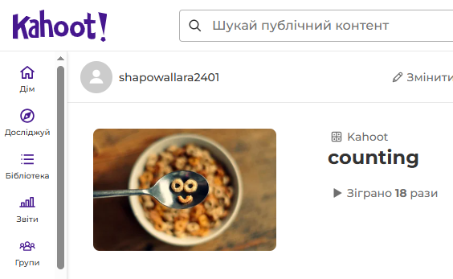
- KAHOOT – Counting
Activity Type: Vocabulary game (numbers, mathematical operations)
Focus: vocabulary and lexical sets
Preparation: create a Kahoot game (or use one of the ready ones), copy the link and have students follow the link and enter the game with their mobiles
Time: 15 min
Aim: to revise counting 1-100, mathematical operations
Points: winner- 15 points, second place- 10 points, third place - 5 points.
Procedure
Contestants follow the link on the Whiteboard, enter a code and join the game online. They can also scan a QR-code and enter the game. The game is held in a team mode, so the students have to enter their teams’ names. The captain presses the correct coloured patches on the phone screen and thus gets the points for correct choices for his/her team. The team which gives most correct answers for the shortest time takes the first place and gets 15 points. The second team gets 10 points and the third team gets 5 points. You can change the game and the number of points depending on the number of participants, their level of knowledge and aiming to check certain vocabulary or grammar. You can play the Counting game following the link.

- FIVE THINGS THAT
Activity Type: Vocabulary Game: brainstorming, listing (group work)
Focus: Vocabulary revision
Preparation: Write a list of categories with five words in each category, e.g
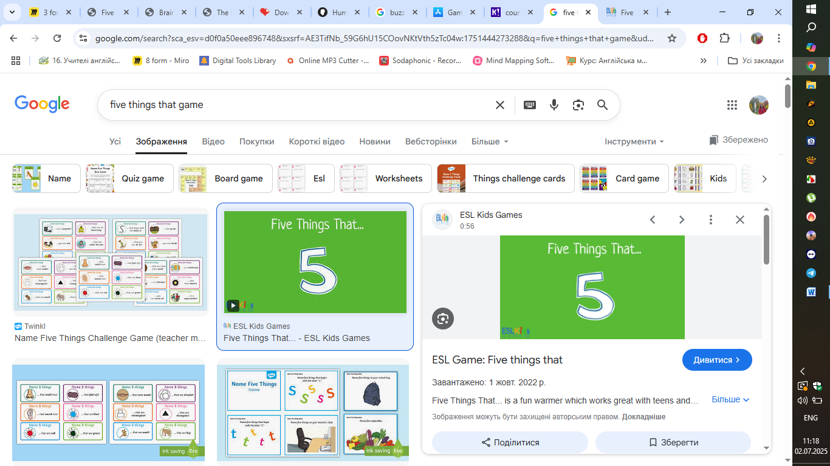
Five things that are watched.
Five things that are round.
Five things that are listened to.
Five things that are made of plastic.
Five things that are used in an office.
Five things that are blue.
Five things that are useful.
Example: Five things that are made of leather.
shoes bags belts wallets jackets
Time: 15 minutes
Aim: To write down five words from a category that match the teacher's answers, to practice vocabulary
Points: 1 point for an answer that matches the teacher’s answer
Procedure
Divide the students into teams of three or four. Give each team a piece of paper.
Explain that you are going to call out a category and that the aim of the game is for the teams to write down five answers that match the five answers you have written down.
Call out a category, e.g. 'Five things that are made of leather'. Students then brainstorm and write down five answers. When all the teams have five answers, they swap papers for marking.
You then call out your five answers. For each matching answer, teams score one point. Play several rounds. The team with the most points at the end of the game wins.

Summing up and announcing the winner
At the end of the game teacher sums up the points, announces the winner, gives sweet prizes to all participants.
Feedback
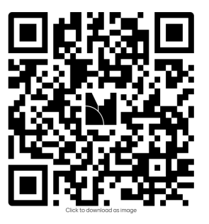
It’s necessary to get feedback from the students. It can be done with Mentimeter questionnaire (to do it, scan the QR code given)

Resource:
- https://www.teach-this.com/esl-games
- https://create.kahoot.it/
- https://wordwall.net/uk

