«English for kids.
Рre-school»
Навчальний посібник
з англійської мови для дітей дошкільного віку

Розробила: Коломієць Ярослава Валеріївна, учитель англійської мови в початкових класах

Lesson 1. Greeting
Hello!

What is your name?

My name is ______

Nice to meet you!

Goodbye!

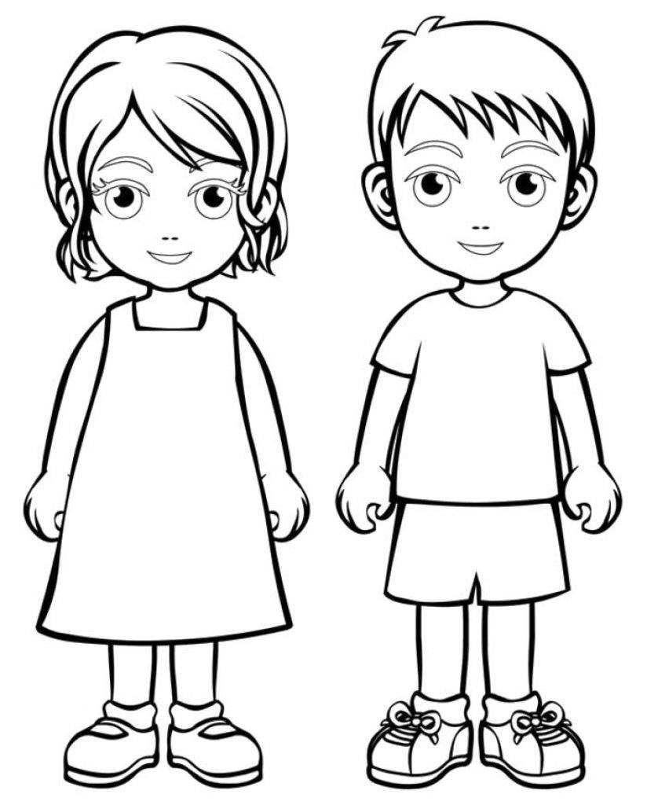
I am a boy. I am a girl.

Greeting (привітання)
Hello! [heˈləu]— Привіт!
What is your name? [neɪm] — Як тебе звуть?
Му name is Lucy. — Мене звуть Люсі.
I am *a girl. [gɜːl] — Я — дівчинка. (* Перед назвами істот і неістот в однині англійці вживають артикль «а» «an».)
Му name is Tim. — Мене звуть Тім.
I am a boy. [bɔɪ]— Я — хлопчик.
Good bye! [ˌɡʊdˈbaɪ] — До побачення!
Nice to meet you! – Приємно познайомитися!

Lesson 2. Letters Aa, Bb
Find and colour a letter Aa.
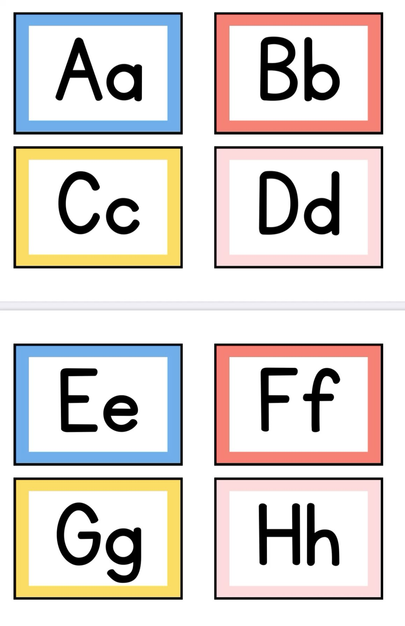
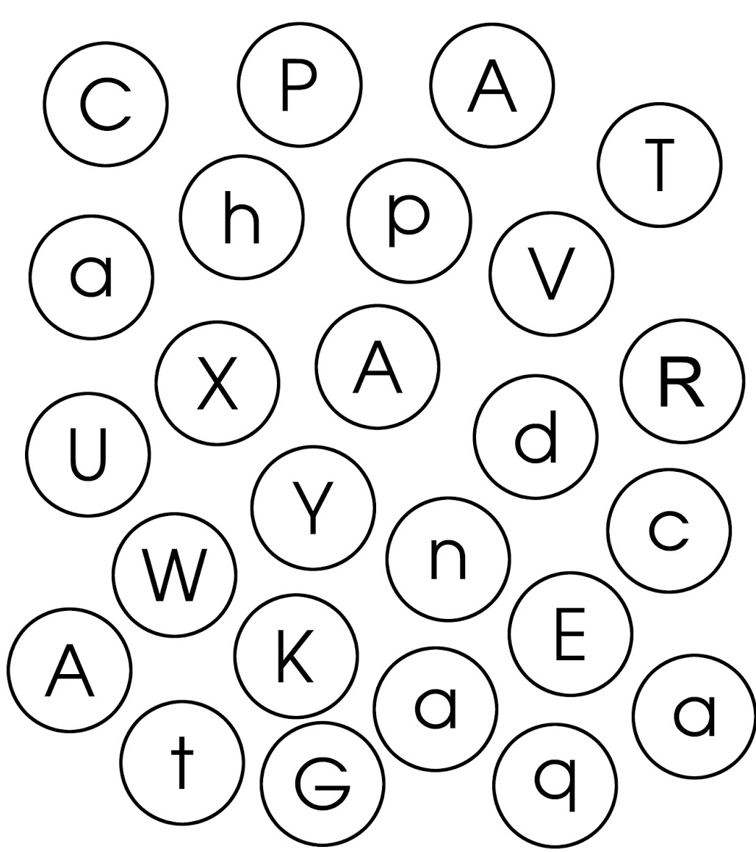
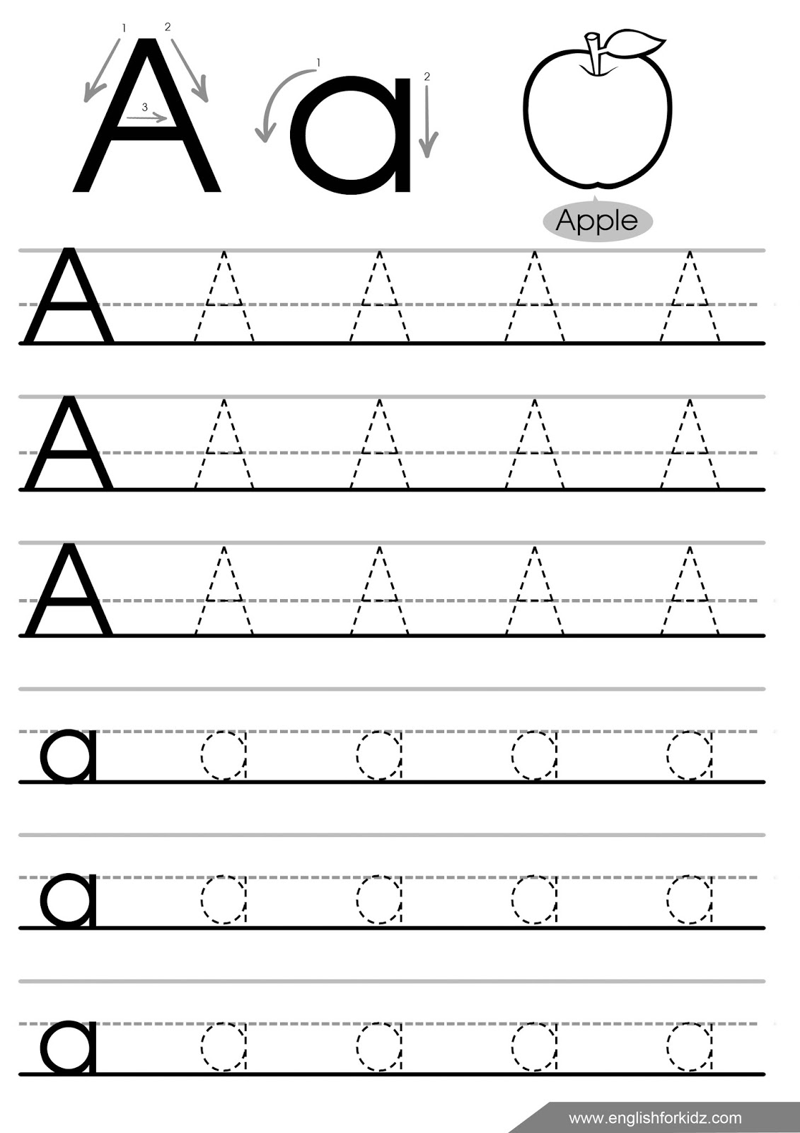

Find and colour a letter Bb through the maze.
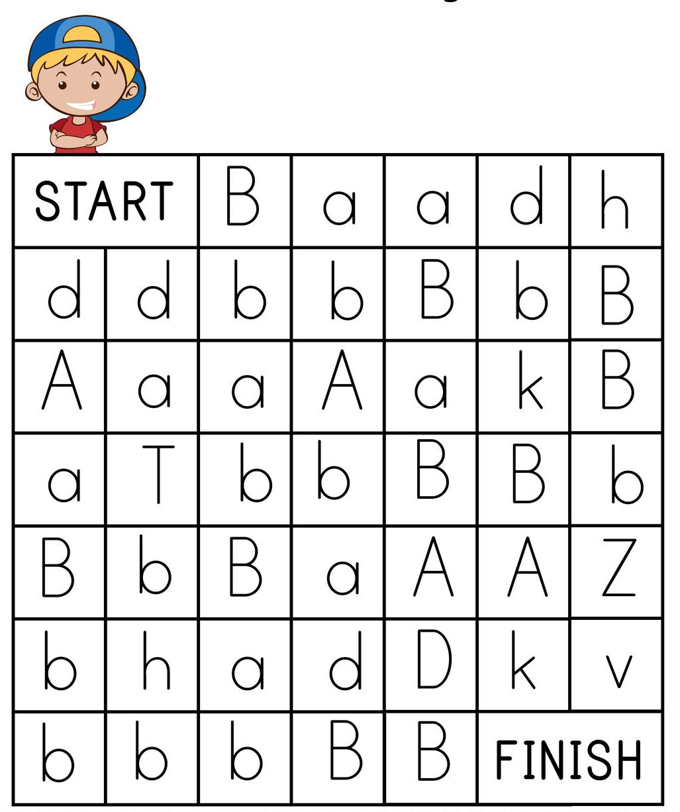
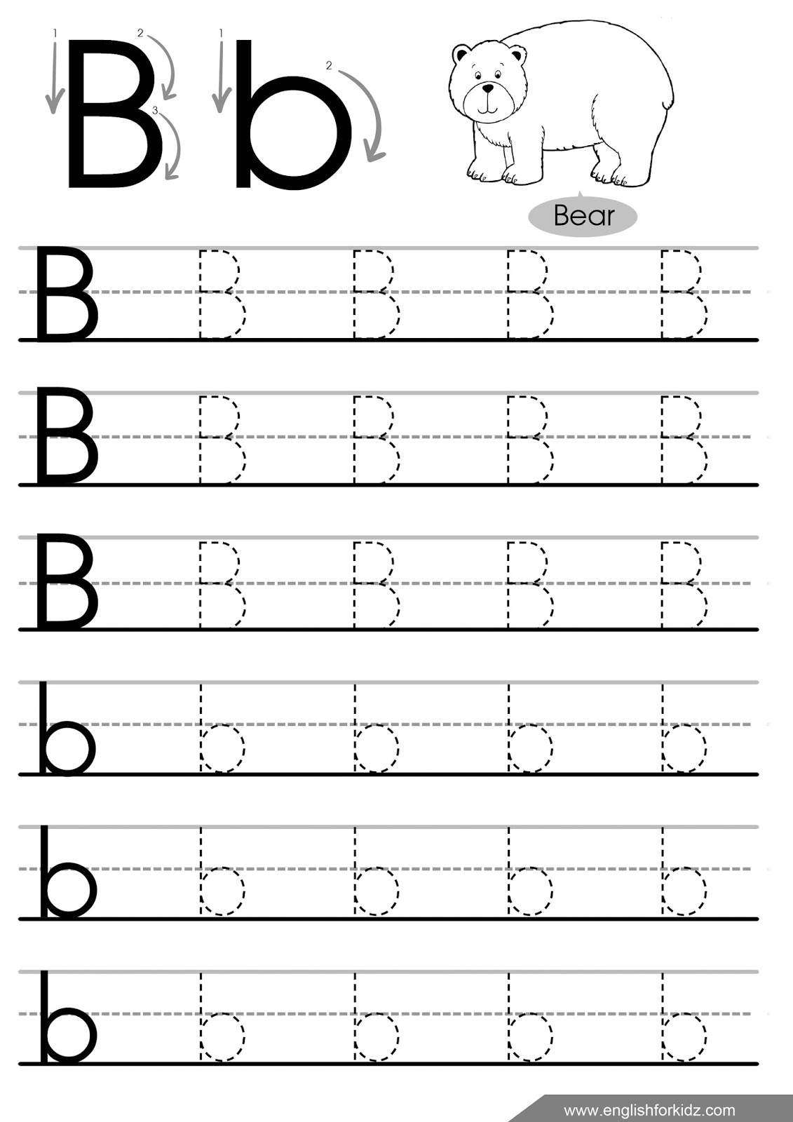

Lesson 3. School things
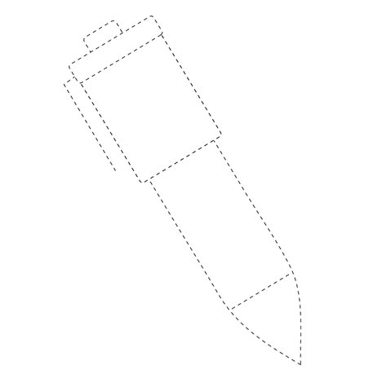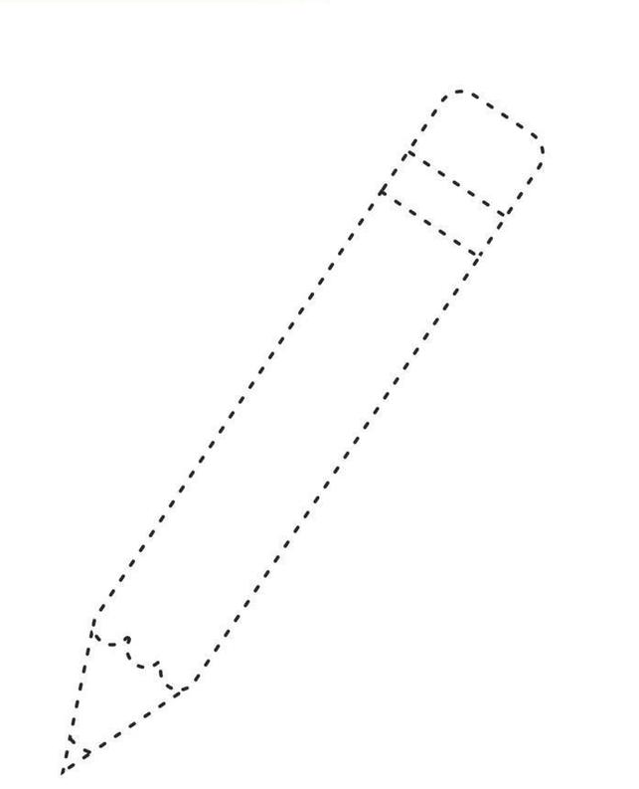
a pen a pencil
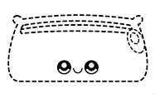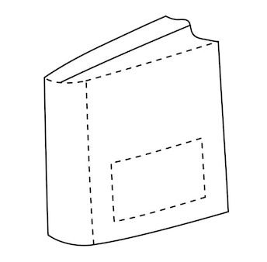
a pencil case a book

School things (шкільні речі)
Stand up! — Встань
Hands up! — Руки вгору!
Hands down! — Руки вниз!
Hands on hips! — Руки на пояс!
Sit down! — Сідай!
red [red] – червоний
a pen [pen] - ручка
a pencil [ˈpens(ə)l] - олівець
a book [bʊk] - книга
a pencil case [ˈpens(ə)l keɪs] – пенал
Lesson 4. Letters Cc, Dd
Find and colour a letter Cc.
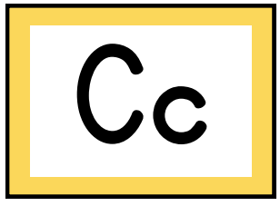
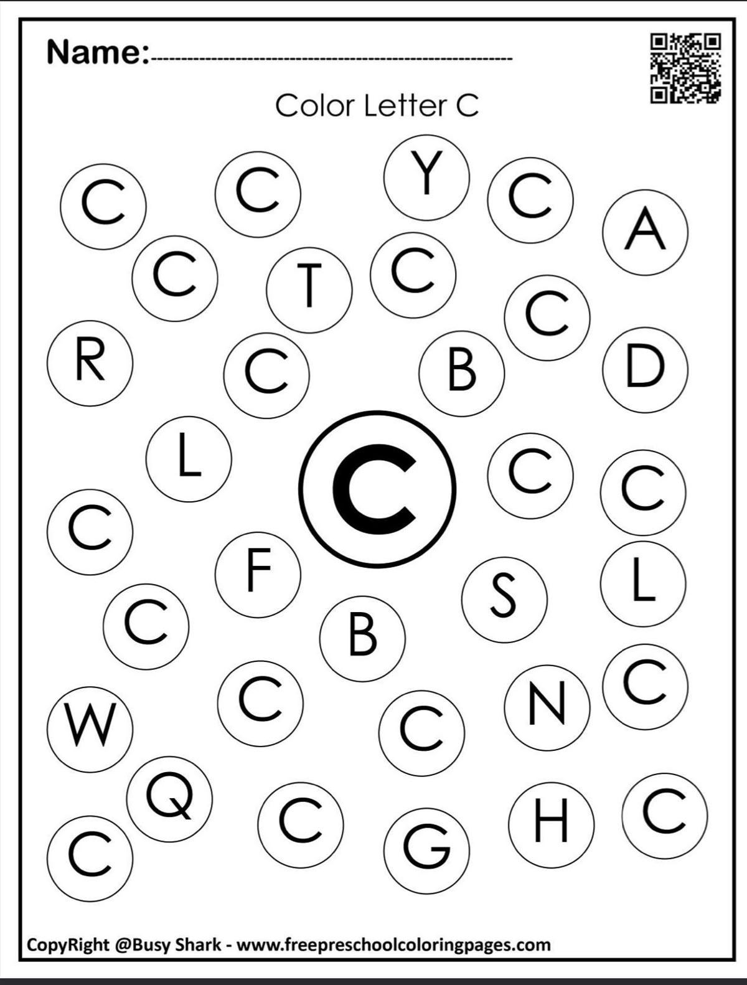
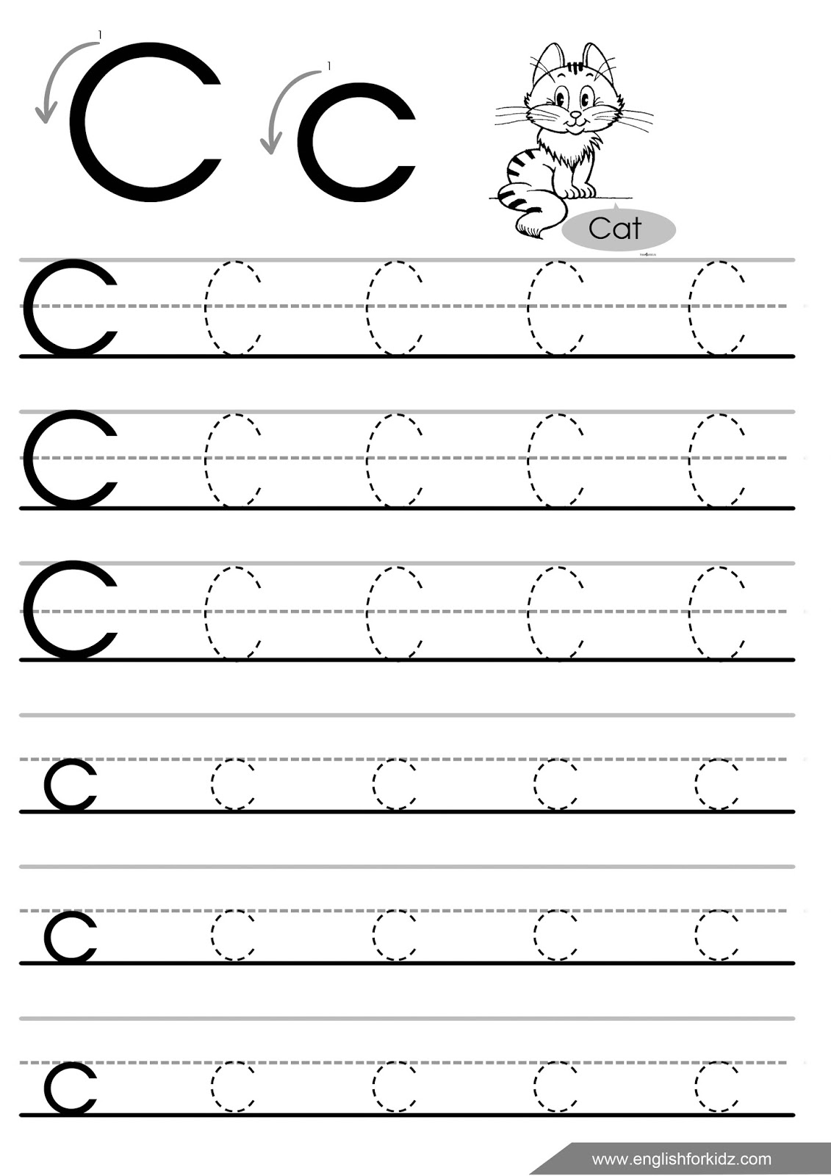

Find and colour a letter Dd.
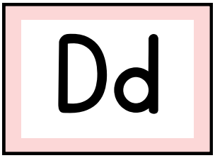
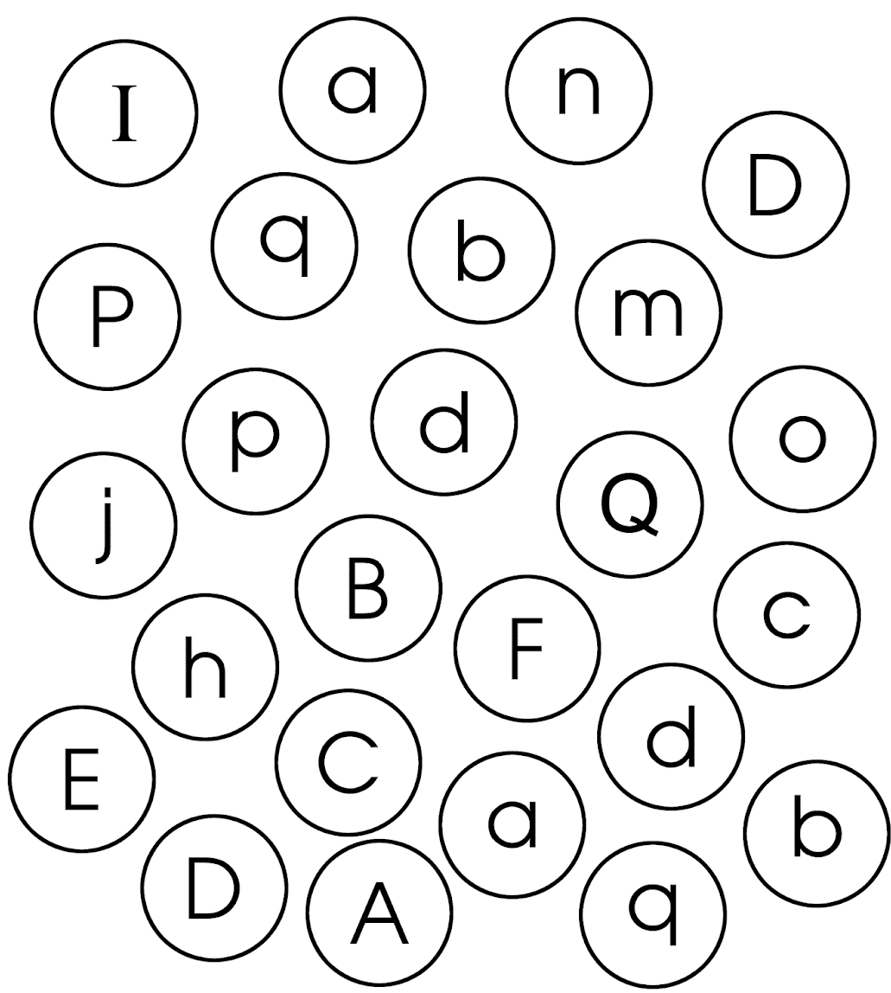
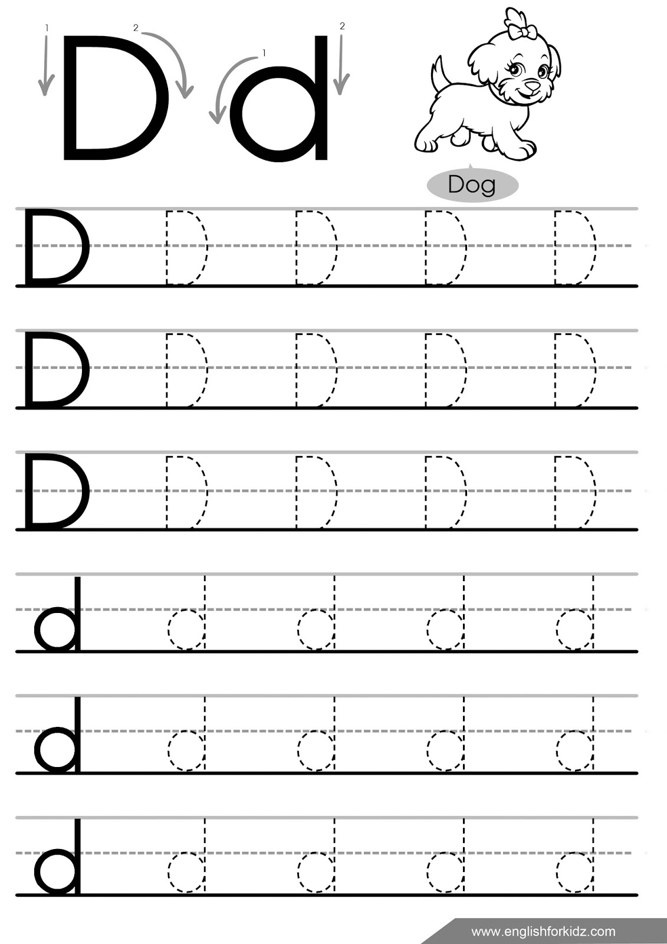

Lesson 5. What is it?

It is a 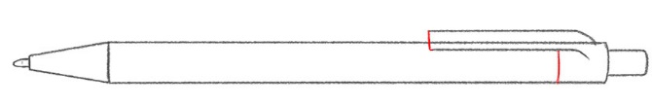 pen.

It is a 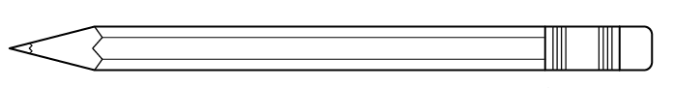 pencil.

It is a 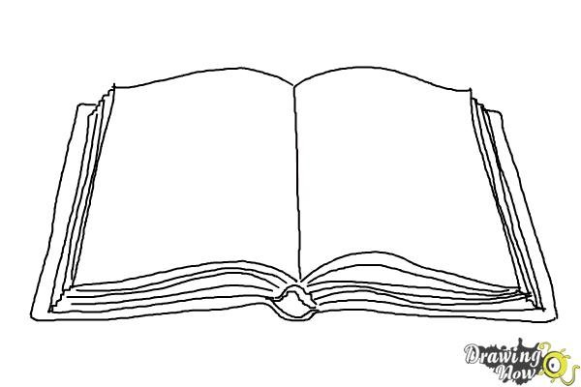book.

It is a 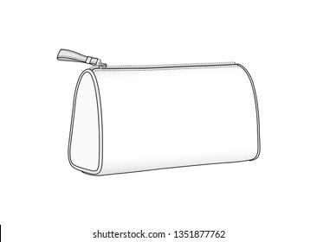 pencil case.

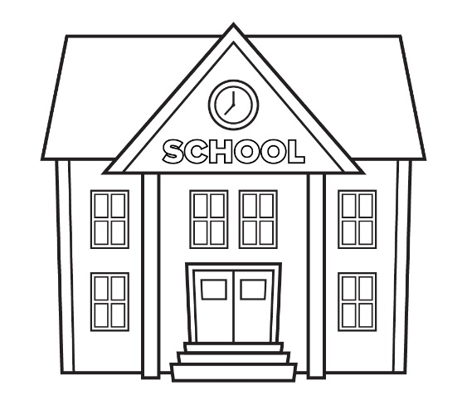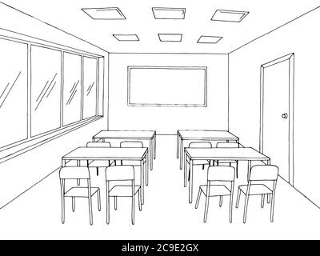
a school a classroom

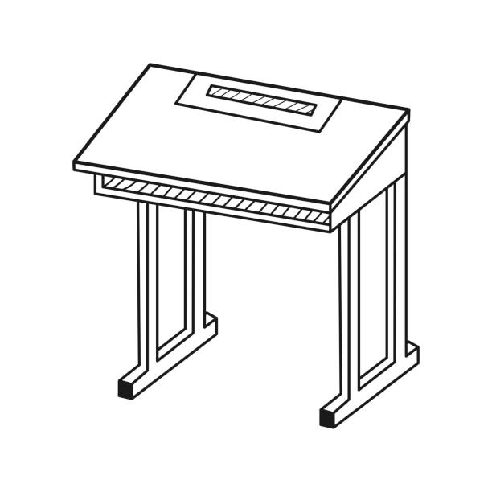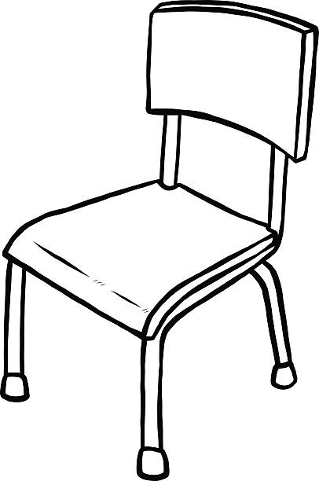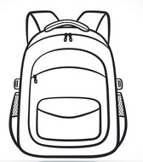
a desk a chair a bag

What is it? (Що це?)
Listen – послухай
Repeat – повтори
a school [skuːl] – школа
a classroom [ˈklɑːsrʊm] – класна кімната
a desk [desk] – парта
a chair [ʧɛə] – стілець
a bag [bæg] – рюкзак
blue [bluː] – синій
yellow [ˈjeləu] – жовтий
Lesson 6. Letters Ee, Ff
Colour the letters Ee.
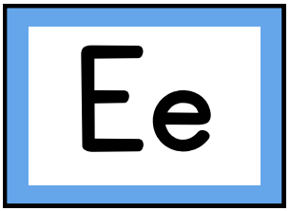
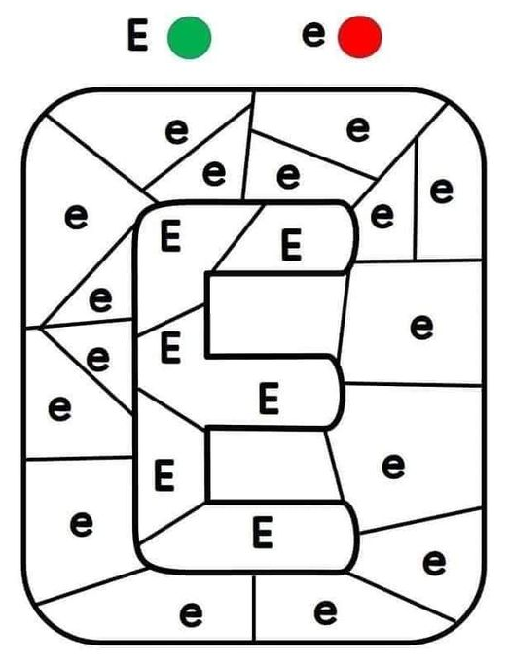
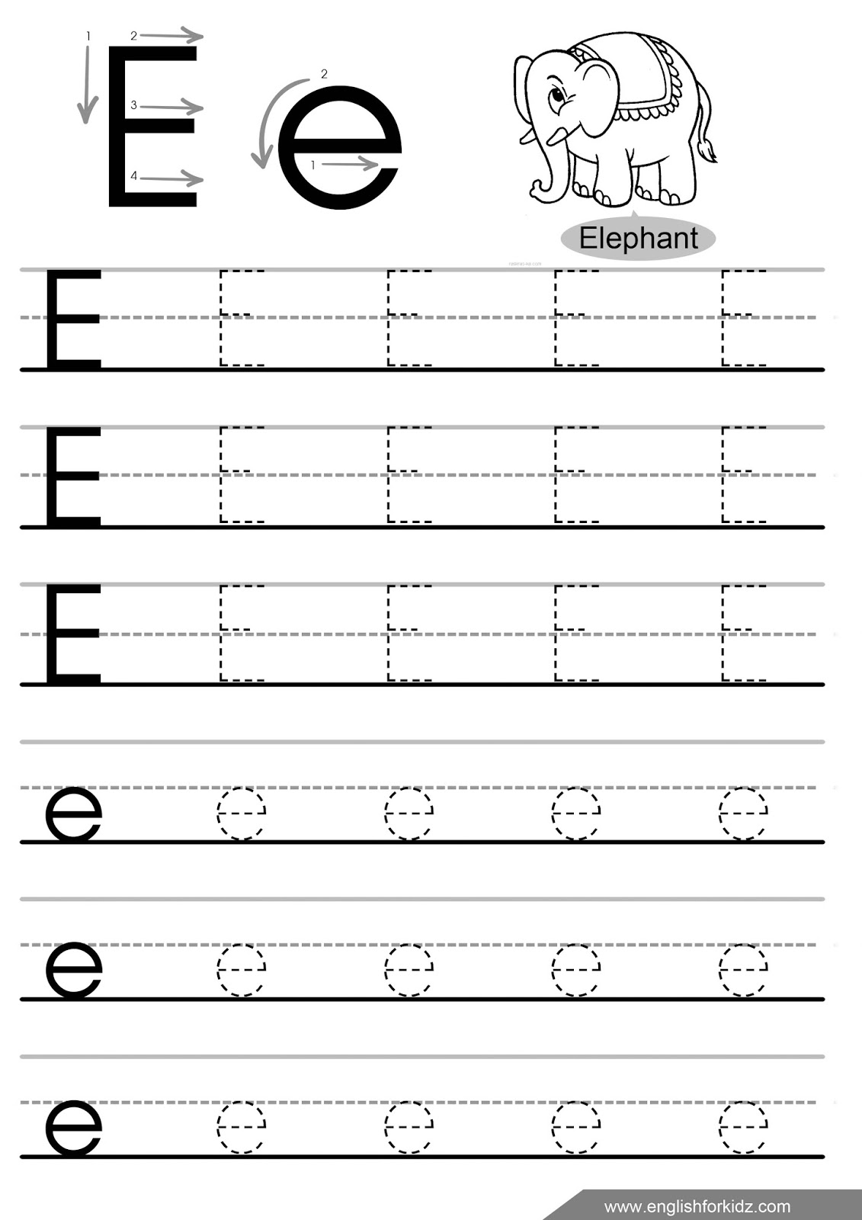

Colour all the fish that contain a letter F.
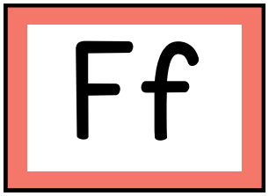
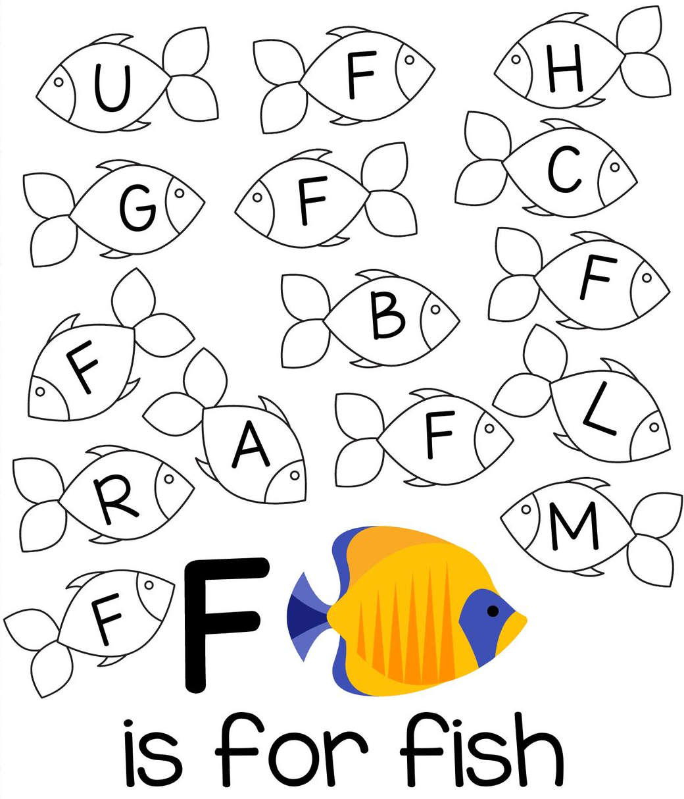

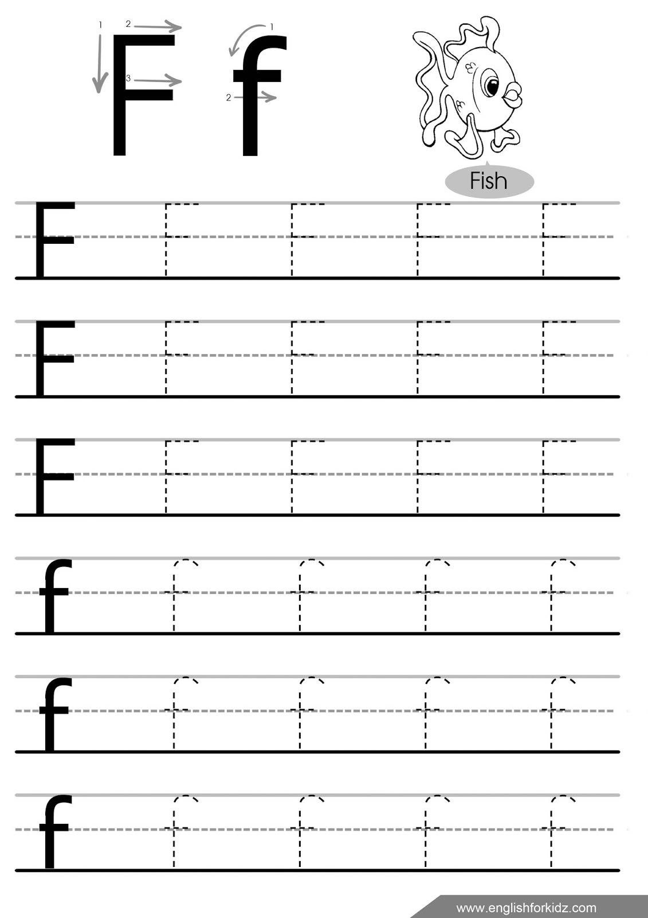

Lesson 7. School
It’s aschool.
It’s a classroom.
It’s a desk.
It’s a 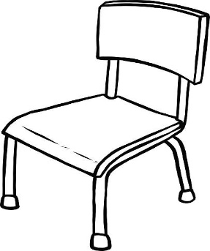 chair.

It’s a pen.
It’s a pencil.
It’s a book.
It’s a bag.
It’s a pencil case.

School (школа)
It is = It’s (скорочена форма)
Look at … – подивись на …
Show me … – покажи мені …
Colour – розфарбуй
green [griːn] – зелений
brown [braun] – коричневий

Lesson 8. Letters Gg, Hh
Find and colour a letter Gg.
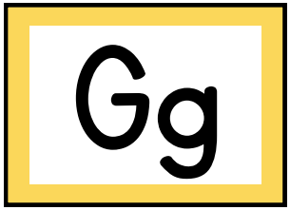
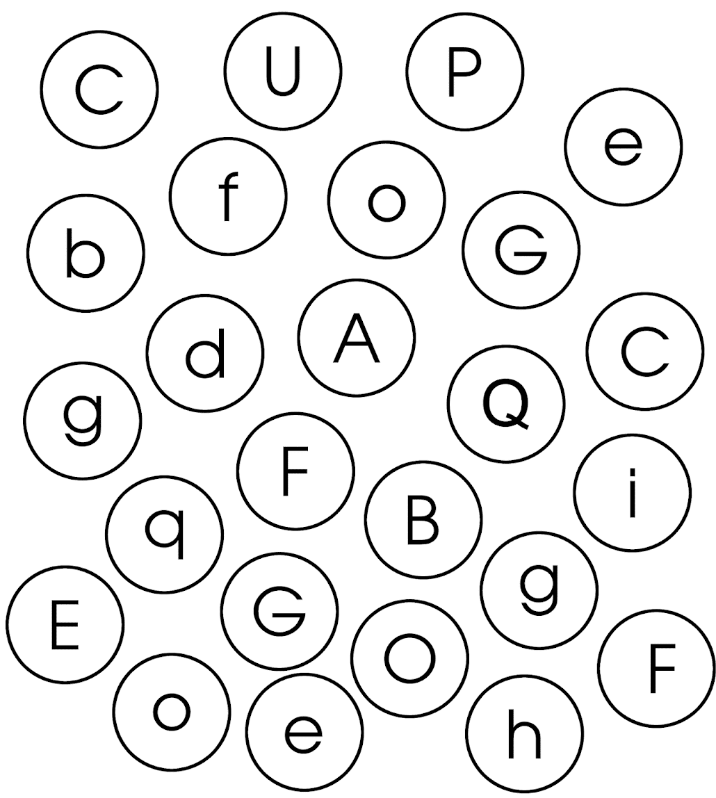
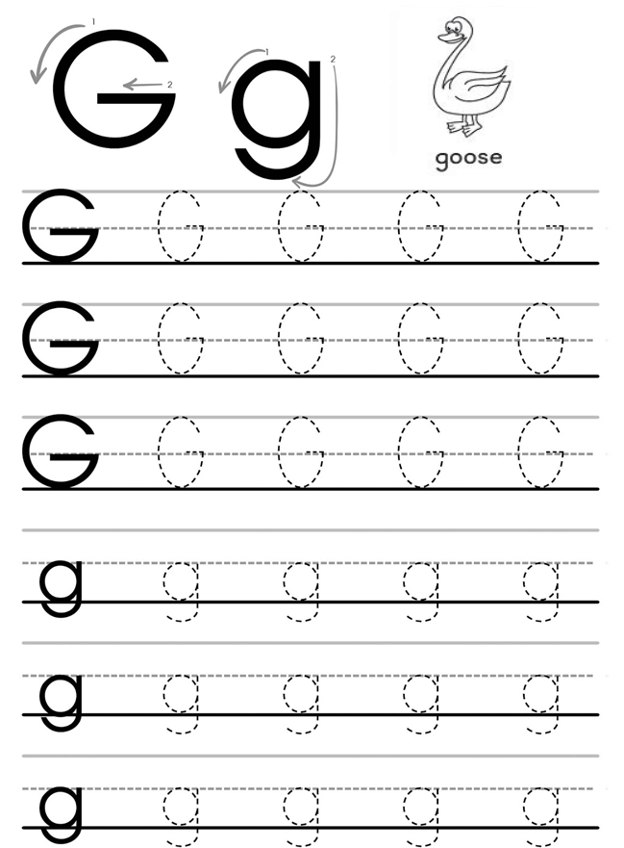

Colour the letters Hh.
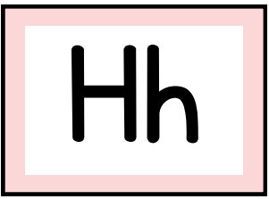
H – red h – green
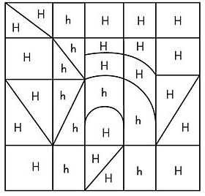

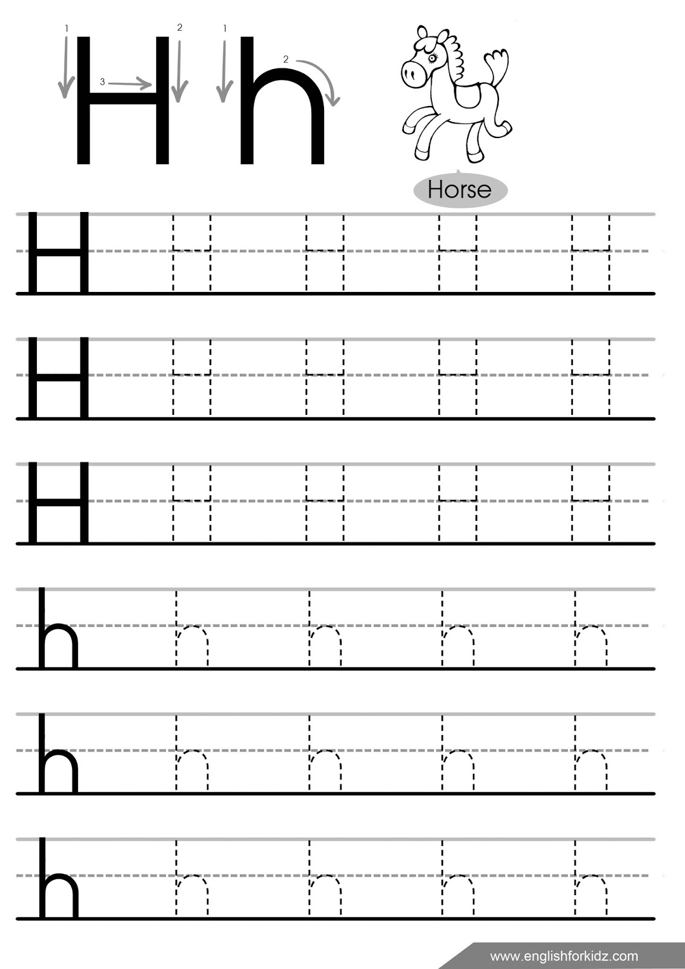

Lesson 9. Animals
What is it?
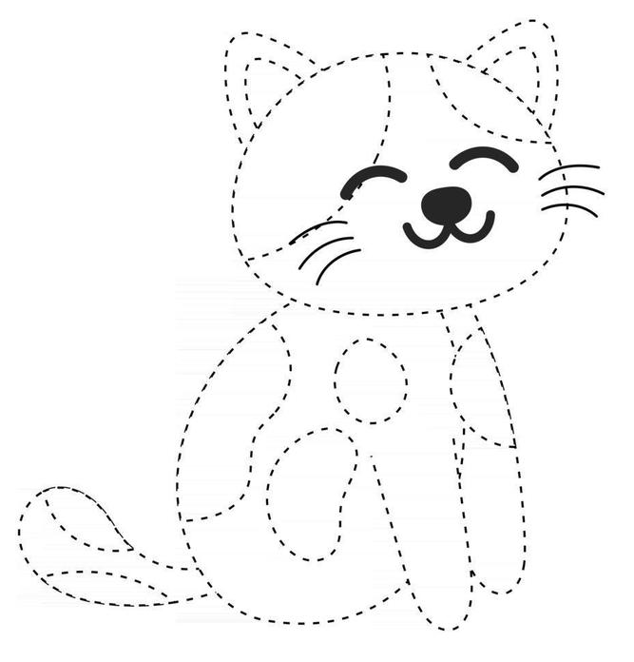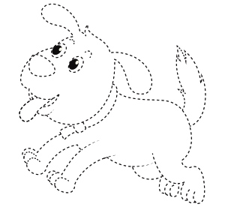
It’s a cat. It’s a dog.

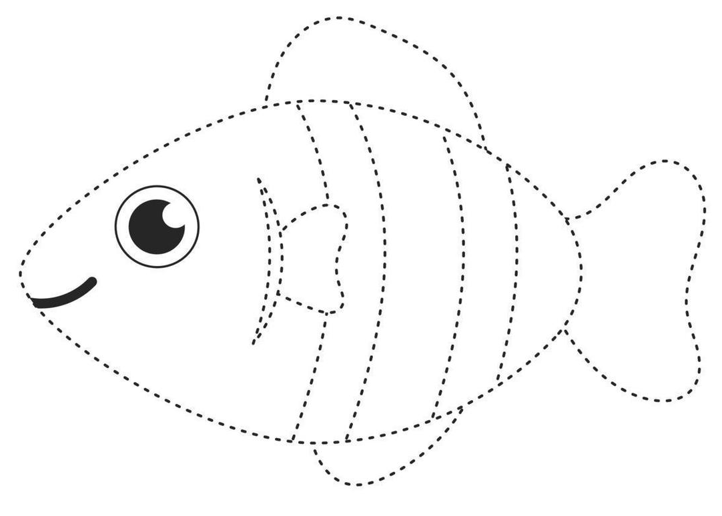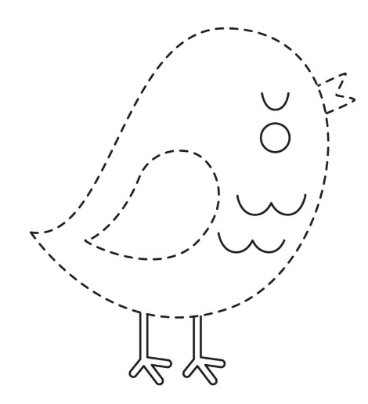
It’s a fish. It’s a bird.

What colour is it? – It’s …

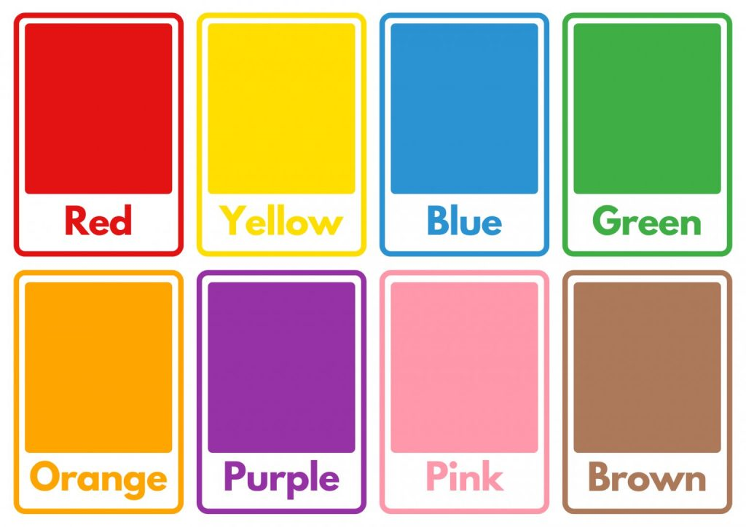
Colour the leaves
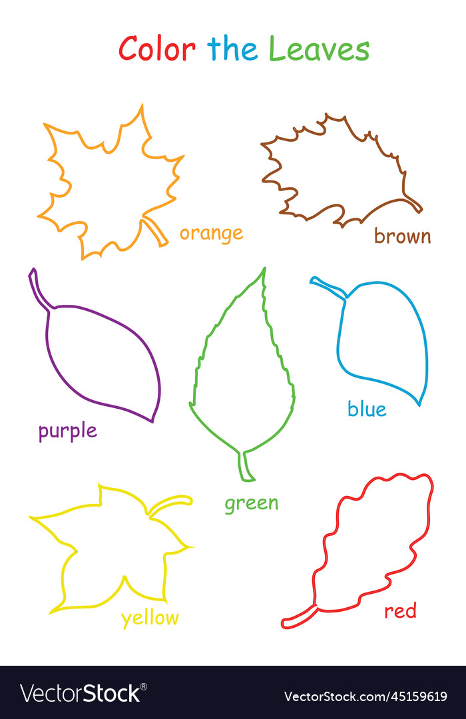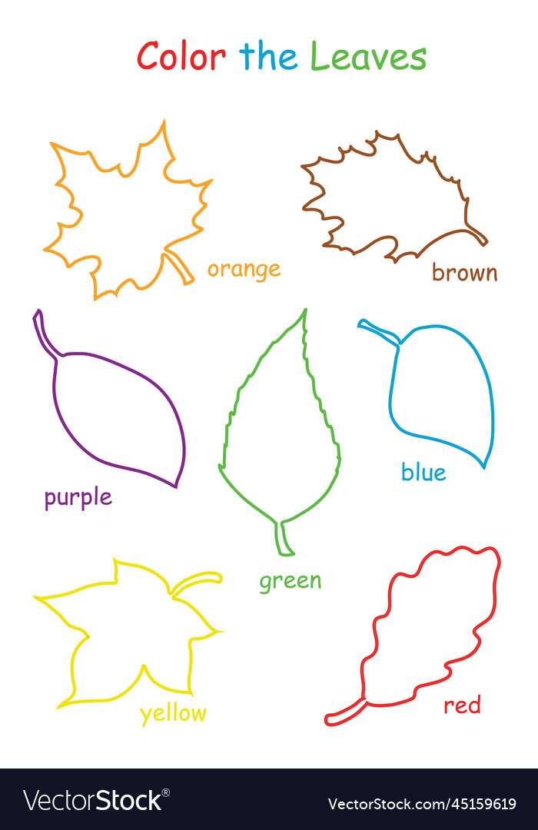
Animals (тварини)
a cat [kæt] – кіт
a dog [dɒg] – собака
a fish [fɪʃ] – рибка
a bird [bɜːd] – пташка
What colour is it? – Який це колір?
Point – покажи
Trace – наведи
Lesson 10. Letters Ii, Jj
Colour all the ice creams with a letter Ii.
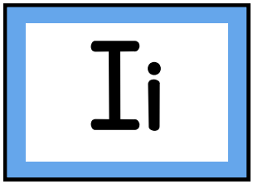
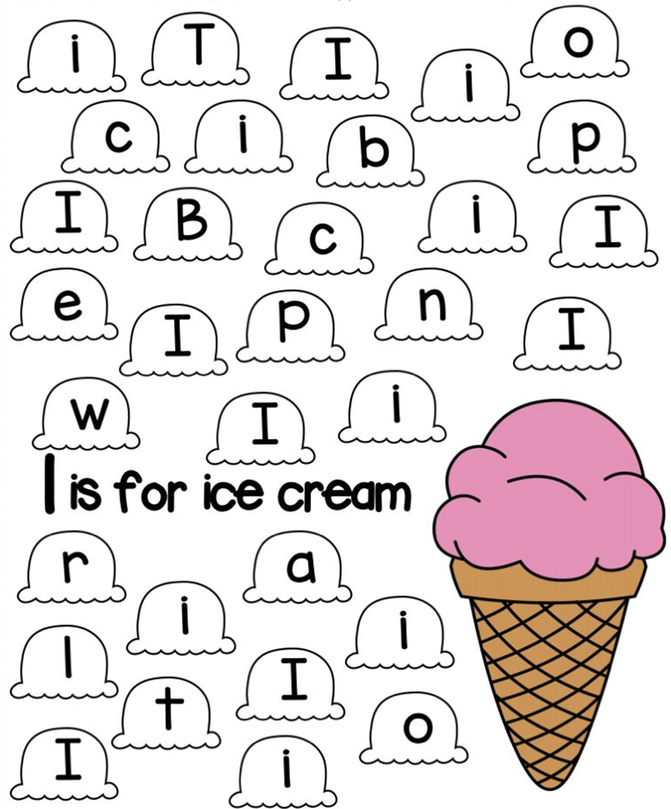
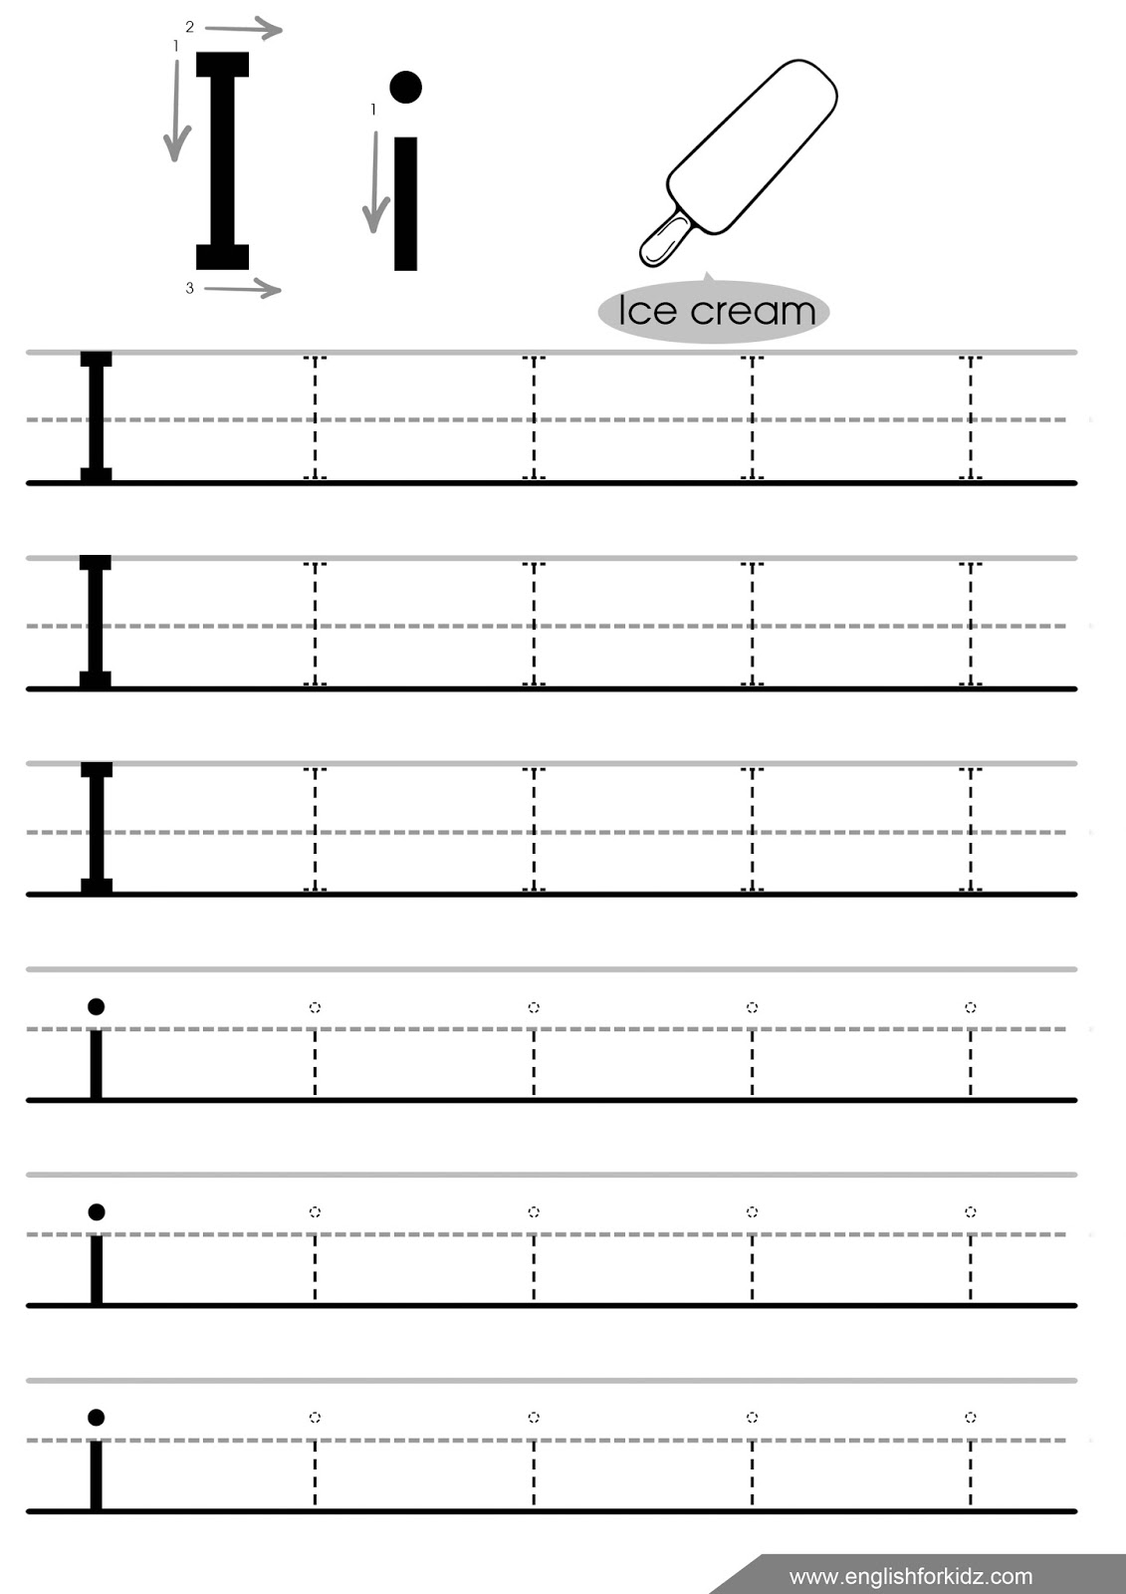

Colour the letter J by numbers.
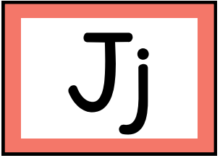
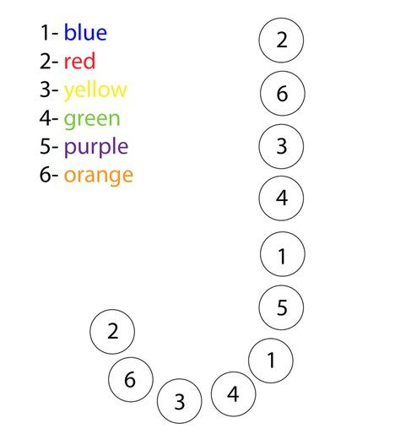
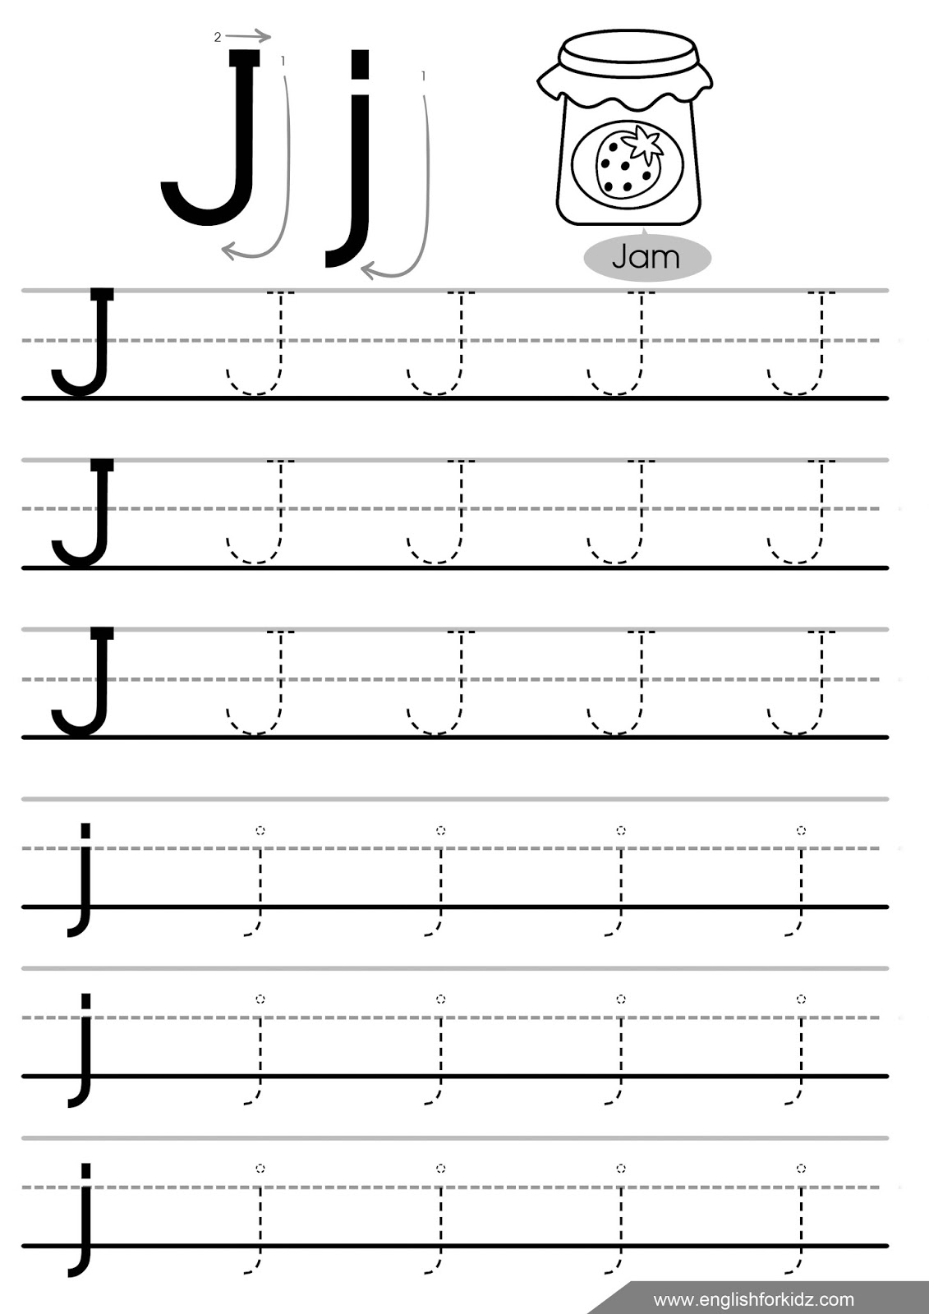

Lesson 11. Animals
Is it a 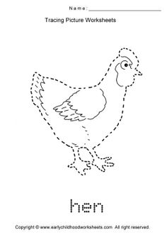 hen?
Is it a 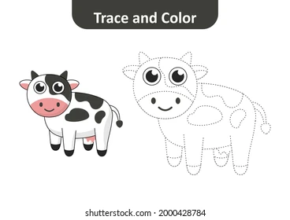 cow?
Is it a 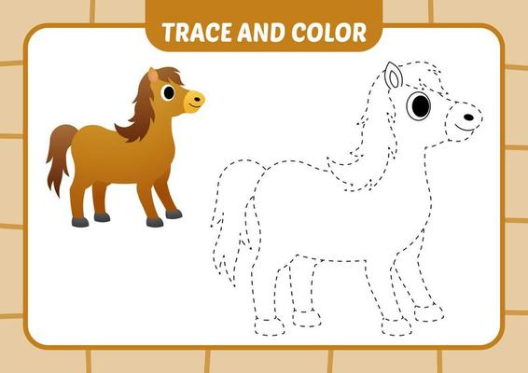 horse?
Is it a 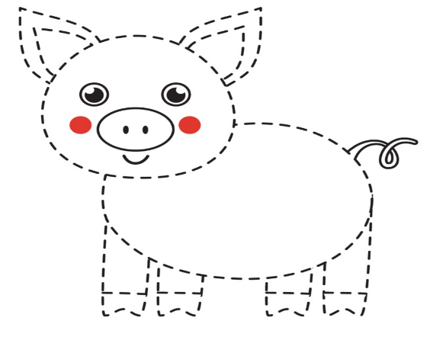 pig?
What colour is it? – It’s …
red green brown blue yellow

Animals (тварини)
a hen [hen] – курка
a cow [kau] – корова
a horse [hɔːs] – кінь
a pig [pɪg] – свиня

Lesson 12. Letters Kk, Ll
Find and colour the letters K.
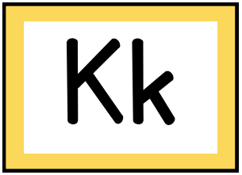
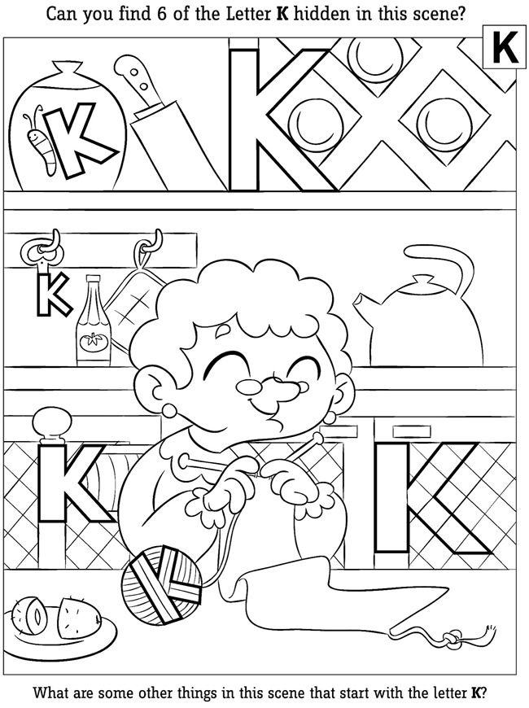
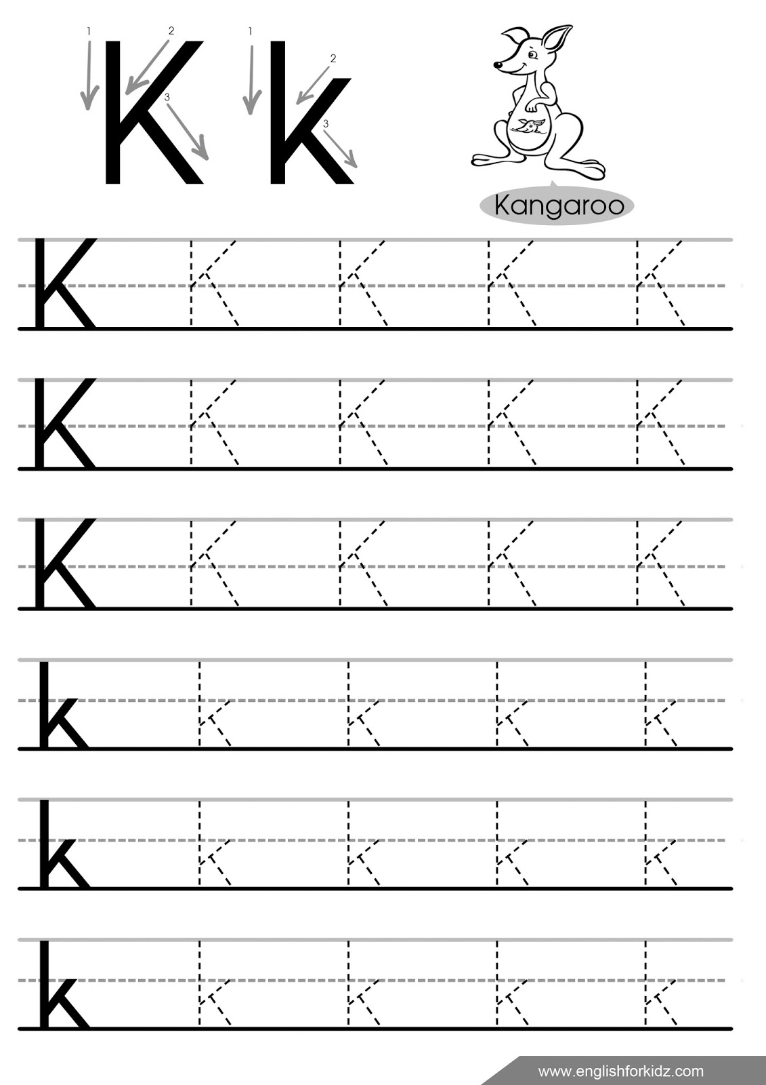

Colour all the lemons that contain a letter L.
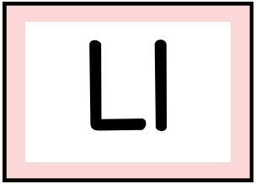

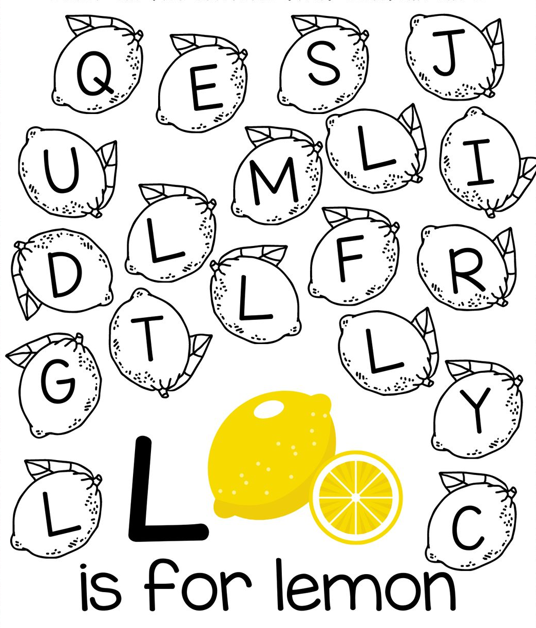
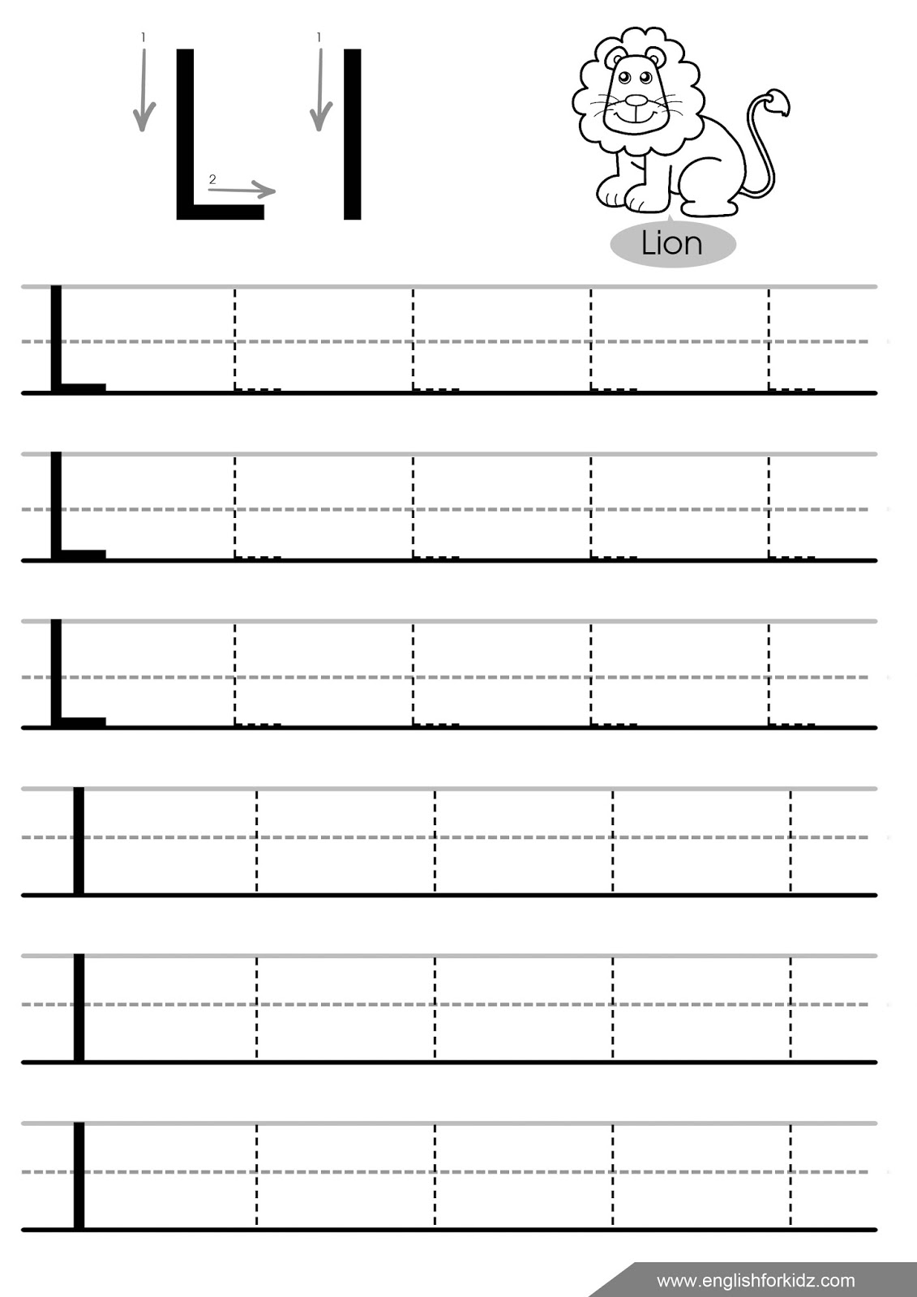

Lesson 13. Zoo animals
What is it?
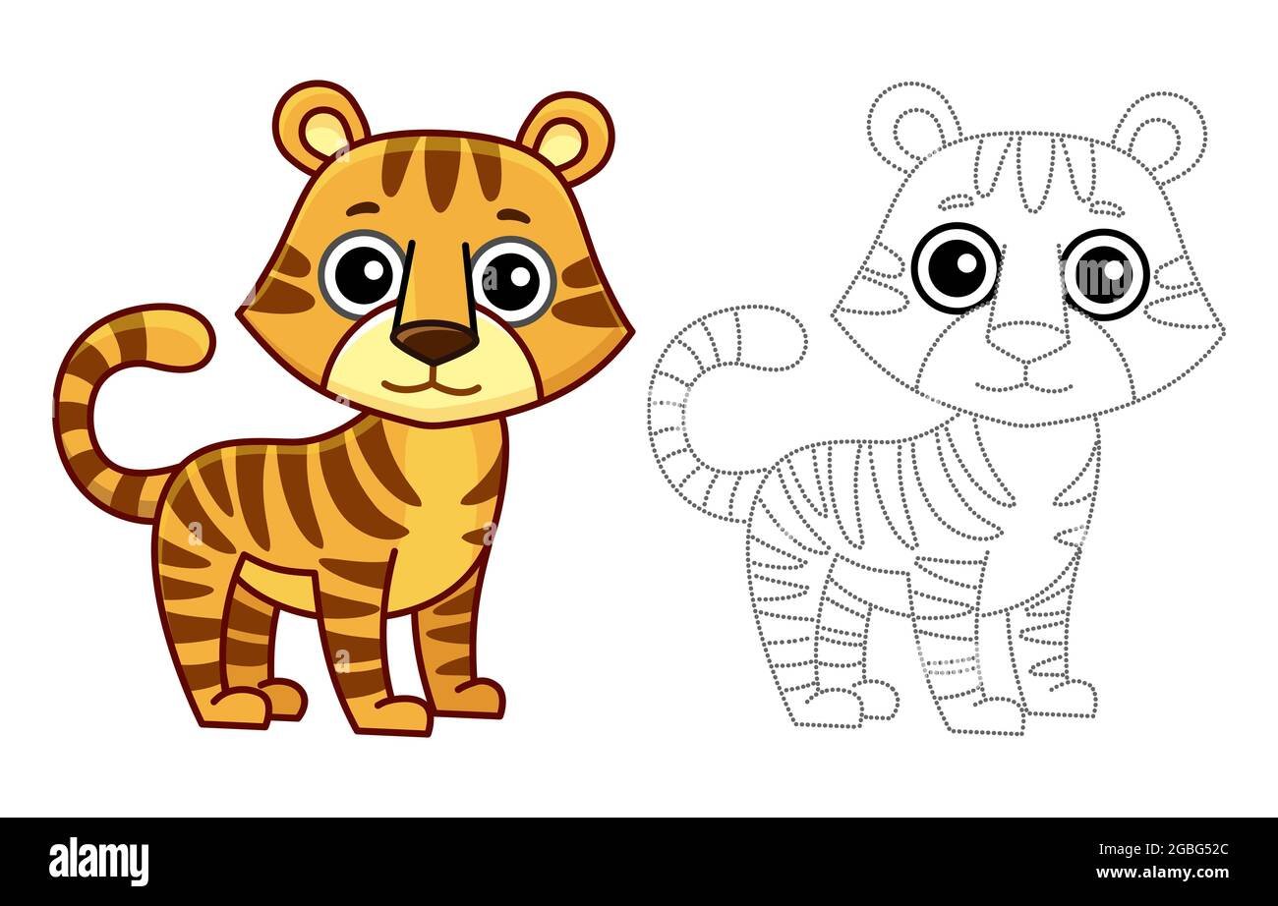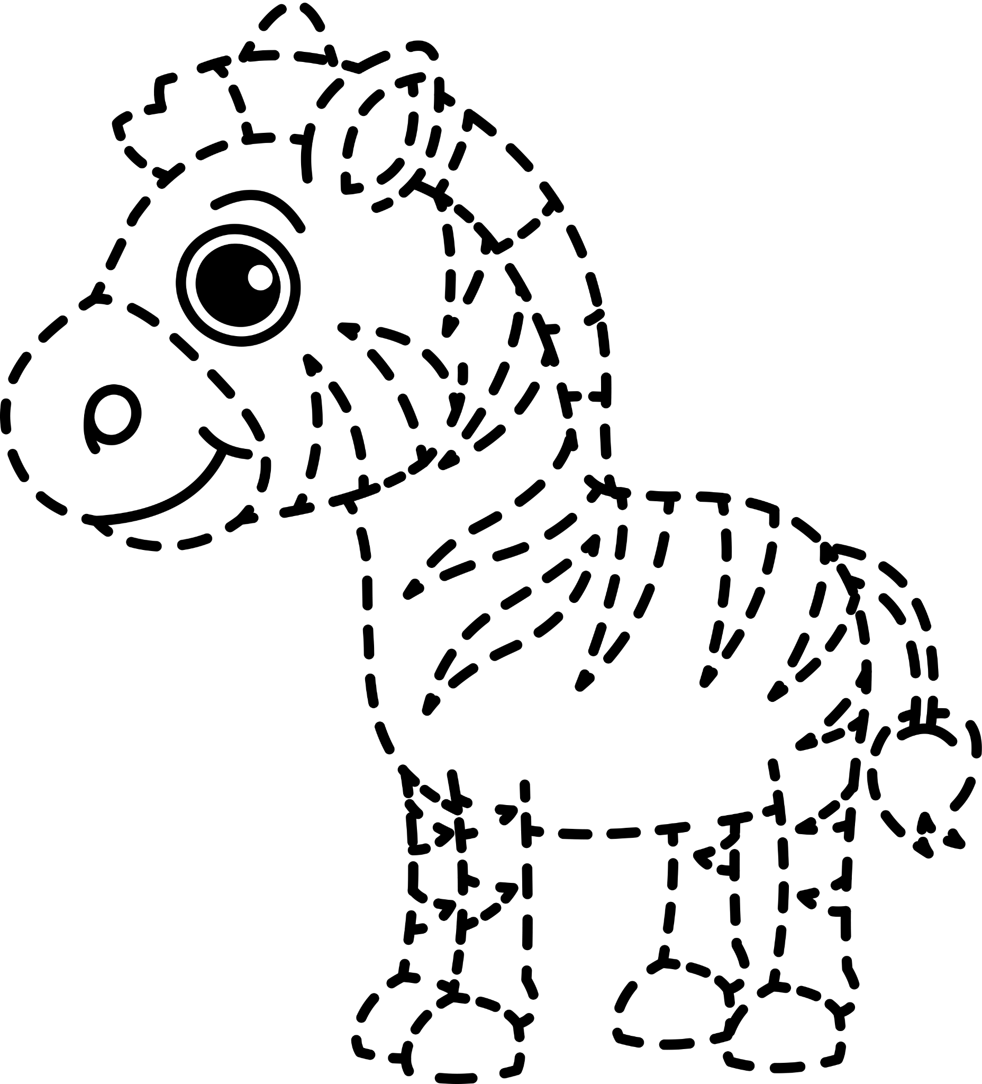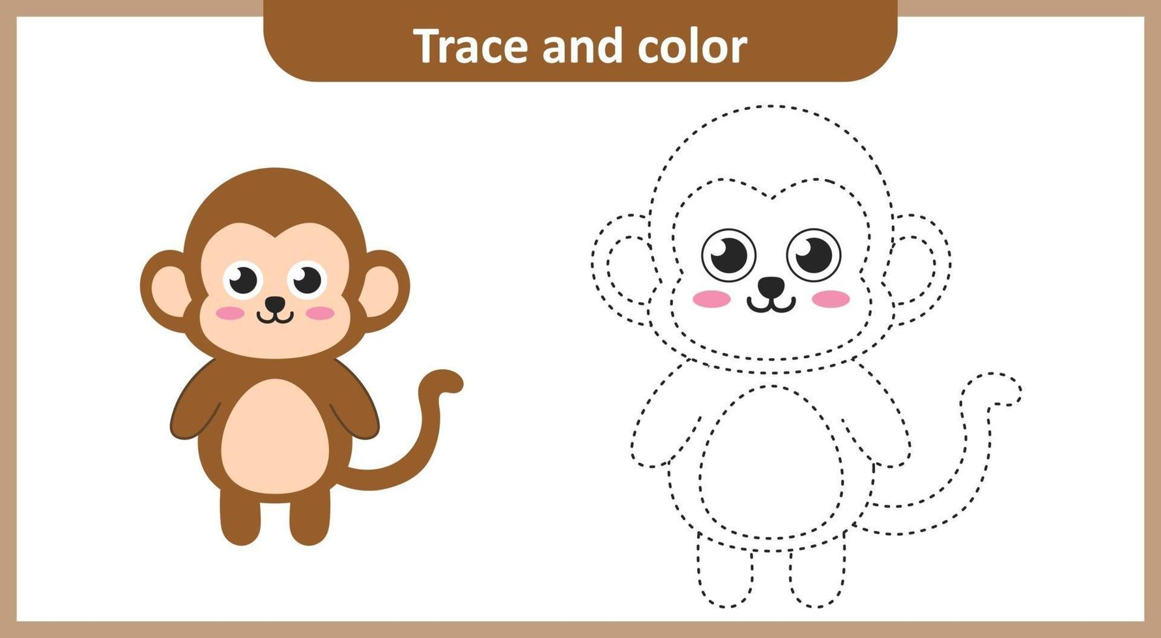
a tiger a zebra a monkey

Numbers
1 - one 2 – two

1 tiger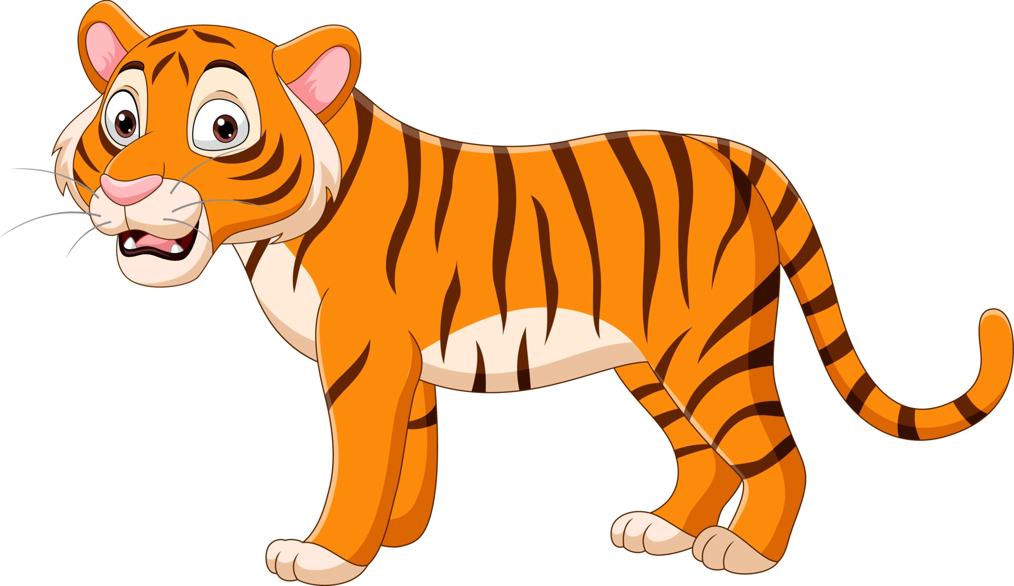 – 2 tigers

1 zebra 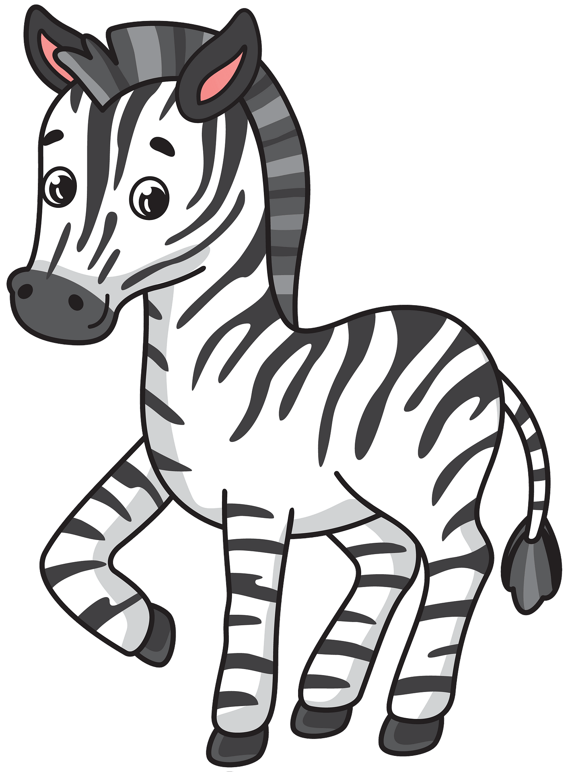 – 2 zebras

1 monkey 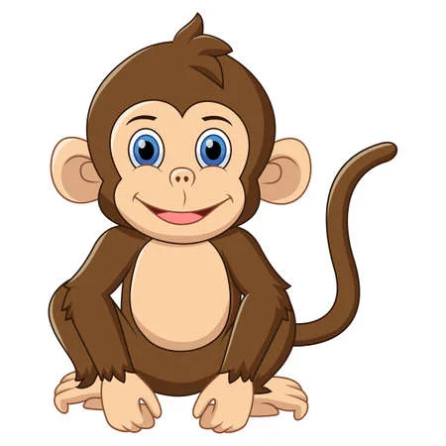 – 2 monkeys

Zoo animals (тварини у зоопарку)
a tiger [ˈtaɪɡə] – тигр
a zebra [ˈzebrə] – зебра
a monkey [ˈmʌŋkɪ] – мавпа
numbers [ˈnʌmbəz] – числа
one – один
two – два

Lesson 14. Letters Mm, Nn, Oo
Find and circle all the letters Mm.

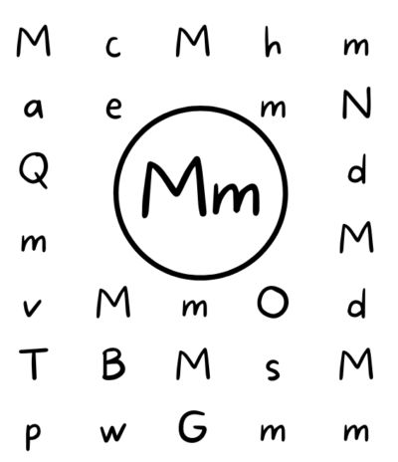
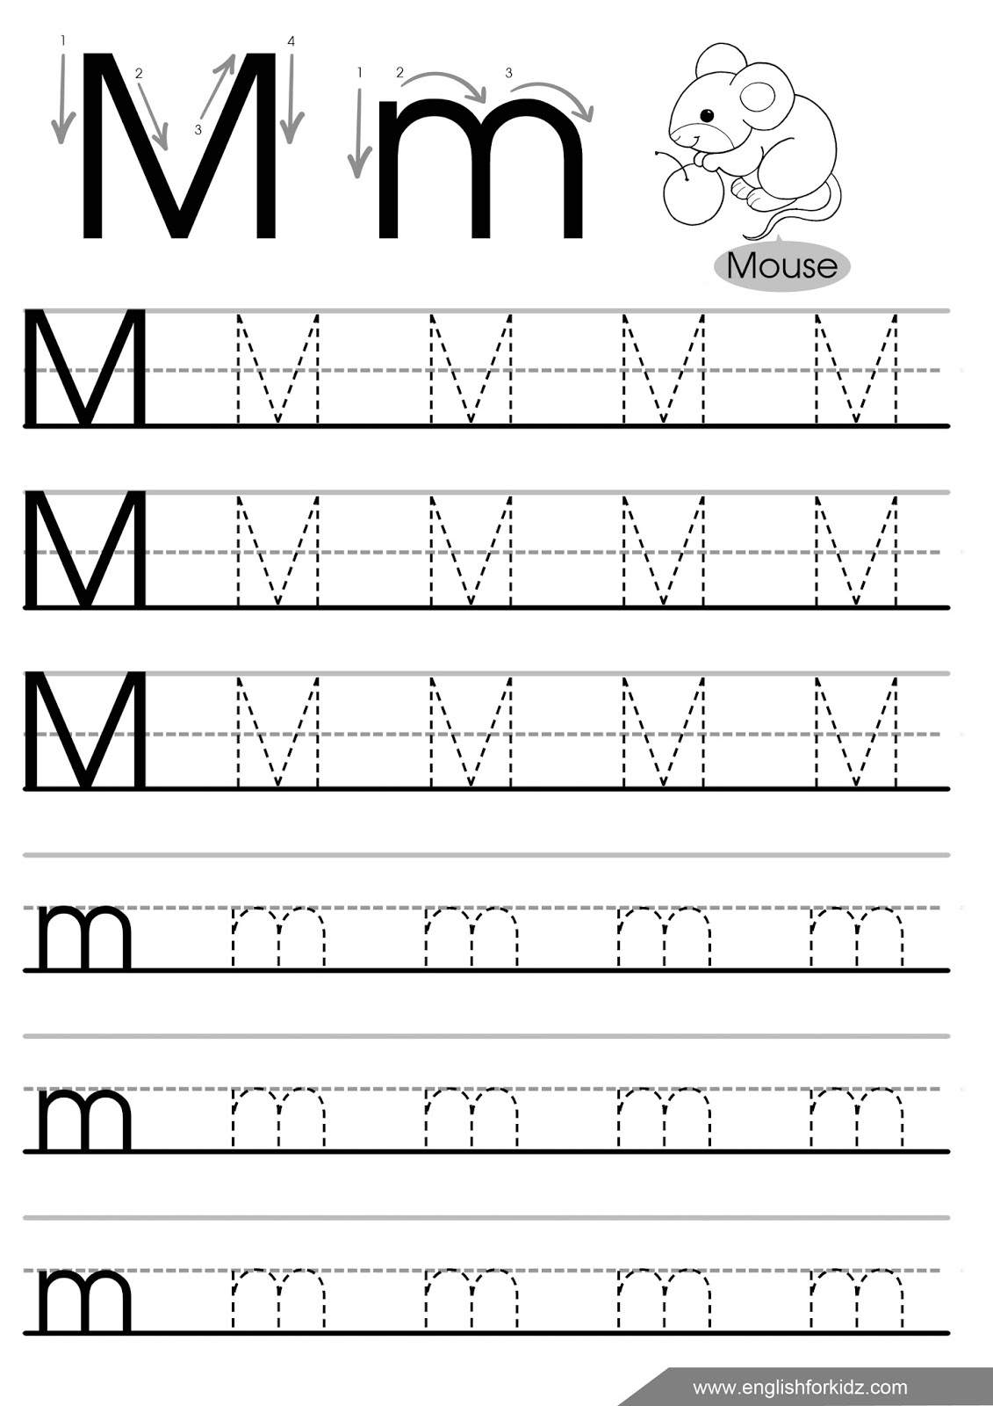

Do a dot letter Nn.
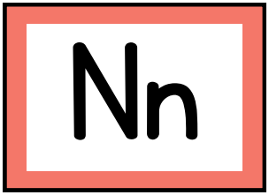

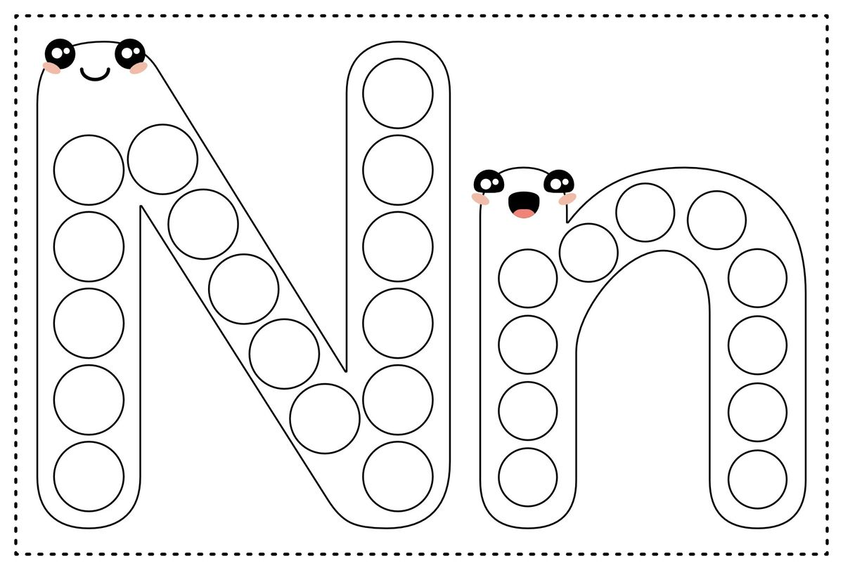
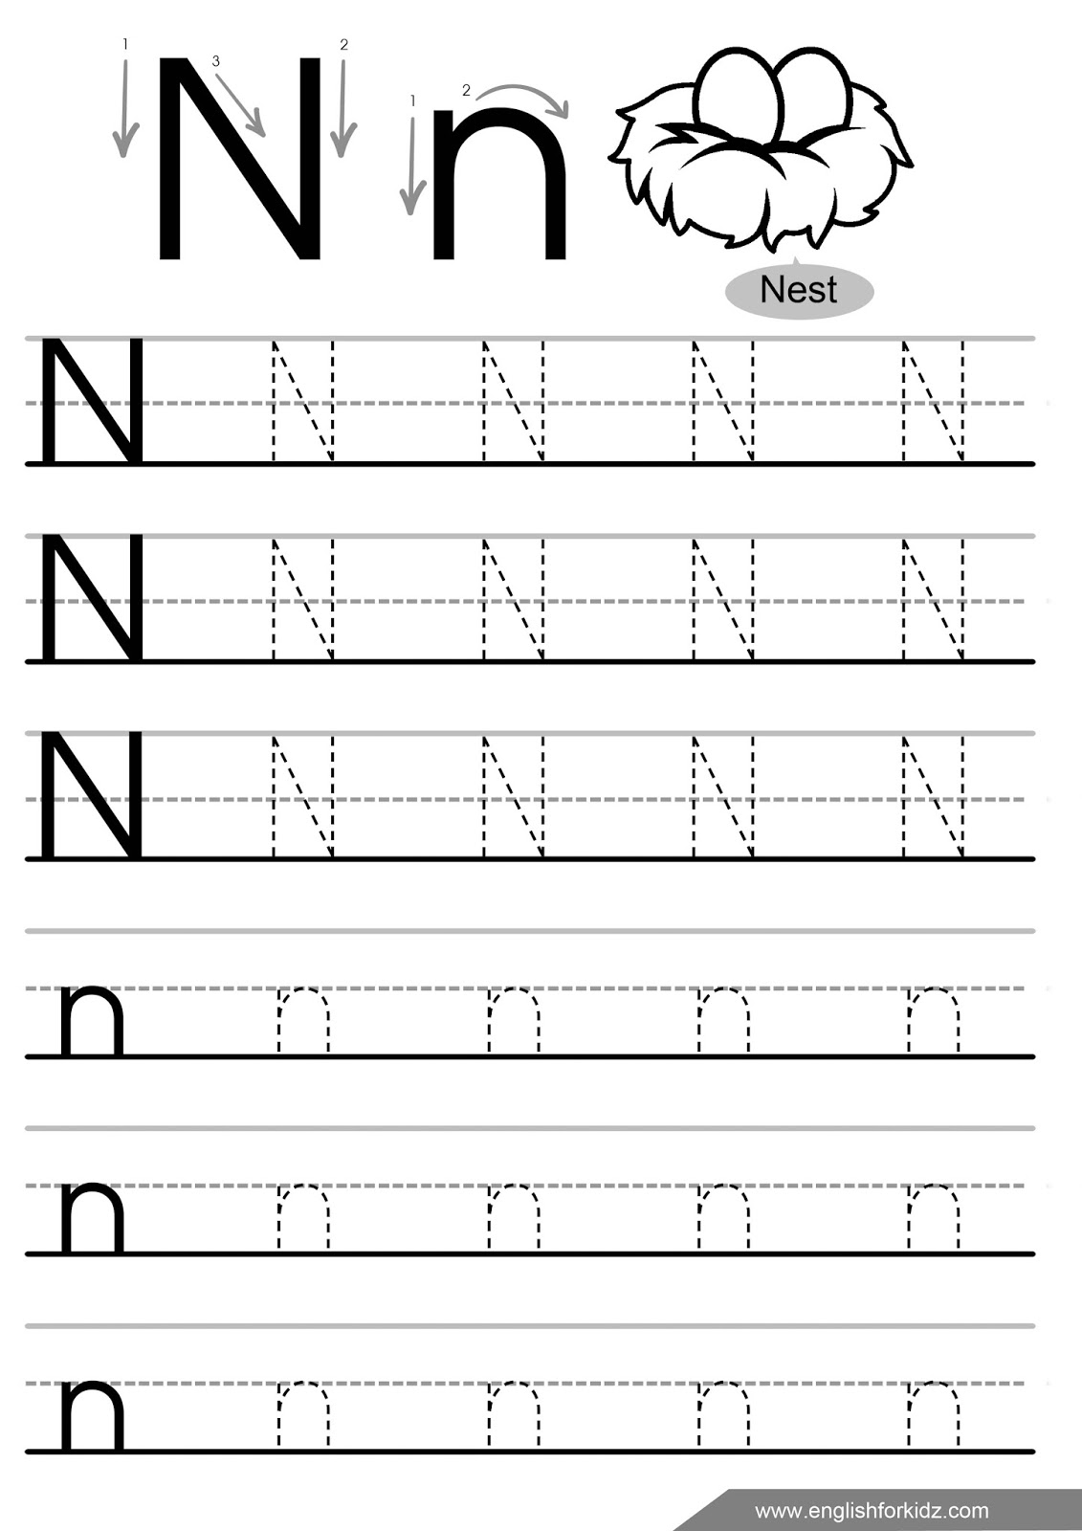

Colour all the oranges that contain a letter O.
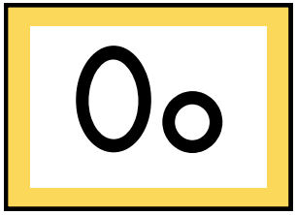
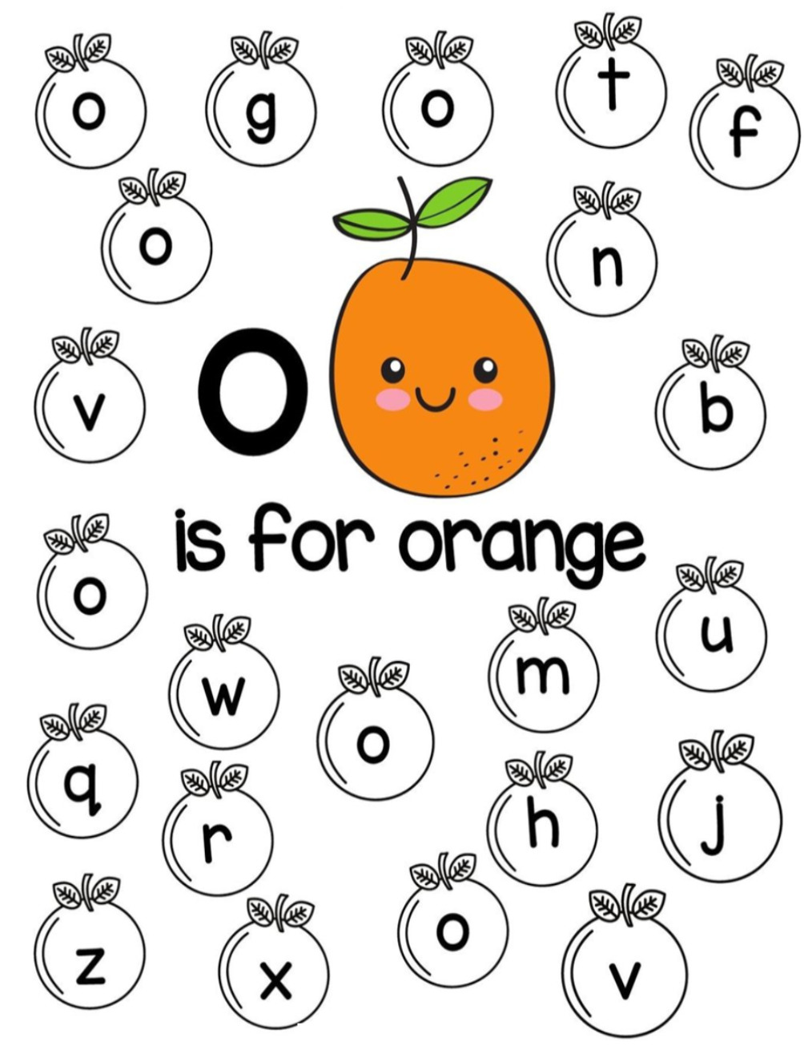
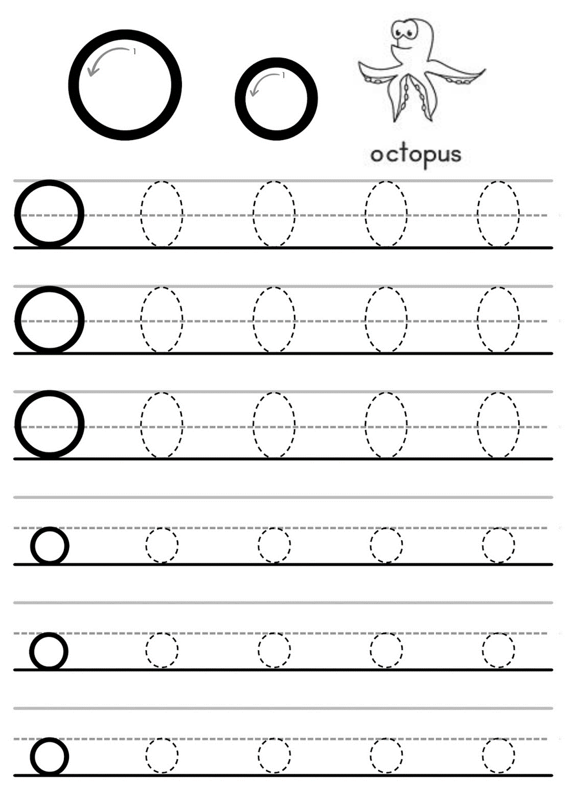

Lesson 15. Animals
How many?
1 - one 2 - two 3 - three 4 - four
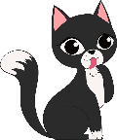 one cat 3
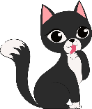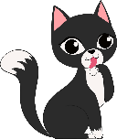 two cats 1
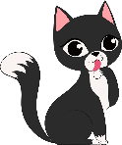 three cats 4
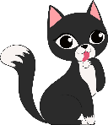 four cats 2
Count the animals
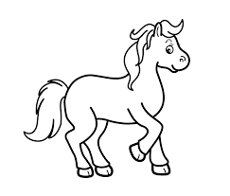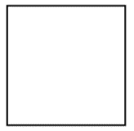
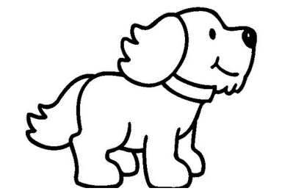
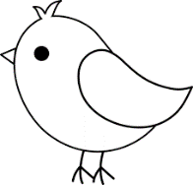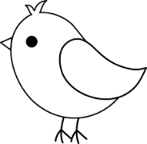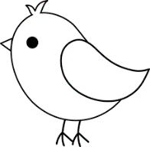
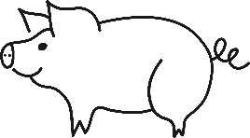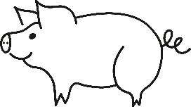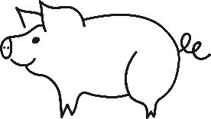
What colour is it? - It’s …
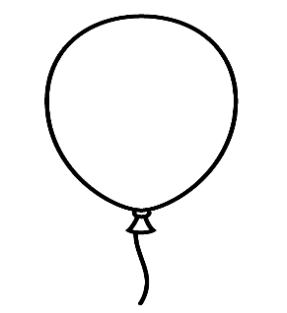
red blue green yellow

pink brown black

Animals (тварини)
numbers – числа
one – один
two – два
three – три
four – чотири
How many? – Скільки?
Count –порахуй

Lesson 16. Letters Pp, Qq
Find and colour all the letters Pp.
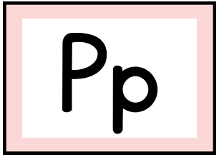

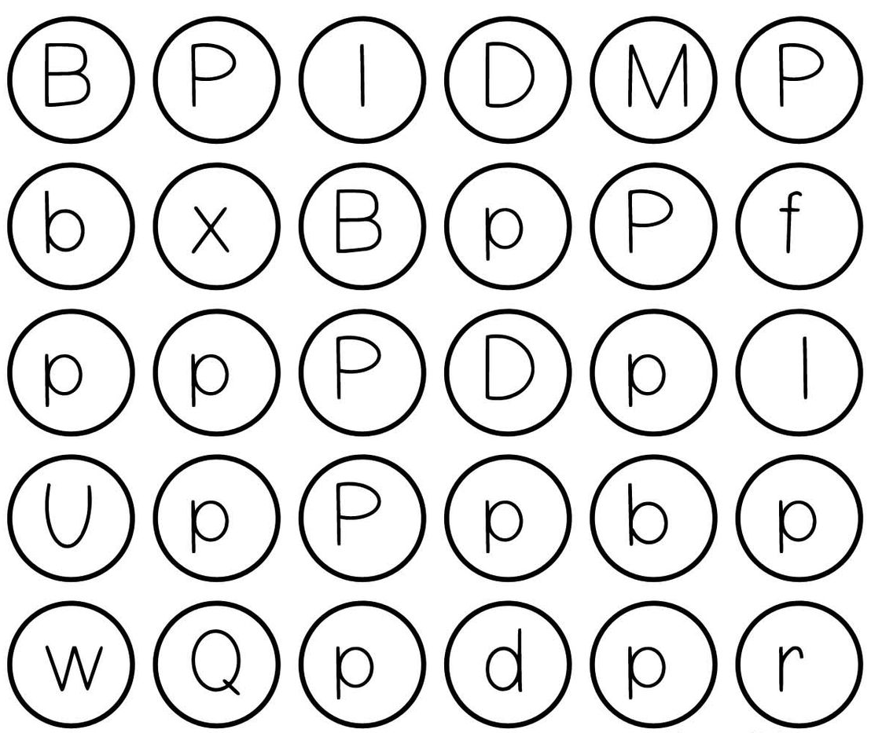

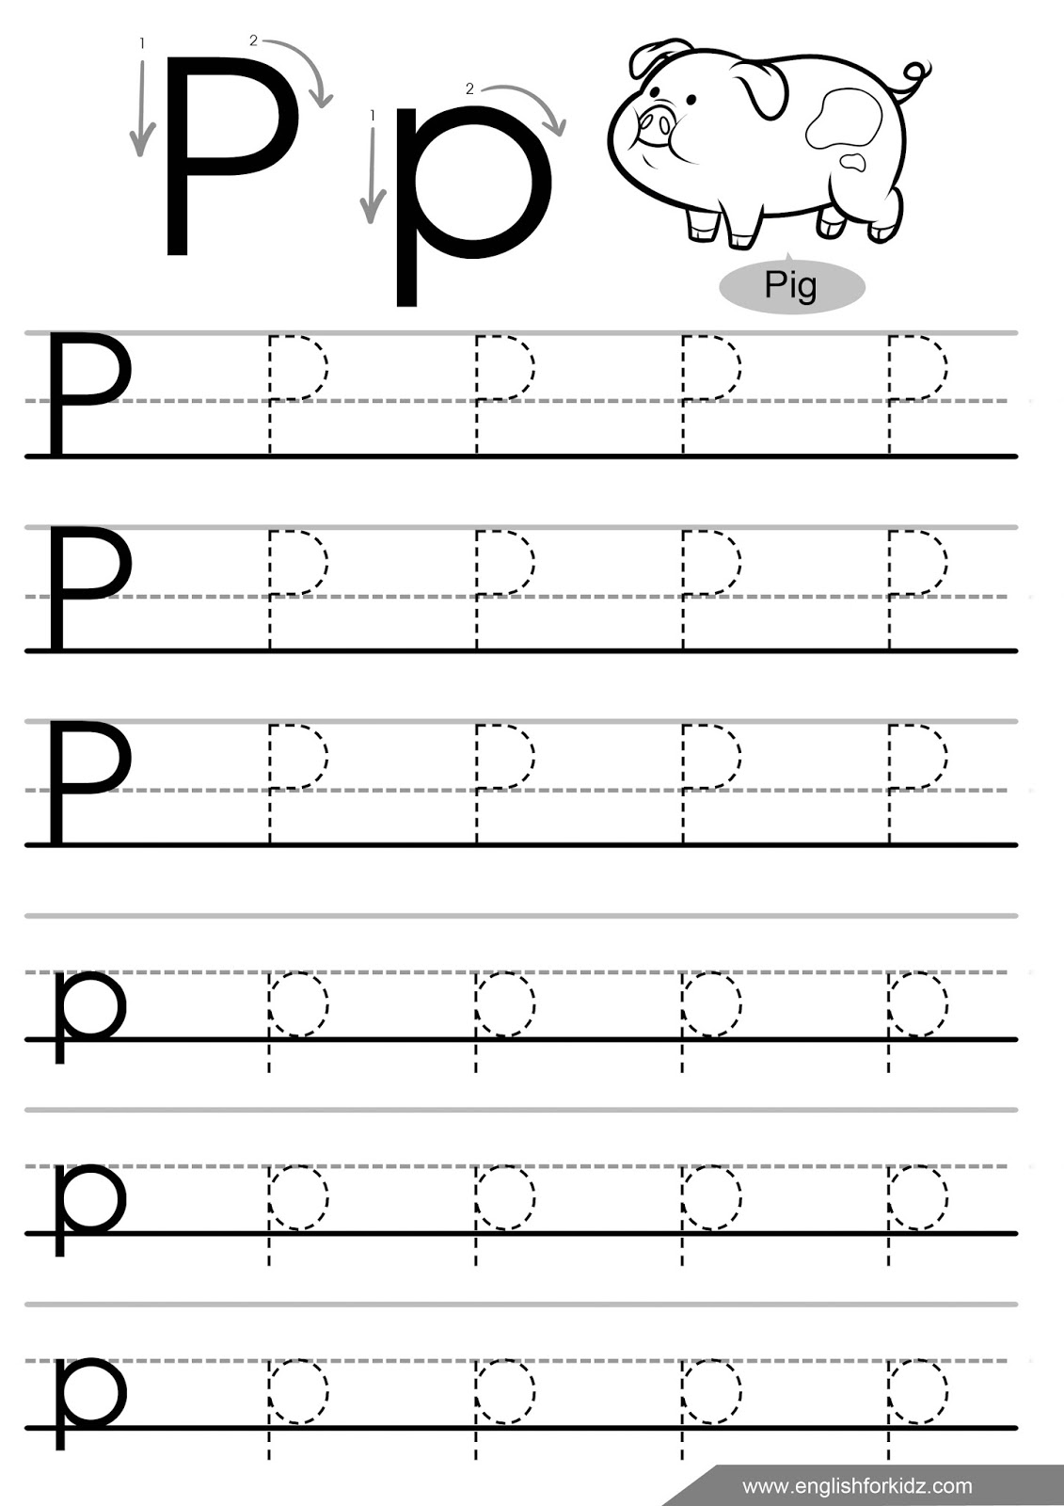

Colour the letter Q by numbers.
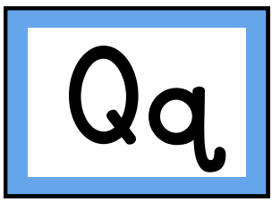

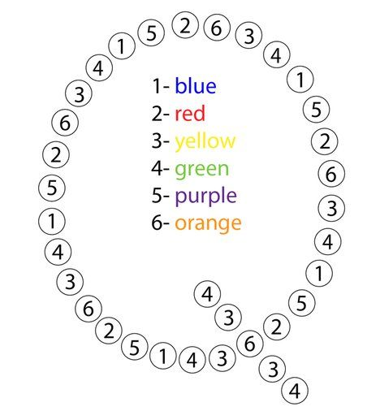

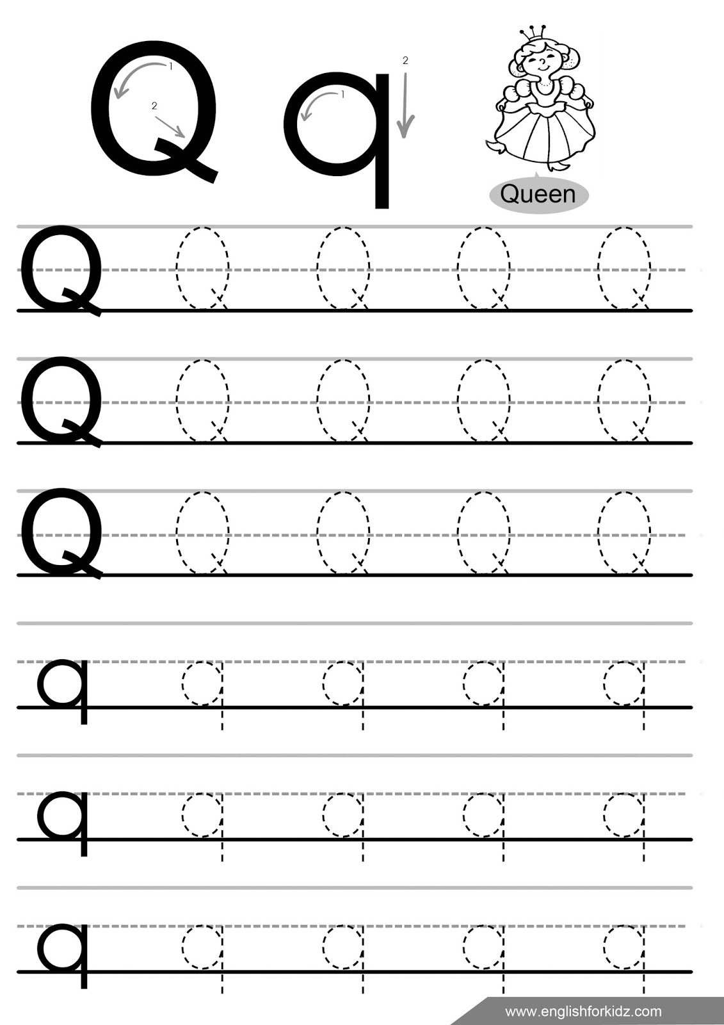

Lesson 17. Family
Numbers
1 - one 2 - two 3 - three 4 – four
5 – five 6 – six
How many animals?
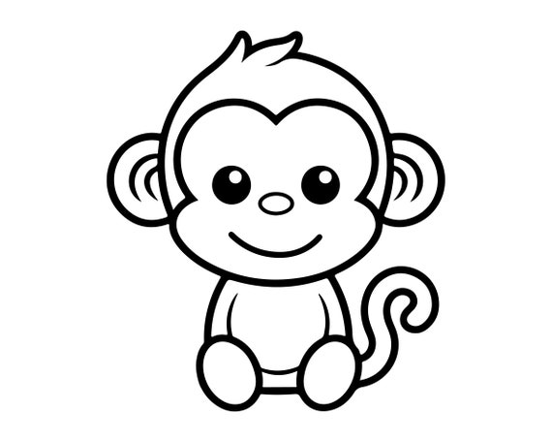 ____ monkeys
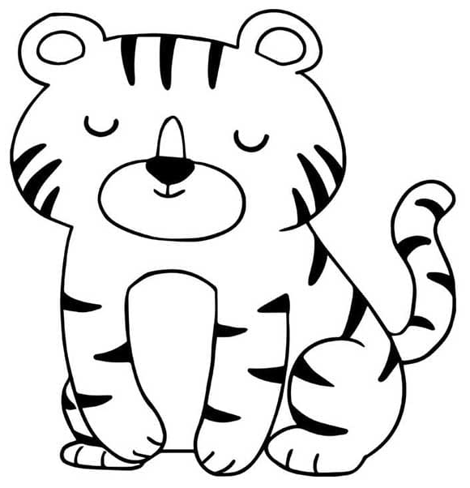 ____ tigers
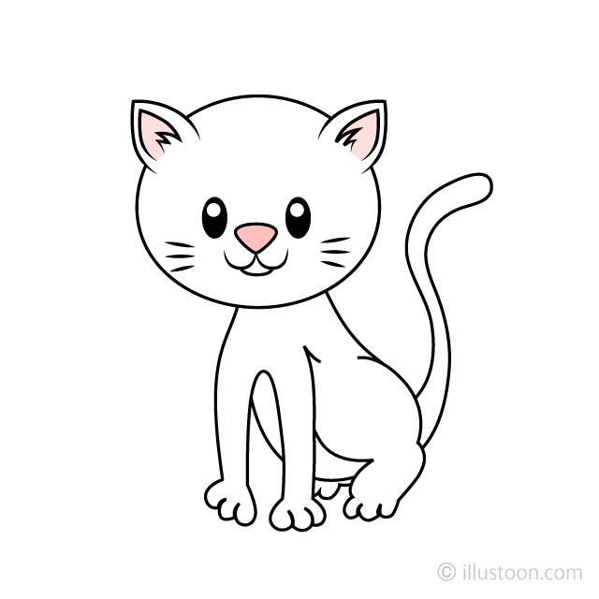 ____ cats
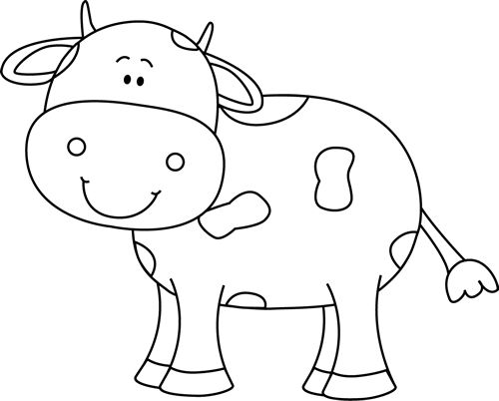____ cows
My family

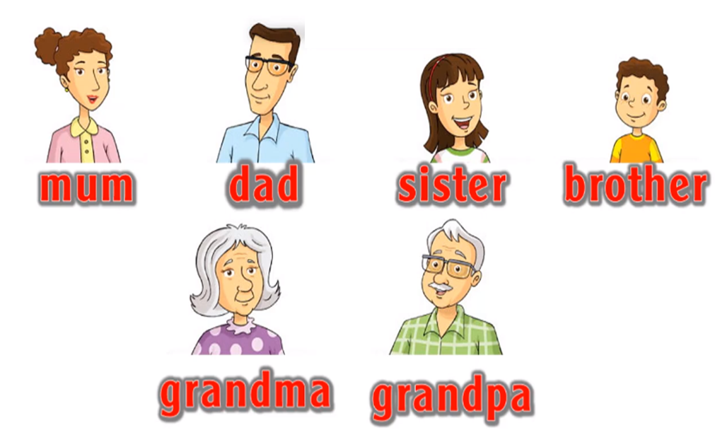

My family (моя сім’я)
a family [ˈfæmɪlɪ] – сім’я
a mum [mʌm] – мама
a dad [dæd] – тато
a sister [ˈsɪstə] – сестра
a brother [ˈbrʌðə] – брат
a grandma [ˈɡræn(d)mɑː] – бабуся
a grandpa [ˈɡræn(d)pɑː] – дідусь
five – п’ять
six – шість

Lesson 18. Letters Rr, Ss
Colour the letters Rr.
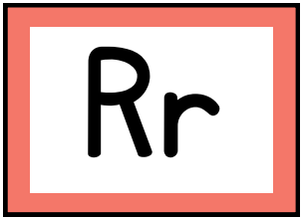

R – blue r – yellow
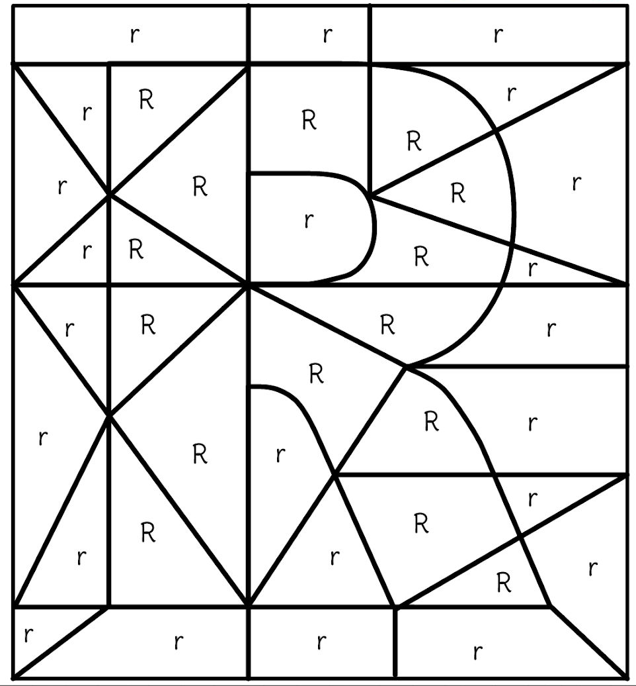
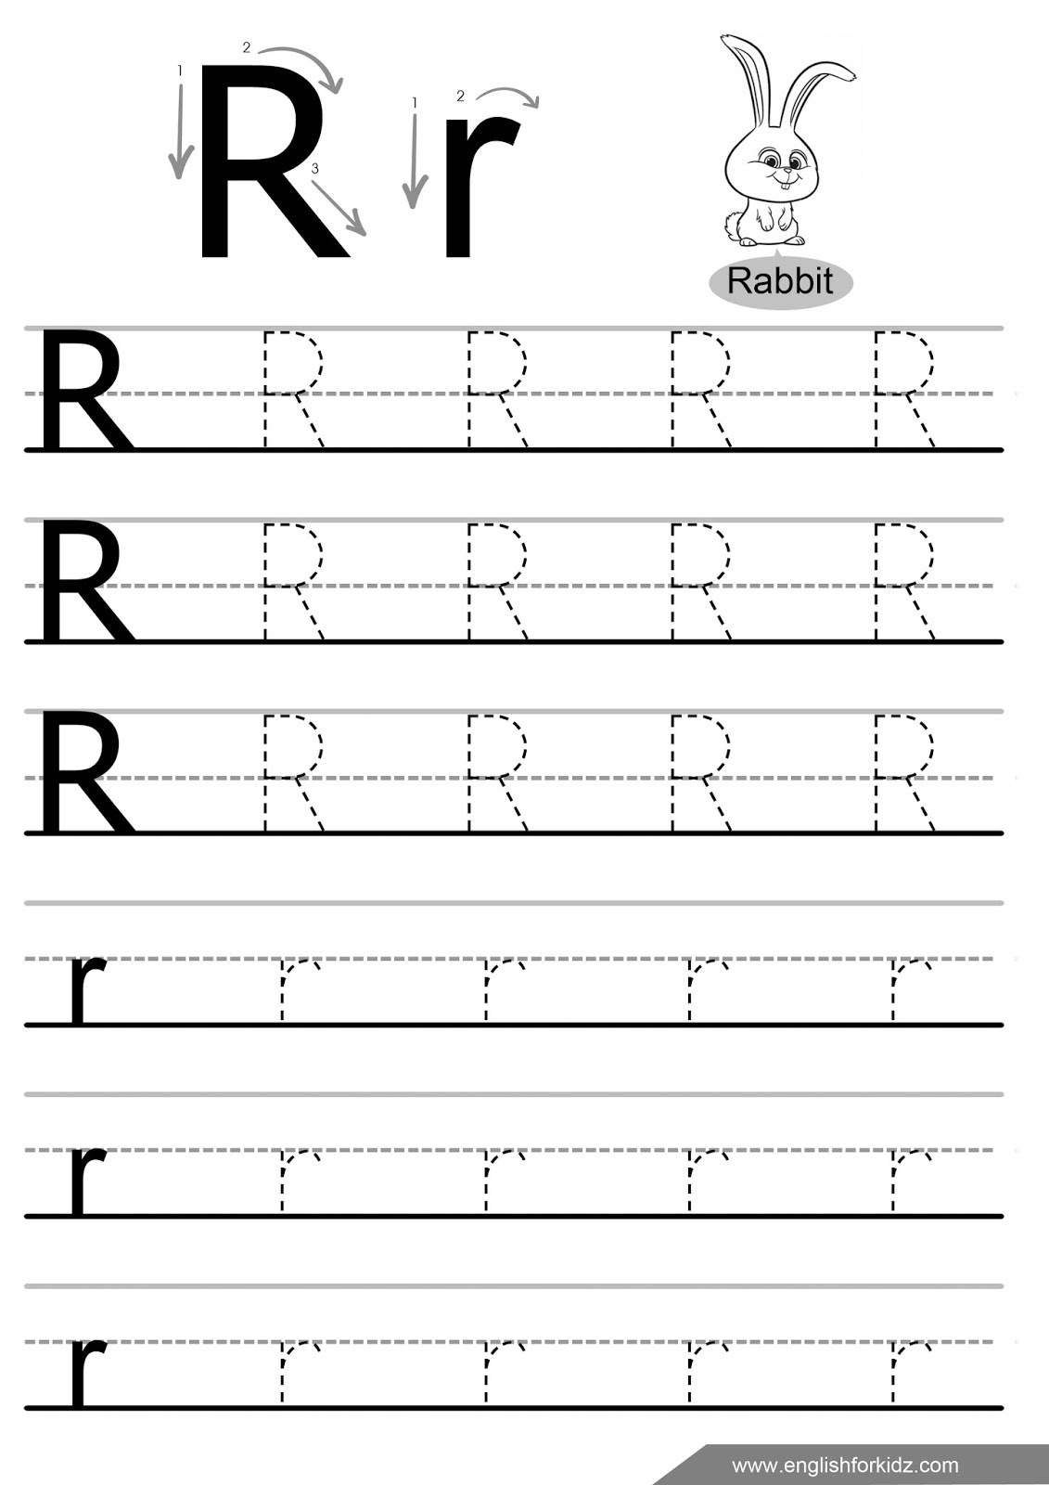

Find and colour the letter S.
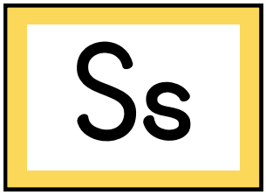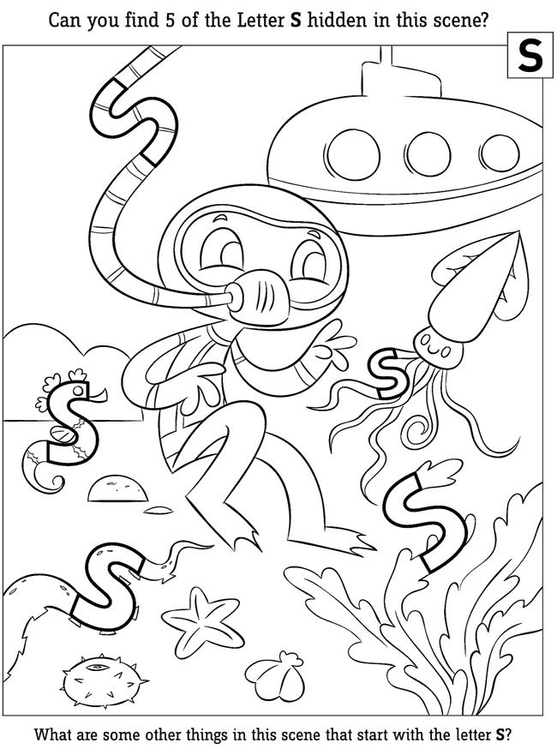
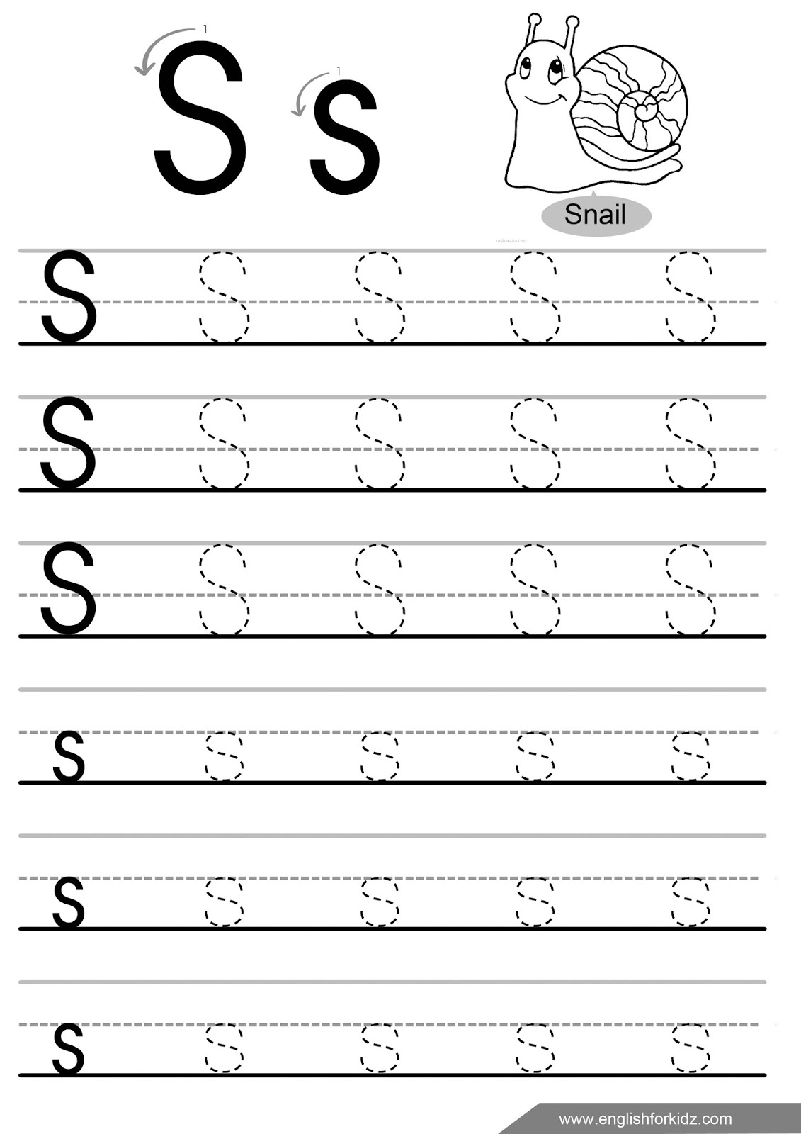

Lesson 19. My family
I have got …
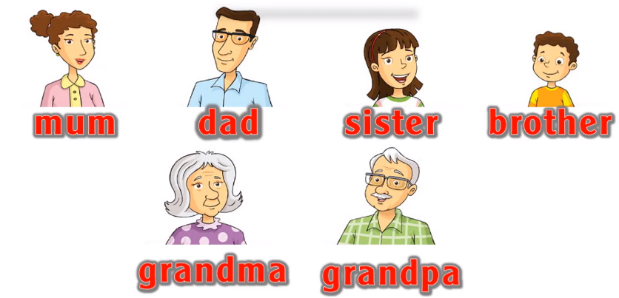
Numbers
1- one 2 -two 3- three 4 - four 5 - five
6- six 7 - seven 8 - eight
How many animals?
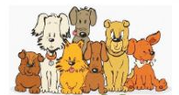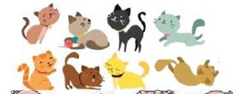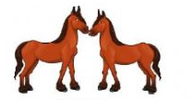

2 horses 7 dogs 8 cats
My family (моя сім’я)
I have got … – У мене є …
seven – сім
eight – вісім
Lesson 20. Letters Tt, Uu
Colour the cells with letter T to receive a picture.
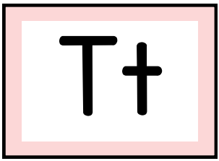
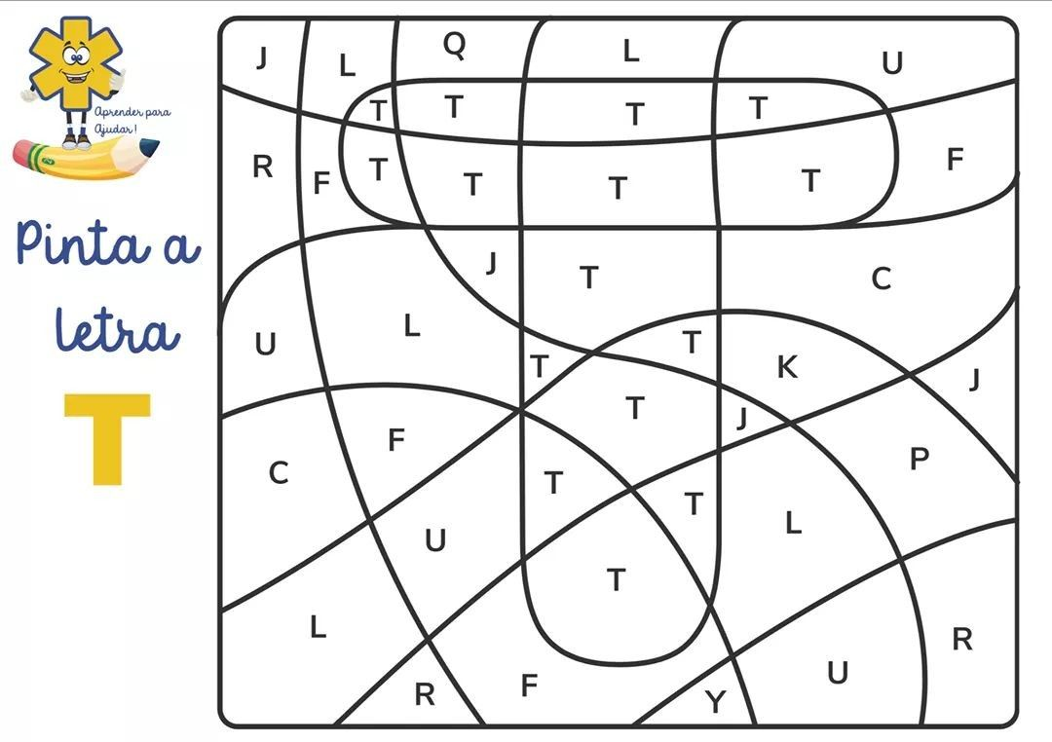
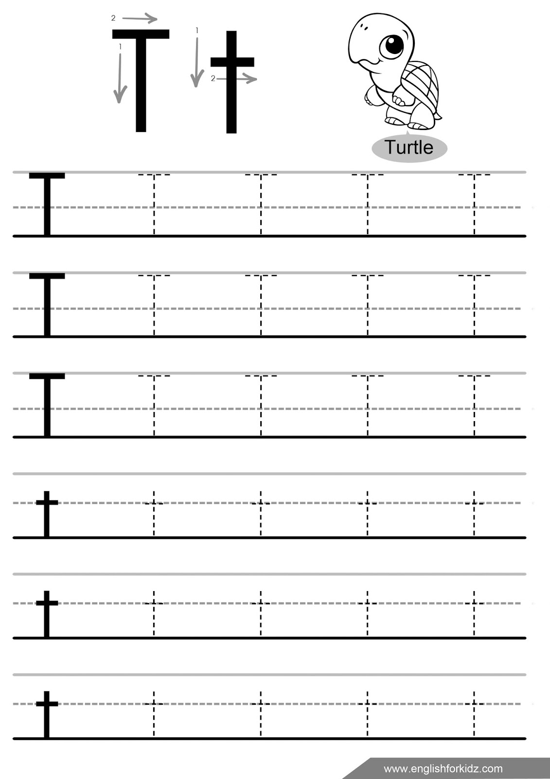

Colour the picture and circle all letters Uu. 
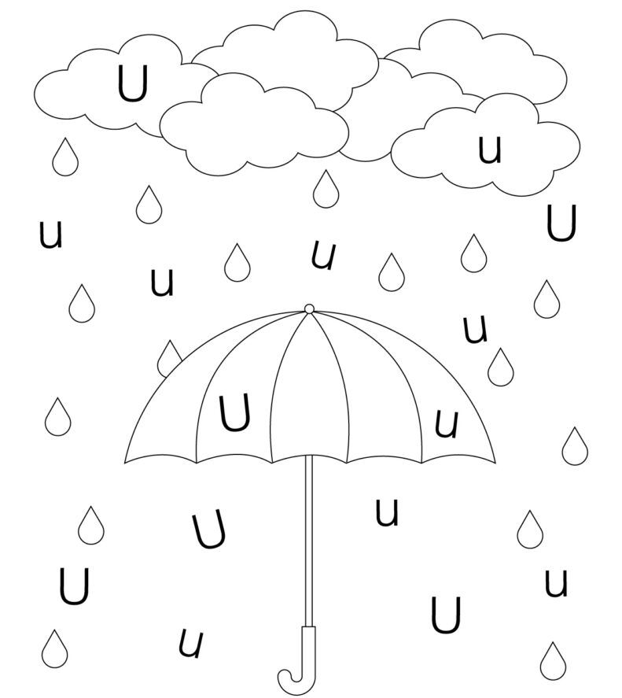
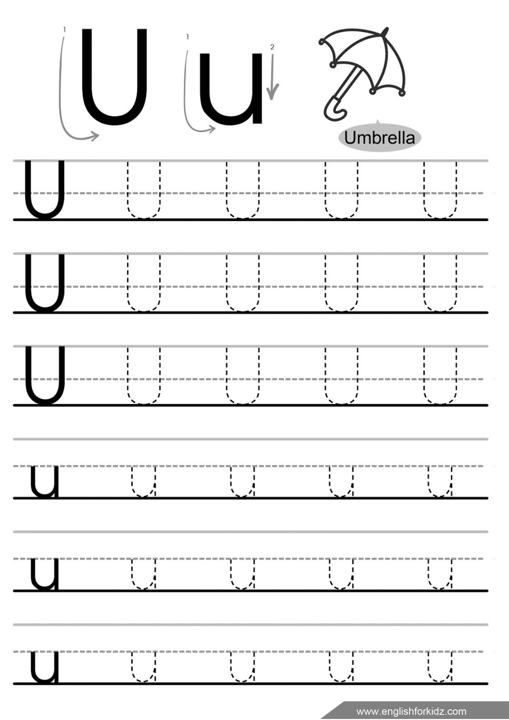

Lesson 21. Fruits
I have got …
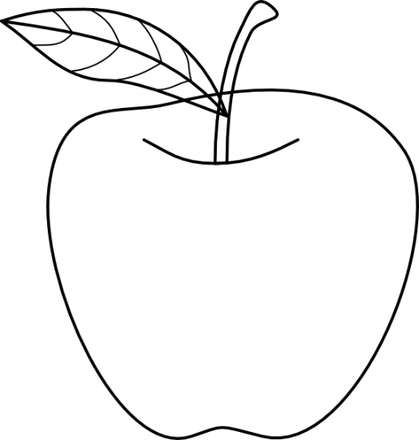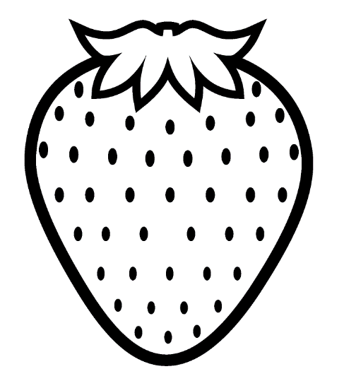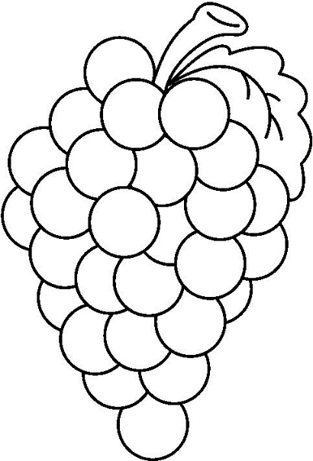
an apple a strawberry grapes
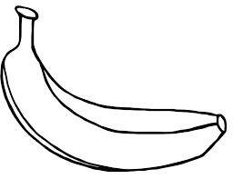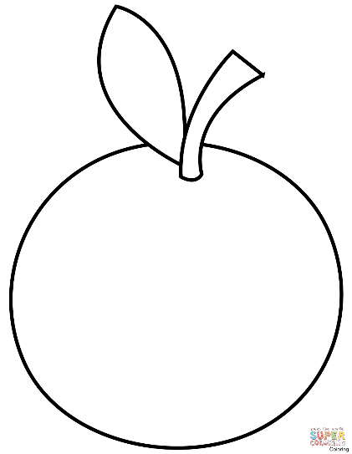
a banana an orange a lemon

Fruits (фрукти)

an apple [ˈæpl] – яблуко
a strawberry [ˈstrɔːb(ə)rɪ] – полуниця
grapes [ɡreɪps] – виноград
a banana [bəˈnɑːnə] – банан
an orange [ˈɒrɪnʤ] – апельсин
a lemon [ˈlemən] – лимон

Lesson 22. Letters Vv, Ww
Find and colour a letter V.
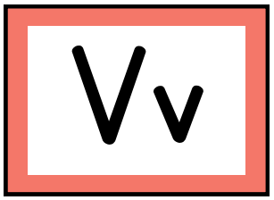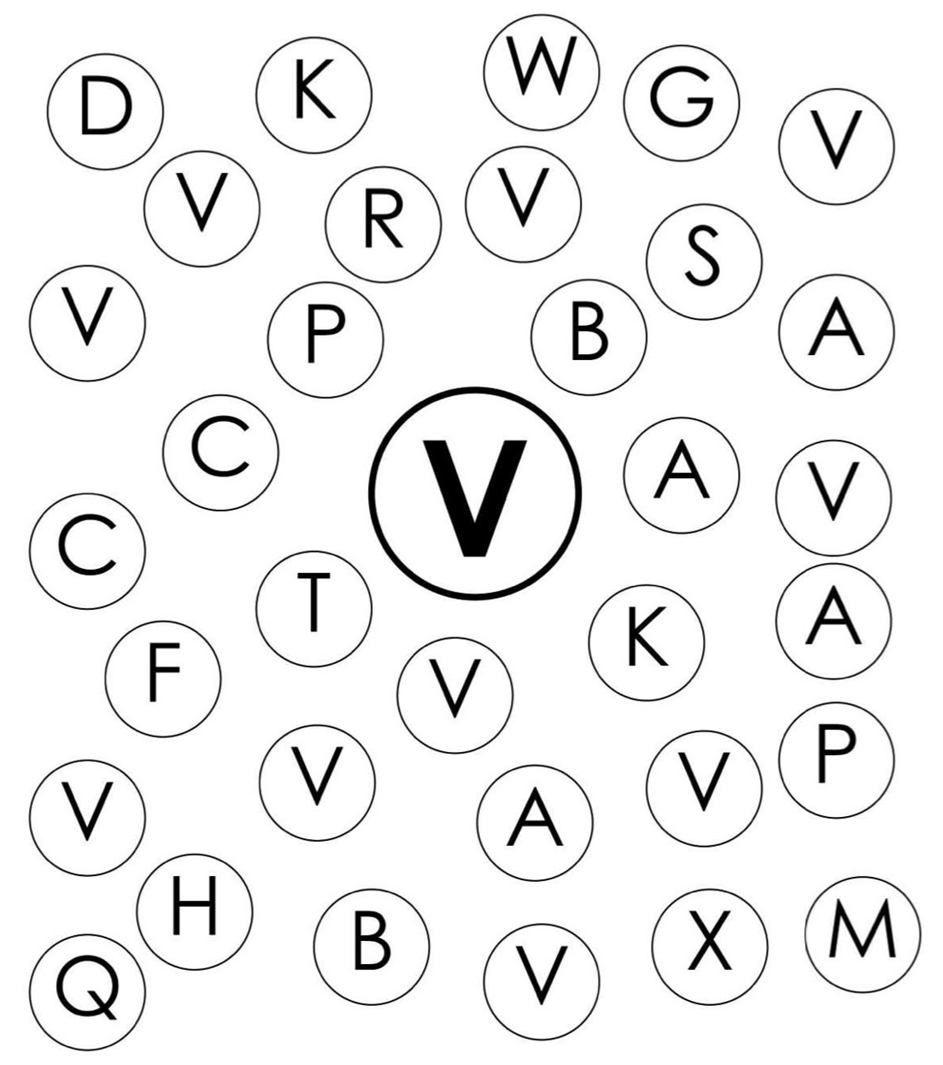
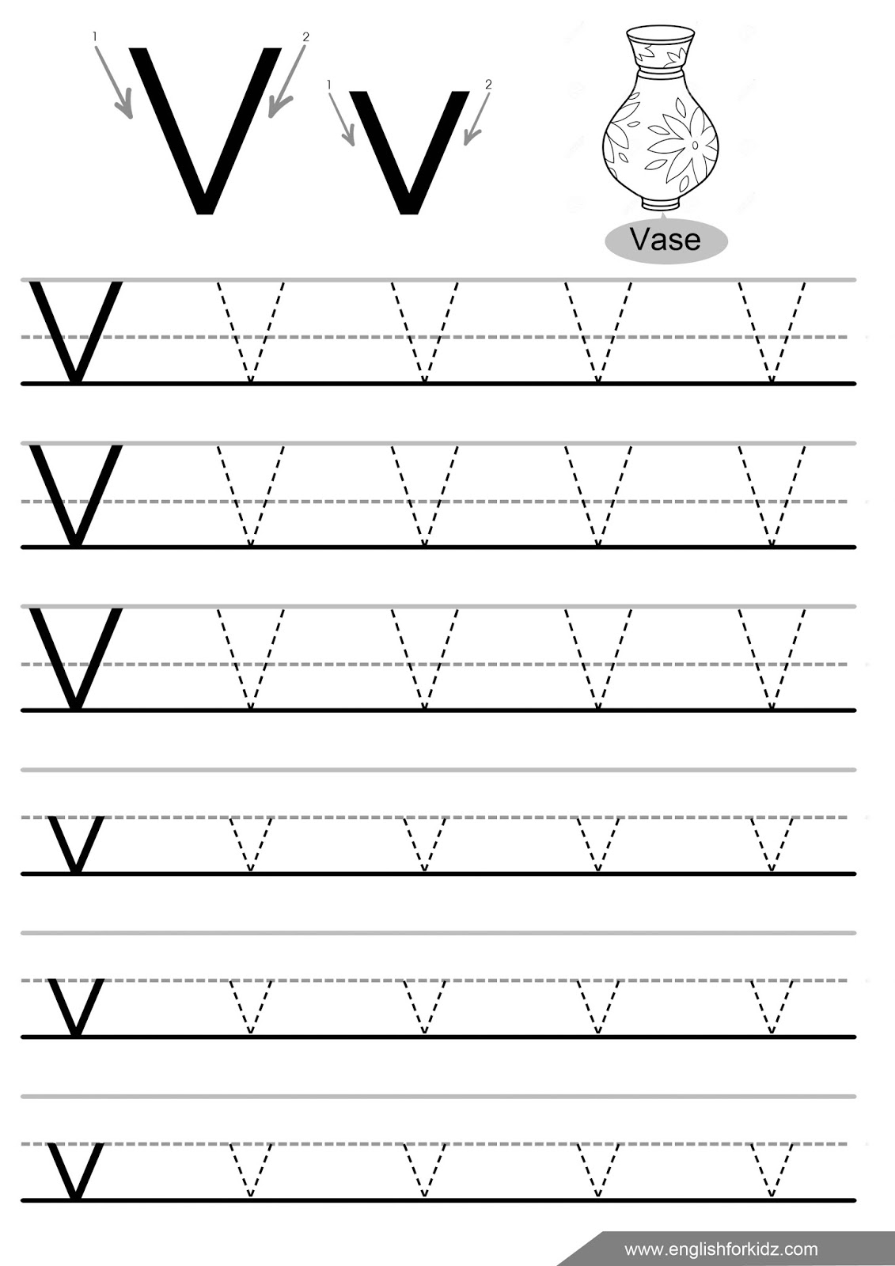

Colour the letter W by code.


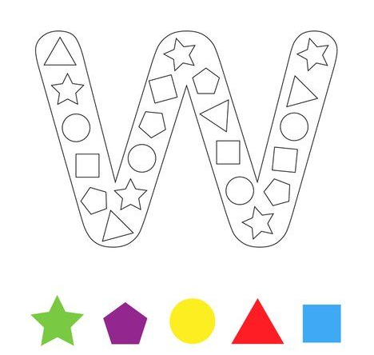
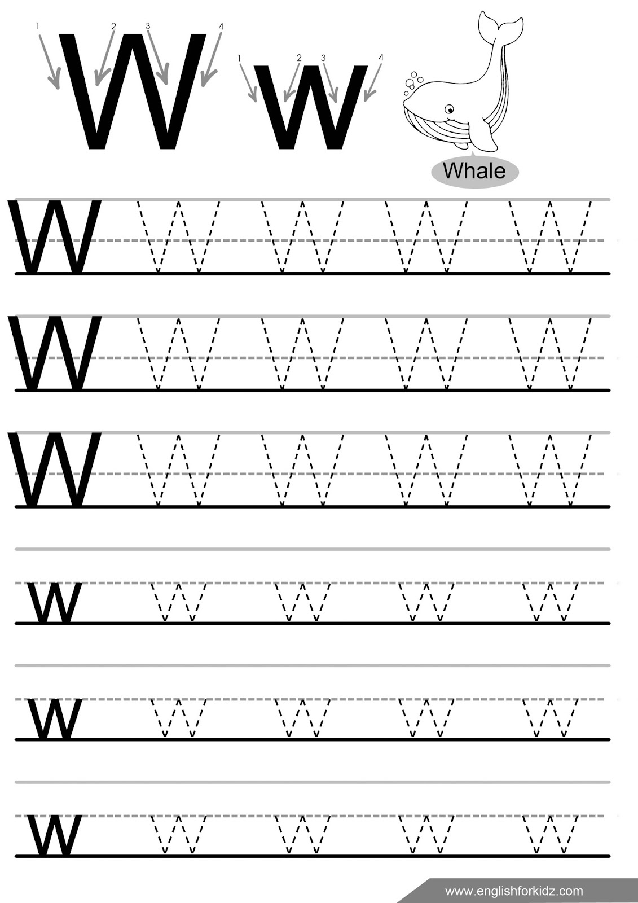

Lesson 23. Fruits
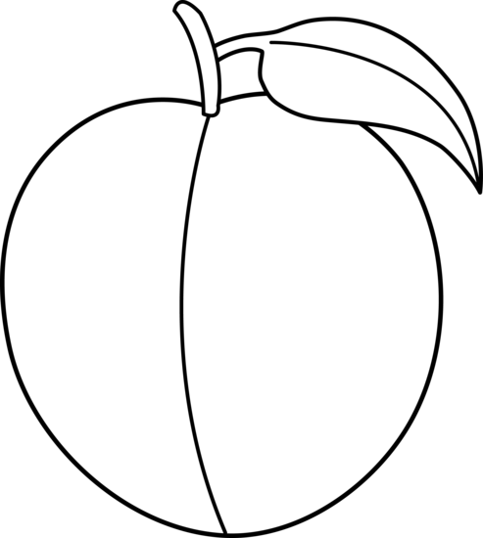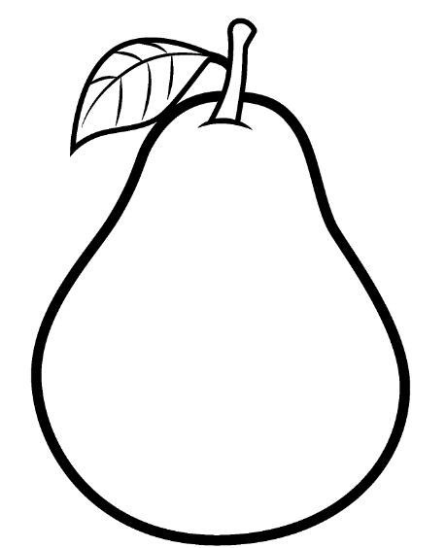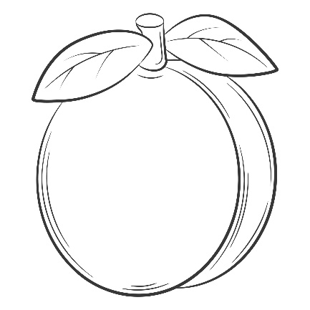
a plum a pear an apricot
Numbers
1- one 2 -two 3- three 4 - four 5 - five
6- six 7 - seven 8 - eight 9 - nine 10 - ten
How many…?
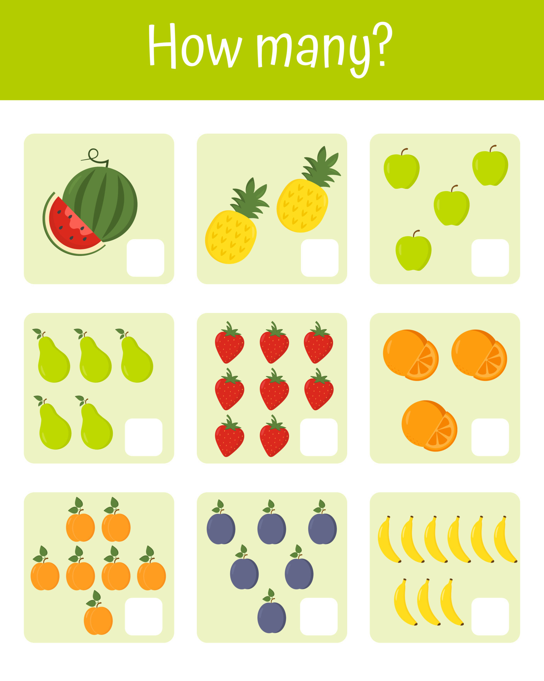

I like …
Fruits


Fruits (фрукти)
a plum [plʌm] – слива
a pear [peə] – груша
an apricot [ˈeɪprɪkɒt] – абрикос
I like … – Я люблю…
nine – дев’ять
ten – десять

Lesson 24. Letters Xx, Yy, Zz
Do a dot letter X.
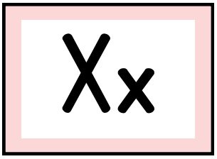
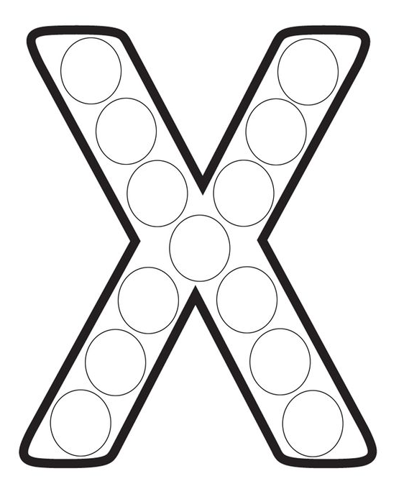
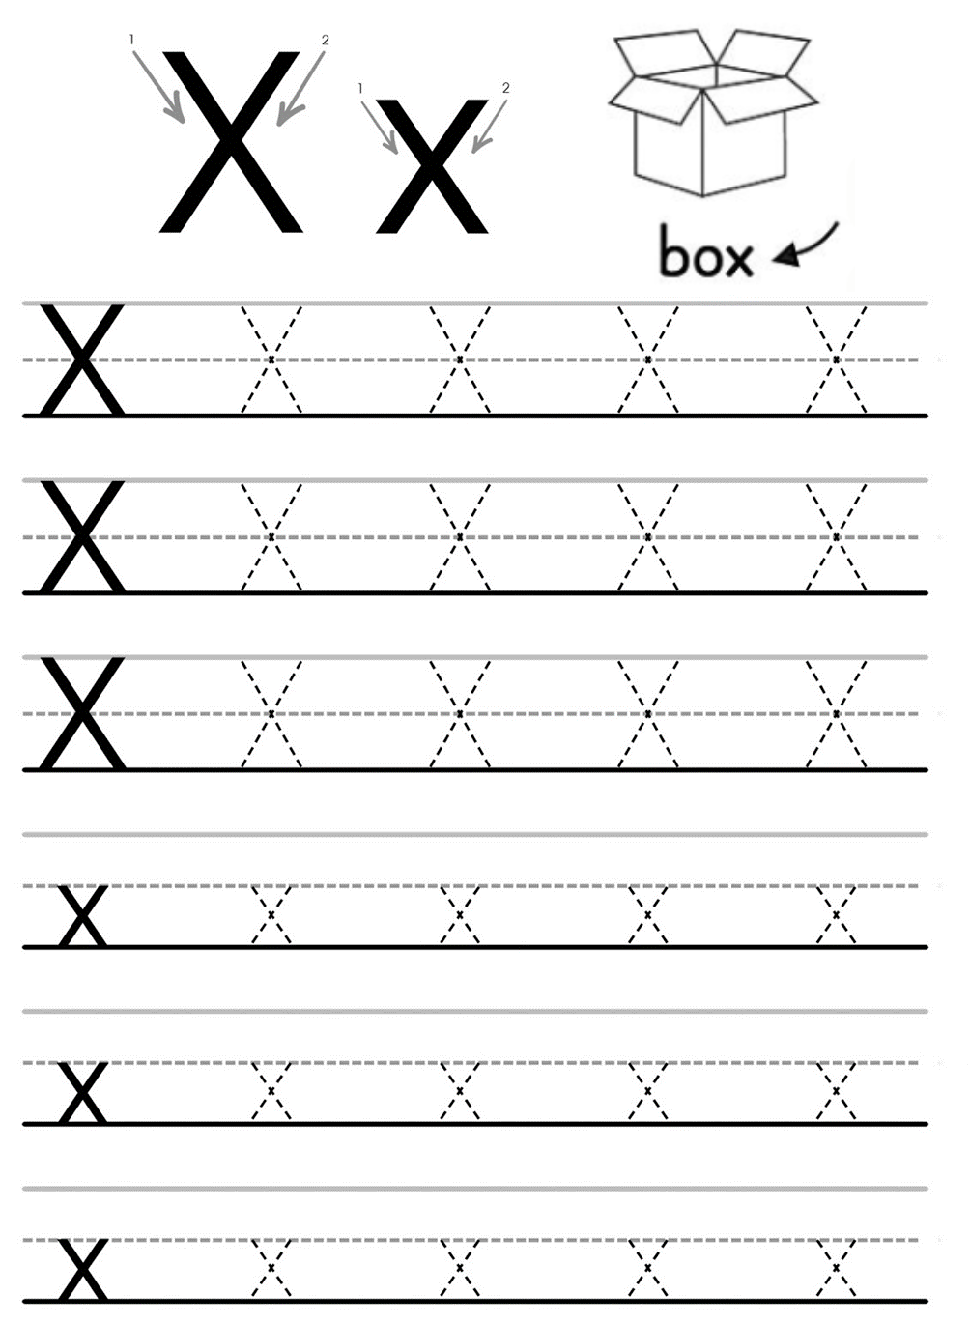

Colour the bubbles. Use the colour key.
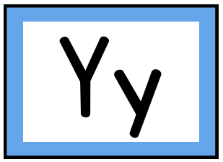

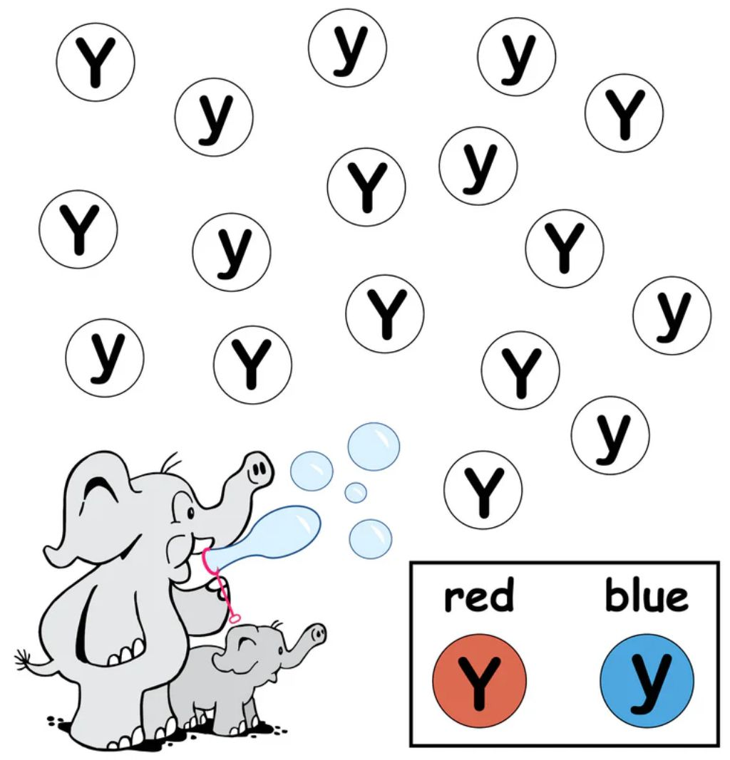
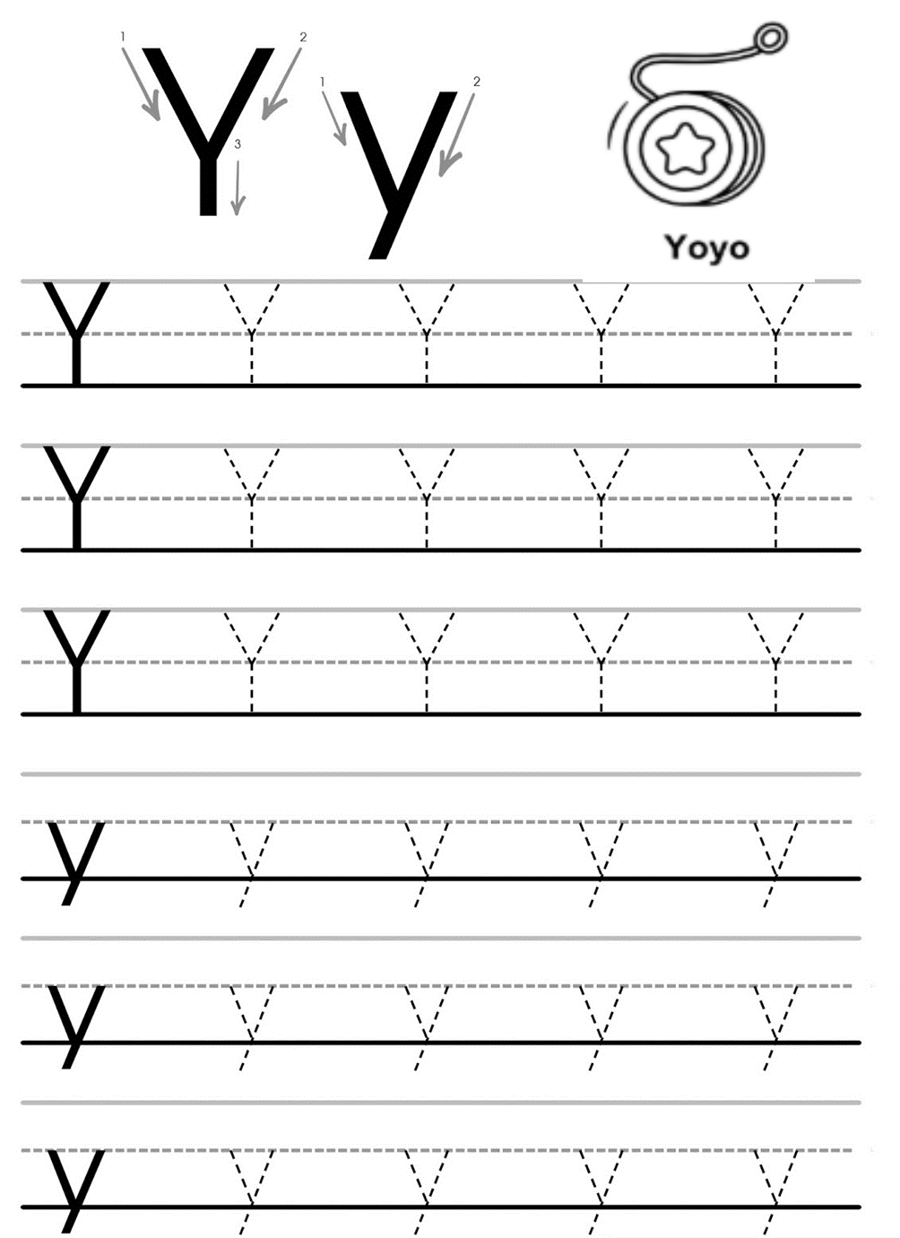

Colour by numbers.
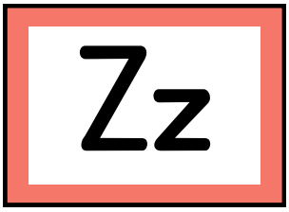

1 – yellow
2 – red
3 – pink
4 - green



