“Bingo” Game. My Town.
This game helps children learn and practice vocabulary.
Instructions
Print out the bingo cards (one for each player) and one call sheet (which contains all the images or words).
Cut out the squares from the call sheet and put them into a hat or a box.
Prepare six place markers for each player (e.g., pieces of paper, buttons, etc.).
How to Play
In large classes, divide the children into smaller groups.
Give each group a set of bingo cards and the hat/box with the cut-out squares.
One child is the 'caller' and takes the hat/box. The other children take one bingo card each.
Choose one variation to play:
1. The caller pulls out one image square and names it.
2. The caller pulls out one word square and shows it to the children.
The children listen or read and cover the matching picture on their card if they have it.
The first person to cover all six pictures on their card shouts 'Bingo!'
To check, the child who shouted 'Bingo' reads out the 6 items on their card.
If they are all correct, that child wins the round. If the child has made a mistake, the game continues until there is a correct winner.
Afterwards, the children can play a new game, with another child taking on the role of the bingo caller.

CALL SHEETS

 |  | 
 |  | 
 |  | 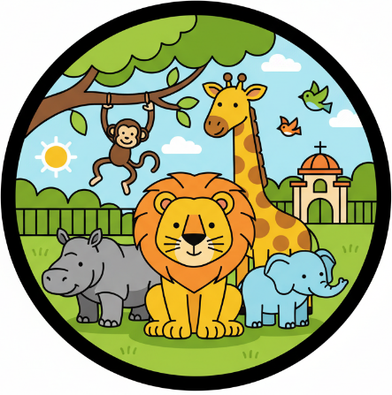
 |  | 
 | 
 | 
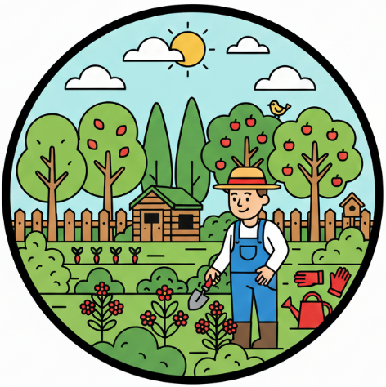 | 
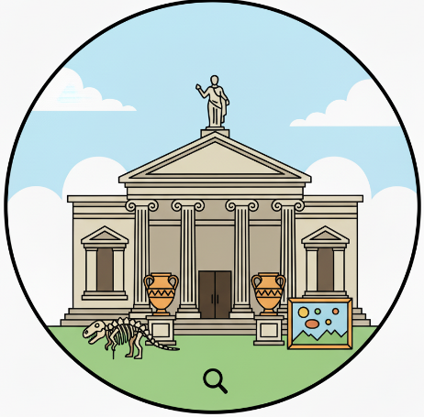

toy shop
pet shop
school
restaurant
park
zoo
supermarket
hospital
police station
playground
cinema
church
garden
theatre
museum

BINGO CARDS
 |  | 
 |  | 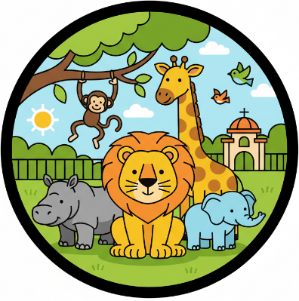

 |  | 
 |  | 

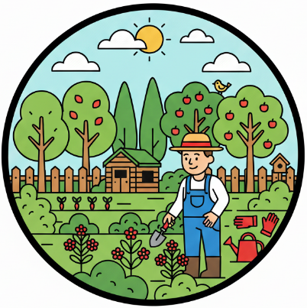 | 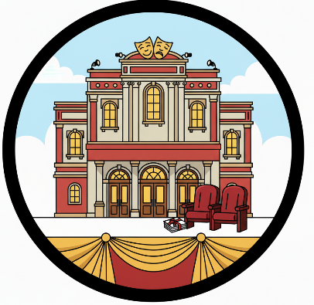 | 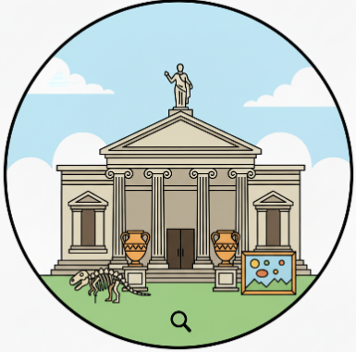
 |  | 

 |  | 



 | 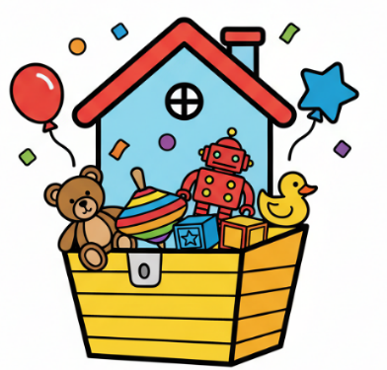 | 

 |  | 


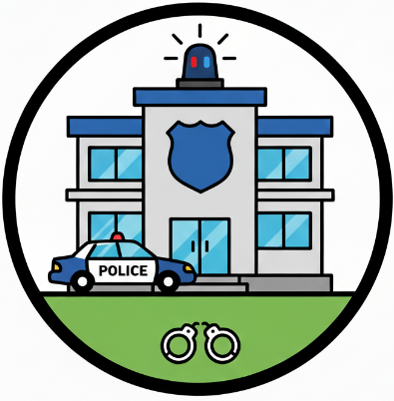

Використані джерела:

Англійська мова: підруч. для 2 класу закл. загальн. середн. Освіти (з аудіосупруводом) / Г. К. Мітчелл, М. Малкогіанні. 2-ге вид., доповн. – К.: видавництво «Лінгвіст», 2024.
Англійська мова: підруч. для 3 класу закл. загальн. середн. Освіти (з аудіосупруводом) / Г. К. Мітчелл, М. Малкогіанні. 2-ге вид., доповн. – К.: видавництво «Лінгвіст», 2024.
Малюнки згенеровані за допомогою штучного інтелекту.

