"I Have… Who Has?" Game
Animals
This card game is a fun way for children to learn and practice vocabulary and reading skills.
Instructions
Print out a set of cards, each with an answer and a question.
Hand each child a card.
If there are extra cards, it is fine to let a couple of players have one more card, or the teacher can hold the extras.
The child with the starter card says, “I have the first card. Who has...?” and everyone listens, checking to see if they have the next card. The child with the correct answer says, “I have...!” and then asks the “Who has...” question that is on their card.
The game continues until all the cards are read.

I have  the first  card | I have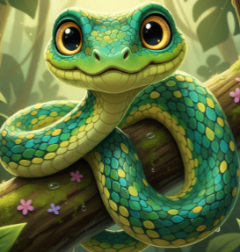 | I have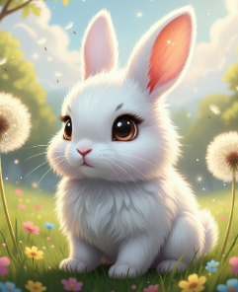
Who has  snake? | Who has  rabbit? | Who has  cat?
I have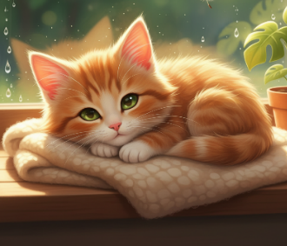 | I have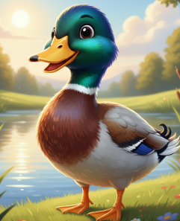 | I have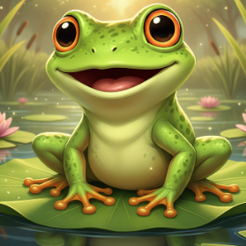
Who has  duck? | Who has  frog? | Who has  dog?
I have  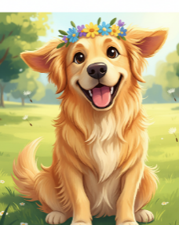 | I have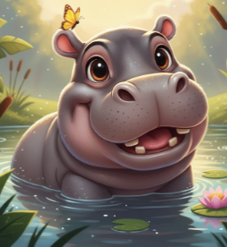 | I have  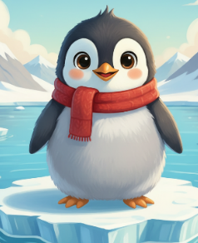
Who has  hippo? | Who has  penguin? | Who has  lizard?
I have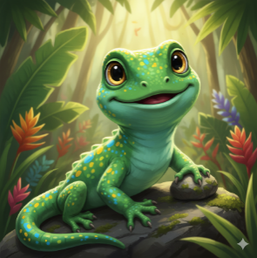 | I have | I have  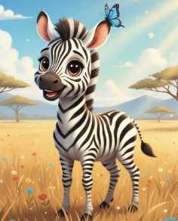
Who has  bear? | Who has  zebra? | Who has  elephant?
I have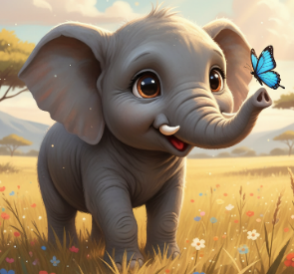 | I have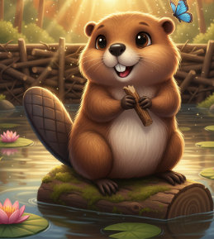 | I have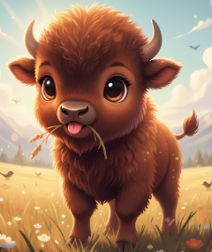
Who has  beaver? | Who has  bison? | Who has  monkey?
I have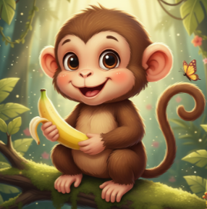 | I have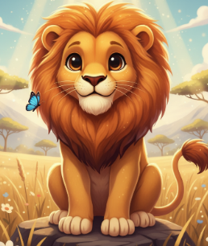 | I have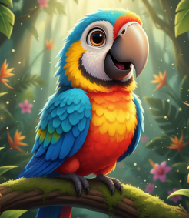
Who has  lion? | Who has  parrot? | Who has  crocodile?
I have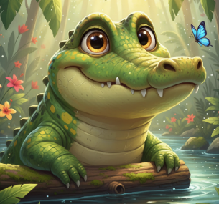 | I have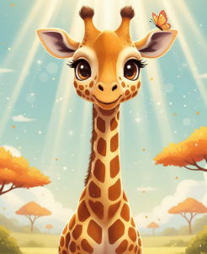 | I have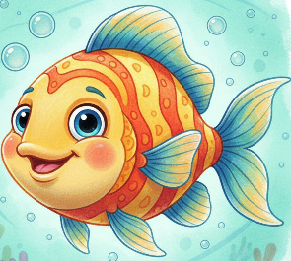
Who has  giraffe? | Who has  fish? | The end

Використані джерела:
Англійська мова: підруч. для 2 класу закл. загальн. середн. Освіти (з аудіосупруводом) / Г. К. Мітчелл, М. Малкогіанні. 2-ге вид., доповн. – К.: видавництво «Лінгвіст», 2024.
Малюнки згенеровані за допомогою штучного інтелекту.

