

What’s the weather like today?
Is it sunny? Can we play?
Is it rainy? Do we run?
Or stay inside and have some fun?
Clouds are floating, sky is grey,
Looks like windy is the day.
Snow is falling, white and bright,
Cold and chilly, what a sight!
No matter what the weather brings,
We can smile and dance and sing!

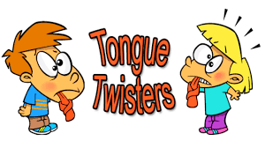
Windy weather, winter weather, when will winter wind be better?

Sunny skies surprise some sleepy students.

Rainy roads are really risky.

Snow falls silently, softly, swiftly.

Clouds come, clouds go, catching colors as they glow.

