КЗ ЛОР "Бродівській педагогічний коледж імені Маркіяна Шашкевича"

Волошина О. С.

Методична розробка заняття
з англійської мови за професійним спрямуванням

«Роль дорослого в житті дитини»

для студентів 4 курсу спеціальності
5.01010101 «Дошкільна освіта»

Броди, 2016 р.
Анотація

В методичній розробці заняття з англійської мови за професійним спрямуванням для студентів спеціальності «Дошкільна освіта» розкривається методика опрацювання теми «Роль дорослого в житті дитини».
Методична розробка містить навчальні матеріали, необхідні для проведення заняття по зазначеній темі з використанням сучасних форм, методів та засобів навчання: інтерактивних методів, ІКТ, елементів проектного методу, мультимедійних презентацій та відеоматеріалів.
Методична розробка відповідає вимогам до сучасного заняття, має практичне значення і може бути використана викладачами англійської мови в процесі роботи над формуванням у студентів мовленнєвої компетенції на заняттях англійської мови за професійним спрямуванням.

Theme. Adults in a Child’s Life.
Objectives:
- to activate and enlarge the vocabulary on the topic;
- to practice in expressing personal opinion clearly;
- to develop listening and reading skills;
- to foster cognitive and creative abilities, logical thinking, language intuition;
- to widen knowledge about adults-child relationship;
- to promote the formation of professional competence and responsible attitude to the teaching career;
- to encourage students to study English.
Aids: LCD projector, laptop, interactive whiteboard, PowerPoint presentations, worksheets, video files.
Resources: Англійська мова (за професійним спрямуванням) в педагогічних навчальних закладах І-ІІ рівня акредитації: Методичні рекомендації для студентів IV курсу спеціальності "Дошкільна освіта"/ укл. Волошина О.С. - Броди, 2014. – 56 с.; Longman Active Study Dictionary. – Pearson Education, 2000. – 796 p.
http://www.ldoceonline.com
https://www.youtube.com/watch?v=Z9UQldMGgdA
https://www.youtube.com/watch?v=K72dRv5ejIc&t=10s
http://www.insideout.net/blog/elessons/video-lesson-3-childhood
Procedure
I. Preliminaries of the lesson.
1. Greeting.
2. Presentation of the theme and the objectives.
The theme of our lesson is “Adults in a child’s life”. We are going to speak about children, adults and their relationships. We’ll discuss the importance of adults in a child’s life.
3. Warm up.
To start with, read some statements and say what they are about.
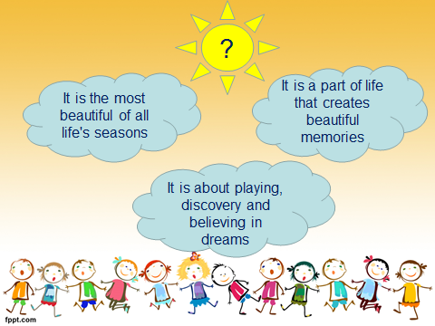

How can you define childhood?
II. Main part.
1. Vocabulary practice. Q & A activity.
Childhood is the most beautiful and memorable time of our life.
Do you remember your childhood? Answer the questions to know how well you remember it.
- Did you have a happy childhood?
- What did you like to do when you were a child?
- How old were you when you learned to ride a bicycle?
- Who was your favorite preschool teacher? Why?
- What was your favorite game?
- Do you remember anything about your personality when a child?
- What did you enjoy doing with your friends?
- What were some embarrassing situations when you were a child?
- What did you like about kindergarten?
- What didn't you like about kindergarten?
- When you were a child, what did you want to grow up to be?
- Can you remember specific things from your childhood clearly?
- How old were you at the time of your first memories?
- What was your favorite toy when you were a child?
- What was your worst punishment as a child?
- Who took care of you when you were little?
- Were you afraid of anything? What?
2. Reading activity. Group work.
Work in two groups. Read the texts and do the tasks.
Text A
Ryan:
My life is very different than it used to be. When I was growing up, I lived in San Diego in California, in America where it was hot and sunny every day even including Christmas. Now I live in London where it’s rainy and cold almost every single day.
My best friend was a boy named John Curtis. We used to play every day.
I didn’t do many naughty things when I was a kid. However, one day me and John climbed to the top of a very tall tree. We couldn’t climb back down, so the fire brigade was called and they brought us down. Both of us were grounded by our parents.
When I was going to the kindergarten, there was one teacher I particularly liked and her name was Mrs Date. She was just a really nice and funny woman. But there was one teacher all children disliked and her name was Mrs Wolken. She really was a monster. She could make any child cry within about three seconds.
My favourite game when I was growing up was a game called kickball and kickball is just like American baseball except it’s played with a bigger ball and you actually kick it.
My greatest wish was to be professional skateboarder, so I worked really hard, I skateboarded a lot and by the time I was twelve I achieved my goal and I became a professional skateboarder.
grounded - someone, especially a child, who is grounded is kept indoors as a punishment.
1. Write ‘’R” for Ryan
… used to live in America.
… used to play in the park at the weekends.
… used to enjoy playing spies.
… didn’t do many naughty things.
… was a very obedient child.
… once had to be rescued from a tree.
… didn’t want to go to the kindergarten because of the cold and strict teacher.
… particularly liked the teacher because she was just a really nice and funny woman.
… liked to play kickball.
… used to like dressing-up.
… was a professional skateboarder.
… used to want to be a pilot.
2. Use the rest of the statements to describe Emily’s childhood.
Text B
Emily:
I lived in London. There was a park near our house that my brother and I used to come and play in at the weekends. I remember it always being sunny, but today it’s quite grey.
I had a best friend Claire Gibson. We used to play together all the time. When we were about six we used to play spies. We liked to play dressing-up. My favourite was dressing up as a teacher, a doctor or a princess then we would play in an imaginary world.
I was a very obedient child and never did anything naughty, except those days when I didn't want to go the nursery school because of Miss Storey. I didn’t like her because she was quite cold, strict and frightening and she was constantly telling me off for giggling.
There was a particular teacher I liked. Miss Berkman was a kind and friendly woman.
I always wanted to be either a teacher or a pilot. A teacher because of Miss Berkman, my favourite teacher, and a pilot because I thought it’d be really exciting.
giggle - to laugh quickly, quietly, and in a high voice, because something is funny.
spy - someone whose job is to find out secret information about another country, organization, or group
Write ‘’E” for Emily
… used to live in America.
… used to play in the park at the weekends.
… used to enjoy playing spies.
… didn’t do many naughty things.
… was a very obedient child.
… once had to be rescued from a tree.
… didn’t want to go to the kindergarten because of the cold and strict teacher.
… particularly liked the teacher because she was just a really nice and funny woman.
… liked to play kickball.
… used to like dressing-up.
… was a professional skateboarder.
… used to want to be a pilot.
2. Use the rest of the statements to describe Ryan’s childhood.

You have chosen some of the statements. Others refer to another person. Use them to tell about Ryan’s or Emily’s childhood.
3. Grammar practice.
Speaking about our childhood we often use the structure used to for something that happened regularly in the past but no longer happens.
Find the sentences with used to in your text. Read them.
Look at the board. Complete the sentences with used to or didn’t use to.

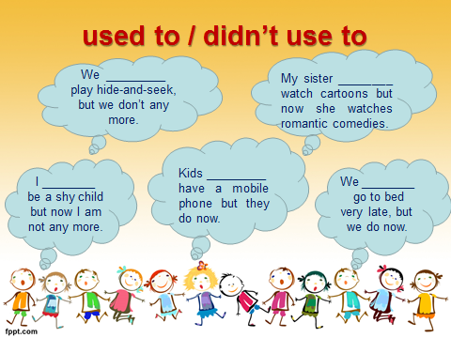

Give your own examples of things that happened regularly in the past but no longer happens.
4. Watching and discussion the video clip (Edison’s mother).
During our childhood we are influenced by many people. Some of them are especially influential. Who are the most important people in a child’s life?
You’ll watch the video about the person who has changed the child’s life.

Before watching, read the words and match them to their definition.

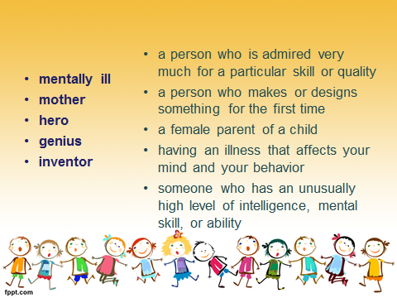

These words are from the video. How do you think what this video is about?

Read and correct the wrong statements.
- Thomas brought a letter from school for his mother.
- His mother was happy reading the letter.
- His mother read aloud that Thomas was a mentally ill boy and couldn’t go to school.
- Several years later Thomas found that letter. It said that he was a genius and his mother should teach him at home.
- Thomas wrote in his diary: “Thomas Alva Edison was a mentally ill child, that by a hero mother, became the genius of the century”.

Words have the great power. And you should remember this every time when you want to say that children are not able to do something, or someone finds them not skillful enough! We should take care of our children, support them in any situation.
5. Students’ project work (presentations).
You have prepared reports about the most influential people in your life - your mother, your grandmother, your preschool teacher (Appendiсes 1-3).
6. Listening and writing activity. Pair work.
There are good teachers, there are bad teachers and then there is the worst teacher...ever.
Watch and say why she is the worst teacher ever (Video “Worst Teacher Ever”).

Work in pairs and write some tips for a preschool teacher.

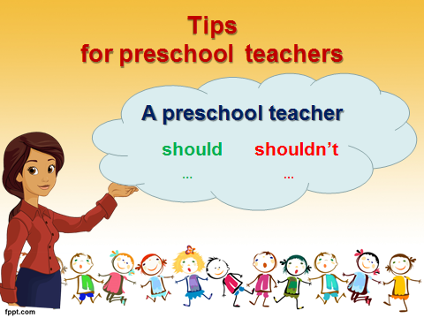
7. Creative work.
The outstanding educator V. Sukhomlynskyi said "I give my heart to children”
What do you give to children?
Write just one word on the heart and stick it on the poster.

KINDNESS
LOVE
CARE

III. Summing up.
To sum up our lesson I’d like you to read and remember the following quote:

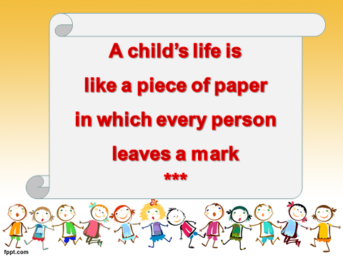

I wish you to leave only good marks in children’s lives.

Appendix 1
Presentation “My Mother”

Slide 1. There is no influence so powerful as that of the mother.
I have had many people influence my life, but the most influential person was my mom. So I would like to tell you about my dear mum.

Slide 2. A good mother is irreplaceable.
From the day I was born she has been taking care of me. When I was tiny and helpless she gave me everything I needed.

Slide 3. Mothers hold their child’s hands for a moment and their heart for a lifetime.
She raised me with her love, affection and mentorship.
Slide 4. A mother’s love for her child is like nothing else in the world.

She devoted all her energy and time to me. We played, sang and had great fun together.

Slide 5. A mother is a child’s first teacher.
She explained me what is good and what is bad and how to differ one from another.

Slide 6. A good mother is worth hundreds of teachers.
She taught me about the world, people and values. She helped me on my education and devoted her life to my upbringing.

Slide 7. Mother’s love is unlimited and never fades
Despite my numerous mistakes and disobedience she loved me, and she helped me to cope with difficult situations.

Slide 8. A mother understands what a child does not say.
My mother understood me in the way no other person would, and she always found proper words to comfort me.

Slide 9. Behind every good kid is a great mum.

She brightly illustrated me what is a real friend, and how to form good and reliable relationships with others.

Slide 10. We are what our mothers made us.
To conclude, I should say that I am a lucky person because I have my loving mum.
I wouldn't be the person I am today without her.

Appendix 2
Presentation “My Grandma”
Slide 1. A grandma is like an angel, who takes you under her wing.
Without a shadow of a doubt, my grandma is the most influential person in my life.
Slide 2. A grandma is a babysitter who watches the kids instead of the television.
In my early childhood she was more than just my grandma. She was my nanny, my mentor, my friend.
Slide 3. Grandmas fill the world with love.
She was very kind, friendly and caring. She loved me so much.
Slide 4. There is no place like home … except Grandma’s.
I enjoyed my grandma’s company, her funny stories and tasty pies.
Slide 5. Grandmas make every day special.
Every day, spent with my grandma, was an adventure.
Slide 6. A grandma always has time for you, even if the rest of the world is busy.
She inspired me to do my best and work my hardest in all I did.
Slide 7. A grandma always gives you the cherry on top.
She never let me down and can brighten my day with her smile.
Slide 8. Grandmas make the world … a little softer , a little kinder, a little warmer.
She taught me how to do the right things and not to lose hope.
Slide 9. A grandma never runs out of hugs and cookies
Whether I succeed or not, she always gave me a big hug and told that everything would be alright.
Slide 10. Grandmas hold our tiny hands for just a little while, but our hearts forever.
My grandma gave me the courage to be the person I am today. She is my role model. I could definitely say I am a granny's girl!
Appendix 3
Presentation “My Preschool Teacher”
Slide 1. Teachers plant seeds of knowledge.
The most influential person in my childhood was my preschool teacher … . She was the first to teach me things which would be necessary in my future life.
Slide 2. A teacher takes a hand, opens a mind and touches a heart.
She was very creative, energetic and sensitive to our needs. She was kind and friendly as well as strict and fair.
Slide 3. A good teacher is an awakener.

She sparked our children's interest, fed our curiosity and encouraged us to be independent.
Slide 4. The best teachers are artists.
She cultivated our love for art and music, developed our creative skills and talents.
Slide 5. Teachers who love teaching teach children to love learning.
She told us fairy tales, taught to count and recognize letters, developed our vocabulary and prepared us to school.
Slide 6. A good teacher makes learning fun.
She played, sang, jumped and ran with us. We always enjoyed ourselves together.
Slide 7. The best teachers teach from heart, not from the book.

She loved us and she was happy with our advancement. She was our friend, guide and educator.
Slide 8. To be a teacher is the greatest work of art.
She inspired us to be active, enthusiastic and be willing to learn throughout the life.
Slide 9. The influence of a good teacher can never be erased.
I greatly admired my preschool teacher , so I have decided to follow in her footsteps and become a preschool teacher too.
Slide 10. A teacher creates the future.
To sum up, I’d like to say that I would not be the person I am today without my preschool teacher.

