How Electricity is Generated
The main aims of the lesson:
- To introduce target language and practise new functional vocabulary
- To enrich students’ vocabulary on the given theme
- To improve students’ ability to talk about the topic of electricity by introducing
lexical set
- Developing listening skills
- To develop students’ ability to identify the main ideas in a reading text
- To develop pupils’ abilities in listening, speaking, writing, reading skills,
communicative competence and grammar.

T: Today we are going to understand the main principles of electricity generation which is the process of generating electric power from sources of primary energy. For electric utilities in the electric power industry, it is the first stage in the delivery of electricity to end users, the other stages being transmission, distribution, energy storage and recovery.
Also, we will learn how electricity is created and the process it goes through to power our homes.
- Lead-in
Discuss
1. Are you interested in subjects like science and technology? Why/Why not?
2. In your opinion, what is the most important invention in the area of
electricity ever made? What makes you think so?
3. How have modern electrical devices helped to improve our life?

- Quiz.
T: Electricity is all around us. Whether it is our bedroom lamp, our favourite gaming system, or the fridge that holds all of our favourite snacks, electricity powers them all. Electricity takes different forms: coal, water, solar, wind, nuclear, hydro and solar.
But have you ever wondered what exactly electricity is made of or how it manages to get to your house? So…

Read the following questions and try to choose the correct answer
(A,B or C)

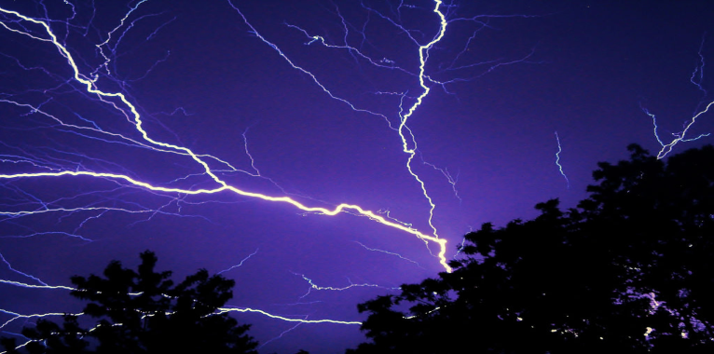

1. Electricity consists of a charge, which is the buildup of charged ___________ .
a) electrons
b) atoms
c) nucleus
2. ________ is an area that neutralizes that charge by removing excess charge.
a) ground
b) water
c) air

Static Vs. Current
There are two types of electricity, static and current.
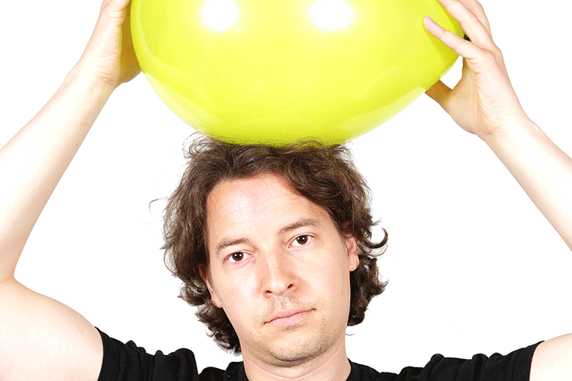
3. Static electricity is a buildup of electrons that creates an imbalance and sudden discharge. This is the type of electrical charge that lightning is, and that you get when you rub your ________ against a balloon.
a) eyes
b) nose
c) hair
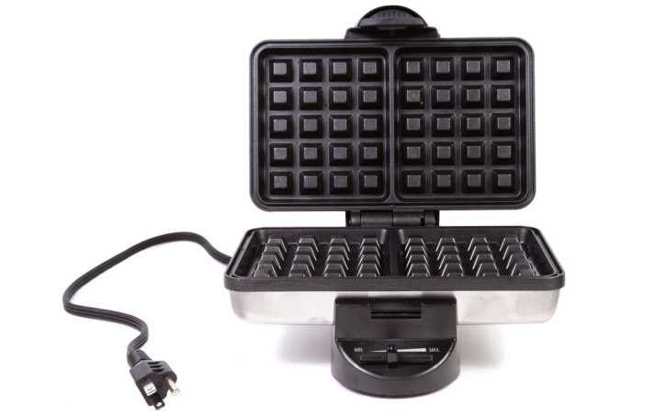

4. _________________ is a constant flow of electrons between a source and ground. This is the type of electricity that power electrical devices. Most importantly, it enables you to make waffles.
a) current electricity
b) alternative electricity

Conductors Vs. Insulators
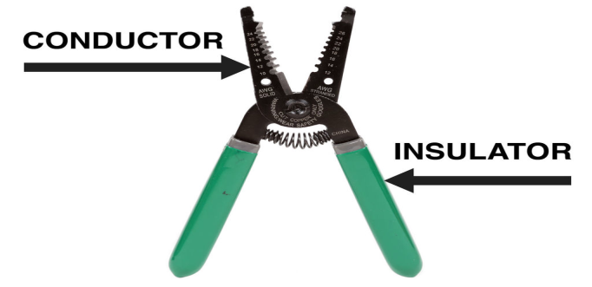
5. To put it simply, an electrical conductor allows the flow of electricity through it. Typically electrical conductors are _______.
a) glass
b) metal
c) plastic
6. An insulator prevents the flow of electricity through it. Typically insulators are materials like ________________.
a) rubber, wood and metal
b) rubber, wood and plastic
c) rubber, wood and ceramics
AC / DC
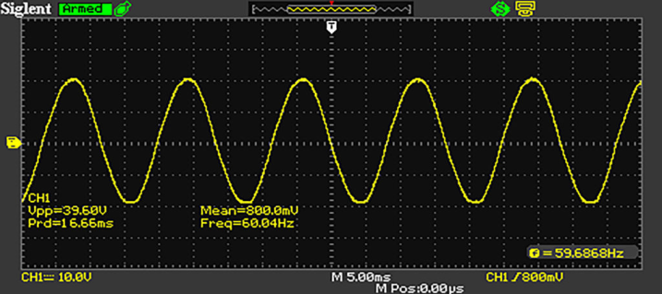
7. There is alternating current or AC. It is called alternating current because the electrical signal alternates above and below the electrical ground (0V). So, if you were to look at the picture of the 12V AC waveform above, you will notice that it alternates above and below the electrical ground (indicated by the little yellow marker on the left). This type of waveform consists of a current that is constantly fluctuating between a positive and a negative _________.

a) capacity
b) voltage
c) measure
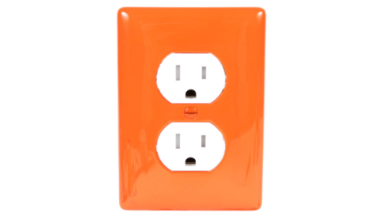

8. AC electricity is the type of _______ you will find coming out of your home wall socket. This is because AC electricity is easier to transmit over long distances than other types.

a) voltage
b) current
c) power

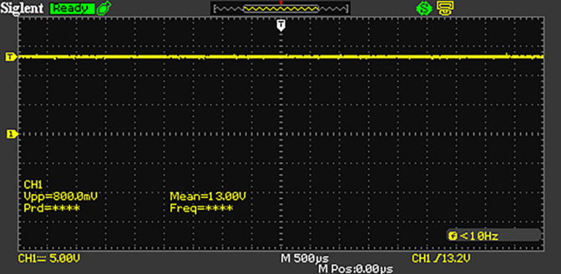
9. The other type of current is direct current or DC. It is so named because it travels in a direct line above ground. If you look at the waveform of a 12V DC voltage supply, you will notice that it's basically a solid yellow line running parallel above the ground. This type of electricity consists of a steady positive _______, set apart from a ground plane.

a) current
b) voltage
c) power

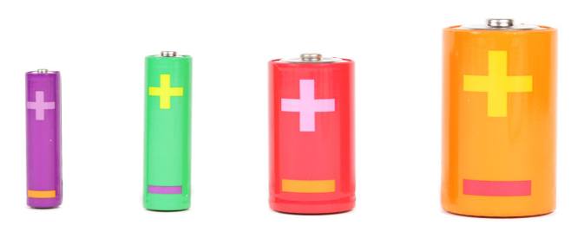
10. DC electricity is the type of current that comes from batteries, which are basically special ________ that store a predetermined amount of voltage.
a) containers
b) sockets

- Listening
Task 3.1. Pre-listening:
Match the words with their definitions
1) сurrent a) A machine for producing electricity
2) еlectricity b) Energy or force that can be used to do work
3) сircuit c) A substance able to attract iron, either natural or by
means of electric current
4) power d) A flow of electricity through something or along a wire
or cable
5) generator e) A supply of electric current for heating, lightning, etc
6) magnet f) An engine or motor whose driving-wheels turned by a
current of water, steam or gas
7) turbine g) A closed path for an electric current

Task 3.2. Listening gap fill:
Electricity 1)___________________ most important inventions ever. It is the thing that powers the Earth. 2)_____________________ no electricity, we’d be back in the dark ages. Few people stop and 3)_____________________ amazing electricity is. With the flick of a switch, 4)_____________________ almost anything. Think 5)_____________________ happen if there was no electricity. We’d have no TV, no computers, no traffic signals. It would be like 6)_____________________ living in caves. There are a few 7)_____________________ about electricity, of course. Number one, it’s dangerous. Thousands 8)___________________ each year from electrocuting themselves or in electrical fires. And number two, it 9)____________________ the environment. Most electricity comes from 10)____________________ and that creates greenhouse gases.
Task 3.3. Correct the spelling:
Electricity is one of the most important 1) nnnitieovs ever. It is the thing that 2)osewpr the Earth. If there was no electricity, we’d be back in the dark ages. Few people stop and think just how 3) anzimga electricity is. With the flick of a 4) sctiwh, you can power almost anything. Think about what would happen if there was no electricity. We’d have no TV, no computers, no 5) fctfair signals. It would be like going back to 6) ivlgni in caves. There are a few 7) gaenivte points about electricity, of course. Number one, it’s 8) urgensoda. Thousands of people die each year from electrocuting themselves or in electrical fires. And number two, it isn’t good for the environment. Most electricity comes from 9) rbugnin coal and that creates greenhouse 10) asesg.
- Reading and Video Watching Comprehension
Warm-Up Activities
Look at these images that represent the highlighted words in the following dialogue and try to understand how they are used in the generator.

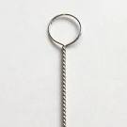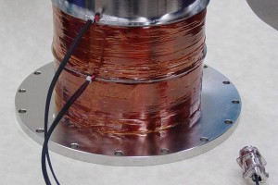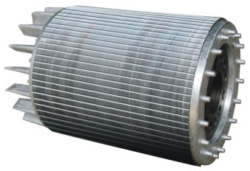
Loop of Wire Coils of Wire Laminated Punchings
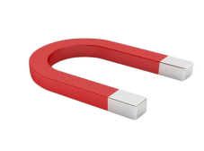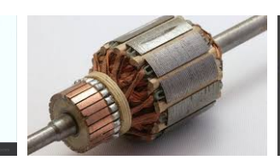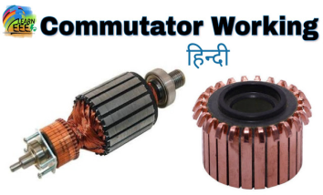
Horseshoe Magnet The Armature The Commutator

Task 4.1. Now watch the video and answer the questions.

1) What special electrical equipment can we see in this video?
2) What is the main idea of this video?
3) How do you understand this phenomenon of electricity that you have watched?

Electric Motors and Generators

Task 4.2. You are going to read the dialogue about generators and electric engines. Choose the correct items.

1) I should like to know where the current comes __________.
A) from B) of C) off

2) … in which way an electric motor __________.
A) works B) plays C) goes

3) It seems so simple to press a ___________.
A) mouse B) button C) computer

4) If you take a single ___________ and move it through the magnetic field between the poles a current will be generated in the wire.
A) loop of rope B) loop of thread C) loop of wire

5) The current reverses itself within one cycle and therefore it is called an _________ current.
A) direct B) alternating C) static

6) The rotating coils are fixed to the __________.
A) rope B) stick C) armature

7) We call this commutator type a dynamo, whereas the slip-ring type, producing alternating current, is called a ___________.
A) generator B) battery C) armature

Dialogue Electric Motors and Generators

"Hello,Max, couldn't you tell me something more about electricity? I should like to know where the current comes from and in which way an electric motor works. It seems so simple to press a button, but I ought to know what happens in a circuit, oughtn't I?"
"Certainly you ought. Never use a thing unless you know its functioning. Get a sheet of paper and a pencil, will you? We will begin with a simple horseshoe magnet. If you take a single loop of wire and move it through the magnetic field between the poles a current will be generated in the wire. This current is very weak and therefore the magnetic field has to be amplified by coils of wire connected to a source of direct current like a battery."
"We could do the same with the loop and use more turns or even a coil, couldn't we?"
"Of course, Jim, the more turns of wire the more lines of force are cut, and the faster the motion the stronger will be the current."
"But if there is only one coil the current cannot flow steadily, can it? It will drop to zero between the poles and change its direction each time it moves from north to south pole, won't it?"
"Quite right, the current reverses itself within one cycle and therefore it is called an alternating current. But you must not forget, in a generator there are many coils and the reversion is so rapid you can't detect it without an instru-
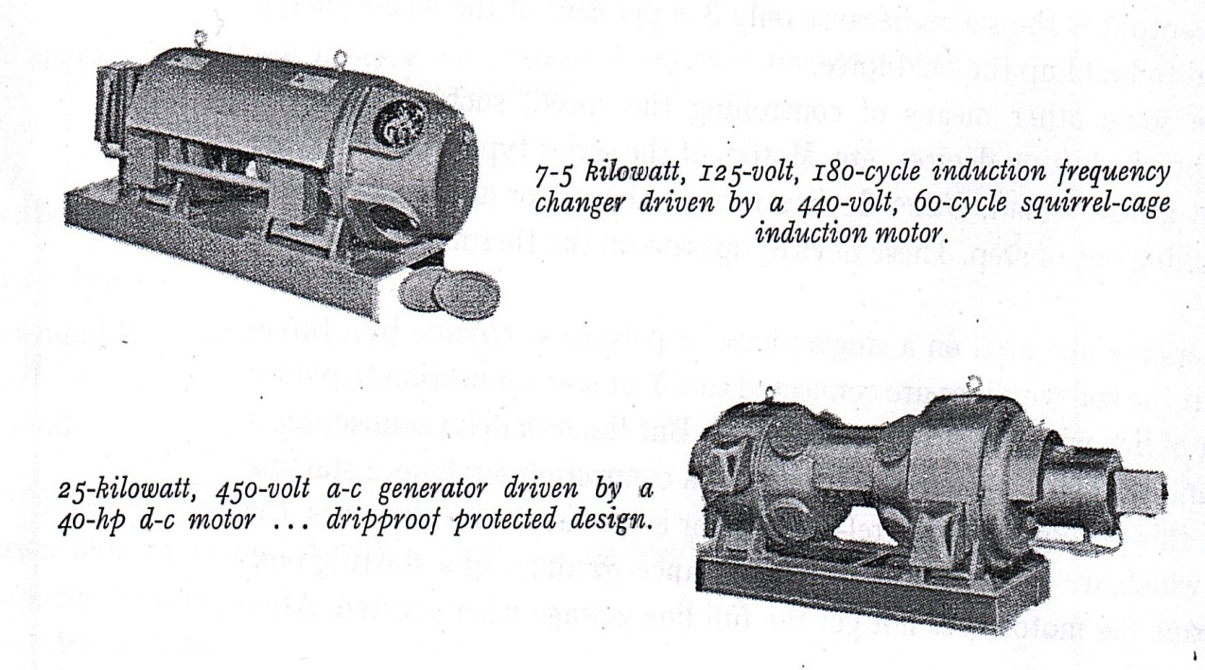
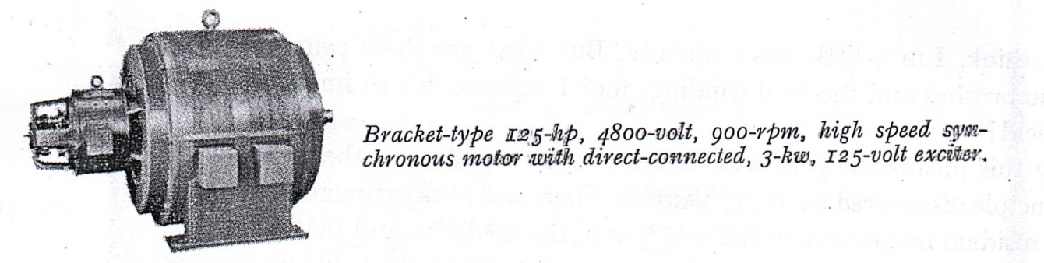
ment. The number of cycles per second is called the frequency. The rotating coils are fixed to the armature, which is constructed of laminated punchings, in the same way as the field core. You may also call them rotor and stator or secondary and primary."
"But till now you haven't mentioned how the current passes from the coils to the busbars. In my opinion this would be somewhat difficult with the coils running at high speed, so there must be a special form of connection, I should say."
"It's the commutator to which all the coils of the armature are connected, and two brushes pick up the current. You'll see on this drawing that each of these brushes picks up either positive or negative electricity and be this means the alternating current is changed into direct current. We call this commutator type a dynamo, whereas the slip-ring type, producing alternating current, is called a generator."
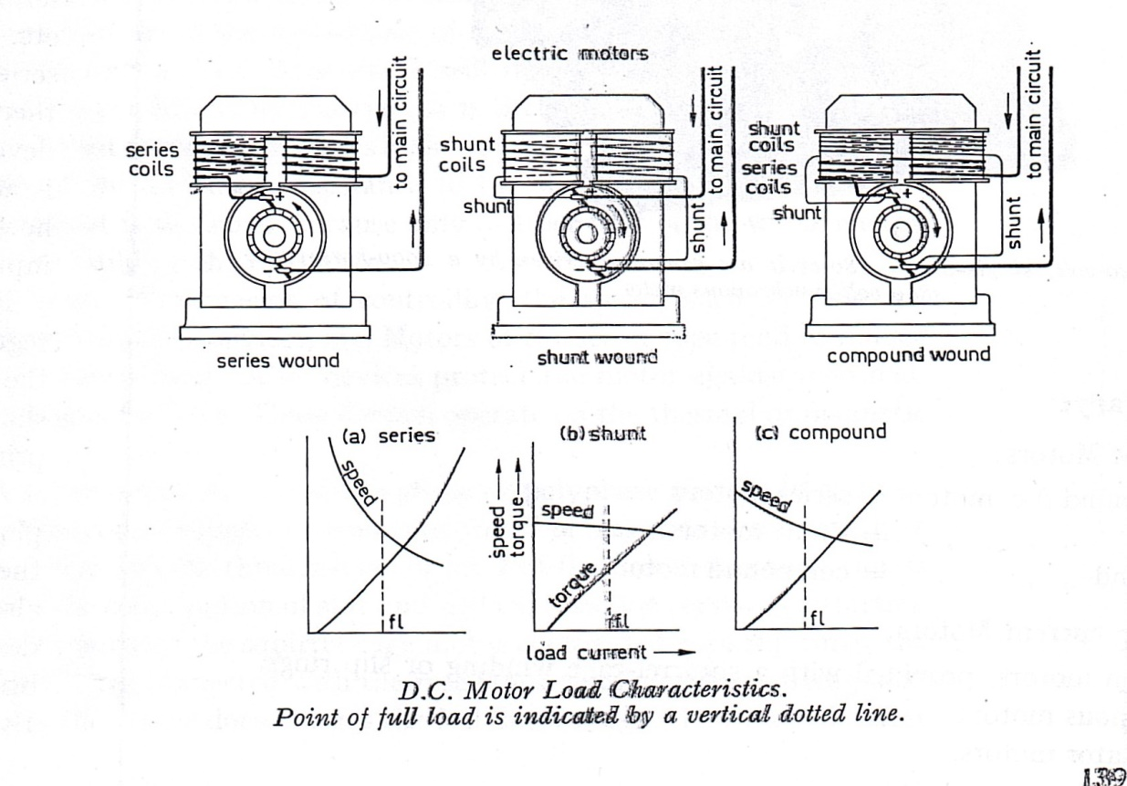
Task 4.3. Match these special terms (a,b,c,…) with their correct adjectives (1,2,3…)
1) electric a) loop of wire
2) single b) motor
3) magnetic c) current
4) direct d) field
5) rapid e) coils
6) rotating f) reversion
7) laminated g) speed
8) high h) punchings
9) special i) electricity
10) positive or negative j) form of connection

Task 4.4. Questions and Suggestions:
What is the difference between a d.c. generator and an a.c. generator?
Name some types of generators
Name the essential parts of a generator.

How Electricity is Generated
Task 4.5. Read this text as quickly as possible and fill in the blanks with appropriate words:
1. A generator is a device that converts mechanical energy into…  2. In 1831 … discovered that when a magnet is moved inside a coil  of wire, electrical current flows in the wire.  3. The generator has a series of insulated coils of wire that form…  4. Steam turbines, internal-combustion engines, gas combustion turbines, water turbines, and wind turbines are the most common methods… | 1. electrical energy  2. a stationary cylinder  3. to generate electricity  4. Faraday  5. Lomonosov

A generator is a device that converts mechanical energy into electrical energy. The process is based on the relationship between magnetism and electricity. In 1831, Faraday discovered that when a magnet is moved inside a coil of wire, electrical current flows in the wire.

A typical generator at a power plant uses an electromagnet—a magnet produced by electricity—not a traditional magnet. The generator has a series of insulated coils of wire that form a stationary cylinder. This cylinder surrounds a rotary electromagnetic shaft. When the electromagnetic shaft rotates, it induces a small electric current in each section of the wire coil. Each section of the wire becomes a small, separate electric conductor. The small currents of individual sections are added together to form one large current. This current is the electric power that is transmitted from the power company to the consumer.
An electric utility power station uses either a turbine, engine, water wheel, or other similar machine to drive an electric generator or a device that converts mechanical or chemical energy to generate electricity. Steam turbines, internal-combustion engines, gas combustion turbines, water turbines, and wind turbines are the most common methods to generate electricity. Most power plants are about 35 percent efficient. That means that for every 100 units of energy that go into a plant, only 35 units are converted to usable electrical energy.

Task 4.6. Answer the following questions:
1. What is a generator?
2. What is the main principle of its functioning?
3. How does a typical generator use at a power plant?
4. What is a principle of an electric utility power station?

Task 4.7. According to the main ideas of this text you had to prepare your own projects. Presentations of students.

V. English in Use. Present Past Future Simple Passive.

Task 5.1. Fill in the gaps with the correct form of Passive.
1) The process _____ based on the relationship between magnetism and electricity.
2) The number of cycles per second _____ called the frequency.
3) This equipment _______ set up last year.
4) I think, this electrical device ________ bought tomorrow.

VI. The Cool Down.
Task 6.1. Closure activities game. Team work.

You are going to play a special game with the day's vocabulary. Match electrical terms ( green cards ) with their definitions ( red cards ).

1) A meter – a) the instrument which measures the electrical
power in watts.
2) An ammeter – b) measures the current in amperes (named after
Andre Marie Ampere, a French scientist).
3) A voltmeter – c) measures the voltage and the potential
difference in volts (named after A. Volta).

4) The current – d) like the metals, copper, silver, aluminum.
5) Good conductors – e) the movement of electric charges (electrons)
through a conductor.
6) Nonconductors – f) the unit by which resistance is measured.
7) The Ohm – g) glass, wood, paper.
8) The ohmmeter – h) the instrument which measures the resistance.
9) A wattmeter – i) any instrument which measures electrical values is
called a meter.

At the end of our lesson I would like to make sure that everyone in this class leaves with more clarity and less confusion about the topics covered in our lesson. So, what information do you find the most important?
What key points from the lesson did you understand the best?
Do you need more practice or information?
Can you predict where you are going?

Thanks for sharing. I appreciate your time and hard work.

Home Task
How Electricity is Generated(2)
Nuclear power is a method in which steam is produced by heating water through a process called nuclear fission. In a nuclear power plant, a reactor contains a core of nuclear fuel, primarily enriched uranium. When atoms of uranium fuel are hit by neutrons they fission (split), releasing heat and more neutrons. Under controlled conditions, these other neutrons can strike more uranium atoms, splitting more atoms, and so on. Thereby, continuous fission can take place, forming a chain reaction releasing heat. The heat is used to turn water into steam, that, in turn, spins a turbine that generates electricity. Nuclear power was used to generate 19.4% of all the country's electricity in 2019.

Hydropower, the source for 5.8% of U.S. electricity generation in 2019, is a process in which flowing water is used to spin a turbine connected to a generator. There are two basic types of hydroelectric systems that produce electricity. In the first system, flowing water accumulates in reservoirs created by the use of dams. The water falls through a pipe called a penstock and applies pressure against the turbine blades to drive the generator to produce electricity. In the second system, called run-of-river, the force of the river current (rather than falling water) applies pressure to the turbine blades to produce electricity.
Geothermal power comes from heat energy buried beneath the surface of the earth. In some areas of the country, enough heat rises close to the surface of the earth to heat underground water into steam, which can be tapped for use at steam-turbine plants. This energy source generated less than 1% of the electricity in the country in 2019.
Solar power is derived from the energy of the sun. However, the sun's energy is not available full-time and it is widely scattered. The processes used to produce electricity using the sun's energy have historically been more expensive than using conventional fossil fuels. Photovoltaic conversion generates electric power directly from the light of the sun in a photovoltaic (solar) cell. Solar-thermal electric generators use the radiant energy from the sun to produce steam to drive turbines. In 2019, less than 3% of the nation's electricity was based on solar power.
Wind power is derived from the conversion of the energy contained in wind into electricity. Wind power, less than 4% of the nation's electricity in 2019, is a rapidly growing source of electricity. A wind turbine is similar to a typical wind mill.
а) Fill in the blanks with appropriate words:
1. Nuclear power is a method in which steam is produced by heating water through a process called…  2. Hydropower, the source for 5.8% of U.S. electricity generation in 2019, is a process in which flowing water is used…  3. Geothermal power comes from heat energy buried beneath…  4. Solar power is derived from…  5. . A wind turbine is similar to a typical… | 1. the energy of the sun  2. wind mill  3. nuclear fission  4. the surface of the earth  5. to spin a turbine

b) Answer the following questions:
1. Which is a method of nuclear power?
2. What is a part of nuclear power of all the country’s electricity?
3. How many basic types of hydroelectric systems are there?
4. Where does geothermal power come from?
5. What are advantages of solar and wind power using?

Answers
II.Quiz
1) a. 2) a. 3) c. 4) a. 5) b. 6) b. 7) b. 8) b. 9) a. 10) a.
III. Listening
Ex 3.1.
1) d. 2) e. 3) g. 4) b. 5) a. 6) c. 7) f.
Ex 3.2
1) one of the 2) If there was 3) think just how 4) you can power 5) about what would 6) going back to 7) negative points 8) of people die 9) isn’t good for 10) burning coal
Ex 3.3
1) invention 2) powers 3) amazing 4) switch 5) traffic 6) living 7) negative 8)dangerous 9) burning 10) gases

IV. Reading
Ex 4.2
1) a. 2) a. 3) b. 4) c. 5) b. 6) c. 7) a.
Ex 4.3
1) b. 2) a. 3) d. 4) c. 5) f. 6) e. 7) h. 8) g. 9) j. 10) i.
Ex 4.4
1) a. 2) d. 3) b. 4) c.

VI. Team Work
Ex 6.1
1) i. 2) b. 3) c. 4) e. 5) d. 6) g. 7) f. 8) h. 9) a.

ЛIТЕРАТУРА
1. Kurt Heber. Englisch fur Techniker: Verlag H.Stam G.m.b.H. - Koln, 1955. pp.138-143.
2. Парахина А.В. Пособие по переводу технических текстов с английского языка на русский. Москва, 1982.
3. Jenny Dooley – Virginia Evans: Grammarway. Express Publishing. 2006
4. Raymond Murphy “English grammar in use”, Cambridge University Press.
5. Sissine, Fred. Energy Efficiency: Budget, Oil Conservation, and Electricity Conservation Issues. CRS Order Code IB10020. Washington, DC: Congressional Research Service, 2006.
6. Yergin, Daniel. "Ensuring Energy Security.": Foreign Affairs, vol. 85, 2006. pp. 69-82.

Iнтернет ресурси:
Sissine, Fred. Renewable Energy: Tax Credit, Budget, and Electricity Production Issues. CRS Order Code IB10041. Washington, DC: Congressional Research Service, 25 May 2006. - http://fpc.state.gov/documents/organization/
Listening - https//listenaminute.com
Video - https//www.youtube.com.watch

