НОВОГРОДІВСЬКА ЗОШ І-ІІІ СТУПЕНІВ №9

УРОКИ

АНГЛІЙСЬКОЇ МОВИ

8 КЛАС

(за новою програмою)

ТЕМА «Я і мої друзі»

Суханова Л.В.

2016

Урок №4

Тема: «Друзі, дружба»

Мета:вдосконалювати здобуті навички і знання усного мовлення, розширювати кругозір учнів; активізувати лексичний матеріал по даній темі; формувати творче та критичне мислення учнів; виховувати доброзичливе ставлення до оточуючих.

Обладнання: прислів’я та приказки про дружбу; тематичні картки; таблиця антонімів; тексти; конверти із буквами; картки із індивідуальними завданнями; музичний центр

Хід уроку

І Підготовка до сприйняття іншомовного мовлення.

- Бесіда із черговим.
- Повідомлення теми та мети уроку.

Friends are people who share,

Friends are people who care.

They try to understand,

They give a helping hand.
Friends, friendship… People sing songs about it, devote poems, stories. A lot has been already written and said. Do you know how the dictionary puts it?
Friendship is a feeling and behaviour that exits between friends but what these feelings are, what this behaviour is, you have to decide for yourself.
3 .Перевірка домашнього завдання.

Your hometask was to find some expressions about friendship. What is friendship? What does friendship mean to you? Isn't it the most important thing in our life?
Учень 1. The person can't live in isolation. It's very important for a human being to have a friend with whom you can be sincere and frank. It's great to think there is someone to turn to for help and advice, someone who will stand by you in any situation and who will tell you the bitter truth If it is necessary.
Учень 2. Friendship means a lot to me. I can't simply imagine my life without friends: they make my life happier and more interesting. With my friends I can find solution to many problems. Real friendship is a thing that we cherish.
Учень 3. I think- friendship is very important in our life. Modern life is very interesting, full of wonders, danger and great opportunities. If you don't have friends, you don't have support, you don't feel yourself comfortable.
4.Мовна розминка.
Вчитель. I quite agree with you that friendship is a very great thing. No wonder why people of all countries have so many proverbs about it. Try to say what proverbs and sayings come to your mind when you talk about friendship. Some of them are written here. Match them.

A friend in need ... | gotten as lost
A man is known ... | before he knows him
A man must eat a packet of salt with his friend.. | is to be one
A friend is not so soon ... | by the company he keeps
The only way to have a friend … | is a friend indeed
Відповіді:
A friend in need is a friend indeed.
A man is known by the company he keeps.
A man must eat a packet of salt with his friend before he knows him.
A friend is not so soon gotten as lost.
The only way to have a friend is to be one
.
Вчитель. I would like you to explain the meanings of some of them.
Учень. "The only way to have a friend is to be one" means that if you don't want to be alone, you don't have to be selfish. Just think a little of others and they will think of you. People usually say "You are treated in the way you treat other people.
Учень. The English proverb "A man must eat a packet of salt with his friend before he knows him" doesn't mean that you need to eat much salt to become friends but you must know your friend very well. If you help, respect, trust each other and do useful and important things together, your friendship will last a very long time.
Учень. I consider the phrase "A man is known by the company he keeps" up to date. In my opinion friends usually respect each other for these or those traits of character. They try to be similar and resemble each other in everything. They have much in common. There is another saying. "Tell me who your friend is and I'll tell you who you are".
Учень. "A friend in need is a friend indeed" means that the best friend is the one who helps you when you are really in need of help. You know your real friends when you are in a difficult situation. It's very difficult to go through the hardships of our life without our friend's support. Only they can give us a piece of good advice, can analyze our actions If friendship never ends it makes your life full.
Учень. The proverb "'A friend is not so soon gotten as lost" means that it takes a long time to become really friendly with somebody. But there are many ways of quickly loosing a friend if you do something wrong. So you must try to keep a close friendship.
Учитель. Now look at the cards and say what friendship means

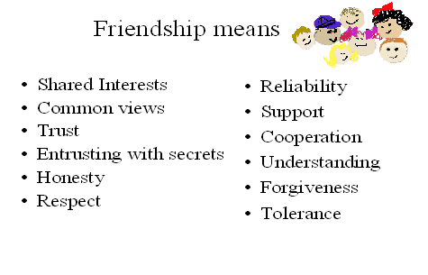
ІІІ Основна частина уроку.
- Творча робота
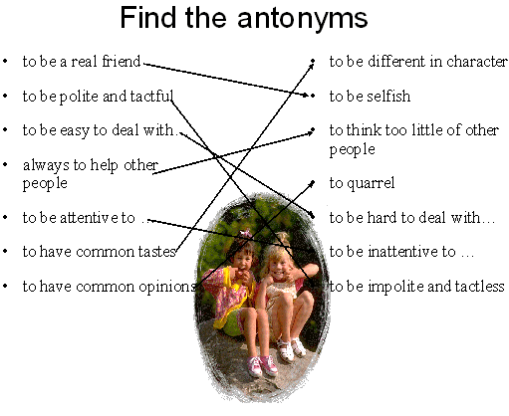
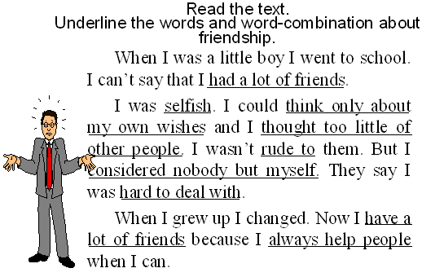
Now you must change this story. Use antonyms and make up a story about a real friend.
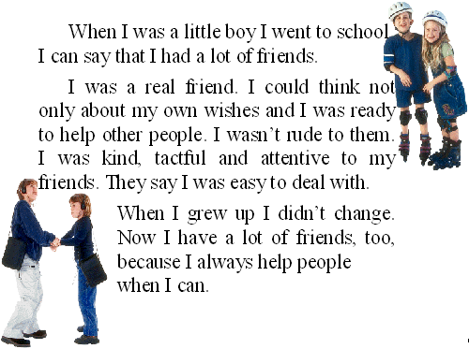
- Гра “People qualities”
Учні отримують конверти із буквами, з яких потрібно скласти та записати слова про риси характеру людини.
Is it good or bad habit?
If you want to have a real friend you must be…
If you are………………. you will never have a real friend.
- Письмо
You think you know your friend well. Let’s check it.
Use the example and write down about your friend.
All about Nelly
School: Nelly goes to school in Kyiv. She is very clever.
Dream: Nelly really wants to be a teacher.
Hobbies: Nelly likes to sing and dance.
Secret: Nelly can’t swim. Don’t tell anyone!

Your best friend
Name:
Dream:
Hobbies:
Secret:

ІІІ Підсумки уроку.

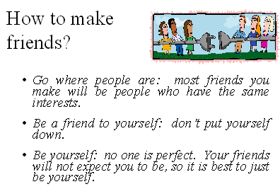

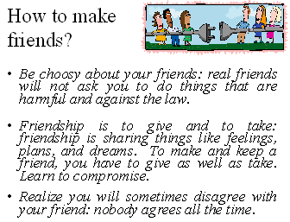
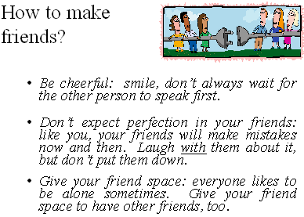
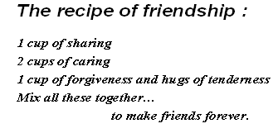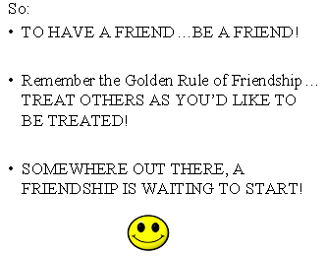
Thank you for your work on the lesson. Our work was very produtctive.Don’t forget that friendship is a very great thing, but at the same time it is also a delicate thing. Try to keep it carefully. I’ll give you the following marks...
Now let’s sing a song about friendship
Friendship our is the best for us
Friendship our is important too,
We are friendly children,
We are happy children
All together we are always
You and you and you.
We have many friends
Real honest friends
We help everybody who is near us
We love kindness very
We love friendship very
All together we are always
You and you and you.
Friends are elder people
Friends are boys and girls
Friends are pupils, teachers
Friend is our world.
We are friendly children
We are happy children
All together we are always
You and you and you.
The lesson is over.

Урок №5
Тема: Friendship is a very great thing
Мета: практикувати учнів у активному використанні вивченого лексичного і граматичного матеріалу в різних видах комунікальної діяльності; розвивати навички усного мовлення; виховувати почуття дружби і товариських відносин з однолітками, цінувати поняття «дружба».
Обладнання: картки, плакати з прислів’ями.

Procedure
- Warm up:
- greetings
- guess the word: 6, 15, 9, 5, 14, 4 (key: friend)
- complete the card:
Friend’s name: ___________________
Friend’s home town: ________________
Friend’s telephone number: _______________________
Friend’s age: _______________
Choise of present for friend: ______________

- Main part of the lesson:

- T: What English proverbs about friends do you remember?
Key:
- A friend in need is a friend indeed.
- A good friend is as the sun in winter.
- A friend is easier lost the found.

2) T: Everybody has a friend. What is friendship? What do you think about it?
P1: To my mind friendship between two people grows when they do something useful together.
P2: When they have the same interests.
P3: When they understand each other well.
T: Do you agree with your classmates?
P4: Yes, I agree. We cannot live without friends. The real friends are always ready to help each other.

T: Do you remember the English proverb “A friend in need is a friend indeed”? Do you agree that real friendship is possible only when people respect and trust each other?
So you can see that friendship between two people I a very great thing. What do you think about the saying of English people “A good friend is as the Sun in winter”? A good proverb, isn’t it?
P1: A real friend makes your life happier and more interesting.
P2: A real friend is dear to you and you want your friendship to last for a very long time.
T: Well, and what does this proverb mean “A friend is easier lost than found”?
P3: I’m sure, it means that it is difficult to find a good friend.
P4: You may lose a friend quickly if you do something wrong.

- Answer the questions:

- Have you got a real friend?
- What do you do together?
- Do you like to read books about friendship? Why?

- T: An English proverb says: “A friend to everybody is a friend to nobody”.
Some people think that they have a lot of friends, but they may not have a friend who is always ready to help. What can you d for your friend? (Key: help him with ….)

- Situations:
a) You came to your friend’s place and asked him/her:
“Can you come out with me for a walk?”
“ I must finish this work first”, answered your friend.
Discuss which is more important for your friend – to do what he must do or what he likes to do with his friends.
(Key: does first what he has to do; understand what has to be done).
b) Say if you have a friend whom you never want to lose. Explain why he/she is so dear to you.
- Work in groups.
1 group.
Answer the question:
- In what way can you learn to kno your real friend.
2 group.
Answer the question:
- What will you do if a boy/girl comes up to you and says: “I’d like you to be friends with me”.
3 group.
Give some reasons of friendship.
(Key: to help each other in a difficult situation; to understand each other; may have the same interests; to respect and trust each other; to talk and go out together).

- Summing – up:
Answer the questions:
- What English proverbs about friendship do you remember?
- One of your classmates said. “That’s not very friendly of you”. What do you think about the boy/girl to whom this was said?
- Is your friend dear to you? Why?
- One of your classmates is absent. The reason is illness. How will you help him?

- Home work.

Урок 6
Тема. “Meet My Friend”.
Підтема: Перевірка домашнього читання. “A Friend in need is a friend indeed”.
Цілі уроку:
Практична: Проконтролювати домашнє читання. Вчити висловлювати іноземною мовою своє ставлення до прочитаного. Удосконалювати навички читання та усного мовлення, використовуючи зорові опори.
Освітня: формувати уявлення учнів про таке граматичне явище як форми дієслів, неправильні дієслова.
Розвиваюча: Розвивати мислення та увагу.
Виховна: Виховувати бажання бути справжнім другом.
Хід уроку.
I. Введення в урок.
1. Вводна бесіда за темою уроку.
Teacher:
1. There is a proverb: “A Friend in need is a friend indeed”. Do you know its Ukrainian equivalent? Have you got friends? Are they real friends? Why do you think so? Do you think you are good friends?
2. Повідомлення теми та завдань уроку.
Teacher: We’ll talk about friendship and real friends at our today’s lesson. We’ll read the text about real friends- Brother Rabbit and Brother Goat. We’ll also
- discuss the problems covered in the text;
- practice new vocabulary in speech;
- revise grammar-regular and irregular verbs and their forms;
- do exercises on the text.
II. Основна частина уроку.
- Check up. Перевірка домашнього завдання.
We’ll start our lesson with a song “A friend is the best thing to have.”
You had to learn the words of this song at home.
Робота з підручником. Exercise 4, page 35.
Учні слухають касету-аудіододаток до підручника та співають пісню.
A friend is the best thing to have,
A friend is the great thing to be,
If you have a great friend
From beginning to end,
You can be as lucky as me!
A friend is the best thing to know,
A friend will always be there,
If you have a great friend
From beginning to end,
You’ll always have someone who cares!
- Reading.
- Pre-reading tasks. Writing. Активізація лексичного та граматичного матеріалу. Роздавальні картки.

Put in the missing letters.
c…r…ot, fi…ld, w…r… cl…th…s, b…st …ish…s, sh…rt
n…t…, m…st he…p, sho…l… b….

Keys: carrot, field, warm clothes, best wishes, short note, must help, should be.
Put in the missing forms of the irregular verbs.
1 | …. | put | put
2 | run | … | run
3 | see | saw | ….
4 | …. | brought | brought
5 | eat | … | eaten
6 | take | … | taken
7 | …. | thought | …..
8 | …. | wrote | written

2) While-reading tasks.
Роздавальний матеріал-картки. Учні читають текст та виконують завдання.
Who did it?
1 |  | picked up four carrots
2 |  | saw the carrots on the table
3 |  | wanted to give other two carrots to his friend
4 |  | must help his friend
5 |  | wrote a short note
6 |  | were good friends

Listening. Учні слухають аудіо додаток до підручнику та читають текст, вправа 1, ст. 36.
Read the text below. For parts (1-3) choose the correct answer (A,B,C or D). There is one choice you do not need to use.
1. _______ Brother Rabbit didn’t have any food to eat. He put on his warm clothes and ran to the field. There he saw four carrots. He picked up the carrots and brought them home. He ate only two of them. He wanted to give the other two to Brother Goat.
2. ________Brother Rabbit took the two carrots to Brother Goat’s house. Brother Goat was not at home. Brother Rabbit put the carrots on the table and went away. Brother Goat saw the carrots on the table and thought; “Oh, what good friend I have. I should be a good friend too. It’s winter now. Brother Rabbit has not got any food to eat. I must help him.” So he ate one carrot, took the other and ran to Brother Rabbit’s house.
3._________ Brother Goat came into Brother Rabbit’s house put the carrot on the table and wrote a short note: “Dear Brother Rabbit! This carrot is for you. With best wishes from Brother Goat. ”
A. Brother Goat wrote a short note to his friend.
B. Brother Rabbit picked up four carrots.
C. Brother Rabbit ate four carrots.
D. Brother Goat thought he had a good friend.
( Читання тексту супроводжується презентацією Microsoft Power Point. Презентація анімована і є сюрпризним моментом для учнів.)
3) Post-reading tasks.
A). For questions (1-6) choose the correct answer (A, B or C)
- Did Brother Rabbit have any food to eat?
- Yes, he does.
- No, he didn’t. +
- No, he hasn’t.
- Where did he run?
- To the garden.
- To the forest.
- To the field. +
- How many carrots did he find?
- 5
- 4 +
- 3
- Did Brother Rabbit eat all the carrots?
- Yes, he did.
- No, he doesn’t.
- No, he didn’t. +
- Was it winter or summer?
- It was winter. +
- It was summer.
- It was neither winter nor summer.
- Who ate only one carrot?
- Brother Wolf.
- Brother Rabbit.
- Brother Goat. +
B) Writing. Exercise 2, page 37. Answer the questions. (Усно чи письмово - вирішує вчитель. Можливо, це було домашнє завдання.)
- Did Brother Rabbit have any food to eat?
- Why was Brother Rabbit happy to have four carrots?
- What did Brother Goat think when he saw the carrots?
- Was it kind of Brother Rabbit to help his friend?
- Why is the story called “A friend in need is a friend indeed?
C) Speaking.
Exercise 3, page 37. Look at the pictures and tell the story. Учні переказують текст, спираючись на зорові опори. (Ілюстрації проектуються на екран).
Problem questions.
- Was Brother Rabbit a true friend?
- Was Brother Goat a real friend?
Why do you think so?
D) Summarizing.
Teacher: You’ve read the text “A friend in need is a friend indeed” and you’ve made some exercises on the text. Now I’d like to know what you’ve learnt about the main characters of the story.
Quiz. Underline the right variant.
Brother Rabbit had/ didn’t have any food to eat. He put on his new /warm clothes and ran to the field. There he saw four/three carrots. He picked up the apples/carrots and brought them home. He ate only three/ two of them. He wanted to give the other two to Brother Fox/ Brother Goat.
Brother Rabbit took the two carrots to the field/to Brother Goat’s house. Brother Goat was/was not at home. Brother Rabbit put the carrots on the table/on the floor and went away. Brother Goat saw the carrots/potatoes on the table and thought; “Oh, what good friend I have. I should be a good friend too. It’s winter/autumn now. Brother Rabbit has not got any food/fruit to eat. I must help him/her.” So he ate/took one carrot, took the other and ran/jumped to Brother Rabbit’s house.
Brother Goat came into Brother Rabbit’s house/bedroom, put the carrot on the table/bed and wrote a short/long note: “Dear Brother Rabbit! This carrot/tomato is for you. With best wishes from Brother Goat/Brother Wolf. ”
III. Заключна частина уроку.
- Домашнє завдання. At home you are to prepare a project about your best friend. In your projects you should:
- express your opinion about your best friend,
- explain why do you think he/she is a real friend,
- supply your projects with photos and pictures.
Write at least 80 (90, 100) words.

- Підведення підсумків уроку.
Did you like the story “A Friend in need is a friend indeed”? Which character of this story (or both) did you like most of all? Why? Do you think that they are really memorable? Would you like to have such friend?

Урок 7
Tема уроку: My family and my friends
Мета уроку: Вдосконалювати навички читання й усного мовлення, формувати навички вимови, вдосконалювати навички монологічного висловлювання,
виховувати уважність, інтерес до англійської мови.

Хід уроку
I Організаційна частина уроку
Привітання й повідомлення теми та мети уроку.
II Основна частина уроку
1. Уведення в іншомовне мовлення
- What do friends mean to you?
- What makes a friend the best friend?
- What makes you a good friend?
- Is it easy for you to make friends?
- Do you have any particularly close friends?
- Do you stay in touch with all of the friends you've made?
- Are friends more important than family? What do you think?
- Do you think you have a special understanding with your friends?
- At which stages of life is it easier to make friends?
2.Перевірка домашнього завдання.
- Підготувати розповідь про літні канікули
- Аудіювання. Прослухати текст та виконати завдання
FRIENDSHIP DAY
Friendship Day takes place on the first Sunday of August every year. It is one day of the year we can say thank you to our friends. The tradition began in the USA in 1935 and has slowly spread around the world. The U.S. Congress declared Friendship Day as a national celebration. It still has a way to go before it is as popular as Mother's Day and Father's Day. On Friendship Day people spend time with their friends and exchange presents. Some people send cards, write special songs or bake friendship cakes. One great way to celebrate is to make a poster or create an album about your friend or friends. Perhaps include Winnie-the-Pooh on it because the United Nations made Pooh the world's Ambassador of Friendship in 1997.
Friends are extremely important to us. They are often like members of our own family. In fact, many people spend more time with their friends than with their relatives. People also tell their friends more secrets. We start friendships almost from the time we can walk. Everyone has special childhood friends, and some of these become lifelong friends. We usually meet out best friends early on in our life. Best friends usually stay best friends forever. Nowadays the Internet has changed the way we make friends. Many people strike up friendships online. The Web is also useful to find long-lost friends. There are many sites to find old friends.
- Match the following phrases from the article.

Paragraph 1.
1) one day of the year we can | a) way to go
2) slowly spread | b) to make a poster
3) It still has a | c) say thank you
4) people spend time | d) Ambassador of Friendship
5) One great way to celebrate is | e) around the world
6) the UN made Pooh the world's | f) with their friends
Paragraph 2
1) Friends are extremely- | a) best friends forever
2) People also tell their friends | b) early on in our life
3) Everyone has special | c) more secrets
4) We usually meet our best friends | d) important to us
5) Best friend usually - | e) lost friends
6) find long- | f) childhood friends

- Тренування учнів у читанні
  - Введення нових слів New Vocabulary: c.8
  - Впр.1, с.7-8-прочитати лист та відгадати значення виділених слів
  - Впр.2, с.8-знайти слова з поданим значенням
-знайти втрачені слова
- Розвиток вмінь письма
  - Впр.3, с.8-9-виписати речення, в яких дівчина розповідає про важливих людей у її житті
  - Впр.4, с.9-пригадати правила написання листа
III Заключна частина уроку
- Домашнє завдання.
  - Впр.5, с.9-написати листа про себе другу по листуванню
  - Виконати тест
Do the quiz How honest are you?
1) You are spending the weekend at a friend's house. While you are doing the washing up, you accidentally crack what was clearly an expensive wine glass. Would you:
- hide the glass in the dustbin and hope that no one notice?
- explain what had happened and perhaps offer to buy a new one?
- put the glass in the cupboard and not mention it?
- say that someone else had broken it?
2) You are with a small group of people on holiday. Someone expresses
some strong political views on a subject, which you disagree with
violently. Would you:
- say that you thought they were right?
- tell them quite bluntly that you thought they were talking rubbish?
- suggest tactfully that there were other ways of looking at the question?
- try and change the subject?
3) You are a member of a team playing a tennis match. At an important
point in the game, your opponent hits the ball, which lands very near
the line, and he / she asks you if the ball was in. You saw clearly that
it was. Would you:
- play fair and say that the ball was in and give your opponent the point?
- cheat and say the ball was out and take the point yourself?
- say it would be best to play the point again?
- say you were not sure?
4) You and your boyfriend / girlfriend have been invited to a party,
but you know your partner doesn't really want to go. You want to go
because you know that someone you are very attracted to will be
there. Would you:
- try and discourage your partner from going with you?
- be open and tell your partner why you really want to go?
- not go to the party at all?
- leave your partner to decide by himself / herself whether or not to go with you?
5) You work in a dress shop and you get paid commission on the dresses
you sell. A woman is interested in a dress which does not suit her
and asks you what you think of it. Would you:
a) say it looks lovely but that you have seen something that might look even nicer?
- say only that you have seen another dress that might suit her more?
- tell her bluntly that it doesn't suit her?
- tell her that it looks very nice and is an excellent choice?
6) You have just found out that the boyfriend / girlfriend of a very
close friend of yours has been seeing someone else. Your friend, who
suspects something, asks if you know anything. Would you:
- beat about the bush and say that you weren't sure either way?
- be frank and tell them what you have heard?
- deny that you know anything?
- suggest that he / she should talk to their partner about it because it might be true?
7) You are selling your car because it has been very unreliable and has
been very difficult to start, especially in the mornings. Someone
from a town a long way away wants to buy it and has just asked you
if it is reliable when starting. Would you:
- say that you have never had any serious problems with it?
- say that you are selling it because it is so bad at starting?
- try and cheat them by saying that it was very good at starting?
- say that it has been giving a bit of trouble recently but that the problem can be fixed easily?
8) Some people you know but find a bit boring have invited you to din
ner at their house. Would you:
- say that you didn't want to go and why?
- accept and say that you were looking forward to it?
- say that you couldn't go because you were going to be busy?
- say you'd love to go, and then not turn up?
Key to the quiz How honest are you? in Lesson 2.

Ia2b4c3dl | 2 al b4 c3 d2 | 3a4blc3d2 | 4 al b4 c3 d2 | 5a2b3c4dl
6 a2 b4 cl d3 | 7 a2 b4 cl d3 | 8a4b2c3dl | 9alb2c4d3 | 10a2blc3d4
Score
10-16: You are not really the sort of person who would make a good friend. You lie, cheat and deceive people (including yourself) all the time. At times your dishonesty could almost be criminal. You had better learn to tell the truth, because you will never have any real friends if you carry on like this.
17-27: You don't tell the truth all the time, do you? You perhaps try to tell yourself that you lie to protect other people's feelings, but there is a little more to it than that. You are secretive and unreliable. Try and be a little more open with your friends and the people you love and don't try and avoid serious problems by lying.
28-35: You would be a good person to have as a friend. You can be trusted and don't delight in making people feel bad for no reason. You are the sort of person who can keep a promise and you don't run away from problems that need to be talked about. The only real lies you would tell are white lies as you are tactful and caring.
36-40 You must be very difficult to live with. You say exactly what you think. You like to think you are straight and honest, but you are often very blunt and rude, and hurt people's feelings for no reason. You are very open, and when someone asks you for an opinion, they know they will get the truth. But are you sure that the absolute truth is really what they always want to hear?

2. Підведення підсумків уроку

Література:

1. Навчальна програма для загальноосвітніх навчальних закладів і спеціалізованих шкіл з поглибленим вивченням іноземних мов "Іноземні мови. 5-9 класи" ВД "Освіта" (зі змінами 2015 року, наказ МОН №585 від 29.05.2015)
2. Підручник. Алла Несвіт. Англійська мова. 8 клас
3.http://www.schoollife.org.ua/
4. http://osvita.ua/school/lessons_summary/
5. http://kutsurubschool.at.ua/

