Тема. Книги в нашому житті
Мета: удосконалювати та перевірити знання учнів з теми, розвивати вміння вести монолог; поглибити знання учнів про життя та творчість англійських та американських письменників; розвивати мовну здогадку та мовленнєву реакцію, індивідуальні здібності учнів; розширити кругозір учнів, прищеплювати любов до читання різних жанрів літератури, фольклорних творів; виховувати учнів на прикладах життя і діяльності видатних письменників.
Спрямованість корекційно - розвивальної роботи: формувати вміння виявляти активність, допитливість, наполегливість в опануванні мови, лексичну та орфографічну пильність; формувати культурну толерантність.
Обладнання: портрети англійських та американських письменників, мультимедійна презентація, наочний матеріал (картки з висловами, ілюстрації до творів), роздатковий матеріал (картки для індивідуальної роботи).
Тип уроку: урок узагальнення вивченого матеріалу.
Хід уроку:
I. Організаційний момент. З'ясування емоційної готовності до уроку.
Teacher. Good afternoon, pupils and guests! I'm glad to see you. How are you? What emotions do you feel?
II. Актуалізація опорних знань учнів. Підготовка до сприйняття іншомовного матеріалу.
1.Фонетична розминка.
If you understand, say ""understand"". If you don't understand, say ""don't understand"". But if you understand and say ""don't understand"". how do I understand that you understand. Understand!?
2.Повторення ЛО по темі "Книги".
Adventure stories, autobiographies, detective stories, fairy tale, poem, novel, historical stories, horror stories, humorous stories, love stories, legends, myths, science fiction, travel stories, true stories.
3. Вправа "Доповни "діряві" речення".
Choose the types of stories from the box to complete the definitions.
Science fiction, autobiography, historical story, horror story, detective story.
1. An … is a story of a person’s life, written by that person.
2. A … is a book about crime.
3. A … story is about events in the future.
4. A … is about a period of fighting between countries or states.
5. A … is a book which makes people frightened.
4. Індивідуальна робота за картками
T: Find the best translation of the words. (Знайдіть правильний переклад видів книг).
1Love stories | b) книги про мандрівку
2Historical novel | c) детективні оповідання
3 Travel books | d) наукова фантастика
4 Detective stories | e) історичні романи
5 Science fiction | f) любовні історії
6 Novels of everyday life | g) романи про повсякденне життя
7 Psychological drama | h) пригодницькі оповідання
8 Adventure stories | a) психологічна драма

5. Інтерактивна вправа "Мозковий штурм".
What kinds of books do you prefer?
What do you like reading? назви творів
III. Мотивація пізнавальної діяльності учнів. Оголошення теми та завдань уроку.
Teacher. Look at the screen and now read the riddle and say what it is about.
I have many leaves,
But I am not a tree;
I’m something nice,
Come and read me.
The field is white,
Black is the seed,
And sower who sowed it
Was clever indeed.
I’m neither a rhyme nor a song,
I can be short or very long,
I can be funny or quite sad,
But to read me you’ll be glad.
Ps. The topic of the lesson is about books.
T. Yes, books in our life.
Today we are going to have a talk about books and people who write them. The main task of the lesson is to summarize the information you have learnt about books. We’ll practice the word that you have learnt in the previous lessons. We’ll sum up the materials about the greatest English and American writers and their brilliant works. You will revise some interesting facts from their life and creative work. I hope you will be active. Enjoy every minute of our lesson.
IV. Основна частина уроку
Teacher. First I’d like to begin our talking with the words written by Pablo Picasso, an Italian painter:
“Literature washes away from our souls the dust of everyday life.”
Translate it into Ukrainian all together.
1. Вправа "Фольклорна хвилинка" (індивідуальна диференційна робота за картками), запис в зошиті.
Teacher. What other saying about books have you learnt during this topic? Let’s recollect them. First of all, I'd like you to revise proverbs and sayings about books and reading. Have a look at the screen. Complete the sentences.
а) T: Match parts of the proverbs.(З'єднати частини прислів'я і пояснити їх).
Choose the author | but buy a new book
Don’t judge a | should be a few but good
A room without books | like book
Think much, say | is a body without soul
Like author | little, write less
Books like friends | as you choose friends
Wear old clothes | book by its cover

б) Вправа "Пазли". Скласти з поданих слів прислів'я.
The more you read, the more you know.
A good book is a source of wisdom.
в) Вправа "Розшифруй прислів'я"
Abooklikeagardencarriedinthepock (Chinese proverb)
2. Виступи учнів з міні - доповідями. (Випереджальне домашнє завдання).
Teacher. I suppose that you understand the importance of books in our life. But today we are going to speak about people, who write books, about their lives and work. So, listen to this well-known writer. Розповіді учнів.
Teacher. Look at the screen again and try to name these famous English and American writers.
Picture1. Robert Burns.
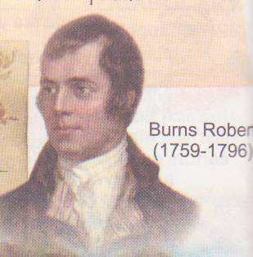
Picture2. Mark Twain.
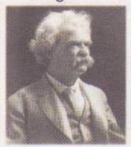
Picture3. Alan Milne.
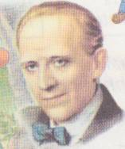
Picture4. William Shakespeare
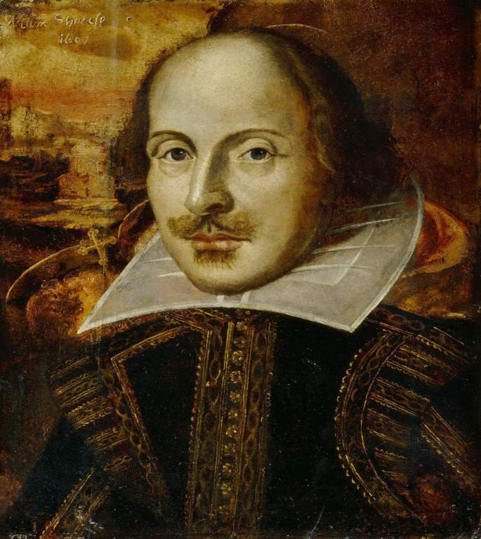
Picture5. Joanne Kathleen Rowling.
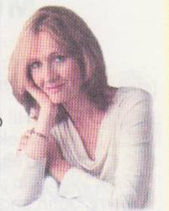
Picture6. Lewis Carrol
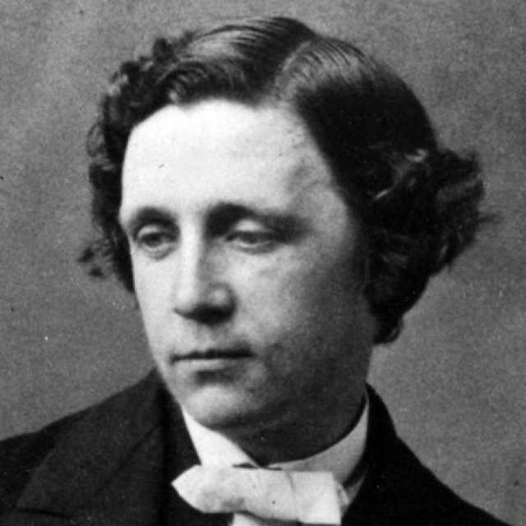
Picture7. Walter Scott
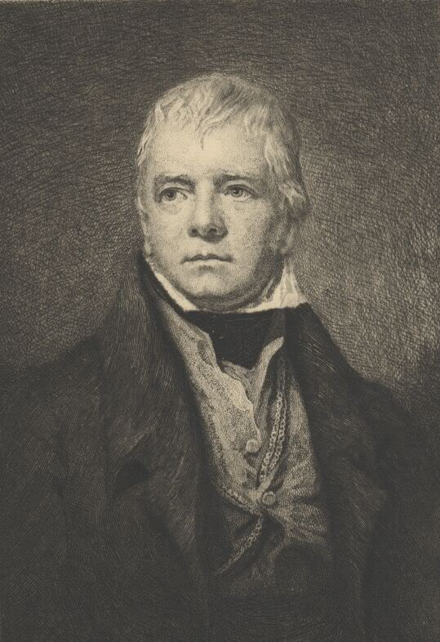
Picture8. Conan Doyle
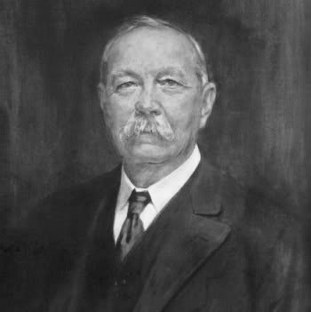
Picture9. John Tolkien
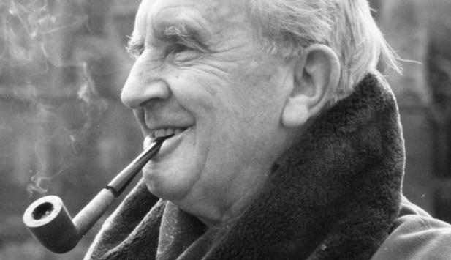
Фізкультхвилинка
3. Вправа "Встанови відповідність" (взаємоперевірка).
Teacher. Say who are the authors of the books.
1) Charlotte Bronte a) Ivanhoe
2) Daniel Defoe b) Winnie-the-Pooh
3) Rudyard Kipling c) The Last Leaf
4) Pamela Travers d) Mary Poppins
5) William Shakespeare e) Sherlock Holmes
6) Conan Doyle f) The Adventures of Tom Sawyer
7) Walter Scott g) Harry Potter
8) Lewis Carroll h) Robinson Crusoe
9) Mark Twain i) Jane Eyre
10) O.Henry j) Alice in Wonderland
11) Alan Milne k) Mowgli
12) J.Rowling l) Romeo and Juliet
Keys: 1 i; 2 h; 3 k 4d; 5 l; 6 e; 7 a; 8 j; 9 f; 10 c; 11 b; 12 g.
4. Вправа "Згадай книгу та героя"
Teacher. Look at these illustrations, please. Name the book and its author. Winnie-the-Pooh
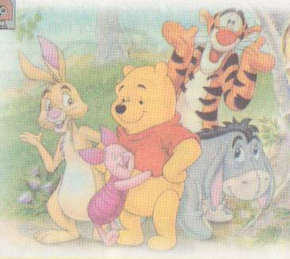

The Lord of the Rings
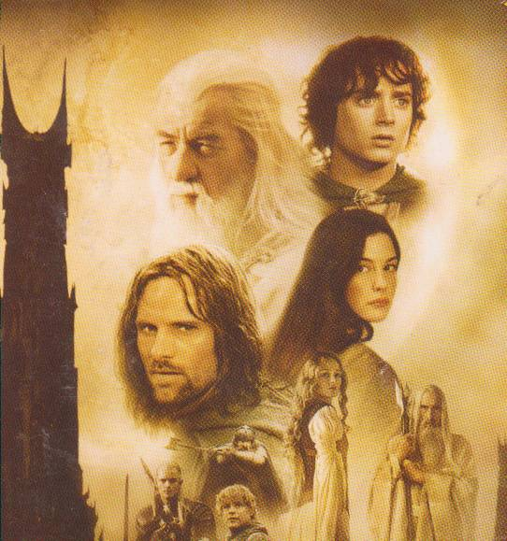
Harry Potter.
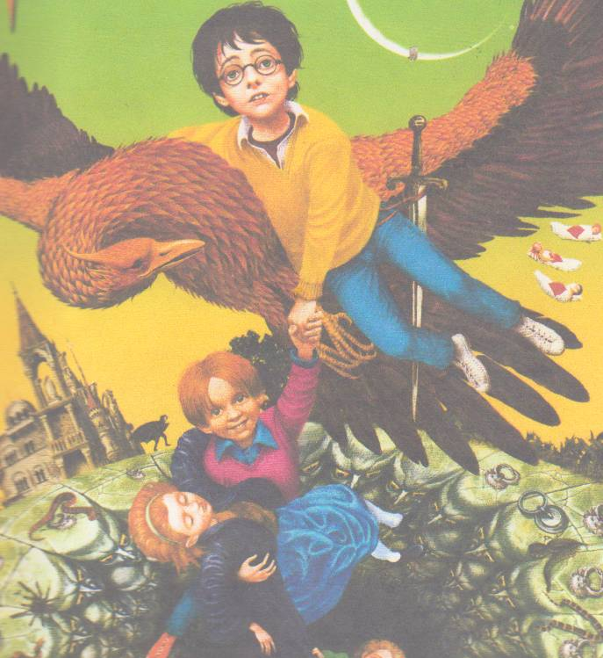
Mowgli
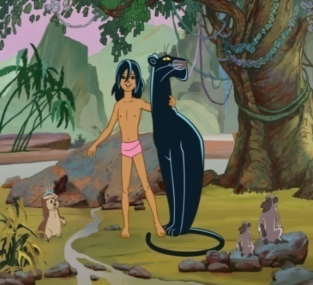
Mary Poppins
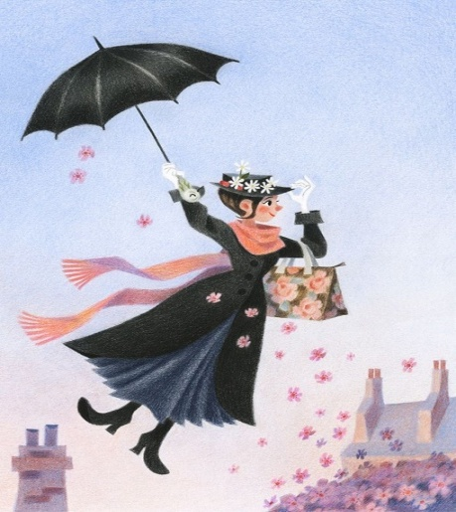
Robinson Crusoe
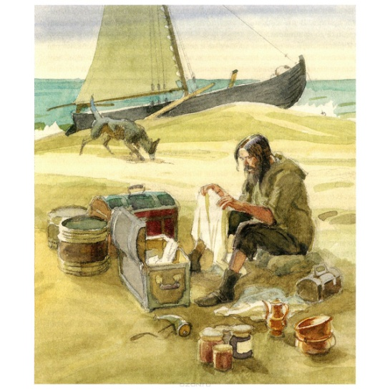
Tom Sawyer
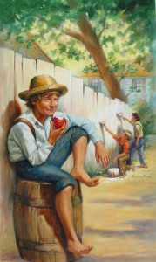
5. Вправа "Відгадай героя за описом"
Teacher. And now we are going to speak about children’s favourite characters. Guess and say what books they are from.
He is brave and strong, clever and honest, fond of nature, not afraid of wild animals, ready to save his animal friends.(Mowgli)
She is strict and kind, fond of children, clever and full of wonderful ideas, can do magic things, can make children happy.(Mary Poppins)
This boy is lazy and naughty, dirty and untidy, does not want go to school, wants to play all day long, likes to boast, silly but kind.(Pinocchio)
The girl is beautiful and clever, tidy and clean, kind and hard-working, ready to help other people. ( Cinderella)
This boy is lively and brave, naughty and lazy. He is a true friend . He is full of ideas and fond of adventures.(Tom Sawyer)
V. Заключна частина уроку.
1. HOMEWORK
Your hometask will be to write a composition “Books in my life”
Опорні картки для виконання домашнього завдання
Books play a very important role in our lives because…
- they teach us to live;
- they help us in self-education;
- they give us pleasant minutes;
- they help us to understand life;
- they teach us to respect other people;
- they help us in deciding problems of life;
- they develop our imagination;
- they broaden our outlook;
- they tell us about customs and traditions of different countries;
- they tell us how great and wonderful the world is;
- they open the door into the world of knowledge, realm of good and beauty.
2. SUMMARIZING.
Індивідуальна робота за картками
T: Put the words in right order to read the rules. (Поставте слова в правильній послідовності та утворіть речення). Say what librarian says to the young readers.
the readers rules for.
- begin hands your to before wash book you
- pages a or anything on pen not pencil do with write the a
- drawings not make in do the book
- it you do that friends not lose means books the lose your
- ears the do dog’s in make book not
- not tear pages the do
Вправа " Так " чи "Ні"
A lot of people enjoy reading
Little children enjoy reading novels
Men like love-stories
Teenagers like horror books
Women like fairy-tales
Books play a very important role in our life
Reading is not the perfect way to spend free time
Teacher. Today we have got a lot of information about books and now we have to sum up the results of the lesson. So, why do we need books? Do they teach us to be kind, clever, wise? I hope you understand that without books our life will be empty and boring. Read good books and enjoy them. Your marks are ...
Hope you’ve enjoyed our work, got a plenty of positive emotions and recollect much about life and creativity of really great English and American writers.
Good-bye.



