Class: 10
Topic: Visiting an art gallery.
Practical aim: to formulate listening comprehension skills.
Adjoining tasks: to contribute to the formulation of learners’ speaking and writing habits on the basis of the topic.
Cultural aim: to contribute to the development of the learners’ intellect, learners’ intellect, logical and abstract thinking.
Educational aim: to contribute to the development of the learner’s artistic tastes on the basis of the topic.
Equipment: hand-outs, a tape-recorder, pictures, a blackboard.
Lesson Structure
1) Warming-up activity
2) Phonetic drill
3) Checking homework
4) Talking about artists
5) Describing the pictures
6) Word listing
7) Listening and identifying pictures
8) Listening for details
9) Discussing
10) Group work
11) Dialogue listening for general information
12) Vocabulary work
13) Categorizing
14) Writing a dialogue
15) Summing up, setting a home task
16) Evaluation

Lesson Procedure
1) Look at the pictures and say which genre of painting you like most and why.
still life historical painting
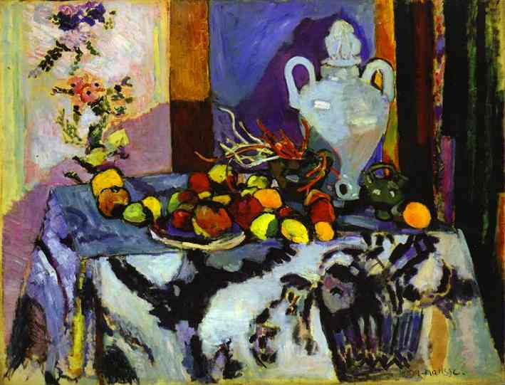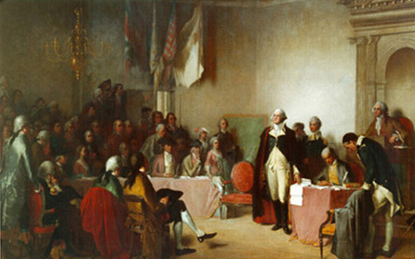
landscape seascape
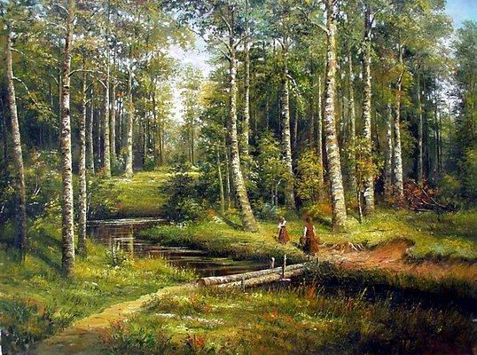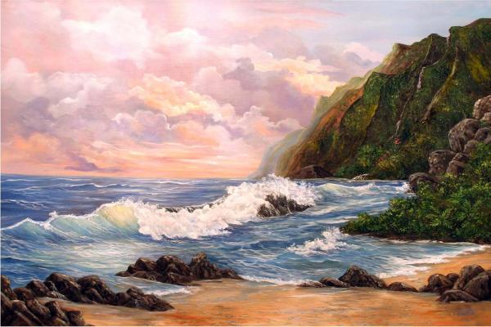
flower piece portrait
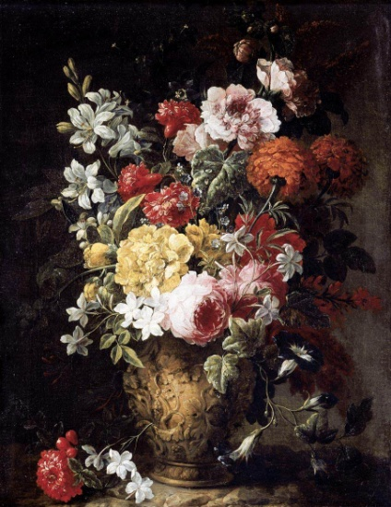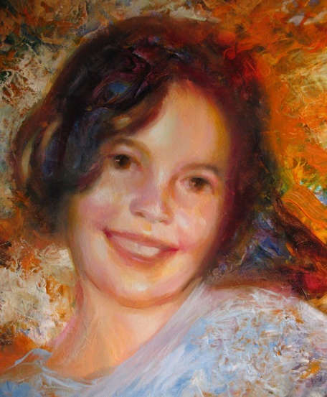
2) Read the poem and practise sentence stress.
Painting with words
Talk…Talk…
Subjects and perspective,
Views and light,
Canvas prepped and colours.
Looking deep…
Thinking…Analysing…
Finding the hidden colours,
Hidden views, hidden perspective,
Complements and contrast.
3) “Life is a great big canvas, and you should throw all the paint on it you can.”- Danny Kaye. Let’s see what “paints” you can “throw” at the part of the canvas responsible for your education and knowledge, by checking your homework. You had to make presentations or collages about modern art styles.
While listening to other groups’ presentation, write down two or three ideas of each style and at the end you’ll report what you have learnt and say which art style you like best.
Everyone did a great job. Now you know a lot about art styles. Today you are going to learn how to discuss works of art.
4) Look at the paintings. Do you know the artists? Do you know any other works by them?
1) 2)
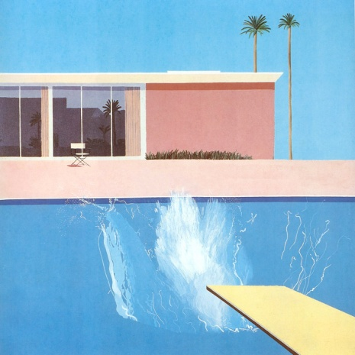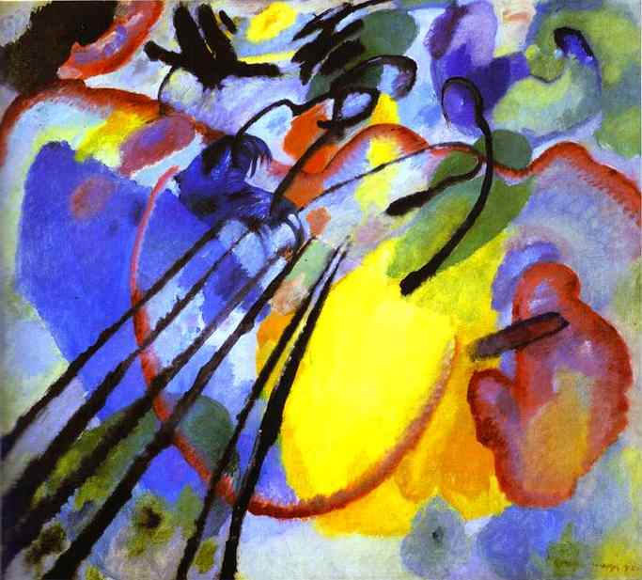
3)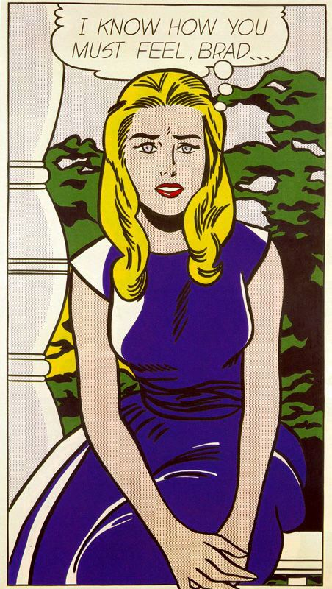 4) 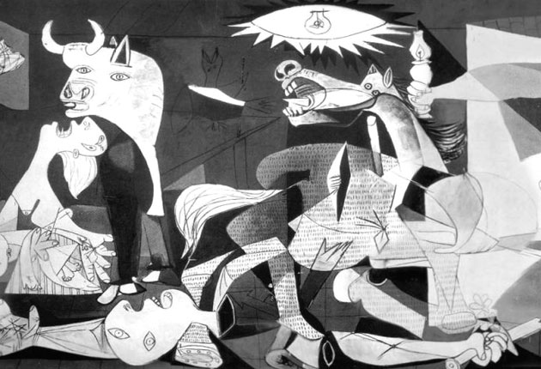
(These paintings are by David Hockney, Pablo Picasso, Roy Lichtenstein and Wassily Kandinsky. Their works are called 1) “A Bigger Splash” (David Hockney), 2) “Improvisation 28” (Wassily Kandinsky), 3) “I Know…Brad” (Roy Lichtenstein), 4) “Guernica” (Pablo Picasso).
David Hockney (born in 1937), an English painter and photographer, is famous for his satirical paintings and penetrating portraits. His style is naïve on purpose and he uses bright and flat acrylic colours. “A Bigger Splash” (1967) is one of his best known works.
Pablo Picasso (1881-1973), Spanish painter and sculptor, is considered by many people to be the most genial artist of the twentieth century. He was creative and prolific. He innovated styles and techniques and was the spinning wheel for many changes in twentieth century painting.
Roy Lichtenstein (1922) is a leading US painter of pop art. He pioneered the use of mass-media techniques in non- commercial art.
Wassily Kandinsky (1866-1944) was a Russian Expressionist painter. He painted the first purely abstract paintings in European art. His paintings are characterized by vivid colours and analogies to music.)
5) Use the Key Words to describe the paintings.
Example A: realistic, bright colours, clear straight lines.
Key Words:
Styles: abstract, cubist, pop, realistic
Subjects: landscape, portrait, war
Colours: bright, light/dark, soft
Shapes: geometric, round, strong
6) Work in pairs or groups, listing the words you know connected with “styles”, “shape” and “colours”. You have one and a half minute. Report to the class.
7) Listen and identify the paintings.
Tapescript
1. Well, I really like this picture- it’s easy to see what’s happening. I like the bright colours- of the girl’s blue dress and her blonde hair. I also like the round shapes in the picture. I think the topic is interesting too- the girl looks worried and she’s thinking about her boyfriend…
2. Personally, I think this one is good. It’s got very strong lines and you can almost feel the music. And the colours- they’re great- they’re really bright. I like abstract paintings because you have to use your own imagination to understand what the painter is trying to do.
3. This one’s my favourite. It shows the horrors of war really well- with the dark, dark colours and the terrible images. The lines and shapes are square and geometrical. They show violence and pain. Look at the horse and the mother with her dead child. It’s a very frightening painting.
Well, I think this one’s best. I really like the bright colours and the clear lines. I love the water in the swimming pool. It’s realistic but very simple at the same time.
8) Listen again. Why do the people like the paintings? Choose two of these reasons for each painting.
- bright colours
- dark colours
- round shapes
- square shapes
- clear/ strong lines
Example 1 a/c
9) Which of these paintings is your favourite? Why do you like it? Talk about these things:
- the style
- the subject
- the colours
- the shapes and lines
10) Work in four groups. Each group should listen carefully to one of the four speakers for any extra information they give about their choice of painting and then each group should tell the class the extra information you remember.
11) Listen to the conversation between Jane and Phil which is happening in an art gallery.
- Do they have the same tastes in painting?
- Which paintings does Jane like? Which paintings does Phil like?
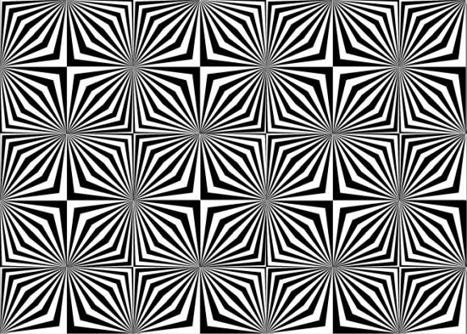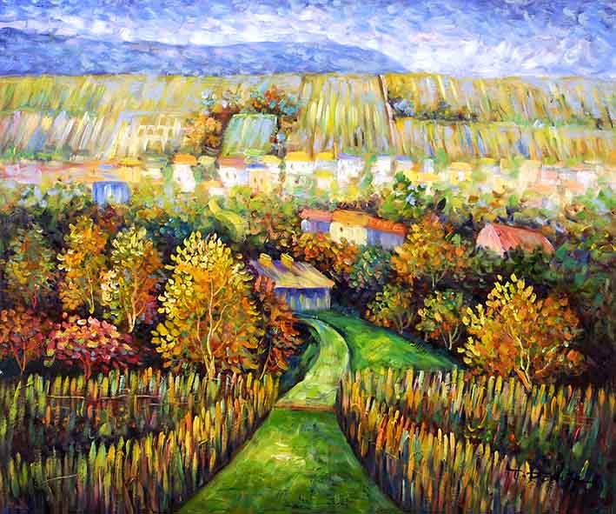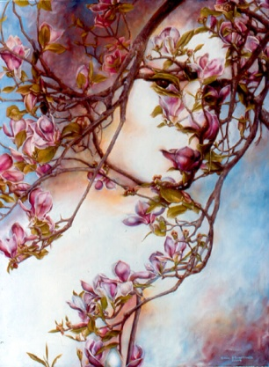
Phil: What do you think of this, Jane?
Jane: Ugh! I think it’s awful, I don’t like it at all.
Phil: Why on earth not? I think it’s fascinating.
Jane: It’s just a lot of funny black lines. It does nothing to me. Ah, but look! What a marvelous picture! All those gorgeous colours.
Phil: Do you really think so? Have you ever seen grass that colour? It’s terrible.
Jane: But it’s not supposed to be realistic. Anyway, let’s not argue. Do you like this one over here?
Phil: Oh, yes, fantastic. That’s what I call a painting.
12) Listen again and put these adjectives in the right order:
terrible, fantastic, fascinating, marvelous, gorgeous, awful
Can you think of other words expressing your attitude to pictures?
13) Write the adjectives in the correct column:
amazing annoying appalling atrocious attractive awesome awful beautiful boring brilliant dire dreadful fantastic fascinating gorgeous great incredible marvelous pathetic silly superb terrible wonderful
Positive | Negative
14) Write a dialogue between Abigail and Freddie about one of the exhibitions. Write about the paintings, the subject, the colours.
Freddie What did you think of……………….?
Abigail It was………………………………....
Freddie What about the………………………?
Abigail The ……..was/were………………….
Freddie And………………………………….?
Abigail I …………….., but…………………..
Freddie ……………………………………....?
Abigail ……………………………………….
Freddie Would you…………………………..?
Abigail ……………………………………….
15) At home you’ll have to make up a similar dialogue. You can bring some pictures of the paintings so that everyone could see what pictures you are talking about.

