Topic: “Computers: Pros and Cons”
Obectives:
-to improve students’ communicative skills;
-to expand students’ vocabulary on the topic “Computing”
- to encourage group and pair work;
- to stimulate students’ creative thinking and imagination;
- to bring up the culture of communication, friendly and tolerant attitude to each other, the ability to prove one’s point of view.
Equipment: multimedia presentation, audio and video materials, handouts ,tape recorder.
Procedure
- Introduction
T. Good afternoon , everybody! Today we are going to speak on the very vital and important topic “Computer in Our Life. Pros and Cons of Using a Computer”. Computer is one of the most important inventions of all times and it has changed our life for the better. So there are quite a lot of advantages of using it. During the lesson we shall discuss its pros and cons, predict about the future of the computers, practise the words and word- combinations connected with computers, revise modal verbs can, be able to, should, find the solutions to the computer problems. By the end of the lesson you will be able to understand and use new words, develop your ability of speaking on the subject and proving your point of view.
II. Warming-Up
T. Now watch a short video “Communication Technology” and answer the following questions:
1. Do you have a computer at school or at home?
2. Do you have a laptop or a desktop computer? Do you have both?
3. When did you first start using a computer?
4. How often do you use a computer?
5. What operating system do you use?
6. What software do you use the most often?
7. Do you use your computer when you do homework for homework for school?
8. Have you ever studied English using your computer?
9. How many times have you upgrated your computer?
Game “Group Survey “Computer Fans” ”
T. Now you are going to make a group survey : you’ll do a test in groups of four and find out how much you depend on a computer ,report back to the class and compare your results with other groups.
HO1 “Are You a Computer Fan?”
How much do you depend on a computer? Answer the questions of the text and tell about the results.
Are You a Computer Fan?
Read the questions and write near them:
A for Always
O for Often
S for Sometimes
R for Rarely
N for Never
________ I chat with friends.
________ I click and double-click with a mouse.
________ I communicate with other computer buffs.
________ I count /calculate with a spreadsheet.
________ I do my homework for my teachers.
________ I download music.
________ I get up early or stay up late to turn on my PC.
________ I go out much and socialize with people.
________ I have problems with my eyes and my back.
________ I have a sense of euphoria when I use a computer.
________ I listen to music.
________ I log on to check my emails.
________I look for information with a search engine.
________ I make copies of my favourite CDs with a CD-burner.
________ I neglect my family and friends.
________ I play video games.
________ I record and print pictures.
________ I scan pictures with a scanner.
________I send and receive emails.
________ I shop online.
________ I speak to my computer.
________ I spend time on my personal website.
________ I surf the Internet.
________ I type letters and documents with a word processor.
________ I use a web cam to see friends.
________ I use all the keys on the keyboard.
________ I use different types of software.
________ I watch movies and videos.
________ I write my own programs.
Count the number of:
A’s______________
O’s______________
S’s______________
R’s______________
N’s______________
If you have more R’s and N’s than A’s and O’s , it means you are OK.
If you have more A’s and O’s than R’s and N’s, it means you suffer from computer addiction.

- Main Part of the Lesson
T.As we know computers can do lots of things but can they replace people?
Look at the table on the blackboard and answer the following questions.
Questions and answers
- Can computers count?
- Can they translate?
Ps. Yes, they can. But some translations are really funny.
- Can they speak ?
Ps. Yes, computers can speak, but limited.
- Can they print ?
Ps. Yes, of course. They can print some documents.
- Can computers forecast the weather?
Ps. Yes, they can.
- Can computers have conversation?
Ps. No, they can’t.
- Can computers write books?
Ps. No, they can’t. Only the man can write them with their help.
- Can computers think?
Ps. No, they can’t think.
- Can computers eat, drink, fall in love?
Ps. No, they can’t.
- Can computers replace people? What conclusion have we come to?
Ps. As we see, computers can do a lot of things, but not all of them, that’s why they can’t replace people. We are better in many ways. But we all use PCs to make our life easier.
Vocabulary practice
T. In the world of computers we use some special words and expressions. So, let’s do some exercises to practice the vocabulary on the topic “Computing”
1.Complete the text with the words from the box.
Virus, software, restarting, error, downloading, data, crashed

My computer 1__________ yesterday. I think I got a 2__________
When I was 3____________ music files from the Internet. First there was an 4__________ message, and then it stopped responding. I tried 5__________ it, but it didn’t help. I lost a lot of important 6________.
I’ve got to buy myself better anti-virus 7_________.

2. What can you do with a file or document?
Complete the table.
 |  | a document/  a file
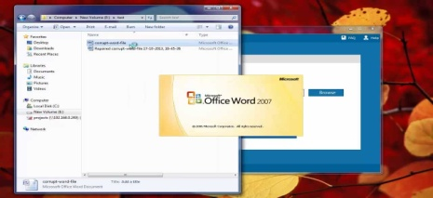 |  | a document/  a file
 |  | a document/  a file
 |  | a document/  a file
 |  | a document/  a file

3. Label the numbered elements in the picture
a)________b)________ 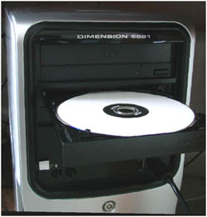cc

c)___________  d)__________ 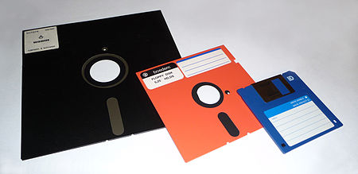

e)__________  f)__________

g)__________ 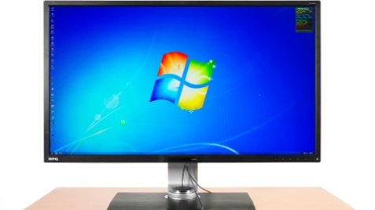h) ________ 

i)__________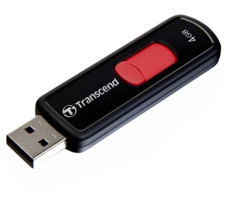 j)__________ 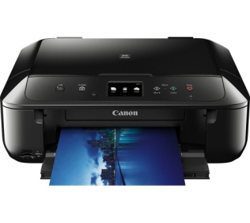
k)__________ 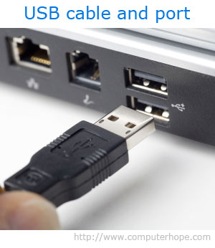 l)__________ 
Listening
1.Pre-listening activity
T. Describe the photo using the phrases below. Why do you think the man looks unhappy?

Describing the picture and expressing your opinion
The picture shows…..
In this picture I can see….
There is …. in this picture.
The man in the picture seems sad because….
I think that..
In my opinion….
It seems to me that…
It’s probably….
I wouldn’t feel comfortable in this situation….
2.Listening
T. You are going to hear a conversation about problems with a computer.
Pay attention to the new words:

Psychology folder- 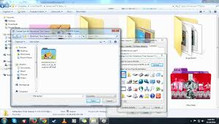
To move cursor onto the icon of the printer- 
To crash- 
A backup- 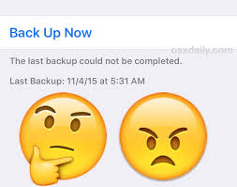
External memory- 
T. Now you are going to hear a conversation about problems with a computer
I’ve got this psychology project to finish for tomorrow morning…. What? Mathematics exam? Poor you! Yes, I know all you computer science students love maths, but…. Hmm…Yeah…Listen, Michelle, do you want to go out for dinner tonight? ….You do!? Well, great! I’ll pick you up at 7… Fantastic!...No, I’ll finish this project in no time…OK, see you at 7…what? No, of course, I won’t be late! Bye! Yes! Right, that’s it!...Half past six! I just have to print this and get ready for Michelle.
So, the brilliant young social scientist takes the mouse and moves the cursor onto the icon of the printer. He clicks once and voila! Clicks once and voila! Double click? Come on computer, print the document! Oh! Sh…ugar! OK, don’t panic. The computer’s crashed. It happens. You’ve got plenty of time. Just restart the computer and everything will be fine…Now, time for a cup of tea…
OK my little lovely PC, you’re going to print my document, aren’t you? Now where is it? In the psychology folder… which file?... em project 4.That’s it…so we’ll just open that… We’ll just open that file…Oh, come on! Please! What’s wrong with you?!
OK, look, if you open this document, I’ll buy you a new keyboard or a nice flat screen monitor or a lovely colour laser printer with scanner and photocopier…Just open it, please! Come on!
Oh no! I don’t believe it! Error!?...Don’t tell me I’ve lost that document. It’s taken me four days. Please, no!
Michelle! I can’t make dinner…I think I’ve got a virus!... No, not me, my computer! It just went dead!... Yeah, the screen went black, nothing works …I’ve lost my psychology project…No, I haven’t got a backup…My pen drive broke down and …Yeah, I know you told me to get an external memory, but… Yeah the only copy is on the hard disc…No, I haven’t downloaded any funny programs recently, and I haven’t been surfing any new sites on the net either…No I haven’t opened any strange emails…I don’t know what to do. I’m not a computer programmer…Really?... You don’t mind? Oh, Michelle, that’s so nice of you…How long? Twenty minutes? OK, I’ll see you then,,, Thanks a lot…

T. For questions 1-6 choose the correct answer A-C

- Tony calls Michelle
A to tell her about his project.
B to talk about exams.
C to invite her to dinner.
- Tony has problems
A printing his project.
B emailing his project to his professor.
C connecting to the Internet.
3.Which of these methods of solving the problem does Tony NOT try?
A. restarting the computer.
B. reinstalling the software.
C. talking to his computer.
4. Tony calls Michelle again in order to
A. tell her he is ill.
B. ask her for advice about his computer problems.
C. cancel their date.
5. Tony
A. has downloaded a suspicious program.
B. has opened a strange email.
C. has not made a backup copy of his project.
6. We can guess that Michelle
A is angry with Tony.
B. offers to come and help Tony.
C. decides to go out with someone else.
3. Post-listening activity
T. In pairs, ask and answer the following questions
- Have you ever a similar problem to Tony’s?
- What happened? What did you do?
- How do you feel about computers? Do you think they are great/awful/problematic but necessary?
- What do you use computers for?
- What do you usually do when you have a computer problem?
Speaking Practice
T. Now find the solutions to the computer problems using the structure “If you……, you should ”
Have a virus- use anti- virus software to do a full scan
Can’t connect to the Internet- call your Internet service provider
Computer crashed- reboot the system
Lost some files- run a research
T. Work in pairs. Use the language in the box to talk about computer problems.

Offering a solution

- Have you tried/thought of…?
- How about…?/Why don’t you …?/you could try…
- I ( would ) suggest that you…
- The best thing to do is to…
Responding

Ok, I’ll try it!
- That’s a good /not a bad idea.
- ( I suppose ) that might work.
- Well, it’s worth a try.
- I’ve already tried that and it didn’t work.
T. Make up the dialogue, using the following scheme:
- A: tell about your computer problem
- B: offer the solution of this problem
- A: respond
- eg A: I think my computer has crashed.
- B: Why don’t you reboot the system
- A: Ok, I’ll try it.
T. Now let’s discuss the pros and cons of computers. We have two groups- group 1 is for using a computer and group 2 is against it. Group 1 has to persuade the opponents that computer is a useful invention; group 2 will have to prove that using a computer has harmful influence. While discussing the problem you should follow these rules:
1) Every participant has the right to speak only with the permission of the leader. Conflicts inside the group are impossible.
2) Every report must be illustrated by the facts or examples from life.
3) You have no right to interrupt each other.
4) You should keep to the topic of discussion.
5) You should respect each other and try not to offend the opponent.
T. While discussing your arguments with other group mates. Let them agree and disagree with you.
Agreement
- That’s right. I also think so.
- I must agree that… You are quite right.
Disagreement
-On the contrary, it is…. I think it’s absolutely wrong to…
-On the one hand…., but on the other hand…
-Don’t forget about the other side of the problem.
-You don’t seem to understand that…
Sample answers:
Computers can do lots of work for us. They help us at school. They keep useful information. Besides, they can even teach us English as well as other subjects.
On the other hand, they have some cons:
Viruses are a headache for many users. You shouldn’t spend too much time at your PC. It’s bad for your eyesight. Chatting in the Internet with your friend is not the same as a face-to-face talk.
- Summing up. Reflection
T. Dear students, what can you say about our lesson? What is the thing you need?
IV. Close up
T. Dear students! I’d like to thank you for your work. You were really great! I hope you’ve learned much and perhaps will use your knowledge of English in the future and believe that the knowledge of computer will be of some use in your future occupation and everyday life.
Homework
T. Write an essay “The Pros and Cons of Using the Computer” (200 words)

