Тема: Екологія передбачає діяльність
Мета.
Навчальна: активізувати лексику уроку; повторити граматичний матеріал (Present Simple Passive); тренувати учнів в аудіюванні,читанні і спілкуванні по темі.
Розвиваюча: розвивати в учнів логічне мислення та уміння висловлювати думки за заданою темою.
Освітня: ознайомити учнів з основними проблемами пов’язаними з екологією рідного міста.
Виховна: виховувати бережливе і економне ставлення до оточуючого середовища.
Обладнання:підручник, робочий зошит, роздатковий матеріал, плакати, кольорові картки, відеоматеріали.
Хід Уроку
|. Підготовка до сприйняття іншомовного мовлення.
1.Привітання
2.Повідомлення теми і мети уроку
Watch the video and guess what the topic of the lesson will be.
(listening to a song of Michael Jackson «Earth Song»)
The topic of our lesson will be Ecology Suggest Activity.
3. Перевірка домашнього завдання.
Children have a look at the pictures on the wall. What do they tell you about? And to be precise? What kinds of pollution?
Water poluttions, Air poluttion, Smog, Trash

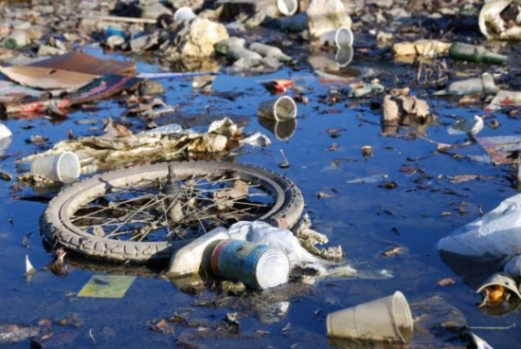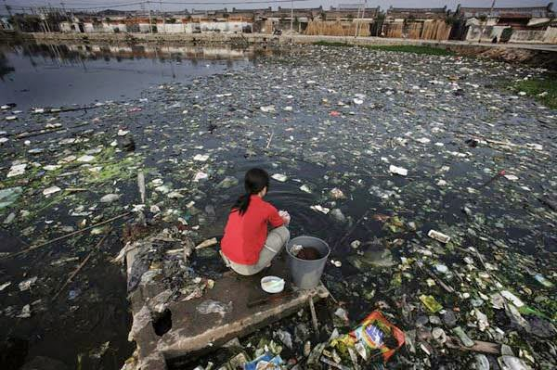
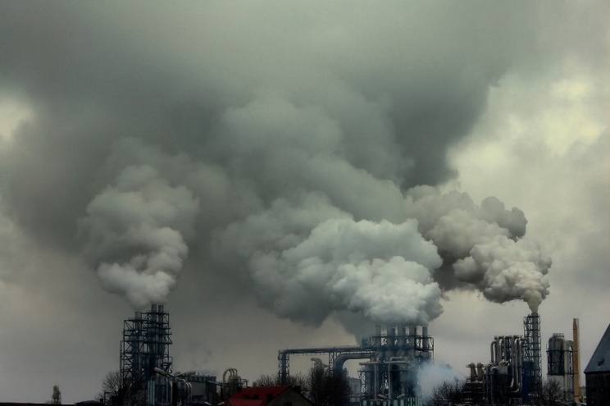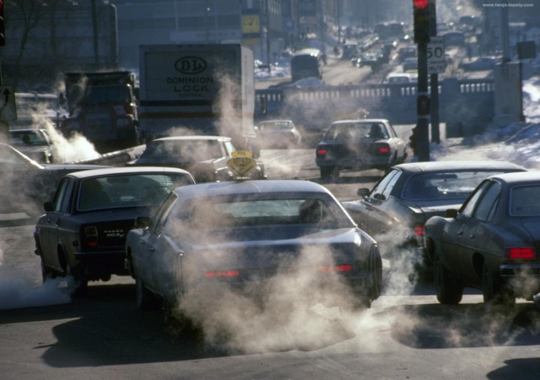
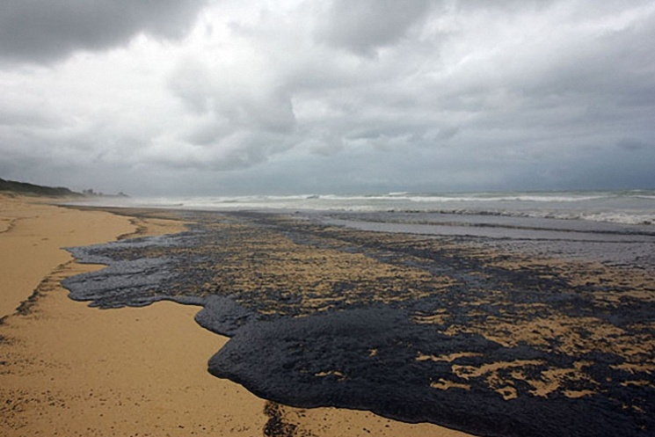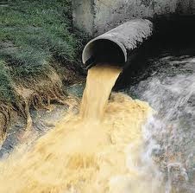
Tell as much as you can about this problem.
- Factories,electric power plants and cars are making a lot of gases. They are trapping more and more of the suns heat. This is called green house effect or global warming.
- Now the ozone layer is being damaged be gases that people have made. They are used in refrigerators, air conditioners, plastic foam and some other things. These gases float up to the top of the atmosphere and «eat up» the ozone.
- Today the air is so polluted that it is not always safe to breathe. Many cities around the world have air filled with a pollution called «smog». This is so strong in some places that the air which should be blue,actually looks brown.
- In many places the water has become polluted. Rivers and lakes are polluted by garbage or by poisonous chemicals which are dumped right into them.
- Underground water can be polluted by gasoline or other harmful liquids that seep into the ground.
- Acid rains are extremely harmful to plants,rivers and lakes and the creatures that live in them. In some places they kill forests. And they pollute the water for drinking.
- Most of our garbage is just buried. Now we are ,making so much garbage that in many places there is not enough room to bury it all.
The hot problem in todays world is the environment. There is a lot of pollution and many animals and plants are in danger. We can all help our panet.
||. Основна частина уроку
1.Аудіювання
Pre-Listening Activity.
I ’d like you to listen to Mr. Dee West who explains what a green school is .
How do you understand this phrase «a green school» .
Pupils answers (P1 I think nature is green, so they teach how to protect it). P2 up to my mind these schools educate the children about environment
Let ’s listen to the recording to find out if you were right or wrong.
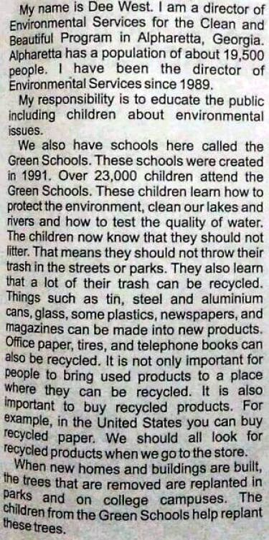

While-Listening Activity
Now we shall listen to the same recording again, but before we do it, have a look at the questions to be ready to answer them after the second listening.
Questions
- What is Dee West?
- Where does she work?
- How long has she worked there?
- What is her responsibility?
- How many children attend the Green Schools?
- What do they learn at school?
- Why do think they call them «Green Schools»?
- What kind of things can be recycled?
- How do American children protect trees?
10. How can you help to protect the environment?
Past-Listening Activity
So, what did you learn about this kind of school. I wonder if there is any green school in Drohobych? Would you like to have such school in Drohobych? Why yes or no? Give your reasons. Would you like to attend it and why? What activities would you suggest?

2. Виконання тесту «How green you are».
Such people who care about the environment are called «green». Let ’s see how green you are. I have got a quiz for you to find it out.

How green are you?
Try this quiz to find out!
I ’s time to get up
- Do you have
- a shower?
- a bath?
- a quick wash?
- Do you use
a)normal soap?
b)soap that is not tested on animals?
c)shower get or shampoo?
You ’re ready for school.
- Do you go
a)by car?
b)by bike?
c)on foot?
d)by bus, boat or metro?
4. Your teacher gives you a piece of paper to do some work. Do you
a)write on both sides?
b)make a paper airplane out of the paper?
c) write on the side of the paper, then ask for more?
It ’s break time.
5.Do you
a)eat sweets or crisps?
b)eat pre-packed biscuits or sandwiches?
c)eat some fresh fruit?
6. What do you do with you rubbish? Do you
a)throw it on the floor?
b)throw it in the nearest bin?
c)throw it in the correct recycling bin?
It ’s home time.

7.Do you
a)phone your friend?
b)play games or sports with your friends?
c)play computer games or surf the Net?
d)play video games or watch TV?
8. How many electrical appliance do you switch on? (lights,air conditioning,heating,computer,CD player, TV,DVD player…)
a)1-2
b)3-4
c)5 or more
It ’s dinner time.
9.Do you eat
a)organic meat and vegetables?
b)what ’s on your plate?
c)free-range eggs?
d)fast food?
It ’s bed time.
10.Do you
a)turn off the monitor on your computer?
b)leave your computer on standby mode?
c)leave your computer on all night?
11.Do you
a)forget to brush your teeth?
b)leave the tap on while you brush your teeth?
c)turn off the tap while you brush your teeth?

And now evaluate your results. This table with help you. Then calculate your points?

Your Score:
1.a)2 b)1 c)3
2.a) 2 b)3 c)1
3.a)1 b)3 c)4 d)2
4.a)3 b)1 c)2
5.a)1 b)2 c)3
6.a)1 b)2 c)3
7.a)3 b)4 c)2 d)1
8.a)3 b)2 c)1
9.a)2 b)4 c)1 d)1
10.a)3 b)2 c)1
11.a)2 b)1 c)3
Results :
11-18: You are not very green,are you? You do not worry about the environment at all! You think pollution is someone else ’s problem,not yours. You think recycling and saving resources are too time-consuming. Please look after our world before it ’s too late.
19-27: You are trying to be more green,but you don ’t always get it right. You take care of the environment and you have some good habits which help save it. However, there are probably a few other things you could do. Learn more about the environment.
28-36 : Well done. You are really green! You definitely care for the environment. You think about it when you make everyday decisions. We need more people like you to help us save our environment. If more people in the world were as good as you are, the planet would have fewer problems.

3.Бесіда в режимі T-Cl.
Very often when we speak about ecology we mean the three R’ s rules. What are they? (Reduce/Reuce/Recycle)
Prefix-re-means to repeat or do it again.
E.g. repeat after me (say it again)
Reread (read it again)
Redo (do it again)
Can you tell me what is the difference between recycle and reuse.
(to recycle means to cycle again; to reuse means to use again).

4.Опрацювання граматичного матеріалу.
Present Simple Passive
Виконання впр. 3 ст. 120
Look at Ex. 3 at page 120 and examine the scheme. The question is in what way one can keeps these rules. Look at the scheme and say what can be recycled, reused and reduced.
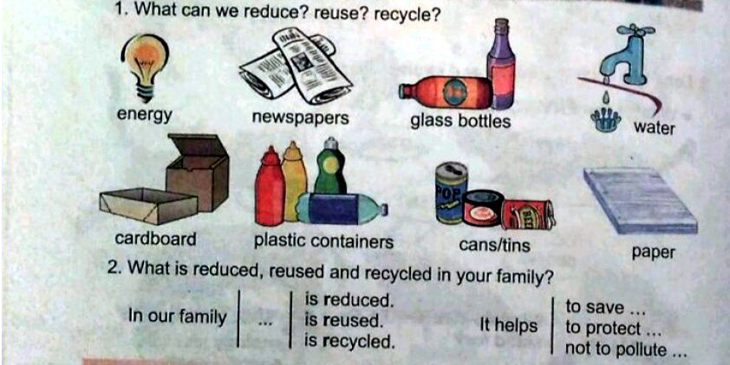

5.Виконання тесту «How long litter lasts»
Do you know how long litter lasts. Let’s do this test.

 | Choices | Objects
1. | 2 months | Traffic ticket
 | 1 months
 | 3 months
2. | up to 2 months  up to 4 months  up to 6 months | Banana peel
3. | 1 year  4 years  3 years | Wool sock
4. | 6 years  4 years  3 years | Wooden stake
5. | 10 years  15 years  13 years | Painted wooden stake
6. | 5 years  1 year  3 years | Wax paper cup
7. | 200 years  100 years  150 years | Tin can
8. | Up to 300 years  Up to 400 years Up to 500 years | Aluminium can
9. | Forever  1000 years 100 years | Glass container
Now listen to the correct answers. Calculate your mistakes. How many mistakes have you done?
Results:
- 3 months
- 2 months
- 3 years
- 4 years
- 13 years
- 3 years
- 200 years
- 400 years
- Forever

Which things were the most difficult or you didn’ t know or doubted?
Which litter do you think is the most dangerous to our environment? Now children you can understand why recycling is so important.

6. Розвиток писемного мовлення.
But ecology suggests activity.
What activities can you offer?
Open your exercise books and write down the activities you can suggest. Don’ t forget to write down the date.
And now compare you ideas with those of your deskmate.
Now form a triad and compare you results. Add the missing ideas to your list. So what you have got. Which ideas did you like best?
7. Розвиток усного мовлення. Бесіда в режимі Cl (-P1 P2 P3-) The guest.
The pupil of the 11 th form… of our school took part in the ecology olimpiad held in Lviv and she took the second place. And I decided to invite her because she devoted her report on ecology in Drohobych. You have a good chance to pepper her with questions concerning the problem. (Pupils questions)
1. What subjects was your report devoted to?
It was devoted to the problem of gabage in Drohobych.
2. Did you use any facts to support the problem? Which ones?
Yes, of course. I illustrated my report with some facts up- to- date statistics and graphics, photos and posters.
3. How long did you work at the problem?
It took me a year.
4. Did anybody help you or direct you?
My classmates and my teacher of biology joined me in my invertigation.
5. What results did you receive after finishing your work?
The received results proved the fact that Drohobych looks ugly because of gabage.
6. Which activities would you suggest to teenagers?
First of all I know that many teenagers eat a lot of packaged fast food and drink many drinks from plastic bottles which litter the town. It means that packages and bottles should be reduce the usage of packed fast food and drinks.
Secondly. Paper schoolchildren use a lot of paper within the academic year. To solve the problem they should either reused the paper if it is possible or collect the waste paper and take it to the recycling centre.
Thirdly. Schoolchildren should save water when in toilets and not to forget to them faucets off, and not to forget to them off the light when leaving the classroom.
Fourthly. Teenagers use a lot of batteries nowadays: mobile phones, cameras, etc. They should take them to special puncts.

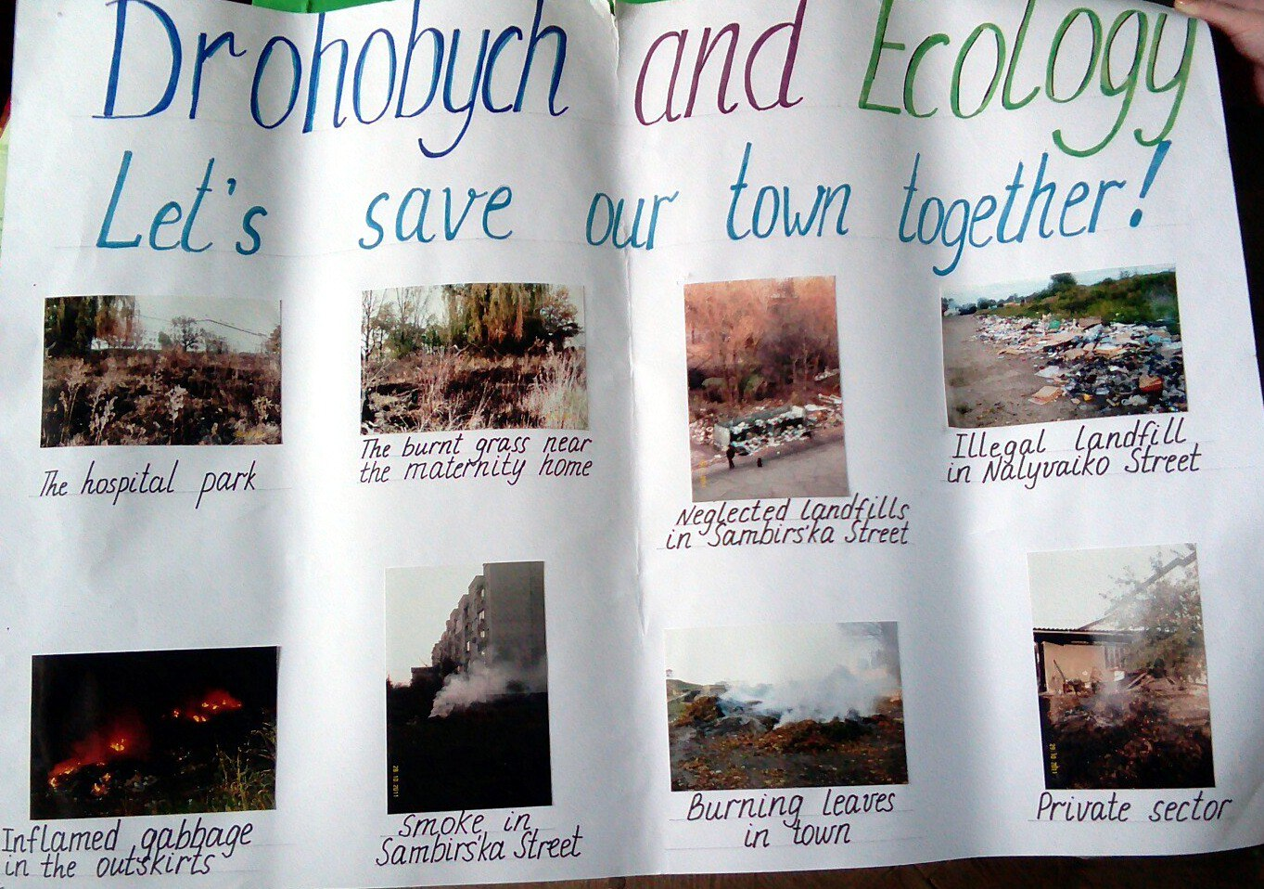

Many thanks to you for coming and showing your interest in the problem.
Look at this poster. And let’s save our town together.
8. Бесіда в режимі T-Cl.
Students. Recently I have read in Kyiv Weekly Newspaper about a very interesting social-ecological project. «Green Publishing». So far 110 companies have joined the project. 430 waste paper containers were places in the offices and over 82 tons of paper have been collected. All these mean that project partisipants were able to save 273 trees. Have you heard about it before?
Would you like to join the project. In what way?
We will discuss it next time.
And I hope our guests will inform their collegues about it and take part in it.

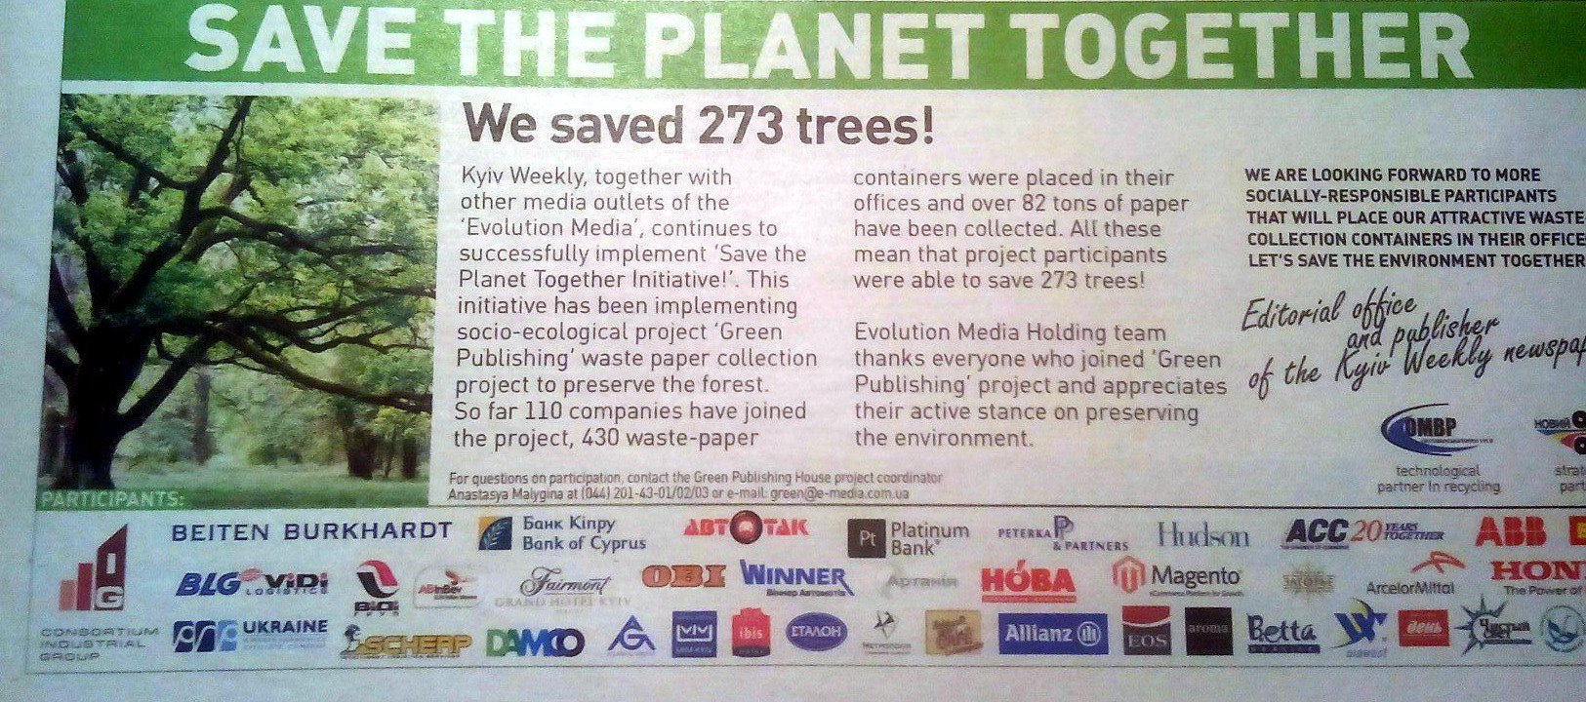
|||. Заключна частина уроку.
- Домашнє завдання
Now unfortunately our time is up and for the next lesson I’d like you to do the following.
Copy the words of Dalai Lama:
Our mother planet is showing the red warning light.
«Be careful», she is saying. To take care of the planet is to take care of own house.
and write a short composition 10-15 centences long on the touched problem, expressing your attitude (it may be either positive or negative).
Hometask
Composition (10-15 sentences long)
2.Підведення підсумків уроку.
And now to our results. I enjoyed your work during the lesson. You were active and deserve the following marks.

Now I prefer you to write down the activities you can suggest to save nature. Everybody has to write his or her ideas on the flower petals now. Lets stick a petals.
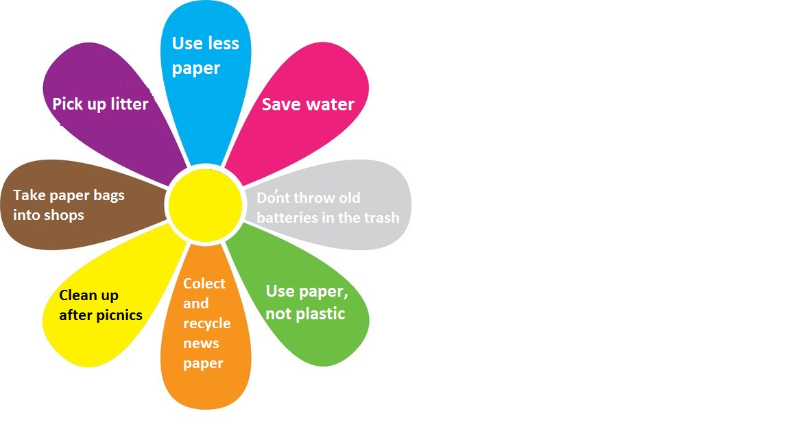
I hope our world will be like this flower under the sun.
Our future in our hands!
Ecology suggests activity.
Let’s sing the song together!

Future’s in our hands
We want to see blue seas We want to see birds fly
We want to see green tress, Up into a clear sky,
We are defenders of our land. We are defenders of our land
We want to breath clean air, We want to see flowers grow
We want to show we care, To pollution we say «No!»
We know the future’s in our hands. We know the future’s in our hands

