Topic: Going green
Мета: активізувати вивчений лексичний матеріал з теми, розвивати уяву та вміння обговорювати питання стосовно теми уроку, практикувати учнів у роботі з непідготовленим текстом та аудіюванні. Виховувати любов до природи й оточуючого середовища.
Обладнання: малюнки, фото, текст для читання, текст для аудіювання, ТЗН, вирази відомих людей до теми уроку, картки.
Хід уроку
- Warm-up:
- Greetings
- Read the quotation by W.Shakspeare about nature.
“One touch of nature makes the whole world kin” (kin (тут) – відчувати родинний зв’язок).
Answer the question: Do you love nature and enjoy being in the open and watching animals and plants?
- Main part of the lesson:
- Look at the picture, close your eyes and listen to the sounds.
Answer the questions:
- Where are you?
- What can you see, smell, touch, hear?
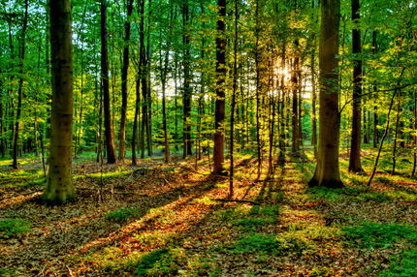

- Listen to the text, read and understand it.
- Say 3 things that impressed you in the text.
- Do the exercises to this text.
Text. Litter is a problem in cities.
- Litter is garbage – like food, paper and cans – on the ground or in the street. Where many people live together, litter is a problem. People don’t always put garbage in the garbage can. It’s easier to drop a paper that to find a garbage can for it. But litter is ugly. It makes the city look dirty and spoils the view.
- The wind blows papers far away. Often they are difficult to catch. When they blow against the fence, they stay there.
- Litter is a health problem, too. Food and garbage bring animals, which sometimes carry diseases.
- Some people want to control litter. They never throw litter themselves, and sometimes they work together in groups to clean up the city. In most places litter is against the law. The law punishes people who throw garbage on the streets. They usually pay a fine, and occasionally they go to jail.
- Two famous sayings in the United States are: “Don’t be a litter bug!” and “Every litter bit hurts!”.

Exercises:
- Find the words that doesn’t go with the text:
paper throw control
can drop punish
rubbish put pay
food collect sell
- Choose the best title for the paragraph 1.
- Litter and the view of the city.
- Garbage cans in the city.
- The problem of litter in the city.

- Write questions to the given answers.
_________________? It’s garbage.
_________________? In the places where people live together.
_________________? They pay a fine or go to jail.

- Find true or false sentences:
- People always use cans for litter.
- In some countries people are punished for throwing litter are the streets.
- There are organizations who struggle for cleanliness of the cities.

- Check home work. Listen to the information about rainforests.
Учні з планшетами інформують клас.
Answer the question: What would happen if we lost all the rainforests?
- Listening.
Listen to a speech by an environmentalist and answer the question: What is the speech about?
- Now read the quotations by The Dalai Lama and William Ralph Ing.
“Mother Planet is showing us the red warming light – “be careful” – she is saying. To take care of our planet is to take care of our own house” – The Dalai Lama
“Civilization is being poisoned by its own waste products” – William Ralph Ing
Look at these photos and answer the questions: Do you agree with these quotations? Why?
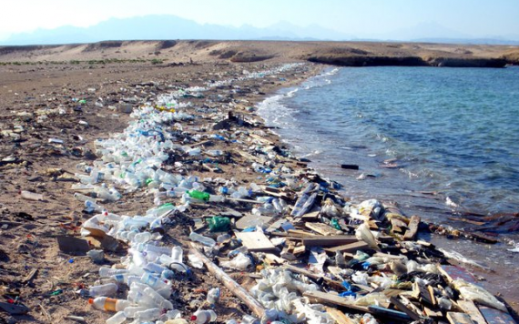
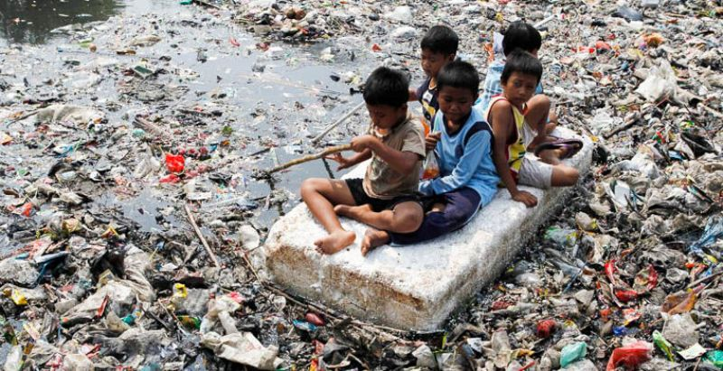

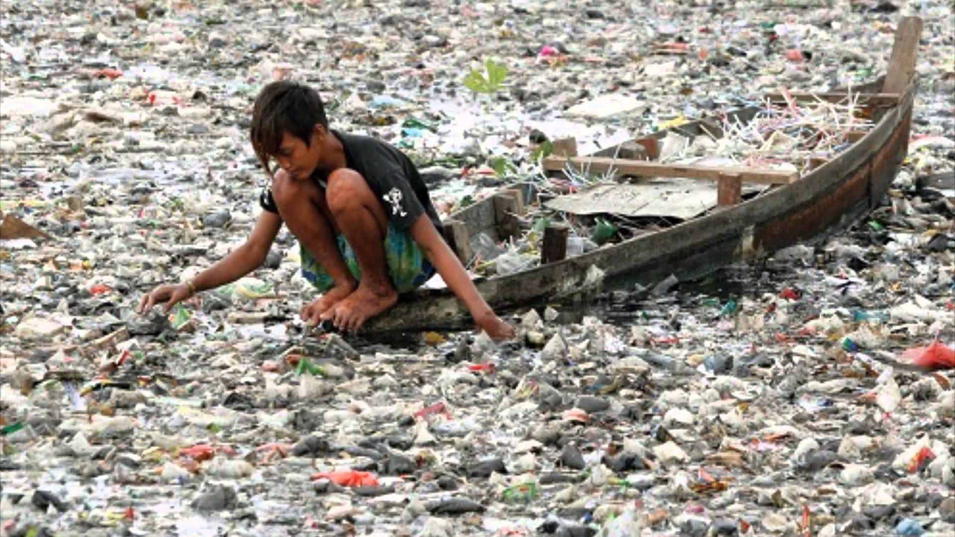
- Writing. Work in groups.
1 group:
Write an open e-mail to people telling them how to improve the environment in your town. Give your practical ideas, and then read your e-mail.
2 group:
Complete the Green calender with practical ideas for pupils. Present the Green Calender to your class.
Green Calender
December
To save heat, put aluminum foil on your radiators.
January
Don’t waste energy! Turn off the light and heating when you go out of the room.
February
Talk about the environment to your friends.
March
The birds are making their nests. Help them!
April
Plant trees and grow vegetables and flowers. No garden? You can grow things in a window box.
May
Plant the tree. Trees help the environment. They produce oxygen.
- Key.
When it’s a nice day we are in the country or a park. We have a picnic. We are happy. But we must follow the country code. Do you agree with me?
Listen to the song and say what we must do or mustn’t do in the countryside.
Don’t keep your dog on a short lead.
Pick wild flowers. Damage plants and trees.
Don’t respect people who work in the countryside.
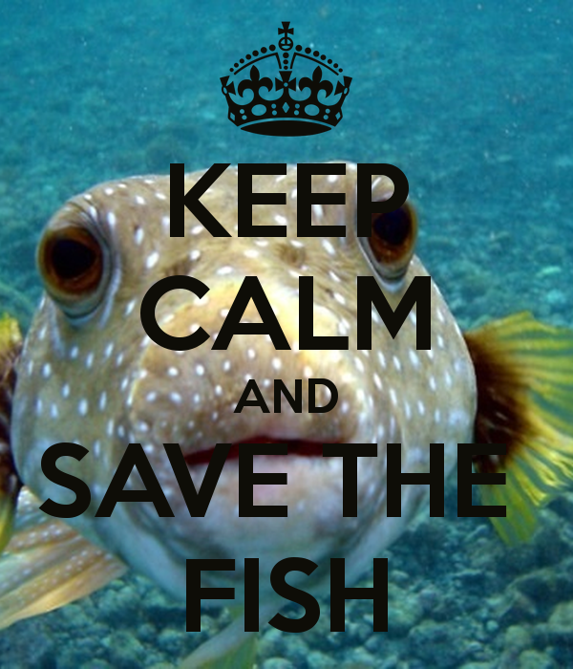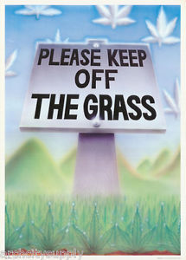
Don’t be a litter bug!
Drop litter. Don’t take rubbish home.
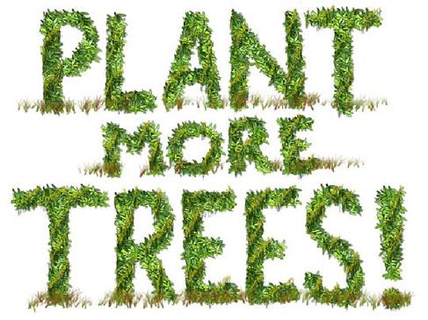

- Summing – up.
What should we do to save our flora and fauna?
What have you learned today?
What can you do now?

- Home work.
Підготувати плакат «What is nature?”, визначити як ви розумієте слово ПРИРОДА.

Птахова Л.В.
Вчитель англійської мови
СШ № 57
м. Херсон

