Case-lesson "Embroidery as a symbol of Ukraine"
What information is waiting for you here?
My mom embroidered shirt, as if fate led cross» ...

Objectives: students will be able to work successfully in small groups and in pairs; practice topical vocabulary; improve their reading, writing, speaking and listening skills; reveal creativity, develop imagination, broaden their mind and learn more about their native culture.

I Warming-up activity
Answer the questions:
- Is it possible to "embroider" the fate?
- Why was it believed, that embroidery is a talisman?
- Why do modern Ukrainians like wearing an embroidery?
- Is it only because it is an ancient art that suddenly become fashionable global trend?
- Why “if fate led cross”? What other stitches and seams can be characteristic of Ukrainian embroidery?
- When do people in Ukraine usually wear national clothes?
Teacher: Let's try to decipher the characters of ancient embroidery to find answers to these today’s questions. Read the article carefully and give the right title to it.
There are a lot of embroidery technologies. Generally, it is believed that there are 250 stitches of Ukrainian embroidery, and they perform 20 techniques.
For example, "wreathing" (ie embroidery on textile with pull strings) is a technique which is based on over thirty separate joints - wreaths.
And every master may add something “own”. This is besides the fact that every region of Ukraine has its own peculiar technique! And even universal, "general" joints have got their "local" flavor. Some techniques are gradually separated in their own "kind."
Let’s watch the box of different stitches of embroidery. Read them one by one

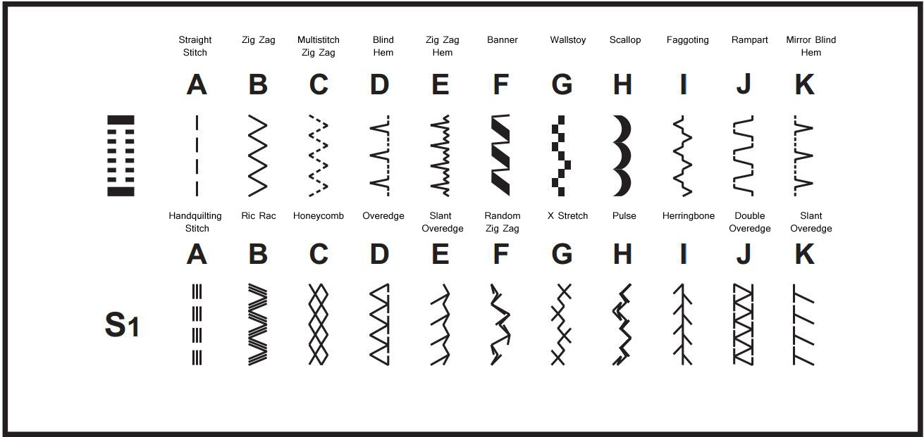

There is a special pattern alphabet for embroidery. Look at the table and read, please.
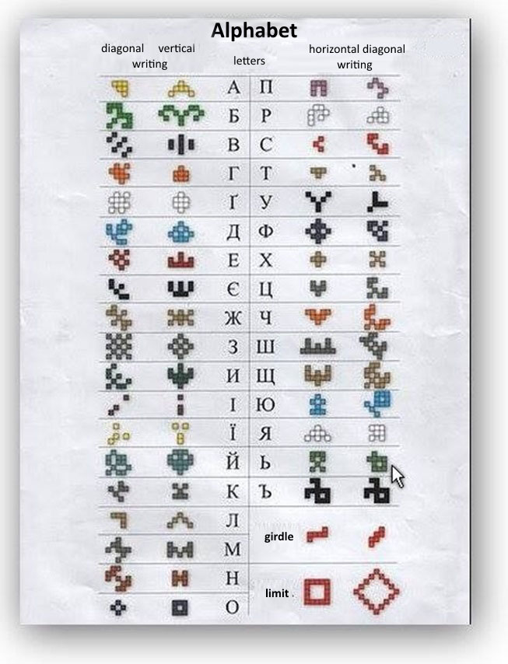

Why don’t we read the article about Ukrainian national clothing?
Pre-reading activity
II Complete the sentences.
- Traditional Ukrainian clothing is worn for ….
- Traditional Ukrainian costumes for women are…
- Ukrainian folk clothing for men includes …
- The embroidery tradition roots came back
III Reading activity
Read the texts and check your answers.
Ukrainian clothes
Traditional Ukrainian clothing is worn for festivals, special occasions, or holidays. National Ukrainian dresses become scarce, and some clothing items can be found in the museums nowadays.
Traditional Ukrainian costumes for women are long skirts, blouses, scarves, decorative headdresses. These clothes are richly embroidered with traditional folk motifs. Red is a prominent color in folk dress of Ukraine.
Ukrainian folk clothing for men includes embroidered white shirts, paired with pants of a bit darker colors. Traditional Ukrainian shoes were made of birch bark. They are not worn anymore, because they are quite uncomfortable, but these types of shoes can still be found today as souvenirs at Ukrainian markets.
Ukrainian people like to wear embroidered clothing. The embroidery tradition roots in pagan beliefs of protection. Ukrainian embroidery can decorate any kind of personal cloths, towels, table linens. Embroidery tradition is passed down from generation to generation.
Modern Ukrainians also like to dress up, mostly in casual and smart casual style. T-shirts and jeans and trainers are absolute favorites of Ukrainians nowadays. Skirts with high heels for ladies and sports costumes for both men and ladies are very popular in Ukraine. Winters are cold in Ukraine. People wear a lot of warm cloths: sweaters, coats, scarves, hats, gloves, and boots.
All churches still require women to cover their heads. Bare arms and legs, tops and shorts both for men and women are inappropriate in the churches.

IV After reading activity. Now let’s work in pairs.
Put 6 questions to the text about Ukrainian national clothes and ask each other.

V And how do we choose a color? Maybe you have seen white embroidery on white, and black, black and red, and color. First, the person's age plays an important role. The older the person is the less colors are used to him.
Look at the photos and read the labels. Now look at your embroidery shirts and tell their symbols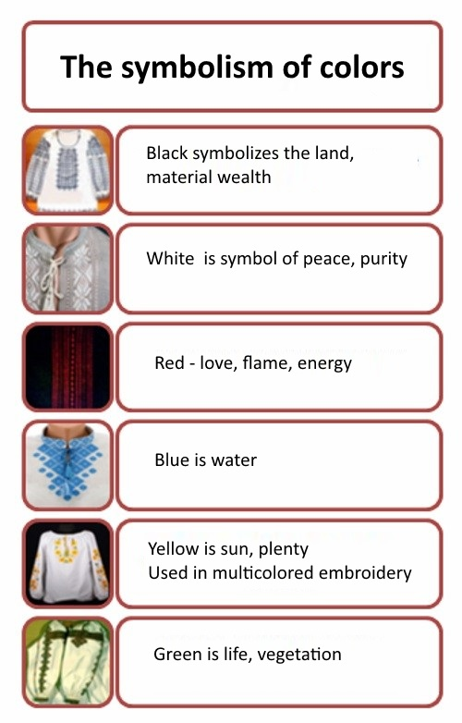

. VI Now represent us your own shirts you are wearing today. Follow the directions:
Today I’d like to tell you about my shirt ... As I know…. Also its colors symbolize ….
If I’m not mistaken …..surely all Ukrainians prefer ….

The main feature of Ukraine's national clothes is the baroque style, which manifests itself in the exaggeration of general forms. Let us recall, let us say, the embroidered sleeves of a woman's shirt, the ornament of embroidery, laces, etc. Special decorative fabrics and different ribbons and threads of beads add festivity to garments.
The most common women's piece of clothes - a long shirt belted at waist - has come to us from the ancient Slavic people. It is decorated by magic ornaments.
At first, people used to wear long shirts, and later, skirts appeared in Ukraine, which had their own peculiarities in different years.
A wreath is one of the main elements of a Ukrainian national women's suit, as well as red boots. A wreath is a symbol of purity and youth. Also, it is an inseparable part of wedding garments. The wedding symbolic of a wreath is reflected in love magic and fortunetelling, in the custom of giving a girl a wreath on the engagement day, in the usage of a wreath at the wedding.
Ukrainian traditional costume consists of: vyshyvanka, zapaska (a skirt) and krajka (woven belt). Often the woven waistcoats with embroidery are carried.
The seed beads jewellery is a must have in female costume. 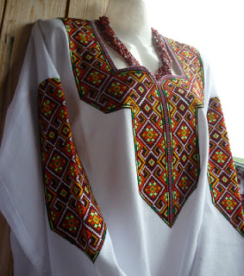

Summarizing
I should tell that everyone has worked hard today. We should be proud of ourselves. Thank you very much.

