Theme: Travelling. Travel broadens the mind.
Objectives:
- To activate the topic related lexis;
- To motivate learners to free speaking and exchanging opinions;
- To develop students’ skills in listening, reading and speaking;
- To enrich students’ knowledge about opportunities of travelling;
- To cultivate students’ aesthetic tastes;
- To develop students skills in making Power Point Presentation;
- To develop students’ memory and attention
Type: combined
Equipment: ‘New Opportunities’ Students’ Book, The Power Point Presentations, CD, notes, pictures
Procedure
I. Introduction (1 min)
- Good morning, students! I hope you are fine today? Welcome to our lesson. I hope you will be active.

II. Warm-up
- Read the quotations and explain the meaning( Appendix 1- teacher’s presentation):
‘Travelling is one way of lengthening life’
Benjamin Franklin
‘He that travels far knows much’
John Clarke
- I think you are ready to guess the topic of today’s lesson. What is it?
- Travelling. Yes, it’s absolutely correct. By the end of the lesson you should be able ( the objectives of the lesson):
- To use the words on the topic;
- To participate in exchanging about travelling;
- To improve your skills in listening, reading and speaking;
- To make a project on the topic
- To answer the question: Does travel broaden the mind?
Motivation: Is it important to study this theme on our English lessons? Why? What are your opinions?

III. Dictionary corner.
- First off all I want to make sure that you don’t forget the words on the topic. Look at the word-box and put the words under the following Headings:
- Types of holiday;
- Places there people stay on holiday;
- Places people visit on holiday;
- Preparation for vacation;
- Thing people do on holiday;
- Problems people have on holiday.
Word-box: To book tickets, camping, resort, museums, queues, ‘bed and breakfast’, crowds, to relax, delays, sunbathing, caravan, sightseeing, beach, tent, cruise, lost luggage, youth hostel, excursion, sunburn, safari, packing baggage, gallery, food poisoning, windsurfing, round-the-world trip, cancellation, scuba-diving, bungalow, to go on tour, hitchhiking, backpacking.

IV. Speaking
- At first, I want to pay our attention on the last heading: ‘Problems people have on holiday’. I propose you to work in pairs and prepare dialogues using the plan to help you. Try to make your dialogues funny and entertaining.
(Students’ dialogues)
- At the previous lesson you were united into 2 groups to do some research work about travelling. You had to interview your classmates. You had some points to do it. Let’s start! Who is the leader of the first group?
- Presentation 1. (pupils’ presentation, group 1)
- What conclusion do we reach?
- Do you agree that travel broadens the mind? (open answers) It was the question for discussion and theme of the second group. Leader, present your ideas.
- Presentation 2. (pupils’ presentation, group 2)
- Make a conclusion
V. Listening
- I want you listen to another conclusion the person reaches.
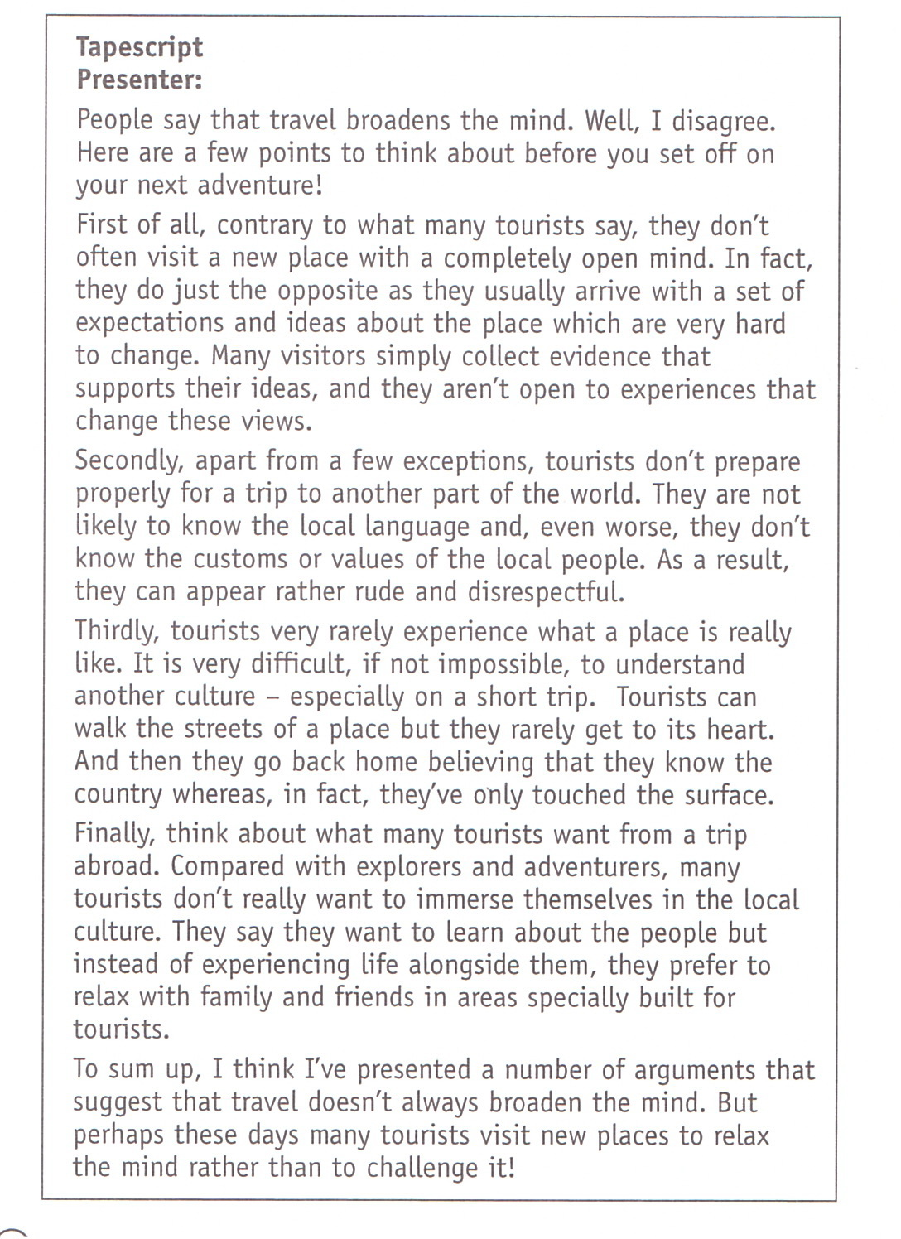
1 st listening . Answer the question: What conclusion does the speaker reach? (Many tourists visit new places to relax the mind rather than to challenge it.)
2nd listening. Listen and complete the notes.
Listening
Name______________________________
‘Travel broadens the mind.’

Tourists say that… | but in fact | they…
1.they visit a new place feeling ready for anything | but in fact
2. they prepare before they set off | but in fact
3. they try to find out what a place is really like | but in fact
4. they want to learn about the local people | but in fact

How do you understand the function of the expression ‘but in fact’ (to introduce a contrasting point)?
VI. Writing (completing the notes)
VII. Reading
-I propose you to read the poem of Ukrainian writer. Look through the words of it. Read with good intonation:

Of travels I am very fond.
I go to sees, to woods and ponds.
I like landscapes and journeys like.
I travel by the cars and bikes.
I also take the photos of
The trees and flowers very soft.
I like to travel very much,
The world is green and large!
You can discover much for you,
And get to know a lot of new!
I have been to the Azov Sea
And to the village Solontsi.
Cherkasy, Kharkiv, Kyiv and
I to the Russia also went.
I was in Moscow, in Chepetsk,
In Yalta, Saki and Donetsk.
I want to say all such words:
Let’s travel, let’s explore the world!

Answer the questions: 1) What is the writer fond of?
2) What means of transport does the writer travel?
3) What is the reason of writing this poem?
VIII. Summary (3min)
- Your home task is to do ex.3p.86 (explain and discuss the quotes), learn the poem by heart or write your poem on the topic for extra-mark.
- What have you learned at the lesson? Who wants to make the general conclusion of the lesson?
- It was very interesting to hear your opinions about travelling. Thanks for your work. Your marks are…(comment the marks)

Extra task
Song ‘Daniel’ by Elton John (p.85)
- Look at the lyrics. Try to guess the missing words.
- Now listen to the song and check your guesses. Answer the questions about the song.
- How does the singer feel about his brother?
- Why do you think Daniel is going away?
- What do you think might have happened in the family?

Appendix 1
Teacher’s presentation
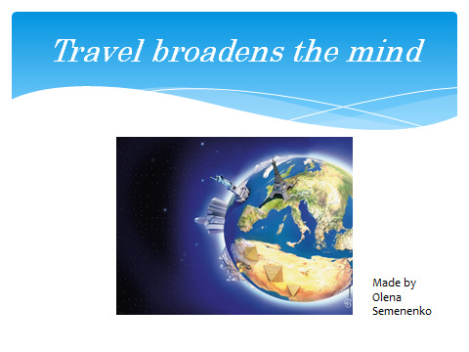
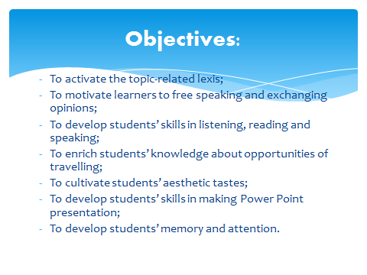

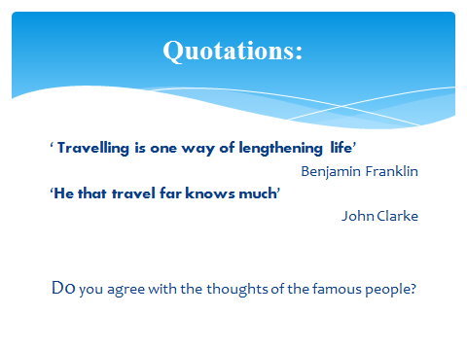

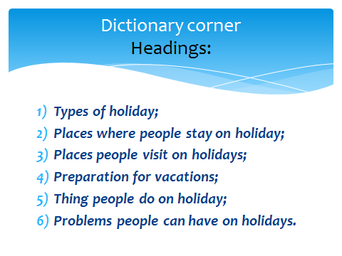

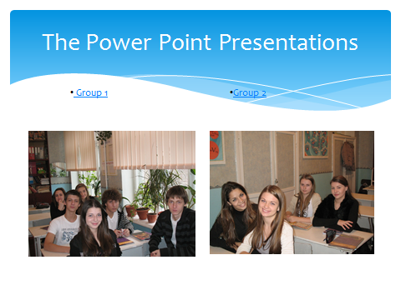

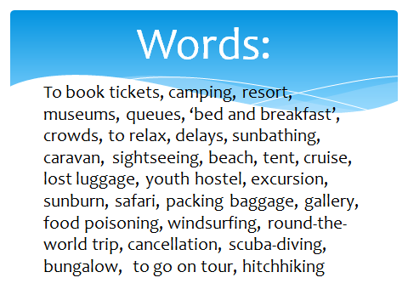

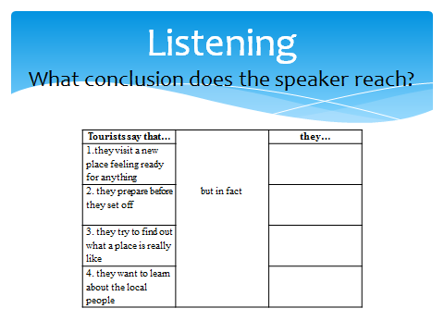
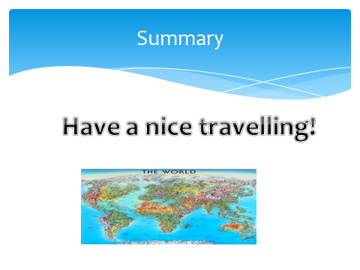

Appendix 2
Presentation of the first group


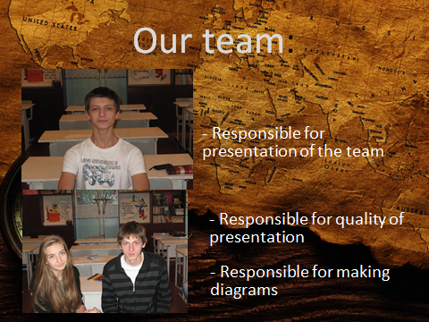

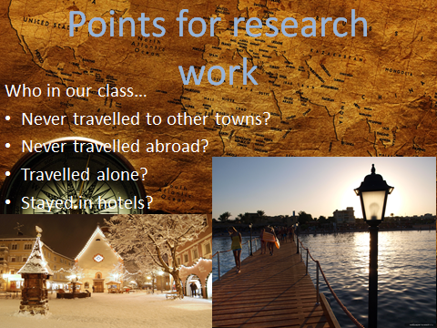

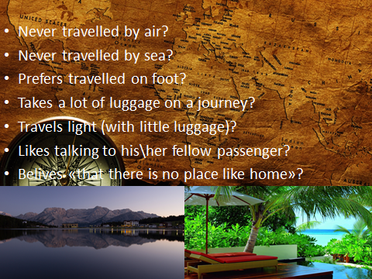

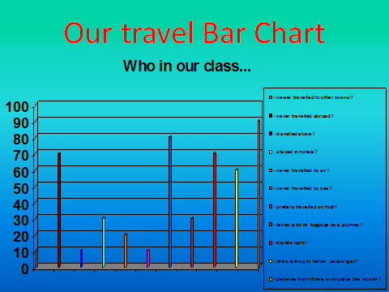

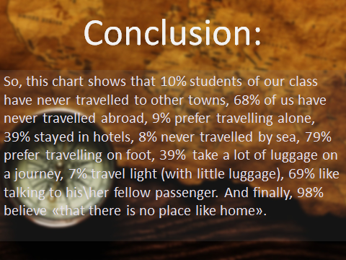

Appendix 3
Presentation of the second group





