Тип заняття | формування вмінь та навичок
Цілі заняття | навчальні: активізувати лексичні одиниці теми за допомогою синонімів в говорінні та розпізнаванні їх в читанні; перевірити вміння складати усне повідомлення за схемою; розвивати вміння аудіювання; продовжувати розвивати вміння перекладу та формувати лексичні знання.  розвивальні :розвивати креативні та мовленнєві здібності у групах та парах; сприяти розвитку здогадки;  виховні: виховувати детальний інтерес до іноземної валюти
Завдання заняття | Удосконалення навичок читання; активізація ЛО у говорінні; практика монологічного мовлення
Знання, уміння, навички, якості, компетентності, компетенції, які актуалізують/набудуть/закріплять тощо учні в ході заняття | Систематизувати ЛО за темою, уміння монологічного мовлення із зоровою опорою, яка передбачає перебудову змісту мовного зразка
Технології, методи, форми роботи | Демонстративний, частково-пошуковий, практичний, словесний; фронтальна, колективна , індивідуальна, групова
Необхідне обладнання і матеріали | Інтерактивне аудіо; тематичні малюнки
Додаткова інформація | -
Використанні джерела і література | розробка на базі підручника Access 4

Очікуванні результати: під кінець заняття студенти повинні
- Вільно використовувати ЛО по темі в читанні та мовленні;
- Читати тексти, побудовані на знайомому мовному матеріалі;
- Самостійно мислити, творчо сприймати добуті знання та реалізовувати їх у практичній діяльності
Timing: 80 minutes
Procedure
- Introduction
Greeting
T. Good afternoon, dear students. How are you today?
Hope, you are OK and our topic today is very interesting. Look at the pictures . Do you know any of the people in the pictures? How can they be related to English banknotes? What are they famous for? Elicit what our lesson may be about?
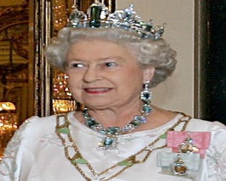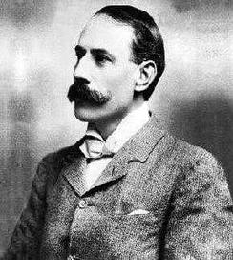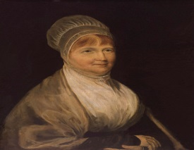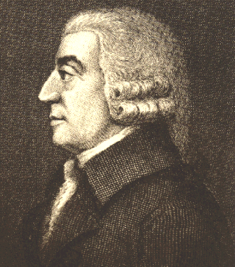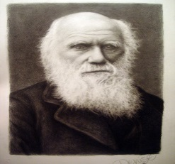
Queen Elizabeth II Edward Elgar Elizabeth Fry Adam Smith Charles Darwin
Aim To introduce the topic of the text
T. Today we’ll speak about English banknotes and English people in the pictures. What do you expect the text to be about? During our class you’ll get know the detail information about the notes. This information is necessary for you and connected with your future profession.
- Main part
Vocabulary revision and practice
T. Firstly, lets revise the new vocabularies. Listen and repeat. What are these words in your language?
Back (n) [bæk] the less important surface of smth.
Banknote(n) ['bæŋknəut] a piece of paper money
come across (phr v) [kʌm ə'krɔs] to find sth by chance
composer (n) [kəm'pəuzə] sb who writes music
develop (v) [dɪ'veləp] to bring sth into existence
division (n) [dɪ'vɪʒ(ə)n] separate part of large organisation
evolution (n) [ˌiːvə'l(j)uːʃ(ə)n] the gradual process of change and development
father (n) ['fɑːðə] the inventor or creator of sth
governor (n) ['gʌv(ə)nə] member of a committee which controls an organization
historical (adj) [hɪs'tɔrɪk(ə)l]that existed in the past and is a part of history
humming bird (n) ['hʌmɪŋ b3:rd] a very small brightly coloured tropical bird with wings that move very quickly
illustration (n) [ˌɪləs'treɪʃ(ə)n]picture diagram
image (n) ['ɪmɪʤ]a mental picture or idea of how sb/sth is
improve (v) [ɪm'pruːv]to make better
issue (v) ['ɪʃuː ]to officially produce sth and make it available
labour (n) ['leɪbə] practical work
living conditions (n) ['lɪvɪŋj kən'dɪʃ(ə)n] situation in which people live
main (adj) [meɪn] :he most important
pin manufacturing (n) [pin ˌmænjə'fækʧ(ə)rɪŋ] the making of small metal pieces pointed at one end
prisoner (n) ['prɪz(ə)nə]sb who is in prison is punishment for a crime they have committed
site (n) [saɪt]the place where something is
theory (n) ['θɪərɪ]a formal set of ideas that is intended to explain sth

T. Match the pictures to the words. Elicit answers from Ss around the class.
Look at the pictures and try to guess their meanings.
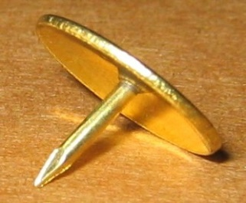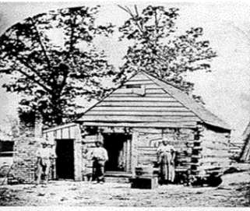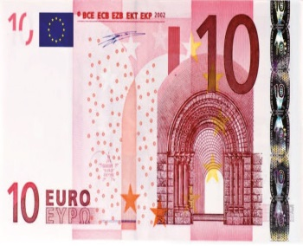

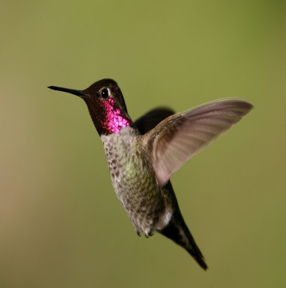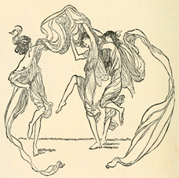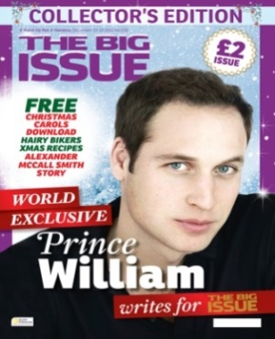

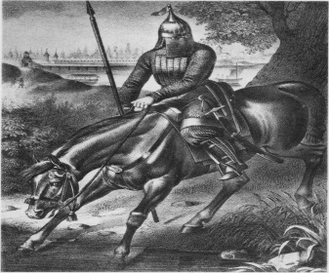 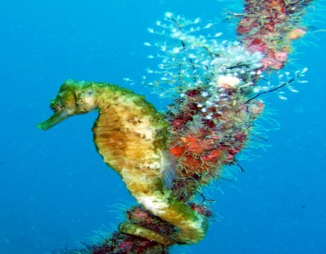 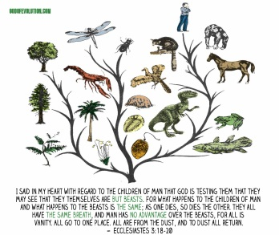 1
T. Let’s play the lexical game “snowball”.
Which of the new words would you use to describe the notes?

Listening Comprehension
While listening activity
Elicit a variety of questions from Ss around the class. Play the recording. Ss listen and follow the text in their books and see if their questions were answered.
T. We are going to listen the recording. Firstly, ask three questions to the text and write them on the blackboard. Be attentive and then answer on them.
Suggested Answer Key
- When did the notes appear?( DS)
- Do all banknotes have a portrait of Queen? (Y)
- Is Charles Darwin illustrated on the note? (Y)

After comprehension activity.
To ask and answer comprehension questions.

T. Ask and answer questions based on the text. Work around the class then some pairs to ask and answer in front of the class. Use the pictures as prompt.

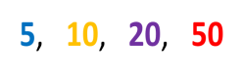

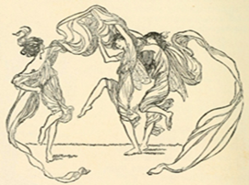
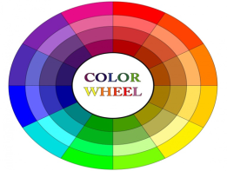
A: What colour is a fiver?
B: Blue and green.
A: Who is on the back?
B: Elizabeth Fry. What does the picture show?
A: It shows her reading to female prisoners in New gate prison. What colour is the tenner?
B: It is orange. Who is on the back?
A: Charles Darwin. What does the picture show? Etc
Reading
Pre-reading activity
T. let’s learn new vocabulary through synonyms. Match the words in bold in the text to their meaning. Use the words to make sentences.
1. director a) improving
2. making better b) illustration
3. location c) developed
4. invented d) evolution
5. gradual development e) governor
6. picture f) site
Reading
All the banknotes in the UK have a portrait of Queen Elizabeth II on the front and a famous historical person on the back. Read on to find out more...
The five-pound note, or fiver, is blue and green in colour and has a portrait of Elizabeth Fry on the back. Fry made her name by improving living conditions for women in European prisons. The main illustration on the note shows her reading to female prisoners in Newgate Prison.
The ten-pound note, or tenner, is orange in colour. It was first issued in 1759. Since 2000, Victorian naturalist, Charles Darwin, who developed the theory of evolution, has been on the back of the note. You can also see Darwin’s ship, the HMS Beagle, as well as various flowers and animals he came across on his travels, in particular the humming bird.
The twenty-pound note is purple and up until very recently it had a picture of the British composer, Sir Edward Elgar on the back. The new twenty-pound note shows Adam Smith, one of the fathers of modern day economics and an illustration of one division of labour in pin manufacturing.
The fifty-pound note is red and has a picture of Sir John Houblon on the back. Houblon was the first governor of the Bank of England. The illustration also shows an image of Houblon’s house in Threadneedle Street, London on the site of the bank’s present day building.
Post-reading activity
To check Ss’ retention of information
T. Say three things you remember from the text.
Grammar
Word formation
T. Look at grammar box and remember forming people nouns from verbs/nouns
We use -er (paint) , -ist (physics - physicist), -or (sail - sailor) to form people nouns from verbs and nouns.
Write the people nouns for the following verbs/nouns.
1 invent 2 astronomy 3 paint 4 science 5 biology 6 teach 7 build 8 write 9 act 10 cook
Speaking
T. Work in groups. Choose the note which you like. (Ss are choosing them from the box) United into groups according your banknotes. What do the banknotes in Ukraine and Europe show? Collect information, and then present it to the class. Make three mistakes. The class correct you.
III. Summing up
Homework
Write a short paragraph about what you can see on each note. Decorate your project with pictures. Be ready to present it to the class.
T. Thank you for your job. Now you can give a presentation on your country’s banknotes. Listen for gist.
Evaluation. Commentaries. Saying goodbye.

