Тhe topic: «А Sound Mind in a Sound Body»
(розробка уроку)

Клас: 9
Підручник: Real Life B1
Вчитель: Нечепуренко Вікторія Леонідівна
Обладнання: комп’ютер, інтерактивна дошка, картки, відео.
Тип уроку: урок узагальнення та систематизації знань.
Школа № 56 м. Одеса

Objectives:
➢ To practice the vocabulary to the topic, Conditionals;
➢ To develop the pupils` speaking, reading and listening skills;
➢ To train the pupils to use the topical materials in communication, to develop their attention, memory and logical and critical thinking;
➢ Develop the ability to work co-operatively in pairs or small groups;
➢ To teach them to follow the rules of healthy eating;

I: Greeting.
T.- Good morning. How are you today?
- I hope you are fine and ready to work hard.
- What would you like to do at our lesson?
Ps. I’d like to train my Speaking skills.
Reading skills
Writing skills
Listening skills
T.- Well, you are going to do all these kinds of activity. Could you tell me what is the topic of our lesson today?
P. I think we will speak about food because I can see a lot of pictures, leaflets and wall papers in the classroom today.
T. Of course, we will speak about healthy food. First, answer my question, please. What happens if on a highway a car goes out of petrol?
P. It can crash; it stops; it may cause an accident; there can be a traffic jam;
T. What happens if we don`t get what our body needs?
P. We can die;
T. Why do we eat?
-We should eat to live; to get energy; to be strong; food lifts our spirits; food makes us feel happy and active, positive and energetic.

II Main part
1) T. I want to say, that Health has always been valued by people. What is health? Actually, most of people, when asked about the definition of health, usually talk about physical state of body. But to my mind, it also concerns physical well-being: structural health (bones, muscles, organs), chemical health (good balance of nutrients) and finally mental health, which refers to peoples` cognitive and emotional well-being. So, how do you understand the proverb: « A sound mind in a sound body»? Pupils` answers.
2) T. Do you know any other proverbs? Take card №1, work in pairs and match the parts of the proverbs and quotations about food. Read them to the group, please.
1 | A sound mind | but to eat intelligently is an art
2 | Let food be thy medicine | good food choices are good investments
3 | To eat is necessity | and high in proteins
4 | You are | will sooner or later have to find time for illness
5 | Your diet is a bank account | not eat to live
6 | Eat to live | and medicine be thy food
7 | Those who have no time for healthy eating | what you eat
8 | I keep my diet low in carbohydrates | in a sound body

Smart answers: 1-8, 2-6, 3-1, 4-7, 5-2, 6-5, 7-4, 8-3
3) T. What should we eat then? Let`s listen to a poem « Sandwiches».
Are sandwiches healthy? Let`s speak about fast food and junk food (pupils` answers).
4) T. Scientists all over the world have worked out a FOOD PYRAMID, which helps people to choose their healthy meals, that make them feel healthy. Let`s watch and listen to the Food Pyramid presentation, prepared by group of pupils and then hold a short group conversation on the topic.
Presentation;
1) All of us live in the world, where we haven’t got time to do something we want. Grown people spend all their day at work and teenagers always busy by their homework. Sometimes we haven’t got time not only for a good sleep, but to balanced diet too. Because of this people start to eat food, which tasty and quick to prepare. But it doesn't mean that it healthy. A quick snack in a small café or lunch in the McDonalds give a big effect not only for our weight, but it destroys our organism at all.

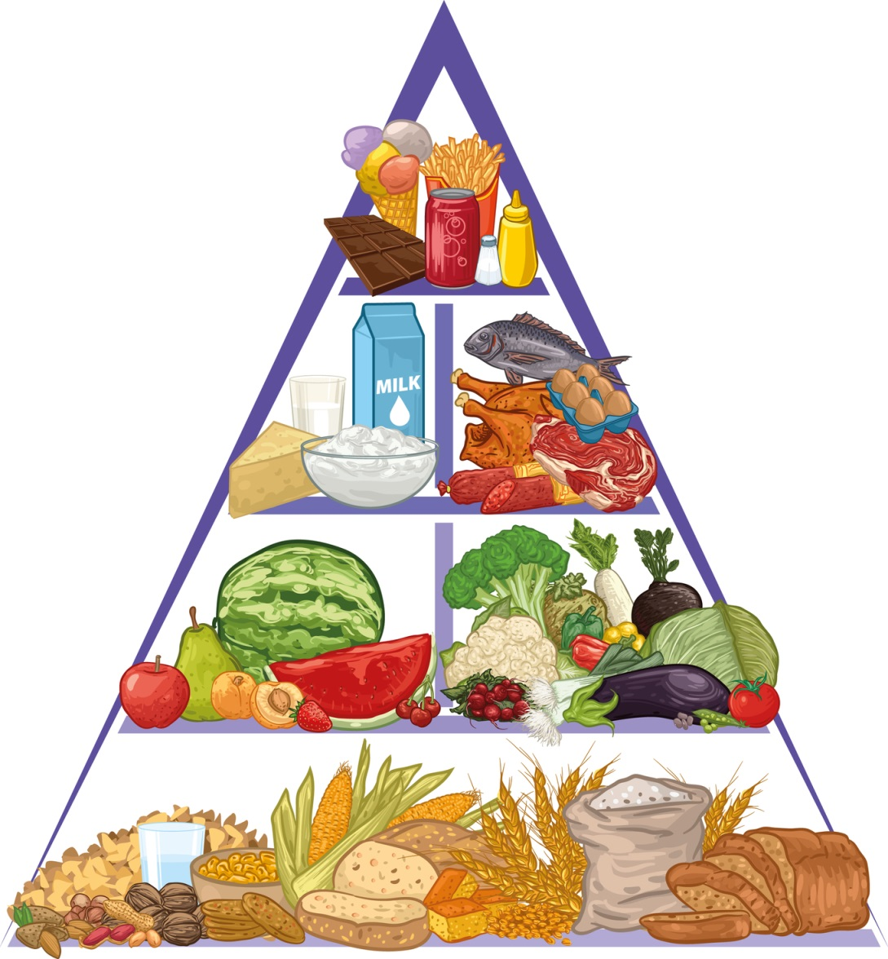

P1. Dear friends, have you ever heard about The Food Pyramid? No? Don’t worry; it isn’t a giant Egypt pyramid with food. The Food Pyramid is a clever chart with the six groups of food, that have all the nutrient that keep your body healthy and make you grown. It was developed in 1992 by Americans nutritionists and students of Harvard University. The main point of this picture is that you can make the balanced diet for all the day. It includes the different kinds of food from all six groups and how much of each type of food you should eat.
P2. The basis of pyramid includes two subgroup: products like (rice, bread, spaggetti, cereal) – that give us many carbohydrates and vegetable fats (olive oil and other). Products from these groups you should eat every day.
The second level hides a big variety of fruits and vegetables. Because of them we can saturate our organism by useful vitamins and minerals. Also it hasn’t got any fats. Fruits – it is the best option to breakfast. For example, the Americans have a tradition – they begin their days with the glass of fresh juice. And I must say, that is a great idea. With vegetables the situation is more difficult. The most people think, that the crisp is the vegetable too. It is a mistake. I mean we must eat raw or steamed vegetables.
P3. The next stop of our pyramid is products with proteins, calcium and ferrum like eggs, meat of birds, beans, nuts, fish and lean meat. Their neighbors are milk products like cottage cheese, yogurt and kefir. As like as meat group this products saturated by proteins, calcium and vitamins B, D and A.
P4. And finally, the top of our hit parade take a big variety of candies, sweets and other nastiness. They include the same fast food and other harmful food, which you have to minimize or exclude in general.
Remember, that eat healthy food is very important. The most crucial meal is breakfast. If you don’t eat healthy food, before you go to school or to work, your health, attention and activity will be bad.

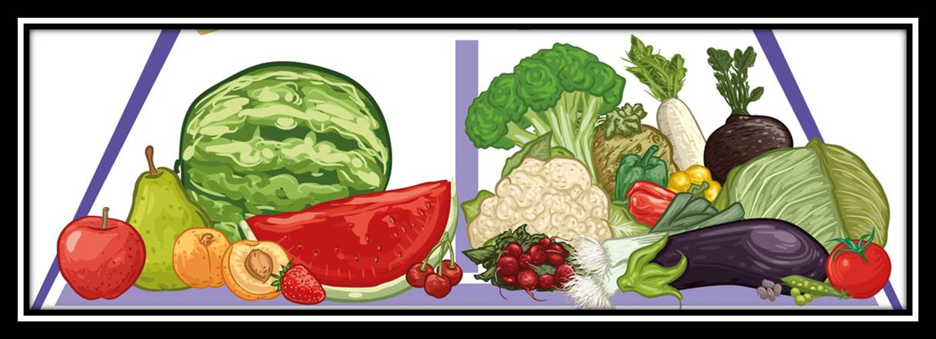

5) T. You got an interesting task at the last lesson:
You had to make a survey about the meal habits of students in our school.
What results do you have?
Video. A report.
I have done a little project about health and healthy food. I have interviewed six
students in our school canteen. And they told me about their lifestyle and their healthy diet. All these interviews were recorded on the video. It was very interesting to get to know information about my friends and style of their eating. And now I want to show you this video-interview.
Also we have interviewed other 39 people – boys and girls. We have made a statistic table with percentage ratio. So I can say that most of them eat a lot of fruits and vegetables and only 35% of them eat fast food, it`s very cool. I think We`ve got good results, because 64% have 3 meals a day and more. So you can pay attention to this table later, if you want.
6) T. It`s time to sum up and make up some rules about healthy eating for our school mates. Imagine that you are dieticians.
Break into three groups discuss your propositions. Three or four propositions should be delivered. Dieticians have a short talk and give their advice.
10 tips to healthy eating
1. Eat a Variety of Foods
You need more than 40 different nutrients for good health and no single food can supply them all. Today's food supply makes it easy to eat a wide variety of foods whether or not you are buying fresh foods to cook, taking advantage of ready-prepared dishes and meals or buying "take-away" foods. Balance your choice over time! If you have a high-fat lunch, have a low-fat dinner. If you eat a large serving of meat at dinner one day, perhaps choose fish the next day.
2. Base your diet on plenty of foods rich in carbohydrates
Most people do not eat enough of foods such as bread, pasta, rice, other cereals and potatoes. More than half the calories in your diet should come from these foods. Try wholegrain bread, pasta and other wholegrain cereals, too, to increase your fibre intake.
3. Enjoy plenty of fruits and vegetables
Most of us do not eat enough of these foods either although they provide important protective nutrients. Try to eat at least five servings a day and if you do not enjoy them at first - try some new recipes or see what ready prepared dishes are available in the supermarket.
4. Maintain a healthy body weight and feel good
The weight that is right for you depends on many factors including your sex, height, age and heredity. Being overweight increases your risk of a wide range of diseases including heart disease and cancer. Excess body fat results when you eat more calories than you need. These extra calories can come from any caloric nutrient - protein, fat, carbohydrate or alcohol- but fat is the most concentrated source of calories. Physical activity is a good way of increasing the energy (calories) you expend each day and it can make you feel good. The message is simple: if you are gaining weight, you need to eat less and be more active.
5. Eat moderate portions - reduce, don't eliminate foods
If you keep portion sizes reasonable, it's easier to eat all the foods you enjoy without having to eliminate any. For example, some reasonable serving sizes are: 100g of meat; one medium piece of fruit, half a cup of raw pasta and 50ml of ice-cream. Ready-prepared meals can offer a handy means of portion control and they often have the calorie values on the pack to help those who are counting. If you are eating out, you could share a portion with a friend.
6. Eat regularly
Skipping meals, especially breakfast, can lead to out-of-control hunger, often resulting in helpless overeating. Snacking between meals can help curb hunger, but don't eat so much as to substitute for proper meals. Don't forget to count your snacks as part of your total calorie intake.
7. Drink plenty of fluids
Adults need to drink at least 1.5 litres of fluid a day! Or more if it's very hot or they are physically active. Plain tap water is obviously a good source of liquid but variety can be both pleasant and healthy. Alternative choices are juices, soft drinks, tea, coffee, milk etc.
8. Get on the move
As we have seen, too many calories and not enough activity can result in weight gain. Moderately physical activity helps burn off those extra calories. It is also good for the heart and circulatory system and for general health and well-being. So, make physical activity part of your daily routine. Use the stairs instead of the liftelevator (up and down!). Go for a walk in your lunch break. You don't have to be an athlete to get on the move!
9. Start now! - and make changes gradually
Gradual changes in your lifestyle are much easier to make than major changes all at once. For three days, write down the foods and drinks you consume at meals and as snacks - Do you have too few fruits andor portions of vegetables? To start with, try to eat just one extra piece of fruit and vegetables a day. Are your favourite foods high in fat and making you gain weight? Don't eliminate those foods and feel miserable, but try to choose low fat options or eat smaller portions. And start using the stairs at work!
10. Remember, it is all about balance
There are no 'good' or 'bad' foods, only good or bad diets. Don't feel guilty about the foods you love, rather eat them in moderation and choose other foods to provide the balance and variety that are vital to good healthise vocabulary of this topic.
7) Reading for gist. Read the text «Food miles» and answer the questions.
FOOD MILES
Recently years have seen not only an increased interest in the freshness of what we eat, but also where the food was actually grown. The term “food miles” was invented as a way of measuring the distance of food, which has been transported until it reaches the dining table. For instance, a shopper in London may be prepared to pay a relatively high price for Japanese prawns that have been caught and flown over on the same morning. However, this badly damages the environment, because the plane and the lorry, which has delivered the prawns have polluted the environment. Research, that has been carried out by environmental groups has found that the environmental cost of food transport is more than 15 million euro a year. Although food miles make up only one part of the total cost of food production, they should be taken into consideration in any discussion on the future of the world in which we live.
a) What`s the main idea of the text? (pupils’ answers).
b) Should our government promote the laws to help our farmers to grow organic food in Ukraine? Make up sentence, using Conditionals. Start your sentences with: «If I were a farmer, I would…» (pupils’ answers)

8) Listening:
T. Watch the cartoon Food Pyramid and answer two questions. Video.
a) What is doctor Menson`s advice? Pupils answers.
The lyrics
. The ancient pharaohs were not too bright they say
But they made one contribution that I live by to this day
It's the food pyramid and it's approved by the USD
Oh, grains are the foundation
So please take my advice
Have 5 to 11 servings of bread, cereal or rice
3 to 5 of vegetables and 4 of fruits is best
Their anti-oxidants and fiber help you to digest
3 servings of yogurt, milk and cheese
Will help your bones and subsidize the cattle industries
A body needs to grow
And growing takes proteins
That’s why meat can be a tasty treat like fish or human beings
And when you eat your sweets
Make sure you try
To limit your servings
Or you'll DIE!
Everybody!
My body is a pyramid that's made of healthy food
So do what we say
(yeah!)
Eat right everyday
(boo!)
I love you
By America
III. Summing up:
T. Thank you for the lesson. We have spoken a lot about healthy food. You are great. Unfortunately, our lesson is coming to an end. I hope that everybody will eat only healthy food since now. My dear students remember: YOU ARE WHAT YOU EAT! (The teacher gives apples to students)
Homework:
T. We are going to celebrate a great holiday soon. Write a letter to your friend and write about about Easter meals and traditions in Ukraine. Have a wonderful day. See you next time.


