Theme: Healthy way of life. Situation “What makes people healthy?”
By the end of the lesson students will be able to:
- use new words, word-combinations and expressions, related to the theme “Health. A Visit to a Doctor”;
- practice new phrases to ask for help, advice and to respond them;
- describe their health mood;
- answer the questions after reading the text;
- match the words with their definitions;
- continue the point of the statement;
- perform an information after listening;
- present their own research on the topic given before.
Equipment: multimedia whiteboard; projector; laptop computer; boards with sayings and proverbs about health; tables with pictures of doctor professions, ways to be healthy; text to read (HO)

Procedure:
- Greeting:
- Good morning, students. I’m glad to see you. How are you today? How is life?
- Today our lesson is unusual a little: we have guests today and you’ll show them your knowledge of English.
- Warming-up. H/t checking:
- At the previous lesson we started to speak about illnesses and diseases and our visit to the doctor. Let’s revise some new words, related to the theme. Look at the table and match the words with their meanings:

A patient The feeling that you have in your body when you are hurt or ill
A hospital Your body is too hot because you are ill
An ambulance A sick person that a doctor is looking after
Pain A place where doctors and nurses look after sick people
Ache A special van that takes sick people to a hospital
To cough A pain that lasts for a long time, e.g. a toothache, headache
A cold To send air of your throat with a sudden loud voice
To catch a cold An illness that makes you cough and sneeze
Flue An illness like a bad cold that makes you ache
Fever To become ill with cold
Sore throat To feel very hot because you are ill
Epidemy A disease that many people in a place have at the same time
To have a temperature Having pain in your throat

- Next your task is to see the pictures on the table and to name the doctors, you can see here and to explain why you think so:
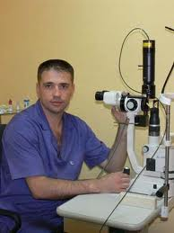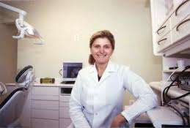

(an ophthalmologist, a dentist, an optician, a chemist, a surgeon, a therapeutist)

- Your home task was to make short dialogues on the topic “Visit to a Doctor”. Now let’s act them out. (the students are speaking on the dialogues of their own)
- Good job! Thank you.
- Presenting of a new theme:
- Today’s our theme is “Healthy way of life. Situation “What makes people healthy?” This theme is very useful for you as for future teachers, because you will teach your children how to take care of your health. At the end of the lesson you will be able: to speak about healthy way of life; to give advices how to be healthy; to use new words and expressions.
- How do you think, how is it like to be healthy? (to be strong and happy)
- Read the sayings and proverbs about health and think over them. Do you agree with these statements? What are the Ukrainian equivalents of them?

- “Early to bed, early to rise makes a man healthy, wealthy and wise”.
- “A sound mind in a sound body”.
- “Good health is above wealth”.
4. “An apple a day keeps the doctor away”

- Reading the text “Good Health!”
- Pre-reading activities:
- Before you read the text, see the words and word-combinations from the text with their explanation:
- Overeating – eating food more than you need or want
- Snack – to have a bite; to have a “quick” meal
- Low-fat food – food which contains a small number of fat
- Harmful – bad for health, injurious
- Drugs – a substance which makes people excited but constant taking drugs is dangerous for health and life
- Cheerful – merry, jolly
- Indoors – activities inside of the room, house
- Outdoors – activities outside of the room, house
- While-reading activities:
- Do you agree with the opinion of the author how we should take care of ourselves to be healthy? What ways of keeping fit do you know else? (reading the text, HO):
Good Health!

Everybody wants to live a long healthy life. Nowadays a healthy body becomes a fashion, an ideal of modern life.
There are many ways to keep fit.
For example, healthy food is a very important factor. Overeating causes many dangerous diseases. We shouldn’t snack and we should have breakfast. We should eat low-fat food, more fruit and vegetables, meat, milk products, which are rich in vitamins and proteins. We shouldn’t eat at night. If you keep to a diet, you must do it carefully, because sometimes diets may be harmful.
Besides, to be healthy, a person must stop smoking and drinking much. Besides, nowadays there is a problem of taking drugs, especially among young people. It causes many diseases and leads to death.
Everyone should remember that cigarettes, alcohol and drugs destroy both body and brain.
And the best way to be healthy is to go in for sports. Sport is very important in our life. It is popular among young and old people. Many people do morning exercises and train themselves in different sections and take part in sport competitions. Sport helps to make people strong, brave and cheerful. We can go in for sports in winter and in summer, indoors and outdoors. To keep fit, it is very useful to walk a lot, to play active games, to spend a lot of time in the fresh air.
Physical training is an important subject at school. Pupils have got physical training lessons twice a week. Boys and girls usually play volleyball and basketball at their lessons. There are some popular kinds of sport in our country: football, volleyball, basketball, hockey, gymnastics, skiing, skating, figure skating.

- Post-reading activities:
- See the tasks after the text:

Match the left column with the right one to make sentences:

Nowadays a healthy body becomes… | …you must do it carefully.
We shouldn’t snack and… | …is to go in for sports.
If you keep to a diet, … | …strong, brave and cheerful.
Nowadays there is a problem… | …an important subject at school.
The best way to be healthy… | …a fashion, an ideal of modern life.
Sport helps to make people… | …of taking drugs.
Physical training is… | …to be healthy!
Live a healthy life… | …we should have breakfast.

Guess: “True” or “False”:

- Everybody wants to live a long healthy life.
- Low-fat food is a very important factor.
- If you keep to a diet, you must do it carefully.
- To be healthy, a person must smoking and drinking much.
- Everyone should remember that cigarettes, alcohol and drugs destroy both teeth and nails.
- Sport is very important in our life.
- Physics is an important subject at school to keep fit.
- There are some popular kinds of sport in our country: golf, cricket, rugby, tennis.
- Listening:
- Listen to the conversation: three persons are asking Dr. Andrew for help.
(the students are listening to the track (Upstream, A2)
- And now do the task: match the people with the problems they are speaking about, and ways of solving these problems, which are proposed by Dr. Andrew:

Speaker 1 | Feels tired | Take up a new sport and don’t drink too much coffee
Speaker 2 | Feels stressed | Eat a balanced diet and take a plenty of exercise
Speaker 3 | Is really overweigh | Sleep enough and swim in the morning

- Listening to the report:
- Two of the students had a task to work on the topic about harmful smoking and today they are going to share this information with you. Welcome you are!
(two students are making report on the topic):

Harmful Smoking
People become aware of the danger of smoking. We can see more and more restrictions on smoking. Most airlines have a no-smoking policy. Also more and more restaurants and public places have nonsmoking sections.
How does the smoke of a cigarette affect a person’s body?
It prevents oxygen from getting into the blood by paralyzing the cells that clean the air in the lungs. Smoking cigarettes also affects the heart because of drug in cigarettes, called nicotine. Nicotine travels rapidly to the brain (in 1minute or two). From the brain, the nicotine travels to other important organs such as liver and the kidneys. In the liver it causes release of sugar into the blood.
Smoking causes one out of every six deaths in the United States. According to the “Surgeon General” every day more than 3,000 teenagers in the USA begin to smoke.
Smoking is expensive, too. The average smoker smokes 14 cigarettes a day at a cost of $1,200 per year.
Many experts feel that cigarette smoking is so common and so dangerous that it can be called epidemic.

- After you have listened to some interesting facts about smoking, answer the questions on the topic the students were speaking on.
(some students get cards with questions to answer them, HO2):
- Where can we see the restrictions on smoking nowadays?
- What does the smoke affect?
- What is the statistics of smoking?
- Is it profitable to smoke?
- What do the experts think about smoking?

- Speaking:
- So, I think , now you can give some advices to people and to yourselves, of course, how to be healthy.
- Let’s make a list of advices to those, who want to become stronger and more healthy. The pictures will help you to do that:

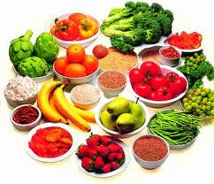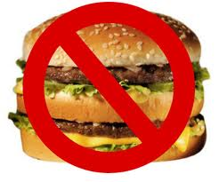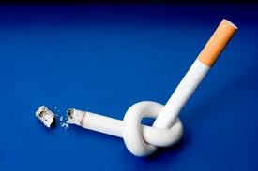

Healthy way
of life

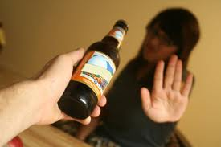

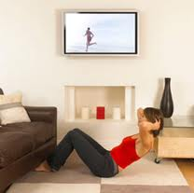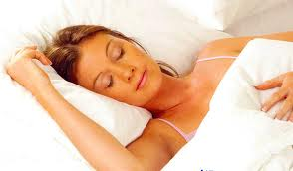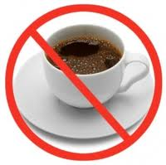

- Drink a plenty of water;
- Eat healthy food;
- Don’t eat fast food;
- Don’t smoke;
- Don’t drink alcohol;
- Don’t drink much caffeine;
- Go in for sports;
- Sleep enough (7-8 hours);
- Do exercises regularly;
- Take positive emotions
- So, did you decide to change anything in your life?

- Summarizing. Home task:
- I’m satisfied with your work today. And I think you’ll keep fit and take care of your health.
- Your home task is to learn and act out the dialogues (ex.103, p.82) and translate the sentences (ex.107, p. 83). Also hold a survey among family members on the topic “Are you a “healthy lifestyle’s person”? Answer 10 questions and make your own conclusions:

- Do you eat a balanced diet?
- Do you sit at the desk all day?
- Do you sleep enough?
- Do you take plenty of exercise?
- Do you eat a lot of fast food?
- Do you get stressed often?
- Do you drink plenty of water?
- Do you walk?
- Do you drink a lot of caffeine?
- Do you eat more in the evenings?
- Thank you for your work at the lesson. I’m glad to put you excellent marks. The lesson is over. Good bye!

