Lesson “ Rules of the road”
(7 form)
Objectives:
- to practice extensive reading and listening for specific information;
- to develop speaking skills of pupils by means of interactive activities.
- to introduce new vocabulary, talk about rules on the road and give directions
- to practice to use must/mustn’t for obligation; imperative.
- to continue practicing sentences in Present Continuous.
Equipment: the blackboard, a computer, cards with the traffic signs, cards with tasks for reading.
Procedure
I Greeting and aim
Good morning children. Our today’s lesson is devoted to the rules on the road. Do you know the traffic signs? Do you know the rules on the road? Do you keep them? We will discuss these questions today.

II Warm up

.a) Right — opposite to “left”.
b) Right — opposite to “wrong”.
c) Right — “at once”, “directly”.
d) All right. ---- Right you are
e) That’s all right.
- Let’s read the dialogue “Keep to the Left.”
(A street in an English town. A policeman stops a car. In the car there is a visitor
from another country who does not know that traffic in England keeps to the left).
P o l i c e m a n (holding up his hand). Stop!
V i s i t o r. What’s the matter?
P o l i c e m a n. Why are you driving on the right side of the road?
V i s i t o r. Do you want me to drive on the wrong side?
P o l i c e m a n. You are driving on the wrong side.
V i s i t o r. But you said I was driving on the right side?
P o l i c e m a n. That’s right! You’re on the right, and that’s wrong.
V i s i t o r . A strange country! If right is wrong, I am right when I’m on the
wrong side. So why did you stop me?
P o l i c e m a n. My dear! Sir, you must keep to the left. The right side is the left.
V i s i t o r. It’s like a looking glass. I’ll try to remember. Well, I want to go to
Bellwood. Will you kindly tell me the way?
P o l i c e m a n. Certainly. At the end of this road turn left.
V i s i t o r. Now, let me think. Turn left. In England left is right and right is
wrong, am I right?
P o l i c e m a n. Y ou’ll be right if you turn left. But if you turn right, you’ll be
wrong.
V i s i t o r. Thank you. It’s as clear as daylight.
- Post-reading activities.
Mind the different meanings of the word “right”. Translate the sentences into
Ukrainian.
• At the end of this road turn right.
• Take the second turning on the right and go straight.
• If you walk from the station, the bookshop is on the right side of the street.
• In Ukraine traffic keeps to the right whereas in England, Australia and Japan
keeps to the left.
• Are we on the right road? We’d better ask someone. That would be the right
thing to do.
• “Does this road go to the port?” “That’s right! (Right you are)”
• You are a stranger here. Am I right?
• We would go sightseeing right away / right now.
• “Will you kindly tell me the way to the post-office?” “That’s right in front of
you”. (“I’m going right up that way myself”.)
• Do you feel all right?
• “It’s a long distance off. Let’s take a bus”. “All right”.
• “Excuse my being late”. “That’s all right”.
• “Excuse my back”. “That’s all right”.

III. Main Part of the Lesson
- Introducing vocabulary.
Listen, repeat and learn new words:
Traffic lights, crash helmet, pavement, road, car park ,motorbike, bicycle, crossroad, cycle lane, pedestrian crossing, traffic sing, traffic warden ,parking meter
- Speaking
- Look at the picture. What can you see on the picture? Card 1
- Pupils, you should make guesses about new vocabulary.
Cars drive here
Its got two wheels.
People walk on this part of a street.
These have red, orange and green lights.
You can park here.
You wear it to protect your head.
(traffic warden 1, pavement 2, traffic light 3, parking meter 4, traffic sign 5, pedestrian crossing 6, cycle line 7, crossroad 8, road 9.)

- Grammar. Check your English.
Make up sentences about what different people are doing in the picture using the Present Continuous. Card 2
- Look at the blackboard. There are 12 road signs found in England. Draw these signs and write the correct words under each sign.
• Maximum speed limit. (3)  • Slippery road. (2)  • One-way traffic. (1)  • Two-way traffic straight ahead. (6)  • No entry. (7)  • Keep left. (8) | • Width limit. (12)  • Height limit. (4)  • No overtaking. (11)  • No waiting. (9)  • Pass either side. (10)  • No through road. (5)

- Speaking
You must or mustn’t wear a crash helmet on a moped.
You must or mustn’t stop at a green traffic light.
You must or mustn’t park on a pedestrian crossing.
You must or mustn’t buy a ticket to travel on a bus.

- Reading
Traffic rules in Great Britain
Once upon a time people kept to any side of the road they liked. But then they decided to make a rule to keep to the left.
As Napoleon hated the British very much, he decided that in France people should keep to a different side, and later on in all the countries which he conquered he made the traffic keep
to the right
It is not a simple thing for a tourist from Europe to cross the street in London, because in Britain the cars keep to the left, and not to the right as in European countries and in Russia.
When English people want to cross the street they must look first to the right and then to the left.
The traffic lights are like it is here. The red light says "Stop", the yellow light says "Wait" and only when you see the green light, which says "Cross", you may cross the street. People usually cross the street at the black-and white "Zebra" crossing. If a person crosses the street in the wrong place, he is stopped by a policeman (“Bobby), who stands at street corners regulating the traffic.
There are also women police in England. They have the same power as men. There are women detectives and women traffic police who regulate street traffic. But most of their work is looking after women and children. You can often see them patrolling parks other places where children play.
Questions:
- What side do the cars keep to in Britain ? in European countries ?
- What do the lights of the traffic lights say ?
- When may you cross the street ?
- Who stands at street corners ?
- Do women regulate street traffic ?
- What is their main duty ?
- Speaking
Work with classmates. Give directions to the different place on the map. Use the phrases in the box to help you. Card 3

Turn left/right at the, keep straight on until, cross the road, it is on the left/right, walk along the road. Excuse me, where is the -------, please?

IV. Summarizing
- Listening
Look at the words on the blackboard and match the words with the definitions
(traffic warden 1, pavement 2, traffic light 3, parking meter 4, traffic sign 5, pedestrian crossing 6, cycle line 7, crossroad 8, road 9, crash helmet 10.)
A road for bicycles. (cycle line)
Place next to the road where people walk. (pavement)
You must wear it on the motorbike. (crash helmet)
You must cross the road here. (pedestrian crossing)
Place where car drive. (road)
Stop when it’s red and drive when it’s green.(traffic light)
Where two roads meet. (crossroads)
You put money in it when you park your car. (parking meter)

Home work
Write a short story or a dialogue of your own about the rules of road safety in Britain and in
Ukraine.
Thank you for your work, pupils. You were bright! Good-buy!

CARD 1
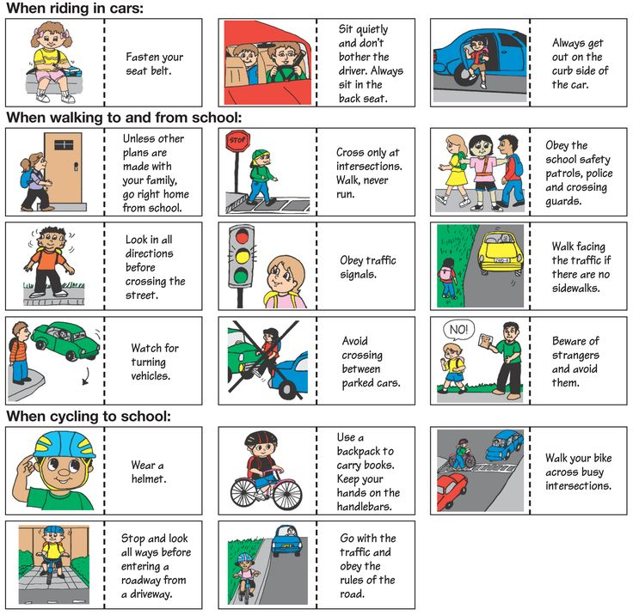

CARD 2
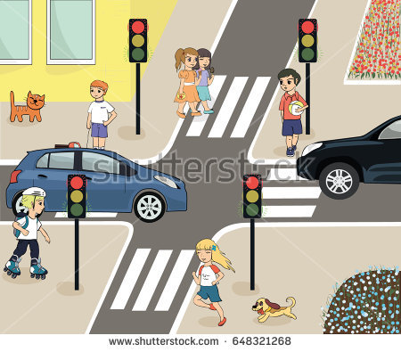

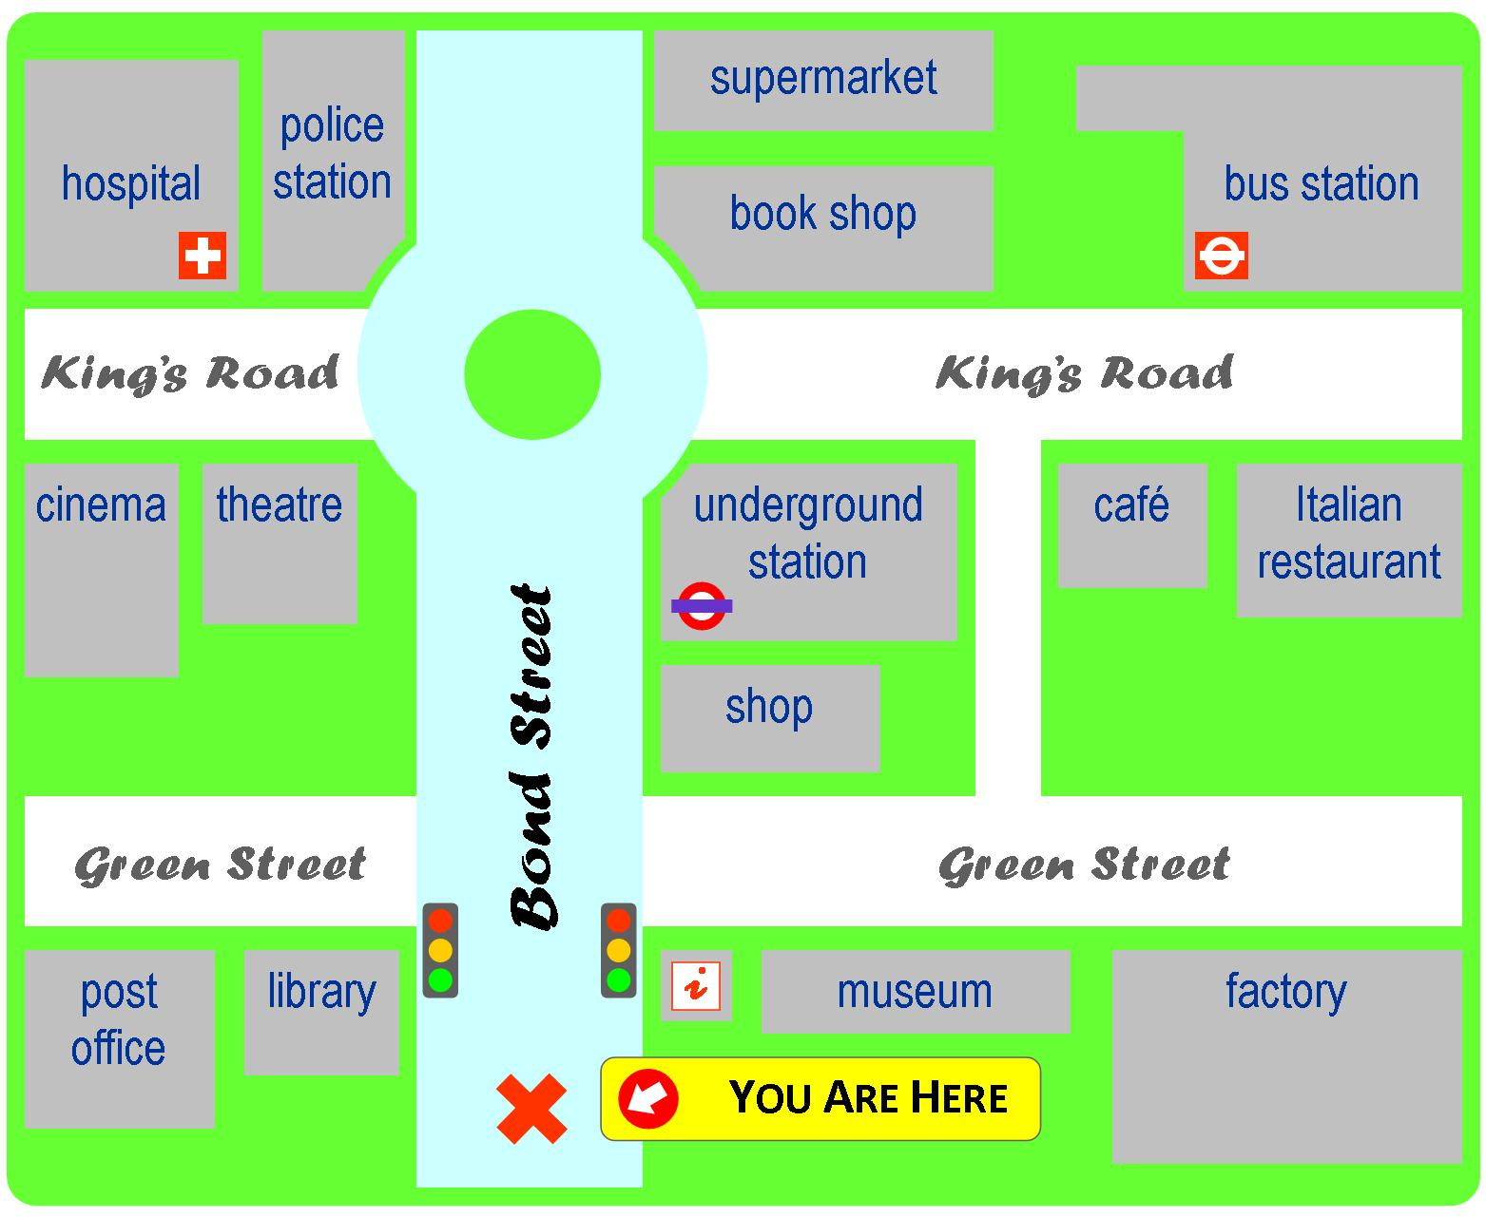
CARD 3

