План-конспект уроку у 5 класі
(за підручником Карп’юк О.Д., Англійська мова: Підручник для 5-го класу загальноосвітніх навчальних закладів. (5-й рік навчання) – Тернопіль: «Видавництво Астон», 2013. – 280 с.: іл.)
Урок №68
Клас 5-А
Дата: 26.02. Тема: Активний відпочинок (Outdoor activities)
Мета:
Практична: вдосконалення навичок мовлення за темою” Відпочинок й дозвілля”; введення нових ЛО;

Освітня: удосконалювати навички діалогічного мовлення, здатність користуватися граматичними ресурсами мови;
Розвивальна: розширювати словниковий запас учнів; розвивати мовленнєву реакцію, слухову пам’ять.
Виховна: виховувати в учнів розуміння поняття відпочинок, дозвілля, формувати інтерес до вивчення англійської мови, повагу до культури та традицій країни.

Обладнання: підручник, ілюстрації, роздатковий матеріал.
Тип уроку: комбінований.
Хід уроку:
І. Початок уроку.
1. Привітання. Бесіда з черговим учнем.
T.: Good afternoon, dear pupils! Nice to meet you. How do you feel today? Tell me, please, who is on duty today? What is your name? What is your surname? What day is it today? Who is absent today? What’s the matter with them? What season is it now? Do you like winter? Why? Or why not? What is the weather like today? Is it typical winter weather?
2. Мовленнєва зарядка.
T: Dear girls and boys! Look at each other! Smile to each other! A warm smile will encourage our work. Let’s repeat the poem “Life” after me all together.
Life is good!
Life is great!
Life is unbelievable!
Life is cool!
Life is sunny!
Life is so beautiful!
3. Перевірка домашнього завдання.
T: What was your hometask for today?
4. Оголошення теми і мети уроку.
T: Today, we are going to start a new topic “Outdoor activities”. You’ll learn new words on the topic and practice using them in dialogues and exercises.
ІІ. Основна частина уроку.
- Введення в іншомовну атмосферу.
Виконання впр.1,стр.168.
T: Pupils open your books on the p.168 and let’s do ex.1. please, say what activities do you do when the weather is hot, warm, cold, snowy, rainy.
- Пояснення нових ЛО і виконання вправ на їх закріплення.

Verb |  | Sport/Activity
PLAY | We use “play” in sports with teams, rules and competitions or tournaments.  Who did you play tennis with? I played tennis with Mark.  We played soccer last Sunday.  I didn’t play rugby on Sunday.  We played ultimate on Saturday. | Ultimate  Basketball  Football  Volleyball  Rugby  Tennis  Soccer
GO | Go + Gerund The name of the activity is the gerund form of the verb (-ing).  We often go camping in the summer.  We went camping last summer.  They didn’t go camping last December.  We went riding (horseback riding) on Sunday.  She went grocery shopping this morning.  I went swimming with my friends, yesterday.  Who did you go dancing with? I went dancing with Stella.  She’s got a new car and went driving for enjoyment. | Gerunds  Camping  Dancing  Hiking  Horse-riding  Sailing  Surfing  Swimming  Sightseeing  Driving  Skating  Shopping  Grocery-shopping  Cycling
DO | We use “do” in all other recreational activities like karate, yoga, etc.  Many people do gymnastics in the mornings.  I didn’t do athletics when I was at school.  She didn’t do aerobics yesterday.  Did she do karate when she was at school?  Sophie does yoga with a group of friends.  She did yoga when she was a teenager, | Aerobics  Athletics  Gymnastics  Judo  Karate  Yoga

Remember!
go boating
go canoeing
go sailing
go swimming
go camping
go fishing
go gathering mushrooms
go skating

покататися на човні
покататися на каное
відправитися в політ
купатися
відправитися в похід
відправитися на риболовлю
йти збирати гриби
покататися на ковзанах

Виконання впр.2, 3 стр.168
thermos flask - термос
tent - шатро , намет /tent/
sleeping bag [’sli:pɪŋ‚bæg] - спальный мешок
torch[tɔ:tʃ] - факел
gas-cooker - газова плита; ˈkʊ.kɜː
compass/ˈkʌm.pəs/ компас
canoe /kəˈnuː/ каное
- Розвиток діалогічного мовлення. Робота в парах.
T: Now, pupils, using this new words you should make dialogues. You make them in pairs, with your neighbors. You should to tell about the season and weather when you do your activities.
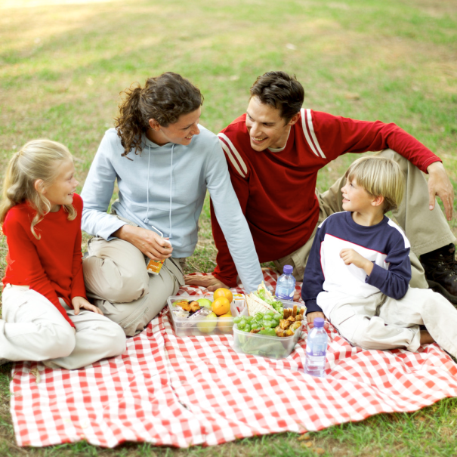
- Cитуативне завдання «На пікніку». Робота в гупах.
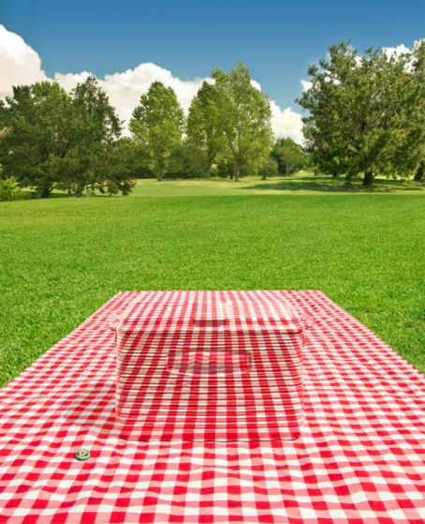

T: Do you like picnics? Look at the blackboard. Do you like this place?



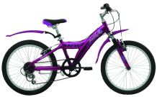

Imagine you are going to have a picnic there. Split into three groups. Each group will be given 6 pictures of the things you will need for a picnic, but you can take only 2of them with you. Choose things you will take and explain why. Take this pictures, go to the blackboard and stick this things.
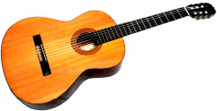

- Фізкультхвилинка.
T: I see you are a little bit tired. Let’s have a rest. Stand up, please, and do after me!
Hands up!
Hands to the sides!
Bend left, bend right!
Touch your nose,
Touch your head,
Turn right, turn left!
- Виконання тесту «Чи активний ти?»
T: Now, you’ll do a test. You have 2 minutes. And we’ll know how active you are.

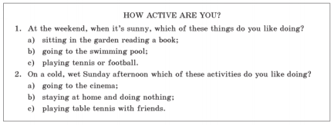

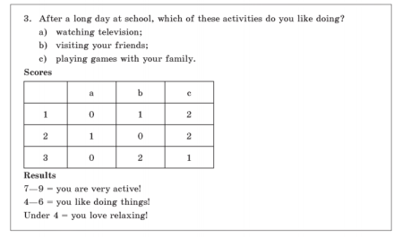

ІІІ. Заключна частина.
- Підсумки. Домашнє завдання.
T: Did you like our lesson today? What did you like most? Do you agree that outdoor activities are important?
So, open your diaries and write down your home task – ex.4, p.169, to write a composition on handouts.
- Оцінювання.
T: You have worked hard today. Your marks are… Thank you for the lesson! Good bye!

