План- конспект уроку
з англійської мови в 5 класі
«Past Simple»

вчитель англійської мови
І категорії
гімназії №267 м. Києва
Мельник Леся Вікторівна

Київ-2018
Topic: Helping
Theme: Past Simple
Suggested level- A1
Form: 5
Aims:
- to practice using Key Words «Community Problems» (vandalism, graffiti, litter, traffic, bulling, volunteer…) in Past Simple;
to practice Past Simple affirmative sentences and to teach Past Simple negative sentences and questions;
to revise time-expressions of Past Simple and Irregular Verbs;
- to develop speaking, listening and reading skills;
to develop skills of working in groups and pairs;
to develop imagination;
- to foster a culture of communication.

Materials:
- cards with Key Words and definitions
- Power Point Presentation
- Handouts
- microphone
- New Challenges 1 (Students’ Book, Workbook, Teacher’s Book)

LESON PROCEDURE
І. Introduction
1. Greeting (слайд 1)
2.Warming up: tongue twisters: /t/, /d/ (слайди 2,3)
1. | Two tiny tigers  Take two taxis to a town | 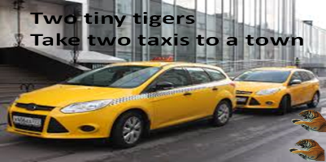
2. | If a doctor  is doctoring a doctor,  Does the doctor  is doing the doctoring

ІІ. MAIN PART
1. Topic of the lesson
-How do you think what we are going to speak about today? (слайд4)
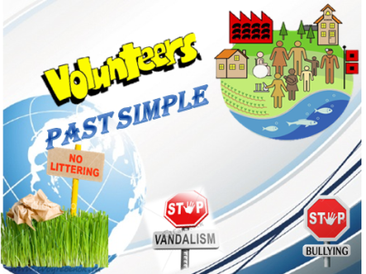
-Yes, you are right. Today we are going to speak about the problems in our community such as litter, bulling, vandalism and about grammar tense Past Simple.
2. Vocabulary
-Your home task was to learn the new words. Now read the word and give us its definition, or read the definition and say the word.

to frighten or  hurt a weaker person | 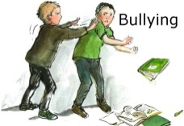
the crime of destroying or damaging public property
small pieces of rubbish such as paper, cans and bottles in public places | LITTER
all transport that is  on the road | TRAFFIC
a signal that controls  the traffic on a road | TRAFFIC LIGHTS
drawings or writing on a wall in public
places
all the people who live
in a country
a person who does a job
without being paid for it

3. Reading: SB: ex.2, p.72
-Read the text by roles.
Naseem Khan – local hero
I: Why did you start community work?
N: I wanted to help young people. They didn’t have place to go after school and at weekends. They were bored and we had a lot of problems with vandalism, graffiti and litter.
I: What did you do?
N: We tidied up the area by the station. We collected litter and broken glass. The council repaired the street lights and built some seats. We made a play area for children and a sports area for teenagers. We also raised money to build a skatepark.
I: Amazing! Did you have a lot of volunteers at the start?
N No, we didn’t. On the first, day we only had about ten people. And we didn’t have a lot of equipment. But we went to the local schools and asked for help. We got a lot of young volunteers.
I: And how often did you meet?
N: Once a week, on Saturday morning. We put people into groups and they worked on different areas.
I: Did you have any problems?
N: Yes, we did! Some people came just once and then didn’t return. And some people didn’t work very hard! But I general it was great. In three months, we made a big difference to the area.
I: Fantastic! And good luck with your next project.
N: Thanks a lot.

4. Grammar: Fairy tale «Past Simple»
1) - Let’s revise the fairy tale about Past Simple.
a) time-expressions
In English Grammar Land there is a kingdom «Past Simple».The king of this kingdom is Yesterday(слайд 6).
-His brothers Last and Ago help him to rule. (слайд 7 )
b) regular verbs
-In this kingdom everybody tells about what they did or what happened. Lots of dwarves live here. Every dwarf is an action which was done (a verb). The dwarves wear shoes «-ed». The dwarves who wear shoes are called «Regular Verbs». (слайд 8)
- The shoes are of different colours: red, blue and green. They make different sounds:
- the red shoes- /t/
- the blue shoes-/d/
- the green shoes-/id/ (слайд 9)
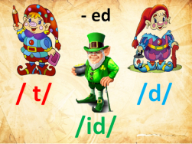
-Now take the papers and read . (слайд 10)
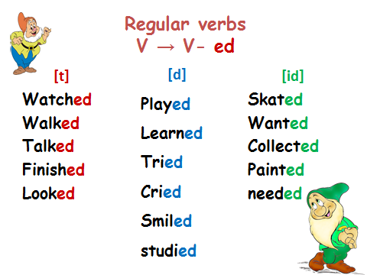
c) irregular verbs
-But some dwarves don’t keep to the rules. They don’t want to wear shoes. They like to wear costumes. These dwarves are called «Irregular verbs». (слайд 11)
-They are very rich and each of them have three costumes (three forms). (слайд 12)
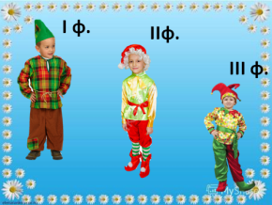
-Let’s revise the irregular verbs you had to learn at home. Match two forms and write the translations in your copy books. (слайд 13)
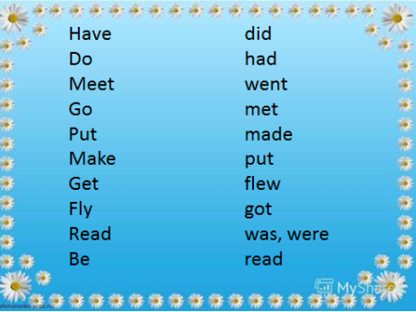
-Check, please. (слайд 14)
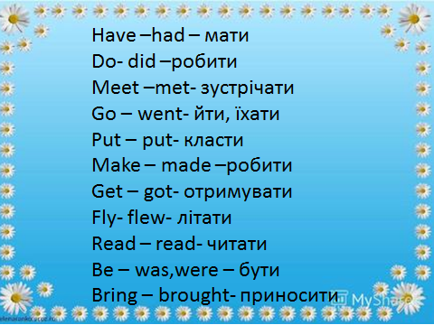
2) -So, my dear students. You have already known the first part of the fairy tale. It’s time to listen to the second one.
-There are two servants in this kingdom: Did and didn’t.
Didn’t helps the king to find out what didn’t happen. It always stands before the dwarf (verb). But didn’t takes a pay for his help. He takes the shoes –ed or the second costume. So the dwarves stay without the shoes or in the first costume. (слайд15)
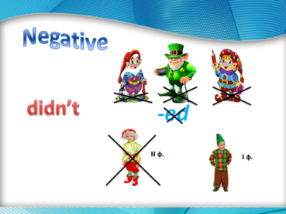
5. Work with the text: SB: ex.2, p.72
-Now take a red pen or pencil and underline the negative sentences in the text.
-Let’s check. (слайд 16)
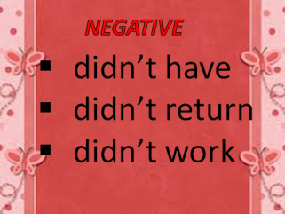
-But the king sometimes wonders if something was done. In this case the servant Did helps him. Did stands on the first place and take a pay too: the shoes and the second costumes. (слайд 17)
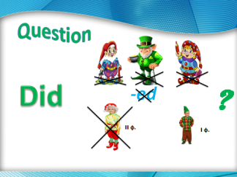
-Now take a green pen or pencil and underline the questions in the text.
-Let’s check. (слайд 18)
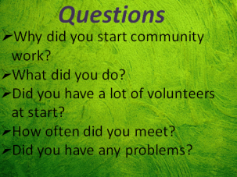
-Now take a blue pen or a pencil and underline the short answers in the text.
-Let’s check. (слайд 19)
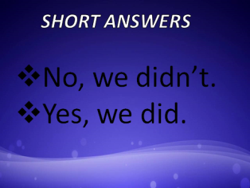

6. Фізкультхвилинка (https://www.youtube.com/watch?v=d6d6Avbpjf8)
Hokey Pokey Lyrics:  You put your right foot in,  You put your right foot out;  You put your right foot in,  And you shake it all about.  You do the Hokey-Pokey,  And you turn yourself around.  That's what it's all about!  You put your left foot in,  You put your left foot out;  You put your left foot in,  And you shake it all about.  You do the Hokey-Pokey,  And you turn yourself around.  That's what it's all about!  You put your right hand in,  You put your right hand out;  You put your right hand in,  And you shake it all about.  You do the Hokey-Pokey,  And you turn yourself around.  That's what it's all about! | You put your left hand in,  You put your left hand out;  You put your left hand in,  And you shake it all about.  You do the Hokey-Pokey,  And you turn yourself around.  That's what it's all about!  You put your whole self in,  You put your whole self out;  You put your whole self in,  And you shake it all about.  You do the Hokey-Pokey,  And you turn yourself around.  That's what it's all about!

7. Writing: SB: ex.7, p.73
-Now your task is to correct the sentences about Naseem and his work. You have to make negative sentences and then true positive ones. Read the examples.
- Naseem wanted to help animals.
Naseem didn’t want to help animals. He wanted to
help young people.
- They had a lot of problems with bulling.
- Th council repaired the traffic lights.
- Naseem had a lot of volunteers on the first day.
- Naseem went to the local shops to ask for help
- Naseem’s group met on Sunday.

-Let’s check (слайди 20,21)
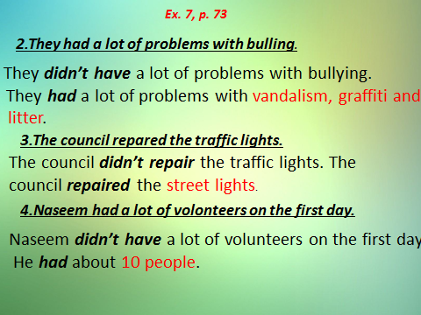 | 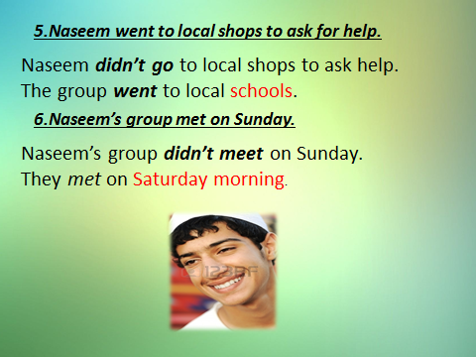

8. Listening and acting out (work in groups)
Відео «What did you do yesterday?» (https://www.youtube.com/watch?v=tGWiowdjnHk)

9.Work in pairs: SB: ex.8,p.73
-You have to work in pairs. Ask and answer. Change the roles.

- He / win / a prize?
Did he win a prize?- Yes, he did.
- Who / he / help?
- What problems / young people / have?
- Where in the town / Naseem / work?
- The council / help / on the project?
- The / group / have / a lot of equipment?
- They / get / the same volunteers / every week?
- How long / they / work on the area?

-Check, please. (слайди 22,23)
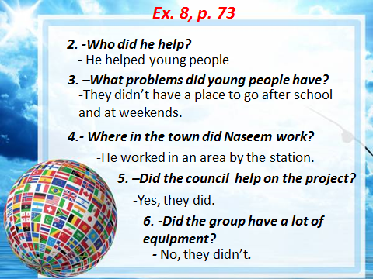 | 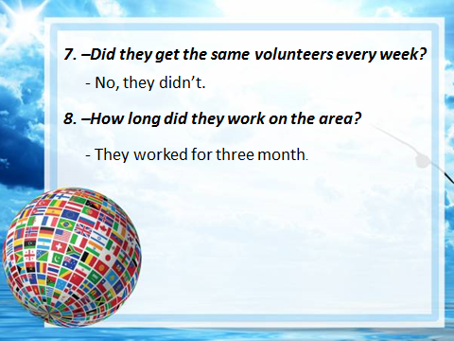

ІІІ. FINAL PART

1.Summing up:
a) Technology «Microphone» (слайд 24)

-So, my dear students, tell me please,
- what you know
- what you can
- what you are good at

Students take a microphone in turn and answer.

b) Reflecion
-You have got such papers on your desks. Put a tick in the line which is about you.
(слайд 25)

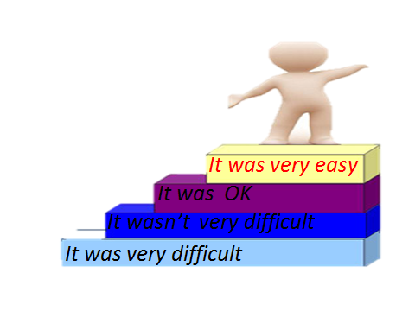

2. Evaluation of Students’ activities.
3.Homework (слайд 26)
