ГІМНАЗІЯ №267 м. КИЄВА

Додатковий матеріал
до теми «Розваги»
(7 клас)

Вікторія Віталіївна Олекса,
вчитель англійської мови вищої категорії,
старший учитель

2018
Parts (Розділи)
- What is Entertainment?
Що таке розваги?
- Types of Entertainment.
Види розваг.
- Quotations.
Вислови про розваги.
- Useful vocabulary.
Лексика до теми.
- Entertainment World:
Світ розваг:
Circus of the Sun.
Цирк Сонця.
Shakespeare’s Globe.
Театр Шекспіра «Глобус».
Interesting facts about music.
Цікаві факти про музику.
Sports and Games.
Спорт та ігри.
Hollywood.
Голлівуд-центр кіноіндустрії.
Charlie Chaplin.
Чарлі Чаплін-зірка світового кінематографу.
Walt Disney.
Волт Дісней та його герої.
Brazilian Carnival.
Бразильський карнавал.
- Exercises.
Вправи до теми (авторська розробка)
- Keys.
Ключі до вправ.

Entertainment is an activity designed to give people pleasure or relaxation. An audience may participate in the entertainment passively as in watching opera or a movie, or actively as in games.
Entertainment has been around almost since the beginning of human time, when early humans started painting in caves. The playing of sports and reading of literature are usually included in entertainment, but these are often called recreation, because they involve some active participation beyond mere leisure.

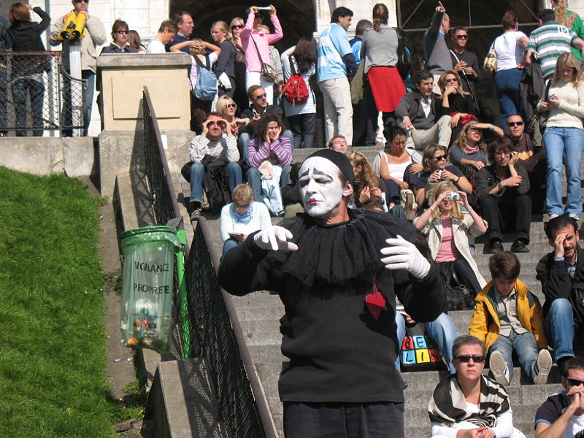

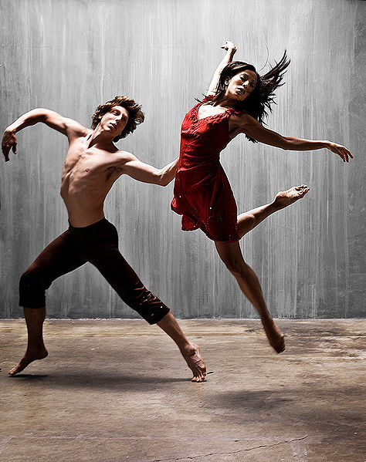
Types of entertainment

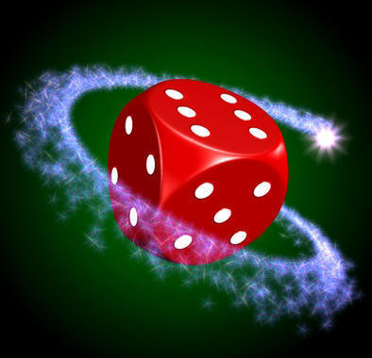
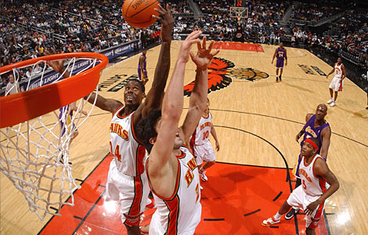
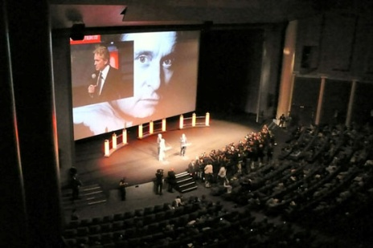
games sports

cinema

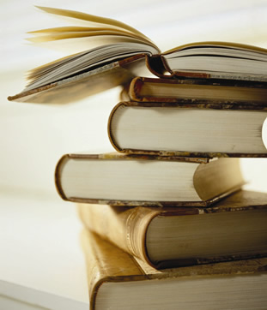
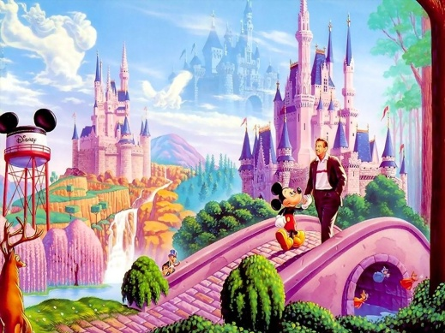
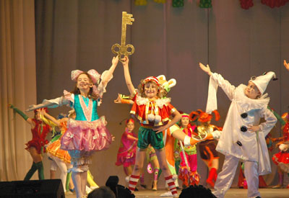
theatre

reading
animation
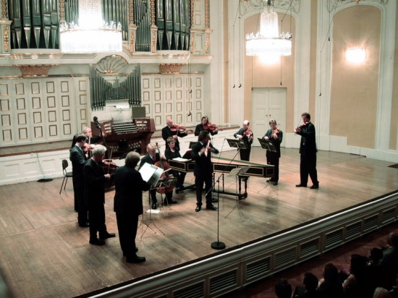
dance

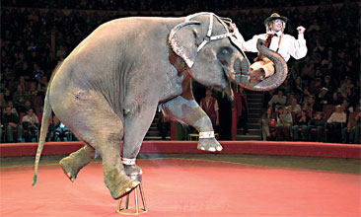
circus

music

Here are famous quotations about entertainment

We aren't in an information age, we are in an ENTERTAINMENT age.
Anthony Robbins

No ENTERTAINMENT is so cheap as reading, nor is any pleasure so lasting.
Mary Wortley Montagu

Nothing is so intolerable to man as being fully at rest, without a passion, without business, without ENTERTAINMENT, without care.
Blaise Pascal

Politics is the entertainment branch of industry.
Frank Zappa

That's what music is entertainment. The more you put yourself into it, the more of you comes out in it.
Kurt Cobain

In a cruel and evil world, being cynical can allow you to get some entertainment out of it.
Daniel Waters

Anyone who tries to make a distinction between education and entertainment doesn't know the first thing about either.
Marshall McLuhan

To me, bad taste is what entertainment is all about.
John Waters

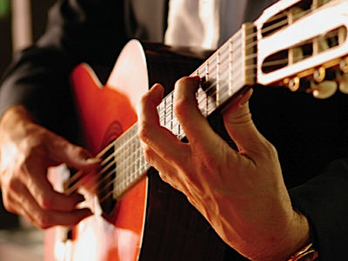

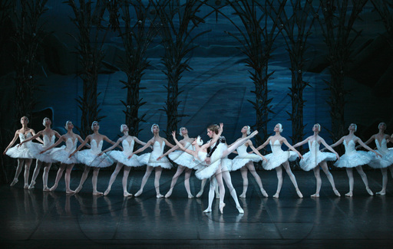
Some types of Watching
entertainment Verbs
applaud attend cheer
clap cry laugh
listen participate watch

Places
auditorium circle orchestra
seat stalls ticket office

People
audience critic spectator
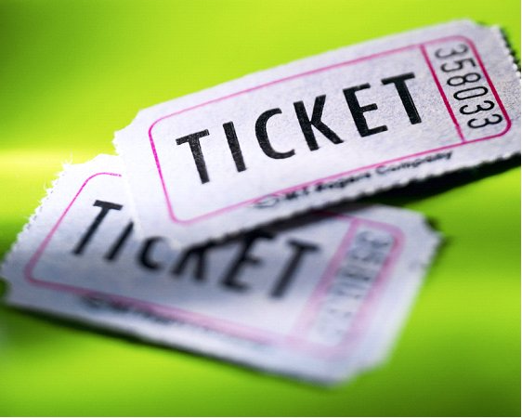

ballet cinema circus
comedy concert dance
drama opera play
music tragedy theatre
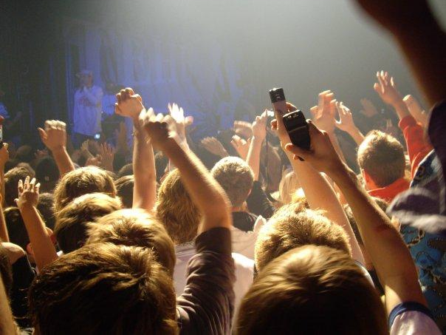
Commenting
Positive
Bravo! Encore! exciting
fantastic funny great
moving superb wonderful
Neutral
not bad O.K. so-so
Negative
awful Boo! boring
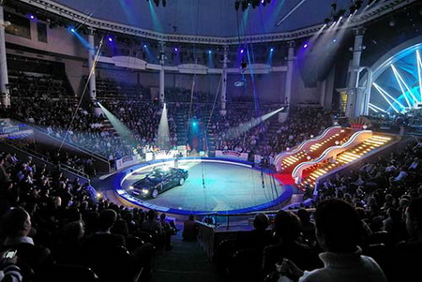
Taking part disastrous dull terrible
Verb
act compose dance
film perform play
record rehearse sing
Places
concert hall platform screen
stadium stage tent
tent theatre
People
actor artist comedian
composer conductor dancer

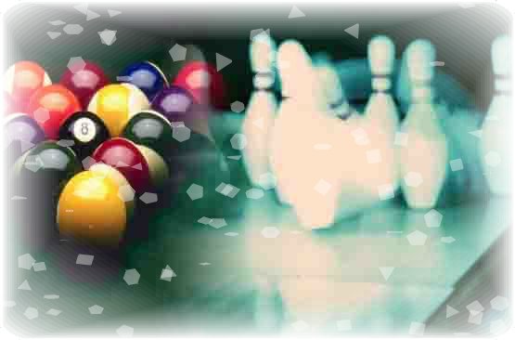

Circus of the Sun
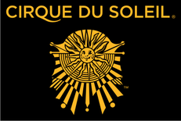
Cirque du Soleil (French for "Circus of the Sun," in English) is an entertainment company. Based in Montreal, Quebec, Canada and located in the inner-city area of Saint-Michel, it was founded in Baie-Saint-Paul in 1984 by two former street performers, Guy Laliberté and Daniel Gauthier.
Initially named Les Échassiers, they toured Quebec in 1980 as a performing troupe and encountered financial hardship that was relieved by a government grant in 1983 as part of the 450th anniversary celebrations of Jacques Cartier's discovery of Canada. Le Grand Tour du Cirque du Soleil was a success in 1984, and after securing a second year of funding, Laliberté hired Guy Caron from the National Circus School to re-create it as a "proper circus". No ring and no animals helped make Cirque du Soleil the modern circus ("Cirque Nouveau"/New Circus) that it is today.
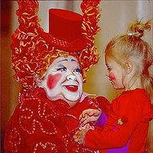
Each show is a synthesis of circus styles from around the world, with its own central theme and storyline. They draw the audience into the performance through continuous live music, with performers rather than stagehands changing the props, and by having no curtains. After critical and financial successes (Los Angeles Arts Festival) and failures in the late 1980s, Nouvelle Expérience was created – with the direction of Franco Dragone – which not only made Cirque profitable by 1990, but allowed it to create new shows.
Cirque expanded rapidly through the 1990s and 2000s, going from one show with 73 employees in 1984 to approximately 3,500 employees from over 40 countries producing 15 shows over every continent except Africa and Antarctica, with an estimated annual revenue exceeding US$600 million. The multiple permanent Las Vegas shows alone play to more than 9,000 people a night, 5% of the city's visitors, adding to the 70+ million people who have experienced Cirque. In 2000, Laliberté bought out Gauthier, and with 95% ownership, has continued to expand the brand. Several more shows are in development around the world, along with a television deal, women's clothing line and the possible venture into other mediums such as spas, restaurants and nightclubs.
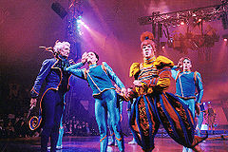
Cirque's creations have been awarded numerous prizes and distinctions, including Bambi, Rose d'Or, three Gemini Awards and four Primetime Emmy Awards. In 2004, Interbrand's poll of brand names with the highest global impact ranked Cirque du Soleil as number 22.

Seeking a career in the performing arts, Cirque du Soleil founder Guy Laliberté toured Europe as a folk musician and busker after quitting college. By the time he returned back home to Canada in 1979, he had learned the art of fire breathing. Although he became "employed" at a hydroelectric power plant in James Bay, his job ended after only three days due to a labour strike. He decided not to look for another job, instead supporting himself on his unemployment insurance. He helped organize a summer fair in Baie-Saint-Paul with the help of a pair of friends named Daniel Gauthier and Gilles Ste-Croix.
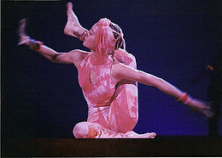
Gauthier and Ste-Croix were managing a youth hostel for performing artists named Le Balcon Vert at that time. By the summer of 1979, Ste-Croix had been developing the idea of turning the Balcon Vert, and the talented performers who lived there, into an organized performing troupe. Although the talent was plentiful, they lacked the funding to make their idea a reality. As part of a publicity stunt to convince the Quebec government to help fund his production, Ste-Croix walked the 56 miles from Baie-Saint-Paul to Quebec City on stilts. The ploy worked, giving the three men the money to create Les Échassiers de Baie-Saint-Paul. Employing many of the people who would later make up Cirque, Les Échassiers toured Quebec during the summer of 1980.
Although well-received by audiences and critics alike, Les Échassiers was a financial failure. Laliberté spent that winter in Hawaii plying his trade while Ste-Croix stayed in Quebec to set up a nonprofit holding company named "The High-Heeled Club" to mitigate the losses of the previous summer. In 1981, they met with better results. By that fall, Les Échassiers de Baie-Saint-Paul had broken even. The success inspired Laliberté and Ste-Croix to organize a summer fair in their hometown of Baie-Saint-Paul.
This touring festival, called "La Fête Foraine," first took place in July 1982. La Fēte Foraine featured workshops to teach the circus arts to the public, after which those who participated could take part in a performance. Ironically, the festival was barred from its own hosting town after complaints from local citizens. Laliberté managed and produced the fair over the next couple years, nurturing it into a moderate financial success. But it was during 1983 that the government of Quebec gave him a $1.5 million grant to host a production the following year as part of Quebec's 450th anniversary celebration of the French explorer Jacques Cartier's discovery of Canada. Laliberté named his creation "Le Grand Tour du Cirque du Soleil".

Shakespeare's Globe
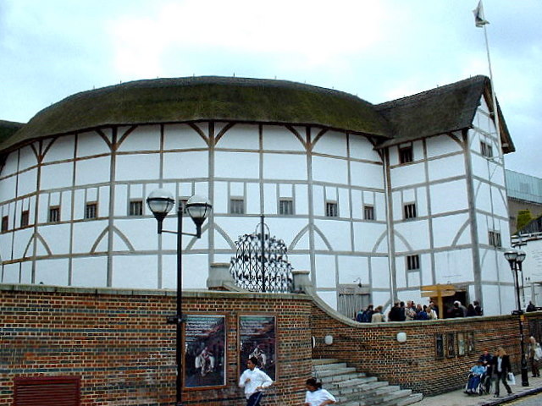
The Globe Theatre was a theatre in London associated with William Shakespeare. It was built in 1599 by Shakespeare's playing company, the Lord Chamberlain's Men, and was destroyed by fire on 29 June 1613. A second Globe Theatre was rebuilt on the same site by June 1614 and closed in 1642.
A modern reconstruction of the Globe, named "Shakespeare's Globe", opened in 1997. It is approximately 230 metres (750 ft) from the site of the original theatre.
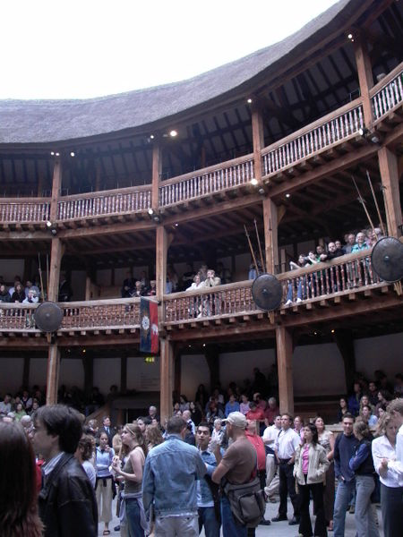
The Globe was owned by actors who were also shareholders in the Lord Chamberlain's Men. Two of the six Globe shareholders, Richard Burbage and his brother Cuthbert Burbage, owned double shares of the whole, or 25% each; the other four men, Shakespeare, John Heminges, Augustine Phillips, and Thomas Pope, owned a single share, or 12.5%. (Originally William Kempe was intended to be the seventh partner, but he sold out his share to the four minority sharers, leaving them with more than the originally planned 10%). These initial proportions changed over time as new sharers were added. Shakespeare's share diminished from 1/8 to 1/14, or roughly 7%, over the course of his career.
The Globe was built in 1599 using timber from an earlier theatre, The Theatre, which had been built by Richard Burbage's father, James Burbage, in Shoreditch in 1576. The Burbages originally had a 21-year lease of the site on which The Theatre was built but owned the building outright. However, the landlord, Giles Allen, claimed that the building had become his with the expiry of the lease. On 28 December 1598, while Allen was celebrating Christmas at his country home, carpenter Peter Street, supported by the players and their friends, dismantled The Theatre beam by beam and transported it to Street's waterfront warehouse near Bridewell. With the onset of more favourable weather in the following spring, the material was ferried over the Thames to reconstruct it as The Globe on some marshy gardens to the south of Maiden Lane, Southwark.
On 29 June 1613 the Globe Theatre went up in flames during a performance of Henry the Eighth. A theatrical cannon, set off during the performance, misfired, igniting the wooden beams and thatching. According to one of the few surviving documents of the event, no one was hurt except a man whose burning breeches were put out with a bottle of ale. It was rebuilt in the following year.
Like all the other theatres in London, the Globe was closed down by the Puritans in 1642. It was pulled down in 1644, or slightly later, to make room for tenements.
Examination of old property records has identified the plot of land occupied by the Globe as extending from the west side of modern-day Southwark Bridge Road eastwards as far as Porter Street and from Park Street southwards as far as the back of Gatehouse Square. The precise location of the building however, remained unknown until a small part of the foundations, including one original pier base, was discovered in 1989 beneath the car park at the rear of Anchor Terrace on Park Street. The shape of the foundations is now replicated on the surface. As the majority of the foundations lie beneath Anchor Terrace itself, which is a listed building, no further excavations have been permitted.
The Globe's actual dimensions are unknown, but its shape and size can be approximated from scholarly inquiry over the last two centuries. The evidence suggests that it was a three-storey, open-air amphitheatre approximately 100 feet (30 m) in diameter that could house up to 3,000 spectators. The Globe is shown as round on Wenceslas Hollar's sketch of the building, later incorporated into his engraved "Long View" of London in 1647. However, in 1988-89, the uncovering of a small part of the Globe's foundation suggested that it was a polygon of 20 sides.
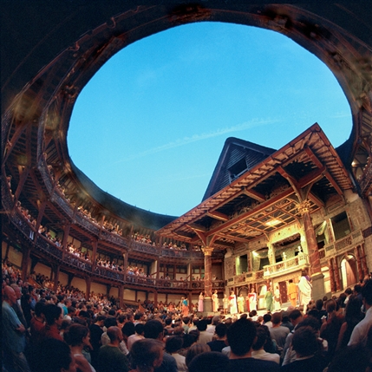
Large columns on either side of the stage supported a roof over the rear portion of the stage. The ceiling under this roof was called the "heavens," and was painted with clouds and the sky. A trap door in the heavens enabled performers to descend using some form of rope and harness. The back wall of the stage had two or three doors on the main level, with a curtained inner stage in the centre and a balcony above it. The doors entered into the "tiring house" (backstage area) where the actors dressed and awaited their entrances. The balcony housed the musicians and could also be used for scenes requiring an upper space, such as the balcony scene in Romeo and Juliet. Rush matting covered the stage, although this may only have been used if the setting of the play demanded it.
Interesting facts about music
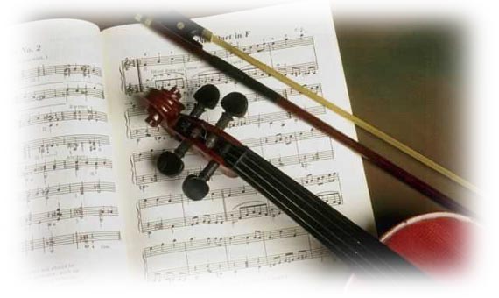
Whistles and flutes around 25,000 years old have been found at Upper Paleolithic sites of the Aurignacian Period.

The first recorded use of the flute, clarinet, oboe, and trumpet was in an cient Egypt.

The first pipe organ was made by Archimedes in 220 B.C.

The longest hymn is Hora novissima tempora pessima sunt; vigilemus by Bernard of Cluny, which is 2,966 lines long.

The earliest known example of musical notation was found on a clay tablet in Mesopotamia (modern-day Iraq), dated to around 1,800 B.C.

"Old King Cole" was a real person. Coel was a fourth-century British prince who is said to be the father of St. Helen, who was the mother of Roman emperor Constantine. Coel appreciated music, which may be why the nursery rhyme makes mention of "his fiddlers three".

The Gregorian chant was named after Pope St. Gregory I.

Jean-Baptiste Lully (1632–1687), the first documented conductor, was the first musician to use a baton. It was a heavy, six-foot-long staff that he pounded on the ground in time to the music. One day, at a concert to celebrate the king's return to health, he accidently stuck the staff into his foot. He developed gangrene and died.

Before the invention of the mechanical clock in the 14th century, the most complex machine was a pipe organ in the cathedral in Winchester, England. It was installed by Bishop Aelfeg around 950 A.D. It had 400 pipes, and 70 men were needed to operate the 26 bellows.

Only one person walked with Mozart's coffin from the church to the cemetery where Mozart was buried in an unmarked pauper's grave.

In contrast to Mozart, who by his death at age 35 had written 41 symphonies, Johannes Brahms did not publish his first symphony until he was 43 years old.

The shortest national anthem is the Japanese national anthem, which is only four lines long. The longest is the Greek national anthem, which is 158 verses long.

Hungarian musician Franz Liszt received so many requests for locks of his hair that he bought a dog and snipped off patches of fur to send to admirers.

Mendelssohn left the score for his A Midsummer Night's Dream overture in a cab, and was able to rewrite every note from memory.

Jimi Hendrix, Janis Joplin, Jim Morrison, and Kurt Cobain all died at age 27.

Because the middle finger on each hand was considered too short, Ignace Jan Paderewski, the famous Polish pianist, composer, and statesman, was told by a teacher that he could never expect to be a competent pianist.
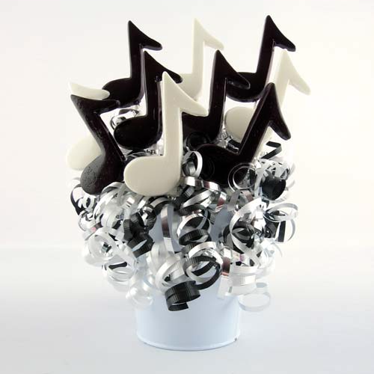
The largest musical instrument in the world is the organ in the Municipal Auditorium, in Atlantic City. Designed by U.S. senator Emerson L. Richards and completed in 1930, the organ has 33,112 pipes ranging in length from 6 millimetres to 19.4 metres.

While bagpipes are today identified with Scotland, they date from ancient times and may have been introduced into the British Isles by the Romans.

Tchaikovsky suffered from many mental breakdowns and neuroses. He believed that his head would fall off, so when conducting an orchestra he would hold his chin with his left hand.
The world's shortest opera is Milhaud's The Deliverance of Theseus, which was first performed in 1928 and is only 7 minutes 27 seconds long.
After attending the first performance of Mozart's opera The Marriage of Figaro, the Emperor Joseph II's only comment was "Too many notes".
American composer John Cage (1912–1992) composed a work in 1952 entitled 4' 33", which consists of four minutes and thirty-three seconds of silence.
A 1964 piece of music written by avant-garde American composer Lamonte Young is called "The Tortoise Recalling the Drone of the Holy Numbers as They Were Revealed in the Dreams of the Whirlwind and the Obsidian Gang, Illustrated by the Sawmill, the Green Sawtooth Ocelot, and the High-tension Line Stepdown Transformer".

Sports and Games

The ancient Egyptians played a game like bo wling using large stones set up as pins and small stones as a ball.

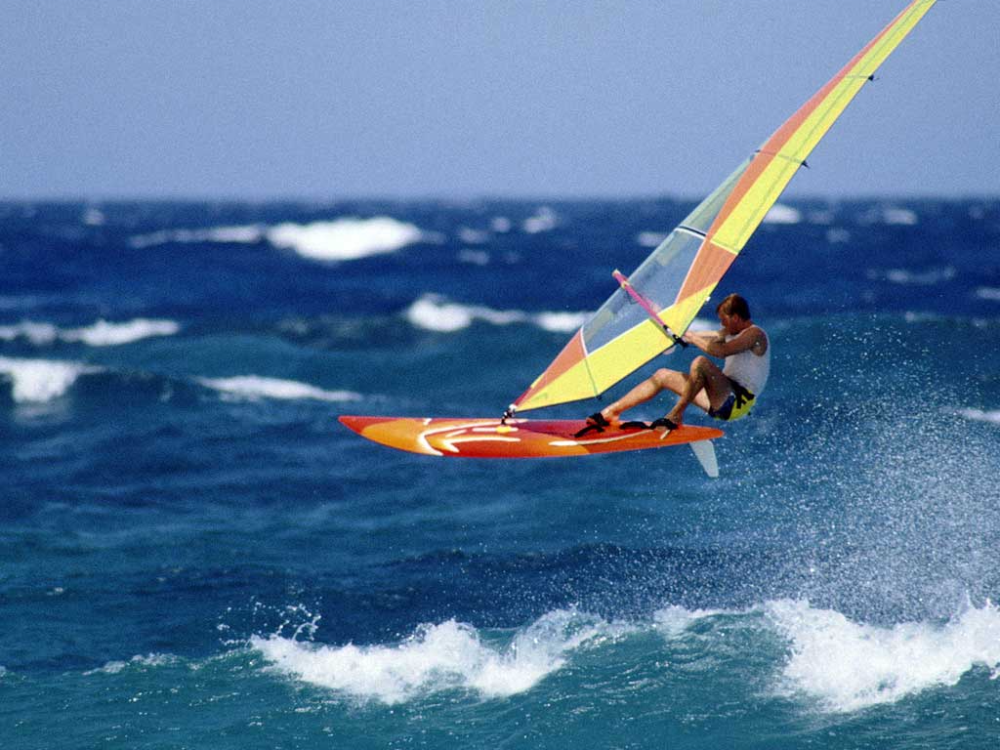
The first (ancient Greek) Olympic games were held in 776 B.C. The only event was a short footrace down the centre of the stadium in Olympia.

Around 600 B.C., a Greek athlete named Protiselaus threw a discus 152 feet from a standing position. That distance was not exceeded until over 2,500 years later, when Clarence Houser threw a discus 155 feet in 1928

The ancient Romans first played a game like golf using bent wooden sticks and a leather ball stuffed with feathers.

The oldest Major League Baseball teams are the Atlanta Braves and the Chicago Cubs. They were formed in 1871 as the Boston Red Stockings and the Chicago White Stockings, respectively.

During the hundred days of the opening games at the Colosseum in Rome, in 80 A.D., over 5,000 animals were killed, including elephants, tigers, lions, elks, hyenas, hippopotamuses, and giraffes.

There are 318,979,564,000 ways of playing the first four turns in a game of chess. There are 169,518,829,100,544,000,000,000,000,000 ways of playing the first ten turns of a game of chess.

Honey has been used both as a centre for golf balls and in antifreeze mixtures.

The longest major league baseball game on record was played on May 1st, 1921, between the Brooklyn Dodgers and Boston Braves. It was called at the end of 26 innings on account of darkness, with the score tied 1-1. Brooklyn's Leon Cadore and Boston's Joe Oeschger both pitched the entire 26 innings. The entire game lasted only 3 hours 50 minutes.

The average life span of a major league baseball is 7 pitches.

Even though "Shoeless Joe" Jackson was barred from baseball's Hall of Fame for his role in the 1919 "Black Sox" scandal, his shoes can be found there.

If the air conditioning at the Astrodome in Houston were turned off, it would rain inside the stadium due to the entrance of humid air.

Thailand, Laos, and Cambodia are building a 27-hole golf course on the border between the three countries, with nine holes in each country. Much of the area proposed for the golf course is currently a minefield.

Parker Brothers prints more money each year for its Monopoly games than the U.S. Government issues in real currency.

American football has the highest injury rate of any sport, with a rate 12 times higher than basketball, the next most injurious sport. Most NFL players eventually suffer a career-ending or career-shortening injury sometime in their career.

The total number of different bridge hands possible is roughly 54,000,000,000,000,000,000,000,000,000.

For the 1960 Summer Olympics in Rome, the Roman Olympic Organisation Committee made a deal with the Association of Roman Thieves not to engage in street thefts during the Olympics. So, during the games, occurrences of pickpocketing, purse snatching, and holdups were at a low.

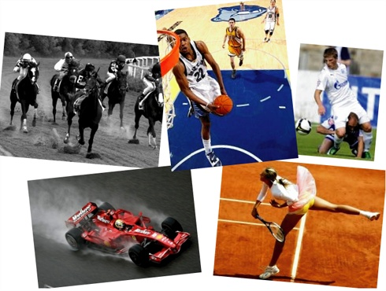
The highest score in a Scrabble game is 1,049, set by Phil Abbleby in 1989. His opponent scored 253 points in the game. The record score for one move was set by Dr. Saladin Karl Khoshnaw, who scored 392 points for playing "CAZIQUES" (meaning "native chiefs of West Indian aborigines"), in a 1982 competition in Manchester.

According to the third edition of The Official Scrab ble Players Dictionary, there are 20 valid words containing no vowels.

Hollywood

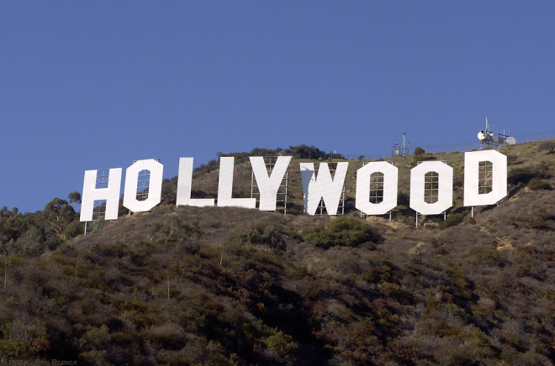
Hollywood is one of the districts of Los Angeles, California. It is identified as one of the most happening places in world. Hollywood is the metonym for the motion picture industry of the United States. The nickname of the Hollywood is "Tinseltown". In February 2006, Goldberg and Koretz, the Assembly members introduced a bill to specify the geographical boundaries of Hollywood. Hollywood Chamber of Commerce and the City Council of LA supporte d this bill and on August 28,2006, this bill was approved by the Governor of California.
The official borders of Hollywood are Beverly Hills on the east, Mulholland Drive, Laurel Canyon, Barham Boulevard and Cahuenga Boulevard on the south, Melrose Avenue on the north, Hyperion Avenue and the Golden State Freeway on the west. Chamber of Commerce, Hollywood, appointed an official who serves as "Honorary Mayor of Hollywood".
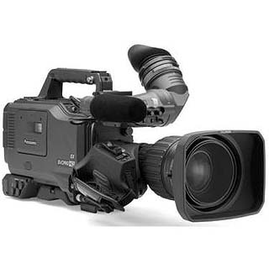
In 1906, a streetcar line was constructed in the Hollywood district down the middle of "Sandy Road". This lane was known as the "Rose City Line". The establishment of the streetcar route facilitated the growth of the suburb of Hollywood.
In 1923, Harry Chandler, a real estate agent and investor built the famous Hollywood Sign to advertise the area "Hollywoodland". The total expense for this advertisement was $21,000. Initially, it was built to last only for eighteen months. However, as of today, the Hollywood Sign has lasted for eighty years.
In 1939, four thousand twenty-watt bulbs were put to illuminate the signboard and a caretaker was appointed to maintain the same. The part of land, which included the "Hollywood" sign, was sold to the city of LA.
In 1949, the alphabets "L, A, N & D" were removed. The board has read "HOLLYWOOD" ever since 1949.
The alphabets of the signboard began to fall down. To restore the same, in 1978 an auction of the alphabets was held by Hugh Hefner, founder of the magazine "Playboy". This auction was held for a period of three months. Alice Cooper, American rock singer, sponsored the alphabet "O". Gene Autry and Paul Williams sponsored the alphabets "L" and "W" respectively.
In 1995, a trust known as "Hollywood Sign Trust" was setup to maintain the Hollywood sign.
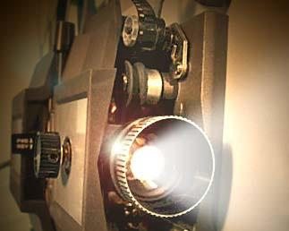
Hollywood is known as the Cinema district of the United States. The reason is it houses many famous theaters and it is the home of many famous and popular film stars.
On May 1927, a Chinese theater known as "Grauman’s Chinese Theatre" was opened in Hollywood. It is one of the most popular and legendary theaters in the world. This Chinese theater is one of the major tourist attractions of the entertainment district. An attractive feature of this theater is its jade-green bronze roof, which is 90 feet high. Grauman’s Chinese Theatre houses many artifacts from China and is truly a Chinese landmark in Hollywood. One of the courts of the theater has the foot and hand prints of various Hollywood legends such as Marilyn Monroe, Judy Garland, John Wayne, Jack Nicholson and so on.
"El Capitan Theatre" hosts many live stage shows and world premieres of the movies. The Walt Disney Company and Pacific Theaters of Warner Brothers renovated it in 1989.

In November 2001, "Kodak Theatre" with the seating capacity of over 3000 was opened in the heart of Hollywood. This theater has become the first permanent location of the Academy Awards.
The other famous theatres include the "Egyptian Theatre" and "Pantages Theatre". These theaters run behind-the-scenes of movies and features dance performances and musical concerts.
Did you know C.C. Brown’s Ice Cream in Hollywood made h ot fudge sundae?
Hollywood Hotel near Northwest Corner of Hollywood and Highland was the first hotel where the elite and movie stars of the yesteryear and those of today gather for lunch or dinner.
In 1920s, the Embassy Club located in Christie Realty building catered to the elite of the Hollywood.
Montmarte Café was the first nightclub of Hollywood. It is believed the actress Joan Crawford was discovered here.
One of the oldest restaurants favored by many in Hollywood is "Musso and Frank Grill". An oldest and the first tourist attraction of Hollywood is Paul DeLongpre Home.

Charlie Chaplin

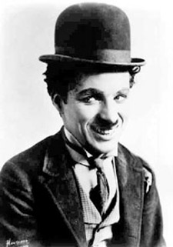
Sir Charles Spencer Chaplin, Jr. KBE (16 April 1889 – 25 December 1977), better known as Charlie Chaplin, was an Academy Award-winning English comedic actor and filmmaker. Chaplin became one of the most famous actors as well as a notable filmmaker, composer and musician in the early to mid "Classical Hollywood" era of American cinema.
Chaplin acted in, directed, scripted, produced and eventually scored his own films as one of the most creative and influential personalities of the silent-film era. His working life in entertainment spanned over 65 years, from the Victorian stage and the Music Hall in the United Kingdom as a child performer almost until his death at the age of 88. His high-profile public and private life encompassed both adulation and controversy. With Mary Pickford, Douglas Fairbanks and D. W. Griffith, Chaplin co-founded United Artists in 1919.
In a review of the book Chaplin: A Life (2008), Martin Sieff writes: "Chaplin was not just 'big', he was gigantic. In 1915, he burst onto a war-torn world bringing it the gift of comedy, laughter and relief while it was tearing itself apart through World War I. Over the next 25 years, through the Great Depression and the rise of Hitler, he stayed on the job. He was bigger than anybody. It is doubtful any individual has ever given more entertainment, pleasure and relief to so many human beings when they needed it the most."
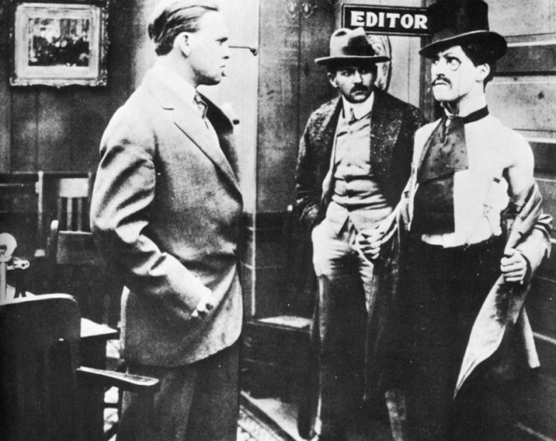
Chaplin was born on 16 April 1889, in East Street, Walworth, London. His parents were both entertainers in the music hall tradition; his father being a vocalist and an actor and his mother, a singer and an actress. They separated before Charlie was three. He learned singing from his parents. The 1891 census shows that his mother, the actress Hannah Hill, lived with Charlie and his older half-brother Sydney on Barlow Street, Walworth. As a child, Charlie also lived with his mother in various addresses in and around Kennington Road in Lambeth, i ncluding 3 Pownall Terrace, Chester Street and 39 Methley Street. His maternal grandmother was half-Gypsy, a fact of which he was extremely proud, but also described as "the skeleton in our family cupboard". Chaplin's father, Charles Chaplin, Sr., was an alcoholic and had little contact with his son, though Chaplin and his half-brother briefly lived with their father and his mistress, Louise, at 287 Kennington Road where a plaque now commemorates the fact. The half-brothers lived there while their mentally ill mother resided at Cane Hill Asylum at Coulsdon. Chaplin's father's mistress sent the boy to Kennington Road School. His father died of alcoholism when Charlie was twelve in 1901. As of the 1901 Census, Charles resided at 94 Ferndale Road, Lambeth, with The Eight Lancashire Lads, led by John William Jackson (the 17 year old son of one of the founders).
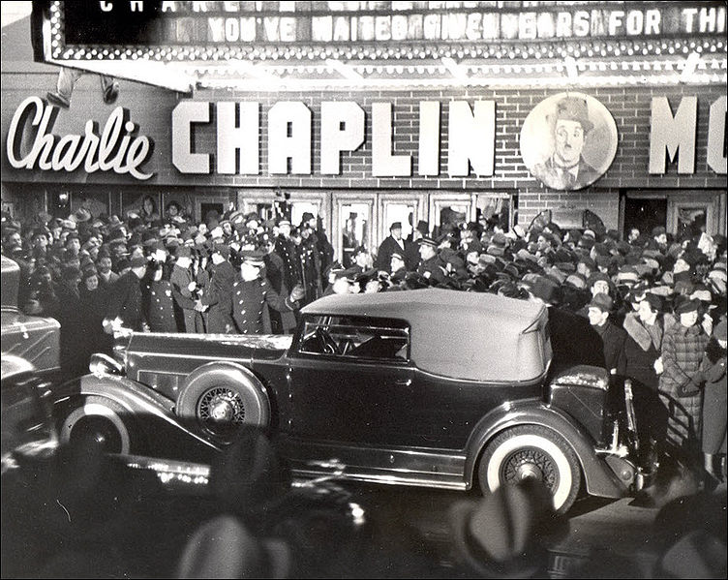
A larynx condition ended the singing career of Chaplin's mother. Hannah's first crisis came in 1894 when she was performing at The Canteen, a theatre in Aldershot. The theatre was mainly frequented by rioters and soldiers. Hannah was badly injured by the objects the audience threw at her and she was booed off the stage. Backstage, she cried and argued with her manager. Meanwhile, the five-year old Chaplin we nt on stage alone and sang a well-known tune at that time, "Jack Jones".
After Chaplin's mother (who went by the stage name Lilly Harley) was again admitted to the Cane Hill Asylum, her son was left in the workhouse at Lambeth in south London, moving after several weeks to the Central London District School for paupers in Hanwell. The young Chaplin brothers forged a close relationship in order to survive. They gravitated to the Music Hall while still very young, and both of them proved to have considerable natural stage talent. Chaplin's early years of desperate poverty were a great influence on his characters. Themes in his films in later years would re-visit the scenes of his childhood deprivation in Lambeth.
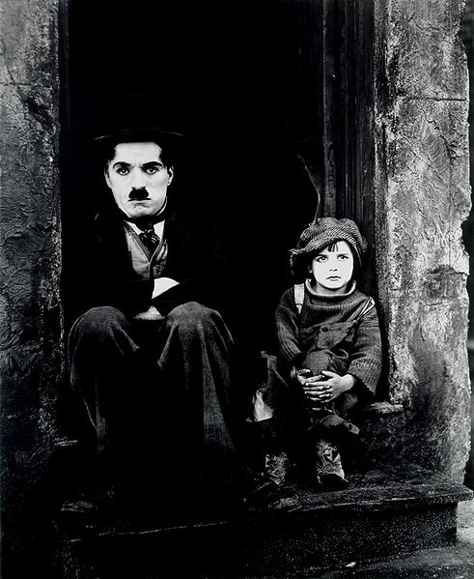
Chaplin's mother died in 1928 in Hollywood, seve n years after having been brought to the U.S. by her sons. Unknown to Charlie and Sydney until years later, they had a half-brother through their mother. The boy, Whe eler Dryden, was raised abroad by his father but later connected with the rest of the family and went to work for Chaplin at his Hollywood studio.
Chaplin's earliest films were made for Mack Sennett's Keystone Studios, where he developed his tramp character and very quickly learned the art and craft of film making. The tramp was first presented to the public when Chaplin was age 24 in his second film Kid Auto Races at Venice (released 7 February 1914) though Mabel's Strange Predicament, his third film, (released 9 February 1914) was produced a few days before. It was for this film that Chaplin first conceived of the tramp. The character would immediately gain huge popularity among theater audiences.As Chaplin recalled in his autobiography:
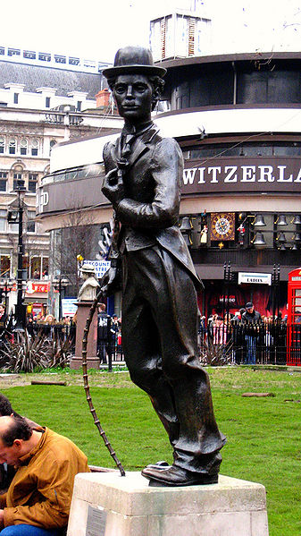
"I had no idea what makeup to put on. I did not like my get-up as the press reporter [in Making a Living]. However on the way to the wardrobe I thought I would dress in baggy pants, big shoes, a cane and a derby hat. I wanted everything to be a contradiction: the pants baggy, the coat tight, the hat small and the shoes large. I was undecided whether to look old or young, but remembering Sennett had expected me to be a much older man, I added a small moustache, which I reasoned, would add age without hiding my expression. I had no idea of the character. But the moment I was dressed, the clothes and the makeup made me feel the person he was. I began to kno w him, and by the time I walked on stage he was fully born."
Chaplin's early Keystones use the standard Mack Sennett formula of extreme physical comedy and exaggerated gestures. Chaplin's pantomime was subtler, more suitable to romantic and domestic farces than to the usual Keystone chases and mob scenes. The visual gags were pure Keystone, however; the tramp character would aggressively assault his enemies with kicks and bricks. Moviegoers loved this cheerfully earthy new comedian, even though critics warned that his antics bordered on vulgarity. Chaplin was soon entrusted with directing and editing his own films. He made 34 shorts for Sennett during his first year in pictures, as well as the landmark comedy feature Tillie's Punctured Romance.
Chaplin's principal character was "The Tramp" (known as "Charlot" in France, and the French-speaking world, Italy, Spain, Andorra, Portugal, Greece, Romania and Turkey, "Carlitos" in Brazil and Argentina, and "Vagabund" in Germany). "The Tramp" is a vagrant with the refined manners and dignity of a gentleman. The character wears a tight coat, oversized trousers and shoes, and a derby; carries a bamboo cane; and has a signature toothbrush moustache. The Tramp character was featured in the first movie trailer to be exhibited in a U.S. movie theater, a slide promotion developed by Nils Granlund, advertising manager for the Marcus Loew theater chain, and shown at the Loew's Seventh Avenue Theatre in Harlem in 1914.
In 1915, Chaplin signed a much more favorable contract with Essanay Studios, and further developed his cinematic skills, adding new levels of depth and pathos to the Keystone-style slapstick. Most of the Essanay films were more ambitious, running twice as long as the average Keystone comedy. Chaplin also developed his own stock company, including ingenue Edna Purviance and comic villains Leo White and Bud Jamison.
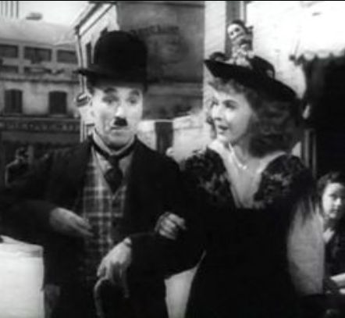
In 1916, the Mutual Film Corporation paid Chaplin US$670,000 to produce a dozen two-reel comedies. He was given near complete artistic control, and produced twelve films over an eighteen-month period that rank among the most influential comedy films in cinema. Practically every Mutual comedy is a classic: Easy Street, One AM, The Pawnshop, and The Adventurer are perhaps the best known. Edna Purviance remained the leading lady, and Chaplin added Eric Campbell, Henry Bergman, and Albert Austin to his stock company; Campbell, a Gilbert and Sullivan veteran, provided superb villainy, and second bananas Bergman and Austin would remain with Chaplin for decades. Chaplin regarded the Mutual period as the happiest of his career, although he also had concerns that the films during that time were becoming formulaic owing to the stringent production schedule his contract required. Upon the U.S. entering World War I, Chaplin became a spokesman for Liberty Bonds with his close friend Douglas Fairbanks and Mary Pickford.
Most of the Chaplin films in circulation date from his Keystone, Essanay, and Mutual periods. After Chaplin assumed control of his productions in 1918 (and kept exhibitors and audiences waiting for them), entrepreneurs serviced the demand for Chaplin by bringing back his older comedies. The films were recut, retitled, and reissued again and again, first for theatres, then for the home-movie market, and in recent years, for home video. Even Essanay was guilty of this practice, fashioning "new" Chaplin comedies from old film clips and out-takes. The twelve Mutual comedies were revamped as sound movies in 1933, when producer Amadee J. Van Beuren added new orchestral scores and sound effects. A listing of the dozens of Chaplin films and alternat e versions can be found in the Ted Okuda-David Maska book Charlie Chaplin at Keystone and Essanay: Dawn of the Tramp. Efforts to produce definitive versions of Chaplin's pre-1918 short films have been underway in recent years; all twelve Mutual films were restored in 1975 by archivist David Shepard and Blackhawk Films, and new restorations with even more footage were released on DVD in 2006.

Walt Disney

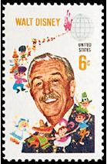
Walter Elias Disney (December 5, 1901 – December 15, 1966) was a multiple Academy Award-winning American film producer, director, screenwriter, voice actor, animator, entrepreneur and philanthropist. Disney is famous for his influence in the field of entertainment during the twentieth century. As the co-founder (with his brother Roy O. Disney) of Walt Disney Productions, Disney became one of the best-known motion picture producers in the world. The corporation he co-founded, now known as The Walt Disney Company, today has annual revenues of approximately U.S. $35 billion.
Disney is particularly noted for being a film producer and a popular showman, as well as an innovator in animation and theme park design. He and his staff created a number of the world's most famous fictional characters including Mickey Mouse. He received fifty-nine Academy Award nominations and won twenty-six Oscars, including a record four in one year, and thus holds the record for the individual with the most awards and the most nominations. He also won seven Emmy Awards. He is the namesake for Disneyland and Walt Disney World Resort theme parks in the United States, Japan, France, and China.
Disney died of lung cancer on December 15, 1966, a few years prior to the opening of his Walt Disney World Resort dream project in Florida.
Oswald the Lucky Rabbit
By 1927, Charles B. Mintz had married Margaret Winkler and assumed control of her business, and ordered a new all-animated series to be put into production for distribution through Universal Pictures. The new series, Oswald the Lucky Rabbit, was an almost instant success, and the character, Oswald—drawn and created by Iwerks—became a popular figure. The Disney studio expanded, and Walt hired back Harman, Rudolph Ising, Carman Maxwell, and Friz Freleng from Kansas City. In February 1928, Disney went to New York to negotiate a higher fee per short from Mintz. Disney was shocked when Mintz announced that not only he wanted to reduce the fee he paid Disney per short but also that he had most of his main animators, including Harman, Ising, Maxwell, and Freleng (notably, except Iwerks, who refused to leave Disney) under contract and would start his own studio if Disney did not accept the reduced production budgets. Universal, not Disney, owned the Oswald trademark, and could make the films without Disney. Disney declined Mintz's offer and lost most of his animation staff.
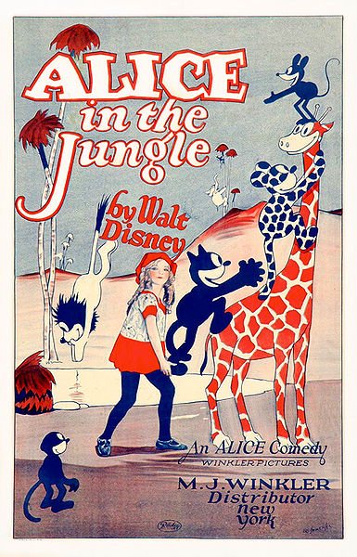
With most of his staff gone Disney now found himself on his own again. It took Disney's company 78 years to get back the rights to the Oswald character. The Walt Disney Company reacquired the rights to Oswald the Lucky Rabbit from NBC Universal in 2006, through a trade for longtime ABC sports commentator Al Michaels.
Alice Comedies
Virginia Davis (the live-action star of Alice’s Wonderland) and her family were relocated at Disney's request from Kansas City to Hollywood, as were Iwerks and his family. This was the beginning of the Disney Brothers' Studio. It was located on Hyperion Avenue in the Silver Lake district , where the studio would remain until 1939. In 1925, Disney hired a young woman named Lillian Bounds to ink and paint celluloid. After a brief period of dating her, the two got married the same year.
The new series, Alice Comedies, was reasonably successful, and featured both Dawn O'Day and Margie Gay as Alice. Lois Hardwick also briefly assumed the role of Alice. By the time the series ended in 1927, the focus was more on the animated characters, in particular a cat named Julius who resembled Felix the Cat, rather than the live-action Alice.
Mickey Mouse
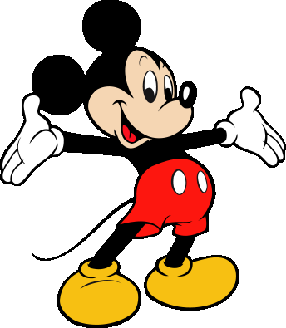
After losing the rights to Oswald, Disney felt the need to develop a new character to replace him. He based the character on a mouse he had adopted as a pet while working in a Kansas City studio. Ub Iwerks reworked on the sketches made by Disney so that it was easier to animate it. However, Mickey' s voice and personality was provided by Disney. As many of the old animators have commented, "Ub designed Mickey's physical appearance, but Walt gave him his soul." Besides Oswald and Mickey, a similar mouse-character is seen in Alice Comedies which featured a mouse named Ike the Mouse, and the first Flip the Frog cartoon called Fiddlesticks, which showed a Mickey Mouse-look alike playing fiddle. The initial films were animated by Iwerks, his name was prominently featured on the title cards. The mouse was originally named "Mortimer", but later christened "Mickey Mouse" by Lillian Disney who thought that the name Mortimer did not fit. Mortimer later became the name of Mickey's rival for Minnie, who was taller than his renowned adversary and had a Brooklyn accent.
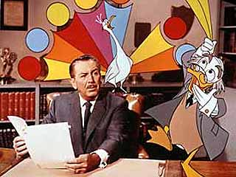
The first animated short with Mickey in it was titled, Plane Crazy, which was, like all of Disney's previous works, a silent film. After failing to find a distributor for Plane Crazy or its follow-up, The Gallopin' Gaucho, Disney created a Mickey cartoon with sound called Steamboat Willie. A businessman named Pat Powers provided Disney with both distribution and Cinephone, a sound-synchronization process. Steamboat Willie became an instant success, and Plane Crazy, The Galloping Gaucho, and all future Mickey cartoons were released with soundtracks. Disney himself provided the vocal effects for the earliest cartoons and performed as the voice of Mickey Mouse until 1946. After the release of Steamboat Willie, Walt Disney would continue to successfully use sound in all of his future cartoons, and Cinephone became the new distributor for Disney's early sound cartoons as well. Mickey soon eclipsed Felix the Cat as the world's most popular cartoon character. By 1930, Felix, now in sound, had faded from the screen, as his sound cartoons failed to gain attention. Mickey's popularity would now skyrocket in the early 1930s.
In 1932, Disney received a special Academy Award for the creation of "Mickey Mouse", whose series was made into color in 1935 and soon launched spin-off series for supporting characters such as Donald Duck, Goofy, and Pluto; Pluto and Donald would immediately get their individual cartoons in 1937, and Goofy would get solo cartoons in 1939 as well. Of all of Mickey's partners, Donald Duck–who first teamed with Mickey in the 1934 cartoon, Orphan's Benefit–was arguably the most popular, and went on to become Disney's second most successful cartoon character of all time.
As Walt Disney Productions began work on Disneyland, it also began expanding its other entertainment operations. In 1950, Treasure Island became the studio's first all-live-action feature, and was soon followed by 20,000 Leagues Under the Sea (in CinemaScope, 1954), The Shaggy Dog (1959), and The Parent Trap (1961). The Walt Disney Studio produced its first TV special, One Hour in Wonderland, in 1950. Disney began hosting a weekly anthology series on ABC named Disneyland after the park, where he showed clips of past Disney productions, gave tours of his studio, and familiarized the public with Disneyland as it was being constructed in Anaheim, California. The show also featured a Davy Crockett miniseries, which started a craze among the American youth known as the Davy Crockett craze, in which millions of coonskin caps and other Crockett memorabilia were sold across the country. In 1955, the studio's first daily television show, Mickey Mouse Club debuted, which would continue in many various incarnations into the 1990s.
As the studio expanded and diversified into other media, Disney devoted less of his attention to the animation department, entrusting most of its operations to his key animators, whom he dubbed the Nine Old Men. During Disney's lifetime, the animation department created the successful Lady and the Tramp (in CinemaScope, 1955), One Hundred and One Dalmatians (1961), Sleeping Beauty (in Super Technirama 70mm, 1959) and The Sword in the Stone (1963).
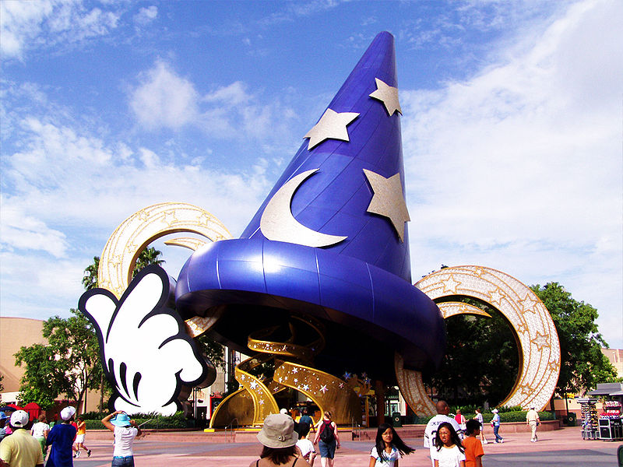
Production on the short cartoons had kept pace until 1956, when Disney shut down the shorts division. Special shorts projects would continue to be made for the rest of the studio's duration on an irregular basis. These productions were all distributed by Disney's new subsidiary, Buena Vista Distribution, which had assumed all distribution duties for Disney films from RKO by 1955. Disneyland, one of the world's first theme parks, finally opened on July 17, 1955, and was immediately successful. Visitors from around the world came to visit Disneyland, which contained attractions based upon a number of successful Disney properties and films.
Walt Disney with Ludwig Von Drake on Walt Disney's Wonderful World of Color in 1961.
After 1955, the show, Disneyland came to be known as Walt Disney Presents. The show transformed from black-and-white to color in 1961 and changed its name to Walt Disney's Wonderful World of Color, moving from ABC to NBC, and eventually evolving into its current form as The Wonderful World of Disney. It continued to air on NBC until 1981, when CBS picked it up. Since then, it has aired on ABC, NBC, Hallmark Channel and Cartoon Network via separate broadcast rights deals. During its run, the Disney series offered some recurring characters, such as Roger Mobley appearing as the newspaper reporter and sleuth "Gallegher", based on the writing of Richard Harding Davis.
Disney had already formed his own music publishing division back in 1949. In 1956, partly inspired by the huge success of the television theme song The Ballad of Davy Crockett, he created a company-owned record production and distribution entity called Disneyland Records.

Brazilian Carnival

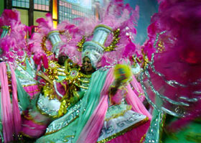
The Brazilian Carnival, properly spelled Carnaval, is an annual festival in Brazil held four days before Ash Wednesday, the day of fasting and repentance that marks the beginning of Lent. On certain days of Lent, Roman Catholics and some other Christians traditionally abstained from the consumption of meat and poultry -- hence the term "carnival," from carnelevare, "to remove (literally, "raise") meat." Carnival celebrations are believed to have roots in the pagan festival of Saturnalia, which, adapted to Christianity, became a farewell to certain pleasures of the flesh in a season of religious discipline to practice repentance and prepare for Christ's death and resurrection.
Brazilian Carnival exhibits some f rom its European counterparts, having mixed African, Native and Euro elements. Furthermore, rhythm, participation, and costume vary from one region of Brazil to another. For example, in the southeastern cities of Rio de Janeiro and São Paulo, organized parades led by samba schools vie for prizes on the "sambodromo" open stage. Only samba-school affiliates participate in the shows. Smaller cities often have no public events but prom ote balls in recreational clubs.
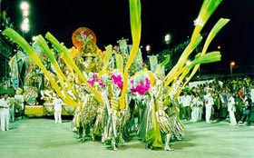
The northeastern cities of Salvador, Porto Seguro and Recife have organized groups parading through streets, but watchers are also welcome to dance. They follow the "trio elétrico" floats through the city streets.
Modern Brazilian Carnival originated in Rio de Janeiro in 1641, when the city's bourgeoisie imported the practice of holding balls and masquerade parties from Paris. It originally mimicked the European form of the festival, later absorbing and creolizing elements derived from Native American and African cultures.
In the late 19th century, the cordões (literally laces or strings in Portuguese) were introduced in Rio de Janeiro. These were pageant groups that paraded through city avenues performing on instruments and dancing. Today they are known as blocos (blocks), consisting of a group of people who dress in costumes or special t-shirts with themes and/or logos. Blocos are generally associated with particular neighborhoods; they include both a percussion or music group and an entourage of revellers.
Bloc parades have become an expressive feature of Rio's Carnival. Today, they number more than 100 and the groups increase each year. Blocos can be formed by small or large groups of revelers with a distinct title that mocks an issue or celebrity. They may also note their neighborhood or social status. Before the show, they gather in a square, then parade in sections of the city, often near the beach. Some blocos never leave one street and have a particular place, such as a bar, to attract viewers. Bloc parades start in January, and may last until Mardi Gras (Fat Tuesday).
"Blocos" parade in Copacabana, Ipanema, Leblon, Lagoa, Jardim Botânico, and in downtown Rio. Organizers often compose their own music themes that are added to the performance and singing of classic "marchinhas" and samba popular songs. "Cordão do bola preta" ("Polka Dot Bloco"), that goes through the heart of Rio's historical center, and "Suvaco do Cristo" (Christ's statue armpit), near the Botanical Garden, are some of the most famous groups. Monobloco has become so famous that it plays all year round at parties and small concerts.
Samba schools are very large groups of performers, financed by respected organizations (as well as suspect ones), who work year round in preparation for Carnival. Samba Schools perform in the Sambadrome, which runs four entire nights. They are part of an official competition, divided into seven divisions, in which a single school is declared the winner, according to costume, flow, theme, and band music quality and performance. Some samba schools also hold street parties in their neighborhoods, through which they parade along with their followers.
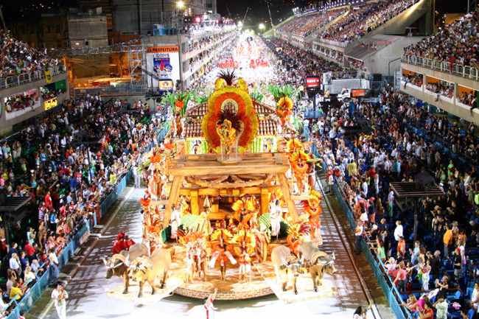
There are several major differences between Carnival in the state of Bahia in Brazil's Northeast Region and Carnival in Rio de Janeiro. The musical styles are different in each carnival; in Bahia there are many rhythms, including samba, samba-reggae, axé, and others, which are performed on a truck equipped with giant speakers and a platform where musicians play called a trio-elétrico. Massive numbers of people follow the trucks singing and dancing. The "Indian" groups were inspired by Western movies. The groups dress up as Native Americans and take on Native American names. Blocos Afros, or Afro groups, were influenced by the Black Pride Movement in the United States, independence movements in Africa, and reggae music that denounced racism and oppression. The groups inspired a renewed pride in African heritage.

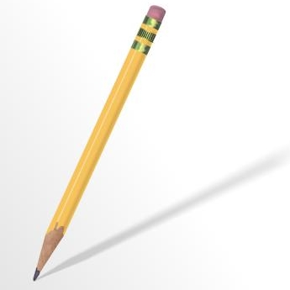

I. Match the types of the films to their descriptions

1.musical a)is one with a lot of action
2.a science fiction film b)is a film with a lot of funny situations
3.an action film c)is a film with spaceflights, fights and space travel
4.a western d)is a film which presents real life situations and facts
5.a comedy film e)is a film with a lot of music and songs
6.a documentary f)is a film which has fights and horse chasing in the Wild West

II. Group the information into the following content areas

Film genres (1) | Film titles(2) | Film actors(3) | Film characters(4)

Words: blockbuster, Matrix, elve, Kozaks, the Fellowship of the ring, Arnold Schwarzenegger, dwarves, evil Sauron, Batman, Keanu Reeves, hobbits, cartoons, a robot, fantasy film, humans, Terminator-2, John Connor.

III. Look at the pictures of the musicians and open the brackets, using the active or passive forms of the verbs
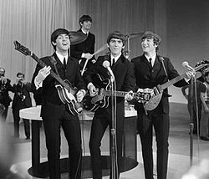
The Beatles

1._________(to create) in the 1960s in Great Britain in Liverpool.
2._________(to write) energetic and powerful music.
3._________(to found) by John Lennon and Paul McCartney.
4._________(to become) popular with songs ‘Yesterday’, ’Yellow Submarine’
5._________(to insprire) other musicians to create new music.

Ruslana
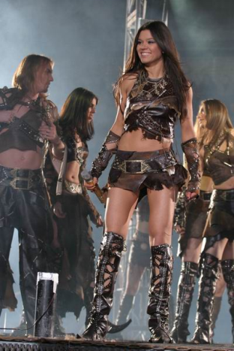
1_______(to get) musical education in Lviv.
2._______(to enjoy) folk songs and dancers.
3._______(to win) Eurovision-2004.
4._______(to become) well-known in Ukraine and abroad.
5._______(to give) exciting and bright shows.
6._______(to make) popular by her wild dancers.

IV. Match the beginnings with the endings

1. Can you teach me to play… a)….cricket?
2.Let’s go… b)…jogging tomorrow morning.
3.Boys and girls like to participate… c)…in local competitions
4.Doing… d)…a new record!
5.Have you ever won… e)…karate requires a lot of skill.
6.Congratulations! You’ve just set… f)…a competition?

V. Look at the photos and describe your tastes in movies

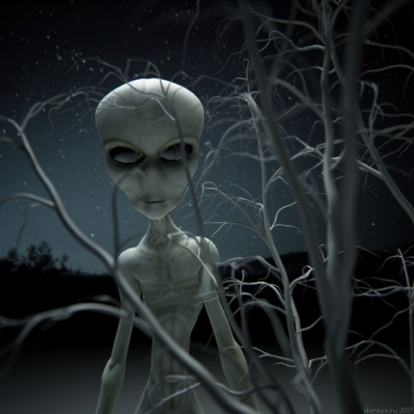
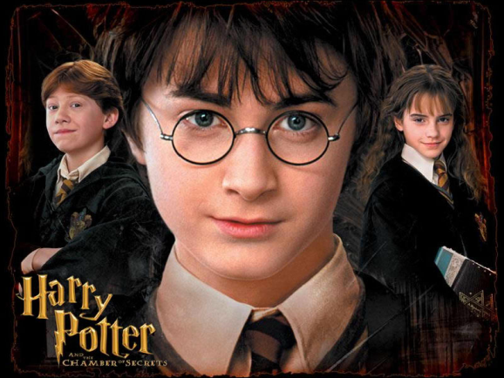
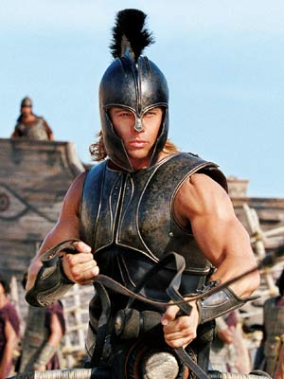

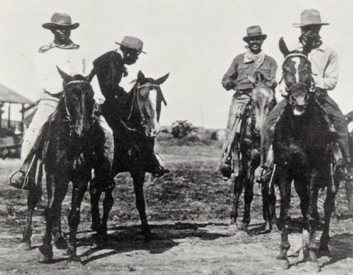
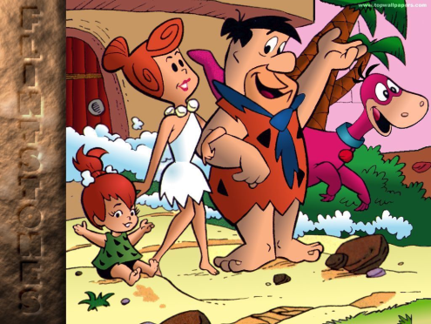

VI. Make up new words from the words in the box and fill in gaps
The English are great (1) of sports and football is one of their (2) games. This sporting (3) is popular with both sexes. Boys and girls like to participate in local (4). Sometimes they become (5) and set new (6). After school some athletes join (7) football clubs to become great (8). David Beckham’s (9) career is a good example to follow. Many teenagers ( 10) of becoming football stars.

Words: record, activity, favourite, professional, sporting, lovers, winners, competitions, footballers, dream.

VIi. Match the names and the instruments

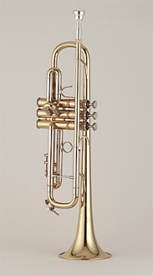
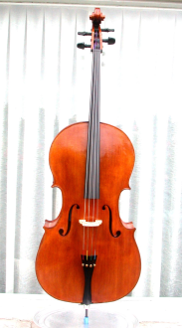
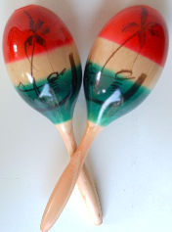
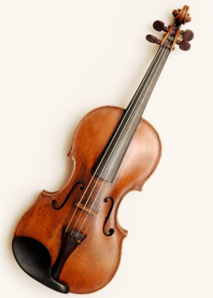
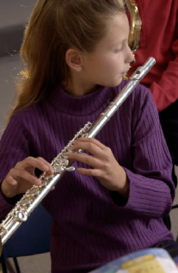
a. cello
b. drums
c. flute
d. guitar
e. maracas
f. trumpet
g. violin
1 2 3 4 5
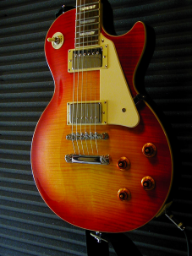
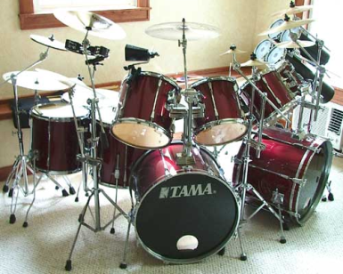

6 7

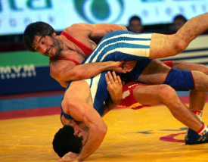
VIII. Match the definitions of sports and games to their pictures
a)
1. a game played by two teams of 5 players and a goalkeeper
each that is played with stick, and a ball on an ice field.


2. a game played between two teams of 11 players using an b)
oval egg-shaped ball that can be handled or kicked.

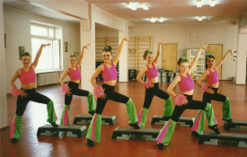
3. a game played with a bat and a ball between two teams of c)
9 players each on a large field that has four bases which a
player must touch in order to make a run.

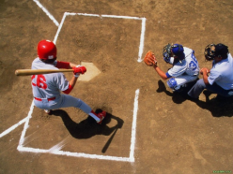
4. a game between two teams of usually 5 players each, in d)
which each team tries to throw a ball through the other
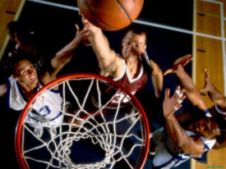
team’s basket.
e)
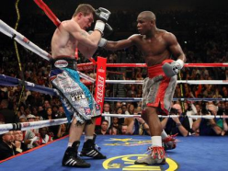
5. the sports of fighting with fists.

6. the sports exercises done to music. f)
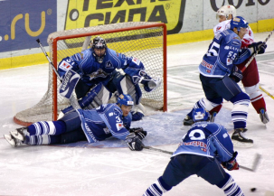
g)
7. a sport in which two people fight in a ring, trying to hold
or throw each other onto the floor.

IX. match the Film Festivals and the top prizes

- Venice a)Oscar
- Cannes b)Golden Bear
- Berlin c)Golden Lion
- Hollywood d)Golden Palm
- Gramado e)People’s Choice
- Toronto f)Kikito

X. Entertainment equivalents: find the pairs here

Watching Doing
1.Going to a concert. a) Telling a joke.
2. Watching a play. b) Making a video.
3. Seeing a great film. c) Dressing up and taking part in a festival.
4. Laughing at a TV cartoon. d) Inventing a good story.
5. Watching a parade. e) Performing in a play
6. Listening to an exciting story. f) Being a DJ on a student radio programme.
7. Visiting a museum. g) Playing live music.
8. Tuning in to your favourite radio channel h) Making your own personal colletion.



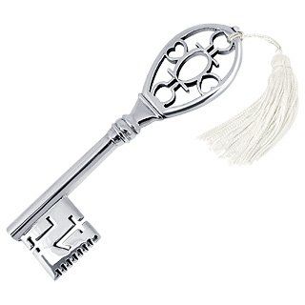

I. 1-e;2-c;3-a;4-f;5-b;6-d.

II. 1. blockbuster, cartoons, fantasy film;
2. Matrix, Batman, Terminator-2, the Fellowship of the ring;
3. Keanu Reeves, Arnold Schwarzenegger;
4. a robot, John Connor, hobbits, humans, dwarves, elve,
evil Sauron, Kozaks.

III. 1-were created; 2-wrote;3- were founded;4-became;5-inspired.
1-got;2-enjoys;3-won;4-became;5-gave;6-was made.

IV. 1-a;2-b;3-c;4-e;5-f;6-d.

VI. 1-lovers; 2-favourite; 3-activity; 4-competitions; 5-winners;6-records;
7-professional;8-footballers; 9-sporting;10-dream.

VII. a-5;b-6;c-1;d-6;e-3;f-4;g-2.

VIII. 1-g;2-b;3-d;4-e;5-f;6-c;7-a.

IX. 1-c;2-d;3-b;4-a;5-f;6-e.

X. 1-g;2-e;3-b;4-a;5-c;6-d;7-h;8-f.

