THE WORLD OF SCIENCE AROUND US (11 FORM)

Дузенко І.С., ЗОШ №27, м. Полтава

Objectives: to practice grammar; to enrich students’ vocabulary; to promote students’ group work; to facilitate reading, writing and communicative activities; to expand students’ worldview, develop their thinking and discussion skills.
Equipment: computer, cards with tasks, textbooks, poster presentations and photos.

PROCEDURE

I. INTRODUCTION
T.: Have you ever thought how the progress of science has improved our life? Numerous essential developments and discoveries have impacted and continue to exert a significant influence on our daily activities. Scientists, who make this progress possible are around us – and maybe very soon, some of you will join this group of people.
Our lesson today will be devoted to researchers who made a paramount contribution to the development of medicine and healthcare in the 20th century. We will discuss, how they achieved their goals, read about their discoveries, do grammar and lexical tasks, speak about your ideas for research and development of the world around us.
Each group of students was assigned a particular project task (posters) to present at the end of the lesson:
Group 1 provided a proposal for the development of artificial intellect technologies
Group 2 provided a project to develop the natural energy sources in Ukraine
Group 3 provided ideas for outer space exploration

WARMING-UP

T.: To begin with, I want you to answer quite a simple question: What is science?
(Pupils try to define the term)
Now look at the screen. You can see the definition given by a famous microbiologist Rita Colwell: “Science is discovery. Science is fun. Science is understanding what makes a clock tick and what makes a cat purr, what makes the Sun rise and what makes the Moon look so large on the horizon…”
Do you agree with this definition? Why? Can you remember some of the most important discoveries and inventions of the 20th century?

II. THE MAIN PART OF THE LESSON

GRAMMAR REVISION

Ex. 1. Read and translate the sentences about science and discoveries. Identify the sentences with Passive Voice:

1. The discovery of electricity gave birth to an innumerable number of inventions.
2. New methods of conserving the environment have been developed to make it fit for human habitation.
3. Formal education and training has equipped human beings with new skills for survival.
4. Trade has been promoted through the use of computers and the Internet.
5. Means of transport and communication have improved social interaction and faster movement.
6. Computer technologies have improved efficiency at work where machines are used.
7. Human beings are now better placed in security matters by use of radar, alarms and electrical fencing.
8. In 1875, crude oil was discovered by David Beaty at his home in Warren, Pennsylvania.
9. The ability of science and technology to improve human life is known to us.

Ex. 2. Read and translate the sentences. Note the use of Future Perfect. Create a specific question for each sentence. Use the interrogative word given in brackets:

1. By 2020, the number of people over 60 will have grown to one billion (When?)
2. By 2100, doctors will have found cures for AIDS and cancer (Who?)
3. By 2500, robots will have replaced humans in most surgical operations (When?)
4. By 2200, mankind will have found a way to eradicate health inequalities (When?)
5. By 2030, our country will have developed a sustainable healthcare system (What?)

VOCABULARY FOCUS

Ex. 3. Each line contains two synonyms and one antonym. Cross out a word that does not fit in:

1. | advance | retardation | development
2. | impair | improve | enhance
3. | minor | significant | important
4. | new | modern | outdated
5. | common | widespread | rare
6. | frequently | regularly | seldom
7. | excess | lack | absence

Ex. 4. The verbs “do” and “make” can have different uses or convey the same meaning. Read and translate the phrases from the table given below.
Do | Make
to do exercises  to do a good/bad job  to do well/badly/one’s best  to do something/nothing  to do your homework  to do the shopping/washing up(dishes)  to do your hair/nails/make-up  to do the laundry (washing)/ironing | to make a noise/sound  to make a suggestion/a speech  to make progress  to make a mistake  to make a decision/choice  to make an impression (good, bad etc.)  to make breakfast/dinner/a cup of tea  to make the bed, to make things tidy

Ex. 5. Add an appropriate preposition (of / for / from / with / about / to / at) to each adjective and translate the word combinations:

Adjective | Preposition | Translation
- crowded
- married
- excited / worried / upset
- good
- different
- afraid
- similar
- famous
- capable
- satisfied / disappointed / pleased

READING AND TRANSLATION PRACTICE
Ex. 6. Read and translate the text. Note the use of Past Simple; explain the use, omission or replacement of the indefinite/definite article:

BARRY MARSHALL – THE DOCTOR WHO SOLVED A MEDICAL MYSTERY

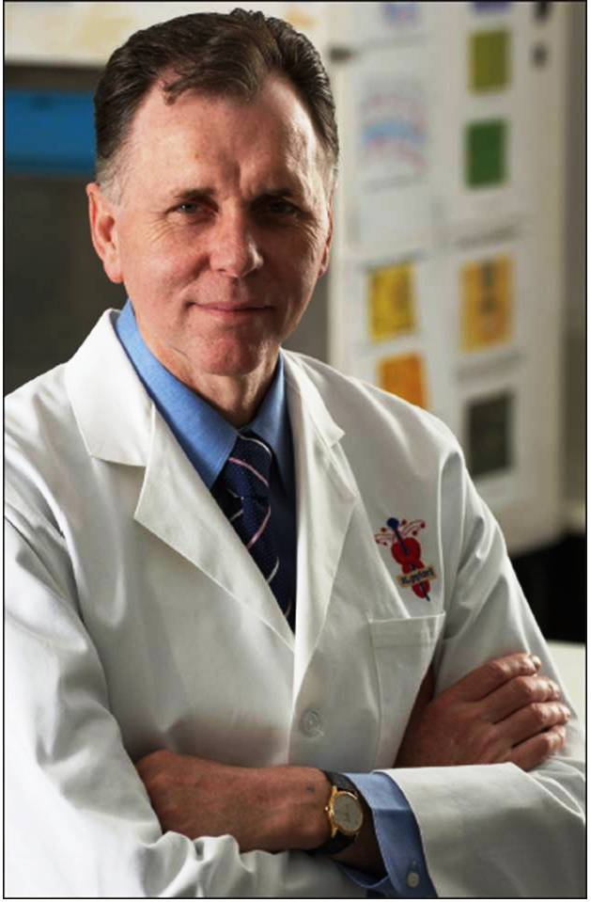
Barry James Marshall (born 30 September 1951) is an Australian physician and Professor of Clinical Microbiology at the University of Western Australia. In 2005, Dr. Marshall won the Nobel Prize in Medicine together with his long-time collaborator Robin Warren. Their discovery allowed for a breakthrough in understanding a causative link between the bacterium Helicobacter pylori, gastritis and peptic ulcer disease, reversing decades of medical doctrine holding that ulcers were caused by stress, spicy foods, and too much acid. Although medicines like antacids relieved the symptoms, ulcers returned after a patient stopped taking them. Marshall and Warren showed that a simple course of antibiotics could cure up to 90 per cent of these ulcers. In 1981, Marshall learnt about John Warren’s discovery of bacteria in stomach biopsies. The two scientists joined forces to learn more. Marshall and Warren soon found that many gastritis and stomach ulcer patients had the spiral bacteria, which they named Helicobacter pylori. Postulating that H. pylori was disease-causing, Marshall realised that antibiotics could replace the current treatments for ulcers.
At that time, the scientific community believed that ulcers resulted from stress or diet. The medical elite thought they knew what caused ulcers and stomach cancer. In their opinion, the presence of H. pylori did not prove that the bacteria led to ulcers. But they were wrong − and did not want to hear the answer that was right. Marshall felt that more evidence was necessary. Research with lab animals was not enough, so he decided to use a human subject: himself. At the age of 32, after verifying that he did not have H. pylori in his stomach, Marshall drank a concoction with cultured bacteria. In a few days, he developed gastritis, the precursor to an ulcer. He started vomiting, he had bad breath, and he felt sick and exhausted. Examinations of his inflamed stomach revealed H. pylori. Taking antibiotics cured him.
Finally, in 1994, the situation changed when the National Institutes of Health (NIH) held a two-day summit in Washington D.C. over the matter. At the end of the summit, they released a statement that “the key to treatment of duodenal and gastric ulcers was detection and eradication of Helicobacter pylori.” In light of this evidence, ulcer treatment protocols slowly began to change: antibiotics became the standard approach.

Ex. 7. Do these statements agree with the information given in Ex. 5?
1. Marshall proved the link between H. pylori and liver cirrhosis | False / True
2. Dr. Marshall proved that ulcers are caused by stress and poor diet | False / True
3. Marshall and Warren shared the Nobel Prize for their joint discovery | False / True
4. Marshall and Warren detected H. pylori in patients’ sputum samples | False / True
5. Marshall drank the infectious broth when he was a medical student | False / True
6. Gastritis is the precursor of ulcer | False / True
7. Drinking the culture of H. pylori produced no symptoms | False / True
8. Marshall managed to convince the scientific community | False / True
9. Elimination of H. pylori is an integral part of treating ulcers | False / True
10. Doctors started to prescribe antibiotics for ulcers | False / True

Ex. 8. Look through the text in Ex. 5, pick 5 statements with a Past Simple verb and change them into questions.

WRITING PRACTICE

Ex. 9. Match the words in column A with the words in column B. Translate the word combinations:

CARD No. 1
A | B
to feel | symptoms
spicy | more
to result | link
to relieve | sick
to lead | treatment
caused by | cancer
to learn | foods
to join | to
stomach | from
current | forces
causative | stress

Ex. 10. Translate the words in column A. Match them with contextual meanings:

CARD No. 2
A | B
- breakthrough  - evidence  - eradication  - to cure  - precursor  - to replace  - to realise  - ulcer  - opinion  - to reveal | - a break in skin or mucous membrane with loss of surface tissue  - to make something publicly or generally known  - a sudden advance especially in knowledge or technique  - to put something new in the place of  - something provides furnishes proof  - the complete destruction of something  - a thing that comes before another of the same kind; a forerunner  - to become fully aware of (something) as a fact; understand clearly  - a view, judgment, or appraisal formed in the mind about a particular matter  - to restore to health, soundness, or normality

LISTENING COMPREHENSION

Ex. 11. Listen to the text:

ALEXANDER FLEMING’S DISCOVERY OF PENICILLIN
One of the most important medical advances in history began by accident. In 1928, Alexander Fleming, Professor of Bacteriology at St. Mary's Hospital in London, discovered penicillin, the world’s first antibiotic.
The discovery of penicillin marks a true turning point in human history, when doctors finally had a tool that could completely cure their patients of deadly infectious diseases. Before its introduction, there was no effective treatment for infections such as pneumonia, gonorrhoea or rheumatic fever. Hospitals were full of people with blood poisoning contracted from a cut or a scratch, and doctors could do little for them but wait and hope.
Returning from holiday in September 1928, Fleming began to sort through Petri dishes containing colonies of Staphylococcus. He noticed something unusual on one dish. It was dotted with colonies, except for one area where a spot of mould was growing. The mould was in the shape of a ring and the area around it seemed to be free of Staphylococcus bacteria. The mould was Penicillium notatum. As Dr. Fleming wrote about that red-letter date: “When I woke up just after dawn on September 28, 1928, I certainly didn’t plan to revolutionise all medicine by discovering the world’s first antibiotic, or bacteria killer, but I guess that was exactly what I did”.
In March 1942, Anne Miller became the first civilian patient to be successfully treated with penicillin, lying near death at New Haven Hospital in Connecticut, after miscarrying and developing an infection that led to blood poisoning. Penicillin also treated diphtheria, gangrene, syphilis and tuberculosis. In 1945, Fleming, along with his colleagues, Chain and Florey, got the Nobel Prize for Medicine. Penicillin heralded the dawn of the antibiotic age.

Ex. 12. Complete the sentences:
1. The discovery of penicillin was important because __________.
2. Before the introduction of penicillin, doctors were __________.
3. Fleming made his discovery _________.
4. Anne Miller was _________.
5. Fleming was awarded the Nobel Prize for Medicine because _________.

COMMUNICATION SKILLS

Ex. 13. Compare the two stories about important discoveries in Ex. 5 and Ex. 10. Answer the questions:
1. What are the similar features about Barry Marshall’s and Alexander Fleming’s discoveries?
2. What are the differences between the two scientists’ stories?
3. Provide 2-3 examples of important discoveries similar to Barry Marshall’s and / or Alexander Fleming’s stories.
4. What will medicine have achieved by the year 2100?
5. What will scientists have discovered by that time?
6. What will researchers have invented by then?

Ex. 14. Poster presentations.
T.: Now let’s see your group projects (Each group of students presents their posters with research proposals. The teacher and pupils ask 1-2 questions on the subject).
Group 1 – How will you develop artificial intellect technologies? Where will they be used? How will they improve people’s lives?
Group 2 – What are the potential natural energy sources in Ukraine? How can we improve these technologies? Why are they important?
Group 3 – Describe your ideas on outer space exploration. What are the benefits and challenges of this area?

III.HOME ASSIGNMENT
Write an essay “The world of science around us.”

SUMMING-UP
T.: What new things have you found out? I hope you learnt some important and interesting facts about science, discoveries and scientists.
Thank you for active participation.

