Objectives:
  - To develop speaking an listening skills in the process of working on the topic “Bonfire Night”;
  - To introduce the traditions and customs of celebrating this holiday in Britain;
  - The expand the pupils’ outlook;
  - To develop reading skills on the topic “Bonfire Night”;
  - To form a positive attitude to peculiarities of a foreign culture, to encourage pupils to realize the importance of their culture on the basis of a foreign one.
Tools: handouts, presentation, computer
Procedure
I. Greeting
– Hello, everyone. Today we are going to know important and interesting facts about unusual and fiery historic event in the life of British people. And you can see the theme of our lesson on the screen. Let’s read it. Will you read? Who knows smth about its celebration?
II. Activating a new vocabulary
– Firstly, you’ll see the crossword in which the first letters of each word are given and there is the list of questions to the crossword. When you guess each word, you’ll be able to read the new one about our theme. On your desks you can find the sheets of papers with the same crossword. Let’s start working on this task!
- A science ………story is about events which take place in the future or in space and usually describes strange creatures and robots.
- A ……. book usually tells about important historical events of any country.
- A ….. is a serious and emotional play, written for the theatre, television or radio.
- A …….story is a book which tells about a criminal and a police officer who investigates the crime.
- If you want to read a book you can……. it from the library.
- A …….is a story of a person’s life written by another person.
- It’s a place where there are a lot of books kept
- It’s a literary work created by an author.

 |  |  |  |  | B
 |  |  |  |  | O
 |  |  |  | D | R |  | L | B
 |  |  |  | E | R | B | I | O
 | H |  | D | T | O | I | B | O
F | I |  | R | E | W | O | R | K
I | S |  | A | C |  | G | A
C | T |  | M | T |  | R | R
T | O |  | A | I |  | A | Y
I | R |  |  | V |  | P
O | Y |  |  | E |  | H
N |  |  |  |  |  | Y

– What is the new word? (firework).
– Great. Why is it important for our new theme? What do you think? Do you like fireworks? When do you usually use them? Do you use them on holidays?
III. Phonetic drill
– Thanks a lot for your answers! And now I would like you to know the new words and then to read a very old nursery rhyme which was known for more than four centuries. To understand it properly, you'll need to become familiar with the following words. Read them, please.
Gunpowder – порох;
Treason – измена;
Plot – заговор;
Reason – причина.

–– Now I’ll read the poem, you’ll need to fill in the gaps. Listen to it and if you are ready, raise your hand. Open your copy books and let’s start working!
Remember, Remember
the fifth of November
Gunpowder, treason and plot.
I see no reason, why gunpowder treason
Should ever be forgot

-What is the first missed word? (the fifth).
– What is the second one in the second line (gunpowder).
– Who guesses the third word? (reason)
– What is the fourth one (treason).
– Well done.
– Thanks. Now read the rhyme and translate it
– Very good.
IV. Pre-reading activity
– It’s just time to know the details of historic and interesting event for British people. And you can see the words for understanding the Guy Fawkes story. Let’s read them after me.
A firеwork – феєpвepк
a bonfirе – багаття
thе Gunpowdеr Plot – "Пopoхoва Змова''
a plotter - змовник
to guard – охороняти
Саtholic – кaтолик
a barrel - бочка
а сellаr – підвaл
to hide hid hidden – ховати
to find out – дізнатися
to order – наказати
to search - обшукати
to blow up smth – підірвати щось
to dig – кoпaти
God Sаvе the King. – Боже, бережи Короля

V. Reading
– And it’s high time to follow the history of the Gunpowder plot. Some students will help us to know more about it. Let’s read the text attentively and be ready to do a quiz afterwards. And who wants to read the phrase for author, for Robert Catesby and for the Guy Fawkes?

James the First became King of England in 1603. He was a Protestant and didn't like Catholics.

In 1604, Robert Catesby, an English nobleman, and a group of other Catholics decided to kill the King. Guy Fawkes was one of the plotters.

(Robert Catesby): Guy, let's blow up the Houses of Parliament!

(Guy Fawkes): Why?

(Robert Catesby): You are a Catholic, I'm a Catholic and our king hates Catholics. We'll blow up the Houses of Parliament and destroy the King and his family!

(Guy Fawkes): When and where?

(Robert Catesby): On the 5th of November, at the opening of the Parliament.

(Guy Fawkes): Excellent! What must I do?

(Robert Catesby): You'll help to bring the gunpowder to the cellar under the building, guard it, and: finally, blow it up!

Guy Fawkes was a soldier and an expert.

He was given the job of keeping watch over the barrels and blowing up the gunpowder.

At last 36 barrels of gunpowder were secretly moved to the cellar and hidden.

But in autumn 1605 one of the plotters wrote an anonymous letter to his relative, a member of the Parliament, asking not to go there on the fifth of November. The king found out about the letter and ordered to search the cellars.

Guy Fawkes was found with the gunpowder.

He was arrested and taken to the Tower of London. So the king wasn't killed.

Since that time English people have been celebrating Guy Fawkes Night.

VI. Post reading activity

– Did you like the story? Answer some questions please!
1. Who became King of England in 1603? (James I) – Good, isn’t it.
2. What did the plotters want to blow up? (The Houses of Parliament) – Wonderful.
3. How many barrels of gunpowder did the plotters have? (36) – First-rate.
4. What did the King do with the plotters? (get them to prison).
5. When do British people celebrate Guy Fawkes Night? (Оn the 5th of November) – That’s right
– Thanks a lot. I see you understood the story very well. You've done really well. Do you want to see how English children celebrate Guy Fawkes Day? OK.
VII. Watching the video "Bonfire Night".
– Well, it’s just the time to watch the video about Guy Fawkes Night and then to do some tasks.
– Do you like the video? And now you should some exercises.
VIII. Post watching activity
– To understand some words clearly, you’ll need to match the words and the picture or photos.
– The photos show some things which are associated with this festival. You’ve got the same task on your desk
- Let’s listen to your answers.
Match the words and the pictures
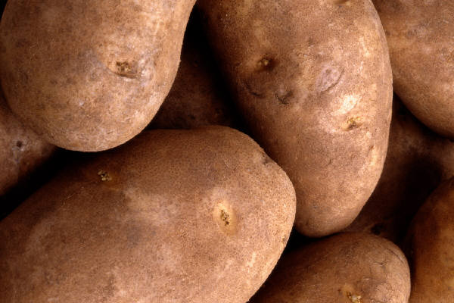 to light sparkles a bonfire
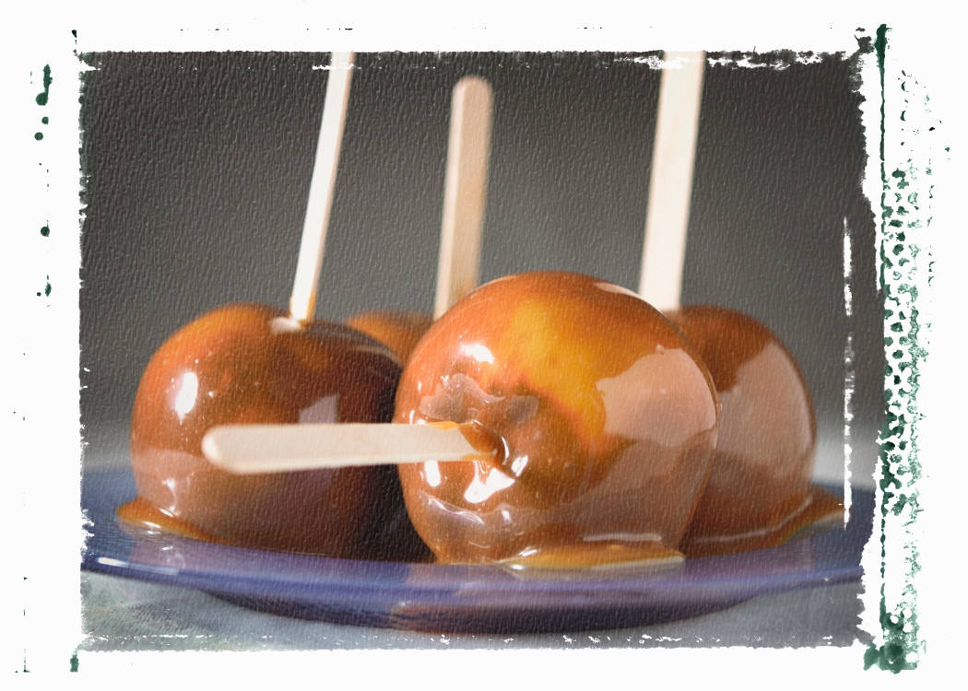 hot dog a guy

 potatoes fireworks
toffee apples sparkles
 sausages a scarf
– And now you can do the next task. This is the dialogue and some phrases from it but some words are missed.
1.
Bonfire, remember, fifth, king, story, gunpowder, Fawkes
  - I’m doing a historic project on ………..Night
  - Do you know the…….? Yes!
  - That’s Guy …… He wanted to kill the King. In 1605 he tried to blow up the Houses the Parliament with ………….. .
  - Did the…… die?
  - No, he didn’t. And every year on the……..of November we light the bonfires to………. what happened.

2.
Poster, homework
- I really make a guy, it’s on a bonfire. I make a safety firework poster for my ………………. . Come and look.
- Very good……….., Sam. That’s a great rocket.
3.
Old, scarf, his, a guy, great
- What are you two doing?
- We’re making …….for Bonfire Night.
- Have you got an old……? Yes, I think so.
Look at …. face. He is great.
- Here is an ……. Scarf. Well, he looks ……..
- Thanks, Dad.
4.
Shop, night, buy, sparkles, can’t, have
- My Dad and I are going to the …….. .Can I have some …….for Bonfire…….. .
-Yes, but you ……. buy them.
- I know children can’t ……fireworks. It’s illegal to sell adult fireworks to anyone under 18.
- Can I ……some sparkles, please.
That’s 1 pound, please. Here they are. Ok, Rosie. Let’s go.

5.
Food, sparkles, the garden, Bonfire Night, are, bonfire, here
It’s ……………….. . Our friends’ll come to our house. We have lots of delicious ……….before we go to the firework’s place.
  - Are we going to eat in………?
  - Yes, we…..
  - We are going to light the ………too. And then we are going to the fireworks place with the big ……...
  - What are those? Tofee apples. Watch out! They are …….
6.
Fun, hot dogs, place, are, guys
-Mmm, I love…….
- Sparkles’re great ……. Be careful. They ……. dangerous.
- Come on everyone. It’s nearly time to go to the fireworks………. We’re going to see a big firework near our house.
- Hurry up. We don’t miss the firework. Have we got the guy?
- Yes, I have. Come on everybody. At the fireworks place people burn the …… on the bonfires and there are lots of beautiful bonfires
– Let’s listen to the dialogue which you’ve got.
IX. Conclusion
–Do you like the tradition of celebrating Guy Fawkes Day? Why? Why not? Would you like to have the same celebration and burn a scarecrow of Guy Fawkes?
– I'm so pleased with your work today. Let’s put down your homework. And your marks for the lesson are the next…
X. Home assignment
– I'd like you to prepare a story about that day in Britain at home and write down your opinions about this tradition.

