10 клас
Тема:

Британська національна кухня. Розвиток навичок аудіювання та читання.
Цілі:
Навчальна: ознайомити учнів з британською національною кухнею, опрацювати та прослухати тематичні тексти, розвивати мовну та мовленнєву компетенцію.
Розвиваюча: розвивати навички читання, сприйняття тематичних текстів на слух, мовленнєву та мовну компетенцію, отримувати вміння вилучати основну інформацію, аналізувати та порівнювати факти.
Виховна: викликати інтерес до вивчення культури народу, мову якого вивчаємо, інтерес до здорового харчування.
Хід уроку
І. Організаційний момент.
II. Мозковий штурм.
T: Today we are going to talk about British cuisine. Tell me please, have you ever tried British food?
What food did you try?
Did you like it?
III. Основна частина уроку.
1) In order to understand English traditional food and meals, let’s read the text Ex 3 p55-56.
2) After reading the text you can fill in the table
breakfast
main course
afternoon tea
high tea

3) T: Now I want you to watch a video about British Food and Meals. After watching it you’ll have to make a plan.
- Breakfast
- Lunch
- Food that the British buy
- Evening Meal
- Going out
- The food, British teenagers prefer
- Traditional take-away food.
4) Subscriber- Messenger
T: Now you will work in groups. Three pupils in the group are subscribers and one pupil is a messenger. The messenger’s task is to bring information which is glued to the walls in the classroom and subscribers have to write it down according to the points of the plan. When you finish, you’ll have a story about the food British eat.
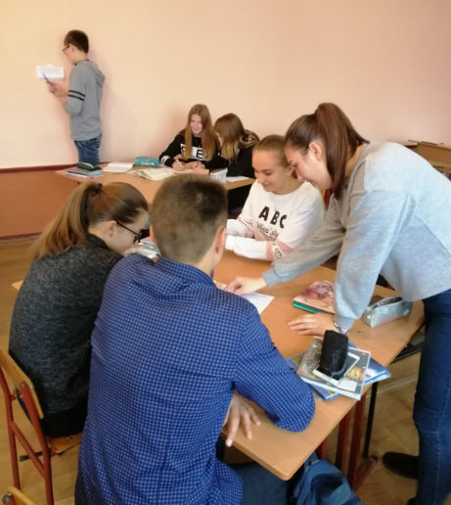
- In the morning milkman brings milk before breakfast.
- This is the usual breakfast: milk and cereal, toast with jam or marmalade, fruit juice, tea or coffee.
- The traditional English breakfast is bacon and eggs, sausage, tomatoes and fried bread, but people don’t eat it very often.
- Lunch is about 12 or 1 o’clock. It can be a sandwich or a snack. They sell an amazing number of sandwiches.
- Most people buy food at the supermarkets. They can be fresh food and convenience food.
- Convenience food must be put into oven or microwave.
- The main meal of the day is in the evening at about 6 or 7.
- Meat or fish and vegetables are popular evening meals. Pizza and pasta are popular too.
- They have a lot of foreign restaurants from 42 different countries.
- Chinese and Indian restaurants are the most popular. So are Thai and Italian.
- Traditional British food is fish and chips.
T: Watch the video once again and check your notes.
5) Now I want you to get to know about one more British Food which is Baked Beans. You must not only read the text but also put the missing words into the blanks.
The UK’s Number 1 Convenience Food!
If you 0) have ever been to Britain, you’ll know that British people love baked beans! People eat 1)………..for breakfast, lunch or dinner. In 2) ……….., baked beans on toast is the most popular convenience food in Britain – so popular 3) ………..the British people buy 97% of all the world’s tinned baked beans! Tinned baked beans consist 4) ………..haricot beans, also known 5) ……….. “navy beans’’, in a tomato sauce. In Britain you can find baked beans in supermarkets for less 6) ………..thirty pence a can. This makes them very popular with people 7) ……….. don’t have a lot of money. However, although baked beans may be cheap, unlike most convenience foods they, are also nutritious. Haricot beans are full of fibre and are rich 8) ………..protein and iron. So, if you are ever in Britain, make 9) ……….. you try some baked beans. Like many foreigners, you might find them strange 10………..first, but you will soon learn to enjoy a food that has been a firm favourite with British people for generations.
IV. Підсумок уроку. Домашнє завдання.
The lesson is coming to the end. Your home task is to be ready to speak about British Food and fill in one column about positive sides of British food in the given table.
English cuisine | Ukrainian traditional dishes | Mediterranean cuisine

10 клас
Тема:

Українська національна кухня.
Цілі:
Навчальна: ознайомити учнів з українською національною кухнею, навчати характеризувати та аналізувати страви, складати меню, вилучати основну інформацію та передавати її в мовленні та на письмі. Формувати вміння логічно та послідовно виражати свої думки в межах теми.
Розвиваюча: розвивати творче мислення, формувати вміння вилучати основну інформацію та використовувати її в мовленні та на письмі, розвивати мовну та мовленнєву компетенцію.
Виховна: виховувати культуру спілкування, інтерес до вивчення традицій свого народу.
Хід уроку
І. Організаційний момент.
T: Today we are going to talk about food and meals and at this particular lesson we will concentrate our attention on Ukrainian traditional dishes at the end of the lesson you will be able to:
- describe Ukrainian dishes, ingredients and recipes;
- compare different cuisines and judge about their benefits for health;
- make the menu and advertise favourite dishes.
II. Warming-up
T: At the beginning of the lesson I want you to answer my questions
- What famous Ukrainian dishes do you eat every day?
- Did your today’s breakfast consist of Ukrainian dishes? Which one?
- Was your breakfast healthy? Why do you think so?
Основна частина уроку
1) T: Before you start talking about Ukrainian cuisine I offer to read the article about benefits of the Mediterranean Diet. While reading choose the proper word to fill in the blanks.
2) All groups have a paper with three columns, we filled the column about benefits of English cuisine at the previous lesson. Now I want you to fill in the column about benefits of Mediterranean dishes.
Mediterranean cuisine | English food | Ukrainian food
- helps to reduce cholesterol and heart diseases  - promotes longevity  - protects against cancer  - helps to maintain body weight | - rather nutritious and healthy  - contains variety of different products which supply the body with useful things | - rather nutritious and gives enough energy for the day.  - has a lot benefits from the medical viewpoint  - it contains a lot of vegetable and fruit dishes which protect against cancer

3) T: So, you have got to know about Mediterranean diet which is considered to be one of the healthiest.
Now let’s get down to discussing Ukrainian dishes. Your task was to prepare presentation of Ukrainian dishes.
Group №1 Presents the report about benefits of Ukrainian dishes.
Group №2 Presents ingredients, recipe and benefits of Ukrainian borsch in the form of video.
Group №3 Presents ingredients recipe and benefits of pancakes.
Group №4 Presents ingredients recipe and benefits of potato pancakes.
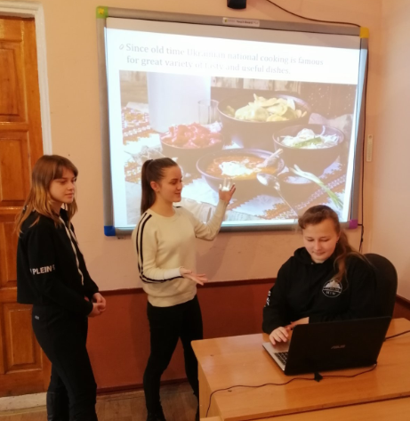

While watching you have to fill in the table.
Dish | Ingredients | Actions

4) a) As we have learnt about national dishes, fill in the second column about benefits of Ukrainian cuisine.
b) compare Mediterranean and Ukrainian cuisines and decide what should we take as a good example from the Mediterranean dishes.
5) Now I want you to work in groups and establish a Ukrainian restaurant and make up menu. You should also include foreign dishes. Make your menu and advertisement on the poster and present in front of the classroom.
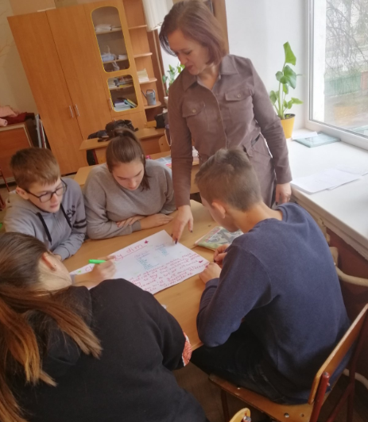
IV T: The lesson is coming to the end. We have worked creatively today. Your marks are…
Your home task is to write a letter to an English friend and convince him to try Ukrainian national dishes. See you.

