Ноздрачова О.Г.,
вчитель англ.мови,
м.Чернівці
ЗОШ 11
18.10.2019
Тема: «Подорожі»
Підтема: "Your last holiday"
Тип уроку: комплексне застосування знань і способів діяльності
Мета уроку: узагальнити і закріпити знання учнів по темі «Подорожі», розвивати навички усного продукування (монологічного та діалогічного мовлення), сприйняття англ. мови на слух (аудіювання) по темі.
Цілі:
Освітні:
• активізація в мовленні лексичних одиниць по темі «Подорожі»
• розвиток навичок усного продукування (монологічного та діалогічного) мовлення;
• розширення застосування словникового запасу (утворення фраз дієслово – іменник);
• вживання форм минулого простого часу правильних /неправильних дієслів;
Розвиваючі:
- тренування уяви, творчого мислення, мовної здогадки;
- тренування мовних здібностей, уміння логічно мислити;
- тренування уміння порівнювати, аналізувати, уявляти;
- тренування «мовної» пам’яті

Виховна:
• виховання в учнів пізнавального інтересу до навколишнього світу
• формувати потреби і здатності до співпраці і взаємодопомоги при роботі в парі

Технології навчання:

• драматизаційні технології
• парна,групова,командна робота
• коригування знань і умінь, уточнення і виправлення відповідей;

Оснащення:
• дошка, ілюстрації із тематичними зображеннями;
• ноутбук,магнітофон
• розрізні картки з тематичними завданнями;

Індивідуальна робота:

• Випереджальне навчання
Хід уроку: My way of travelling
1.)Warming Up. Greetings
Ss: 1.Hello! It’s a pleasure to meet you.
2. Good morning. It’s nice to meet you.
3. Good afternoon. How are things (with you)?
4.Hi! It’s good to see you!
5. Hey there. “What’s up?
6. Yo! I haven’t seen you for ages.!
7. Hello,friends! Have a good day
8. Hey, guys ! Long-time no see. How are you?
9.Hi! What have you been up to all these years?
10. Morning! Pleased to meet you!
11.Hello! It's nice to see you again!
12. Good day! How are you doing?
13.Good evening! How's it going?
14.Hi! How's your day?
15. Long time, no see!/ It's been a while!
2) Warming Up.( at customs)
(розподіл на команди- декларація є- синя,декларації немає – червона)
Два працівника таможні: -Good day! Speak about yourself?.........
-Take a blue/red card.
Passenger Details  Come from: Japan  Purpose: Business  Length of stay: 2 weeks  Staying at: The Hilton Hotel  Declaration: No | Passenger Details  Come from: America  Purpose: Tourist  Length of stay: 3 weeks  Staying at: The Disney Hotel  Declaration: No | Passenger Details  Come from: Mexico  Purpose: Tourist  Length of stay: 1 1/2 weeks  Staying at: Friend’s house  Declaration: Yes  - Sweets
Passenger Details  Come from: Canada  Purpose: Tourist  Length of stay: A month  Staying at: motel  Declaration: Yes  - Medicine | Passenger Details  Come from: New Zealand  Purpose: Business  Length of stay: 3 days  Staying at: sister’s house  Declaration: Yes  - Medicine | Passenger Details  Come from: England  Purpose: Business  Length of stay: 12 days  Staying at: Hotel  Declaration: No
Ss:

3.Brainstorming. Work with a partner.
Tell your partner one thing about your last holiday.
1. carefully planned
2. A Spontaneous Holiday
3. fulfilment of a dream
4. it was short, but very sweet
5. A Long And Winding Road
6. Looking Like Hell
7. I was so excited
8. it was awesome
9. I really want to go back!
10. it was wonderful.
11. I can’t remember a happier holiday
12. totally relaxed
13. a warm, and humorous atmosphere
14. I was really happy
15. I’d like to share with everybody the great time
16. surfing lessons
17. the most special time
18. It was so much fun.
19. Nature was amazing up there
20. historic monuments
21. a lot of things.
22. a beautiful nice journey
23. three amazing days
4. Vocabulary - Match the verb to the activity

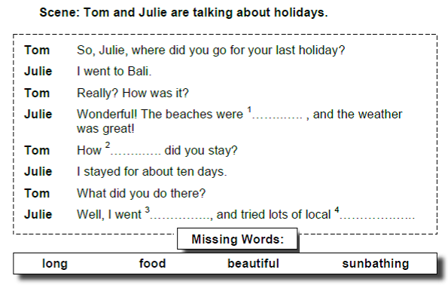
5.Language work#1 – Read the conversation and fill in the missing words

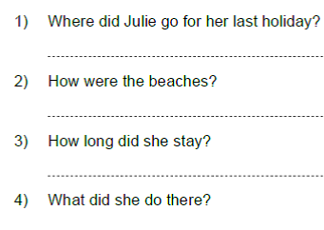
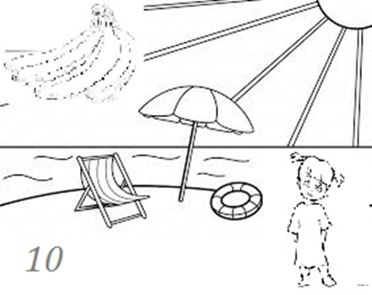
6.Language work#2 – Write answers to these questions

7) Post Listening Memorising / Oral practice – How well do you remember questions?
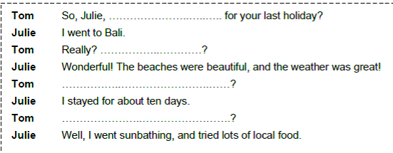

8)Speaking – Dramatization ( the dialogue)
Tom: So, Julie, where did you go for your last holiday?
Julie :I went to Bali.
Tom: Really? How was it?
Julie: Wonderful! The beaches were beautiful, and the weather was great!
Tom :How long did you stay?
Julie: I stayed for about ten days.
Tom: What did you do there?
Julie: Well, I went 3 sunbathing, and tried lots of local food

9)Relaxation time - ЗАРЯДКА: " How Did You Get Here Today?"
How did you get here today?
How did you get here today?
Verse 1:
I got here on foot
I got here by bus
I got here by bicycle
I got here by car.
How did you get here today?
How did you get here today?
Verse 2:
I got here by train
I got here by boat
I got here by airplane
I got here by rocket.
Wow!
10 – 9 – 8 – 7 – 6 – 5 – 4 – 3 – 2 – 1
Blast off!
10)Game- MATCHING: faces/information
1) перемішані картки faces/information, скласти відповідно
2) заповнити таблицю на дошці
Name | Pit | Lily | Kate | Laura | Mike | Jack | Polly | John
Nationality | Germany |  | England |  | Brazil |  |  | Scotland
purpose of visit |  |  | To study at a language school | To sell wine | . |  | To study at the university.
Period of staying | 3 weeks | 2 months |  | 2 weeks | 3 days. | until next Wednesday |  | until July 20th
Place of staying |  | uncle’s house. |  |  |  | hotel | student house.

1.You are a German tourist.You have just come from Berlin. You want to stay for 3 weeks. You are just sightseeing. You are staying at a hotel.
Passport  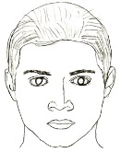 | Name: Pit  Nationality: Germany
2.You are visiting your uncle who lives in this country. You will be staying for the summer vacation (2 months). You will be staying at your uncle’s house.
Passport  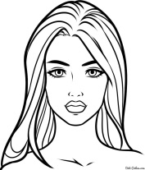 | Name:Lily  Nationality: France
3.You are an exchange student. You will be studying at a language school. You will be staying for 6 months. You will be staying in a student house.
Passport | Name: Kate  Nationality: England
4.You are on a business trip. You are selling wine. You will be staying for 2 weeks. You will be staying at a hotel.
Passport   | Name: Laura  Nationality: Poland

5.You are a Brazilian soccer player. You are coming to play a soccer game. You will stay for 3 days at a hotel.
 | Passport | Name: Mike  Nationality: Brazil
6.You are traveling on business. You are selling baby clothes. You will be staying there until next Wednesday at a hotel.
 | Passport | Name: Jack  Nationality: Canada
7.You are going to study at the university. You are a graduate student doing an MA in history. You will be studying there for 2 years. You will be staying in a student house..
Passport | Name:Polly  Nationality: Australia
8.You are visiting your brother. I need a new car.You will be staying until July 20th at your brother’s house.
 | Passport | Name: John  Nationality: Scotland
11)Conclusion
You have heard amount of travel information. And now this information can be presented as “Must Haves” list. Do it individually. What is the most important ,so called , “a travel thing” for you?
На дошці під MUST HAVES кожен індивідуально пише свої варіанти відповіді.
12) Home task:використовуючи всі варіанти для « MUST HAVES» ,+ BECAUSE – закінчити речення.
e.g. I MUST HAVE ___________ BECAUSE _____________

