Theme: SUMMARY LESSON IN THE 5 FORM TO THE THEME ‘HOBBIES AND INTERESTS.’
Aim: to revise and enrich students’ vocabulary on the topic “Hobbies and interests”
to check the use of the verbs do, go and play while talking about activities,
to provide opportunities for developing speaking skills in pairs and in groups and giving an interview.
to develop students’ independent thinking and creative abilities,
to bring up students to respect each other points of view
Equipment: texts and pictures for reading, practicing grammar, listening and writing , cards to practice Present Simple, a microphone for the role-play, little red, green and yellow cards with the words ‘go’, ‘do’ and ‘play’ (one of them for each pupil), text for listening (tape-recording for the textbook by Oksana Karpyuk ‘English 5’ p 71), pictures with different kinds of sport, 4 envelopes with pictures for the game and а lot of small cards with a “smiley” for distributing to children for correct answers.

Procedure:
1 Greeting and introducing the topic.
Today we’re going to talk about our free time, out hobbies and interests and having fun at parties. We will work individually, in pairs and in groups and you will get a ‘smiley’ for your every right answer. Everybody who will get … or more cards with a smiley by the end of the lesson will get a ‘10’. So, be active!

2. Warm –up (Speaking)
1 Quiz
There are a lot of hobbies and interests in the world but I think sport is the most useful and the most interesting of all. Can you guess the name of the sport and have a smiley? If you are ready, let’s start.
1 to do this sport people go to the swimming pool
2 to do this sport people take a ball and go to the stadium
3 when people do this sport they throw a ball into the basket
4 To do this sport people go to the skating rink
5 To do this sport people go to the park
6 To do this sport people have a bob

3. Speaking.
(The teacher distributes sheets of papers with additional tasks (see the appendix))
I see you are good at solving riddles. Do you know the names of some other kinds of sport you can see in the pictures in ex. 1? Raise your hand and get your smiley! (appendix ex. 1)

4. Speaking.
Look at the pictures again and tell me
which sport can you do
At home?
Outside?
In a gym?
In a team?

5. Grammar. Work with class.
(The teacher distributes the children the red, yellow and green cards with the words on them DO (for example, on the green one), PLAY (for example, on the red one), GO (for example, on the yellow one). One card (red, green or yellow) to every pupil)
When we want to tell somebody about the sport that we do we should use the words Do, Play, or Go.
Look at the blackboard and complete the word-combinations
PLAY
GO
DO (possible answers: basketball, swimming, judo)
Now, I will tell you the name of the sport and you should show me the card with the neсessary word.
(the teacher shows pictures with different kinds of sport and pupils show the card they have when it is necessary. As the cards have different colours it is very easy for the teacher to control the answers and correct the wrong ones. )

6. Speaking. Making up dialogues. Game “Journalist”
I see that you know how to use your words correctly. So we will play the game “Journalist”. Imagine that I am a journalist and I want to learn more about the sport you are doing. I will ask you, “What sport do you do? “ and you should give me the answer but be attentive! You must use the word on your card: do, play or go. If you give the right answer, you will get a smiley.
(First, the teacher takes a microphone and acts as a journalist, then some children who want to do it become ‘a journalist’ in turn. The game goes on until all the children talk with the ‘journalist’)

7. Grammar. Reading.
When we want to tell about our favourite activities, our friends’ or relatives’ ones, we should use Present Simple Tense. Look at the blackboard. (there is the scheme of forming Present Simple on the blackboard)
If I do something regularly I use the first form of the verb. If he or she, my friend my brother or sister does sport regularly, we add the ending S. We use do/ does and V₁ in the negative and interrogative sentences.
Look at ex 2 on your sheet of paper, complete the sentences and get a smiley. I will begin: Liam does gymnastics on Friday evenings. Who wants to continue?

8. Reading. Speaking.
Sport is a great thing but there are a lot of other hobbies. Look at ex 3 and complete the word-combinations with the words in the box and get a smiley for the right answer.

9. Team-work. Speaking. Vocabulary.
(The teacher divides the class into 4 groups. Then the teacher shows the pupils 4 envelopes with the signs ‘my father’s hobbies’, ‘my mother’s hobbies’, ‘my friend’s hobbies’, ‘my brother’s hobbies’. There are some pictures in the envelopes according to the number of the children in a group.)
(The teacher explains the task and shows the procedure)
I have a nice family and a very good friend and they all have a lot of hobbies. You should open the envelope a little and in turn put your hand into it. Don’t look into the envelope! Choose one picture. Pull the picture out, look at the thing in the picture and try to guess the name of the hobby this thing is necessary for. If you can’t guess, ask the other members of your team to help you!
(The teacher gives the captains of the teams the envelopes and in a few minutes asks the members of the teams to name the hobbies. If a pupil and his/her team cannot give the right answer, the teacher asks other teams for help.)

10. Grammar.
Teacher: When we want to ask about our friends’ hobbies we can use such questions as
What do you like doing? And it’s OK. But we all have a lot of hobbies, so it is very boring to use the word ‘like’ lots of times. That’s why we can use other words. Look at the blackboard and complete the guestions with prepositions:
What hobbies are you fond …?
What hobbies are you keen …?
What hobbies are you crazy…?
What hobbies are you good…?
What hobbies are you interested …?
(The teacher writes down the students’ answers on the blackboard, after finishing the students read the questions together after the teacher and then the teacher washes the prepositions off the blackboard and asks the students to do ex 4 and gives a ‘smiley’ for each right answer.)

11. Pair-work. Making up dialogues.
Look at the blackboard again. We can ask questions about hobbies and give answers. Now you will work in pairs. Ask each other about your hobbies and give answers. In a minute we will listen to your dialogues and learn more about your hobbies and interests.
(In a minute the teacher asks 2-3 pairs of the students who are ready to act the dialogue . Then she makes the task a little more difficult)
Teacher: When we talk about something we usually not only exchange the information but also express our feelings. What can we say if we like something? (possible answers: It’s great! It’s fantastic! It’s cool!) And what can we say if we don’t like someone’s hobby? (possible answers: It’s not interesting! It’s boring! It’s very difficult!)
The teacher writes all options on the blackboard and offers the students to add these sentences to the dialogues. Then the other students act out their dialogues and get their cards with ‘smiley’.

12. Speaking.
Teacher: It is really great to have an interesting hobby and spend your free time interesting. However, I think that it is much more interesting to have fun together with friends. That’s why all people like to have parties so much. Look at ex 6 on your sheets of paper. Do you remember that there are different kinds of parties? Can you guess the kind of parties the children had only looking at the pictures?

13. Listening.
Some children decided to throw a party for their friend. Listen to the tape-recording and choose the right answer and get one more smiley. (ex 5. Tape-recording: Textbook by Oksana Karpyuk ‘English 5’ p 71)

14. Homework.
I think you all like parties too. But before having a party you should invite your friends to it. So you have to write an invitation card. Do you remember how to do it? You will have to do it at home because your homework will be ex 7. Take your smartphones and take a photo of the exercise. At home you must copy the text of the invitation card and complete it with the missing words from the box.

15. Summarizing and evaluation.
Now the lesson is over and let’s summarize. You all worked well and I want to thank everybody for your reading, speaking and taking active part in the lesson. Count your smileys and now I’ll come to everybody and give a mark. If you don’t have enough smileys, don’t be sad. You worked well and next time everything will be better. Thanks everybody for the lesson.

Вправи для виконання учнями під час уроку. Роздрукувати і покласти на кожну парту
1 2 3 4 5 6 7
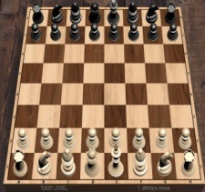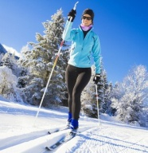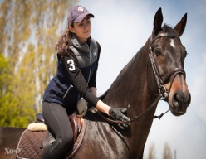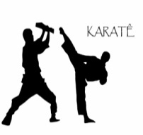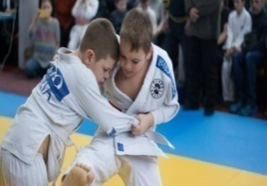
8 9 10 11 12 13
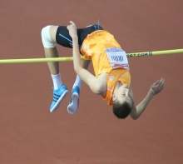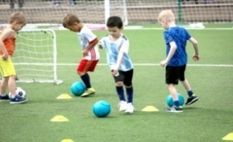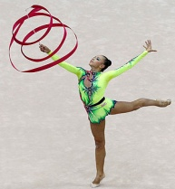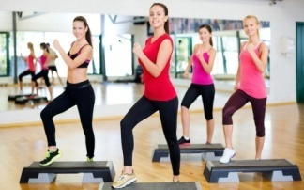
Ex 2 Complete the sentences. Use the present simple form of  do, play or go.  1 Liam ________ gymnastics on Friday evenings.  2 I ________ basketball after school.  3 We don't ___________ athletics at school.  4 My sister _________karate.  5 Jason_________ skateboarding with his friends.  6 My cousin________ tennis on Sundays.  7 I don't_______ ice skating very often.  8 My friends and I_________ rollerblading in the park.  9 A lot of people _______ skiing in winter.  10 My sister___________ athletics in summer.  11 Do you ________tennis well?  12 We ________ yoga in the evening. | Ex 3 Complete the activities with the words in the box  1. listening ___  2 video ___  3. ice ____  4. board ____  5. ice _____  6. going ____  7. reading _____  8. surfing _____  9. watching _____  10. taking ______
  Films • games • games • hockey • jogging • magazines • photos • skating • the Net • to music
Ex 4 Complete the sentences  1. I am really ________________ about music  2 My brother is _______________ at sport  3. My sister is _______________ on reading books  4. Lily is ________________ of playing the guitar.  5. They really ______________ playing football | Ex 5  1) The children have a birthday party/ surprise party.  2) The children decorate the room by ballons/ by flowers.  3) The children gave Nigel a book / an animal
  Good • fond • crazy • keen • like
Ex 6 1 2 3 4 5 6
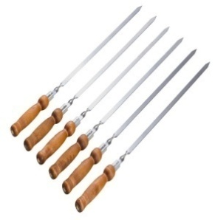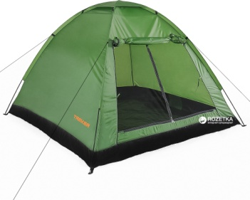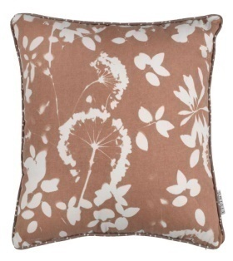
Ex 7
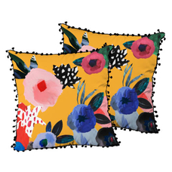 | Dear Mary,  There will be my ________ on Friday. I’m having a party. It will be a _______ party so take your _________ with you. We will eat a _______ and have _____ . The party will be at 35 Green _______ . It _______ at 5 o’clock.  You are ____  Linda.  PS. Please, let me know if you ____.
  Pyjamas • fun • welcome • birthday • sleep-over • cake • street • come • starts

Малюнки для виконання командного завдання. («вгадай хобі за малюнком»)
 | 
 | 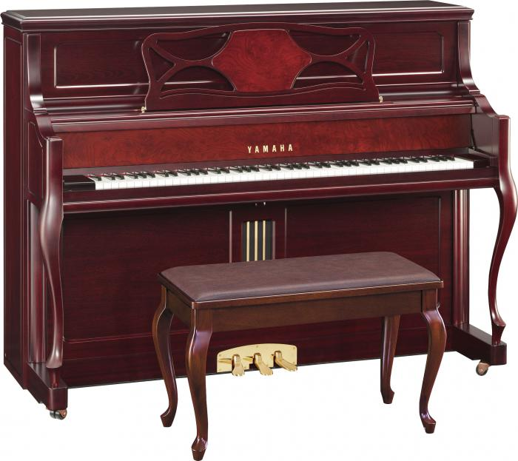
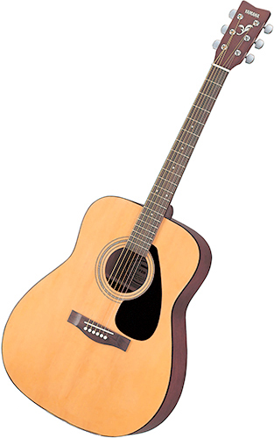 | 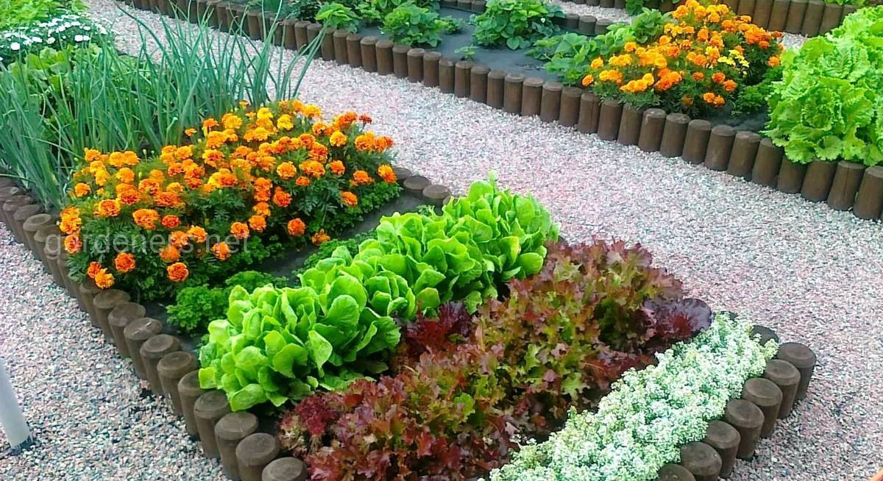
 | 
 | 
 | 
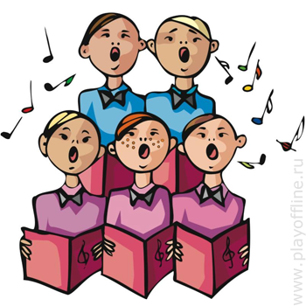 | 
 | 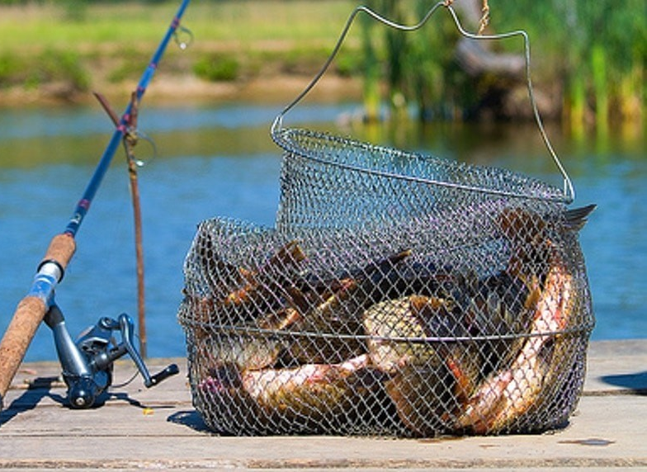
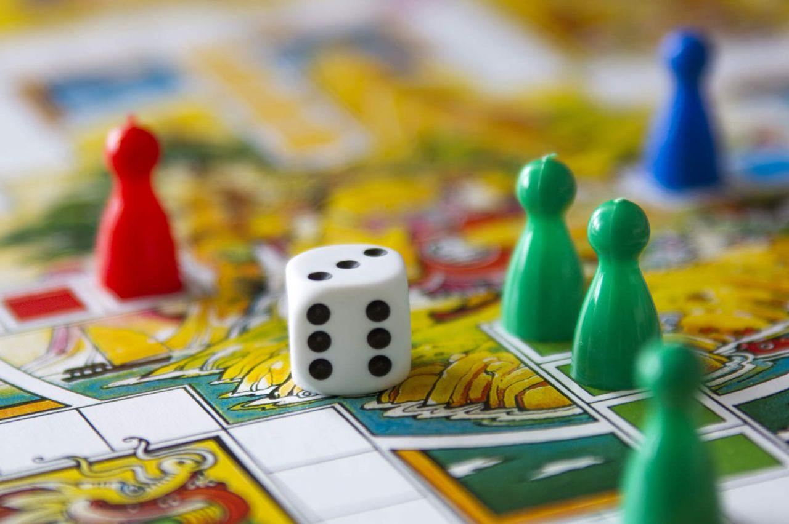 | 

