Тopic: Welcome to London
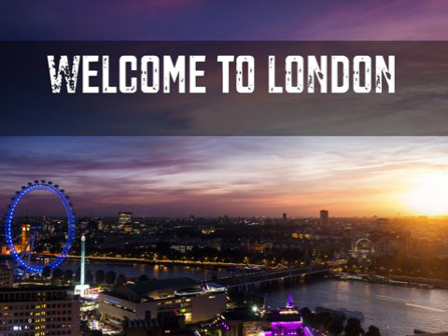
Objectives:
- to develop students’ reading skills;
- to practice students’ speaking skills;
- to improve listening comprehension;
- to involve the pupils into communication according to the given situation;
- to develop logical thinking;
- to develop socio-cultural competence and cultural awareness;
- to educate respect to other people’s culture;
- to foster positive emotions;
- to enlarge the knowledge of London and its places of interest.
Equipment: a map of Great Britain, a portrait of the Queen, Power Point Presentation about sights of London, cards with the text, a table “Key Facts”, a picture of the British flag.
Procedure
I. Introduction 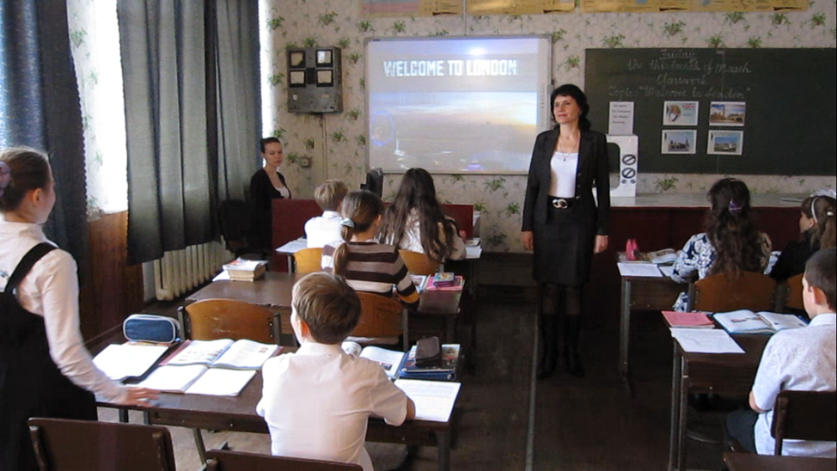
T: Good morning, children. Is anybody absent? I’m glad all are present. Today we’ll have an unusual lesson. We are going to fly to London, the capital of Great Britain. But first of all let’s turn on a TV set and listen to the weather forecast.
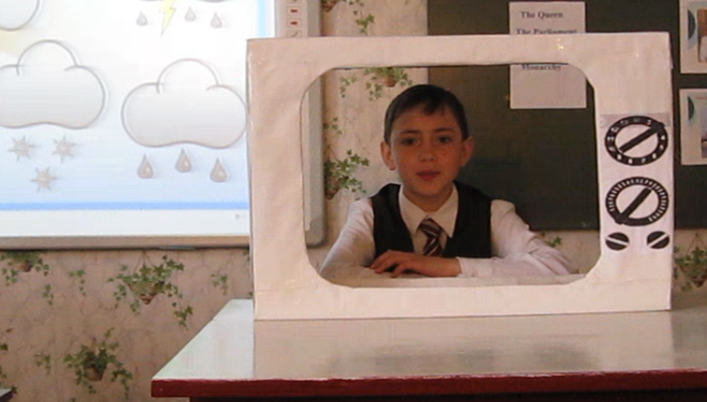
II, Warming-up
P: Good morning. The weather forecast promises us good weather today. The sky is blue; it is not covered with dark clouds. The sun is shining brightly. The light wind is blowing from the west. The temperature is 10 degrees above zero. Thank you for your attention. Good bye.
III. Main part
1. Speaking
T: The weather is fine to start our travelling. Please, think of possible ways of getting to England.
(Pupils give their ideas. Teacher writes them down on the blackboard.)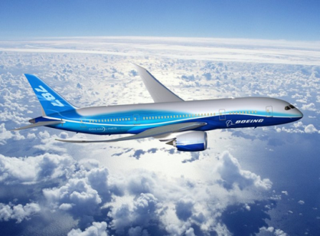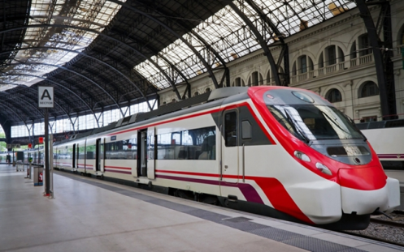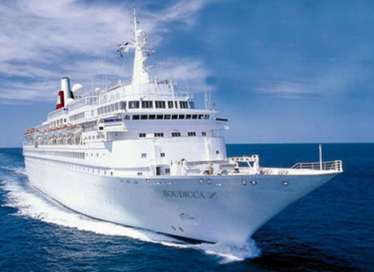
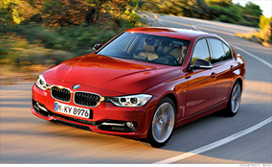

Holidays are near, oh what fun!
It’s time for travelling for everyone,
Packing the baggage, and all the rest
My travelling time – I like you best!
T: So ,we are going to travel by plane. You will learn many interesting facts about this country, visit beautiful places and see many sights. I hope you’ll have good time there. Now we are ready to leave for Great Britain.
Let me introduce my assistant, our stewardess.

Stewardess: Good morning, everyone, I’d like to welcome you aboard this plane. As you know we are flying to London. Will you fasten your seatbelts now? Have you got any questions to me?
P1: What altitude is our plane flying at?
Stewardess: We are flying at the altitude of 15.000 feet.
P2: What is the arrival time?
Stewardess: We’ll arrive at 4 pm.
P3: What time will lunch be served?
Stewardess: Lunch will be served at 1 pm.
(The stewardess offers coffee, soft drinks to the passengers.)
2. Listening
Stewardess: Now I invite you to listen about the traffic in London.
Text
Welcome to London! We are glad that you are here, and to make your stay nice and comfortable, we would like to inform you about what you may find unusual in London. First, of course, it is that we drive on the left side of the road, not on the right as Europe and America do.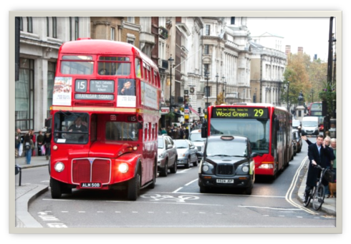
You should be very careful and attentive when you cross the road and look first to the right and then to the left, not like in your home country. If you don’t know how to get around in the city, ask the nearest policeman. They are very polite and always eager to help. 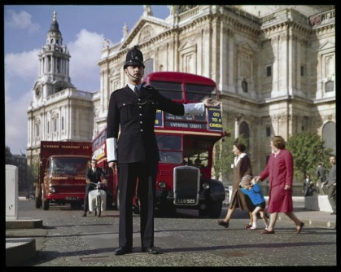
There are no trams or trolleybuses in London, the main transportation is buses and the metro, we call it the Tube. When you get on a bus, you should pay the fare. There is a special conductor for that. London buses have two floors; we call them “double-deckers”. 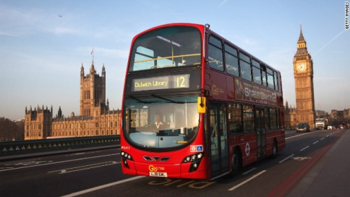
They are of different colours, and that will help you find the bus you need. The London metro, or the Tube, is very convenient. It can carry you to any place in the city, but it is a little too expensive. So, enjoy your stay in our capital.
T: Note down the main differences between the means of public transportation in England and Ukraine.
 | Traffic | Buses | Trolleybuses | Trams | Metro
England
Ukraine

3. Speaking
Stewardess: Before coming to England let’s remember English customs.
Possible answers:
P1: People in England do not shake hands as much as we do in our country or in Europe.
P2: Men raise their hats to women but not to each other.
P3: If you go a friend’s house for dinner, you don’t say “Thank you” at the end of the dinner. You say “Thank you” when you go home.
P4: It is difficult to know if an Englishman is married, because they do not wear wedding rings.
P3: The English do not talk as much as we do.
P6: Traffic keeps to the left.
P7: The English is a nation of stay-at-homes. They prefer to sit at the fireplace after the working day.
P8: The English drink a lot of tea.
P9: They always drink tea out of cups, never out of glasses.
P10: In England many people drink tea with sugar and milk. Tea with lemon is called “Russian Tea“.
P11: The British always eat bread with their soup. They never eat any bread with meat and vegetables.

Stewardess: We are landing. Unfasten your seatbelts, please. I’m sure the flight was pleasant for you. Thank you for your attention. The guide will meet you at the airport and will take you on an excursion.

4. Reading
Pre-reading
T (guide): Welcome to Great Britain!
There are the following words on the blackboard: the Queen, the Parliament, the Minister, monarchy. Teacher demonstrates the national flag of the United Kingdom of Great Britain and Northern Ireland and the portrait of the Queen of England and asks pupils to share their ideas about the things. The pupils will most probably come to a logical conclusion about the flag and the head of the state.
Teacher explains students are going to find out more about England and suggests reading a short article for more information.
(She gives the cards with the text to pupils.)
Text
The country we are going to visit has name of Great Britain; it has water on all sides and is an island. It is not a very big country. Ukraine is bigger, but there are more people in Great Britain than in Ukraine (more than 60 million people). Great Britain has 4 parts; they are England, Scotland, Wales and Northern Ireland. England is the biggest part; it is in the centre of the island. The other three parts are much smaller.
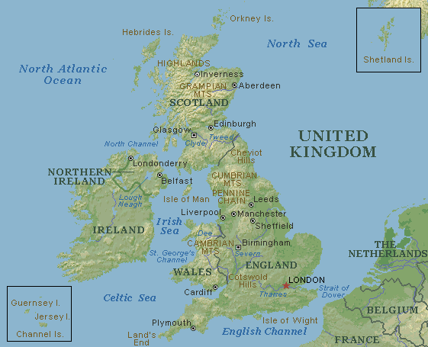
Not very many people live there (about 8 million people), they have their languages and cultures but they all speak English because English is the official language. Great Britain has very beautiful rivers (Thames, Severn, Mersey), mountains (Ben Nevis, Snowdon) and lakes (Lake District, Lough Neagh). There are large cities in Great Britain but many people live in small towns or villages. London is the capital city of the country. It is a very old city, and it has a lot of historical monuments. You can get Great Britain by plane, by ship, by train or by car.
Great Britain is an independent state in Europe. It has its national anthem and flag. The flag has colours of the parts of the country; its name is Union Jack.
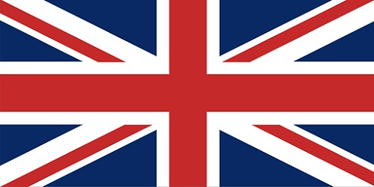
Great Britain is a monarchy. Now the head of the state in Great Britain is Queen Elizabeth II but she does not really rule the country.
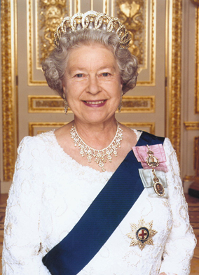
The people of Great Britain love their queen but they elect the Parliament, and the real head of the state is the Prime Minister.
Post-reading
T: Now the pair work. Let’s sum up the text and fill in the table.
- Key facts
Name
Parts
Type of land
People
Language
Cities
Capital city
Rivers
Lakes
Mountains
How to get
- Students use the map of Great Britain to find the missing information and complete the table.
- Then pupils make up sentences about the country using the information they have found themselves.

5.Relaxation
T: I see you are tired, let’s have a rest!

Jump, jump, jump up high
Lift your hands up to the sky
Touch your head and your knees and toes.

Roll your shoulders round and round
Roll your hands down to the ground
Clap ,clap ,clap and let’s shout “Hooray!”
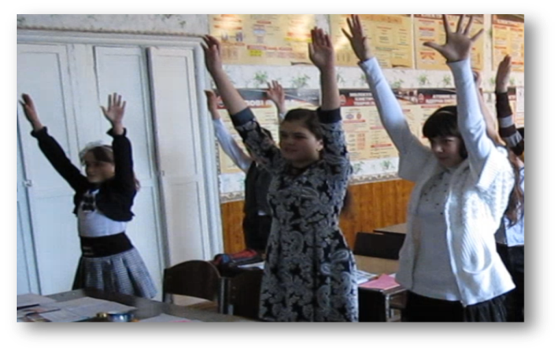

6. Watching a presentation
T: Now let’s have an excursion around London, the capital of Great Britain. (The guide demonstrates a presentation about London.)

Look at the board. You can see the names of some London’s sightseeing.
- First read after me. London sights:

The National Gallery
The Tower Bridge
St. Paul’s Cathedral
Westminster Abbey
Trafalgar Square
Buckingham Palace
Houses of Parliament
Covent Garden

- Now the pair work: you have the cards with the words – read in pairs, match the parts and give the names of London’s sights in pairs. Write them down into your exercise books:
Big Palace
Trafalgar London
Buckingham Ben
Westminster Square
The Houses of Parliament
The Tower of Abbey

7. Game

T: And now let’s work in groups. But before you’ll start this working I’d like you to revise the Rules of group work:
- Keep to the topic.
- Do not say anything to hurt feelings of someone present. Be polite.
- Do not begin to talk while someone else is talking. Say excuse me if you need to interrupt someone. Then wait for your turn.
- Do not talk too loudly.

Let’s play a game.

T: Today we have two teams: “Fire” and “English Bridge” – take your places in teams. As you know the climate of Great Britain is damp, it’s often rains there. That’s why I have prepared you the clouds and drops. I give you the clouds and each team can win the drops. The winner will be the team which has the more drops on their cloud.

Quiz:” Who Knows London Better?”
T: So, we have learnt a lot of things about London and its sights and now we’ll see who knows London better. I’ll ask you questions and you’ll get drops for each right answer. Are you ready? Let’s start. (Slide)

T: Let’s count the drops on your clouds. The winner is the team which has more drops. I reward the gold medal the team – winner and silver medal the second team.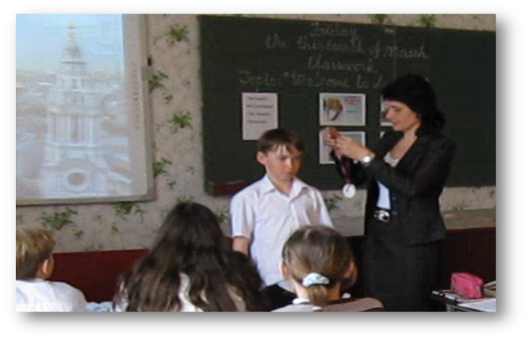
T: Our excursion is over. I wish you a pleasant way back home!
(Pupils thank the guide.)

IV. Summing-up
Stewardess: Take your seats on the plane. We are coming back to Ukraine.
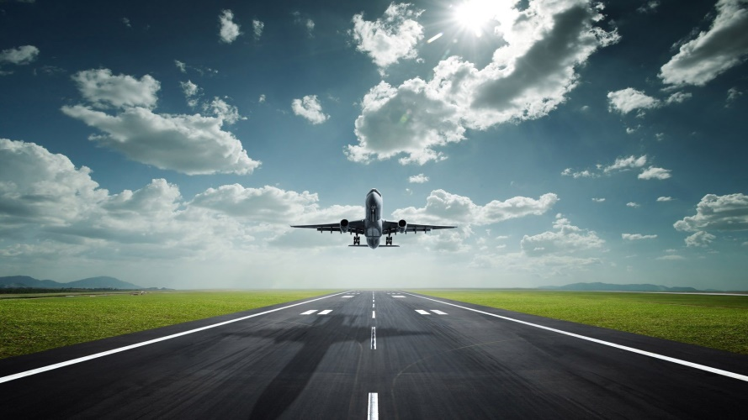

T: So, let’s sum-up. What did you do? What have you seen? What have you learnt about Great Britain? Your marks are…
V. Home assignment
T: Write a short composition “ I’d like to visit…”.

