Ars longa, vita brevis
“Life is short, Art is long”
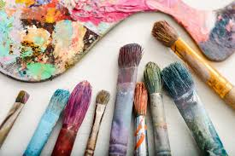
Theme: “Painting. ”
Focus: Reading /Vocabulary
Aim: to help pupils:
- to develop reading skills (scanning and skimming)
- To practice vocabulary
- to develop imagination
Цілі:
Практична: ознайомити учнів з новими словами за темою «Мистецтво» та навчити використовувати нову лексику. Удосконалювати вміння читати текст та знаходити потрібну інформацію.
Розвиваюча: розвивати пізнавальну здібність учня та вдосконалювати навички самостійної роботи.
Виховна: прищеплювати любов до мистецтва.

Хід уроку
Task1
Turn on music Shopen Noktyrn 2. Relax , listen to music and think about art.
Imagine different types of Art. Use the presentation.

Task 2
Read the text.
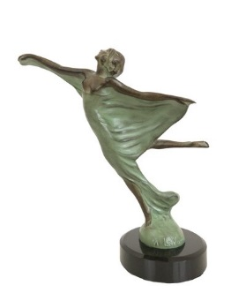
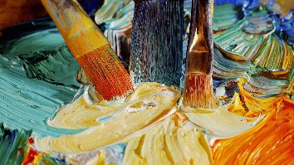
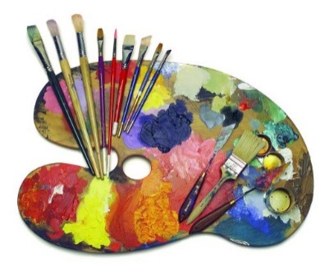
Art can be classified in 2 categories i.e. fine arts and performing arts. However, the term 'art' is considered different from 'arts'. The former is used to group together only the visual forms of art. Other types such as literature and performing arts do not come under the term 'art'. A broad classification of visual arts classifies them into different groups like painting, drawing, sculpting, architecture, printmaking, ceramics, photography, collage, digital graphics, film-making, etc. Earlier, handicrafts and applied arts were not part of this category. It was only in the beginning of 20th century that the 'Arts and Crafts Movement' (Britain) brought a lease of life to these art forms.
Painting
It is said that painting is the art of depicting the beauty of nature. For some, painting could be a medium of expressing their feelings. For few others it could be a way of depicting the surroundings they observe. Painting is basically an art of applying pigment to a surface (medium) like canvas, paper, wall, wood panel, etc. Brush is a tool commonly used for painting. There are many different forms of painting. Landscape painting and abstract painting are the common.
Sculpting
A sculpture is a three-dimensional artwork created with the help of materials like rocks, wood, plastic, clay, etc. Carving out a sculpture and assembling it are the 2 different ways. In some cases, sculptures may also be painted.

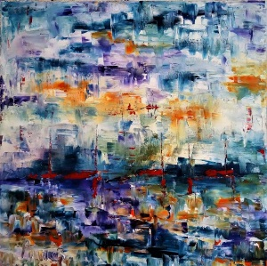
New Age Visual Arts
The new age arts are a product of industrial revolution. Development of technology leads to use of different techniques for creating these artworks. Photography is one such art to have developed with the invention of camera and photographic film.

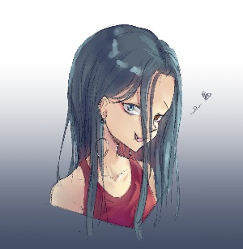

Digital Art
The digital or computer art is widely used in creating websites, video games, clip arts, templates etc. Use of computer in the field of visual arts began in the 1960s. In today's digital art industry, animation is the buzzword. Use of 3D animation techniques is made in many different fields like filmmaking, TV advertising, web advertising, etc. Digital technology has given a boost to the art industry since newer and innovative tools have been developed.
Filmmaking
Filmmaking comes under the discipline of visual arts. However, scriptwriting, music, and many such arts converge and complement each other in this art form. A story or script is the core or soul of a film. It acts as a thread that guides the process of making a film. Incorporating features like audio and video offer viewers with a complete and fulfilling experience. It is the main reason why movies have become so popular.
The topic of visual arts is vast and a rough outline of different forms of these arts is presented above. Many other art forms like literature and performing arts are however, not included. The brief account of different types of art presented above should help readers gain a better understanding of them.
Task 4
Find the words and word combinations in the text and underline the sentences: fine arts, performing arts, visual forms, classify, express, painting, drawing, sculpting, architecture, printmaking, ceramics, photography, collage, digital graphics, film-making, depict, observe, landscape, abstract, assemble, light patterns, emit, reflect, surface, he digital or computer art, innovative tools, scriptwriting
Task 5
Guess their meanings or use the vocabulary.
Use http://dictionary.cambridge.org/dictionary/learner-english/ to find unknown words.
Task 6
Read the text once more. Answer the questions:
- What types of art are there?
- What is the difference between the term 'art' and the term 'arts'?
- What are the groups of visual arts?
- Does sculpture depict the beauty of nature?
- The common forms of painting are landscape painting and abstract painting , aren`t they?
- What materials are used to create sculptures?
- Why some visual arts are called new age visual arts?
- Where do people use digital art?
- What are the compounds of the film?
- What is the main reason why movies have become so popular?

Task 7

Match the equivalents:
fine arts | Живопис
Painting | Oбразотворче мистецтво
Sculpting | Кераміка
Architecture | Скульптура
Ceramics | Колаж
Collage | Пейзаж
digital graphics | Архітектура
landscape | Сценарій
surface | Поверхня
innovative tools | Цифрова графіка
scriptwriting | Інноваційні прилади

Task 8
Fill in the gaps with the words or their forms:
classify, express, photography, filmmaking, depict, observe, abstract, assemble, reflect, computer art, innovative tools, landscape
- Visual Art can be ……..in some categories.
- It is said that painting ……..the beauty of nature.
- Fine arts help us to ……..the world and ……..our feelings
- Brushes and teasels are not …….. ……..but they are traditional instruments for painters.
- ……..painting and ……..painting are the common forms.
- She had ……..a collection of her favourite sculptures.
- The new product of industrial revolution was…….., which appeared with the invention of camera and photographic film.
- The digital or …….. …… is used in creating websites, video games, clip arts, templates.
- The art of …….. ……..all spheres of life.
Task 9
Learn the words from tasks 4. 5 and make sentences with them.
Send them to the teacher to check.

Task 10
Tell about your favourite visual arts. Use the scheme:
1. | What visual arts you know.
2. | Your favourite visual arts. Why you prefer them.
3. | What artworks you know or have at home.
4. | Where you can watch or see them.
5. | Have you got any collection?
6. | Your attitude to art.

Keys
Answers 6
1. Fine arts and performing arts
2. Visual arts are “art” and performing arts are 'arts'.
3. Painting, drawing, sculpting, architecture, printmaking, ceramics, photography collage, digital graphics, film-making).
4. No, it`s painting but for some, painting could be a medium of expressing their feelings for few others it could be a way of depicting the surroundings they observe.
5. Yes, they are)
6. A three-dimensional artwork is created with the help of rocks, wood, plastic, clay, etc.
7. The new age arts are a product of industrial revolution. Development of technology leads to use of different techniques for creating these artworks.
8. In filmmaking, TV advertising, web advertising, etc.
9. Some of them are scriptwriting and music.
10. Incorporating features like audio and video offer viewers with a complete and fulfilling experience.
Answers7
Fine arts | Oбразотворче мистецтво
Painting | Живопис
Sculpting | Скульптура
Architecture | Архітектура
Ceramics | Кераміка
Collage | Колаж
Digital graphics | Цифрова графіка
Landscape | Пейзаж
Surface | Поверхня
Innovative tools | Інноваційні проистрої
Scriptwriting | Сценарій

Answers8
- Visual Art can be classified in some categories.
- It is said that painting depicts the beauty of nature.
- Fine arts help us to observe the world and express our feelings
- Brushes and teasels are not innovative tools but they are traditional instruments for painters.
- Abstract painting and landscape painting are the common forms.
- She had assembled a collection of her favourite sculptures.
- The new product of industrial revolution was photography, which appeared with the invention of camera and photographic film.
- The digital or computer art is used in creating websites, video games, clip arts, templates.
- The art of filmmaking reflects all spheres of life.

