Розробка циклу уроків з теми «Travelling And Money» на основі підручника Laser (10 клас)

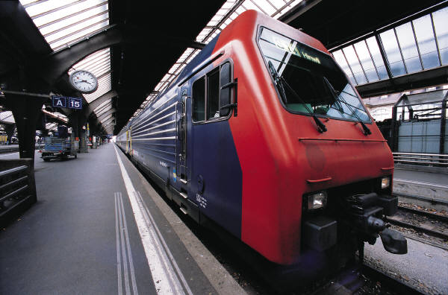
Соціокультурний розвиток учнів на уроках англійської мови в контексті європейської та світової культури

„Жити філософією серця”
(Галицько – Волинський літопис)
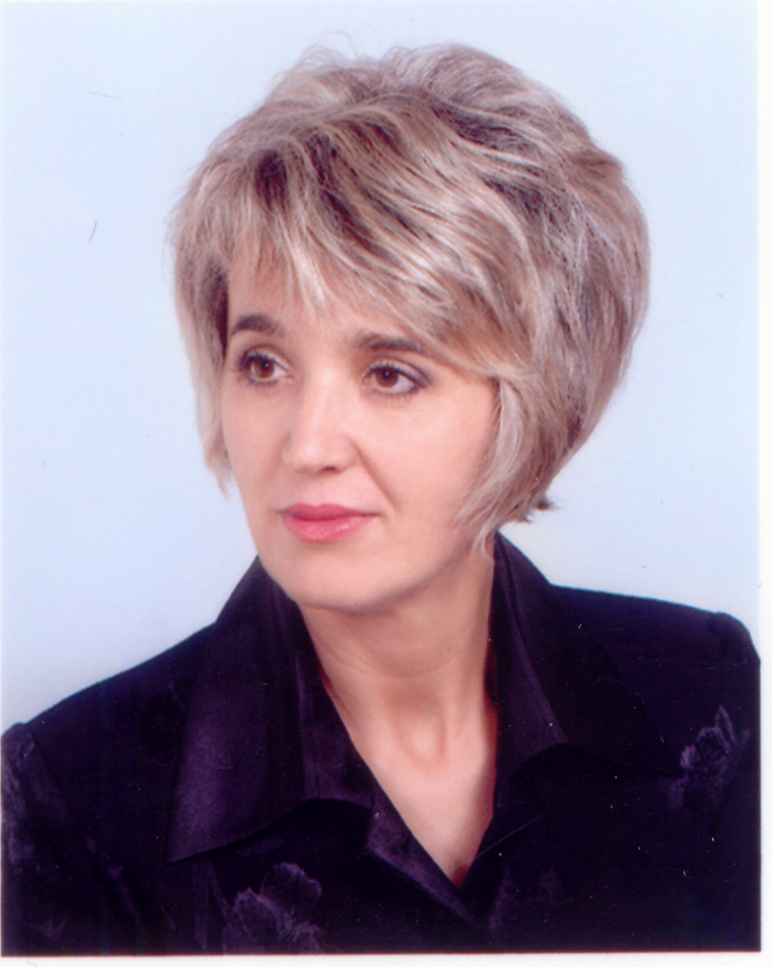
Світлана
Світлана
Петрівна
Ізбаш

Учитель іноземної мови Врадіївської районної гімназії,
спеціаліст вищої категорії,
учитель-методист.

TRAVELLING AND MONEY
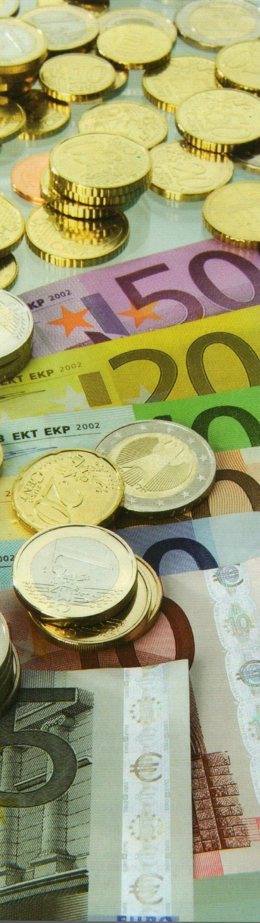
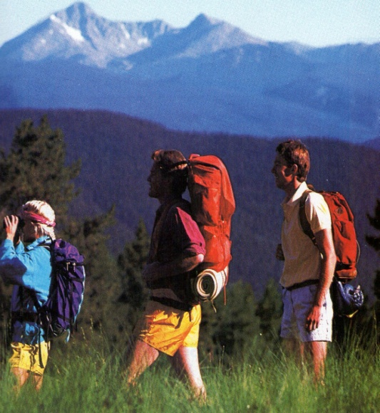

Practical aim: teaching learners
how to use the topical
language to do with travel
and money.

Educational aim: assisting in
formation of the socio –
cultural competence of the
learners.

Cultural aim: contributing to the
development of learners’
speaking and writing compe-
tence on the basis of the
lexis-grammar material
suggested.

Developmental aim: forming the
learners’ socio-linguistic
outlook, memory and creative
thinking.

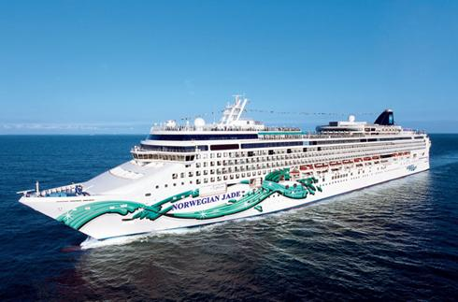

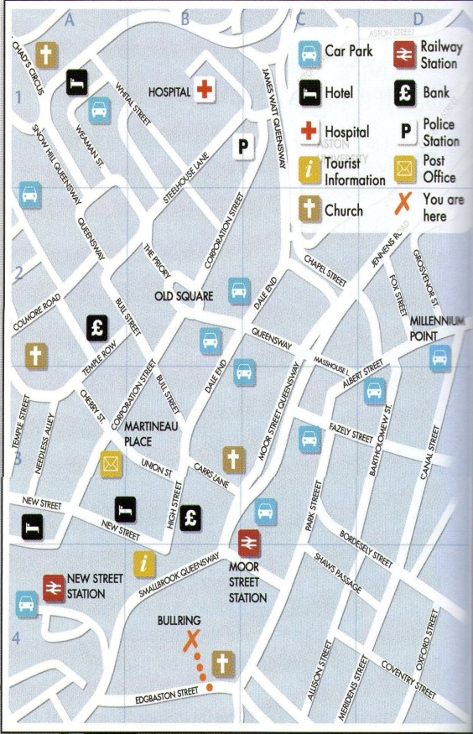

Topic
Students will discuss different ways of travelling and explore their attitude to different kinds of holidays

Grammar
Past simple – affirmative, negative, interrogative

Vocabulary
Key vocabulary
Phrases and collocations
Word formation

Writing skills
Writing a discursive essay

Culture Zone
Holiday bookings in Britain
THE WORLD OF TRAVELLING

Lesson Plan
Don’t worry about the
world ending today … It’s
already tomorrow in Australia
The Procedure:
Get warmed up!
T: Good morning, students. I hope you are well today. Now you are listening to a song “One – way ticket” and you understand that we’ll talk about travelling. So let’s get down to work.We should revise the material on the topic and discuss different ways of travelling.
A lot of people all over the world are fond of travelling. They travel to discover for themselves a world of wonder, where the mountains are taller, the rivers mightier and the wildlife more plentiful than any other place on earth, visit beautiful islands and escape the paradise on next vacation: sleep under a palm tree, stroll on endless beaches and eat ice-cream while floating in a turquoise sea, visit castles, museums and galleries, explore ancient cities and winding canals, glorious gardens, gilded theatres and fabled landmarks. It is all a picture-perfect experience. And without travelling you will never see it. So it is impossible to imagine our life without travelling. People can express their emotions in different ways. Some of them draw pictures of their favourite places, others write poems. I have found a very nice poem for you. Let’s read it with a bit of feeling and think of your own emotions and associations.
What is travelling for?
What is travelling for me?
It is the shining sun, the sea;
The golden sand which look like beads;
The blue-eyed sky and tender breeze.
What do I see when close my eyes?
A milk0white ship with two red strips;
The limpid clouds at the dawn
And sun that rises all alone…
And when the twilight falls from height.
The night appears from heaven’s gate.
I see the moon in magic light.
And stars that sparkle at the night.
That’s what I’m looking for in dreams.
And they are my inspiring beams!
I want to see it to behold
And travel all over the world!
Dictionary Corner
T: First of all I want to make sure you don’t forget the words on the topic “Travelling”. Look at the word box on your4 desks and put the words under the following headings:
- types of holiday;
- places where people stay on holiday;
- places people visit on holiday;
- things people do on holiday;
- problems people can have on holiday.
Camping, resort, museum, queues, bed and breakfast, to relax, crowds, delays, sunbathing , caravan, sightseeing, beach, tent, cruise, lost luggage, youth hostel, excursion, sunburn, safary, gallery, food poising, wind-surfing, round-the world trip, cancellation scuba-diving, bungalow

T: Well done. And we continue our work. You have to match the words with their explanations.
travel you travel in other country
journey you buy it
voyage it is a place where you go to travel
advantage to move from one place to another
disadvantage a trip from one place to another
request stop sea trip
ticket the bags carried by the people who are travelling
pursuit a good or useful quality that something has
destination the transport will stop, if you signal the driver
abroad different holiday activities
luggage a bad quality that something has
Talking Point
T: Let’s do some search work. Interview your classmates and find out which of them:
- never travelled to other towns or cities
- never travelled abroad
- travelled alone
- stayed at hotels
- never travelled by air
- never travelled be sea
- prefers travelling on foot
- hates travelling by train
- can drive a car
- takes a lot of luggage on a journey
- travels light (with little luggage)
- likes talking to his of her fellow passengers
- likes seeing people off
- believes that “there is no place like home”

Social English
T: The two charts show information about holiday bookings in Britain. The first one shows how people book their holidays, and the other shows the kinds of holiday they book. Talk about the information presented in the charts. As you see people book most holidays at travel agents’ offices. They use the Internet to book a large number of holidays. People with demanding jobs take a lot of short-break holidays and often take their honeymoon abroad. Do you think the situation will change in the future? How?

Pupils’ answers
- I suppose the traditional way is to go into the travel agent’s office.
- It’s not surprising that the Internet is so high when you think how many websites are travel ones.
- The honeymoon figure must be lower because you only on one of those!
- I imagine it’s more likely to be younger people using websites to book their trips.
- I guess that in the future we’ll see the Internet increasing further.
- I think I’d still feel safer booking it by going into an office myself.
Reading
T: Now we are going to read a text. But at first pre-reading activity. Answer the questions after correcting some mistakes.
- What’s last holiday you had?
- Had you been to there before?
- What did you do white you were away?
- What preparations did you make before leave?
- Where are you going for next your holiday?

Holidays from A to Z
ACTION ADVENTURE
Cross the sahara on a camel. Fly in a balloon safari. Sleep under the stars. Live you life to the full!
BEAUTIFUL BEACHES
White sand and palm trees as far as the eye can see. Bright sun and warm water. Exchange your stress for peace!
COUNTRYSIDE CAMPING
Put down the picture postcards of the pretty countryside and pack your bags because we’re going there. Be part of nature!
DATE WITH HISTORY
Bored with TV? Come on our grate tour of monuments and museums and historical town centers. Feed your brain and your eyes!
EXCITING SPORTS
Fed up with sitting around? Want to get fit and have fun? Water sports, mountain-climbing, indoor skiing, and more: everything’s possible at our special centre!

T: Let’s do a post-reading task. Discuss the following issues and choose a holiday from the options below:
- which would be the best type of holiday to go on
- what you would like to do while you are there
- how long you would like to go for
- what preparations you need to make for the trip
Questions-based-discussion
T: It is high time to start a discussion
STUDENT A’s QUESTIONS (Do not show to student B)
- Do you like travelling?
- What is travel for you?
- What different finds of travelling are there?
- What’s the best place you’ve been to?
- Would you like to go travelling for a few years non-stop?
- What are the good and the bad things about travelling?
- Where do you want to travel to before you die?
- Is it better to travel or to arrive?
- Lin Yutang said: “:No other realizes how beautiful it is to travel until he comes home and rests his head on his old, familiar pillow.” Do you agree?
- Elizabeth Drew said: “Too often travel, instead of broadening the mind, merely lengthens the conversation.” What does this mean? Do you agree?
STUDENT B’s QUESTIONS (Do not show to Student A)
- What spings to mind when you hear the world “Travel”?
- Are you a traveler?
- Is travel an education?
- Would you like to travel in space or to the moon?
- Would you like to work in the travel industry?
- What are the pros and cons of traveling first class and backpacking?
- What abilities of a snake would you like to have?
- What would make you wiser – travelling around the world for ten years or reading 10,000 books?
- Mason Cooley said: “Travelers never think that they are the foreigners.” Do you agree?
- St. Augustine said: “The World is a book, and those who do not travel read only a page.” What does this mean? Do you agree?
T: I’m afraid it’s time to stop. I want you to write an essay on the topic “Travelling is meeting the cultures”.

Topic
Students will discuss different means of travelling, the positive and negative aspects and explore how to make the travel easier

Grammar
Using phrasal verbs
Prepositions

Vocabulary
Key vocabulary
Phrases and collocations
Word formation

Writing skills
Writing a report

Culture Zone
Local buses in Britain
DIFFERENT MEANS OF TRAVELLING

Lesson Plan
He who would travel
happily must travel light
Antoine de Saint – Exupery
The Procedure:
Get warmed up!
T: Good morning, students. As you see there are different cars, buses, trains and even planes. I think you understand that we’ll talk about different means of travelling and its characteristics, both advantages and disadvantages. Let’s start our lesson with making up cinquains about travelling. Do you remember what is it? It is a kind of poem consisting of 5 lines (a general word, two adjectives on the topic, three verbs, the main idea of your “poem” (it must consist of 3 – 4 words) and a synonym of the general word Make up as many cinquains as you can.
Pupils’ cinquains. Examples.
Travelling  - exciting, comfortable  - to enjoy, to relax, to visit  - a change of scene  - journey | Travelling  - fascinating, interesting  - to swim, to sunbathe, to walk  - the best way to relax  - holidays
Travelling  - enjoyable, convenient  - to impress, to explore, to admire  - travel broadens your mind  - voyage | Travelling  - picturesque, romantic  - to dance, to bath, to enjoy  - the way to escape from every day life  - trip

Pair Work
T: Now try to identify different means of transport working in pairs. Differentiate the words and word – combinations to the following groups:
- Travelling by air
- Travelling by car
- Travelling by train
- Travelling by sea
Speed, compartment, stewardess, to take off, accident, traffic “jam”, to get stuck in the mud, berth, voyage, amid ship, to stand in a queue, to ride, booking – office, dinning – cars, sea –sick, flight, on board a ship, round –about, a spin, a single ticket, to land, coaches, sea – gulls, to see off, to go brown, quay, to moor, to become home - sick, to fasten the bells, timetable, to rent a room, flight – information board, to be X-rayed, a boarding pass, delay, departure, to board a train, hitch-hiking, engine, carriage, comfort

Six Thinking Hats
T: Everybody knows that different kinds of travelling have their own positive and negative aspects. You are divided into 2 teams. The first team will put on a black hat. It means that you should think of disadvantages.
The second team will put on a yellow hat. You’ll try to find out only advantages.

Possible answers

advantages disadvantages
by plane
- Air travel is quicker than other means of transport.  - People enjoy travelling by air because of the meal and the entertainment on board.  - The time goes by more quickly when travelling by plane. | - The trip to the airport took almost as long as the flight.  - There are usually long queues at the checking-in.  - Flying often involves delays and cancellation  - Turbulence can also spoil the flight.  - There are occasionally terrorists which would spoil any journey.  - You luggage can be lost.  - It is the most expensive way of travelling.

by train
- The seats were made into beds on night journeys.  - Railway stations are usually in the centre of the city. (it is closer to your home than the airport).  - The tickets are less expensive.  - There is a buffer car selling drinks and snacks.  - You can look out of the window and enjoy picturesque landscapes around you.  - The porter can help you with the luggage. | - Your fellow - passengers can be annoying.  - Sometimes it is stuffy in the compartment.  - It isn’t convenient to have meals on the upper berth.  - Toilets are usually dirty.

by car
- You can stop wherever you want.  - You don’t have to buy any tickets.  - You shouldn’t follow any timetable (you don’t depend on any schedule). | - Petrol is very expensive.  - Sometimes it is difficult to find a service (or a filling) station in an unknown place.  - Roads (highways) are not in good condition.

by ship
- There is a lot of entertainment on board a large cruise liner.  - The ship stops in different ports and you can go on the shore for excursions. | - You are afraid of tossing.  - You can suffer from seasickness.  - Your voyage depends on the weather.

Social English
T: Now try to learn some useful information before going abroad
Going by train
- A single is a one-way ticket.
- If you ask for a return, the clerk may ask you when you are coming back. This is because there are at least two types of return ticket;
- An ordinary return - the more expensive and valid on any train for a period of three moths.
- A cheap day return – valid only on the day you buy it, and usually only after a certain time in the morning. Check first!
- If you are staying in a town near London and you want a day return to London, you may be able to buy a tail ticket which is also valid on the London Underground.
- Always keep your ticket until the end of your journey, when your ticket may be collected at the barrier.
Speaking to another passenger
Remember, if you speak to a stranger, you usually begin with
“Excuse me”.
- Is this seat taken?
- Are these two taken?
- Do you mind if I move your bag , please?
- Could you keep an eye on my things for a moment, please?
- Do you mind if I close/open the window, please?
- Is this (York) we/re coming to?
Do you know if there’s a buffer car on the train?
if we’re on time?
what time we get to (York)?
Local Buses
- In most towns there are different kinds of bus “pass”. Each town has its own system for these tickets which will save you money if you have to use buses every day.
- Unlike your own country, in any British town there may be more than one bus company. The buses from the different companies may even run on the same routes.
- If you are waiting at a bus stop with the sigh “Request Stop”, it means the bus will only stop if you stick your arm out to signal to the driver.
- When you get on to a bus, the driver or conductor will expect you to say your destination clearly.
Say, for example: Marina Drive, please or Two to the station, please. On man buses where you pay the driver as you get on, you will see the sign:
Please tender correct fare and state your destination.
- If you don’t known when to get off:
Could you let me know where to get off for the swimming pool, please?
Reading
T: Now you’ll read some topical texts and try to do some tasks. Write one word in each gap.
1)The Segway
The Segway HT (Human Transporter) (1) …………………. first presented to the public in 2001. It is a revolutionary form of transport, which runs (2) ……………….. electricity and allows the rider to balance on a small platform between two wheels. Balance (3) ………………… maintained by two computers, which monitor the Segway’s (4) …………….. move. A the vehicle moves off balance, the computer turn the wheels to compensate, (5) ………………. this way restoring balance. If the rider leans forwards or backwards, the Segway moves in that direction in an attempt to steady (6) …………….. . If the rider continues to lean, the vehicle continues to move at up to 10 mph. Once you are (7) ……………….. the move, the Segway (8) …………………. be steered in the direction you want to go using the handlebars.
(9) …………………. are thought to be a number of advantages to the Segway for short, inner-city journeys. It’s a very safe environmentally-friendly means of transport, and a number of organizations, such as police forces and postal services, consider (10) ………………….. to be a possible alternative to cars and bicycles.
Answers: 1 was 2 on 3 is 4 every 5 in 6 itself 7 on 8 can 9 There 10 it

2)My disastrous holiday
It happened two years ago. I was getting ready to go to Paris to have the time of my life when one day before my train journey I was knocked (1) …………….. by a bus and broke my arm. I thought nothing worse could happen to me, so I decided to go anyway.
I managed to talk my father into giving me a ride to the station , which was five kilometres from our house. We planned to set (2) …………….. very early to catch the 7 a.m. train. The car wouldn’t start because my father had left the headlights (3) ……………. all night and the battery had run down. When we finally left it was already 6.30. My father is a very slow driver so I asked him to speed (4) ……………… and when we were doing 120 km/h a police car caught (5) ……………….. us. We pulled up by the side of the road and got (6) …………….. car. The policeman glared at us and handed out a rather heavy fine to my father for speeding. I was very nervous – it was 6.45 and we were nowhere near the station yet. To make things worse, the car started to jerk and it soon turned (7) ……………. we had run (8) ………………… petrol. We had to stop at the petrol station to fill up the tank. We finally got to the railway station at three minutes to seven. I kissed my father goodbye, jumped on the train and breathed a sign of relief. But as soon as we reached the next station, I realized that I had got (9) ………… the wrong train: I was travelling to Island, not Paris!
Answers: 1 off 2 up 3 up with 4 down 5 out 6 out of 7 in 8 out of the 9 on

3)Trains – the Best Way to Travel
For many people, going (1) ………… train is the most exciting way to travel. You don’t have to wait (2) …………. hours at the airport with thousands (3) …………….. other passengers. You just go (4) …………….. stations a few minutes before the train (5) ………….. , buy a ticket, get on train and journey begins. You can look at things (6) ……………. the windows, have a sleep, read a book or go for a walk up and down the train. There is usually someone interesting to talk (7) ………….. and when you get hungry, you can eat your picnic. If you didn’t bring (8) ………….. picnic with you, there’s often a restaurant or a small cafe on the train where you can buy (9) ……………. food and a drink.
 | A | B | C
1 | On | At | By
2 | For | In | At
3 | And | From | Of
4 | At | To | In
5 | Will leave | Left | Leaves
6 | By | Through | Inside
7 | For | At | To
8 | A | Some | The
9 | A | Any | Some

Making and dramatizing the dialogues
T: It’s high time to make up dialogues to the suggested situations.
Studying English
- Two friends are discussing different ways of spending their holidays. They both want to travel, but one of them is an enthusiast ready for anything and the other is a cautious and a sceptical person. (use the following: there is nothing like travel by air/ by sea, etc. ; it is more convenient to …; there is none of the …; speed, comfort and pleasure combined; there is no travel so fine as by …; the rise and fall of the waves; coming in to the harbour; that’s all right for those that like it; when the sea is rough; hitch-hiking; it’s risky, isn’t it? I prefer to be on the safe side; I’d rather stay at home.)
- A person who has just returned from a foreign cruise is answering the questions of an eager listener. (Use the following: a most exiting experience; I really envy you; Do tell me all about it; Where did you sail from? What were your ports of call? Go ashore; Go sight-seeing; What was the place that impressed you most? I didn’t think much of…; The journey was tiring; But you did enjoy it, didn’t you?)
- An old lady is talking to a porter at the railway platform. She keeps forgetting the name of the place she is going to and does not quite know how many pieces of luggage she has.(Use the following; Will you see to my luggage? Where for, madam? It just slipped my memory; It’s a sort of resort place; Would you like me to have these trunks put in the luggage-van? Where on earth is that suitcase? It will never go on the luggage-rack; I must have a seat facing the engine; Dear me, I’m sure to miss the train; Is it a through train? I hate to change; When are we due to arrive?)

Talking Point
T: Let’s summarize some basic travel vocabulary.
Transport type | Different kinds of vehicle |  | Parts of vehicle | People working with it |  | Associated facilities
road |  | Sports car, estate car, bus, coach, tram, van, lorry. | Boot, engine, gears, steering-wheel, brakes, tyres |  | Driver, mechanic, chauffeur, bus-conductor | Petrol station, garage, service station
rain |  | Passenger train, freight train, local train, express | Sleeping-car, buffet, restaurant-car, compartment |  | Engine-driver, ticket collector, guard, porter | Waiting-room, ticket office, signal-box.
sea |  | Yacht, rowing-boat, fishing-boat, liner, ferry, trawler | Engine-room, deck, bridge, gangplank, companion way. |  | Captain, skipper, purser, docker, steward (ess) | Port, buoy, quay, customs shed, light-house, docks
air |  | Aeroplane, jet, helicopter, supersonic aircraft | Cockpit, nose, tail, wings, fuselage, joystick |  | Pilot, ground staff, steward, air traffic controller | Duty-free shop, departure lounge, hangar, runway

Making recommendations
T: We have worked hard today . It’s time to come to conclusion. Let’s make a list of things which can make your travel easier or spoil the impression.
Examples.
These things can make your journey easier or more rewarding:
- A season ticket or a travel card cost you less than a regular ticket:
- A nice book or an interesting magazine help you to while away the time on the journey;
- A hearty talk with your fellow passengers may be very pleasant;
- You can look through the window and admire the picturesque views.
These things can spoil the impression of your journey;
- Travel sickness (but you can take a medicine for it);
- Heavy luggage (but you can hire a porter or use a trolley);
- Talkative fellow passengers ( but you can always pretend that you’re reading or that you are deaf);
- Missing your transport (this won’t happen if you’re well-organized);
- Bad food (but you can always pack a couple of sandwiches just in case);
- Delays and cancellations of trains, flights etc. (but it may be nice to have some time to yourself );
- Bad weather (but suitable clothes can help you).
T: Thank you for your productive work. I appreciate it very much. You have coped with the work. You have made a progress. Your hometask is to write a report about your ideal holiday.

Topic
Students will develop their listening and speaking skills at the focused practice stage

Grammar
Structures with wish and if only

Vocabulary
Key vocabulary
Phrases and collocations
Word formation

Writing skills
Writing a letter of complaint

Culture Zone
US English vs UK English
AVAY FROM HOME

Lesson Plan
When you travel, remember that foreign country
is not designed to make you comfortable.
It is designed to make its own people comfortable.
Clifton Fadiman
The Procedure:
Get warmed up!
T: Good morning, students. Today at the lesson we are going to go away from home. It’s strange a bit but we try. Now let’s name as many means of transport as possible, try to say more unusual ones as well as the everyday ones.
Student’s answers
- a non-stop one-week car tour
- lorry
- helicopter
- ferry
- hovercraft
- submarine
- hot air balloon
- scooter
- camel
- rickshaw
Grammar in use
T: Now let’s do some exercises referring to wish and if only structures.
I wish (1) ………… on that business trip to the Far East last month. I arrived at the airport late, so I missed my flight. Thankfully, the ticket agent found me another flight (six hours later!) and sent me off with ‘If only I (2) ………… all problems so easily!’ The weather was so bad during the flight I felt ill throughout the 12-hour journey. I really wished I (3) ………….. on the plane in the first place. The person who met me at the airport kept saying ‘please’ and ‘thank you’. He was so polite! It began to annoy me. ‘I wish you (4) …………… “please” and “thank you” all the time,’ I said with clenched teeth.
‘I’m sorry. You must be tired,’ he answered politely.’ I (5) ……………… you have a pleasant stay. I’ll pick you up tomorrow at 8,’ he added and said ‘thank you’ again before exiting.
1 a wasn’t going b didn’t go c hadn’t gone
2 a would solve b could solve c had solved
3 a hadn’t got b couldn’t get c didn’t get
4 a didn’t say b weren’t saying c wouldn’t say
5 a wish b want c hope
She isn’t coming on the school trip with me
T: Complete Andy’s wishes

Natalie won’t go on holiday with me.

I want to go bungee jumping in New Zealand!
Natalie and her friends keep teasing me.
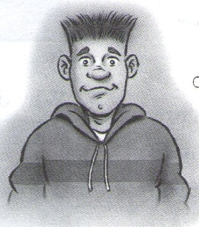
It’s a pity I didn’t go to German when my pen-friend invited me.
I should have gone to Peru with my dad when he went.

I wish … If only…
Use your English!
T: If you go on the cruise you need to understand some notices. Let’s read some of them and choose the statement that means the same as the notice.
Read these notices from the cruise ship. For each one, choose the statement that means the same as the notice.
1 Please note: As the ship departs at 5 pm there will not be time for those leaving the ship to cross the border from Gibraltar into Spain.
A Make sure you’re back from Spain by 5 pm.
B You cannot take a trip to Spain today.
C Only those people staying on the ship can go to Spain.
2 Digital camera found!
If you’ve lost yours, came and describe it to me and tell me about the photos you’ve taken. If it’s your camera, I’ll give it back! Helen – Cabin 307 Come between 6 and 7 pm)
A You have to show me that it’s yours.
B You have to show me where you lost it.
C You have to show me when you lost it.
3 Fun Quiz!
Tonight – 8.30 pm – Topsiders Lounge
Free entrance!
(Latecomers will not be admitted, so be on time!)
A You mustn’t get there before 8.30 pm.
B You must be there by 8.30 pm.
C The doors open at 8.30.
4 ALWAYS GIVE YOUR NAME AND CABIN NUMBER TO A MEMBER OF STAFF BEFORE LEAVING THE SHIP
A Tell us if a member of staff leaves the ship.
B Remember your name and cabin number when you are not on the ship.
C Don’t get off the ship without telling us.
5 IN CASE OF EMERGENCY, FOLLOW THE DIRECTIONS BELOW TO LOCATE THE NEAREST MEETING POINT ON BOARD.
A Stay here if there is a serious problem on the ship.
B When there is a serious problem, arrange to meet other passengers here.
C Find a meeting point and go there when there is a serious problem.
6 To: Ian
From: Alex
The cruise has been delayed because of the weather. This means that Tom will be picking you up in his car instead of me to take you to the port. Can you call him today to arrange it?
A Ian is now going on a driving holiday and not a cruise.
B They are going on the same trip but starting later.
C Ian needs to drive Tom to the ship at the start of their holiday.
7 PASSENGERS ARE REMINDED THAT AN ALARM WILL SOUND 15 MINUTES BEFORE THE SHIP IS DUE TO LEAVE THE PORT
A You should leave the ship for 15 minutes when you hear the alarm.
B When you hear the alarm, you have a quarter of an hour to get back on the ship.
C You shouldn’t visit the port before you hear the alarm.

Listening
T: Now it’s high time to check up your listening skills. You are going to hear five people talking about something connected to the topic.
Task 1. Who do these people usually deal with? Choose a or b.
1 travel agent a visitors b customers
2 hotel receptionist a customers b guests
3 airline pilot a passengers b customers
4 radio presenter a viewers b listeners
5 tour guide a tourists and visitors b guests
Task 2. You are going to listen to five people speaking. For each questions, choose the correct picture.
- Who is speaking?
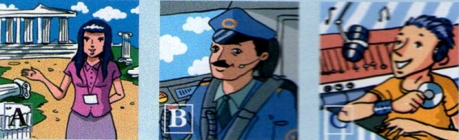
- Where might you hear this?
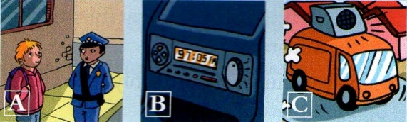
- Who is speaking?
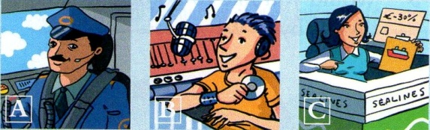
- What does the woman say is expensive?
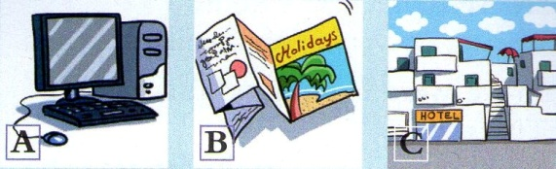
- Who is speaking?
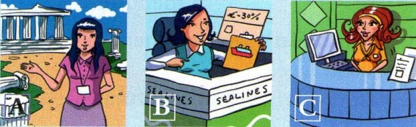
Task 3. Now listen to the people again in a different order. This time, circle the correct answer a, b or c.
- Where are the passengers when the captain makes his announcement?
a at Barcelona airport
b in the air above Barcelona airport
c At an airport far from Barcelona
- What does the tour guide say about the furniture?
a it has been replaced since the time of Queen Anne.
b it is Queen Anne’s original furniture.
c it used to be in a different room.
- What does the receptionist NOT give Miss Baker?
a a leaflet
b a credit card
c a key
- What has NOT caused any local problems so far this morning?
a heavy traffic
b bad weather
c an accident
- The travel agent is unsure if
a summer holidays are more expensive than spring holidays.
b her customers want to stay in a hotel while on holiday.
c another company offers the same holiday at a cheaper price.
Five people speaking
Speaker 1: Well, everyone else seemed to enjoy it, and I suppose in places it was funny, but to be honest, after about an hour and a half I just wanted it to end. Two hours for a comedy is a bit much, isn’t it?
Speaker 2: I enjoyed it. Not much happened, to be honest, and it was a bit slow in places, but Brad Pitt was excellent. All the actors were, actually. I think that’s why I liked it so much. It was just great watching their performances. They were so believable.
Speaker 3: It wasn’t bad, but they should have spent more on the special effects. I mean, when the spaceship explodes at the end, it should have been exciting, but I just laughed, to tell you the truth. It just didn’t look real at all. Shame.
Speaker 4: It’s actually a really long film – almost three hours, but you don’t realize that. There’s so much going on, and you never know what’s going to happen next. You don’t have time to get bored. And the ending! Well, I won’t tell you what happens, but you’ve got to see it. You won’t believe it! Really well done.
Speaker 5: You should have come with us. You would have loved it. It was really good. I don’t think I stopped laughing the whole way through. It was just one joke after another. Actually, I’m laughing now just thinking about it. I’d love to see it again.
T: Now I want to know what kind of holiday you prefer. Exciting and adventurous holidays or peaceful and relaxing holidays? Here’s a test to find out which one is the ideal vacation for you.
ADVENTURE HOLIDAYS
What kind of holiday do you prefer?
Exciting and adventurous holidays or peaceful and relaxing holidays?
Here’s a test to find out which one is the ideal vacation for you.
1. Which means of transport do you prefer?  a) a plane  b) a car  c) a train  2. Where would you like to spend your holidays?  a) in Central Africa  b) at the seaside  c) in the country  3. When you go away on holiday, do you:  a) forget about everything?  b) send a few postcards to you relatives or close friends?  c) wake up most mornings worrying about what’s going on at home?  4. What do you think of skydiving?  a) I think it would be really exciting.  b) I’d do it if I had proper training.  c) It’s a crazy idea.  5. Would you like to set sail on:  a) a big sailing boat?  b) a submarine?  c) a fast liner?  6. Which would you rather do:  a) looking for sharks in the ocean?  b) fishing at night with a net?  c) sailing on a boat? | 7. What do you like best about mountains?  a) the possibility of doing mountain climbing  b) the scenery  c) silence  8. When you go to the seaside, do you prefer to:  a) go swimming among the reefs?  b) lie in the sun?  c) read a nice book?  9. If someone invited you to spend a fortnight on a desert island, would you:  a) agree enthusiastically?  b) accept the invitation with hesitation?  c) refuse the invitation?  10. When you watch an Indiana Jones film, do you:  a) want to be in his place?  b) watch it because it is interesting?  c) get bored?  11. Do you think that taking along a tent on a holiday is:  a) exciting?  b) nice only in an organized camping trip?  c) troublesome?  12. Which of the following words reminds you of holidays?  a) freedom  b) enjoyment  c) going for a walk
Above 42 points — Adventurous  If you could, you would always have a backpack, ready to leave for an adventurous journey. Holidays, for you, mean looking for adventure without organizing or planning before. You are enthusiastic and curious. You’d rather go to an unknown, undiscovered place than go back to a place you know well. It’s your curiosity that helps you to overcome every obstacle. | You score: 3 points if you tick a, 2 points if you tick b, 1 point if you tick c.
Less than 25 points — Peaceful
You are a calm type. For you, an ideal holiday is sitting under a beach umbrella or relaxing under a tree in the silence of the countryside. Adventure activities don’t attract you. You like to meditate for some time before acting logically. Holidays, for you, should be a way to do sports and exercises and to meet new people.
From 25 to 42 points — Imaginative
You have a good dose of adventurous spirit and a good deal of courage, but you don’t like to get into trouble. You are quite enthusiastic about inventing hundreds of adventurous ideas. You should leave your school books and worries behind and use your imaginative quality to make new friends and to enjoy yourself.

Social English
T: When travelling it’s necessary to know British and American English concerning the topic. Here are some words which are different. Try to make up sentences
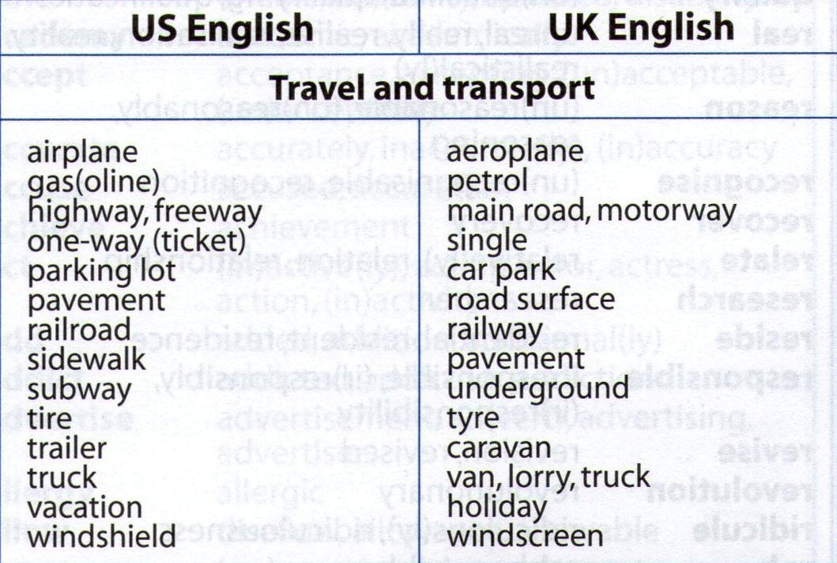

Speaking and writing
T: It happens so that sometimes people are holiday. Read this advertisement and the notes below. Explain in detail what went wrong.
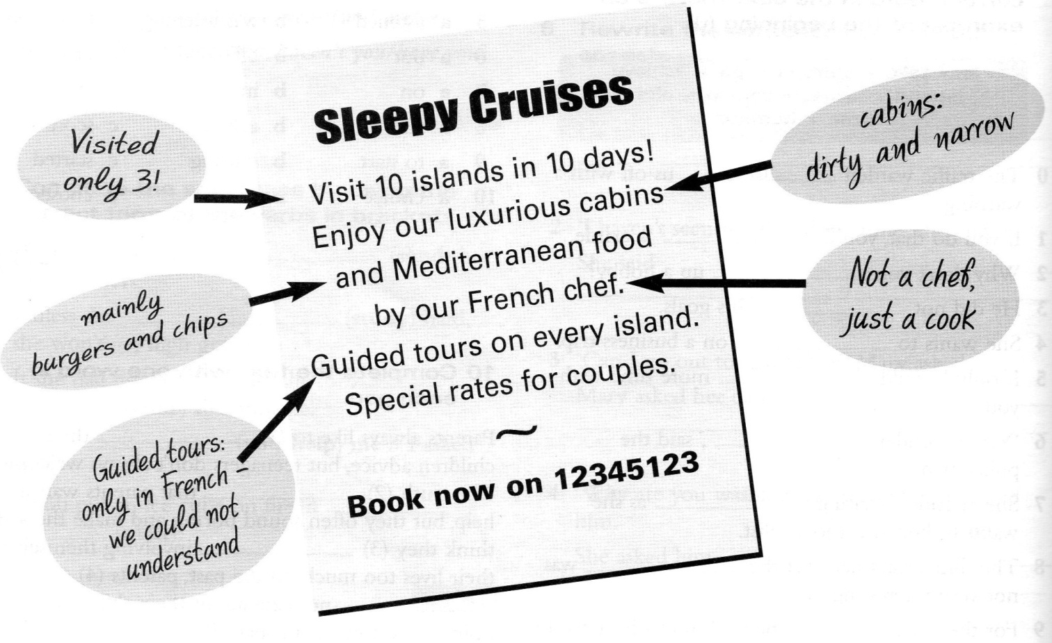
Examples

- visiting 10 islands in 10 days only 3 islands
- living in luxurious cabins dirty and narrow cabins
- eating Mediterranean food chips and burgers
- having a French chef a cook
- providing with guides only in French
- suggesting special rates for couples

T: Our today’s lesson is over. Your hometask will be as following. Write a letter of complaint to the cruise company and ask for a refund or another cruise on a better boat.

MONEY AND PAYING

Topic
Students will enlarge their knowledge connected with money, learn about the currencies of some countries and find out some problems and good points of money

Grammar
Little/ a little, few/a few, many/much/a lot of

Vocabulary
Key vocabulary
Phrases and collocations
Word formation

Writing skills
Writing an argumentative essay

Culture Zone
The currencies of the world

Lesson Plan
Money makes the world goes around
The Procedure:
Get warmed up!
T:Good morning, friends! Today we are going in groups to brainstorm everything connected with money. There are a lot of words and word combinations with the word «money». Let us see if you remember these words. So look at the ABC and try to say a noun or a verb associated with the topic of our lesson.

- A – account
- B – bank , buy budget
- C – credit, coin
- D – discount, dollar, debt
- E – earn, economic
- F – finances
- G – go0ld, gain, guarantee
- H – hryvnya
- I – income, inflation, invest
- J – jack-pot
- K – key-money
- L – lend, loan
- M – money, mortgage
- N – note
- O – owe, outlay
- P – pay, payment
- R – rent, rate recession
- S – sale, stock, saving account
- T – tax, trade
- U – use, umpire
- V – value
- W - withdraw money

T: What is the currency in your country?
What is the exchange rate with the Euro/the US dollar?
What’s the rate of income tax and VAT in your country?
How would society work without money?
Do you think poor countries should be required to pay their debts to the rich countries?
The world’s richest three men have more money between them than the world’s poorest sixty countries – should there be a redistribution ? How?

Explorations
T: At our previous lessons we were speaking about travelling. To travel you need to know the currency of the country you go to.
Look at the national currency codes in the left-hand column of the table below, and complete the other columns with the name of the currency and the name of the country it is used in. Choose answers from the two boxes. The first one has been done for you. Note that some standard currency names (e. g., Dollar, Dinar) are usually preceded by the name (or adjective form) of the country they are used in ( e. g. , Singapore Dollar, Jordanian
Dinar ).
Currency: Baht, Bolivar, (Name of country), Dinar, Dirham, (Name of the country), Dollar, Dong, (name of the country) Franc, Koruna, Lira, ( Name of country) Peso, (Name of country) Pound, Pound Sterling, Real, ( Name of country) Rial, Riyal, Rouble, (Name of country) Rupee, Won, Yen, Yuan.

Name of country or territory: Australia, Brazil, Chile, China, Cyprus, Czech Republic, Egypt, Hong Kong, India, Iran, Japan, Jordan, Kuwait, Malta, Russia, Saudi Arabia, Singapore, South Korea, Switzerland, Thailand, United Kingdom, United Arab Emirates, United States of America, Venezuela, Vietnam

Currency code | Name of currency | Name of country / territory
- SGD  - THB  - KWD  - INR  - CHF  - CNY  - GBR  - RUR  - VND  - VEB  - HKD  - CYP  - KRW  - USD  - CLP  - IRR  - EGP  - JPY  - SAR  - AUD  - AED  - BRR  - CSZ  - JOD  - MTL | Singapore Dolar | Singapore

Wordpower
T: Rearrange the letters in bold on the left to make the names of the countries where you would spend the currencies on the right. The first on has been done as an example.
- RCDEOUA = ____ Ecuador__________ ( Currency = Dollar )
- EARISL = ______________________ ( Currency = Shekel)
- NOTIEAS = _________________ (Currency =Kroon )
- TUOHS ARIAFC = ________________ (Currency = Rand )
- IATLNIAHU = ___________________ (Currency = Litas )
- TVAALI = _____________________ (Currency =Lat )
- IAENLOSV = _________________(Currency =Tolar )
- IAERAOMN = __________________ (Currency =Lei )
- KIPANAST = ______________________ (Currency =Rupee)
- EPUR = _____________________ (Currency =Sol)
- EHANADSGLB = ________________ (Currency =Taka)
- AGINUCRAA = ________________________ (Currency = Cordoba)
- NEUAKIR = ____________________________ (Currency =Hryvnia)
- IASINONDE = __________________________ (Currency = Rupiah)
- ALASIMYA = _______________________ (Currency = Ringgit)

Reading
T:Well done. Now we are going to read a text. To read it you need to use the words and expressions in the box.

Advance, bureau de change, cash, commission, credit card, credit limit, debit card, exchange rate, hard currency, interest in the black, in the red, soft currencies, strong transaction, traveler’s cheques, weak

When you go travelling, it is always a good idea to take a bit of 1. ___________ (coins and notes) with you preferably a 2.____________ like US British pounds. A lot of places will refuse to change 3. _____________ from countries with weak economies. The British pound is 4.____________ at the moment, so when ____________ British travellers go to the USA , their pound will buy more dollars. When it is 5._________, they will get fewer dollars for their money. You can change 6.__________ at any bank or 7._________ in the city, but check the 8. ________ they are offering you first, and also check how much 9._________ you will be charged ( this can be as high as 5, or 8 % of your total 10. ___________ , in some places. If you are using a cash machine abroad to withdraw money, it is better to use a 11.___________ (where money is taken directly from your bank account) rather than get an 12.___________ on a 13. ______________ (such as American Express, Visa or Mastercard )as you don’t have to pay 14. ___________ to the card company. This usually only works, however, if your bank account is 15.____________ and you have sufficient funds. If your account is 16.____________ ( there is no money in your account and/ or you owe your bank money), you may not be able to withdraw money from it ( unless your bank gives you a good 17. ______________ )

Grammar Practice
T: Complete the sentences with little/a little, few/ a few, many/much/a lot of. (Students fill in the gaps)

Speaking
T: Now it`s high time to summarize your findings out concerning money. Working in groups try to be ready to answer the given tasks.
Let`s start. The quickest is the winner!

What are the good points (pros) and problems (cons) with the following:
a. The lottery; b. A pyramid scheme; c. Internet deals; d. The stock market; e. Real estate;
f. A savings account.
Agree or disagree with these statements. Explain:
- There’s nothing wrong with getting rich without working.
People who buy stock are making money and they aren’t working. Nobody wants to put them in jail;
- People who want to get rich quick deserve to lose their money. They’re lazy and just don’t want to work like the rest of us.
Making the money
- In small groups, brainstorm ways of getting rich, e. g. marrying into money, winning the lottery, buying a racehorse. Make a list of your top five.
- Swap lists with another group. Decide whether you would support the other group’s ideas and whether any are illegal or immoral. Mark the list accordingly and return it.
- In your groups, choose your favourite money-making idea and make a list of arguments to persuade someone to go into business with you as a partner.

Money
- Ask each other questions about the things you have with you in the class, using buy, pay, spend and cost. Follow this sequence and then make an offer for the thing in question.
- How much did you buy your pen for? I bought my pen for 3 euro. How much did you pay for your pen? I paid 3 euro for my pen. How much did you spend on your pen? I spent 2 euro on my pen. How much did you pen cost? My pen cost 3 euro. I’ll give you 2 euro for it.
Sayings
- In small groups, discuss what these saying mean. Do you agree or disagree.
- You can’t buy love. Property is theft. Money talks. Time is money. Money makes the world go around. He who pays the piper calls the tune. A fool and his money soon parted. Money is the root of the evil.
- Tell the rest of the class some money saying from your country.

Hard sell
- In pairs, think of arguments to persuade people to buy these objects, e. g. empty coke can – You could use this as a vase.
- A snowball, a dirty comb, one sock, a used teabag, a broken plate, old fish and chips, a clock with no hands, a house with no roof, a bucket with a hole, a piece of string
(Invite volunteers to try to persuade the class of the value of each object)

T: It`s a pity but we have to finish our today`s work. You all were clever, brave and witty. I think you enlarge your knowledge on the topic. I really enjoyed your work. At home try to agree a list of ten major changes that you think will take place during the next hundred years. Include these things: technology, culture, economics, Europe, ecology, euro, dollar, hrivnia.

Topic
Students will learn about different operations with money and express their attitude to some sayings about money

Grammar
Conditionals

Vocabulary
Key vocabulary
Phrases and collocations
Word formation

Writing skills
Writing an essay

Culture Zone
The proverbs in English
The sayings in English
MONEY, MONEY, MONEY!

Lesson Plan

Money talks
The Procedure:
Get warmed up!
T: Good morning, dear friends. Today we are going to speak about money and its role in our life, we`ll discuss some problems connected with money and I suppose have a very interesting lesson.
To start with, decide which phrase correctly finishes each sentence.
1.If I lend you money a) you owe me money.
b) I owe you money.
2.If I borrow money from you a) you should pay me back.
b) I should repay you.
3.If you can`t afford things a) you can borrow money from me.
b) you can lend me money.
4.If I sell something for more than I paid for it a) I have made a loss.
b) I have made a profit.
5.If I purchase something and pay more than it`s worth a) I will probably make a loss when I sell it.
b) I will probably make a profit when I sell it.
Reading
T: To know more about different operations with money let`s read the story.

Money
Rene Labouche was a young man with very little money, but very big dreams. He worked in a factory and earned only a few hundred francs a month. He owned almost nothing – some old furniture, some clothes and an old bicycle, but he dreamed of having a big house and a big car.
Every day Rene purchased five lottery tickets for five francs each. He dreamed that one day he would win the big prize in the national lottery and become a millionaire. Then he could afford to buy whatever he wanted and would never have to work another day in his life.
One day as usual Rene opened the newspaper to check his numbers. He read the numbers slowly, 6 – 11 – 31 – 32 – 47 – 49. Those were his numbers! He looked again. 6 – 11 – 31 – 32 – 47 – 49. He had won. He had won the national lottery. He was a millionaire!
Suddenly everyone wanted to be Rene’s friend. Many people came to him and asked if they could borrow money. “Of course, we’ll pay back every centime”, they said. Others told him about their wonderful ideas for making money. “If you invest 500,000 francs in this project”, they said, “I promise in two years you will make a big profit and double you will make a big profit and double your money”.
The money had come easily and Rene spent it easily. He lent 25,000 francs to this friend and 50,000 francs to that. He invested 500,000 francs here and 800,000 francs there. He made no effort to save anything.
When he bought something he never looked at the price. If something cost a thousand francs, he paid a thousand francs. He never worried about whether it was worth it or not. He bought cars, jewellery , and clothes. He also bought airline tickets. He flew first class to all the major cities of the world. He stayed at the best hotels, he ate at the best restaurants, and he bought the finest clothes.
Then one day, when he went to pay his bill at a hotel in Rio, the manager had to tell him, “I’m sorry sir, but I’m afraid your credit card company will not pay this bill”. Rene flew home. It was true he had no more money. He went back to the people who owed him money, but they were unable to repay him. The projects in which he had invested his money had all made losses. In six months Rene had spent ten million francs.
Rene now had no choice. He had to sell the cars, the watches and the clothes and he had to go back to work in the factory.

Post-reading

T: Now find the correct ending for each sentence according to the information in the story.
1______Rene used to earn a) a lot of money from him.
2______Rene used to purchase b) him a lot of money.
3______Rene used to own c) ten million francs.
4______Rene won d) money in some of his friends` ideas.
5______Rene`s friends borrowed e) a few hundred francs a month.
6______Rene invested f) the money he had lent them.
7______Rene`s friends owed g) lottery tickets every day.
8______Rene`s friends couldn`t repay h) an old bike and some old furniture.

Explorations

T: Let`s do some search work. You have the words in the box. Match the words with their definitions. Give some examples.

a)fess b)interest c)taxes d)wages e)salary f)rent g)pension h)fare i)cash j) change

1_____ money paid for a place to live
2_____ money paid to the government
3_____ money paid for professional services
4_____ money in coins and notes, not cheques
5_____ money paid to workers by the hour or week
6_____ money paid as charges on the money you borrow
7_____ money paid to workers for a month`s or year`s work
8_____ money paid to older people who no longer work
9_____ money returned to you after you pay too much
10____ money paid for a journey by bus, train or plane

Use your English!

T: Well done! You were great! Now the next task:
try to make up sentences with these word combinations:
- enough money
- much money
- little money
- pocket money
- a lot of money
- to need money
- to spend money
- to get money
- to lend money

Listening

T: Great! People have created different proverbs and sayings about money. Listen to the halves of the proverbs and find the second half. Explain.

1.Money spent on the brain…..
2.No money…..
3.A fool and his money…..
4.Time is…..
5.Lend your money…..
a)are soon parted.
b)is never spent in vain.
c)money.
d)and loose your friend.
e)no honey.

Keys: 1-b, 2-e, 3-a, 4-c, 5-d
(Students read the proverbs, explain how they understand them and give their Ukrainian equivalents of the proverbs if they know) Thanks.

Mind-up –based discussion

T: Imagine that you have just got one million hrivnias. What would you do with the money?
Let`s make a kind of mind-map.
Examples

Spent on computer Put it in the bank to have
1000000
games 7% of interest

Fast car Exotic holidays

invest in some projects give… to a cancer
1000000
research

a fund for charity
veterans of war

a research mummy
organization
for Chernobyl fund

buy present buy lots of designer
clothes
1000000

a cottage near a big shop
the sea

a big house with a swimming pool

Social English
T: It`s high time to express your attitude to some sayings in English about money.

“A penny saved is a penny earned.”
Benjamin Franklin
Do you save money? Are you saving for anything right now? What?
Do you keep your money
- In the bank?
- In a safe?
- In a book?
- Under the bed?
- In the refrigerator?
Do you have a bank account? Do you have a checking account or a savings account? What’s the interest rate? If your account was overdrawn, how much would the bank charge you?
“Buy now; pay later.”
Do you have a credit card? Which one? (Visa? American Express? Diner’s Club? MasterCard?)
When you pay cash, do you ask for a discount? Do you usually get it?
“A fool and his money are soon parted.”
Where do you carry your spending money?
- In a purse
- In a wallet
- In a pocket
If you keep it in a pocket, which pocket do you keep it in?
- Inside pocket of coat/jacket
- Breast pocket of coat/jacket
- Side pocket of coat/jacket
- Back pocket of pants
- Front pocket of pants
Have you ever had your pocket picked?
- In your suitcase
- Under the mattress
- In the pillow
- In a book
- Somewhere else
Is gambling legal or illegal in your city/state/province/country? Do people bet? What do they bet on?
- Cards
- Horse racing
- Dog racing
- Football/soccer/boxing/other sport
- National lottery
- Something else

“Neither a borrower nor a lender be.”
From Hamlet by William Shakespeare
Have you ever borrowed money from anyone? Who from? How much?
Have you ever lent money to anyone? Who to? How much?
Are you in debt at the moment (i.e., do you owe anyone any money)?
Does anyone owe you any money? Who? How much?
“The customer is always right.”
Have you bought anything this week? What?
What did it cost? Was it worth it?
Was it new or used?
Was it a bargain? Did you get a receipt?
Have you ever returned anything you had bought? What? Where?
Did you get your money back, a new article, a different article, or credit for a future purchase?
T: Friends, our lesson is coming to an end. I`m happy to say we`ve done a good bit of work during the lesson. At home, please, write an essay on the topic ‘If I were a millionaire’. Use your imagination.

