Topic: Youth fashion. The Vyshyvanka 9 form
Objectives : to revise and enrich students’ vocabulary on the topic; to develop students’ listening skills; to practice speaking and reading skills of students; to broaden students’ knowledge of the topic; to develop students’ thinking educate respect for national clothing and pride for their country
Materials:cards, the text for listening comprehension; computer and whiteboard for presentation
Procedure
Greeting and aims
The topic of today’s lesson is teens’ fashion, so we’ll read and discuss the Ukrainian national clothes and differences of Vyshyvankas
Warming up
Answer the questions:
- Do you often buy new clothes?
- Do you think it is important to wear fashionable clothes?
- Have you ever made your own clothes?
- What do you know about our national Ukrainian clothes?
Vocabulary
- Mark the word with it’s translation
patterns | дерево калини
embroidery | мак
a viburnum tree | візерунок
ornament | достаток
oak pattern | вишивка
poppy | ажурна вишивка
abundance | бісер
needlework | дубовий візерунок
motif | нитка
openwork embroidery | рукоділля
cross-stitch | мотив
thread | вишивка хрестом
bead | орнамент
- Complete the sentences
- Something used for decoration is …..( ornament)
- A flowering plant is ….(poppy)
- (Embroidery) …. is the craft of decorating fabric or other materials using a needle to apply thread or yarn
- A very large quantity of something ( abundance)
- (Cross-stitch) … is a form of sewing and embroidery in which X-shaped stitches in a tiled
Listening
- Pre- listening
- Have you got the Vyshyvanka?
- When and where do you wear it?
- Listening
“In ancient times people could guess what village a person came from just from the embroidery on his or her clothes. Now people think about the meaning of embroidery much less. Actually, they simply want to see their clothes aesthetically beautiful.
The Vyshyvanka (Вишива́нка) is a traditional Ukrainian embroidered shirt. The date the Vyshyvanka was first made remains unknown, yet it formed gradually with the implementation of symbolic decorative patterns on the shirt. The history of Ukraine, its belief and culture are symbolised on the embroidered shirts.
Each embroidery design and colour has got a different connotations and meanings, although some remain ambiguous:
The floral ornament starting with a viburnum tree – the birth of the universe and immortality
Oak pattern embroidered only on men’s shirts – masculine strength, development and force
Grapes – joy and delight of family life
Poppy – protection from harm (particularly embroidered on girls’ shirts whose father had died in the war)
Animal symbols – variety of interpretations (ambiguous)
- Post-listening
Guess what the colour means
White colour | death, loss of a loved one, grief
Red colour | abundance, wealth, the sun as the energy of all life on earth
Green colour | birth and growth (used for grass and leaf patterns)
Yellow colour | symbolic of the sun, good luck and protection
Black colour | protection against evil forces and natural beauty (mainly used for young girls to imply modesty)

White colour – protection against evil forces and natural beauty (mainly used for young girls to imply modesty)
Red colour – symbolic of the sun, good luck and protection
Green colour – birth and growth (used for grass and leaf patterns)
Yellow colour – abundance, wealth, the sun as the energy of all life on earth.
Black colour – death, loss of a loved one, grief
Reading
- Read the text about Ukrainian embroidery
Embroidery is remembered as a national pastime and is a part of the Ukrainian cultural and national identity.
Ukrainian embroidery has many variations from region to region, or even village to village. However, most embroidery is generally similar overall for most Ukrainians. Even with these variation, the styles of needlework found throughout Ukraine, when taken together, represent a definite Ukrainian national style of embroidery. Red and black were the most common colors of Ukrainian embroidery. Ukrainian folk embroidery is notable for great variety of its techniques.
Central and Eastern Ukraine
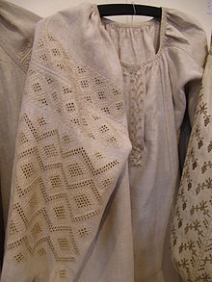
White-on-white openwork embroidery of Poltava Region
In the Central and Eastern parts of Ukraine, embroidery usually consists of geometric forms and plant ornaments. The color range of the motifs is very delicate and very diverse as to individual details. In the Poltava Region, the colors usually include pale blue, white, light ochre, pale green and gray tones. Poltava products are especially famed for their “white-on-white” and openwork embroidery. The red, red-blue (or red-black) color scheme plays an important role in Central- and Eastern-Ukrainian embroidery, as it did throughout almost the whole of Ukraine.
Western Ukraine
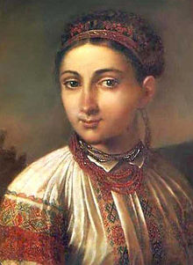
In Western Ukraine, especially the Hutsul region, embroidery uses geometric ornament and a sharply contrasting palette. Besides the now widely used cross-stitch, there is still the ornamental needle-weaving stitch called “nyzynka”, which is executed predominantly on the reverse of the fabric and gives a sort of “tweed” effect.
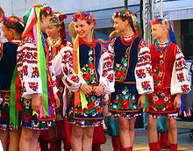
The embroideries of Bukovyna are among the richest in all of Ukraine, often combining as many as nine or more colors, including silver and gold metallic thread as well as colored glass beads. It also uses a number of stitches.
The needlework of Pokuttya was also rich and intricately executed, and also quite varied. Red was the predominant color in many of the styles of embroidery in this region, usually being worked in thick home-processed wool threads, sometimes with accents of yellow, green and blue added. Although cross-stitch was not uncommon, the older and more traditional technique was that of the so-called “curly stitch” (quite popular, in fact, throughout many areas of Southwestern Ukraine). In some parts of Pokuttya and neighboring Podillya, wide motifs of intricately worked white-on-white embroidery combined with open work were popular. The embroideries of Podillya were similar in many respects to that of both Bukovyna and Pokuttya, with discreet yet recognizable differences in color scheme, motifs and placement that nonetheless set them apart.
In Halychyna, there is a variety of embroidery styles that were specific for individual localities, such that when one sees a piece of embroidery there is no mistaking its origin.
Northern Ukraine
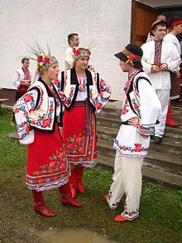
In the northwest and north of Ukraine (including the Ukrainian ethno-historic territory of Poland) needlework traditions have been preserved relatively intact from the oldest of times. Red, as well as red-blue and red-black were the predominant color schemes in the archaic geometric embroideries of these northern regions of Ukraine, executed primarily in dense rows of a horizontal needle-weaving stitch (called “zavolikannia”) that created horizontal bands of patterns reminiscent of weaving. Floral motifs are also popular in the North, using red, red-blue or red-black, but in the much more recent technique of cross-stitch.
- Do the tasks
- Make as many questions as you can to the text and ask your classmates
- Make a table of Ukrainian regions and elements on embroidered shirts
Region | Colours | Some elements
Central and Eastern parts of Ukraine |  | geometric forms and plant ornaments
Summary
What do you know about the Vyshyvanka?
Has each embroidery design and colour got a different connotations and meanings? What do you remember?
Is there difference between variations from region to region?
Homework: write short composition about your attitude to the fashion

