План-конспект
відкритого уроку
з англійської мови
по темі : «Наука»
у 10 класі Миргородської
спеціалізованої з англійської мови школи
І-ІІІ ступеня №5
2019-2020 н.р.
Вчителя Д. В. Гребінник

Тема: «Наука»
Підтема : «Роль науки, винаходів вчених у житті людини»

Цілі:

Навчальна:
- активізувати вивчені лексичні одиниці, структури, граматичний матеріал в усному мовленні по темі «Наука»;
- познайомити учнів з різними висловлюваннями та прислів’ями про роль науки.
Розвиваюча:
- розвивати навички усного мовлення з використанням особистого досвіду та знань учнів;
- розвивати творче мислення, здатність логічно висловлювати думку, порівнювати, аналізувати, робити висновки.
Виховна:
- виховувати любов до оточуючого нас світу, помічати та цінити ті зміни у нашому житті, які досягнуті суспільством завдяки розвитку науки та новітніх технологій.
Оснащення:
- портрети видатних вчених; висловлювання відомих людей про роль науки; таблиці; тестові завдання; CD із записом тексту для аудіювання; відеофільм по темі.

Plan

- Introduction.
- Science, it’s definition, the theme of theme of the lesson.
Main part:
- Changes of life which science brings people.
- Branches of science.
- Scientists and traits they should possess.
- Tests.
- Prominent scientists.
- “Necessity is the mother of invention”.
- Listening.
- Inventions which are named by names of people who invented them.
- Scientists and their inventions.
- Modern inventions.
- Nanotechnology, a film.
- Advantages and disadvantages of science.
Conclusion
- “What is Life”, a poem.

- Introduction

T – What century do we live in?
P – We live in the 21st century.
T – Now, use your vivid imagination and imagine that we have found ourselves some hundred years ago. Now, tell me what people couldn’t even imagine that we can do now?
P₁ – Many hundred years ago it was hard to imagine that we would fly by airplanes from one continent to another in few hours.
P₂ – …sail across seas and oceans in big ship liners.
P₃ – launch satellites and space-ships into space.
P₄ – …use robots that can substitute people in many branches of their life.
P₅ – … use means of communications which link continents into single unity.
P₆ – … cure many dangerous illness that people die from many years ago.
P₇ – … be possible to feed, to cloth, to provide prosperity to large population due to the development of industry and agriculture.
T – Thank you, pupils. We can make this list endless. But I wonder, what has it become possible to? The computer gives us three variants of the answer. Choose the right one:
- Art
- Science
- Magic
P – It can be neither art nor magic. Great changes have become possible thanks to the rapid development of science and scientific progress. So, it is science.
T – I fully agree with you that it is science that gives great impact to the development of our civilization.

- Science, its definition, the theme of the lesson.

T – So, the theme of our lesson today is “Science”. We will speak about science, its role in our life, advantages and disadvantages of its development, about prominent scientist and their inventions.
But first of all I would like to know what is science?
P₁ – Science is branch of people’s activity for developing theoretical knowledge about reality.
P₂ – Science is a branch which occupies a leading position in modern society.
P₃ – Science is a part of the spiritual culture of the society.
T – You definitions are true.

- Changes of life which science brings people.

T – According to you definitions of science we should admit that science is the most essential part in the modern society. What role does it play?
P₁ – Great discoveries made centuries ago continue to play an important role in life of people.
P₂ – The marvelous ideas and inventions of scientists of different countries in different branches of science changed the face of the earth, the way of life; they contributed greatly to the development of modern civilizations.
P₃ – It is difficult to imagine our life without discoveries and inventions of Newton, Einstein, Faraday, Lomonosov and many others who made discoveries in the field of physics, chemistry, economy and different technical sciences.
P₄ – Everything has been done to make our life happier and more comfortable.
P₅ – It is obviously that science has changed our life for better and there is no reason why we shouldn’t make it work for our advantages.

- Branches of science.

T – Like tree science has got branches. There are so many branches of science that it is possible to list them all. Look at our science and name its branches.
P₁ – Social science, biochemistry, botany, chemistry, computer science, Earth and Space science, engineering, environmental science, mathematics, medicine and health, physics, zoology.
T – Like a tree has got leaves on its branches, each science has got sub-branches. Now, find in your lists sub-branches and label them to their branches.
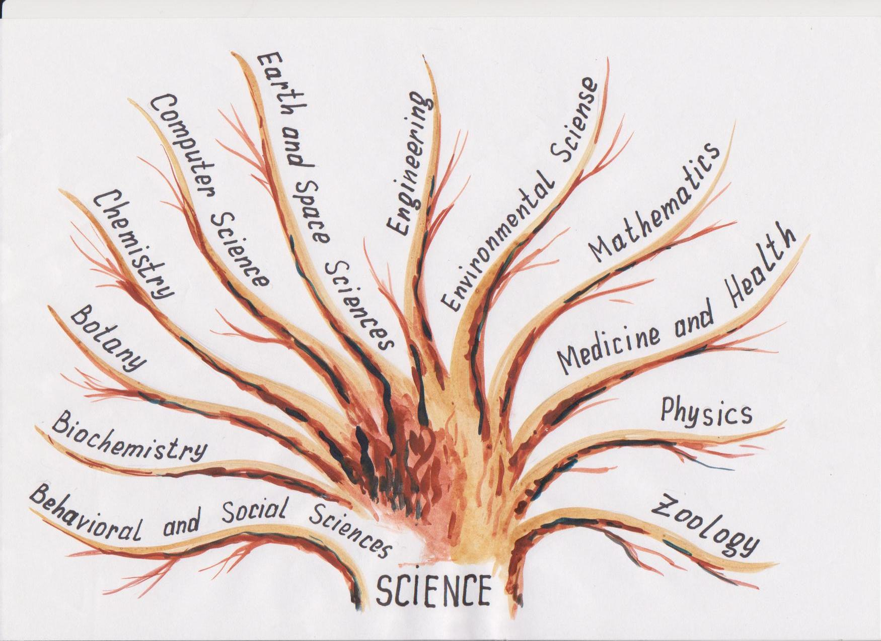

Branches of Science
1.__________ 7.__________
Anthropology Aeronautics
Archeology Bioengineering
Economics Chemical
Education Electrical
Ethnology Electronic
Linguistics Mechanical
Psychology
Sociology
2.__________ 8.__________
Endocrinology Endangered Species
Genetics Global Warming
Hematology Pollution
Molecular Biology Soil Contamination
Photosynthesis
3.__________ 9.__________
Agriculture Algebra
Agronomy Applied Mathematics
Anatomy Geometry
Forestry Pure Mathematics
Physiology Statistics
4.__________ 10.__________
Fuels Dentistry
Materials Dermatology
Metallurgy Ophthalmology
Organic Chemistry Pharmacology
Physical Chemistry Speech Therapy
5.__________ 11.__________
Computer Computations Acoustics
Computer Data Bases Atomic Physics
Computer Graphics Light
Computer Hardware Mechanics
Software Development Nuclear Physics
Networking Particle Physics
6.__________ 12.__________
Astronomy Anatomy
Astrophysics Ornithology
Geography Ichthyology
Geology

Keys: 1. Social sciences, 2. Biochemistry, 3. Botany, 4. Chemistry, 5. Computer science, 6. Earth and space sciences, 7. Engineering, 8. Environmental sciences, 9. Mathematics, 10. Medicine and Health, 11. Physics, 12. Zoology.
- Scientists and traits they should possess.

T – A person who works in any field of science is called a scientist. I wonder what qualities should a man possess to become a scientist?
P₁ – I think a man should be a genius.
T – I don’t think so. Look at Edison’s words, read them and make a conclusion.
P₁ – “Genius is one per cent inspiration and ninety nine per cent – perspiration”, once said Tomas Alva Edison. So, I think, a person should be hardworking first of all.
P₂ – To my mind a man should be persistent in achieving his aim and results of his work.
P₃ – I’m sure that a person has to be creative to invent things.
P₄ – From my point of view a person should be intelligent in his branch of science.
P₅ – I hope that a man should be accurate in everything he does.

- Tests.

T – Now, I check whether you possess such traits and can become good scientists.

- Match.

First of all scientists should know perfectly well everything about the branch of science they work at. So, match definitions with branches.
Match :
- Scientific study of animals;
- Scientific study of living beings;
- Scientific study of nature of living bodies;
- Scientific study of plants;
- Scientific study of societies;
- Scientific study how the bodies of living beings work;
- Scientific study of nature of man;
- Scientific study of mind and the way it works;
- Scientific study of inherited characteristics;
- Scientific study of combination and reactions of elements;

- Biology
- Botany
- Zoology
- Anatomy
- Physiology
- 6.Psychology
- Sociology
- Anthropology
- Chemistry
- Genetics
Keys: 1 – b, 2 – d, 3 – a, 4 – c, 5 – f, 6 – h, 7 – e, 8 – g, 9 – j, 10 – i.

- Say in one word.

Scientists should be brief in formulating laws, ideas.
So, try to say in one word.

Say in one word

- Systematic knowledge
- Opening something new
- Electronic calculating machine
- Science that deals with living organisms
- A person who works in any branch of science
- Things created by a man
- The science of numbers and figures
- Making something that didn’t exist before
- Anything very small
- The science and art of curing illness

a - atom
b - biology
c - inventions
d - medicine
e - maths
f - discovery
g - scientist
h - science
j - computer
j - man-made things
Keys: 1 – h, 2 – f, 3 – I, 4 – b, 5 – g, 6 – j, 7 – e, 8 – c, 9 – a, 10 – d.

- Synonyms.

Scientists should be broad-minded. They should know and keep in mind much information. Now, try to reveal these qualities. Find pairs of synonyms.
Synonyms

- Scientists a to achieve a success
- Artificial b branch
- Opening c learning
- to succeed d thanks to
- field e drug
- knowledge f opportunity
- due to g public
- medicine h to make rich
- chance i discovery
- national j scholars
- to enrich k man-made
Keys: 1 – j, 2 – k, 3 – I, 4 – a, 5 – b, 6 – c, 7 – d, 8 – e, 9 – f, 10 – g, 11 – h.

- Insert a missing letter.

Scientists should be accurate in everything they do. Try to insert a missing letter in words but without making any mistakes.
Insert a missing letter
- Sc…ence
- Dis…overy
- Inv…ntion
- s…ccess
- to c…lculate
- br…nch
- b…ology
- chem…stry
- ph…sics
- to cre…te
- artif…cial
- eng…neering
- knowl…dge
- tec…nology

- New words from old ones.

Scientists should be very creative to invent new things. Try to form new words from old ones, like in the example.
New words from old
Handbag, sleeping bag, kitbag, bagpipes
- band, chair, fire, pit;
- hanger, over, rain, waist;
- battle, friend, space, wreck;
- fall, proof, salt, melon;
- flower, coffee, tea;
- basket, eye, snow, room;
- cloth, coffee, spoon, time;
- page, cow, friend, hood.
Keys: 1. Man, 2. Coat, 3. Ship, 4. Water, 5. Pot, 6. Ball, 7. Table, 8. Boy.

- Odd word out.

Scientists should be selective to be able to select the most important information. So, find the odd word.
Odd word out

- to discover, to invent, to design, to walk, to explore
- a scientist, a designer, a carpenter, an explorer, a professor
- progress, result, achievement, kindness, success
- the Earth, the sun, sandwich, space, satellite
- academy, sports ground, university, laboratory, technical school
- radio, television, revolution, computer, the Internet
Keys: 1 – walk, 2 – a carpenter, 3 – kindness, 4 – sandwich, 5 – sports ground, 6 – revolution.

- Put the words in brackets into Past Simple.

Scientists are usually able to do several things at the same time. Try to put verbs into Past Simple, read, understand the text and catch the main idea of the text.
The text is : “Louis Braille”.

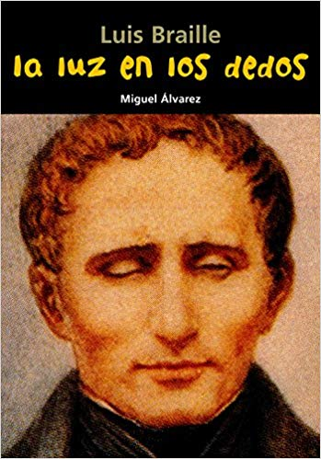
Put the words in brackets into Past Simple
Louis Braille (1809-1852)
Louise Braille 1) _____(be) the son of a French leather worker. He 2) _____ (go) blind at the age of three when he 3) _____ (fall) on a tool in his father’s workshop. But Louis was a brave and talented boy. He 4) _____ (want)to be a musician, so he 5) _____ (learn) to play cello and at the age of the age of ten he 6) _____ (win) a scholarship to the National Institute for Blind Children in
Paris. He 7) _____ (can) play the cello, but he 8) _____ (cannot) read or write.
In 1819 a French Soldier Charles Barbie 9) _____ (invent) “night writing”. He 10) _____ (use) patterns of twelve raised dots on paper so that soldiers 11) _____ (can) read in the dark. Louis Braille 12) _____ (understand) the importance of this invention for blind people and when he was fifteen, he 13) _____ (make) it simple with six dots, not twelve.
In 1829 he 14) _____ ( introduce) it at the Institute.
By the 1932 “Braille” was in use all over the world in many languages, but unfortunately Louise 15) _____ (die) of tuberculosis in 1852 and never 16) (know) of the importance of his inventions.

- Prominent scientists.

T – The results of tests you’ve just done proved that you can become scientists. But our world knows a lot of prominent scientists. Now, tell us a few words about some of them. It was your home task to prepare a short story about any scientist you like and about his inventions.
Pupils’ monologues. For example:
P₁ – I’d like to tell you about James Watt. He is a Scottish engineer and the inventor of the universal steam-engine. Besides he made other inventions. He invented a copying-machine. The unit power is named after him.
P₂ –
P₃ –
P₄ –

- “Necessity is the mother of invention”.

T – You have just named outstanding Ukrainian, English, American, German scientists. The main task of any scientist is to develop knowledge about reality, then to spread them and then to invent things which didn’t exist before. Without doubt scientists invent things because people need them.
Please, comment on the proverb: “Necessity is the mother of invention”.
P₁ – It’s a well known fact that a great desire to produce more cars made Henry Ford invents the mass production assembly line techniques.
P₂ – I believe that a necessity to improve people’s life made J. Edison invent electric light bulb.
P_{3 …}

- Listening.

T – Now, pupils, we’ll learn about the necessity of invention of a sandwich. Nowadays we can’t imagine even a day without this tasty and very convenient food. We eat sandwiches for breakfast; take them to school to eat during the break, make sandwiches for a hike or a trip. Now, let’s listen two texts about invention of a sandwich. Your task will be to choose a true one and explain your choice.
Listen to the first story:
English people have picnics. They like eating in the countryside, in parks and even on the beaches. The only problem about eating on the beach in that the sand often gets into the food. One day someone had a very good idea of putting onto the food. It is because of this that today we call sandwiches “sandwiches”.
Listen to the second story:
An eighteenth century English aristocrat, the Earl of Sandwich, loved playing cards. He used to play cards all day and night and hated having to stop a game for his meals. One day he thought of a way of putting meat between two slices of bread. In this way he could eat continue playing cards. It is because of the Earl of Sandwich that today we call sandwiches “sandwiches”.
Answer the question:
Which story is true?
P₁ – I would like to choose the second text, because sometimes unusual, funny situations give the impetus for inventions like a sandwich.
P₂ – I share N’s opinion and choose the second situation, too. The first one seems to me very common, simple and ordinary. There is nothing unusual about it.
T – Your choice is right.

- Inventions which are named by
names of people who invented them.

T – Very often things are named after inventors like in our example with a sandwich. I hope you have heard the words as a raglan, a cardigan, a mackintosh. You are right: they are related to clothes. But do you know that they are actually the names of the people who invented those things?
Here is a test. Match the people and the items of clothing.
Match the people and the items of clothing:

- Mackintosh a) a sleeve style
- Cardigan b) a waterproof coat
- Raglan c) a woolen jacket with buttons
Keys: 1 – b, 2 – c, 3 – a.

- Scientists and their inventions.

T – Many things which we got used to in our everyday life were invented by certain people.
Look at the table and make up sentences matching the invention with the name of a person who invented it.
Scientists and Their Inventions
inventions |  | scientists
- The first spaceship  - Combustion engine  - X-ray  - Bicycle  - Telephone  - Television  - Aspirin  - Paper  - Helicopter  - Jeans  - Record player  - Scanner and Fax  - Microwave oven  - Electric light bulb  - Ballpoint pen  - Telegraph | designed  was invented by discovered | - Rudolf Diesel  - John Baird  - Thomas Edison  - Sergei Korolyov  - Felix Hoffmann  - Samuel Morse  - Wilfelm Conrad Rontgen  - Percy Spencer  - Graham Bell  - Rudolf Hell  - Karl Friedrich von Drais  - Laszlo Biro  - Emil Berliner  - Heinrich Focke  - the Chinese  - Levi Strauss

Key: 1– d, 2 – a, 3 – g, 4 – k, 5 – i, 6 – b, 7 – e, 8 – o, 9 – n, 10 – p, 11– m, 12 – j, 13 – h, 14 – c, 15 – l, 16 – f.

- Modern inventions.

T – It’s time to speak about modern inventions of the 20th century. What are they? What would you like to tell us about?
P₁ – I’d like to tell you about a mobile phone. Now it is used by millions of people. It appeared in 1973. An American Martin Cooper invented the first mobile phone – Motorola. It weighed a kilo. Now mobile phones have made a massive impact on social and working activities and changed the way we communicate.
P₂ – One of the modern inventions is a computer. The first computers were huge. They were used for scientific purposes only. Now computers have changed the way we live. We can use a computer to write a letter, to design a house or to exchange messages with someone around the world.
P₃ – I’d like to tell you about a TV set. A Russian engineer Vladimir Zvorykin immigrated to the USA and there in 1931 produced an apparatus that later became known as a television set. The first TV station was located on the Empire State Building in New York. The programs could be watched only by those who lived not father than 60 miles from the station. Now modern television offers to the viewers a wide choice of programs on different channels.
T – What other modern inventions do you know?
Pupils: microwave oven, iron, CD player, fax machine, answer phone, plane, video recorder, camera, washing machine, dishwasher, etc.

- Nanotechnology. (a film)

T – Pupils, you have already named many inventions, old and new ones, which changed our life greatly. But while speaking about science we can’t but mention new technologies. One of them is nanotechnology. After watching it be ready to answer the following questions:
- What is nanotechnology?
- What fields of life can it be applied in?
- How can it change our future?
https://www.youtube.com/watch?v=IGjCOJqINPA

- Advantages and disadvantages of science.

T – During the lesson we have already spoken much about science, inventions, technologies which do people good , make their life easier and more comfortable. Now, I would like you to tell me are all these things useful or may be harmful for mankind?
P₁ – I think some inventions are very good, useful and positive for mankind, because they change the way of life, improve our lifestyle.
T– Can you give examples?
P₂ – To my mind such inventions as computers, rockets, space stations, microscopes and telescopes bring us progress and success in different branches of our activity.
P₃ – In my opinion vacuum cleaners, electric razors, microwave ovens, CD players, music systems, dishwashers, coffee makers, mixes improve our life.
P₄ – I believe that such inventions as planes, cars, mobile phones, TV sets, trains, helicopters changed our life for the better.
P₅ – On the other hand there are inventions which may cause death, sufferings, war destruction and pollution of the environment.
T – Can you give examples?
P₆ – It seems to me that such inventions as bombs, dynamite and weapons cause danger, suffering, death.
P₇ – I’m sure that such inventions as chemicals, hydrogen bombs, nuclear cause death to people and animals and environmental pollution.
T – Your answer have just proved that rapid development of science and scientific progress has its advantages and disadvantages.

- “What is Life” (a poem)

T – In spite of its advantages and disadvantages science makes our life wonderful. So, let’s enjoy its wonders!
Many people claim that a scientist can’t be a poet. Let’s prove that it is not so. A wonderful poem “What is Life?” will summarize today’s lesson. But the poem is lack of some lines, your lines, which you are going to compose now.
A poem “What is Life?”
Life is a mystery, know it.
a promise, fulfill it.
a struggle, accept it.
a tragedy, confront it.
…… , …… .
Life is life, fight for it!
Keys: an opportunity, use it; a beauty, admire it; a dream, realize it; a wealth, keep it; a game, play it; a song, sing it; love, sing it; a gift, accept it; too precious, do not destroy it.

Додаток
до уроку по темі
«НАУКА»

“Science is the most important, the
most magnificent and the most
necessary element of life”
(A. Chekhov)

“I value experiment higher than a thousand opinions born of imagination”
(M. Lomonosov)

“The job of science is to serve people”
(L. Tolstoy)

“The only good is knowledge, and the only evil is ignorance”
(Diogenes)

“Genius is one per cent inspiration and ninety nine per cent – perspiration”
(Tomas Alva Edison)

“A wise man’s question contains half the answer”
(Solomon Ibn Gabriel)

“It is capital mistake to theorize before one has data”
(A. Conan Doyle)

“Necessity is the mother of inventions”
(a proverb)

