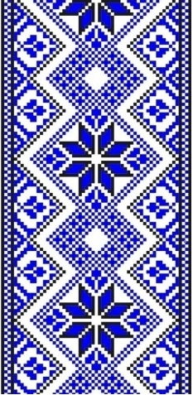
МІНІСТЕРСТВО ОСВІТИ І НАУКИ УКРАЇНИ
ДЕПАРТАМЕНТ ОСВІТИ І НАУКИ КИЇВСЬКОЇ ОБЛАСНОЇ ДЕРЖАВНОЇ АДМІНІСТРАЦІЇ

НАВЧАЛЬНО-МЕТОДИЧНИЙ КАБІНЕТ ПРОФЕСІЙНО-ТЕХНІЧНОЇ ОСВІТИ У КИЇВСЬКІЙ ОБЛАСТІ

ДПТНЗ «БРОВАРСЬКИЙ ПРОФЕСІЙНИЙ ЛІЦЕЙ»
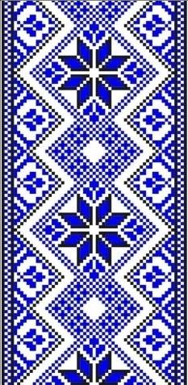

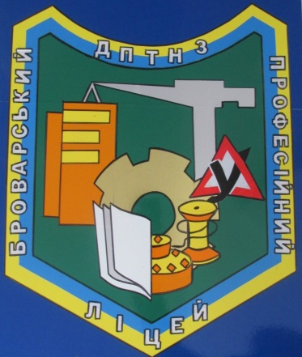

Методична розробка уроку
з предмету «Англійська мова.»
на тему: «Жанри живопису»
10 клас

Розроблено:
Викладачем вищої категорії
Бєлова С.М.

м. Бровари
2020р.

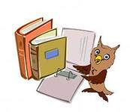
Тема уроку : ЖАНРИ ЖИВОПИСУ
Мета уроку :
навчальна: систематизувати та узагальнити знання учнів з теми,
практикувати у пiдготовленому монологiчному мовленнi;
розвиваюча: розвивати навички читання, говоріння, письма, а також творче мислення, мовну здогадку; сприяти розвитку пізнавальних інтересів учнів, розширенню світогляду;
виховна: виховувати почуття прекрасного, а також повагу до культури та мистецтва інших народів.
Тип уроку: комбiнований
Методи навчання, прийоми: метод «Асоціацій», «Картинна галерея», «Мозковий штурм», евристична бесіда, робота з ІКТ
Міжпредметні зв’язки: художня культура, історія, мистецтво
Обладнання: підручник, комп’ютер, мультимедійний проектор,
дидактичні матеріали різного спрямування, схеми, кросворд.
ПЛАН – КОНСПЕКТ
І. Підготовка до сприйняття іншомовного мовлення
1. Привітання.
2. Повідомлення теми та мети уроку.
3. Мовна зарядка.
ІІ. Основна частина заняття
- Перевiрка домашнього завдання.
- Активізація лексичних одиниць теми.
3.Читання та переклад тексту.
4.Рольова гра «Екскурсія до картинної галереї».
5.Письмо
ІІІ. Заключна частина заняття
1. Пiдбиття пiдсумкiв.
2. Оцiнювання учнiв.
3. Домашнє завдання.

ХІД УРОКУ/PROCEDURE
І. Підготовка до сприйняття іншомовного мовлення.
1. Привiтання: (Greeting.)
Т:Good morning, children! I am very glad to see you!
P:We are glad to see you to!
T:How are you today?
2. Повідомлення теми та мети уроку
T: The topic of our lesson is “Genres of painting”. (Слайд 1)
Мета: (Aim.) (Слайд 2)
Today we’ll continue discussing art in general and painting trends and genres in particular.
By the end of the lessons you will be able to:
- discuss paintings;
- reinforce vocabulary related to the topic;
- develop retelling skills;
- know more about painting trends and genres.
3. Уведення в іншомовну атмосферу
Учні обговорюють визначення слово «Мистецево» та висловлюють свою думку щодо нього.
Warming up: (Слайд 3)
Т:One of the definitions of the word “Art” is the study or creation of beautiful things
Brainstorming:
Т:So, we’ll start with mind-map. What works of art can you name?
WORKS OF ART

T:Where we can see works of art?
P:(We can see works of art In many places: in the streets, it the theatre or cinema,at home as well as in museums exhibitions and art or picture galleries.)
ІІ. Основна частина уроку
1. Перевірка домашнього завдання
Checking home task
Т: Now we’re going to check our home task. You have to revise the genres of painting and styles of art to guess what genre of painting and style of art is hidden in each definition .
(Вчитель розда картки з визначеннями жанрiв живопису i стилiв мистецтва , учні працюють з індивідуальними картками.) (Додаток 1),(Додаток 2);
(Слайди 4, 5, 6, 7, 8, 9, 10, 11, 12,13.)
2. Активізація лексичних одиниць теми (Додаток 3); (Слайд 14)

Read and match the words with their definitions.

1. painting | a) a picture made using very small pieces of glass or stone
2. drawing | b) a picture made using paint
3. photograph | c) pots, bowls etc. made of clay
4. mosaic | d) a work of art made of materials such as stone, metal, or wood
5. collage | e) a picture drawn with pencils or pens
6. sculpture | f) a picture made by sticking paper, cloth, or other pictures onto a surface
7. ceramics | g) a picture made using a camera

Учні самостійно співвідносять подані художні терміни з їхніми визначеннями, а потім по черзі читають їх.

Match the words with similar meanings (Слайд 15)

1.  2.  3.  4.  5.  6.  7.  8. | work of art  painting  artist  depict  art gallery  paint  type  prominent | a)  b)  c)  d)  e)  f)  g)  h) | draw  show  museum  outstanding  masterpiece  painter  picture  style
Гра “Show and Say”(Слайди 16,17, 18,19,20,21,22,23,24,25,26,27,28,29,30.)
Учитель демонструє репродукції картин, а учні повинні назвати їх художній напрямок.

3.Читання (Додаток 4)
Reading
Т: Read the text and circle the correct word.
Art museums preserve numerous masterpieces / landscapes which prove that art painting goes back thousands years. Even now we admire the mosaic and fresco pictures / images, icons which have survived through hundreds of years. Among the best known portraits /icons is The Trinity’ by Andrey Rublyov, a portratist /painter who opened a new era in world painting.
The works of painters, whether Italian, German, English, Dutch, Ukrainian, French or Russian are always marked by a profound humanism and are reflected/ inspired by innovatory ideas.
The names of the greatest impressionists / specialist realists C. Monet, Renoir, Degas are well-known for their individual blossoming fields, so beloved by Claud Monet, the world seems to be constantly changing and shimmering.
Auguste Renoir’s favourite theme /topic is the bright crowd of a merry Parisian festival. Painters Cezanne and Van Gogh portrayed / expressed in their works the desire to return to an integrated perception of world.
In the middle of the nineteenth century Ukrainian art found itself under the strong inspiration / influence of Taras Shevchenko’s art and verse. He created emotionally attractive still life paintings / images and acquired his own vision of Ukrainian folk / rural life.
Lovely Ukrainian natural scenes / sceneries inspired many Ukrainian n Russian painters to create poetic landscapes / portraits. Nowadays Ukrainian art probably develops every well-known genre / trend, ranging from Neorealism to Post- Modernism.
4.Рольова гра :«Екскурсія до картинної галереї» (Демонстрацiя учнiвських презентацiй)
T: Today at our lesson we’ll have a role play «Let’s go on an excursion to the museum and art gallery». Here we have guides from different museums and galleries. Listen to them attentively. They will tell us about famous English painters and their pictures. So, let’s start our excursion.
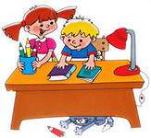

P1: My name is __________I’ll be your guide for today and I want to tell you about William Hoggart. He is one of the greatest of English artist of 18th century. William Hoggart made his name as an artist painting “conversation pieces”. These little pictures were very popular in England during the 18th century. They represented members of the same family or close friends having tea, playing cards or simply talking to one another. Hoggart said that his picture was his stage, and men and women his players.
The masterpiece of the series was the famous “Marriage a la Mode”. This set of pictures describes a marriage between the daughter of a rich man and a young lord, the son of an old Earl. The girl’s father has brought a bag full of money with him. Their children are together but apart: the young man is watching himself in the glass; the girl is listening to a young Counsellor. The pictures round the room help understand the situation. In one of the pictures Madame sits listening to the young Counsellor, whose portrait hangs in her room. Other pictures in the series show My Lord who amuses himself with a bad company.
Hoggart’s fame is, in fact, based on these “moral” engravings. They are full of humour.You must read them, and not look at them like other works of art.
P2: My name is__________. I am your guide. I’ll tell you about John Constable, one of the greatest landscape painters. He was born in Sufford, on June 11, 1776. He was the son of a wealthy miller. He began to take interest in landscape painting while he was at grammar school. His father did not favour art as a profession. As a boy Constable worked almost secretly, painting in the cottage of an amateur painter. His keen artistic interest was such that his father allowed him to go to London in 1795, where he began to study painting.
Constable was the first landscape painter who considered that every painter should make his sketches direct from n Constable ature, that is, working in the open air.
Constable was a realist. The most notable works of Constable are “Dedham Vale”, “Flatford Mill“, “A Cottage in a Cornfield”, “The Hay Wain”, “Malvern Hall”, “Weymouth bay”, “Boat Building” and others.
In England Constable never received the recognition that he felt he was due. The French were the first to acclaim Constable publicly.Constable may truly be considered the father of modern landscape painting.
P3: My name is ____________I want to tell you about Thomas Gainsborough. He was a portraitist and landscape painter. He was born in Sudbury in 1727 and was the son of merchant. His father sent him to London to study arts. Thomas Gainsborough spent 8 years working and studying in London. There he got acquainted with the Flemish traditional school of painting.
He was the first British painter who painted British native countryside. His works of landscape contain much poetry and music. His best works are “Portrait of Sarah Buxton”, “Lady Georgiana Cavendish”, “Lady in blue”, “Portrait of Sarah Siddons”, “Cornard Wood”, “Sunset”, “The cottage door”, “The market cart” and “The bridge”.His art became a forerunner of the Romantic Movement.


Учні слухають доповіді й заповнюють таблицю.

PAINTER | PICTURES

T: So we have been to the picture gallery and listened to the guides.
5.Письмо
Writing (Додаток 5)
Т:Complete the sentences using the words.
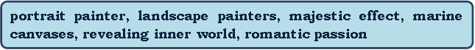
1.John Constable, the greatest of English _______, came from Suffolk .
2. Constable was an acute observer of nature and had a ________ for light.
3. Thomas Gainsborough succeeded brilliantly as a___________.
4. The painting which portrays the conflict of wind and tide created a___________
5.Turner’s ________ reveal the grand beauty of the sea.
6. Reynolds succeeded in ____ the sitters’ ____________________.
Key:1-2, 2-6, 3-1, 4-3, 5-4, 6-5.
ІІІ. Заключна частина заняття.
1.Підбиття підсумків. (Summarizing)
T:Today we have trained to use the words and words-combinations on the topic «Painting » and listened to the reports about English painters. Thank you for your efforts to make our lesson really interesting, you played your roles of guides excellently and it was a real pleasure to listen to you. Now you know a lot of words on this topic.
2.Оцiнювання учнiв.(Mark)

3.Домашнє завдання) (Homework ) (Додаток 6);(Слайд 31)
T:Have you ever tried to guess a crossword in English?
Find eight words connected with art and use some of them in plural to complete the sentences below.

g | n | i | t | n | i | a | p | t | n
b | o | a | m | o | n | p | l | j | o
r | f | s | s | i | l | o | y | g | i
z | p | i | c | t | u | r | e | n | t
q | k | t | u | c | m | t | v | i | i
o | v | t | l | e | g | r | d | w | b
s | h | n | p | l | n | a | d | a | i
r | b | i | t | l | r | i | a | r | h
q | t | a | o | o | p | t | h | d | x
p | j | p | r | c | b | x | c | e | e
painting
portrait
exhibition
collection
paint
picture
drawing
sculptor

- He did all his ……… with a charcoal.
- He has painted the ……… of a lot of famous people.
- Van Gogh’s “Sunflowers” is one of the most famous ……… in the world.
- The museum has one of the world’s finest ……… of impressionist paintings.
- Her first works were the ……… made with water colour.
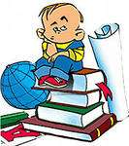

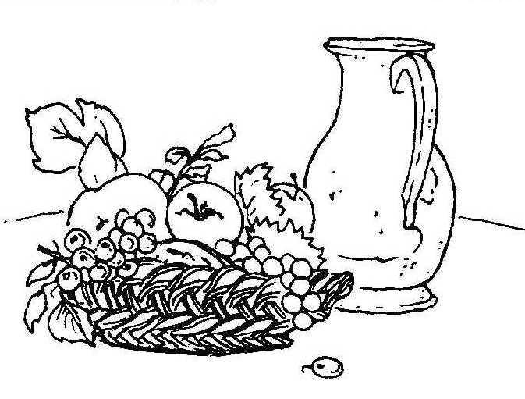 | (Додаток 1)  Genre of painting  A picture of an object or several objects, especially fruit or flowers
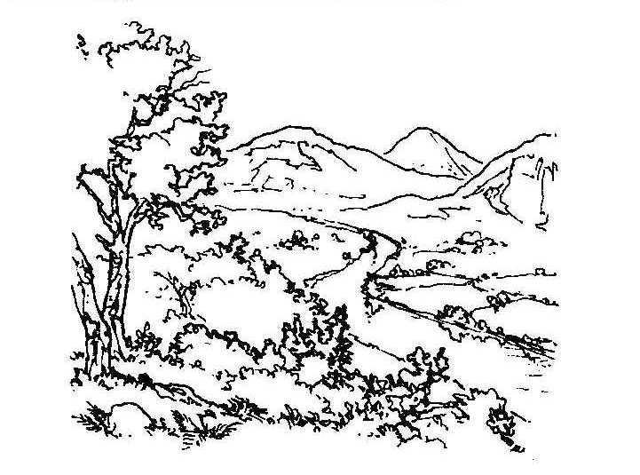 | +  A picture representing a tract of country with the various objects it contains
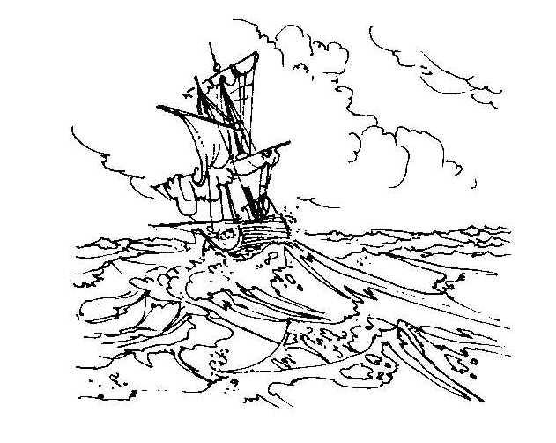 | A painting or other artistic representation of the sea
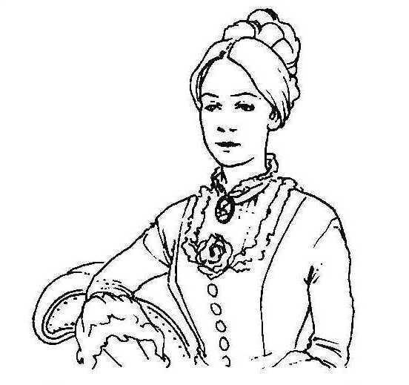 |  | A painting, picture or representation of the person

A painting which represents scenes from everyday life in a more or less realistic way

(Додаток 2)

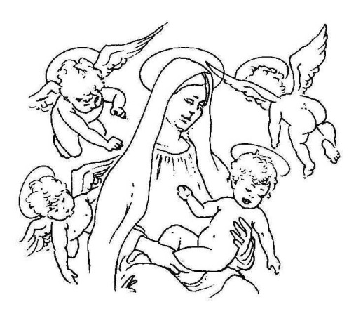 | Styles of art  The main style of art in 18th century Europe, based on the styles of ancient Greece and Rome, often showing scenes and characters from the Christian religion
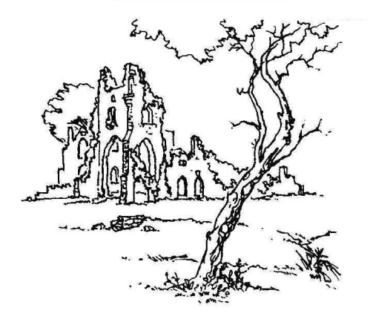 | A style of art popular in 19th century Europe, often showing the sea or the countryside, and Usually expressing strong emotions
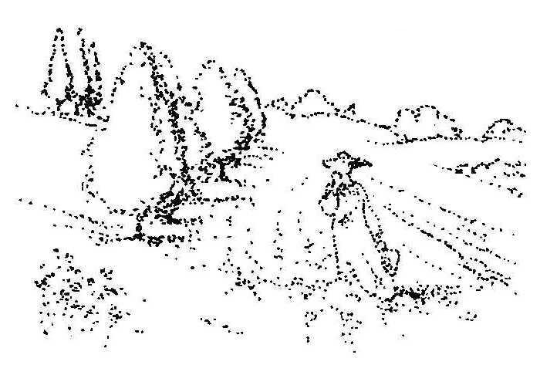 | A style of art that was developed in France in the late 19th century, which uses colours to show the effects of light on people, objects, and places, and does not show small details
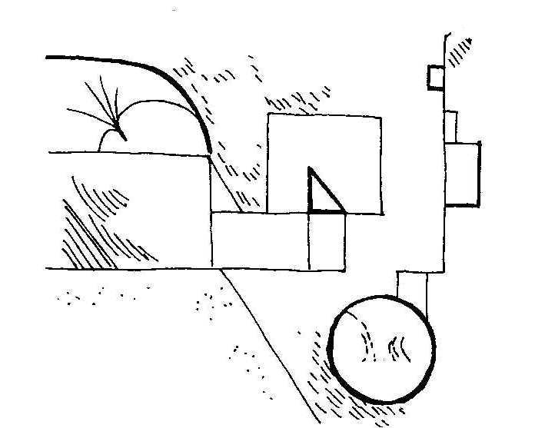 | The style of art in the 20th century that is deliberately different from art of the 18th and 19th centuries, and does not show people, objects, or places as they appear in real life
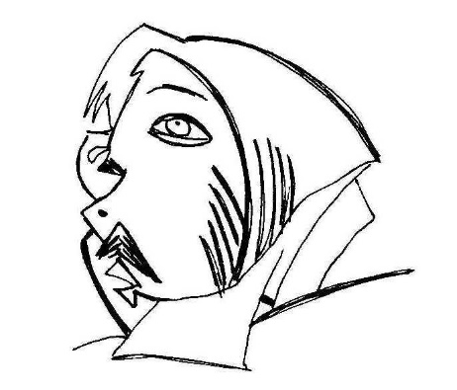 | A type of modern art that uses shapes, colours, and patterns to express ideas and feelings, rather than pictures that look like people, objects, or places
(Додаток3)
1. Read and match the words with their definitions.

1. painting | a) a picture made using very small pieces of glass or stone
2. drawing | b) a picture made using paint
3. photograph | c) pots, bowls etc made of clay
4. mosaic | d) a work of art made of materials such as stone, metal, or wood
5. collage | e) a picture drawn with pencils or pens
6. sculpture | f) a picture made by sticking paper, cloth, or other pictures onto a surface
7. ceramics | g) a picture made using a camera

2. Match the words with similar meanings

1.  2.  3.  4.  5.  6.  7.  8. | work of art  painting  artist  depict  art gallery  paint  type  prominent | a)  b)  c)  d)  e)  f)  g)  h) | draw  show  museum  outstanding  masterpiece  painter  picture  style  
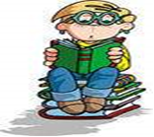
(Додаток 4)

Reading
Т: Read the text and circle the correct word.
Art museums preserve numerous masterpieces / landscapes which prove that art painting goes back thousands years. Even now we admire the mosaic and fresco pictures / images, icons which have survived through hundreds of years. Among the best known portraits /icons is The Trinity’ by Andrey Rublyov, a portratist /painter who opened a new era in world painting.
The works of painters, whether Italian, German, English, Dutch, Ukrainian, French or Russian are always marked by a profound humanism and are reflected/ inspired by innovatory ideas.
The names of the greatest impressionists / specialist realists C. Monet, Renoir, Degas are well-known for their individual blossoming fields, so beloved by Claud Monet, the world seems to be constantly changing and shimmering.
Auguste Renoir’s favourite theme /topic is the bright crowd of a merry Parisian festival. Painters Cezanne and Van Gogh portrayed / expressed in their works the desire to return to an integrated perception of world.
In the middle of the nineteenth century Ukrainian art found itself under the strong inspiration / influence of Taras Shevchenko’s art and verse. He created emotionally attractive still life paintings / images and acquired his own vision of Ukrainian folk / rural life.
Lovely Ukrainian natural scenes / sceneries inspired many Ukrainian n Russian painters to create poetic landscapes / portraits. Nowadays Ukrainian art probably develops every well-known genre / trend, ranging from Neorealism to Post- Modernism.

(Додаток 5)

4.Учні слухають доповіді й заповнюють таблицю.

PAINTER | PICTURES

5.Письмо
Writing
Т:Complete the sentences using the words.
1.John Constable, the greatest of English _______, came from Suffolk .
2. Constable was an acute observer of nature and had a ________ for light.
3. Thomas Gainsborough succeeded brilliantly as a___________.
4. The painting which portrays the conflict of wind and tide created a___________
5.Turner’s ________ reveal the grand beauty of the sea.
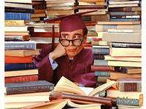
6. Reynolds succeeded in ____ the sitters’ ____________________.

(Додаток 6)
Домашнє завдання
Homework :
T:Have you ever tried to guess a crossword in English?
Find eight words connected with art and use some of them in plural to complete the sentences below.

g | n | i | t | n | i | a | p | t | n
b | o | a | m | o | n | p | l | j | o
r | f | s | s | i | l | o | y | g | i
z | p | i | c | t | u | r | e | n | t
q | k | t | u | c | m | t | v | i | i
o | v | t | l | e | g | r | d | w | b
s | h | n | p | l | n | a | d | a | i
r | b | i | t | l | r | i | a | r | h
q | t | a | o | o | p | t | h | d | x
p | j | p | r | c | b | x | c | e | e
painting
portrait
exhibition
collection
paint
picture
drawing
sculptor

- He did all his ……… with a charcoal.
- He has painted the ……… of a lot of famous people.
- Van Gogh’s “Sunflowers” is one of the most famous ……… in the world.
- The museum has one of the world’s finest ……… of impressionist paintings.
- Her first works were the ……… made with water-colour.
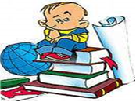

Find eight words connected with art and use some of them in plural to complete the sentences below.

g | n | i | t | n | i | a | p | t | n
b | o | a | m | o | n | p | l | j | o
r | f | s | s | i | l | o | y | g | i
z | p | i | c | t | u | r | e | n | t
q | k | t | u | c | m | t | v | i | i
o | v | t | l | e | g | r | d | w | b
s | h | n | p | l | n | a | d | a | i
r | b | i | t | l | r | i | a | r | h
q | t | a | o | o | p | t | h | d | x
p | j | p | r | c | b | x | c | e | e
painting
portrait
exhibition
collection
paint
picture
drawing
sculptor

- He did all his ……… with a charcoal.
- He has painted the ……… of a lot of famous people.
- Van Gogh’s “Sunflowers” is one of the most famous ……… in the world.
- The museum has one of the world’s finest ……… of impressionist paintings.
- Her first works were the ……… made with water-colour.

Find eight words connected with art and use some of them in plural to complete the sentences below.

g | n | i | t | n | i | a | p | t | n
b | o | a | m | o | n | p | l | j | o
r | f | s | s | i | l | o | y | g | i
z | p | i | c | t | u | r | e | n | t
q | k | t | u | c | m | t | v | i | i
o | v | t | l | e | g | r | d | w | b
s | h | n | p | l | n | a | d | a | i
r | b | i | t | l | r | i | a | r | h
q | t | a | o | o | p | t | h | d | x
p | j | p | r | c | b | x | c | e | e
painting
portrait
exhibition
collection
paint
picture
drawing
sculptor

- He did all his ……… with a charcoal.
- He has painted the ……… of a lot of famous people.
- Van Gogh’s “Sunflowers” is one of the most famous ……… in the world.
- The museum has one of the world’s finest ……… of impressionist paintings.
- Her first works were the ……… made with water-colour.

