Nina Pyschyk, Romaniv Gymnasium
English with Smiling Sam 2
Lesson plan
Topic: Now I know I can Revision. Unit 3 ( Я знаю і вмію ) . In my classroom. Підсумковий урок. Aim : - To revise and consolidate vocabulary
and structures learnt in previous lessons.
To monitor Ss progress and understanding the words they
have learnt in unit 3 “ In my classroom”.
-make the table game into Portfolio.
( Перевірити і закріпити словниковий запас учнів та розуміння
вивченої лексики. Виготовити настільну гру : “ I know how it say!”.
Grade: 2
Lessons time: 40 minutes.
Learning objectives: by the end of the lesson pupils will make the game and have revised all
vocabulary they have learnt in this unit using the
songs and videos..
Recycled language: numbers, feelings , classroom items.
Materials: a notebook, internet resource ( videos), flashcard numbers , magnet cards, colored pencils, activity books, pictures, glue.
interactive white board.
- Warmer: T: greets the children and do the actions (wave, smile).
Look at the screen ! Sound [ u: ] – oo ( book school room )
Listen and say : - yes- or – no-

https://www.youtube.com/watch?v=tVlcKp3bWH8&ab_channel=SuperSimpleSongs-KidsSongs

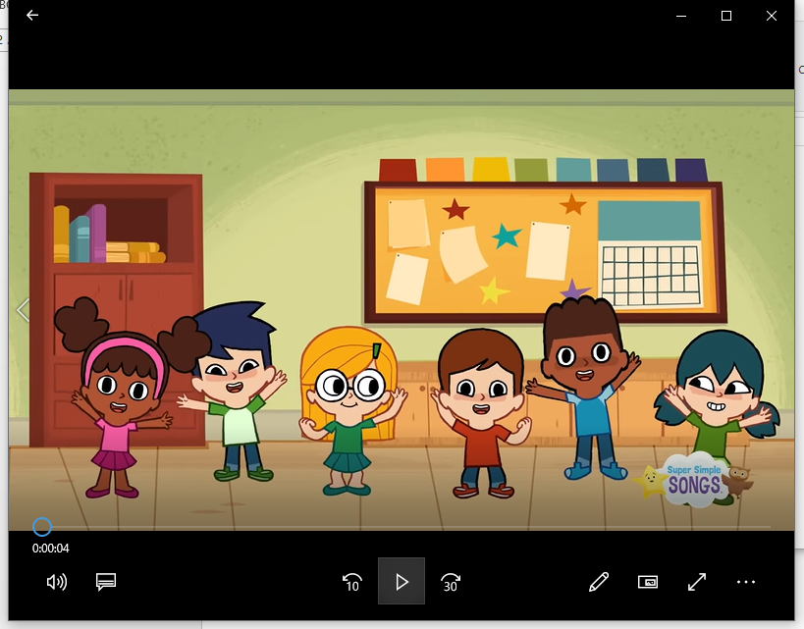

Текст песни
Hello, Hello
Can you clap your Hello, Hello!
Can you clap your hands?
Can you stretch up high?
Can you touch your toes?
Can you turn around?
Can you say, "Hello"?
Hello, Hello!
Can you stamp your feet?
Hello, Hello!
Can you stamp your feet?
Can you stretch up high?
Can you turn around? ll Can you stamp your feet?
Источник: Musixmatch

2 .The main part
Teacher: Look at the screen :
- You can see pupils. ( yes) They are in the garden.( no)
- You can see 4 boys ( no ) They are in the café ( no).
- You can see 2 girls ( no ) They are at school ( yes)
- Children are playing football ( no )
- They are jumping ( no) They are washing the hands ( no)
- They are singing and dancing ( yes)

2. Let’s sing with them. ( singing )

3. They [ ] – t+h

4. – How are you ? ( I’m good. I’m great! I’m wonderful )
5. Time to play and guess
( Вчитель закрив папером картку з зображенням, а діти мають
Відгадати , за допомогою запитань: Is it a….?

( bag. school bus , clock )

6 Student’s book p. 48 Lesson 11-12 Revision

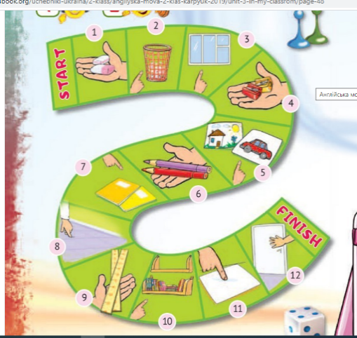
7. Let’s make your board game . You need a paper, a ruler, a pencil, glue.

1  . 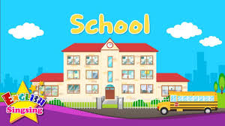 | 2.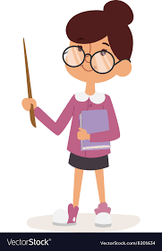 | 3  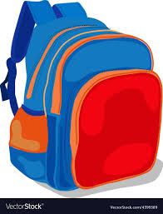
4.  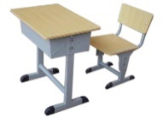 | 5.  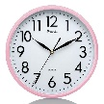 | 6.  ehs ( she )
7.  Oobk ( book) | 8.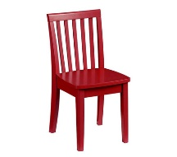 | 9.  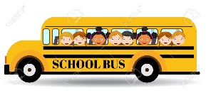
10  .htey ( they ) | 11- eleven | 12 twelve

- School 2- teacher 3- bag 4 –desk 5- clock 6- she 7-book
8- chair 9- school bus 10- they 11- eleven 12- twelve

3/. Closing activity:
T: It’s time to finish. Thank you class. You were great!
Goodbye!
Ss: Goodbye teacher!

