Тема програми: «Автомобілі. Складові частини автомобіля.»
Тема уроку: Двигун внутрішнього згоряння.
Мета: Ознайомити учнів з новою лексикою до теми та вчити використовувати її в мовленні; формувати лексичні навички й навички вимови; вдосконалювати навички читання й усного мовлення за професійною спрямованістю; формувати потребу у практичному використанні англійської мови у професійній сфері; розвивати мовну здогадку й мовленнєву реакцію учнів; прищеплювати інтерес до обраної професії; виховувати загальну культуру здобувачів освіти, зацікавленість у розширенні своїх знань, справедливість, доброзичливість, гуманність, повагу до людей.
Методи та прийоми: групова, індивідуальна робота, робота з картками, робота з тестами.
Тип уроку: урок засвоєння нових знань.
Основні терміни та поняття: internal combustion engines, piston strokes, pumping action of a piston, to operate on a cycle, four-stroke engine, outward (inward) stroke of a piston, admission of a charge, combustible gaseous mixture, two-stroke cycle, to have certainadvantages, fuel economy, air charge, high speed.
Міжпредметні зв'язки:cпецтехнологія, будова автомобіля.
Наочність: роздатковий матеріал (картки з завданнями).
Технічні засоби навчання:комп'ютер
Procedure
І. ПОЧАТОК УРОКУ.
1. Привітання.
Good morning pupils! I see that all are present today. I am fine. How are you? And you? That’s OK! Let’s begin our lesson.
2. Повідомлення теми та завдань уроку.
Today we are going to speak about engines. We are going to have some tasks in reading and listening comprehensions, get some new information.
3.Warming-up activity.
Мовленнєва зарядка (введення в комунікативну ситуацію)
Now you are the students of the High Vocational School and in a year you’ll get the profession. But in order to be a good specialist you must know everything about the cars, engines, your duties etc. Day by day we learn all what you must know. And now let’s review what we have studied at the previous lessons.
4. Check on homework.
Teacher to pupils: Try to answer my questions.
1. What does the word “transport” mean?
2. What does motor transport include?
3. How many stages is the history of transport divided into?
4. What is the first stage?
5. When did the second stage begin?
6. Who were the first porters and why?
7. What made it possible to use wheeled traffic?
ІІ. ОСНОВНАЧАСТИНАУРОКУ.
Teacher: Translate the sentences using the words.
- a duration – тривалість
Duration is a continuance in time.
2. а cycle – цикл
The work of engine is divided into cycles.
3. а piston – поршень
4. а stroke – хід
The piston makes strokes.
5. to complete –завершувати
The work was completed to the appointed time.
6. a succession-послідовність
Succession is the coming of the thing after another in time.
7. a revolution – оборот
One cycle is completed within one revolution.
8. to revolve – обертатися
Spaceships are revolving in orbit.
9. a cranksharft - колінвал
The pistons make revolutions of the crankshaft.
10. gaseous - газоподібний
Gaseous clouds were seen in the sky.
11. a mixture - суміш
Air is a mixsture of gases.
12. to expand - розширювати
The gases are expanding at a high temperature.
13. to blow out - видувати, задувати
The candle was blown by the wind.
14. a pressure - тиск
The cylinder is filled with the gases to atmospheric pressure.
15. a charge - порція, заряд (горючої суміші)
16. to expell - видаляти, виштовхувати
To expell means to send out by force.
This student was exppelled from the Institute.
17. to pump out - викачувати
a pump - насос
The water was pumped out of a river.
It is working as a pump while the piston is moving into a cylinder.
18. a unit - агрегат, вузол
The construсtion units were brought to the 18 site by lorries.
19. intermittent - переривчастий
Intermittent means to stop for a while.
20. a fuel - паливо
What kind of fuel is used in this motor car?
21.a flexibility - гнучкість
22. a volatility - летючість
volatile – летючий, швидковипаровується
23. horse- power (h.p.) - кінська сила
The engine of this car is 75 h.p.
- READING
Teacher: Read the international words and guess their meanings.
Cylinder, to evacuate, gas, operation, economy, phase, product
Teacher: Read and translate the text.

Internal combustion engines
The engines are generally referred to the internal combustion engines.
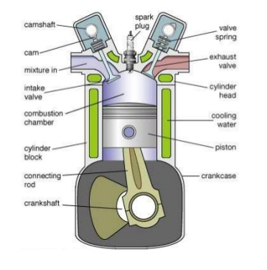
Combustion engines may be divided into types according to the duration of the cycle on which they operate, in terms of piston strokes. By a cycle is meant the succession of operations in the engine cylinder which enstantly repeats itself. The great majority of modern automobile engines operate on the four stroke cycle, usually referred to as the Otto cycle, which is completed in four strokes of the piston, or during two revolutions of the crankshaft. Engines are also being built to operate on a cycle which is completed in two pistons strokes, in this cycle a combustible gaseous mixsture is compressed in the cylinder during the outward stroke of the piston, and burned and allowed to expand during the following outward stroke. Evacuation of the products of combustion and admission of a new charge take place during the later part of the expansion, stroke. Since there is no separate exhaust stroke, the burnt gases cannоt be expelled from the cylinder by pumping action of the piston therein.

Іnternal combustion engines

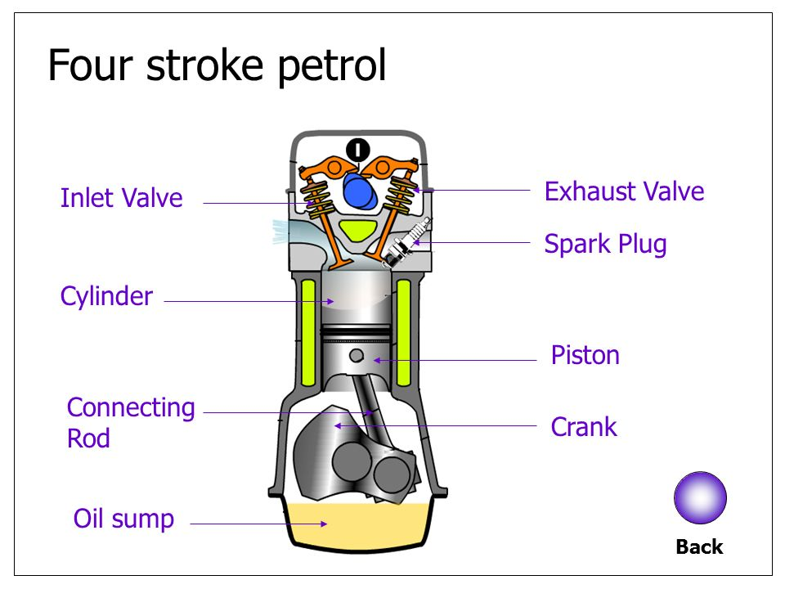
The burnt gases must be blown out, by either fresh air or combustible mixture, under pressure, a process known as scavenging. Two-stroke engines with scavenging by combustible mixture are used only in small units (outboard engines, for example), and generally only in applications where the operation is quite intermittent. Their chief advantage is low first cost; their disadvantages are low fuel economy and lack of flexibility.
All of the high-speed combustion engines in use today operate on volatile fuels, more than 99 per cent of the total horse power undoubtedly work on the four-stroke cycle.
The four-stroke cycle comprises the following four phases or operations in the order in which they are given:
- admission of the charge to the cylinder;
- compression of the charge;
- combustion of the charge (which includes its ignition and expansion );
- explosion of the products of combustion.
- WRITING
Teacher:Write the general questions to the sentences and answer them. Combustion engines may be divided into types according to the duration of the cycle.
- A cycle is the succession of operations in the engine cylinder.
- The Otto cycle is completed during two revolutions of the crankshaft.
- A combustible gaseous mixture is compressed in the cylinder.
- Evacuation of the products of combustion takes place during the later part of expansion.
- There is no separate exhaust stroke.
- The burnt gases cannot be expelled from the cylinder.
- Two-stroke engines are used in small units.
- The high-speed combustion engines operate on volatile fuels.
- The four –stroke cycle comprises four phases.
- SPEAKING
Group work.
Teacher: The first group translates the word-combinations in Ukrainian.
internal combustion engines, piston strokes, pumping action of a piston, to operate on a cycle, four-stroke engine, outward (inward) stroke of a piston, admission of a low charge, combustible gaseous mixture, two-stroke cycle, to have certain advantages, fuel economy, air charge, high speed.
Teacher: The second group matches the words with their translations.
A.1. a revolution
2. to divide
3. according to
4. to repeat
5. a majority
6. gaseous
7. a combustion
8. a piston
9. a pressure
10. a fuel
11. an ignition
12. to vaporize
В. 1. поршень
2. займання
3. повторювати
4. ділити
5. випаровуватися
6. паливо
7. газоподібний
8. згоряння
9. більшість
10. згідно
11. оборот
12. Тиск
Teacher: The third group chooses the correct answer.
1.internal а) зовнішній в) внутрішній
с) широкий d) вузький
2.to divide а) горіти в) ставитися
з) двигун d) ділити
3. an engine а) двигун в) вантажівка
с) сила d) джерело
4. a piston а) циліндр в) цикл
с) сила d) суміш
5.to complete а) ділити в) завершувати
с) приналежність d) працювати
6. a mixture а) поверхня в) двигун
с) колесо d) суміш
7. a scavenging а) подувка в) випуск
с) горіння d) дія
- LISTENING
Watching the video.
Teacher: You have just watched the video about the 4-stroke engine. What are these strokes?
Pupil names the strokes and write them down on the blackboard.
III. ЗАКЛЮЧНАЧАСТИНАУРОКУ
- SUMMARY
Заключна частина уроку
Teacher: Today you have got a lot of new information. You have worked hard. Thank you. Your marks are the following…..
- ІНСТРУКТАЖ ДОМАШНЬОГО ЗАВДАННЯ
HOME ASSIGNMENT
At home study all the new words and word- combinations. Be ready to tell about the internal combustion engines. Good luck. Have a break.

