THE MINISTRY OF EDUCATION AND SCIENCE OF UKRAINE TERNOPIL SPECIALIZED SCHOOL #29

The demonstrative lesson:

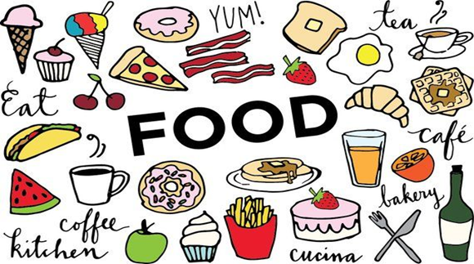

Prepared by:
Nadiia Maryniak,
a teacher of English

Ternopil 2019
Topic: Food
Objectives:
- To summarize and systematize students’ knowledge on the topic;
- To develop listening , reading, writing, speaking skills:
- To practise food vocabulary:
- To develop speech competence:
- To bring up students as hard-working people.
- To foster students desire to learn English.

Equipment: a board, pictures on the topic, a laptop, projects, handouts.

PROCEDURE
Teacher: Good morning, children. I’m glad to see you today.
How are you?
What is the weather like today?
(the students’ answers)
You’re fine, the weather is fine, I hope our lesson will be fine too?!
Warm up
Teacher: Before we start our lesson, I have one task for you! I brought a bag of smth.You have to put your hand into, touch and guess what it is.
Use such phrases as: I think, I suppose, In my opinion….
St.: I think It’s a banana.
Teacher: Do you know what is the topic of our lesson today?
St.: Yes, we’ll speak about ‘Food’
Teacher: On this lesson we’ll revise food vocabulary, practise using countable and uncountable nouns, practise using quantifiers and talk about nutrients.
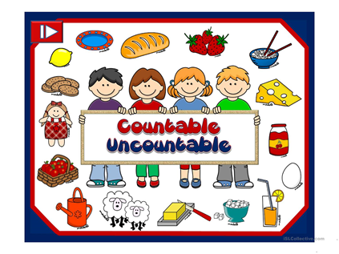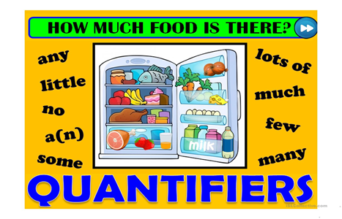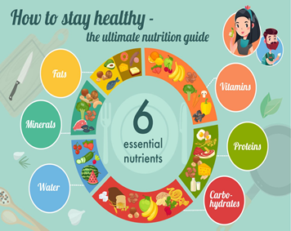
We have to revise the food words we`ve learnt. We’ll do it in the form of the alphabet. Take one letter and write as many food words as possible starting with this letter.
(the students’ answers)A: apricot, apple, aubergine….
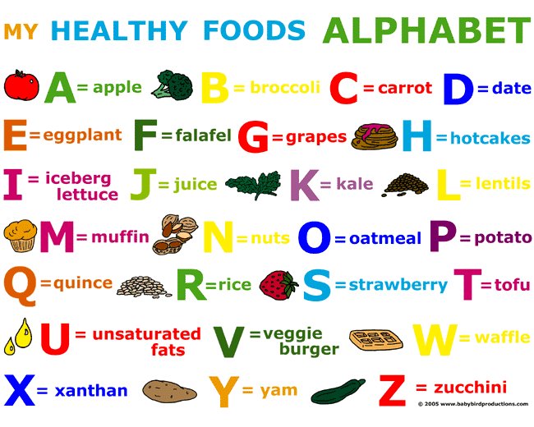
Teacher: I can see that you know lots of words. So It’s important to distinguish between countable and uncountable nouns. Let’s recite some rules. Which nouns are countable? And uncountable?
The students’ answers: Countable nouns are the things we can count using numbers, and uncountable are the things we cannot count using numbers.
Teacher: Thanks a lot! Let’s practise. Stand up, please. If you hear countable noun –stand up! If –uncountable noun, stand still, if you make a mistake – take your sit.
Words:
Rice,
Flour,
Coffee,
A cup of tea
An apple,
An orange,
A bowl of soup
A tomato
Salad
Pizza
Chips
Teacher: Good job!!!
Let’ s come to quantifiers. What quantifiers do you know?
St.: Much, many, a lot of.
Teacher: Look at the board!!!! Have you ever seen this picture before?
(Student’s book)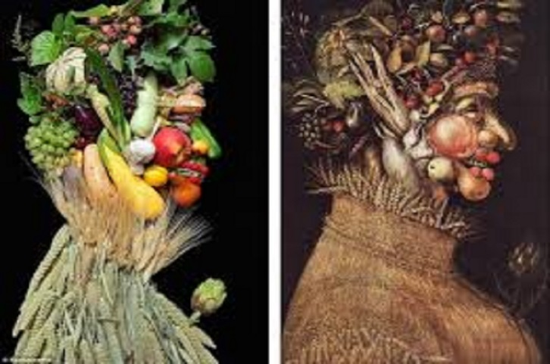
Make questions to this picture. Choose a partner and ask him a question about it. You have 20 seconds for thinking.
Ex.Is there any fruit on the picture? How many vegetables are there?
And now let’s practise again. You’ll write unusual dictation which is called “Picture dictation”.
I’ll dictate you’ll draw. Listen to me attentively and draw.
Picture dictation
This is a table. There are a lot of vegetables here. There are a lot of eggplants but not many tomatoes. On this table there is a lot of fruit too: three bananas, two apples, six cherries but there aren’t any pears. In the middle of the room there is a cat. It is eating meatballs.
And now who can go to the board and describe your picture?
What is meatball? Why did I mention it? Yes we’ll have a minute of relaxation. Let’s sing a song.
“ Banana banana meatballs” https://www.youtube.com/watch?v=BQ9q4U2P3ig

Now you’re relaxed. So let’s go to the main part of our lesson. One of the most important thing is to know which food is healthy and which is unhealthy. Some students prepared videos about the food they prefer. Let’s watch them. Be attentive because after watching you have to answer the questions. And now look at the sheets of paper and go through the questions.

Denys’s video
What does Denys Like eating for breakfast?
What makes Denys strong?
Vika’s video
What does Vika’s ideal lunch consist of?
Why does Vika like drinking tea with honey?
What advice does Vika give us at the end of the video?
Veronika’s video
What type of pizza does Veronika like?
What ingredients were mentioned in the video?
Amelia’s video
Is dark chocolate useful for our health?
What is the most powerful disease fighter ?

Summing –up.
Let’s sum up our lesson.
What should you eat if you want to be healthy?
What do nutrients give us?
How many types of nutrients do you know?
Where can you find protein?
What gives us energy?
What nutrient can you find in fruit and vegetables?
What is important for strong teeth?
What can happen with people who don’t eat many vitamins?
What food refers to unhealthy fat?
Where can you find much water?
Our lesson is coming to the end. Thanks for being active, excited, and creative. All of you get good marks. Your h/w is SB.p.118(6). I have some advice for you!!! Look at the board and try to guess what word is missed.
An______a day keeps a doctor away.

Teacher: An apple – yes, you are right.

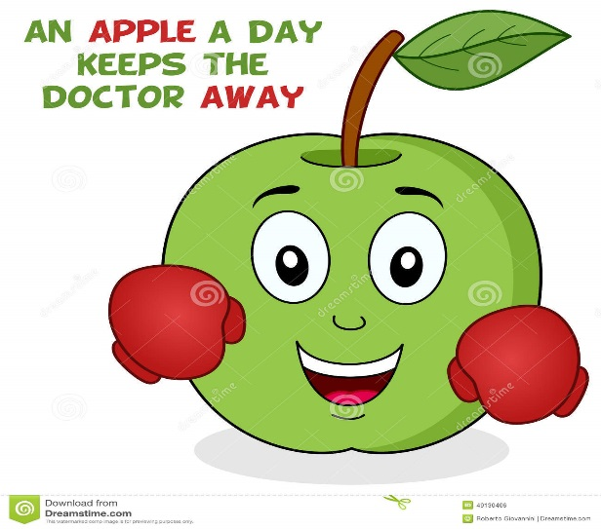

Eat apples and be healthy!!! The lesson is over. See you tomorrow.

