UKRAINIAN CITY
Zaporizhzhia
PRE-LISTENING
1. Work with a partner. Match the photos below to these words. There is one word you do not need. Listen, repeat and check your answers.
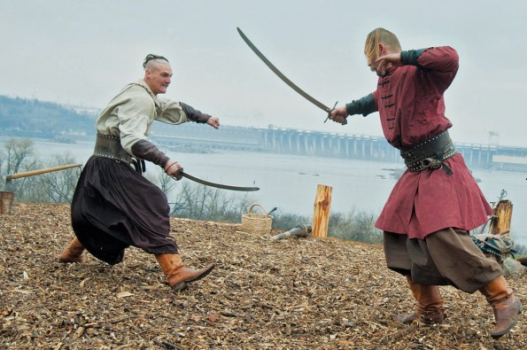 | 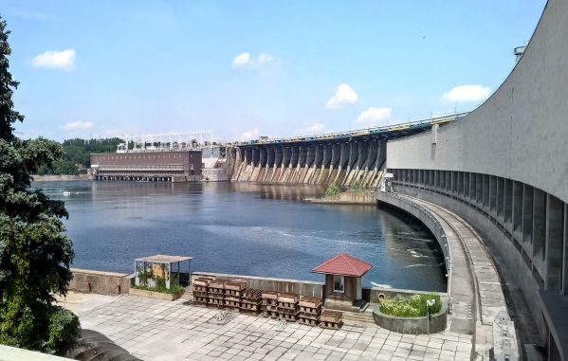
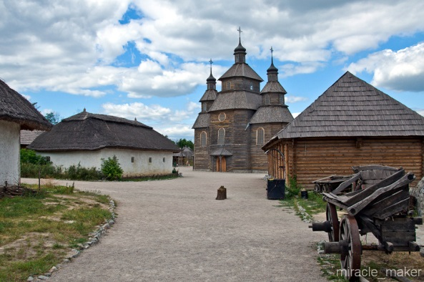 | 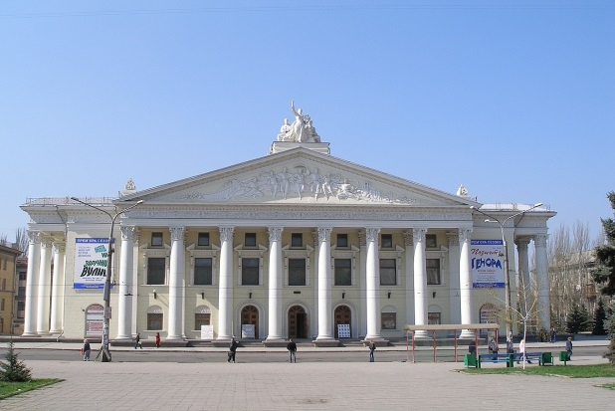

Drama theatre Rapid Cossacks Zaporizhian Sich
Dnipro Hydroelectric Power Station

INTRODUCTION OF THE NEW VOCABULARY
2. Match the words with their definitions.
1. population |  | to divide, or to make something divide, into two or more parts
2. constitute |  | calculated by adding several amounts together, finding a total, and dividing the total by the number of amounts
3. fortress |  | to an average extent; fairly but not very
4. fortification |  | (of an area of a town) suitable for living in; consisting of houses rather than factories or offices
5. occupy |  | a large quantity that is more than enough
6. comprise |  | all the people who live in a particular area, city or country; the total number of people who live there
7. abundance |  | o have somebody/something as parts or members
8. residential |  | to fill or use a space, an area or an amount of time
9. moderately |  | a building or place that has been made stronger and protected against attack
10. average |  | to continue to be something; to be still in the same state or condition
11. remain |  | a tower, wall, gun position, etc. built to defend a place against attack
12. split |  | to be the parts that together form something

LISTENING
3. Listening to the text and mark sentences T (true), F (false) or DS (doesn`t say).
1. The city of Zaporizhzhia is a regional center, one of the largest administrative, industrial and cultural centers. | ……..
2. Zaporizhzhia is a regional city and a river port on the Dnipro. | ……..
3. A TV centre works in the city. | ……..
4. Its population was 749 thousand people, which is the sixth mark in Ukraine. | ……..
5. The city comprises about 1500 avenues, streets, lanes, and squares. | ……..
6. Zaporizhzhia has a moderate-continental climate with cold, dry winters and hot dry summers. | ……..

READING
4. Read the text and use the information to complete the sentences.
1. The centre of Ukrainian Cossacks, Zaporizhian Sich……………………………...
2. The fortress was named …………………………………………………................ Oleksandr Golitsyn.
3. Zaporizhzhia …………………………., with the Khortytsia island splitting it into two streams.
4. Zaporizhzhia lies in the zone of continental climate …………………………….., which is characterized by aridity and abundance of sunny days.
5. The ……………………………….. is 60 per year.
6 The monuments of architecture …………………………………………………, the Dnipro Hydroelectric Power Station (1927-1932), the Drama Theatre (1944-1953).

About Zaporizhzhia
Zaporizhzhia is a historic region of Ukraine. The centre of Ukrainian Cossacks, Zaporizhian Sich was situated there in 16th-18th centures. Zaporizhzhia is a regional city and a river port on the Dnipro. The population of the city is over 700 000.
Ukrainians constitute 63.8% of the population, and Russians -31.1%. It is an industrial city.
Zaporizhzhia came into being in 1770 when a fortress was build here during the Russian-Turkish war of 1768-1774. The fortress was named Oleksandrivska after the commander of the First Russian army Oleksandr Golitsyn (1718-1783).
Zaporizhzhia is a cultural and educational centre. The city boasts of its University and higher educational establishments, numerous scientific establishments, three theatres, the Philharmonic Society, two museums, and the Historical and Cultural Khortytsia Reserve.
The monuments of architecture include the remains of fortifications on the Khortytsia island, the Dnipro Hydroelectric Power Station (1927-1932), the Drama Theatre (1944-1953).

Territory
Zaporizhzhia is located on banks of the Dnieper river, with the Khortytsia island splitting it into two streams. The city's area is 331 square kilometers, and it is the fifth largest city in Ukraine. Water resources occupy 13% of the territory, industrial and warehouse facilities take in 24%, 18% is used for agriculture, the rest of the territory is occupied by residential construction.
The city comprises about 1300 avenues, streets, lanes, and squares. A visiting card of Zaporizhzhia is the main street of the city, Sobornyi Avenue, which stretches for 10.8 km through four districts of the city.
Climate
Zaporizhzhia lies in the zone of continental climate in the southern climatic region, which is characterized by aridity and abundance of sunny days. The city has warm and long summer − it can last from the beginning of May until the end of September. Winter is moderately soft and dry.
The average annual temperature is + 9.0 , the average July temperature is + 22.8 , in January it is −4.9 . The record high is + 40.2 , the record low is −29.3 .
Every year, on average, the city is covered in fog for 45 days a year. The greatest number of fogs is 60 per year.

5. Answer the questions.
1. Is Zaporizhzhia a historical region of Ukraine? Why?
2. Where is Zaporizhzhia situated?
3. When was Zaporizhzhia founded?
4. What is the most remarkable sight of the city?
5. What is population of the city?
6. When was the Dnipro Hydroelectric power station built?
VOCABULARY
6. Find synonyms in the text to the words.
1. make up something | …………………………………………
2. reasonably | …………………………………………
3. location | …………………………………………
4. plenty | …………………………………………
5. province | …………………………………………
6. take up something | …………………………………………

SPEAKING & WRITING
7. Work with a partner. Make notes about your home town. What type of place is it? What is special about it? Has it changed in the last few years? How?

CHECK THESE WORDS!
Population, remain, fortress, fortification, occupy, comprise, abundance, residential, moderately

