План- конспект уроку з англійської мови
Клас: 6
Тема: Подорож. Подорож до Канади
Мета:
Практична: навчити учнів висловлюватися іноземною мовою у життєвих ситуаціях, активізувати лексику теми, навчити учнів правильно використовувати граматичні конструкції , навчити учнів давати відповіді на питання, висловлювати власні думки
Освітня: забезпечити засвоєння, поглиблення, узагальнення та закріплення основних лексичних знань учнів з даної теми, формувати вміння і навички монологічного мовлення , спонтанного висловлювання, використання здобутих знань на практиці, розширити світогляд учнів щодо особливостей подорожі
Розвиваюча: розвивати здатність самостійно робити висновки з теми, систематизувати , встановлювати зв`язки раніше вивченого з новим; розвивати логічне мислення, увагу, їхній творчий потенціал
Виховна: формувати такі якості особистості як відповідальність, організованість, дисциплінованість, виховувати всебічно розвинену особистість через отримання інформації , виховувати зацікавленість у подорожі та вивченні англійської мови
Тип уроку: комбінований
Обладнання: презентація з відео, наочність, малюнки, роздатковий матеріал
Хід уроку:
І. Початок уроку. Підготовка до сприйняття іншомовного мовлення. Preparation for apprehension foreign speech
- Організаційний момент. Привітання . Greeting.
Вірш «The lesson has begun»
Good morning ,everyone!
Its time to have some fun,
And we have come today
To write and read and play
The day is warm and bright,
Our class is light
Be ready , everyone!
The lesson has begun/
I want to ask you to be attentive and active. Don’t be afraid, don’t be silent. Speak and express your opinion. OK, look at each other, please. Smile! Look at me. Smile! So, let’s start our communication.
2. Introducting of the topic. Aim.
Повідомлення теми і мети уроку.
Look at the blackboard and say : What is the topic of our lesson? The topic of our today’s lesson is “Travelling”. Today we’ll do different tasks. As we have already learned many words and about different ways of travelling you can show and use your knowledge.
To begin our lesson I would like to practice some sounds with you.
3. Warm-up.
1) Фонетична зарядка.

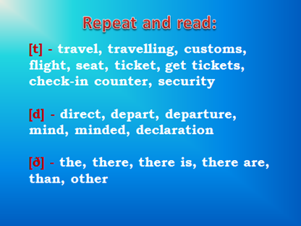

2.Мовленнєва зарядка
Explain, please, how do you understand these words 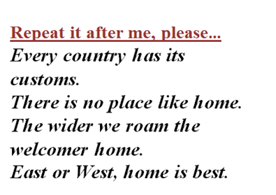
ІІ. The basic part of the lesson ( Основна частина уроку)
- Епіграф уроку. Motto.

Look at the blackboard. There is a sentence here. But all the words in it are written together. Try to divide these words and read the sentence.
Everyjourneygivesyouitsownfavor
Well-done. So, this is the motto of our lesson: “Every journey gives you its own favor”.
At this lesson we’ll speak about different kinds of travelling, about Canada
2.Активізація знань лексики. Повторення теми «Подорож»

Modern life is impossible without travelling. What means of travelling do you know?
Complete the spider gram

By plane

We can travel by…

By ship by bus

By car by train

What are the means of travelling by air, water, land?
-by plane, by rocket, by spaceship
- by ship, by boat, by canoe
- by car , by bus, by train

- 2. Make up words from letters and complete the poem
Travelling
We go by ……..arc
And we go by ….. raitn
We go by ….. hspi
We go by,,,,,palen

We go by land
And sea and air
We go, go, go from here to here.

And what about you? Do you like to travel? What kind of travelling do you prefer?
- I like to travel by,,, because it is….
- I like to travel by ,,,,, .But sometimes it is
- 3. Conversation «Reasons of travelling»
People travel because they want to visit new countries.
They often travel on business.
We travel to get new impressions.
They travel to meet new friends.
My cousin travels to study at a university.
Some people travel to earn much money.
We travel to visit our relatives
Робота в парах. Відгадування загадок.
Let’s work in pairs. Guessing of riddles.
T. To check your knowledge about the kinds of transport guess my riddles:
Take a riddle, read it, try to guess and take a picture that can illustrate your answer.

This is a house on wheels is running a race,
Taking people from place to place. (A bus)

When it is driven it goes,
When it stops, it falls down. (A bike)

What is it? That has no wheels
And leaves no tracks on the water behind it? (A boat)

Through not a bird, not a butterfly,
I can fly high up in the sky. (A plane)

T. Great. You're very smart. You've guessed everything.

Робота в групах. Work in groups
Some people like to travel by car, some people like to travel by plane.
We often use adjectives to describe different kinds of travelling , give 2-3 for each name
(Ps. Receive cards with kinds of travelling by air, by land, by water)
You can use the word map on p.150 . what are advantages and disadvantages of each way of travelling?
Interesting, boring, exiting, expensive, fast, cool, great, dangerous, safe, cheap, slow, comfortable
Робота з підручником ( ex.5 p.146)
My friend Julia likes to travel by plane. Read the letter and say how the girl felt about her travelling by plane
Ex. 6 p.147 (choose the correct word to complete each sentence)
Фізхвилинка
Робота з текстом
Now I want you to read an interesting article about trains
Choose the best word (a,b,c,) for each space
Trains - the best way to travel
For many people , going ______ train is the most exciting way to travel . You don’t have to wait___ hours at the airport with thousands _ other passengers. You just go ___ station a few minutes before the train ______, buy a ticket , get on train and the journey begins.
You can look at things _____ the windows, have a sleep, read a book or go for a walk up and down the train
 | A | B | C
1 | on | at | by
2 | for | in | at
3 | and | from | of
4 | at | to | in
5 | Will leave | Left | leaves
6 | by | through | inside
Today we are going to make our trip to one of the most beautiful countries in the world, the country with a rich history , the country of beautiful landscapes. The name of this country is Canada.
What do you know about Canada?
- What does word Canada mean?
- How many provinces has Canada?
- Flag of Canada
- Who is the head of Canada?
- What are national symbols?
- Name me the biggest cities of Canada
Перегляд відео
7.What is the capital of Canada?
Lets watch video about Ottawa

Вікторина –перевірка знань після перегляду презентації

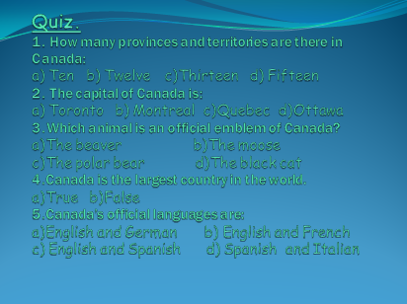

The Canadian love their country and they say
Together we are Canada
One nation strong and free
With sharing , friends and happiness
Forever we will be
These words are illustrated in their national anthem «O Canada»
Lets listen this anthem

We are Ukrainian. We are strong and free with sharing , friends and happiness. . We are one nation .

III. Заключна частина уроку.
- Використання інтерактивної вправи «Сенкан».
T. Now we’ll sum up our lesson and do it in a form which is called “cinquain”. Let’s remember the rules of such a form.

Structure of “cinquain”
1 line: Theme (the main word)
2 line: two adjectives
3 line: three verbs (actions of the main word)
4 line: a sentence (quotation on the topic)
5 line: synonym / antonym of the main word.

T. Our main word is “Travelling”. You should try to use different notions connected with it in order to this structure.
Travelling
Interesting, exiting
To go, to visit, to learn
Travelling is very popular in modern life.
Journey.
- It was a very interesting excursion. I like to travel with the cleverest pupils. And what about you? What did you do on the lesson today?
- What was the topic of the lesson? Did you like our visit to Ottawa?
Оцінювання відповідей за урок Our lesson is coming to the end. You worked hard today and got good marks…

