COUNTRY STUDIES LESSONS.
Canada
Aims:
- to teach students to respect the culture of foreign country;
- to teach students to take responsibility for their own learning;
- to teach students to think in detail about what they have learnt;
- to introduce and practice the vocabulary;
- to widen the students’ outlook;
- to develop interactive skills based on the country study.

Materials: multimedia complex, cards with tasks, map of Canada, tape-recorder, CD record of the text.

PROCEDURE
- Warm-up.
Dear friends! Our theme is devoted to one of the greatest states in the world.
We are going to talk about Canada, it’s history, political system, geography, industry, agriculture, holidays, cities, ways of life, culture, hobbies of the Canadian people. I hope you will learn many interesting things during this theme.

- Reading
Before you read
Practice the new vocabulary.
New words to know:
- millennia – тисячоріччя;
- cede – віддавати територію;
- accretion – приріст;
- subsequently – згодом, пізніше

Read the text
Canada
Canada is a North American country consisting of ten provinces and three territories. Located in the northern part of the continent, it extends from the Atlantic to the Pacific and northward into the Arctic Ocean. Canada is the world's second-largest country by total area, and its common border with the United States is the world's longest land border.
The land that is now Canada has been inhabited for millennia by various Aboriginal peoples. Beginning in the late 15th century, British and French colonial expeditions explored, and later settled, the region's Atlantic coast. France ceded nearly all of its colonies in North America to the United Kingdom in 1763 after the French and Indian War, which was essentially the North American theatre of the Seven Years' War. In 1867, with the union of three British North American colonies through Confederation, Canada was formed as a federal dominion of four provinces. This began an accretion of provinces and territories and a process of increasing autonomy, culminating in the Canada Act 1982.
Canada is a federal state governed as a parliamentary democracy and a constitutional monarchy, with Queen Elizabeth II as its head of state. The country is officially bilingual and multicultural at the federal level, with a population of approximately 35 million as of 2013. Canada's advanced economy is one of the largest in the world, relying chiefly upon its abundant natural resources and well-developed trade networks, especially with the United States, with which it has had a long and complex relationship.
Canada is one of the world's most developed nations, with the ninth highest per capita income globally, and the sixth highest ranking in human development. Subsequently, Canada ranks among the highest in international measurements of education, government transparency, civil liberties, quality of life, and economic freedom. Canada is a recognized middle power and a member of many international institutions, including the G7, G8, G20, NATO, NAFTA, OECD, WTO, Commonwealth of Nations, Francophonie, OAS, APEC, and the United Nations.

3. Understanding the texts.
1. Whеre is Canada situated?
2. When were British and French colonial expeditions explored and settled the region's Atlantic coast?
3. Whom has been Canada inhabited for millennia?
4. When was Canada formed as a federal dominion of four provinces?
5. How many people live in Canada?

4. Agree or disagree with the statements. Give your reasons.
1. Located in the northern part of the continent, Canada extends from the Atlantic to the Pacific and northward into the Arctic Ocean.
2. Canada is not the world's second-largest country by total area, and its common border with the United States is the world's longest land border.
3. Canada is a federal state governed as a parliamentary democracy and a constitutional monarchy.
4. Canada is one of the world's most developed nations, with the eighth highest per capita income.
5. Canada's advanced economy is one of the largest in the world.

5. Reading, writing and speaking
Group discussion.
The students read, discuss the Fascinating facts about Canada and do the tasks.

Some Fascinating Facts About Canada
Like many of the world’s nations, Canada is often the subject of gross stereotypes. One of the most sparsely populated places on the globe, Canada is often seen as a frozen wasteland of moose, Mounties, and maple syrup. But beyond the funny accent, there are few better places on earth to live, as Canadians consistently rate in the highest categories for quality of life.

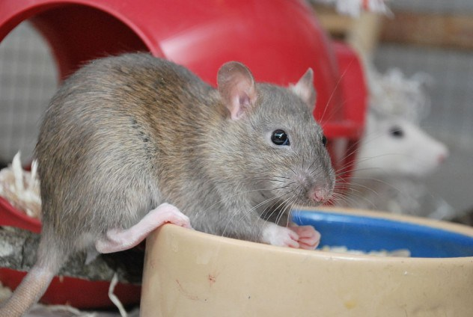
Rat-Free Alberta
Rats are a dreaded vermin the world over, spoiling billions of dollars worth of food supplies, spreading a laundry list of disease, and even causing house fires from chewed wires. These creatures have infested the globe, and dwell over nearly every inch of North America. Except the Canadian province of Alberta. When rats threatened the eastern border of the province (shared with infested Saskatchewan), a perimeter was set up and staunchly defended.
Alberta even has dedicated “border guards” who are responsible for protecting the border, carefully distributing poison, destroying derelict properties, and sometimes even digging rat burrows out with backhoes. Those rats which might be lucky enough to make it past this boundary are forced to contend with a rugged, often bitterly cold backcountry, and a sparse population density. Without warm human dwellings in which to take refuge, the rats freeze to death or succumb to predators. Thus far, Alberta remains free of rats; even the white laboratory variety typically found in pet stores can only be kept by zoos.

The Polar Bear Capital of the World
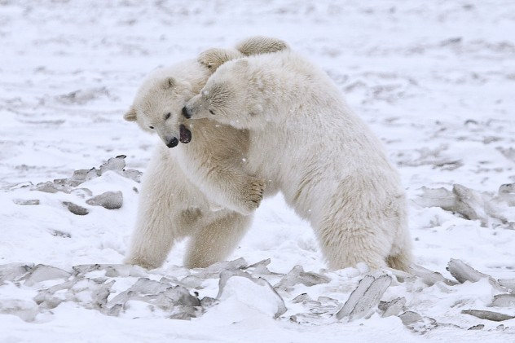
Churchill, Manitoba is a tiny village of less than a thousand people on the shores of the Hudson Bay. Its bitter cold affords it a curious and sometimes dangerous resident - the polar bear. The bears gather near the town in autumn, waiting for the bay to freeze over. In the winter, they head out onto the ice, where they hunt their favorite prey, the ringed seal. There is a bear for every person in the town and, while they bring in a collection of tourists, life with giant carnivores loping down Main Street can be a little tricky.
There are officers you can call specifically to deal with bothersome bears. Residences often come equipped with “Churchill welcome mats”, which are sections of plywood with nails sticking out. Bears intrepid enough to attempt breaking in will come away with bloody paws for their effort. The problem is so serious that most people leave their homes and cars unlocked to provide refuge in case someone is being chased.

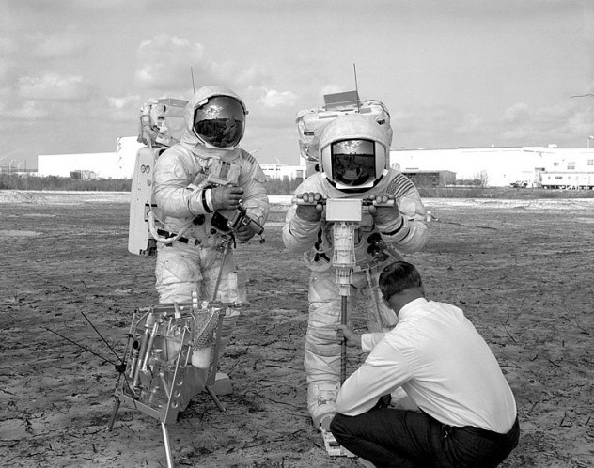
Missing Gravity
In the 1960s, when Earth’s global gravity fields were being charted, scientists discovered an intriguing anomaly in Canada’s Husdon Bay region. The difference is minuscule and undetectable by humans. There is about a tenth of an ounce less of pressure on a 68-kilogram (150-lb) person. Research has continued for decades concerning this mystery, and in recent years, a pair of theories have been combined to provide a compelling answer.
The first theory is that the molten rock in Earth’s mantle (which is subject to currents similar to ocean currents) has shifted away from the area. The second theory is that, during the last ice age, the Hudson Bay region was covered by a glacial shelf some 3.7 kilometers (2.3 mi) thick, which compressed the Earth and reduced its mass. The land is slowly rebounding - about a centimeter a year, and in another 5,000 years or so, everything should be back to normal.

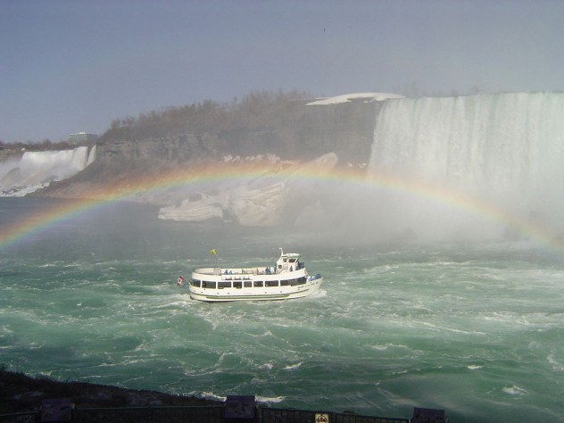
Going over Niagara Falls
Niagara Falls is composed of three separate waterfalls, of which only the largest (Horseshoe Falls) is located in Canada. The Falls are a breathtaking natural attraction, bringing in throngs of tourists. Most are content to snap a few pictures, or maybe take a ride on the Maid of the Mist, but a few arrive with more potent sentiment in to - that of adventure or tragedy.
Ever since Michigan schoolteacher Annie Taylor survived a plunge over the Falls in a barrel in 1901, daredevils have flocked to Niagara. Protected by all kinds of homemade devices (including inner tubes, rubber balls, and steel capsules), the majority have survived, although there have been a handful of ill-fated attempts. In 1920, an Englishman named Charles Stephens went over in a barrel. When the barrel was recovered, only his right arm was still inside. In 1995, a man named Robert Overcracker rode over the falls in a Jet Ski. The parachute he was wearing failed to deploy, and he plummeted to his death.
Unfortunately, the danger of the Falls has also led to be considered a hot spot for suicides. Although precise numbers aren’t known (many bodies go unrecovered), it is believed several thousand have killed themselves in this fashion. There are usually a couple attempts every week. Strangely enough, at least four people have survived going over with just the clothes on their backs-three were suicide attempts who were severely injured, and one was a drunken stuntman named Kirk Jones. Jones received only minor bruises. He was fined $2,300 and banned from ever entering Canada again. Worse still, Kirk’s cameraman was too drunk to operate the camcorder, and his brush with greatness went unrecorded.


Education
Despite spending a fraction of the United State’s budget on education, Canada is the one of the most scholarly nations in the world. More Canadians attend college than in any other country in the world-over half of all adults, compared with around 42 percent of Americans (which came in at fourth place-Israel and Japan ranked second and third, respectively). The major difference is expense: American students are often required to take out prohibitive loans to attend college, whereas Canadian universities are almost entirely public. The small handful of private schools there are mostly religious institutions.

Royal Canadian Mint
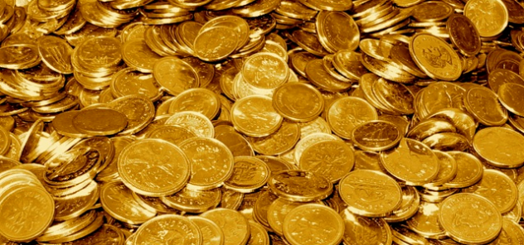
The Royal Canadian Mint is responsible for the production of all of Canada’s coinage (as well as some for other countries, like New Zealand and Papua New Guinea). Aside from the typical circulation coins, the Mint is known to produce a vast array of collector coins, not limited to glow-in-the-dark dinosaur versions. While all these novelty coins are technically legal tender, it is up to the individual bank or business whether they want to accept them or not. In 2007, they unveiled their most impressive model yet, a 100-kilogram (220-lb) gold bullion coin about the circumference of a large pizza. It boasts a face value of one million dollars, but at more than 99 percent pure gold, it is actually worth well over three million dollars at current trading rates.

Quebec
Independence
Today, the idea of Quebec seceding from Canada is seen by many as a pipe dream, along the lines of Puerto Rico becoming the 51st US state. But in 1995, a referendum posed to Quebecois voters on whether they wanted to separate from Canada was defeated by just 1 percent, with 50.58 percent voting “No” and 49.42 percent voting “Yes”. The result was met with a great deal of controversy, especially regarding the wording of the question, found by many to be unnecessarily complicated. Translated to English, the ballot asked, “Do you agree that Québec should become sovereign after having made a formal offer to Canada for a new economic and political partnership within the scope of the bill respecting the future of Québec and of the agreement signed on June 12, 1995?”
Quebec began as a royal province of France, but was lost to the British in the French and Indian War, signed over in the Treaty of Paris in 1763. A quarter of a century later, tensions remain strong. The secessionist movement reached a brutal head in 1963, when the paramilitary group Front de liberation du Québec (FLQ) began a campaign of terror, bombing and attacking English businesses and institutions. In 1970, the group kidnapped James Cross, the British Trade Commissioner to Canada and Pierre Laporte, a provincial minister and Vice-Premier. Cross was eventually released in a prisoner trade, but Laporte was strangled to death with his own rosary beads. His corpse was later found in the trunk of an FLQ member’s car. The murder forced Canadian Prime Minister Pierre Trudeau to invoke the War Measures Act, a sort of martial law, to crush the revolt. Hundreds of arrests where made, and the FLQ was effectively destroyed.

6. Check it
Fill in the missing words.

Responsible, royal, vermin, largest, village, anomaly, scholarly

- Rats are a dreaded … the world over, spoiling billions of dollars worth of food supplies, spreading a laundry list of disease, and even causing house fires from chewed wires.
- Churchill, Manitoba is a tiny … of less than a thousand people on the shores of the Hudson Bay.
- In the 1960s, when Earth’s global gravity fields were being charted, scientists discovered … in Canada’s Husdon Bay region.
- Niagara Falls is composed of three separate waterfalls, of which only the … (Horseshoe Falls) is located in Canada.
- Despite spending a fraction of the United State’s budget on education, Canada is the one of the most … nations in the world.
- The Royal Canadian Mint is … for the production of all of Canada’s coinage (as well as some for other countries, like New Zealand and Papua New Guinea).
- Quebec began as a royal province of France, but was lost to the British in the French and Indian War, signed over in the Treaty of Paris in 1763.

7. Say it
(Pair-work)
Explain in English these words from the text:
to discover
tiny
gravity fields
education
country
province

8. Homework
Look at the key facts about Canada, choose one of them and write down what you already know about it.
Use reference books, the Internet and find out more about it. Share the information with the rest of the class.

