COUNTRY STUDIES LESSONS.
Ottawa – the capital of Canada
Aims:
- to develop thinking skills;
- to practice writing;
- to expand students’ knowledge about the capital of Canada;
- to teach students to work in groups;
- to broaden their outlook;
- to develop speaking, reading skills.

Materials: map of Canada, handouts, multimedia complex, CD record of a text.

PROCEDURE
1. Warm-up

Read the poem by Archibald Lampman and discuss it.
To the Ottawa
Dear dark-brown waters full of all the stain
Of sombre spruce-woods and the forest fens,
Laden with sound from far-off northern glens
Where winds and craggy cataracts complain,
Voices of streams and mountain pines astrain,
The pines that brood above the roaring foam
Of La Montagne or Les Erables; thine home
Is distant yet, a shleter far to gain.
Aye still to eastward, past the shadowy lake
And the long slopes of Rigaud toward the sun,
The mightier stream, thy comrade, waits for thee,
The beryl waters that espouse and take
Thine in their deep embrace, and bear thee on
In that great bridal journey to the sea.

2. Reading.
Read the text and do the tasks which follow.

Ottawa
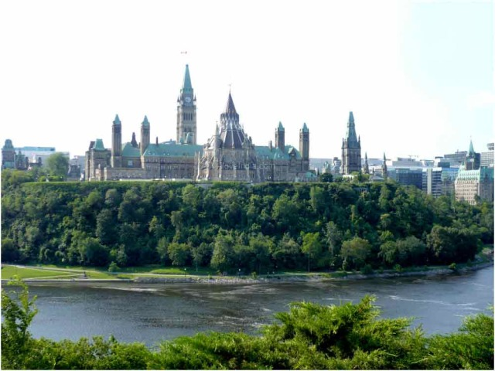
Ottawa is the capital of Canada. It stands on the south bank of the Ottawa River in the eastern portion of Southern Ontario. Ottawa borders Gatineau, Quebec. The 2011 census reported a population of 883,391 within the city, and 1,236,324 within the CMA, making them the fourth-largest city and the fourth-largest CMA in Canada respectively. The City of Ottawa has since estimated it had a population of 943,260 in 2013.

Founded in 1826 as Bytown and incorporated as "Ottawa" in 1855, the city has evolved into a political and technological centre of Canada. Its original boundaries were expanded through numerous minor annexations and ultimately replaced by a new city incorporation and major amalgamation in 2001 which significantly increased its land area. The name "Ottawa" is derived from the Algonquin word adawe, meaning "to trade".
Initially an Irish and French Christian settlement, Ottawa has become a multicultural city with a diverse population. The city is known as being among the most educated in Canada and hosts a number of post-secondary, research, and cultural institutions. Ottawa has a high standard of living and low unemployment. It ranks 2nd out of 150 in the Numbeo quality of life index, 14th out of 221 in the Mercer Quality of Living Survey, and it contains a UNESCO World Heritage Site.

3. Post-Reading Activities with the focus on writing.
Finish the sentences.
- Ottawa is the …. .
- The City of Ottawa has since estimated … .
- Founded in 1826 as Bytown and incorporated as "Ottawa" in 1855, the city … .
- The city is known as being among the most educated … .
- The city is known as … .

4. Write which 4 facts from the text about Ottawa impressed you most of all.

- Listening. Work in groups.
Teacher: You are divided into three groups. One pupil is from Ukraine, another from Canada. One of you are an interviewer. Listen to the texts and speak about the capital of Canada.

Places of interest in Ottawa
Ottawa grew up between 1820 and 1840 from a construction base where the Rideau Canal diverged from the Ottawa River. British Colonel John By (1779-1836) was in charge of the canal project, and consequently, the town was known as "Bytown." In 1854, the town changed its name to Ottawa, and later developed as the Canadian capital. The Parliament buildings were built in 1865, high above the Ottawa River, and it was here that the first Canadian Parliament met following the founding of the Dominion of Canada in 1867.
Together with Gatineau across the Ottawa River in Québec, Ottawa has succeeded more than any other Canadian city in developing a life of lively intellect and culture. Universities and several research institutes have all contributed to this, as have such internationally famous venues as the National Arts Center, a venue for opera and concerts; the National Library and Archives; the National Gallery, in a fine building by Moshe Safdie; and the Canadian Museum of Civilization, in an imposing building by Douglas Cardinal.

Parliament Hill

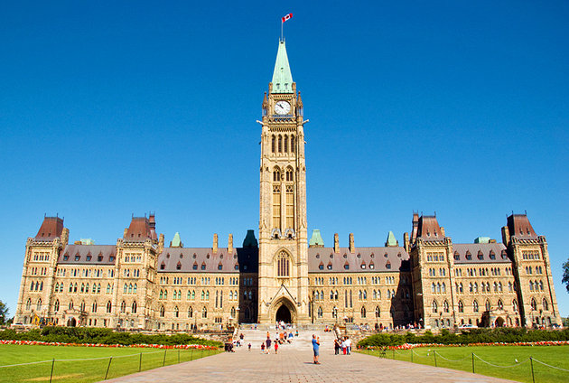
The Parliament Buildings, in all their splendor of Victorian Gothic sandstone, are quite an imposing sight on a 50-meter-high hill looking out over the Ottawa River. The Parliamentary Library, at the back of the building opposite the entrance, is a wonderfully furnished octagon that was untouched in the 1916 fire. Free, guided tours explore the sprawling historic Centre Block, and the public can also attend question period when the government is in session or climb the Peace Tower. The grounds encompass many sculptures, and in front of the Parliament buildings extends an attractive grassed area patrolled in summer by members of the Canadian Mounted Police, looking very dashing in their Mountie uniforms of scarlet jackets, Stetsons, riding breeches, and knee boots.

Rideau Canal
The Rideau Canal, also known unofficially as the Rideau Waterway, connects the city of Ottawa, Ontario, Canada, on the Ottawa River to the city of Kingston, Ontario, on Lake Ontario. It is 202 kilometres in length. The name Rideau, French for "curtain," is derived from the curtain-like appearance of the Rideau River's twin waterfalls where they join the Ottawa River. The canal system uses sections of two rivers, the Rideau and the Cataraqui, as well as several lakes. The Rideau Canal is operated by Parks Canada.
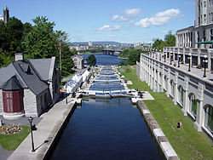
The canal was opened in 1832 as a precaution in case of war with the United States. It remains in use today primarily for pleasure boating, with most of its original structures intact, operated by Parks Canada. The locks on the system open for navigation in mid-May and close in mid-October. It is the oldest continuously operated canal system in North America, and in 2007 it was registered as a UNESCO World Heritage Site.

National Gallery of Canada
Located just steps from Parliament Hill in downtown Ottawa, the National Gallery of Canada is the country's showcase of the visual arts and a spectacular architectural landmark. Created in 1880, the National Gallery is one of Canada’s oldest national cultural institutions and offers both a permanent collection as well as special exhibitions in a building designed by famed architect Moshe Safdie.
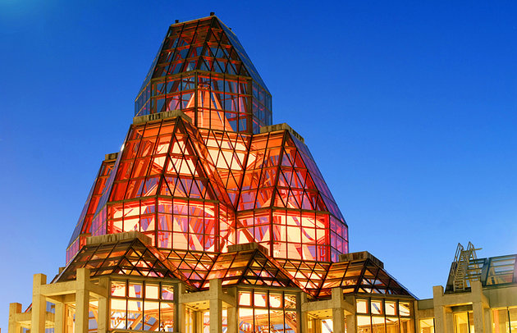
The works of renowned Canadian artists such as Tom Thomson, Emily Carr, Alex Colville, David Milne, Alfred Pellan, Elizabeth Wyn Wood, Jean-Paul Riopelle and more, grace the walls and rooms. The works of art reveal the past, celebrate the present, and probe the future. You drink in the Canadian wilderness captured by the distinctive brushstrokes of the Group of Seven. Experience European and American Galleries display paintings, sculpture, and decorative arts from the early fourteenth to the late twentieth century. The contemporary works of film, sound, videos, multi-media and paper provoke surprise and delight and change every three to six months to offer rich and varied encounters with art created over the past three decades in Canada and abroad. Be mesmerized by the Rideau Street Chapel, saved from demolition in 1972, it was dismantled into 1,000 pieces, stored and reconstructed within the Gallery.

Canada Aviation and Space Museum

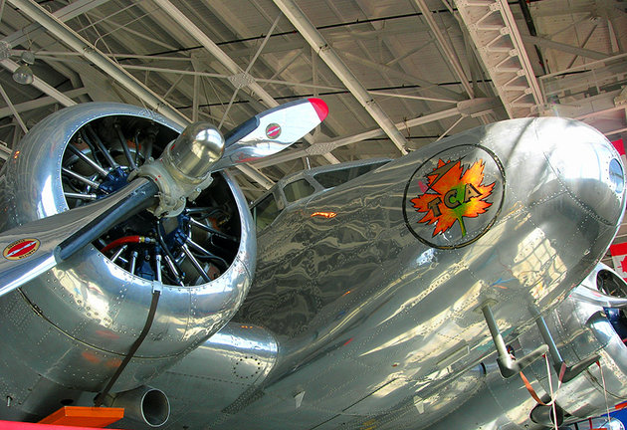
Telling in detail the story of Canadian civil and military aviation, the Canada Aviation and Space Museum is at Rockcliffe Airport, on the northern edge of town. Among the aircraft on display are a replica of the Silver Dart, which in 1909 made the first flight in Canada, fighter planes from the First and Second World Wars, and some of the seaplanes and other aircraft that helped open up Canada's uncharted northern wilderness.

Canadian Museum of Nature
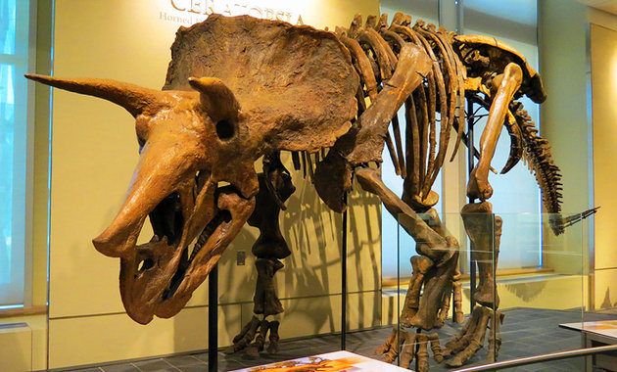
Canadian Museum of Nature takes visitors through the world of the dinosaurs all the way up to today's animal population, and also features poignant temporary exhibits. It is the national natural sciences and history museum, and the historic building (once the Victoria Memorial Museum) is the birthplace of Canada's national museums. Construction on this castle-like building was completed in 1910.
6. Understanding the text.
Which of these statements are wrong? Correct them.
- The Parliament Buildings, in all their splendor of Victorian Gothic sandstone, are quite an imposing sight on a 50-meter-high hill looking out over the Ottawa River.
- The Rideau Canal, also known unofficially as the Rideau Waterway is 204 kilometres in length.
- Located just steps from Parliament Hill in downtown Ottawa, the National Gallery of Canada is the country's showcase of the visual arts and a spectacular architectural landmark.
- The Canada Aviation and Space Museum is at Rockcliffe Airport, on the western edge of town.
- Canadian Museum of Nature takes visitors through the world of the dinosaurs all the way up to today's animal population.

7. Speaking
Give a short summary of the text using the plan:
- The Parliament Buildings.
2. The Rideau Canal.
3. The National Gallery.
4. The Canada Aviation and Space Museum.
5. Canadian Museum of Nature.

8. Homework.
Write a letter to your friend and tell him/her about places of interest in Ottawa.

