Halloween Party
https://www.youtube.com/watch?v=iYH1p65e-Jw
1 Presenter: Attention, please. Hello, friends! Ladies and Gentlemen. Today is Halloween or the “Holly Evening”! And we get together to celebrate “Halloween Party”. Let’s begin our holidays.
2 Presenter: It’s interesting what will happen when ordinary young people and ghosts or dark forces meet?
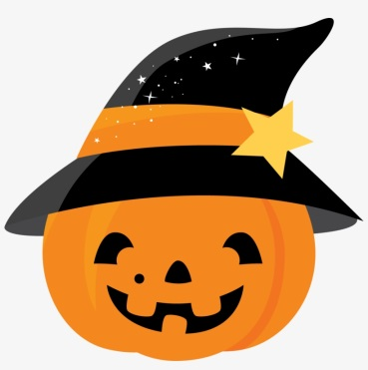
1 Presenter: I think that it will be just a happy holiday!
3 Presenter Everyone’s dressed and ready to go
There’s going to be quite a costume show
Halloween party time is here
Come to the party with me, my dear

Let’s put some monster music on
And sing a toe tapping Halloween song
There’s a lady wearing pearls and perky hat
Back in the olden days, that’s where she’s at.

В зал входять діти під музику “ Adam’s Family”
Black Cat 1: It’s Halloween, it’s Halloween!
The moon is full and bright.
And we shall see, what can’t be seen
on any other night!

Black Cat 2: Skeletons, spiders and ghouls
Greening goblins fighting duels
Ghosts riding from their tombs,
Witches on their magic brooms.

Black Cat 3: In masks we haunt along the streets
And knock on doors for trick or treat.
Tonight we are the king and queen,
For tonight it’s Halloween!

Пісня “Guess Who?”

Pointed hat and long nails.
Pointed nose and long broom.
Can you guess who I might be?
You are a witch!
Oh, yay-yay-yay-yay!

Bones, bones, bones and no skin.
Bony, bony, bony and so thin.
Can you guess who I might be?
You are a skeleton!
Oh, yay-yay-yay-yay!

Guess who? Guess who?

Floating in the dark with bright eyes.
Round head and a white body.
Can you guess who I might be?
You are a ghost!
Oh, yay-yay-yay-yay!

Square head and square shoulders.
Pokey hair and green, green skin.
Can you guess who I might be?
You are Frankenstein!
Oh, yay-yay-yay-yay!

Happy Halloween!
We are Halloween friends!

Pupil I made a funny pumpkin
For everyone to see,
It so big and terrible
It even frightened me.

Pumpkins1: Pumpkins are a curious thing,
They don’t dance and they don’t sing.
They don’t have hair, they don’t meow,
They don’t look much like a cow.
Pumpkins2: Pumpkins just sit around all day,
Out in the fields among the hay,
Sometimes they gather by the stable,
Sometimes they end up on the kitchen table.

Pumpkins3 I was a pumpkin big and round
When I grew upon the ground
Now I have a mouth and a nose
And two big eyes that never close.

Pumpkins4: I’m Jack-o-lantern
Fat and fine,
They picked me off a pumpkin vine.
Halloween is coming, don’t you know?
Just light my candle and watch me grow.

Пісня ”One little, two little, three little pumpkins”

One little, two little, three little pumpkins, four little, five little, six little pumpkins.
Seven little, eight little, nine little pumpkins, ten little pumpkins in a row.
Carve a face and make a jack-o-lantern, carve a face and make a jack-o-lantern.
Carve a face and make a jack-o-lantern, Halloween is here!
One little, two little, three little witches, Four little, five little, six little witches.
Seven little, eight little, nine little witches, ten little witches in a row.
Put them on a broom and fly away witches, put them on a broom and fly away witches.
Put them on a broom and fly away witches. Halloween is here!
One little, two little, three little ghosts, four little, five little, six little ghosts.
Seven little, eight little, nine little ghosts, ten little ghosts in a row.
BOO says the ghosts and then they disappear,
BOO says the ghosts and then they disappear.
BOO says the ghosts and then they disappear,
Halloween is here! Halloween is here! Halloween is here!

Танок: “Witches on Halloween”

Witch 1 Hello! I am a Witch. I am a very good Witch. Look! I have many bottles.
Bottles on the table,
Bottles on the floor,
Bottles on the shelves
One, two, three, four…

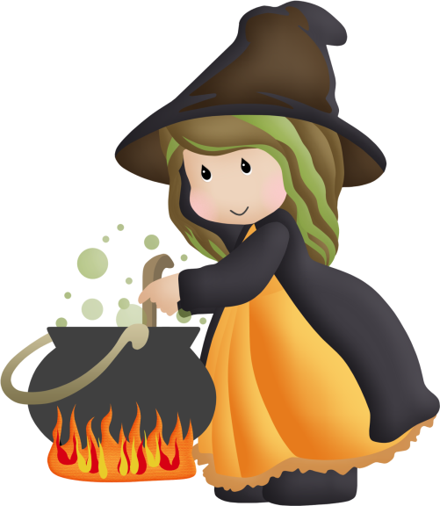
Witch 2 The witches fly
Across the sky
The owls go, "Who? Who? Who?"
The black cats yowl
And green ghosts howl
"Scary Halloween to you!
Witch 3 Witches flying through the air,
Witches, witches everywhere,
Witches here, witches there,
Witches, witches everywhere.
Witches hiding in the dark,
Witches dancing in the park.
Big black hats on the red-pink hair,
Witches, witches everywhere.

Witch 4 The witches are flying
Black cats can be seen,
It’s crystal clear, darling,
Tonight's - Halloween!

Witch 5 I like witches, spooky witches,
Happy witches, messy witches,
Fat witches, any kind of witches.
I like witches.

Witch 6 I like witches. Thin witches,
Mean witches, Green witches,
Nice witches, scary witches,
Old witches, I like all witches.

Пісня Halloween Creatures

What's that sound? It's all around!
I see 10 little witches (ghosts, monsters, vampires, werewolves) dancing on the ground
Let's count!
(Choruses)
1, 2, 3, 4, 5
and they say hee, hee, hee (boo, rarara, hahaha, aroo)
6, 7, 8, 9, 10
and the say hee, hee, hee (boo, rarara, hahaha, aroo)

Танок: “Ghost Family”

Ghost1: Three little ghostesses
Sitting on postesses,
Eating buttered toastesses
Greasing their fistesse
Up to their wristesses
Oh, what beastesses
To make such feastesse!

Ghost2: Witches with warts and fairies with wings,
Movies stars with sparkling rings,
Vampires with fangs that bite,
Ghost that boo all dressed in white.
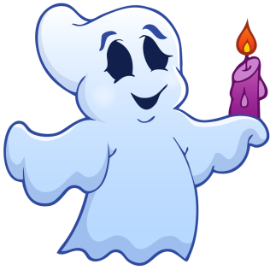
Ghost3 Slinky, inky, blinky cat,
Why do you arch your back like that?
What scary creatures have you seen?
Could be, must be, Halloween!

Ghost4 It's time to hide, it's time to fear –
The night of Halloween is near!
A loving Boo,
I send to you!
When spooks abound and ghosts are seen,
I'll keep you safe on Halloween!

Пісня Dem bones!

Dem bones, dem bones, dem oh, dancing bones.
Dem bones, dem bones, dem oh, dancing bones.
Dem bones, dem bones, dem oh, dancing bones.
Oh, dance with the skeleton band.

The foot bone’s connected to the leg bone.
The leg bone’s connected to the knee bone.
The knee bone’s connected to the thigh bone.
Oh, dance with the skeleton band.

The thigh bone’s connected to the hip bone.
The hip bone’s connected to the back bone.
The back bone’s connected to the neck bone.
Oh, dance with the skeleton band.

Dem bones, dem bones’ gonna walk around.
Dem bones, dem bones’ gonna walk around.
Dem bones, dem bones’ gonna walk around.
Oh, dance with the skeleton band.

Skeleton1 The skeletons are out tonight,
they march about the street,
With bony bodies, bony heads
and bony hands and feet.

Skeleton2 Bony bony- bony bones
with nothing in between,
Up and down and all around
they march on Halloween.

Skeleton3 Pumpkin time is here again
Time to play Trick or Treat.
Pumpkin time is here again
Our spooky friends we’ll meet.

Skeleton4: Trick or treat,
Give me something nice to eat!
Give me candy or the cake,
Give me something sweet to take!

Skeleton5: A Happy Halloween to you,
Watch out for ghosts and goblins - BOO!
Trick or treat,
Smell my feet,
Bring me something
Sweet to eat!

Trick or Treat Song

On Halloween night
We walk, walk, walk
On Halloween night
We knock, knock, knock
Chocolate, please!
Cookies, please!
Candy, please!
We love to trick or treat

Hurray, hurray, it’s Halloween
It's Halloween, hurray!
Hurray, hurray, it's Halloween
Trick or treat! , we say!

On Halloween night
We walk, walk, walk.
On Halloween night
We knock, knock, knock.
Lollipops, please!
Jelly beans, please!
Candy corn, please!
We love to trick or treat

Hurray, hurray, it’s Halloween
It's Halloween, hurray!
Hurray, hurray, it's Halloween
Trick or treat! , we say!

Chocolate, please!
Cookies, please!
Candy, please!
We love to trick or treat

Lollipops, please!
Jelly beans, please!
Candy corn, please!

We love to trick or treat
Hurray, hurray, it’s Halloween
It's Halloween, hurray!
Hurray, hurray, it's Halloween
Trick or treat! , we say!

Pupil1 Halloween wishes are sent your way
For a fun and scary Halloween day!
A scary time I wish for you,
With ghosts and werewolves, vampires too!

Pupil2 Halloween wishes
I’m sending your way
For funny and spooky
Halloween day!

Pupil3 I send this spooky
Little greeting
To wish you happy
Trick or treating!

Pupil4 The blackest cat
That you ever seen
Wishes you luck
On this Halloween!

Танок: Monster Shuffle Halloween Song

https://www.youtube.com/watch?v=XgFxo-IkCNQ

