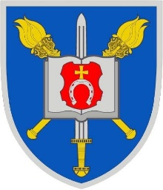

NATIONAL IDENTITY

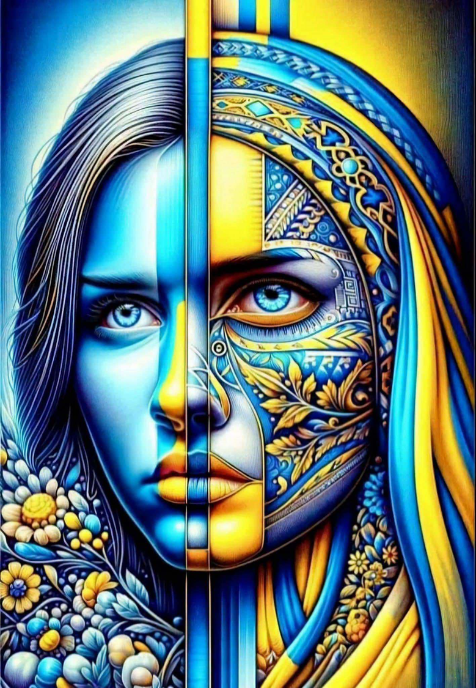

A demonstrative workshop

Prepared by A.B. Paliyenko
Platoon 33
November ,7

THEME: NATIONAL IDENTITY
ОBJECTIVES:
- Developing speaking skills involving pupils’ own life experience
- Introduction of the vocabulary on the subject.
- Developing listening/ reading speaking skills on the
covered material.
- To encourage the pupils to justify their opinion.
- Developing students' abilities to work in groups/pairs.
EQUIPMENT: a projector, a Power Point presentation, individual reading cards, some visual material, worksheets with topical materials, a video about national identity, speaking prompt handouts.

PROCEDURE OF THE LESSON
1. Organization moment of the lesson
- a report
2. Presenting the theme and the aim
Hope you are ok today and we’ ll have positive vibes at our demonstrative workshop. While working with this new textbook we try to make our revision lessons brighter and finish each topic with a project work.
So, the previous unit was about your personal traits, biography, family and hobbies. We spoke about our “personal identity”.
Do you remember what were the most important values for us (family, friends, work …)
Today we’ ll speak about “National Identity” and by the end of our lesson you’ ll understand and be able to talk about your national identity, realize the key factors of the Ukrainian symbols and traditions. This lesson will allow you to improve both listening and reading skills. You can develop your critical thinking skills through group work, discussions, and writing tasks.
By the end of the lesson you will create your personal vision of the topic.
So, write down the date and the topic into your exercise books.

3. Warming up ( Lexical)

Now I want you to be divided into 2 groups.

Just to tune in I’ d like you to watch this motivation video.
While watching it try to grasp some words that were unknown to you before (for example dignity - гідність). The subtitles will help you to do it easily.
Watching
- What are your bargains?.....
Today we are working groups of 5 and each group has to write a mind map of the association words with Ukraine national Identity, because at the end of our lesson we’ ll have a special activity.
4. Developing Listening Skills
ACTIVE LISTENING
Let’s travel around amazing Ukraine!
While watching the short video make notes of the fascinating places that are of great national pride.
- Name the places that were mentioned in the video EXERCISES for eyes
5. Developing Reading skills
Cossacks
PRE-READING ACTIVITIES
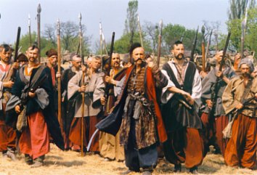
1. Whom can you see in the picture?
2. What interesting facts do you know about them?

Cossacks
Warrior =soldier, fighter Infantry =soldiers marching or fighting on foot

At the end of 15th century, people who called themselves Cossacks appeared on the banks of the Dnipro River down the rapids пороги. They originated from the Ukrainian peasants and poor citizens. These brave people were full of heroism and were ready to fight for the social and national independence of Ukraine. They began building ground fortifications укріплення that were called “siches” on the Dnipro islands. These siches were joined into one system that was a political, administrative and military centre. Later it became the centre of the liberation movement визвольний рух of the Ukrainian people.
Cossacks were free and independent people and armed warriors воїни. Sich was a fortress made from wood and stones. The first Sich was built on Khortytsia Island. Hetmans headed Cossacks, who were courageous men, and led their army into the fight against enemies.
Zaporizhian infantry піхота formed the basis of the army and these armed forces were the best in Europe in the 15th – 17th centuries. Cossacks ships were called “chaikas”. Each ship was 60 meters long and it was made of wood.
Cossacks food was honey, kulish and fish. Cossacks did not have any bread. They lived in kurins (a kind of hut) on the island of Khortytsia, that was the largest island on the Dnipro.
Zaporiz’ka Sich was a sovereign state. Pylyp Orlyk was the author of the first constitution in Europe that was in 1710. The list of Sich hetmans accounts 83 people.

POST-READING ACTIVITIES
1Agree or disagree with these statements. True or False?
- Cossacks originated from the Ukrainian the poor. _____
- They were ready to enrich themselves. ______
- They built strong fortifications. ______
- Zaporizhian infantry formed the basis of the army. ______
- Sich was a sovereign state. ________
- Cossacks were vegetarians. ________
2. Complete the sentences:
1. Cossacks … on the banks of the Dnipro:
a) worked b) trained c) appeared
2. Siches were joined into one .. centre:
a) trade b) military c) enternainment
3. Cossacks didn’t have any …
a) pork dishes b) bread c) porridge
4. They lived in …
a) small villages b) underground fortification c) kurins
2. Answer any questions:
1. Who were Cossacks?
2. What does the word Sich mean?
3. What was Cossacks’ food like?
4. What were they ready to fight for?
5. How did Cossack’s ships look like?
6. Were their armed forces the best in Europe?

- Pair work
Except official symbols of every country Ukraine is rich in unique traditional symbols that were a part of Ukrainian culture for the centuries.
Let’s find some of them. The task of eanch pair is to read information, find a symbolic thing and present it to our platoon.

1 Embroidery for Ukrainians is much more than just a way of decorating clothes or various household items. Embroidery is part of the Ukrainian world outlook, of the Ukrainian self-awareness; it is a sort of a sacred ritual of their life.
Vyshyvanka is a kind of traditional clothing in Ukraine. It is a part of the Ukrainian national costume
Today the embroidered shirt has taken on a special importance as a means of expressing patriotism. Vyshyvanka is a symbol of freedom!And freedom is the key trait of Ukrainian national identity !

2 Motanka is a traditional Ukrainian handmade doll made from fabric and thread, without the use of needles. These dolls are often created without faces, which makes them unique. Ukrainians believe that motanka dolls have protective powers and can bring good luck.

Motanka was traditionally made for important occasions, such as weddings or holidays, and passed down through generations. The motanka doll is a symbol of family, heritage, and the connection between generations in Ukrainian culture.
3 Viburnum is the symbol that has strong associations with the Ukrainian land.
A viburnum bush has always been of great value to Ukrainians. Viburnum was usually perceived as a sign of well-being, family well-being, and over time became a national treasure of Ukraine.
4 Pottery is the art and craft of creating objects from clay . It has been practiced by humans for thousands of years and has played an important role in human history, culture, and society.
5 Pysanka is an integral part of the national cultural heritage (спадщина).It is a symbol of a new life.

7. Recreational educational activity
Language is a soul of any nation.
What’s the official language that we speak and adore?
What national writers poets bards do you know?
Let’s admire a poem by Vasyl Symonenko. Khrystyna has learned a poem “Do you know that you are a human by heart?”

Ukrainians are an old nation. Ukrainians are known as hard-working and skilled farmers with a very special sense of humour.
We are very well - wishing and frank people!
It’s true that we are also optimistic and conflict-free, careful and brave.
We are proud of our national IDENTITY!
8. Group work (reflection)
Summary of the lesson
Lets make an interactive summary of our lesson!
Write as many words as you can that are associated with the notion ‘National identity’

9. Hometask setting =Developing Writing Skills
WRITE AN ESSAY “PROUD TO BE UKRAINIAN’’
10 Self evaluation
Marks: 12/11/10

