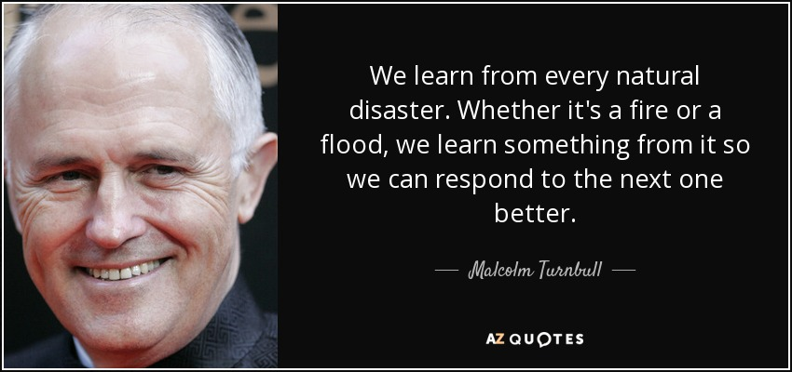
Group up the next words according to the type of natural disaster:
tornado, earthquake, tsunami, volcano eruption, flood, hurricane, drought, blizzard, avalanche, hailstorm, whirlpool, heat wave, landslide, forest fire, typhoon, thunderstorm.
Match the words and find their definition

1 hurricane
2 hailstorm
3 flood
4 earthquake
5 avalanche
6 tsunami
7 heat wave
8 landslide
9 blizzard
10 tornado/twister
11 volcanic eruption
12 drought
14 forest fire/wildfire
15 lightning

Abrupt electric discharge from cloud to earth accompanied by the emission of light
a rain of solid, frozen water
excess of snow and winds
a tidal snow wave provoked by vibration of movement of the earth or sound
a whirlpool of water
a tidal wave provoked by an earthquake
days or weeks in which temperature rises a lot
the movement of the tectonic plates
an uncontrollable fire
excess of water provoked by heavy rain
the explosion of lava from a volcano
A long period of dry weather
a falling of rocks from hills or mountains due to heavy rains or earthquakes
the mixture of hot and cold winds which due to its pressure, creates a whirlpool

Group up the next words according to the text. There are some words belonging to the both texts. There are some extra words:
The Paradise club, The UK, to sleep, an afternoon meal, an earthquake, a volcano eruption, Santa Librada,sea,survived,fear,panic,helplessness,horror,calmness,death.
Melinda Ronald

Match the halves of sayings:

Better to be a thousand times careful…
Know safety, no injury.
Safety is a cheap and…
Danger never takes…
Safety isn’t expensive...
Safety is as simple as ABC –

We have completed all the tasks and it’s time for self-assessment. Use the QR code or follow the link
https://docs.google.com/forms/d/12NqzhG37lSmhhol5hkhMCDbrqYd_sOFPdRIWQ9ZyGHQ/edit
and evaluate your today’s work.

It is priceless.
Always Be Careful.
than once dead.
effective insurance policy.
No safety, know injury.
a vacation


