SCHOOL LIFE
(конспект уроку «Шкільне життя» з іноземної (англійської) мови в 11 класі)
Ольга Майборода,
викладач І категорії,
викладач іноземної мови,
ВСП Технолого-економічний фаховий коледж
Білоцерківського НАУ.

Lesson plan
Topic: School life
Aims:
- to revise the vocabulary on topic “School life”;
- to help students focus on fluency when speaking;
- to develop learners’ communication skills;
- to practice reading for cohesion and checking comprehension;
- to practice listening for specific information;
- to exchange ideas and opinions:
- to personalize the topic and talk about exams.
Materials: textbook (Bob Hastings, Marta Uminska, Dominika Chandler, Kristof Hegedus, Exam Activator. – Pearson, 2013. – 230p.); Audio (CD 1-34, 1-35); Power Point Presentation; WoodWardEnglish vocabulary https://www.vocabulary.cl/Intermediate/Do_Make.htm.

Procedure
- Lead-in
  - Greetings. Hello, dear students. How are you doing today? How the weather?
  - Introduce the topic. So, it’s high time to start our lessons. And what we are going to speak today I’d like you to figure out by yourselves. For this reason look at the pictures and guess what they are related to. First, look and say what you can see at the picture and then why you need it for.
(PowerPoint presentation)
Ss: At the picture we can see children, balls and bats. We need them for doing sport.
Now having this information can you suggest what we are going to speak today?
(Ss: School life)

  - Warming-up.
Look at the pictures and match them to the appropriate sentence. Prove.
(Textbook: Exam Activator Unit 3, ex.1, p.86)
S: At the first picture in the foreground we can see a little girl who is crying. In the background there are other children who are sitting and probably playing or colouring together. At the floor we see some toys. So, we can suppose that it’s a kindergarten. To my mind it’s the first day at the kindergarten for the girl who is crying. Another idea is that she doesn’t like going to a kindergarten. I think we can match this picture with the third sentence.

- Main part
  - Introducing new vocabulary. Guessing the meaning of the following words and word-combinations. Use the words from the next exercise.
T: primary school (high school, etc.)
Ss: початкова школа (старша школа. і т.д.)
Note: You can write unknown words on the board and later check their meaning together at next exercise.
  - Reading the words with the translation. One by one.
primary school |  | початкова школа |  | secondary school |  | середня школа
high school |  | старша школа |  | school-leaving exam |  | випускні іспити
entrance test |  | вступний тест |  | classmate |  | однокласник
deputy head |  | заступник директора |  | head teacher |  | директор
staff |  | персонал |  | hard |  | наполегливо
pay attention |  | звертати увагу |  | mistake |  | помилка
activity |  | діяльність |  | academy honesty |  | чесність у навчанні
cheat |  | шахраювати |  | steal |  | красти
miss |  | пропускати |  | truant |  | прогульник
  - Completing the sentences with the words from the box.
(Textbook: Exam Activator Unit 3, ex.5, p.87)
  - Making two sentences with new words from ex. 2.2. Asking group mates to give their Ukrainian equivalents.
S1: You should pay more attention to your pronunciation.
S2: Тобі слід звернути більше увагу на вимову слів.
  - Reading.
- Before reading activity. Answer the following questions.
- What types of school do you know?
- Would you like studying in a state or a private school? Why?
- What do you thing about boarding schools?
- The usage of the verbs Do and Make.
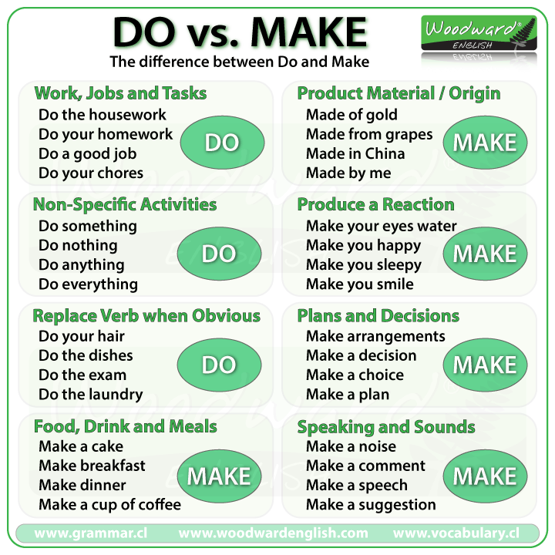
- While reading activity. Read the girl’s letter from her boarding school to her parents and complete the sentences with the correct form of Do or Make. (Textbook: Exam Activator Unit 3, ex.11, p.87).
- After reading activity. Read the following statements and decide whether they are true or false. Correct the false ones and prove the right.
- If you don’t pay attention in the class and don’t revise the material you won’t get good marks.
- Teachers give you extra tasks if you don’t do your homework in time.
- According to Zoe most of the time studying is fun.
- Studying in that school is easy but helps to improve your knowledge.
- Zoe isn’t sure she manages to pass her exams well no matter how hard she is studying.
  - Listening
- Before listening activity. Answer the following questions.
1. What do you think teaches usually like their work at school? Why?
2. What can annoy teaches at school?
- While listening activity. Match the speakers 1-6 to the statements A-H. (Textbook: Exam Activator Unit 3, ex.4, p.91).
- After listening activity. Match the collocating words. (Textbook: Exam Activator Unit 3, ex.5, p.91).

  - Speaking
- Arrange the words from the box to tell the story of someone who took an exam, but didn’t succeed the first time. (Textbook: Exam Activator Unit 3, ex.8, p.87)

3. Final part
  - Summing-up.
  - Setting homework: Write a short story according to the plan: p.87, ex.8.

Contributed by ____________________________________

