The sights of America

Мета: активізувати вживання ЛО в мові учнів з теми «Визначні місця Америки»; практикувати їх в умінні ставити незаплановані запитання, що виникають під час бесіди, та відповідати на них; удосконалювати навички роботи в групах; ознайомити з визначними місцями Сполучених Штатів Америки; виховувати інтерес до культури народу, мова якого вивчається.

PROCEDURE
1. Warm up
On the blackboard the quotation from John Clarke is written: “He that travels far knows much”.
- What do you think about this quotation?
- How do you understand these words?
- What’s your opinion?
(Students exchange their opinions using the expressions:
I think …
To my mind …
In my opinion…
It seems to me …
As for me…
From my point of view )

2. Reading

Across America
Mike and Diana are fourteen and sixteen years old. They live in New York. Together with their parents they are driving across America in a camper for their summer vacation.
They set off towards the Canadian border. Read what they tell you about the journey and see if you can follow it on the map.

Before you read
Practice the new vocabulary.
New words to know:
- incredible – неправдоподібний
- handicraft – ремесло, ручна робота
- necklace – намисто
- earthquake – землетрус
- damage – шкода, пошкодження
- repairs – ремонтувати, лагодити
- barrel – бочка
- tool – робочий інструмент

June 16
Mike
Today we saw Niagara Falls. It was incredible! The guide told us that many years ago, some man rode over the falls in a barrel and another person used to walk across the falls on a tightrope. We had ice cream in a small diner.
(Note. Niagara Falls is about 25,000 years old. It is partly in
Canada, partly in America. The falls are used to make electricity.)

At the diner

Waitress Can I help you folks?
Dad Yes, we’d all like one of these big sundaes.
Waitress Anything to drink?
Dad Two coffees and two cokes. Is that all right with you, kids?
Mike OK. Does this jukebox work?
Waitress Sure, just put a quarter in and press the button for the song you want to hear.
Diana Oh, not that. Can’t we listen to something else instead?
Mike You can pick your own song next time. Now it’s my turn.

June 22
Diana
We’ve been on the road for a week now! Today we got to Minneapolis. The trip from Chicago took a lot longer than we thought, because the camper broke down in Milwaukee. We were lucky to get it fixed the same day. Mom and I went to a museum, but Dad and Mike waited for the car to get fixed. Dad wasn’t at all happy about having to pay for the repairs, but he’ll get the money back later on, he says.

At the garage

Mechanic You’re lucky. There’s almost no oil left at all in the engine.
Dad What’s wrong?
Mechanic Last time they changed the oil, they forgot to put the plug back properly. The engine could have been ruined.
Dad Will it cost much?
Mechanic Like I said, you’re lucky. I can fix this in a couple of hours.
Mike Can I watch?
Mechanic Ok. You can hand me the tools when I ask for them.

June 24

Mike
Minneapolis is a beautiful city. There are lakes everywhere. So this afternoon we’ll all go for a swim in a lake near our hotel. We saw another waterfall here called Minnehaha Falls. That’s Indian for ‘laughing waters’. This is an old Indian country. We saw a lot of Indian handicrafts in small shops along the highway on our way here. Diana bought a necklace and a copy of an old Indian totem pole.

June 30

Diana
We’re in Utah. I really think this is the best part of the trip. Today we were in Zion National Park and rode through the mountains on horseback. I almost fell off! We drove across Kansas yesterday. It was really flat! When we got to Colorado the scenery changed. Mom was really impressed by the state capitol building in Denver. The dome was covered in gold.

July 4

Mike
In Nevada we drove by a herd of buffalo. They started running when they heard the sound of our camper driving by. What a cloud of dust! I sure wouldn’t want to get in their way. In Reno we played the slot machines. Dad lost 20 dollars!

July 10
Diana

We’re finally in California! Yesterday we drove along the Pacific coast from San Francisco to Los Angeles. Now we are going to leave the camper and fly back to New York. When we were in San Francisco there was a small earthquake, but no buildings got damaged and no one got hurt. We won’t have time to go to Disneyland. Mom says it’ll have to wait until our next trip.

3. Understanding the texts
- What are the main characters of this story?
- What do they think about the Niagara falls?
- What did Mike have to do to make the jukebox work?
- What happened in Milwaukee that cost extra money?
- What did Mike do at the garage?
- What did the family do in Utah?
- Where did they meet a herd of buffalo?
- In what state did they end their journey?

4. Speaking.
Words and phrases
Look at these key words from the text.
In what state or city do you find them?
1 herd of buffalo
2 earthquake
3 ‘laughing waters’
4 Disneyland
5 Zion National Park

5. Check it
Fill in the missing words.

Incredible, sundaes, scenery, broke down, vacation, engine, oil

1. Mike, Diana and their parents are on summer … .
2. Niagara Falls is … .
3. We’d all like one of these big … .
4. The camper … … in Milwaukee.
5. There’s almost no … left in the … .
6. When we got to Colorado the … changed.

6. Relaxation.
Read the joke silently to make sure you understand each sentence. Retell the joke.
Rather Late
It was a dark night. A man was riding a bicycle without a lamp. He came to a crossroad and did not know which way to turn. He noticed a pole with something white which looked like a sign. Climbing to the top of the pole he lit a match and read: “Wet Paint”.

7. Work in groups.
Choose on of the items below and make up the dialogue.
Say what you think the family said when
- they saw Niagara falls.
- the camper broke down.
- they saw all the Indian handicrafts.
- they rode through the mountains on horseback.
- they drove by a herd of buffalo.

8. Agree or disagree with the following statements. Give your reasons. (Individual work)
1. Exotic places attract people like a magnet.
2. Travelling round the world is a dream come true.
3. Interesting trips bring back memories.
4. When people visit a foreign country, they may find life in it a bit of a culture shock.
5. Without traveling people’s life lacks variety, and variety is the spice of life.
6. Environment-friendly tourism becomes popular nowadays.

9. Make up short conversations in the following situations.
1. You are thinking about going to the USA on vacation. Ask a travel agent where he / she thinks you should go.
2. Your friend has just returned from a trip to the USA. Ask him / her about it.

10. Group work
Look at the photos. Do you know where they were taken?
Guess these sights and tell a few words about them.
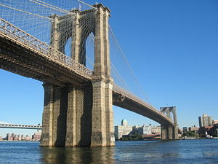
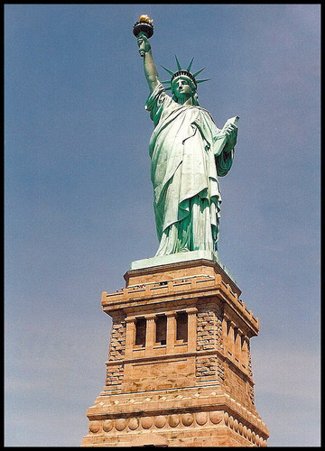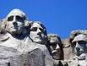
11. Homework
Write a story based on the dialogue.
- I travel much. I go from place to place seeing things, meeting people. There is nothing like travelling.
- It has been my dream for ages to travel.
- You can count on me in your travelling.
- Have you packed everything?
- Yes. I’m proud of my packing. I know more about it than you.
- How neatly you pack?
- It’s practice. I’ve been practicing all my life. Don’t you forget anything?
- Always. Toothbrushes and soup especially. And the funny thing is, I always remember the soapdishes and put them in empty.

