Thanksgiving Quest
Умови гри: квест для учнів 6-x класів. B класi заздалегідь обираються команди по 5-6 учнів. Учасникам видається маршрутний лист з назвами станцій. На кожній станції ведучі пояснюють завдання та записують результати у маршрутний лист. Перемагає команда, яка найшвидше та якісніше виконає завдання. Всі учасники нагороджуються сертифікатами за участь.
Мета: удосконалення знань, вмінь та навичок, отриманих на заняттях англійської мови, розширення світогляду та ерудиції учнів; розвиток їх творчих здібностей, самостійності, естетичних смаків; формування вміння концентрувати увагу, логічно мислити і правильно викладати думку, заохочувати учнів до роботи в команді; виховувати інтерес до вивчення англійської мови.
Хід гри
Ведучий 1. Hello, dear children and guests. We are spending the English quest today. 3 teams are taking part in this quest. Each team has its own name
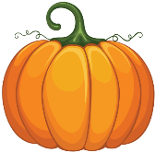  CRAZY PUMPKINS | 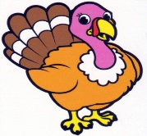  FUNNY TURKEY | 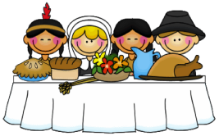  BRAVE PILIGRIMS
Ведучий 2. Now you can hear some information about the rules of our game.
Ведучий 1. At first I am asking everyone to look at the field of our quest. On the playing field, you can see tables with numbers. They have the task of our quest. Each team must do these tasks in order to reach the finishing line. All teams are on the equal footing. Tasks for all the teams are the same, but they perform them in a different sequence. To do the assignment the contestants need to use their knowledge of English as well as erudition, observation and ingenuity.
Now each team is making a representation of its name, after that it will receive a starting number. All the teams are starting at the same time with their team leaders.
Stop #1” Thanksgiving quiz”
Hello, everybody! I’m glad to meet you at my station ’’Thanksgiving quiz.” On my stop I want to check your knowledge about Thanksgiving Day. For every right answer you’ll have 1 point! But don’t cry, or I’ll take your goals back! Are you ready? Get set, go!
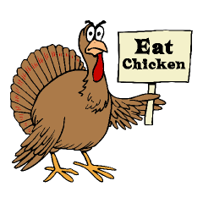
Thanksgiving quiz
1. Who were the English settlers who sailed from Europe to North America on the Mayflower?
a) The Pilgrims
b) The Beatles
c) The Mormons

2. What landmark is known as the place where the English landed in America?
a) Pilgrim Rock
b) Patriot's Rock
c) Plymouth Rock

3. The Pilgrims came to America:
a) For religious freedom
b) To fight the Indians
c) To trade tea and animal furs

4. When was the first Thanksgiving celebrated?
a) 1621
b) 1777
c) 1800
5. The Native American Indians who celebrated the First Thanksgiving dinner with the Pilgrims were from which tribe?
a) Cherokee
b) Mohican
c) Wampanoag

6. In the U.S., Thanksgiving is celebrated on:
a) The day before the Winter Solstice
b) The fourth Thursday of November
c) The last Thursday of November

7. Thanksgiving is the biggest travel day of the year in the United States.
a) True
b) False

8. Which wild bird was NOT on the Pilgrims’ First Thanksgiving menu?
a) Turkey
b) Duck
c) Goose
d) Bald Eagle
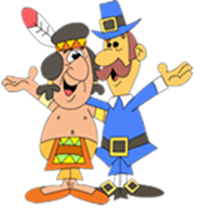
9. A typical Thanksgiving meal is ...
a) melon, chicken and pumpkin ice cream.
b) turkey, potatoes, corn and pumpkin pie.
c) pumpkin soup, hamburger, fries and carrot cake.

10. What follows the Thanksgiving day in USA nowadays?
a) Yellow Friday
b) Black Friday
c) Green Friday

Stop #2 “QR Codes ”
Hello, everybody! I’m glad to meet you at my “QR Codes” Stop. Your task is: scanning the QR Code, read the definition of the word and try to guess what it is. For every right answer you’ll have 1 point!
 |  |  |  |  |  | 
 |  |  |  |  |  |  | 
1. Dinner, 2. Harvest, 3. Indian, 4. Pilgrims, 5. Plymouth Rock, 6. Pumpkin, 7. Thanksgiving Day8. The Mayflower,9. Turkey

Stop #3” Word Chain”
Hello, everybody! I’m glad to meet you at my ’’Word Chain” Stop. Now you get a circle, divide it and find the Thanksgiving words.
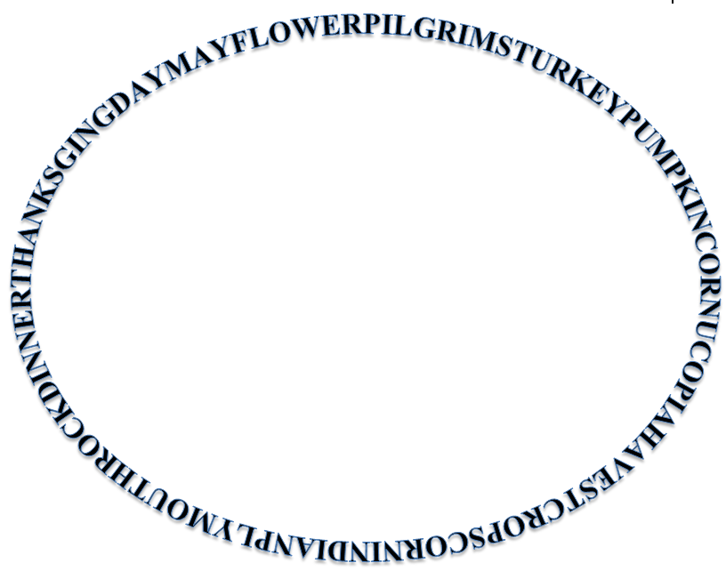
THANKSGING DAY MAYFLOWER PILGRIMS TURKEY
PUMPKIN CORNUCOPIA HARVEST
CROPS
CORN
INDIAN PLYMOUTH ROCK DINNER

Stop #4 “Puzzle” Stop
Hello, everybody! I’m glad to meet you at my “Puzzle” Stop. Now look at the picture and solve a jigsaw puzzle. For the right answer you’ll have 5 points!
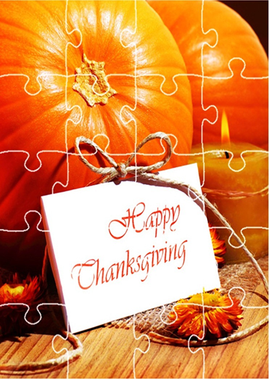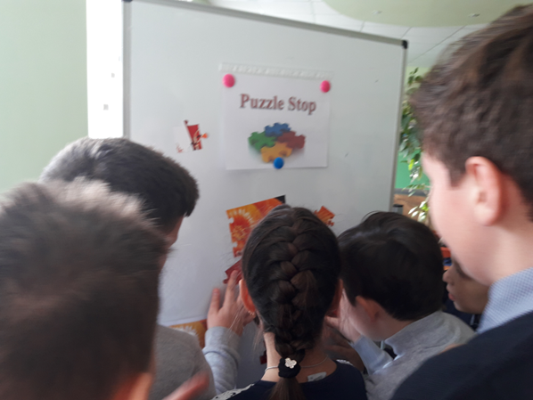
Stop #5” Magic Sentences” Stop
Hello, everybody! I’m glad to meet you at my “Magic Sentences” Stop. Your task is to scramble the sentence, but use your imagination. For the right answer you’ll have 5 points.
The original Thanksgiving lasted three whole days and can you believe that all that food was prepared by three women! The colonists continued to celebrate the autumn harvest with a feast of thanks. Abraham Lincoln established the last Thursday in November as a day for all Americans to give thanks.

The original Thanksgiving lasted three whole days and can you believe that all that food was prepared by three women! The colonists continued to celebrate the autumn harvest with a feast of thanks. Abraham Lincoln established the last Thursday in November as a day for all Americans to give thanks.(use the mirror to read)

Stop #6” Make up Sentences Stop”
Hello, everybody! I’m glad to meet you at my “Make up Sentences” Stop. Your task is to make up the sentences, use your brain. For every right answer you’ll have 1 point!

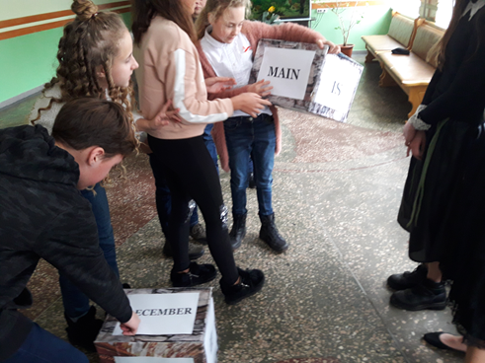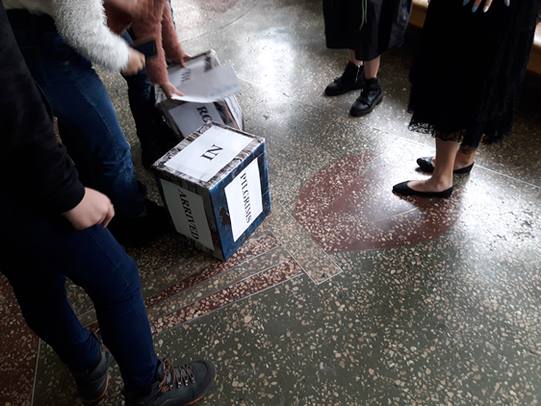

1. Pilgrims arrived in America on December. 2. The main dish was pumpkin pie.
Stop #7” Memory Stop”.
Hello, everybody! I’m glad to meet you at my “Memory Stop”. .Now watch the video for 1 minute and try to remember all the pictures and then name them. For every right answer you’ll have 1 point!

Stop #8” Song Stop”.
Hello, everybody! I’m glad to meet you at my “Song” Stop. Now listen to the song and try to remember it-makes up the text. For each right answer you’ll have 5 points!
Today’s Thanksgiving Day!
Today’s Thanksgiving Day!
The turkey’s in the oven.
The table’s set.
Today’s Thanksgiving Day!
The peas and carrots are ready.
The cranberry sauce is here.
The pumpkin pies look wonderful!
Today’s Thanksgiving Day!
Is the turkey ready?
No, not yet.
Is the turkey ready?
No, not yet.
The turkey’s ready.
Here it comes!
Today’s Thanksgiving Day! Hooray!


